Table S1. Area under the receiver operating curve (AUROC) comparisons of IMPACT scoring system stratified according to the year of admission. The comparisons were performed using the DeLong’s test.

AUROC comparisons | P Value
Total vs 2020 | 0.2862
Total vs 2021 | 0.5685
Total vs 2022 | 0.8123
2020 vs 2021 | 0.1731
2020 vs 2022 | 0.7523
2021 vs 2022 | 0.6793

STEP-BY-STEP MODEL CONSTRUCTION

Step 1

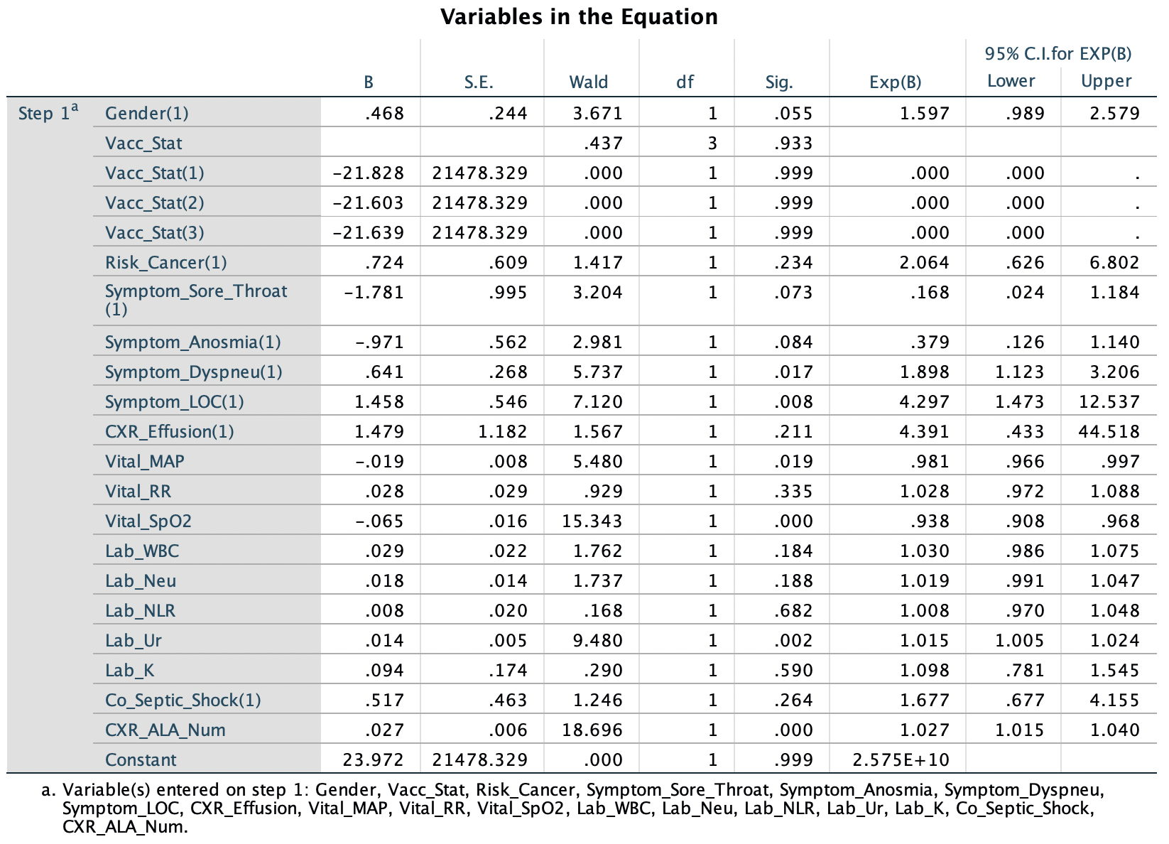

Step 2

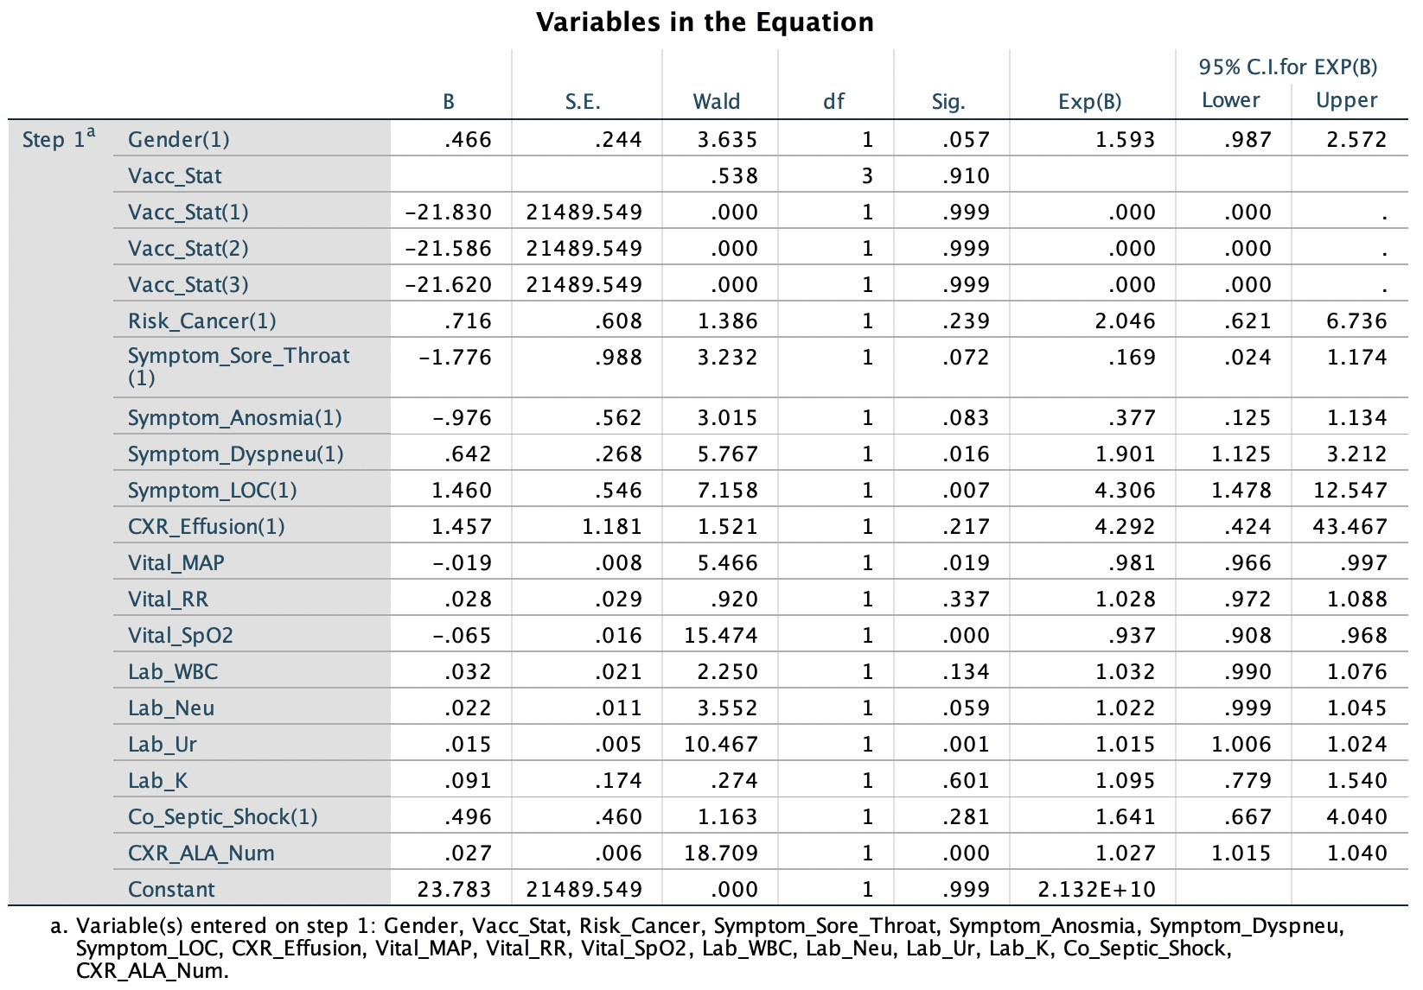
Step 3
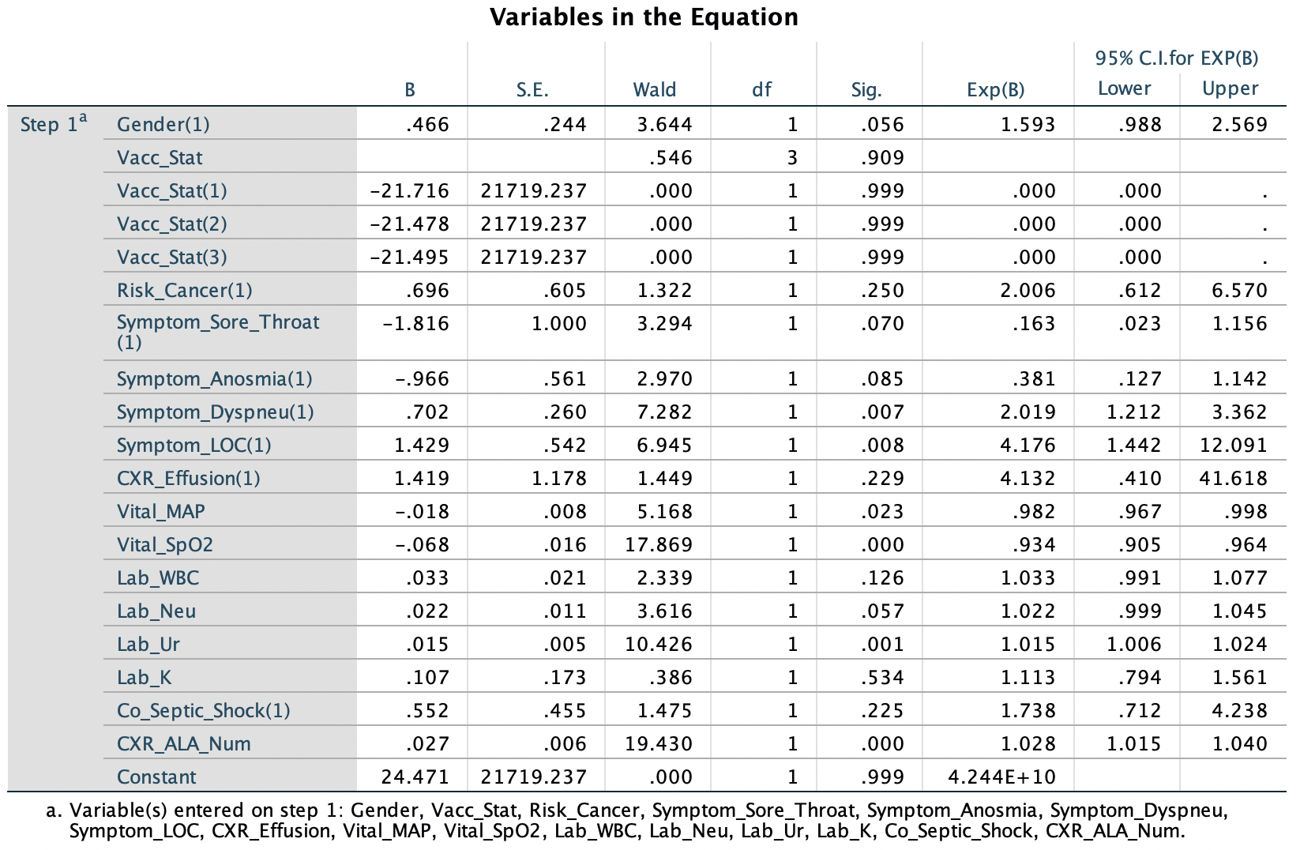

Step 4
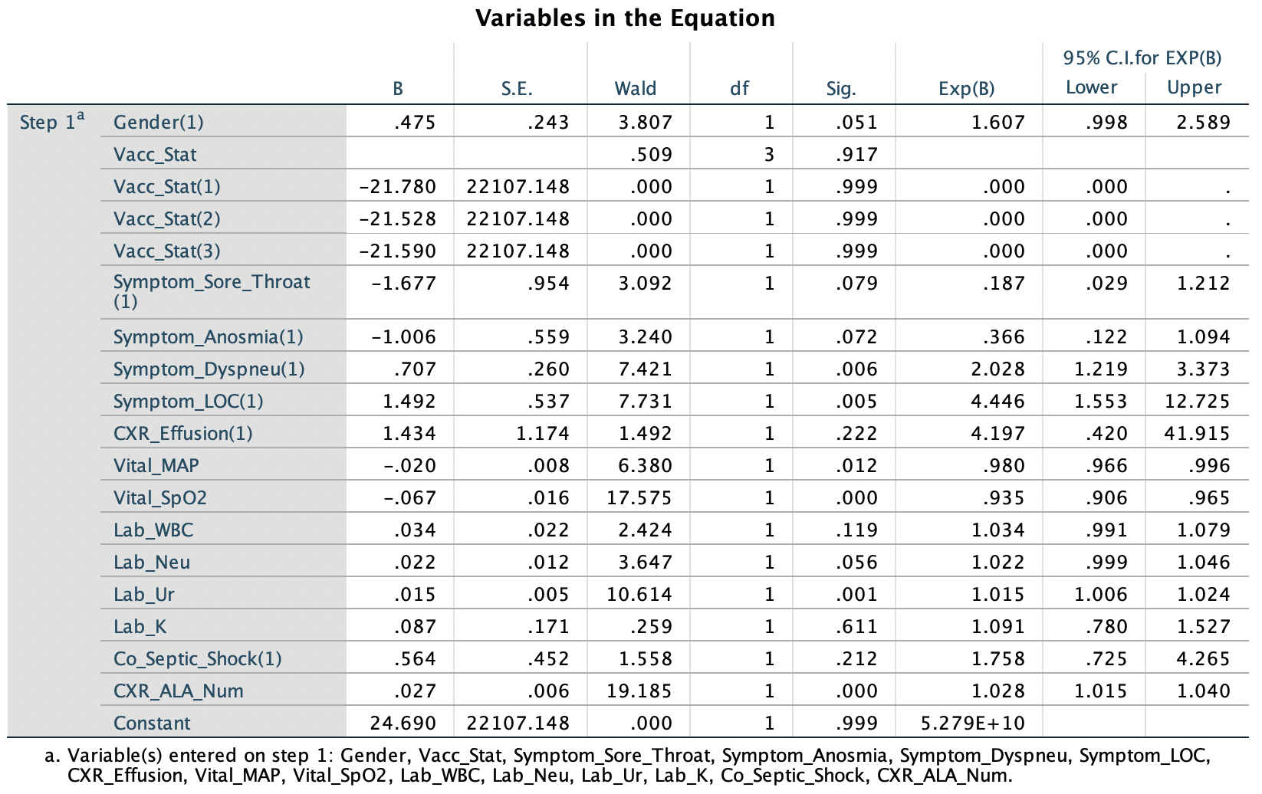

Step 5
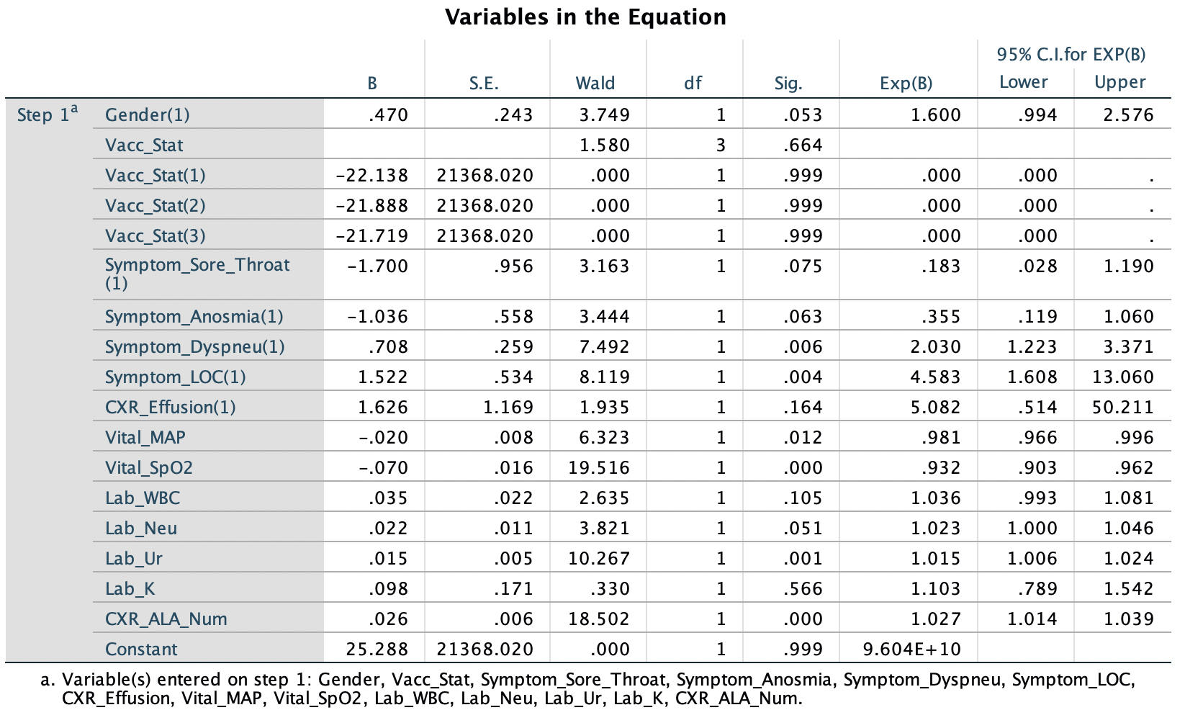

Step 6
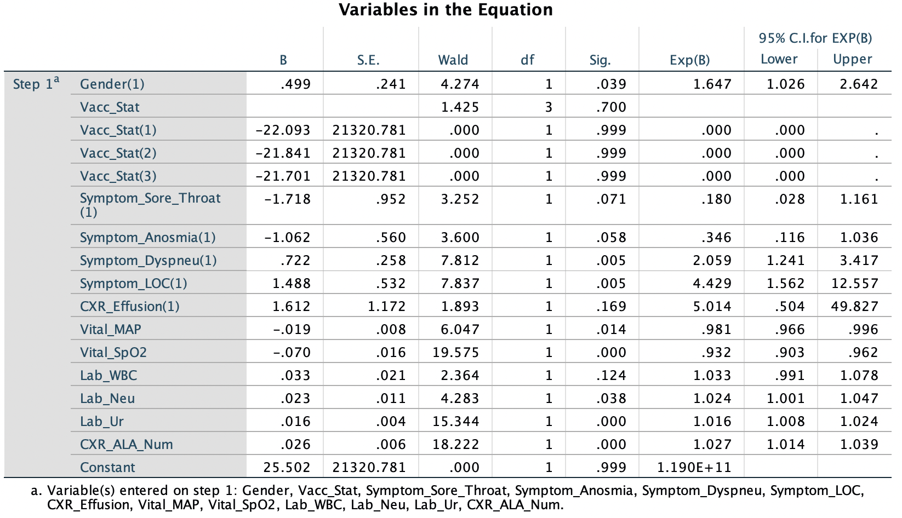

Step 7
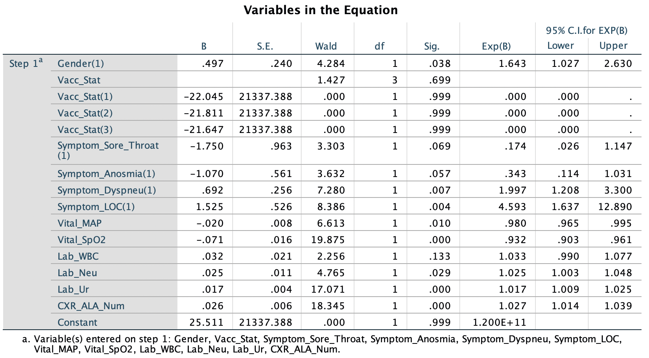

Step 8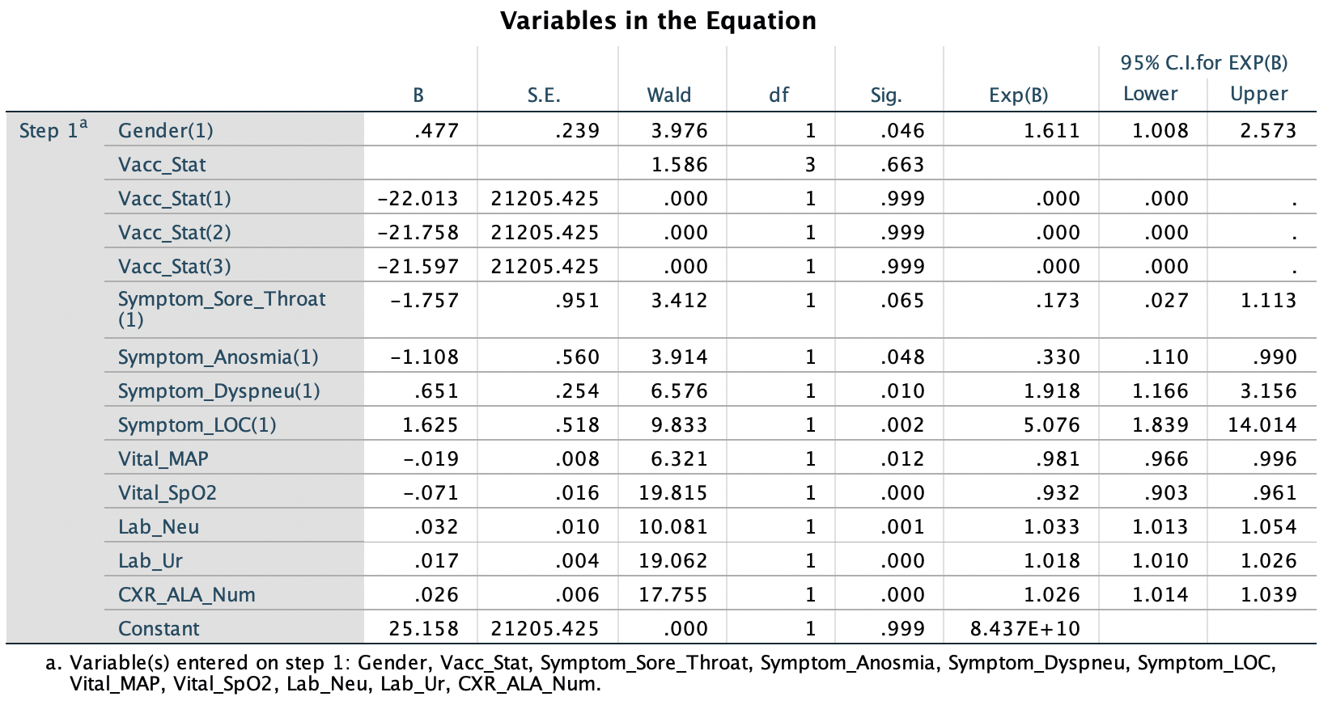

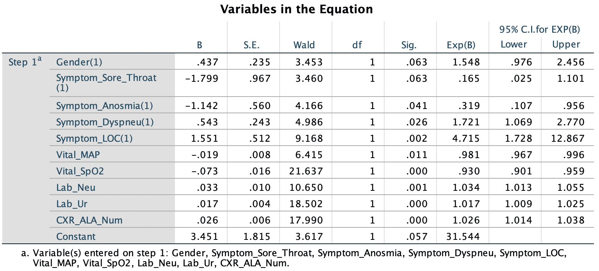
Step 9

Step 10
