Supplementary Materials for

ITGB1 and DDR activation as novel mediators in acquired resistance to osimertinib and MEK inhibitors in EGFR-mutant NSCLC

Caterina De Rosa¹, Viviana De Rosa², Concetta Tuccillo¹, Virginia Tirino³, Luisa Amato¹, Federica Papaccio ⁴, Davide Ciardiello ⁵, Stefania Napolitano ¹, Giulia Martini ¹, Fortunato Ciardiello¹, Floriana Morgillo¹, Francesca Iommelli^{2,†}, Carminia Maria Della Corte^{1,†,}
* Correspondence: carminiamaria.dellacorte@unicampania.it ; Tel.: +393929160541

The PDF file includes:

Figure S1. FACS analysis of α5β1 and αv in all cell lines

Figure S2. MTS of parental cells with selumetinib

Figure S3. PC9/OR and H1975/OR MTS cytotoxicity assay in response to DDRi

Figure S4. Western blot of PARP, p-Chk2, p-ATM/ATM and p-ATR/ATR in parental and resistant PC9 and H1975

Table S1. Cytotoxicity IC50 values of DDR inhibitors in OR NSCLC cell lines

Figure S5. Original western blot images included in Figure 1b. Cropped WB bands displayed in Figure 1b are highlighted by a yellow box

Figure S6. Original western blot images included in Figure 1c. Cropped WB bands displayed in Figure 1c are highlighted by a yellow box

Figure S7. Original western blot images included in Figure 1d. Cropped WB bands displayed in Figure 1d are highlighted by a yellow box

Figure S8. Original western blot images included in Figure 2c. Cropped WB bands displayed in Figure 2c are highlighted by a yellow box

Figure S9. Original western blot images included in Figure 3b. Cropped WB bands displayed in Figure 3b are highlighted by a yellow box

Figure S10. Original western blot images included in Figure 3d. Cropped WB bands displayed in Figure 3d are highlighted by a yellow box

Figure S11. Original western blot images included in Figure 4b and c. Cropped WB bands displayed in Figure 4a are highlighted by a yellow box

Figure S12. Original western blot images included in Figure 4d. Cropped WB bands displayed in Figure 4c are highlighted by a yellow box

Figure S13. Original western blot images included in Figure 5b. Cropped WB bands displayed in Figure 4d are highlighted by a yellow box

Figure S14. Original western blot images included in Figure 5c. Cropped WB bands displayed in Figure 5a are highlighted by a yellow box

Figure S15. Original western blot images included in Figure 5d. Cropped WB bands displayed in Figure 5b are highlighted by a yellow box

Figure S16. Original western blot images included in Figure 6a. Cropped WB bands displayed in Figure 5c are highlighted by a yellow box

Figure S17. Original western blot images included in Figure 6b. Cropped WB bands displayed in Figure S2 are highlighted by a yellow box

Figure S18. Original western blot images included in Figure 6c. Cropped WB bands displayed in Figure S2 are highlighted by a yellow box

Figure S19. Original western blot images included in Figure S4. Cropped WB bands displayed in Figure S2 are highlighted by a yellow box

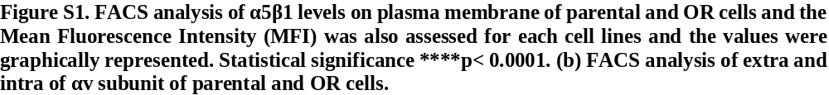

Figure S2 MTS of parental cells with selumetinib.

Figure S3. PC9/OR and H1975/OR MTS cytotoxicity assay in response to increasing concentrations DDRi (PARP-I, ATM-I, DNA-PK-I, AURK-A-I, berzosetib, ATR-I) for 72 h

Figure S4. Levels of PARP, p-Chk2, p-ATM/ATM and p-ATR/ATR in response or not to treatment with selumetinib (2.5 µM) for 72 h in parental (PC9, H1975) and resistant (PC9/OR, H1975/OR) cell lines. Tubulin was used to ensure equal loading.

Table S1. Cytotoxicity IC50 values of DDR inhibitors in OR NSCLC cell lines

(µM) | PC9/OR | H1975/OR
DNA-PK-I | 10.61 | 24.91
ATM-I | 6.735 | 9.522
Berzosertib | 5.020 | 3.684
ATR-I | 2.723 | 9.914
PARP-I | 2.183 | 0.7014
AURK-A-I | 2.834 | 2.954

Figure S5.

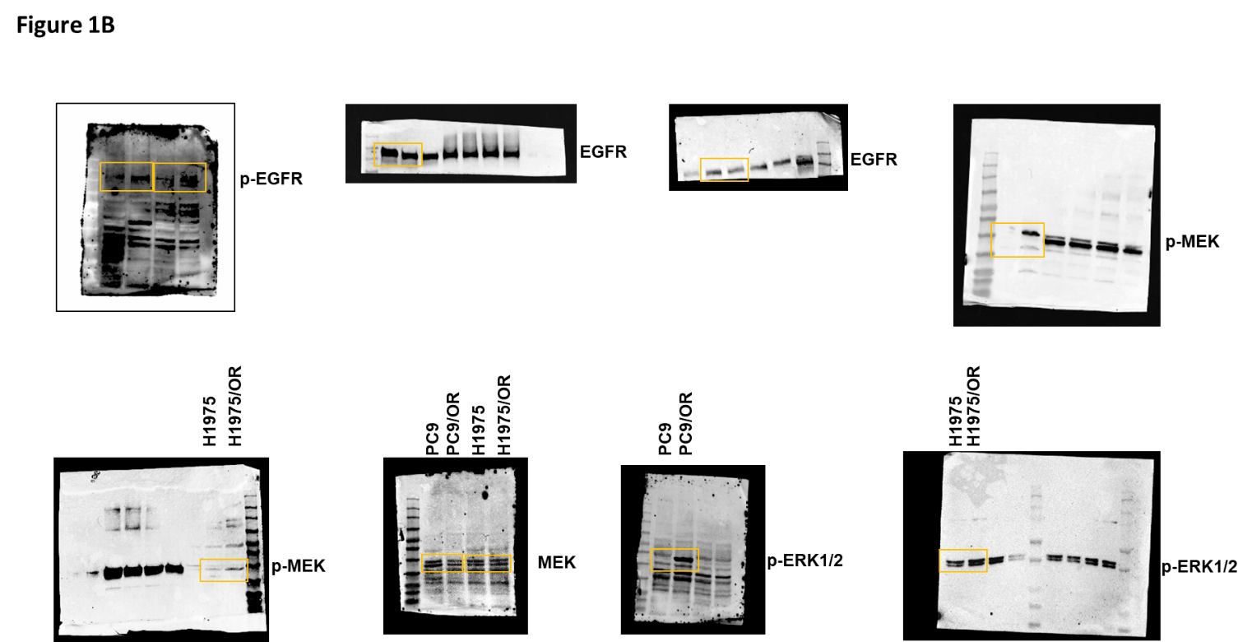

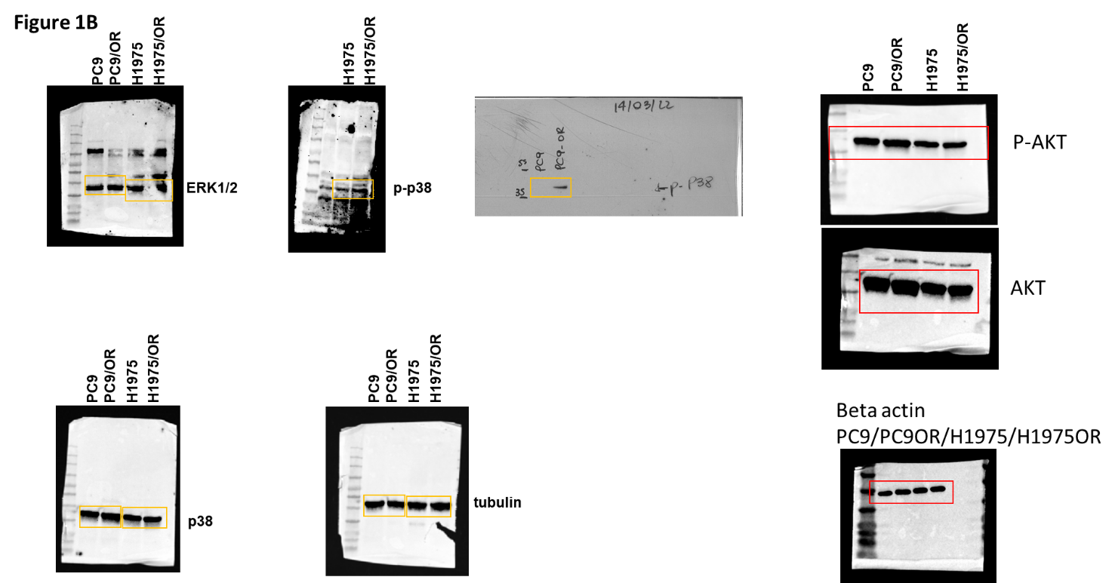

Figure S6

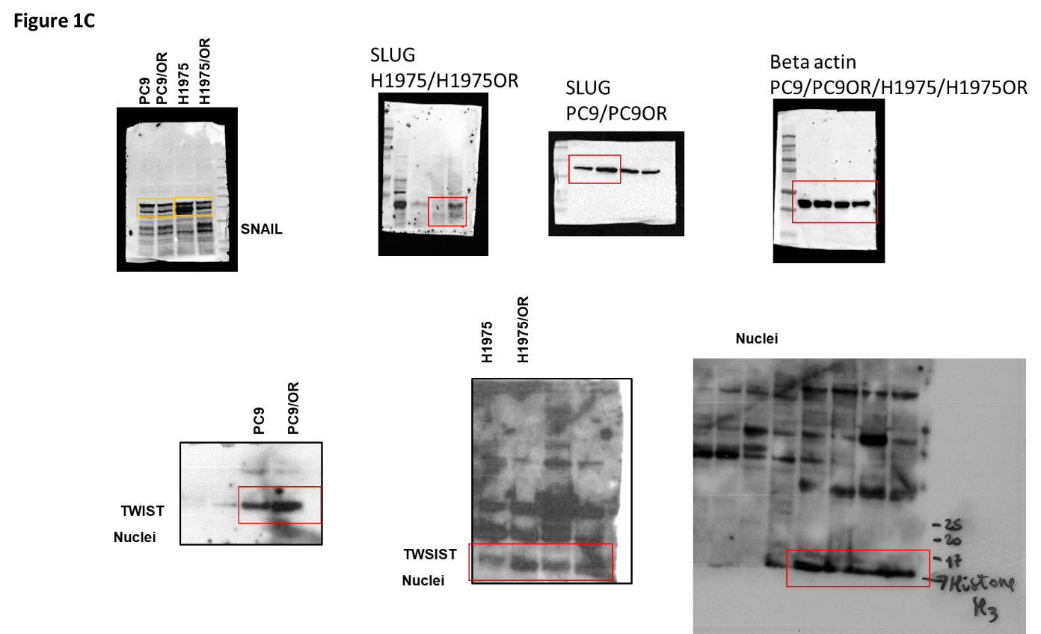

Figure S7.
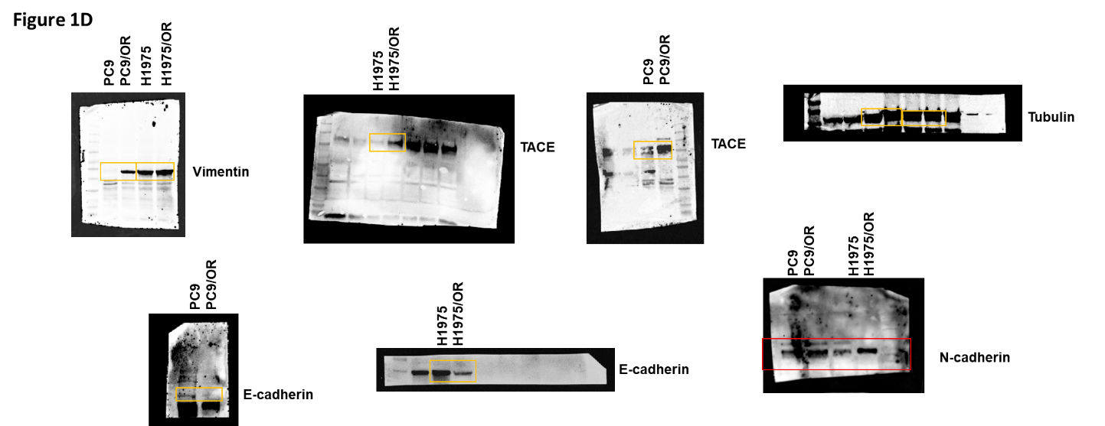

Figure S8.

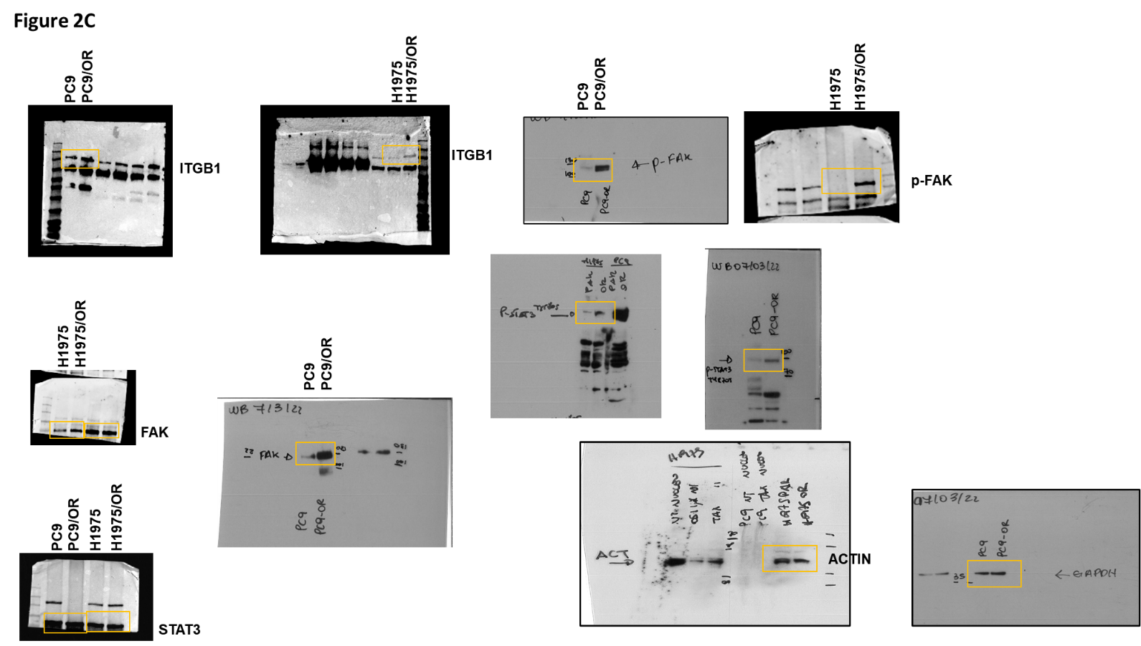

Figure S9.
Figure 3b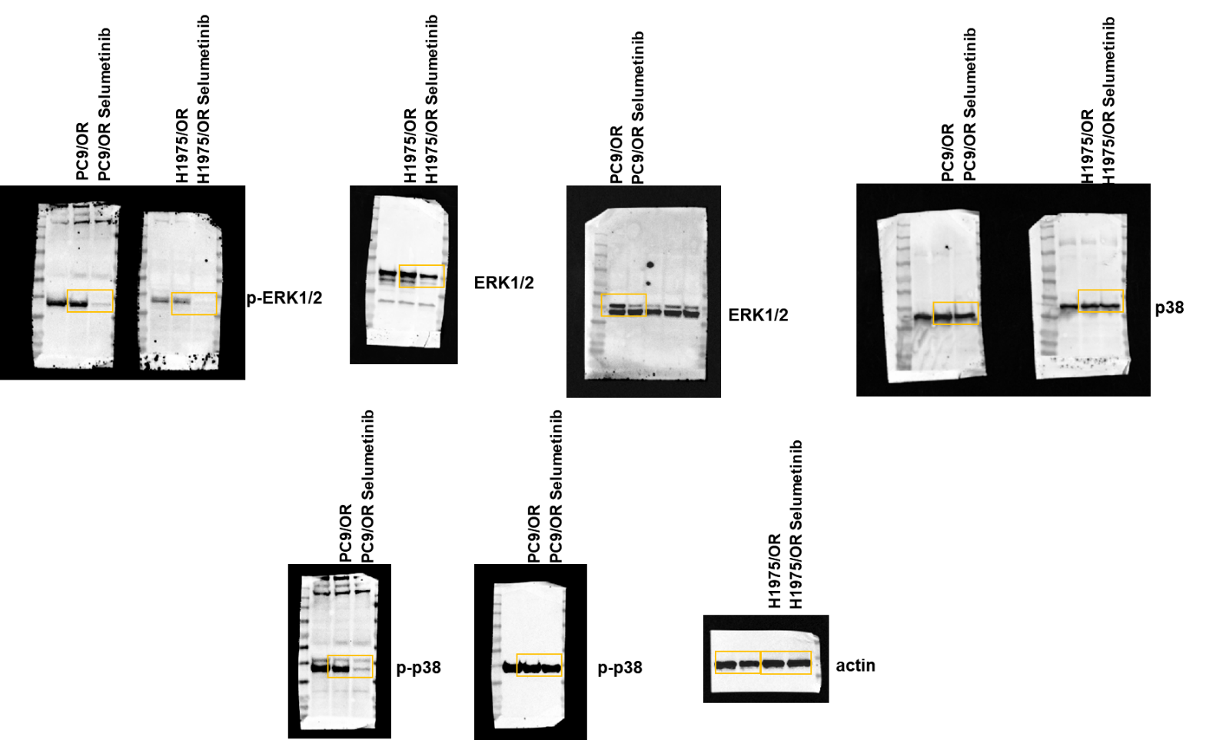

Figure S10.
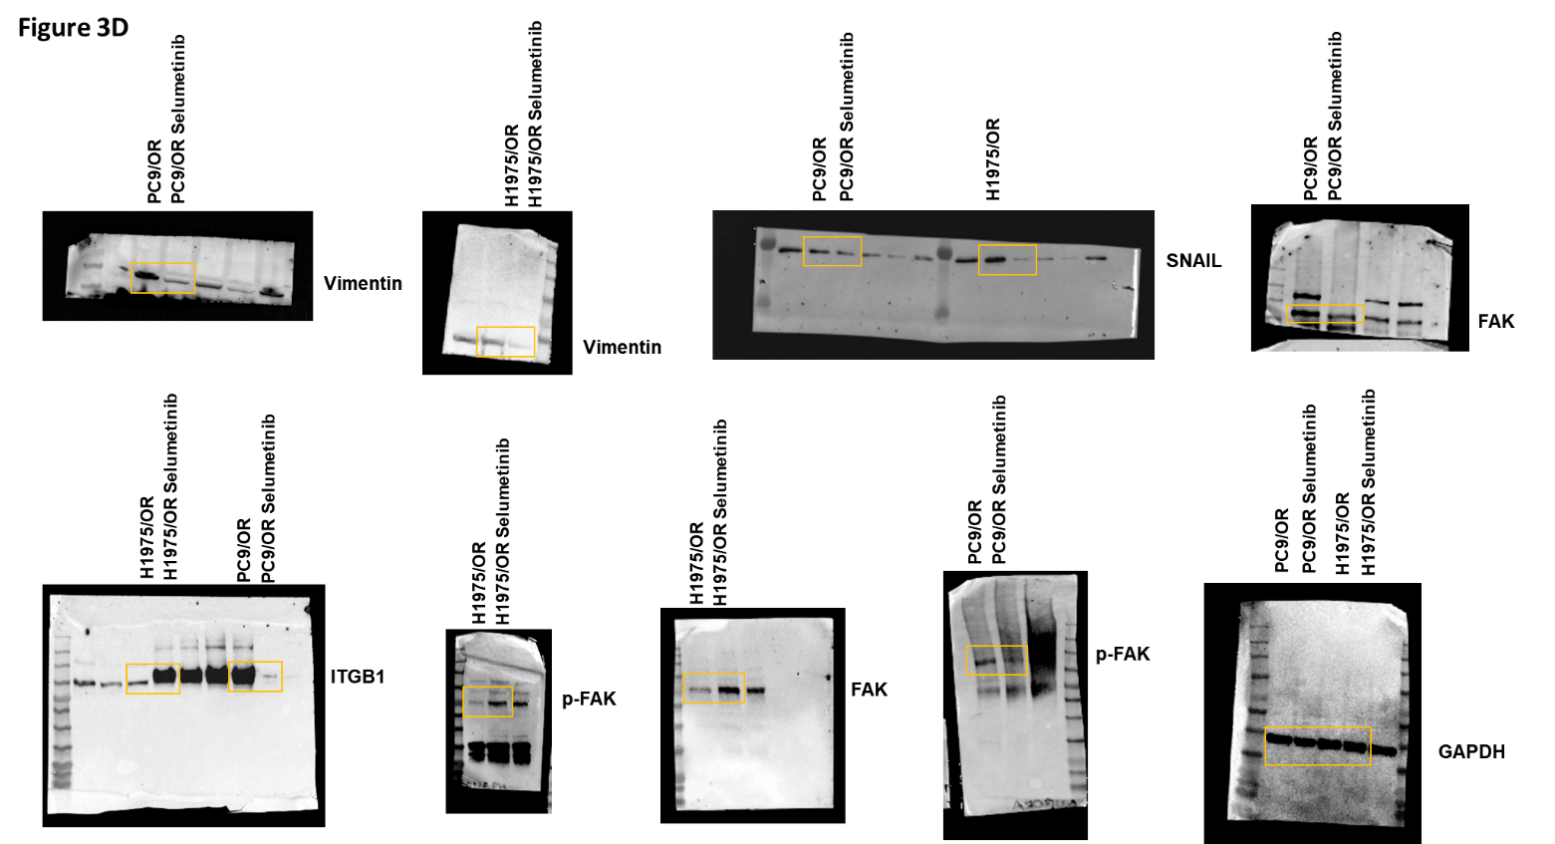

Figure S11.
Figure 4b and c
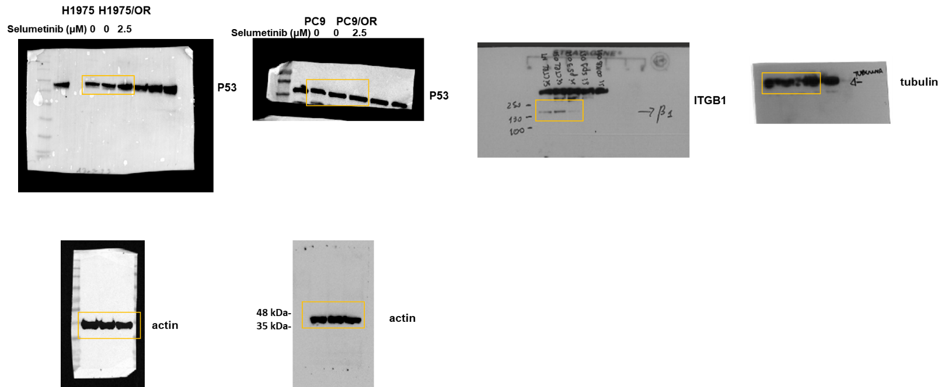

Figure S12.

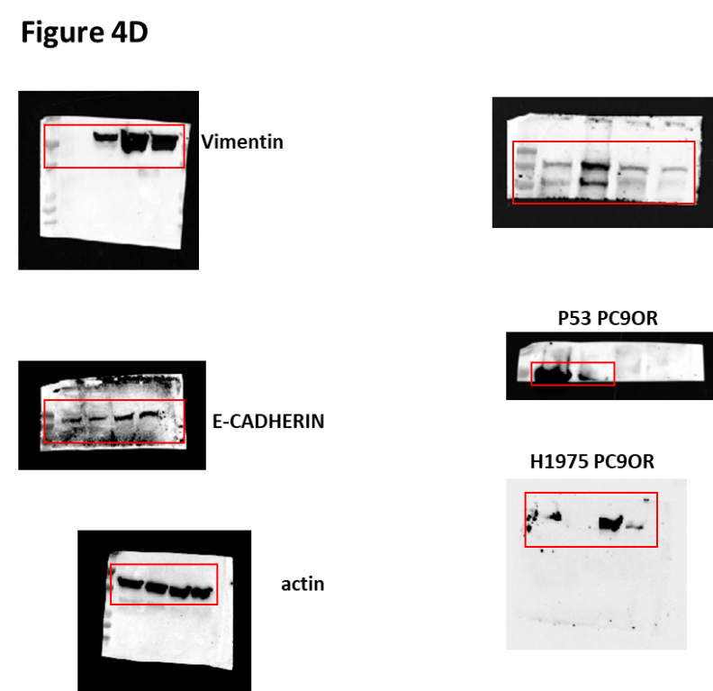

Figure S13.

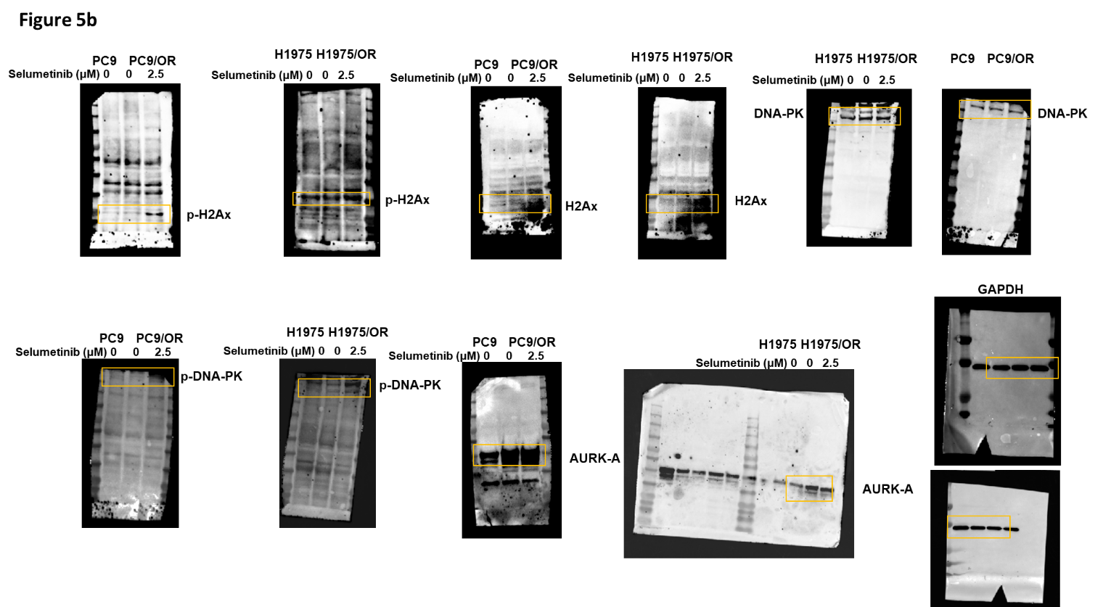

Figure S14.
5c

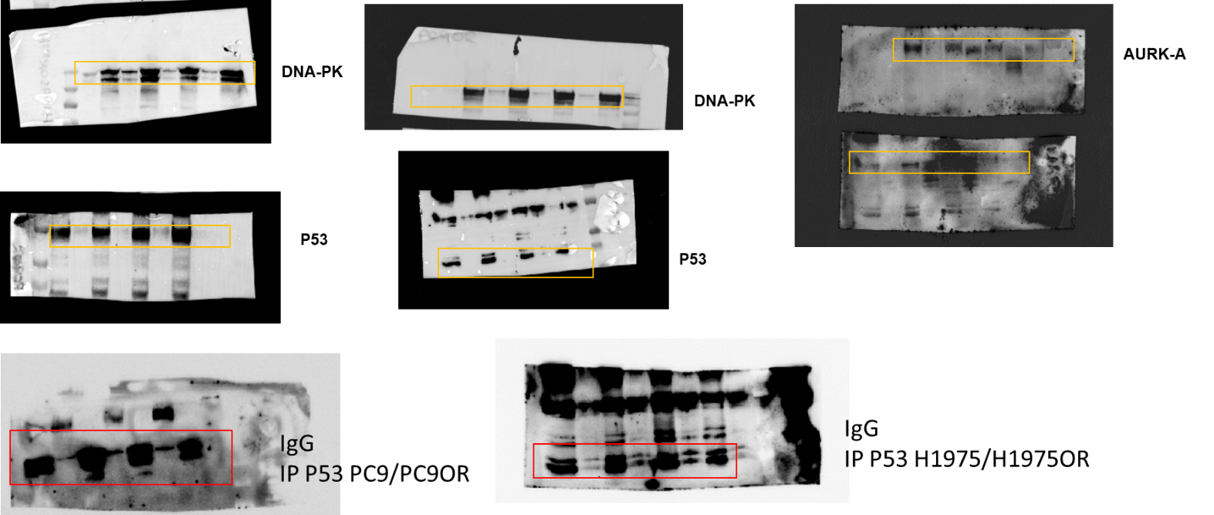

Figure S15.

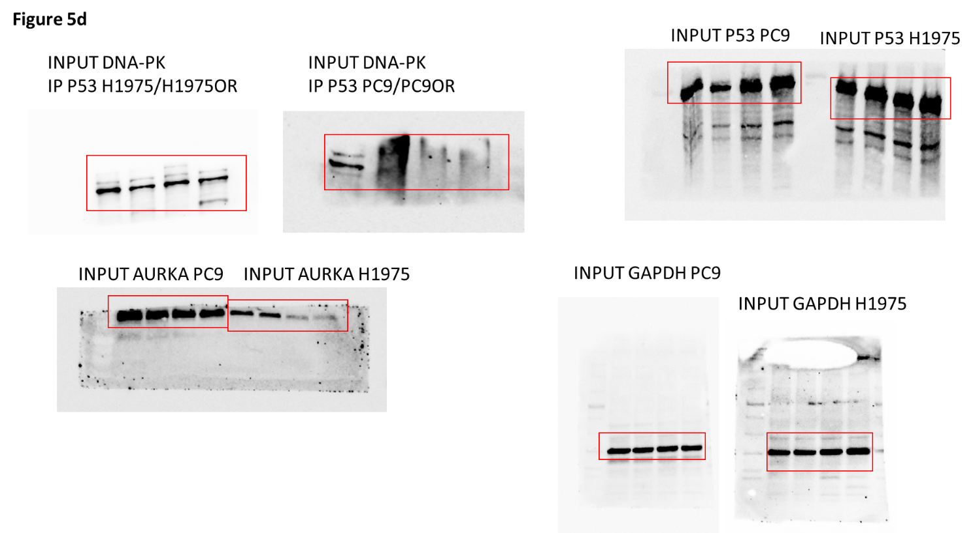

Figure S16.

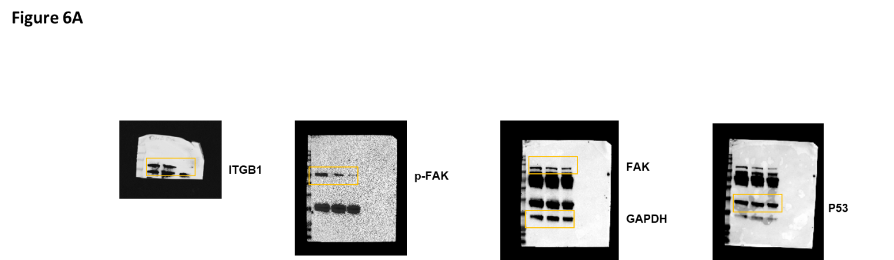

Figure S17.

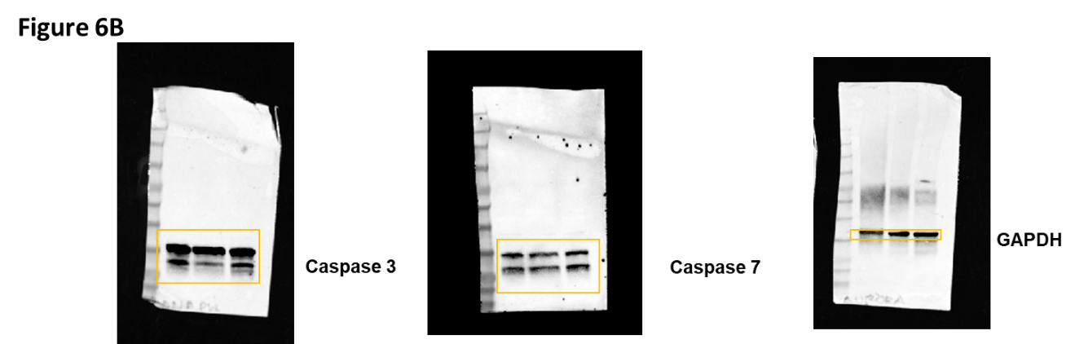
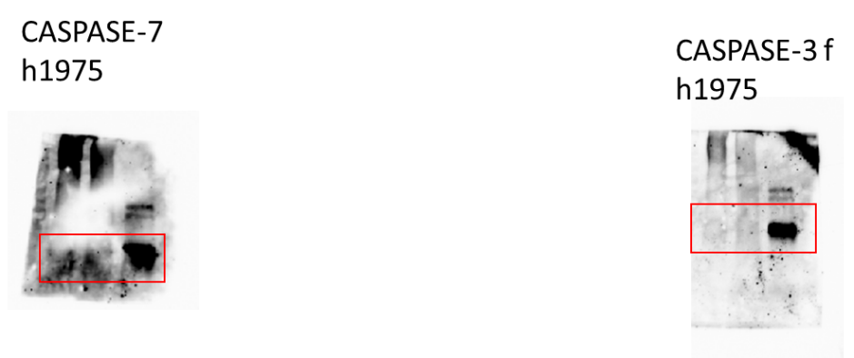

Figure S18.

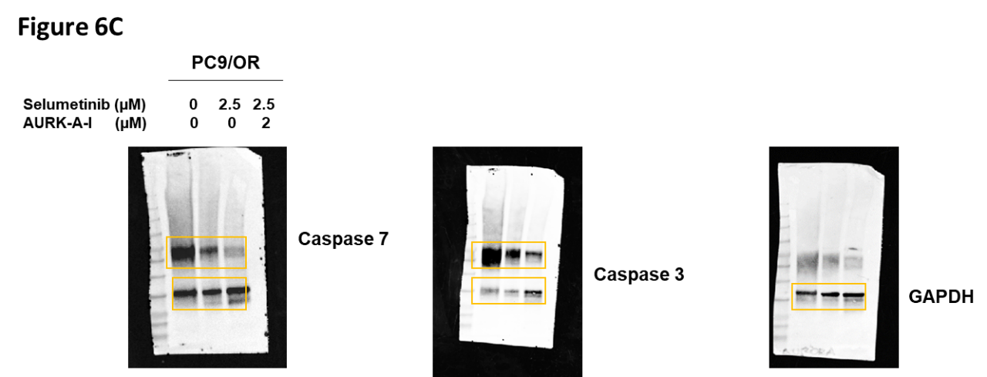

Figure S19.
