Supplementary Data:

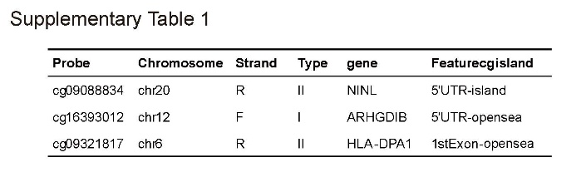
Supplementary Table 1: Three dividual methylation probes associated with overall survival of melanoma patients.

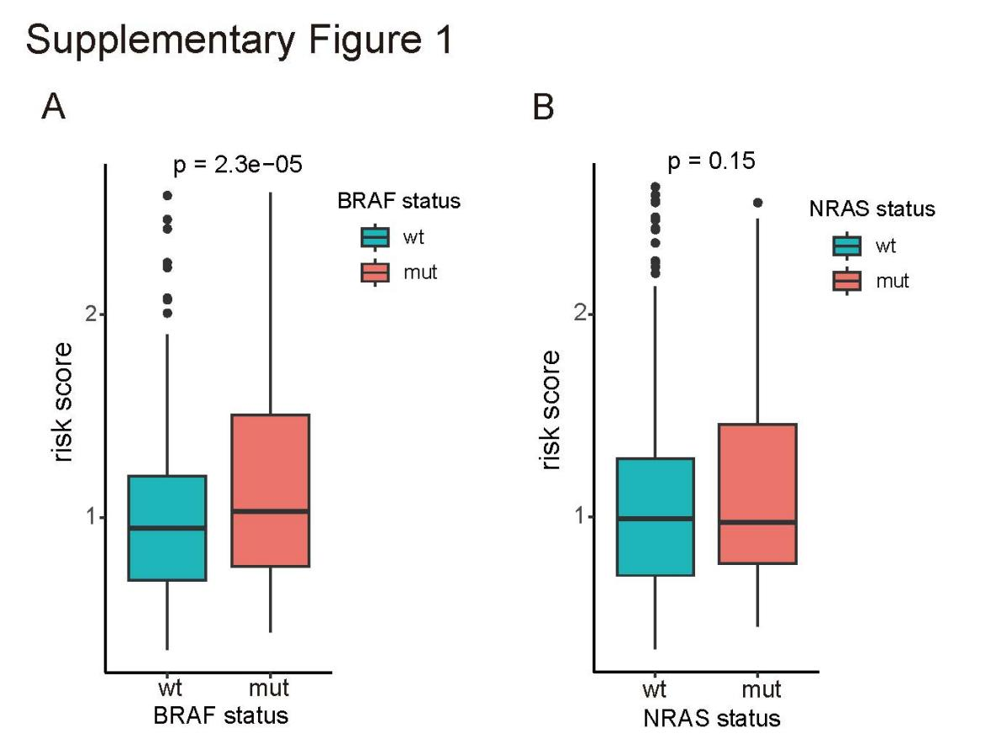
Supplementary Figure 1: The distribution of methylation-based signature in different BRAF status(A) and NRAS status(B).

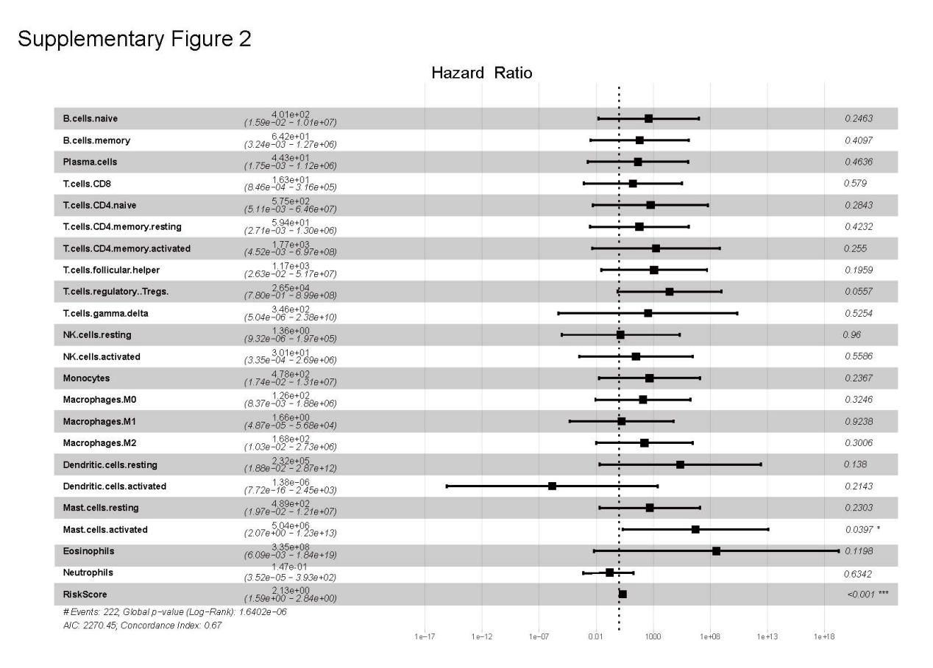
Supplementary Figure 2: The multi-cox regression analysis was performed considering 22 immune cells as covariates.

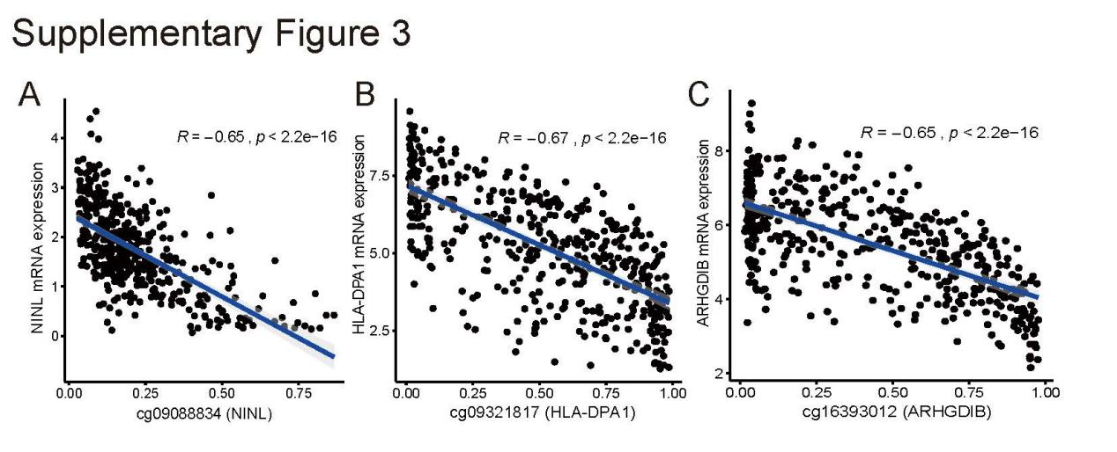
Supplementary Figure 3: Correlation between methylation and mRNA expression of cg09088834(NINL, A), cg09321817(HLADPA1, B) and cg16393012(ARHGDIB, C).

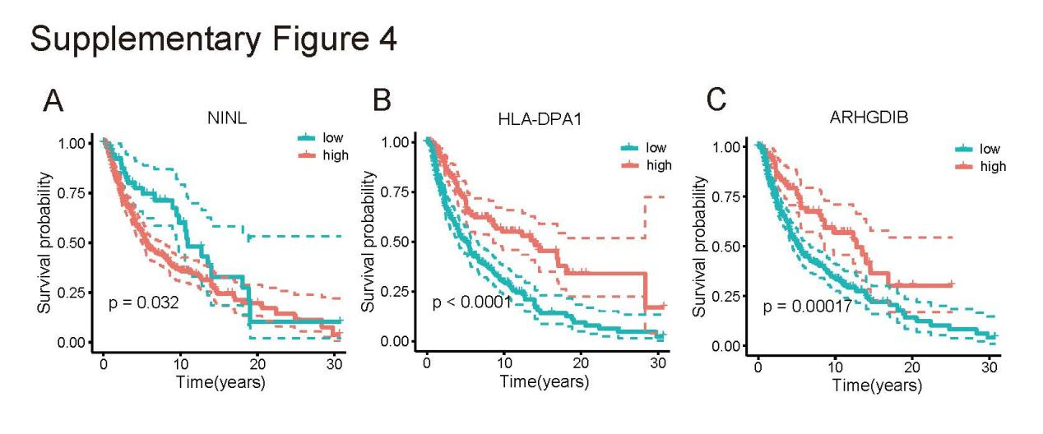

Supplementary Figure 4: Survival curve for 3 corresponding mRNA, NINL(A), HLA-DPA1(B), and ARHGDIB(C).

