Supplementary Figure S1A. Retinal heatmap: occluded vs. open eye differences interacting with time.
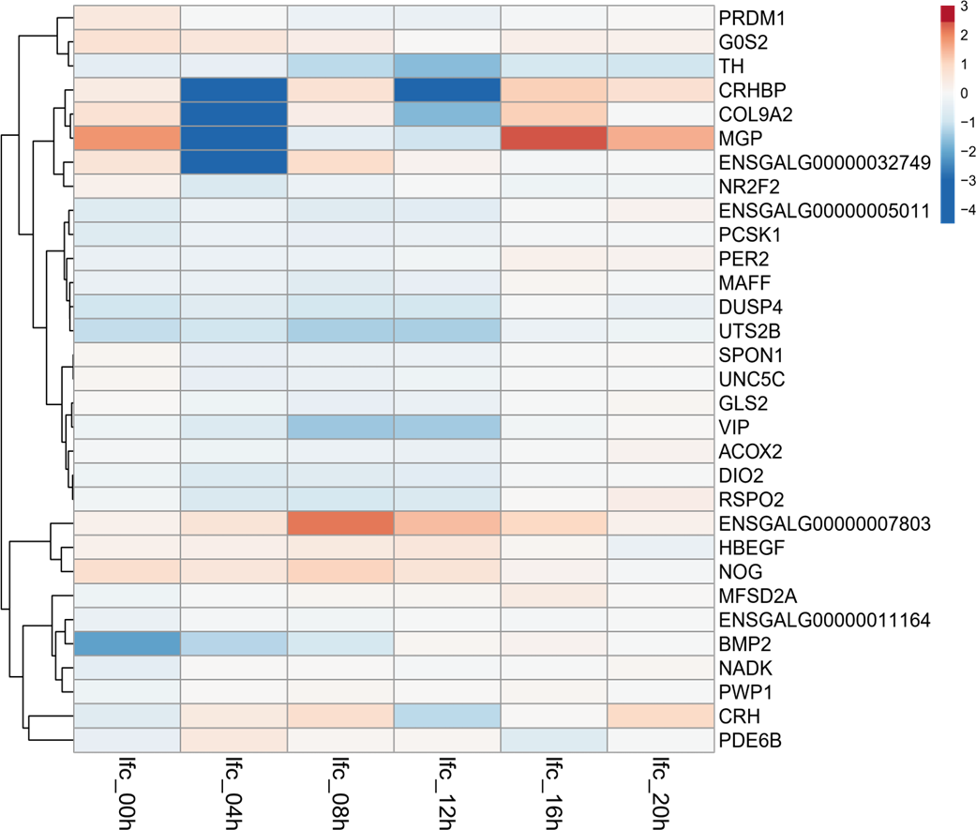
Heatmap of the log₂ fold-changes in retina are shown across the sampling times for the occluded vs. open eye differences interacting with time.
Key in upper right gives the magnitude of log₂ fold-changes, and the color shows the direction of gene expression differences between occluded and open eyes – red, expression higher in occluded eye; blue, expression lower in the occluded eye. See Figure 2, Table 4, and Suppl. Table S3A.
lfc; log₂ fold-change, followed by the ZT of the tissue sampling time.
Left ordinate: dendrogram indicating the arrangements of the gene clusters.
Right ordinate: gene name.

