Supplementary Figures
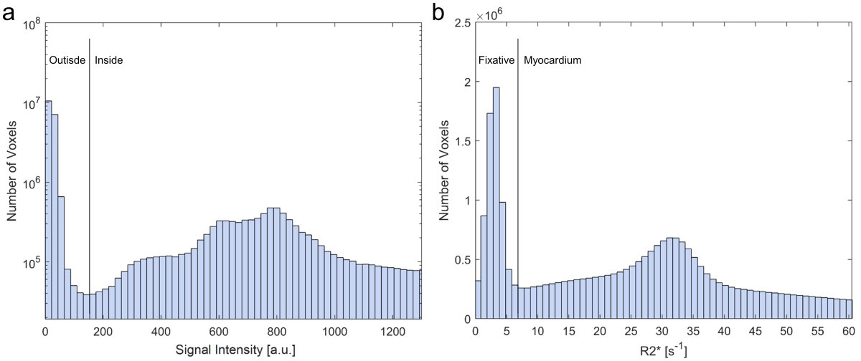
Supplementary Figure 1. Exemplary histograms of the signal intensity (a) and R2* values (b) of an ex vivo measurement. The threshold for the signal intensity was set manually for each heart (here: 175) to exclude the region outside the container, i.e. air. The threshold for R2* was set to 10s⁻¹ for all hearts to suppress the fixative, which has a mean of (31.2 ± 3.5) s⁻¹ showing no substantial variation between different hearts.
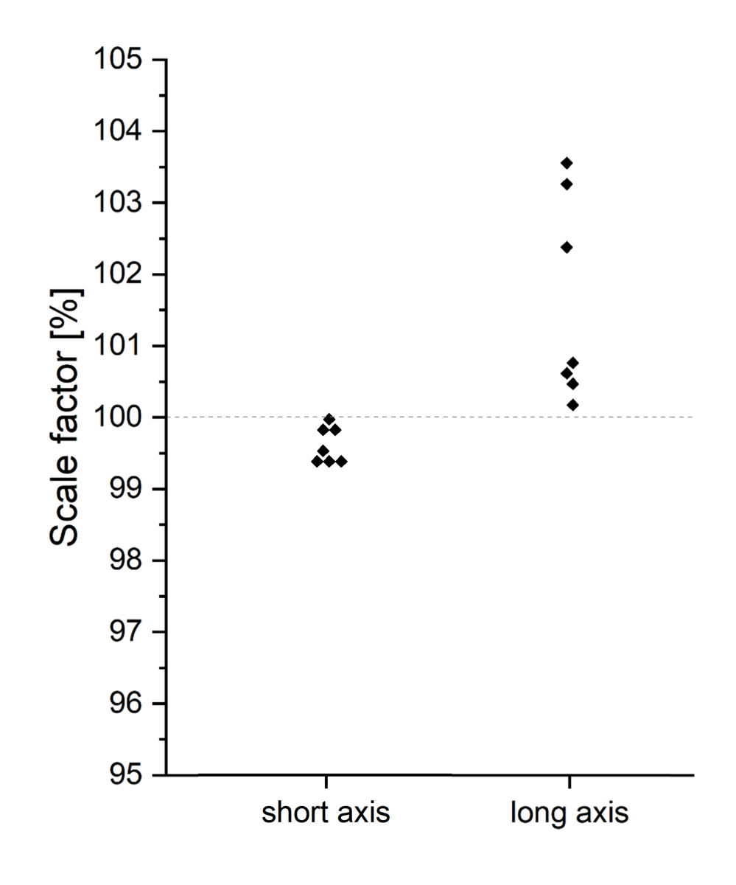
Supplementary Figure 2. Results of the scaling factors used to co-register the post- to the pre-extraction images of the hearts. Here, a scale factor of below 100 % is indicative of the heart being larger in the post-extraction dataset. Thus, the values show that the hearts were larger in short axis and smaller in long axis direction post sample extraction.

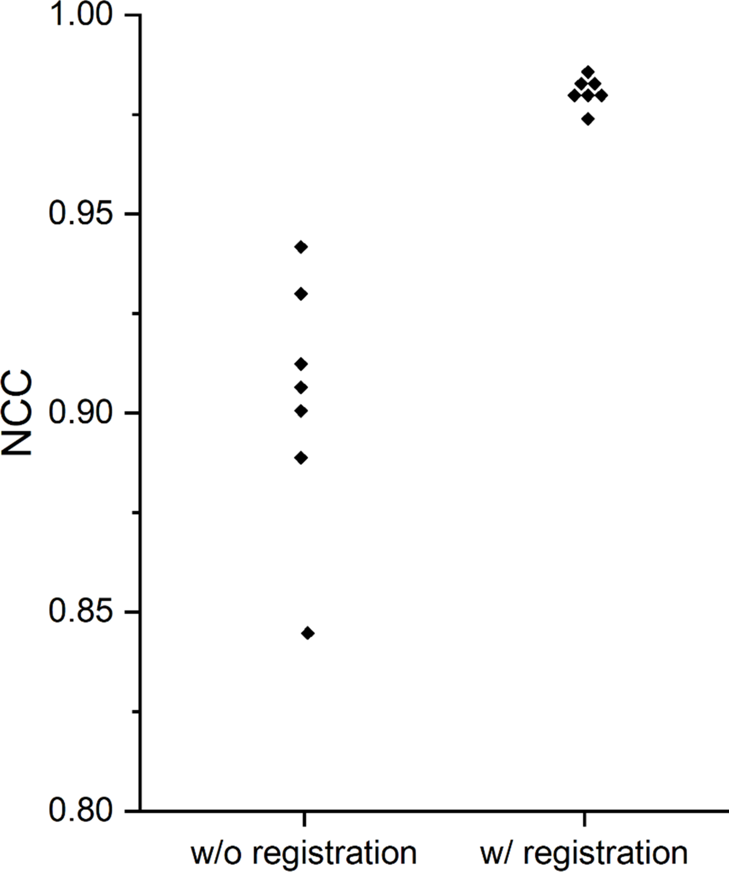
Supplementary Figure 3. Values of the normalized cross-correlation (NCC) between the pre- and post-extraction datasets. The NCC is calculated for all seven hearts without and with co-registration.

