Supplementary tables
Supplementary Table 1. Demographic information of animals included in this study.

 |  | Color |  |  |  |  | Total
 |  | Dark | Demi | Mahogany | Pastel | Stardust | Total
Sex | Female | 7  (8.2%) | 22  (25.9%) | 13  (15.3%) | 5  (5.9%) | 3  (3.5%) | 50 (58.8%)
Sex | Male | 9  (10.6%) | 10  (11.8%) | 7  (8.2%) | 5  (5.9%) | 4  (4.7%) | 35 (41.2%)
Total |  | 16  (18.8%) | 32  (37.7%) | 20  (23.5%) | 10  (11.8%) | 7  (8.2%) | 85 (100.0%)

Supplementary Table 2. Descriptive statistics for CIEP, VP2 ELISA, and AMDVG ELISA records in animals included in this study.

Test | N¹ | CIEP+² | CIEP-² | VP2 cat. 8³ | VP2 cat. 0³ | AMDVG cat. 7⁴ | AMDVG cat. 0⁴ | Mean¹ | SD¹ | Min¹ | Max¹ | CV (%)¹
CIEP | 79 | 48 | 31 | - | - | - | - | 0.61 | 0.49 | 0 | 1 | 80.33
VP2 ELISA | 85 | - | - | 18 | 31 | - | - | 3.82 | 2.78 | 0 | 8 | 72.77
AMDVG ELISA | 85 | - | - | - | - | 10 | 35 | 2.79 | 3.40 | 0 | 7 | 121.86
¹N: number of records, mean: arithmetic mean, including the percentage of positive animals based on CIEP test and the average of VP2 and AMDVG ELISA optical density values, SD: standard deviation, Min: minimum, Max: maximum, CV (%): coefficient of variation percentage.
²CIPE+: number of animals with CIEP positive record; CIEP-: number of animals with CIEP negative record.
³VP2 cat. 8: number of animals classified in category 8 in VP2 ELISA test; VP2 ELISA cat. 0: number of animals classified in category 0 in VP2 ELISA test.
⁴AMDVG cat. 7: number of animals classified in category 7 in ADMVG ELISA test; AMDVG cat. 0: number of animals classified in category 0 in AMDVG ELISA test.

Supplementary Table 3. Identified candidate genes located within the putatively selected regions overlapping between tests within CIEP study.

Chrª | Start position (bp^{b}) | End position (bp) | Gene ID | Z_{(FST)} | log_{2(θπ ratios)} | XP-EHH
1 | 42,756,498 | 42,780,882 | SLC35A1 | ×^{c} | × | -^{d}
1 | 42,787,791 | 42,844,995 | CFAP206 | × | × | -
1 | 42,876,448 | 42,893,869 | C1H6orf163 | × | × | -
1 | 42,935,707 | 42,948,189 | GJB7 | × | × | -
1 | 56,358,569 | 56,377,670 | RAB32 | × | × | -
1 | 77,770,526 | 77,788,115 | SMPDL3A | × | × | -
1 | 77,829,681 | 77,933,740 | PKIB | × | × | -
1 | 78,022,879 | 78,057,252 | SERINC1 | × | × | -
1 | 78,059,083 | 78,094,914 | HSF2 | × | × | -
1 | 81,473,536 | 81,484,315 | PLN | × | × | -
1 | 81,404,474 | 81,594,095 | CEP85L | × | × | -
1 | 90,019,450 | 90,039,163 | ABCC10 | × | × | -
1 | 90,889,627 | 90,939,342 | CDC5L | × | × | -
1 | 92,538,026 | 92,807,355 | RCAN2 | × | × | -
1 | 92,947,771 | 92,975,260 | SLC25A27 | × | × | -
1 | 93,485,324 | 93,549,929 | TNFRSF21 | × | × | -
1 | 94,047,591 | 94,230,349 | PTCHD4 | × | × | -
1 | 97,738,076 | 98,213,846 | PKHD1 | × | × | -
1 | 98,435,287 | 98,530,078 | PAQR8 | × | × | -
1 | 98,538,717 | 98,606,632 | EFHC1 | × | × | -
1 | 98,608,048 | 98,690,116 | TRAM2 | × | × | -
1 | 99,481,153 | 99,529,420 | GCLC | × | × | -
1 | 102,308,800 | 102,780,046 | DST | × | × | -
1 | 102,779,984 | 102,831,149 | BEND6 | × | × | -
1 | 102,881,613 | 102,986,587 | ZNF451 | × | × | -
1 | 105,941,472 | 107,593,901 | EYS | × | × | -
1 | 111,863,825 | 111,957,675 | COL9A1 | × | × | -
1 | 118,914,596 | 118,980,320 | ITPR3 | × | × | -
1 | 119,108,583 | 119,140,172 | SYNGAP1 | × | × | -
1 | 119,144,037 | 119,149,122 | PHF1 | × | × | -
1 | 119,150,291 | 119,163,372 | KIFC1 | × | × | -
1 | 119,225,004 | 119,232,375 | RGL2 | × | × | -
1 | 119,234,730 | 119,243,361 | WDR46 | × | × | -
1 | 119,252,887 | 119,270,337 | VPS52 | × | × | -
1 | 130,411,883 | 130,540,455 | RREB1 | × | × | -
1 | 130,567,273 | 130,593,210 | SSR1 | × | × | -
1 | 130,604,760 | 130,654,200 | CAGE1 | × | × | -
1 | 130,654,361 | 130,684,189 | RIOK1 | × | × | -
1 | 139,672,472 | 139,682,922 | RBM24 | × | × | -
1 | 196,446,677 | 196,485,687 | ERAP2 | × | × | -
1 | 204,344,646 | 204,412,936 | TMEM161B | × | × | -
2 | 31,155,943 | 31,198,032 | ZMPSTE24 | × | - | ×
2 | 31,204,571 | 31,220,042 | COL9A2 | × | - | ×
2 | 31,245,662 | 31,291,628 | SMAP2 | × | - | ×
2 | 31,311,406 | 31,323,759 | ZFP69B | × | - | ×
2 | 31,331,710 | 31,347,702 | ZFP69 | × | - | ×
2 | 83,029,941 | 83,871,891 | DPYD | × | × | -
4 | 159,411,288 | 159,417,539 | MTERF1 | × | × | -
4 | 159,456,853 | 159,643,617 | AKAP9 | × | × | -
4 | 161,975,512 | 162,042,151 | SGCE | × | × | -
4 | 162,042,321 | 162,055,735 | PEG10 | × | × | -
4 | 162,189,534 | 162,488,748 | PPP1R9A | × | × | -
6 | 68,905,894 | 69,012,447 | XRN1 | × | × | -
6 | 69,013,813 | 69,112,247 | ATR | × | × | -
6 | 69,132,416 | 69,249,204 | PLS1 | × | × | -
6 | 78,902,359 | 78,908,907 | RAP2B | × | × | -
6 | 80,720,939 | 80,724,530 | STRIT1 | × | × | -
6 | 89,742,112 | 89,844,449 | SI | × | × | -
6 | 89,945,457 | 89,954,703 | SLITRK3 | × | × | -
6 | 102,085,063 | 102,324,062 | KCNMB2 | × | × | -
11 | 95,900,902 | 96,246,050 | CAMK2D | × | × | -
11 | 96,349,273 | 97,004,412 | ANK2 | × | × | -
11 | 128,758,412 | 128,859,951 | RXFP1 | × | × | -
12 | 75,732,267 | 75,951,858 | CPNE8 | × | × | -
13 | 53,427,389 | 53,468,830 | KLHL28 | × | × | -
13 | 111,405,001 | 112,004,404 | UNC13C | × | - | ×
ªChromosome number
^{b}Base pair
^{c}Detected
^{d}Not detected

Supplementary Table 4. Identified candidate genes located within the putatively selected regions overlapping between tests within VP2 ELISA study.

Chrª | Start position (bp^{b}) | End position (bp) | Gene ID | Z_{(FST)} | log_{2(θπ ratios)} | XP-EHH
1 | 75,914,369 | 76,914,219 | NKAIN2 | ×^{c} | × | -^{d}
1 | 92,538,026 | 92,807,355 | RCAN2 | × | × | -
1 | 94,047,591 | 94,230,349 | PTCHD4 | × | × | -
1 | 97,738,076 | 98,213,846 | PKHD1 | × | × | -
1 | 105,941,472 | 107,593,901 | EYS | × | × | -
1 | 118,914,596 | 118,980,320 | ITPR3 | × | × | -
1 | 118,998,561 | 119,012,034 | BAK1 | × | × | -
1 | 119,104,804 | 119,107,733 | ZBTB9 | × | × | -
1 | 119,108,583 | 119,140,172 | SYNGAP1 | × | × | -
1 | 119,142,353 | 119,143,935 | CUTA | × | × | -
1 | 119,144,037 | 119,149,122 | PHF1 | × | × | -
1 | 119,150,291 | 119,163,372 | KIFC1 | × | × | -
1 | 119,199,258 | 119,199,500 | SMIM40 | × | × | -
1 | 119,204,992 | 119,209,483 | DAXX | × | × | -
1 | 119,210,177 | 119,213,508 | ZBTB22 | × | × | -
1 | 119,225,004 | 119,232,375 | RGL2 | × | × | -
1 | 119,233,337 | 119,234,649 | PFDN6 | × | × | -
1 | 119,234,730 | 119,243,361 | WDR46 | × | × | -
1 | 119,243,652 | 119,245,334 | B3GALT4 | × | × | -
1 | 119,246,062 | 119,252,735 | RPS18 | × | × | -
1 | 119,252,887 | 119,270,337 | VPS52 | × | × | -
1 | 119,293,422 | 119,297,406 | RING1 | × | × | -
1 | 119,299,016 | 119,301,311 | HSD17B8 | × | × | -
1 | 289,083,212 | 289,259,797 | SPEF2 | × | × | -
2 | 83,029,941 | 83,871,891 | DPYD | × | × | -
2 | 210,499,604 | 210,592,456 | R3HCC1L | × | × | -
2 | 210,595,231 | 210,614,490 | LOXL4 | × | × | -
2 | 237,782,992 | 237,868,347 | C2H10orf143 | × | - | ×
2 | 237,884,270 | 237,918,382 | GLRX3 | × | - | ×
5 | 136,533,697 | 136,816,788 | MYCBP2 | × | × | -
6 | 37,748,501 | 38,827,099 | CADM2 | × | × | -
6 | 40,554,251 | 40,558,056 | CGGBP1 | × | × | -
6 | 40,558,281 | 40,640,279 | ZNF654 | × | × | -
6 | 40,644,230 | 40,654,566 | C6H3orf38 | × | × | -
6 | 69,739,577 | 70,425,604 | SLC9A9 | × | × | -
6 | 116,025,781 | 116,027,427 | CPN2 | × | × | -
6 | 116,040,015 | 116,041,775 | LRRC15 | × | × | -
6 | 116,083,861 | 116,090,578 | GP5 | × | × | -
6 | 116,089,406 | 116,181,494 | ATP13A3 | × | × | -
8 | 58,028,494 | 58,075,247 | LONRF2 | × | × | -
8 | 58,106,135 | 58,138,712 | CHST10 | × | × | -
8 | 113,418,493 | 113,474,676 | ATL2 | × | × | -
9 | 97,712,221 | 97,758,164 | IPPK | - | × | ×
9 | 97,789,108 | 97,832,330 | BICD2 | - | × | ×
11 | 115,732,693 | 116,968,169 | CCSER1 | × | × | -
11 | 148,947,753 | 148,988,407 | SMARCA5 | × | × | -
11 | 149,036,912 | 149,163,525 | GAB1 | × | × | -
11 | 149,249,105 | 149,286,304 | USP38 | × | × | -
ªChromosome number
^{b}Base pair
^{c}Detected by the test
^{d}Not detected by the test

Supplementary Table 5. Identified candidate genes located within the putatively selected regions overlapping between tests within AMDVG ELISA study.

Chrª | Start position (bp^{b}) | End position (bp) | Gene ID | Z_{(FST)} | log_{2(θπ ratios)} | XP-EHH
1 | 114,051,167 | 114,583,189 | KCNQ5 | ×^{c} | × | -^{d}
1 | 119,589,865 | 119,602,944 | TAP2 | × | × | -
1 | 133,815,924 | 133,823,812 | C1H6orf52 | × | × | -
1 | 133,829,248 | 133,844,605 | PAK1IP1 | × | × | -
1 | 133,868,259 | 133,924,333 | MAK | × | × | -
1 | 139,672,472 | 139,682,922 | RBM24 | × | × | -
1 | 139,757,819 | 139,896,722 | CAP2 | × | × | -
2 | 37,490,288 | 37,492,857 | FOXD2 | - | × | ×
2 | 85,728,541 | 85,788,787 | SLC35A3 | × | × | -
2 | 85,798,629 | 85,840,447 | MFSD14A | × | × | -
3 | 78,449,241 | 78,480,559 | FRZB | - | × | ×
3 | 78,538,470 | 78,641,444 | NCKAP1 | - | × | ×
3 | 78,665,748 | 78,684,593 | DUSP19 | - | × | ×
3 | 78,707,774 | 78,743,505 | NUP35 | - | × | ×
3 | 103,603,706 | 103,605,271 | C1QL2 | × | × | -
3 | 158,985,755 | 159,307,870 | KIAA1328 | × | × | -
3 | 159,307,993 | 159,368,558 | TPGS2 | × | × | -
3 | 159,377,144 | 159,833,881 | FHOD3 | × | × | -
5 | 16,354,263 | 16,462,697 | EFCAB13 | × | - | ×
5 | 16,476,392 | 16,527,526 | ITGB3 | × | - | ×
5 | 136,533,697 | 136,816,788 | MYCBP2 | × | × | -
6 | 40,554,251 | 40,558,056 | CGGBP1 | × | × | -
6 | 40,558,281 | 40,640,279 | ZNF654 | × | × | -
6 | 40,644,230 | 40,654,566 | C6H3orf38 | × | × | -
6 | 75,310,943 | 75,329,636 | TM4SF18 | × | × | -
6 | 116,089,406 | 116,181,494 | ATP13A3 | × | × | -
6 | 37,748,501 | 38,827,099 | CADM2 | × | × | -
7 | 157,927,050 | 158,411,542 | SBF2 | × | × | -
9 | 97,342,783 | 97,371,444 | ZNF484 | - | × | ×
9 | 97,380,004 | 97,449,092 | IARS1 | - | × | ×
9 | 97,451,038 | 97,474,363 | NOL8 | - | × | ×
9 | 97,476,759 | 97,554,142 | OGN | - | × | ×
9 | 97,561,154 | 97,571,560 | OMD | - | × | ×
9 | 97,588,850 | 97,613,706 | ASPN | - | × | ×
9 | 97,632,133 | 97,665,257 | ECM2 | - | × | ×
9 | 97,712,221 | 97,758,164 | IPPK | - | × | ×
9 | 97,789,108 | 97,832,330 | BICD2 | - | × | ×
11 | 115,732,693 | 116,968,169 | CCSER1 | × | × | -
11 | 149,036,912 | 149,163,525 | GAB1 | × | × | -
ªChromosome number
^{b}Base pair
^{c}Detected by the test
^{d}Not detected by the test

Supplementary Table 6. Functional enrichment of candidate genes detected by all three conducted signatures of selection studies.

Tool | Source | Term | Description | FDR valueª
PANTHER | GO:MF^{b} | GO:0005515 | protein binding | 0.000
g:GOSt | GO:CC^{c} | GO:0005593 | FACIT collagen trimer | 0.019
g:GOSt | GO:CC | GO:0005594 | collagen type IX trimer | 0.019
g:GOSt | GO:BP^{d} | GO:0006942 | regulation of striated muscle contraction | 0.042
g:GOSt | GO:BP | GO:0019932 | second-messenger-mediated signaling | 0.042
g:GOSt | GO:BP | GO:0055085 | transmembrane transport | 0.042
g:GOSt | GO:BP | GO:0060306 | regulation of membrane repolarization | 0.042
g:GOSt | GO:BP | GO:0060307 | regulation of ventricular cardiac muscle cell membrane repolarization | 0.042
g:GOSt | GO:BP | GO:0061337 | cardiac conduction | 0.042
g:GOSt | GO:BP | GO:0070296 | sarcoplasmic reticulum calcium ion transport | 0.042
g:GOSt | GO:BP | GO:0086004 | regulation of cardiac muscle cell contraction | 0.042
g:GOSt | GO:BP | GO:0099622 | cardiac muscle cell membrane repolarization | 0.042
g:GOSt | GO:BP | GO:0099623 | regulation of cardiac muscle cell membrane repolarization | 0.042
g:GOSt | GO:BP | GO:0099625 | ventricular cardiac muscle cell membrane repolarization | 0.042
g:GOSt | GO:BP | GO:1903115 | regulation of actin filament-based movement | 0.042
g:GOSt | GO:BP | GO:1990036 | calcium ion import into sarcoplasmic reticulum | 0.042
g:GOSt | GO:BP | GO:1901894 | regulation of ATPase-coupled calcium transmembrane transporter activity | 0.046
ªFalse discovery rate adjusted p-value
^{b}Gene Ontology molecular function
^{c}Gene Ontology cellular component
^{d}Gene Ontology biologic process

Supplementary Figures

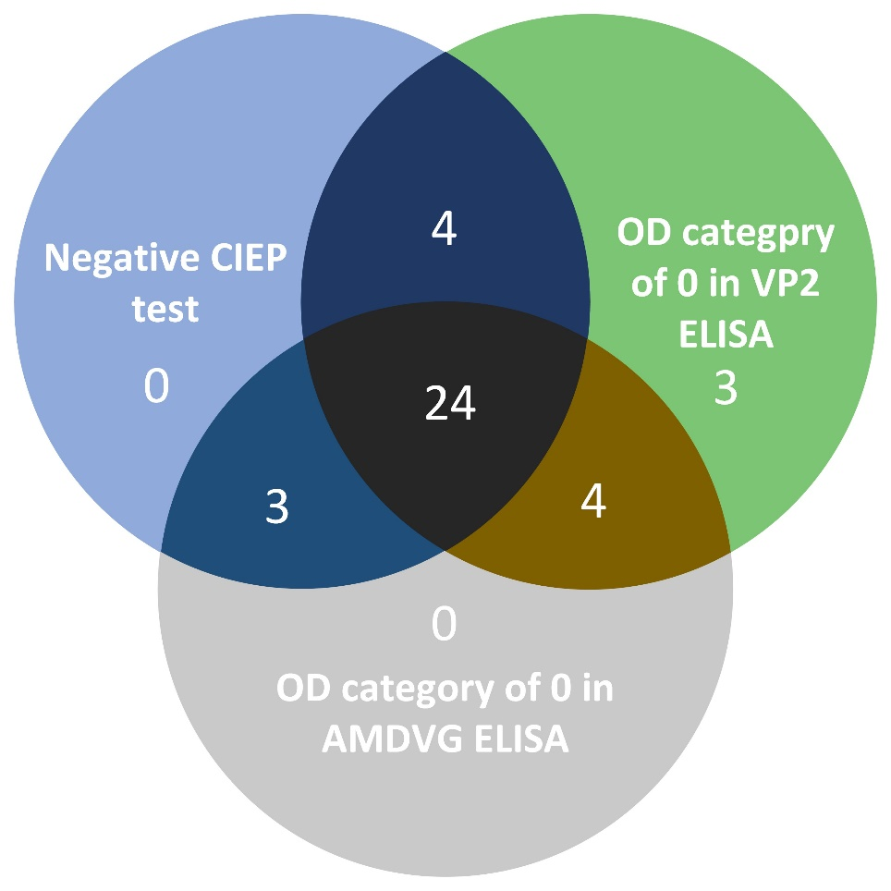
Supplementary Figure 1. Venn diagram of overlaps among control groups of the three signatures of selection studies.

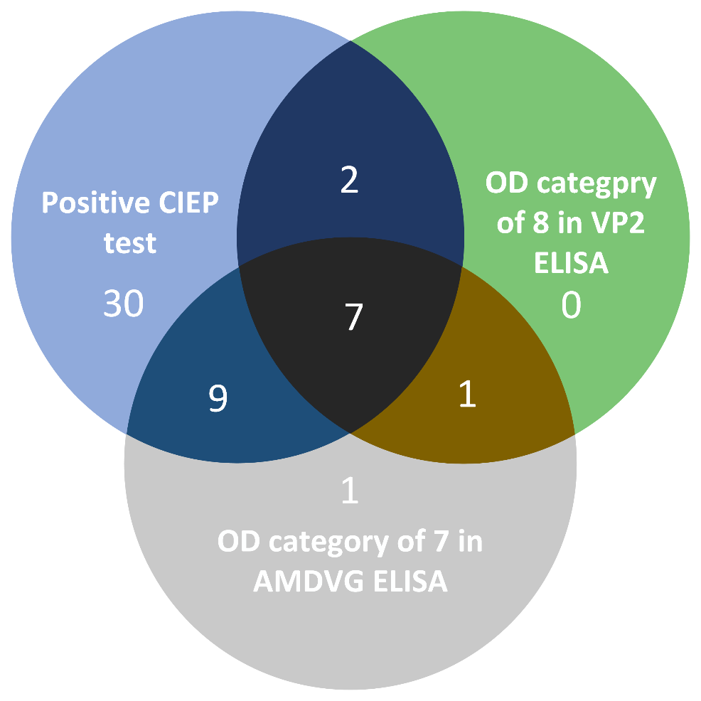

Supplementary Figure 2. Venn diagram of overlaps among case groups of the three signatures of selection studies.

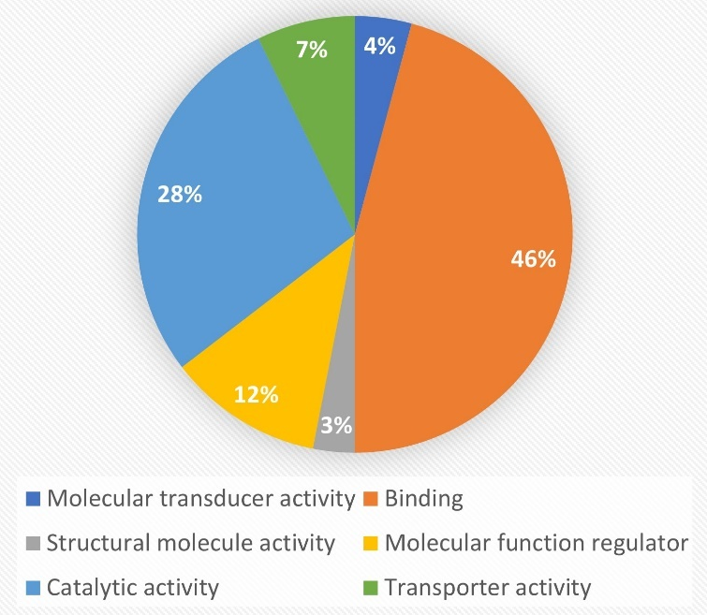
Supplementary Figure 3. Pie chart of functional classification of candidate genes detected by all three conducted signatures of selection studies.

