Supplementary information for:

Synthesis and Biophysical Evaluation of Carbosilane Dendrimers as Therapeutic siRNA Carriers
Serafin Zawadzki ^{1,2}, Ángela Martín-Serrano ³, Elżbieta Okła ¹, Marta Kędzierska ¹, Sandra Garcia-Gallego ^{3,4,5}, Paula O. López ^{3,4,5}, Francisco J. de la Mata ^{3,4,5}, Sylwia Michlewska ⁶, Tomasz Makowski ⁷, Maksim Ionov ^{1,8}, Elżbieta Pędziwiatr-Werbicka ¹, Maria Bryszewska ¹ and Katarzyna Miłowska ¹

1. Department of General Biophysics, Faculty of Biology and Environmental Protection, University of Lodz, 141/143 Pomorska St., 90-236 Lodz, Poland; 2. BioMedChem Doctoral School of the University of Lodz and Lodz Institutes of the Polish Academy of Sciences, 21/23 Matejki St., 90-237 Lodz, Poland; 3. University of Alcalá, Department of Organic and Inorganic Chemistry, IQAR, 28805 Madrid, Spain; 4. Networking Research Center on Bioengineering, Biomaterials and Nanomedicine (CIBER-BBN), 28029 Madrid, Spain; 5. Ramón y Cajal Health Research Institute (IRYCIS), 28034 Madrid, Spain; 6. Laboratory of Microscopic Imaging and Specialized Biological Techniques, Faculty of Biology and Environmental Protection, University of Lodz, Banacha 12/16, 90-237 Lodz, Poland; 7. Centre of Molecular and Macromolecular Studies, Polish Academy of Sciences, Sienkiewicza 112, 90-363 Lodz, Poland; 8. Mazovian Academy in Plock, Collegium Medicum, Faculty of Medicine, 2 Dabrowskiego Sq, 09-402 Plock, Poland

Figure S1. a) ¹H-NMR (CDCl₃) of intermediate compound G₃Si(SPEG6000)(SNMe₂HCl)₃₁. The signal at 3,60 ppm corresponds to PEG and NMe_{2·}HCl, which are overlapped. b) ¹H-NMR (CDCl₃) of intermediate compound G₃Si(SPEG6000)(SNMe₂)₃₁. The signal at 3,60 ppm corresponds to PEG and the signal at 2,25 ppm corresponds to NMe₂

Figure S2. ¹H-NMR (DMSO) of the final compounds. The signal at 3.40 ppm corresponds to PEG and NMe₃, which are overlapped.
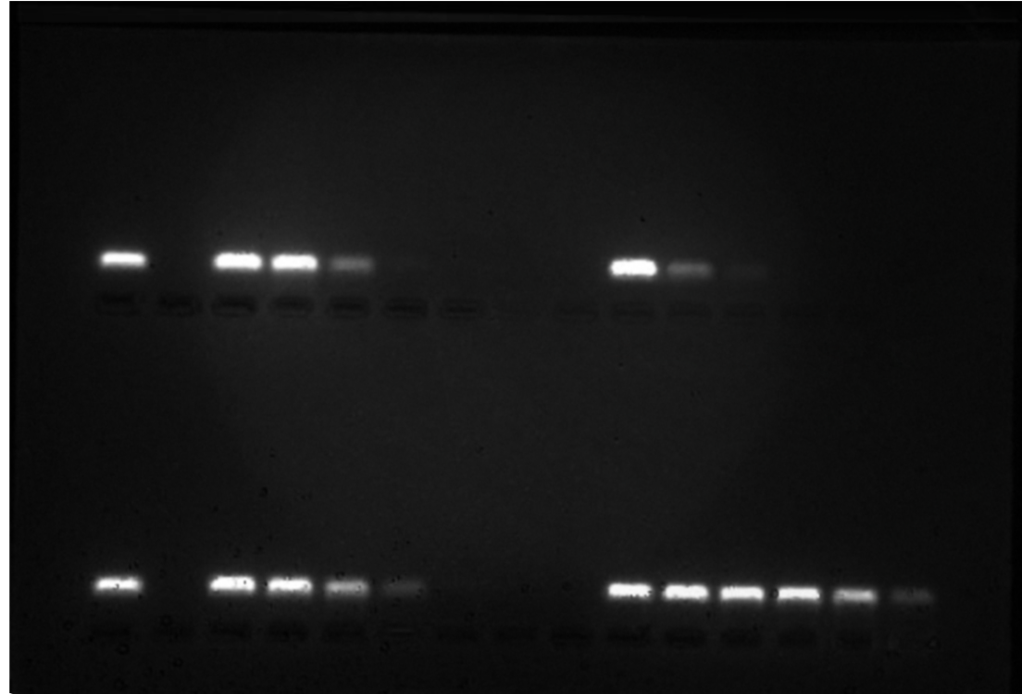
Figure S3. Original image corresponding to the Figure 15 in the main manuscript. Analysis of dendrimer/siRNA complexes in different ratios in 3% agarose gel with GelRed. Complexes were prepared in 10 mmol/l PBS.

