Supplemental materials

Comparative effectiveness of moderate-intensity statin with ezetimibe therapy versus high-intensity statin monotherapy in patients with acute coronary syndrome: A nationwide cohort study

Ji-Yong Jang^{1†}, Seonji Kim^{2,3†}, Jaehyeong Cho^{2,3}, Sung-youn Chun⁴, Seng Chan You^{2,3,*}, Jung-Sun Kim ^{5,*}

¹ Division of Cardiology, National Health Insurance Service Ilsan Hospital, Goyang, Korea
² Department of Biomedical Systems Informatics, Yonsei University College of Medicine, Seoul, Korea
³ Institute for Innovation in Digital Healthcare, Yonsei University, Seoul, Korea
⁴ Department of Research and Analysis, National Health Insurance Service Ilsan Hospital, Goyang, Korea
⁵ Division of Cardiology, Severance Hospital, Yonsei University College of Medicine, Seoul, Korea

† These authors contributed equally to this work.

Supplementary Table S1. Exposure drugs description
Variables | Dosage
Moderate-intensity statin monotherapy
Atorvastatin | 10mg
Atorvastatin | 20mg
Atorvastatin + amlodipine | 10mg + 5mg
Atorvastatin + S-amlodipine | 10mg + 2.5mg
Atorvastatin + amlodipine | 20mg + 5mg
Atorvastatin + amlodipine | 20mg + 10mg
Atorvastatin + irbesartan | 10mg + 0.15g
Atorvastatin + irbesartan | 10mg + 0.3g
Atorvastatin + irbesartan | 20mg + 0.15g
Atorvastatin + irbesartan | 20mg + 0.3g
Fluvastatin | 80mg
Pitavastatin | 2mg
Pitavastatin | 4mg
Pitavastatin + valsartan | 2mg + 80mg
Pitavastatin + valsartan | 2mg + 160mg
Pitavastatin + valsartan | 4mg + 80mg
Pitavastatin + valsartan | 4mg + 160mg
Pravastatin | 40mg
Pravastatin + fenofibrate | 40mg + 0.16g
Rosuvastatin | 5mg
Rosuvastatin | 10mg
Rosuvastatin + olmesartan | 5mg + 10mg
Rosuvastatin + olmesartan | 5mg + 20mg
Rosuvastatin + olmesartan | 10mg + 10mg
Rosuvastatin + olmesartan | 10mg + 20mg
Rosuvastatin + telmisartan | 5mg + 40mg
Rosuvastatin + telmisartan | 5mg + 80mg
Rosuvastatin + telmisartan | 10mg + 40mg
Rosuvastatin + telmisartan | 10mg + 80mg
Rosuvastatin + valsartan | 5mg + 80mg
Rosuvastatin + valsartan | 5mg + 160mg
Rosuvastatin + valsartan | 10mg + 80mg
Rosuvastatin + valsartan | 10mg + 160mg
Simvastatin | 20mg
Simvastatin | 40mg
Simvastatin | 80mg
Simvastatin + fenofibrate | 20mg + 0.145g
Simvastatin + fenofibrate | 40mg + 0.145g
Moderate-intensity statin with ezetimibe combination therapy
Atorvastatin + ezetimibe | 10mg + 10mg
Atorvastatin + ezetimibe | 20mg + 10mg
Rosuvastatin + ezetimibe | 5mg + 10mg
Rosuvastatin + ezetimibe | 10mg + 10mg
Simvastatin + ezetimibe | 20mg + 10mg
Simvastatin + ezetimibe | 40mg + 10mg
High-intensity statin monotherapy
Atorvastatin | 40mg
Atorvastatin | 80mg
Atorvastatin + amlodipine | 40mg + 5mg
Rosuvastatin | 20mg
Rosuvastatin + olmesartan | 20mg + 20mg
Rosuvastatin + olmesartan | 20mg + 40mg
Rosuvastatin + valsartan | 20mg + 80mg
Rosuvastatin + valsartan | 20mg + 160mg
Rosuvastatin + telmisartan | 20mg + 40mg
Rosuvastatin + telmisartan | 20mg + 80mg
High-intensity statin with ezetimibe combination therapy
Atorvastatin + ezetimibe | 40mg + 10mg
Rosuvastatin + ezetimibe | 20mg + 10mg

Supplementary Table S2. Covariates and patient outcomes
Variables | Code | Further description
Comorbidity and revascularization (diagnosis during 2 years before PCI intervention)
Diabetes mellitus | ICD-10: E10, E11, E12, E13, E14 | Patients with diabetes mellitus and prescribed antidiabetic drugs
Hypertension | ICD-10: I10, I11, I12, I13, I15 | Patients with hypertension and prescribed antihypertensive drugs
Old MI | ICD-10: I21, I22, I252
Heart failure | ICD-10: I110, I130, I50, I971
PAD | ICD-10: I700, I701, I702, I708, I709
ESRD | EDI: O7011, O7012, O7013, O7014, O7015, O7016, O7017, O7018, O7020, O7021, O7061, O7062, O7074, AZ231, D0327002, E6593, IB510, IB511, IB520, IB530
Prior PCI | ICD-10: Z955, Z958, Z959  and  EDI: M6551, M6552, M6561, M6563, M6562, M6564, M6553, M6554, M6565, M6566, M6567, M6571, M6572
Prior CABG | ICD-10: T822, Z951, Z95  and  EDI: OA63, OB63, OA641, OA642, OA647, O016, O0170, O1641, O1642, O1643, O1644, O1645, O1646, O1647
Clinical presentation at index procedure
STEMI | ICD-10: I21, I210, I211, I222, I223  and  EDI: M6553, M6565
NSTEMI | ICD-10: I214, I219, I22, I220, I221, I228, I229, I252
Unstable angina | ICD-10: I200
Stable angina | ICD-10: I20, I201, I208, I209
Outcome
Primary endpoint | Composite of all-cause death, myocardial infarction, or stroke
All-cause death | - | Patients were died from first PCI intervention date to last date of the study
MI | ICD-10: I21, I210, I211, I212, I213, I214, I219, I22, I220, I221, I228, I229, I25.2  and  M6551, M6552, M6561, M6563, M6562, M6564, M6553, M6554, M6565, M6566, M6567, M6571, M6572
Stroke | ICD-10: I63, I64 | Hospitalized patients
Secondary endpoint | All-cause death, myocardial infarction, and stroke individually
ICD, international classification of diseases; EDI, electronic data interchange; MI, myocardial infarction; PAD, peripheral artery disease; ESRD, end-stage renal disease; PCI, percutaneous coronary intervention; CABG, coronary artery bypass graft; STEMI, ST-elevation myocardial infarction; NSTEMI, non-ST elevation myocardial infarction

Supplementary Table S3. Baseline characteristics of the matched population using inverse probability of treatment weighting
Statin group | Inverse probability of treatment weighting
Statin group | Moderate Statin + Ezetimibe | High  Statin | Standardized Difference
Participants | 10,992.6 (100.0) | 120,129.0 (100.0)
Male sex | 8,179.0 (74.4) | 89,023.5 (74.1) | 0.01
Age groups |  |  | 0.04
≤40s | 1,369.9 (12.5) | 15,231.6 (12.7)
50s | 2830.9 (25.8) | 29,656.3 (24.7)
60s | 3,039.7 (27.7) | 32,953.9 (27.4)
70s | 2,509.9 (22.8) | 28,418.9 (23.7)
≥80s | 1,242.1 (11.3) | 13,868.3 (11.5)
Comorbidity and revascularization
Diabetes mellitus | 3,208.0 (29.2) | 35,536.0 (29.6) | -0.01
Hypertension | 9,376.9 (85.3) | 100,799.0 (83.9) | 0.04
Old MI | 6,169.2 (56.1) | 64,462.2 (53.7) | 0.05
Heart failure | 1,914.8 (17.4) | 22,440.3 (18.7) | -0.03
PAD | 631.2 (5.7) | 7,145.8 (6.0) | -0.01
ESRD | 325.3 (3.0) | 3,255.5 (2.7) | 0.02
Prior PCI | 920.9 (8.4) | 9,935.1 (8.3) | 0.01
Prior CABG | 928.8 (8.5) | 10,051.4 (8.4) | 0.01
Clinical presentation at index procedure
 | 10,120.9 (92.1) | 108,882.6 (90.6)
STEMI | 2,651.1 (24.1) | 28,612.7 (23.8) | 0.01
NSTEMI | 4,573.5 (41.6) | 46,814.2 (39.0) | 0.05
Unstable angina | 2,896.3 (26.4) | 33,455.7 (27.9) | -0.03
Potent P2Y12 inhibitor | 2,176.7 (19.8) | 22,561.2 (18.8) | 0.03
Tertiary general hospital | 5,481.8 (49.9) | 66,340.5 (55.2) | -0.11
Years of PCI |  |  | 0.04
2013 | 1,019.9 (9.3) | 10,783.1 (9.0)
2014 | 1,352.2 (12.3) | 14,048.6 (11.7)
2015 | 1,588.1 (14.5) | 15,431.9 (12.9)
2016 | 1,546.4 (14.1) | 17,287.9 (14.4)
2017 | 1,712.9 (15.6) | 19,206.1 (16.0)
2018 | 1,816.5 (16.5) | 20,967.2 (17.5)
2019 | 1,956.6 (17.8) | 22,404.2 (18.7)
Data are number (%) or mean ± standard deviation (SD).
MI, myocardial infarction; PAD, peripheral artery disease; ESRD, end-stage renal disease; PCI, percutaneous coronary intervention; CABG, coronary artery bypass graft; STEMI, ST-elevation myocardial infarction; NSTEMI, non-ST elevation myocardial infarction

Supplementary Table S4. Risk of clinical outcomes and description of statin adherence in the matched population using inverse probability of treatment weighting
 | IPTW-adjusted
 | Hazard ratio | P value
Primary endpoint - Composite of all-cause death, myocardial infarction, and stroke | 0.91 (0.86-0.95) | 0.000
All-cause death | 0.86 (0.80-0.93) | 0.000
Myocardial infarction | 1.00 (0.91-1.09) | 0.924
Stroke | 0.93 (0.85-1.01) | 0.101
Data are number (%).
Hazard ratio for moderate statin + ezetimibe group was derived from Cox proportional analysis.
IPTW, inverse probability of treatment weighting.
Supplementary Figure S1. Propensity score distribution before propensity score matching between moderate-intensity statin with ezetimibe therapy and high-intensity statin monotherapy

Moderate Statin + Ezetimibe | High Statin
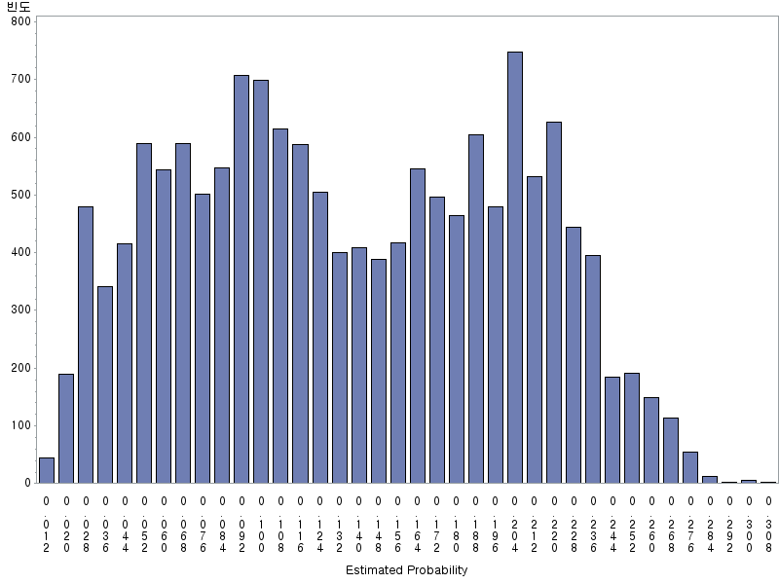 | 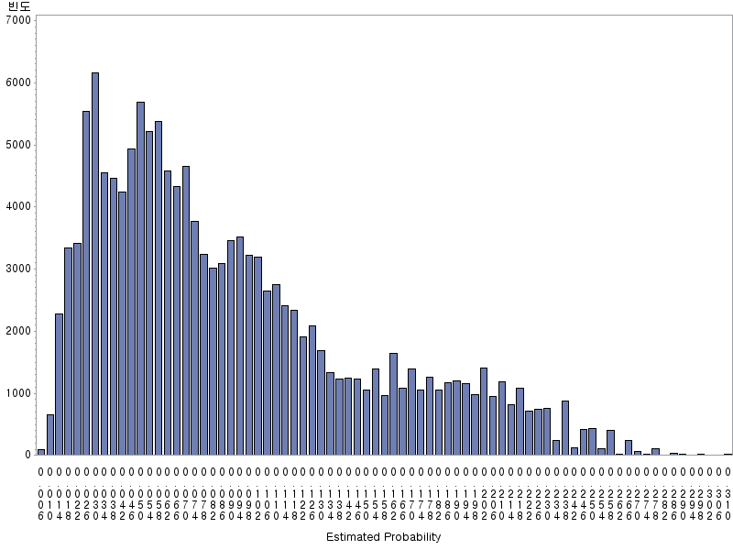
The propensity score is use to balance the distribution of baseline covariates between two groups.

