Immune and stromal transcriptional patterns that influence the outcome of classic Hodgkin Lymphoma
Victoria Menéndez, José L. Solórzano, Mónica García-Cosío, Ruth Alonso-Alonso, Marta Rodríguez, Laura Cereceda, Sara Fernández, Eva Díaz, Carlos Montalbán, Mónica Estévez, Miguel A. Piris, and Juan F. García.

Supplemental Table 1. Genes used in the analysis. The custom genes specific to Hodgkin’s Lymphoma are included with the NanoString nCounter® PanCancer Immune Profiling Panel genes, representing up to 800 genes in total.
A2M | ACVR1C | ADAM12 | ADGRE1 | ADM | ADORA2A | AKT1 | ALDOA | ALDOC | ALK | ANGPT1
ANGPT2 | ANGPTL4 | ANLN | APC | APH1B | API5 | APLNR | APOE | APOL6 | AQP9 | AREG
ARG1 | ARG2 | ARID1A | ARNT2 | ATF3 | ATM | AXIN1 | AXL | B2M | BAD | BAMBI
BATF3 | BAX | BBC3 | BBS1 | BCAT1 | BCL2 | BCL2L1 | BCL6B | BID | BIRC3 | BIRC5
BLK | BLM | BMLF1 | BMP2 | BNIP3 | BNIP3L | BRCA1 | BRCA2 | BRD3 | BRD4 | BRIP1
BTLA | BZLF1 | C1QA | C1QB | C2 | C5 | C5AR1 | C7 | CASP1 | CASP3 | CASP8
CASP9 | CBLC | CCL13 | CCL14 | CCL18 | CCL19 | CCL2 | CCL20 | CCL21 | CCL22 | CCL3/L1
CCL4 | CCL5 | CCL7 | CCL8 | CCNA1 | CCNB1 | CCND1 | CCND2 | CCND3 | CCNE1 | CCNO
CCR2 | CCR4 | CCR5 | CD14 | CD163 | CD19 | CD1C | CD1a | CD2 | CD207 | CD209
CD23 | CD244 | CD247 | CD27 | CD274 | CD276 | CD28 | CD300A | CD33 | CD36 | CD38
CD3D | CD3E | CD3G | CD4 | CD40 | CD40LG | CD44 | CD45RA | CD45RB | CD45RO | CD47
CD48 | CD5 | CD58 | CD6 | CD68 | CD69 | CD7 | CD70 | CD74 | CD79A | CD79B
CD80 | CD84 | CD86 | CD8A | CD8B | CD96 | CDC20 | CDC25C | CDH1 | CDH11 | CDH2
CDH5 | CDK2 | CDK4 | CDK6 | CDKN1A | CDKN1C | CDKN2A | CDKN2B | CEACAM3 | CEBPB | CENPF
CEP55 | CES3 | CHUK | CLEC14A | CLEC4E | CLEC5A | CLEC7A | CLECL1 | CMKLR1 | CNTFR | COL11A1
COL11A2 | COL17A1 | COL4A5 | COL5A1 | COL6A3 | COMP | CPA3 | CR1 | CR2 | CRABP2 | CRTAM
CSF1 | CSF1R | CSF2 | CSF2RB | CSF3 | CSF3R | CST2 | CTAG1B | CTLA4 | CTNNB1 | CTSS
CTSW | CX3CL1 | CX3CR1 | CXCL1 | CXCL10 | CXCL11 | CXCL12 | CXCL13 | CXCL14 | CXCL16 | CXCL2
CXCL3 | CXCL5 | CXCL6 | CXCL8 | CXCL9 | CXCR2 | CXCR3 | CXCR4 | CXCR5 | CXCR6 | CXorf36
CYBB | DAB2 | DDB2 | DEFB134 | DEPTOR | DKK1 | DLL1 | DLL4 | DNMT1 | DNMT3 | DPP4
DTX3L | DTX4 | DUSP1 | DUSP2 | DUSP5 | E2F1 | E2F3 | EDN1 | EGF | EGFR | EGR1
EGR2 | EIF2AK2 | EIF2B4 | EIF4EBP1 | EIF5AL1 | ELOB | ENO1 | ENTPD1 | EOMES | EPCAM | EPM2AIP1
ERBB2 | ERO1A | ESR1 | EXO1 | EZH2 | F2RL1 | FADD | FAM124B | FAM30A | FANCA | FAP
FAS | FASLG | FBP1 | FCAR | FCGR1A | FCGR2A | FCGR2B | FCGR3A/B | FCGRT | FCN1 | FCRL2
FGF13 | FGF18 | FGF9 | FGFR1 | FLNB | FLT1 | FOSL1 | FOXM1 | FOXP3 | FPR1 | FPR3
FSTL3 | FUT4 | FYN | FZD8 | FZD9 | GAS1 | GATA3 | GBP1 | GBP2 | GBP4 | GHR
GIMAP4 | GIMAP6 | GLI1 | GLS | GLUD1 | GLUL | GMIP | GNG4 | GNLY | GOT1 | GOT2
GPC4 | GPR160 | GPSM3 | GZMA | GZMB | GZMH | GZMK | GZMM | H2AFX | HAVCR2 | HCK
HDAC11 | HDAC3 | HDAC4 | HDAC5 | HDC | HELLS | HERC6 | HES1 | HEY1 | HIF1A | HK1
HK2 | HLA-A | HLA-B | HLA-C | HLA-DMA | HLA-DMB | HLA-DOA | HLA-DOB | HLA-DPA1 | HLA-DPB1 | HLA-DQA1
HLA-DQA2 | HLA-DQB1 | HLA-DRA | HLA-DRB1 | HLA-DRB5 | HLA-E | HLA-F | HMGA1 | HMGB1 | HNF1A | HRAS
HSD11B1 | ICAM1 | ICAM2 | ICAM3 | ICAM5 | ICOS | ICOSLG | ID4 | IDO1 | IER3 | IFI16
IFI27 | IFI35 | IFI6 | IFIH1 | IFIT1 | IFIT2 | IFIT3 | IFITM1 | IFITM2 | IFNA1 | IFNAR1
IFNG | IFNGR1 | IFNGR2 | IGF2R | IHH | IKBKB | IKBKG | IL10 | IL10RA | IL11 | IL11RA
IL12RB2 | IL15 | IL16 | IL17A | IL18 | IL18R1 | IL1A | IL1B | IL1R2 | IL1RN | IL2
IL21 | IL21R | IL22RA1 | IL24 | IL2RA | IL2RB | IL2RG | IL32 | IL33 | IL34 | IL4
IL6 | IL6R | IL7R | INHBA | IRF1 | IRF2 | IRF3 | IRF4 | IRF5 | IRF7 | IRF8
IRF9 | ISG15 | ITGA1 | ITGA2 | ITGA4 | ITGA6 | ITGAE | ITGAL | ITGAM | ITGAV | ITGAX
ITGB2 | ITGB3 | ITGB8 | ITPK1 | JAG1 | JAG2 | JAK1 | JAK2 | JAK3 | KAT2B | KDR
KIF2C | KIR2DL3 | KIR3DL1 | KIR3DL2 | KIT | KLRB1 | KLRD1 | KLRK1 | KRAS | LAG3 | LAIR1
LAMA1 | LAMB3 | LAMC2 | LCK | LDHA | LDHB | LGALS9 | LIF | LILRA1 | LILRA3 | LILRA5
LILRB2 | LILRB4 | LMP1 | LOXL2 | LRRC32 | LTB | LTBP1 | LY9 | LY96 | LYZ | MAGEA1
MAGEA12 | MAGEA3/A6 | MAGEA4 | MAGEB2 | MAGEC1 | MAGEC2 | MAML2 | MAP3K12 | MAP3K5 | MAP3K7 | MAP3K8
MAPK10 | MARCO | MB21D1 | MELK | MET | MFGE8 | MFNG | MGMT | MIB1 | MICA | MICB
MKI67 | MLANA | MLH1 | MME | MMP1 | MMP7 | MMP9 | MMRN2 | MRC1 | MRE11 | MS4A1
MS4A2 | MS4A4A | MS4A6A | MSH2 | MSH6 | MTOR | MUC1 | MX1 | MXI1 | MYC | MYCT1
MYD88 | NANOG | NBN | NCAM1 | NCR1 | NDUFA4L2 | NECTIN1 | NECTIN2 | NEIL1 | NF1 | NFAM1
NFATC2 | NFIL3 | NFKB1 | NFKB2 | NFKBIA | NFKBIE | NGFR | NID2 | NKG7 | NLRC5 | NLRP3
NOD2 | NOS2 | NOTCH1 | NOTCH2 | NRAS | NT5E | OAS1 | OAS2 | OAS3 | OASL | OLFML2B
OLR1 | OTOA | P2RY13 | P4HA1 | P4HA2 | PALMD | PARP12 | PARP4 | PARP9 | PC | PCK2
PDCD1 | PDCD1LG2 | PDGFA | PDGFB | PDGFRA | PDGFRB | PDK1 | PDZK1IP1 | PECAM1 | PF4 | PFKFB3
PFKM | PGPEP1 | PIAS4 | PIK3CA | PIK3CD | PIK3CG | PIK3R1 | PIK3R2 | PIK3R5 | PIM1 | PIM2
PKM | PLA1A | PLA2G2A | PLOD2 | PMS2 | PNOC | POLD1 | PPARG | PPARGC1B | PRDM1 | PRF1
PRKAA2 | PRKACB | PRKCA | PRKX | PRLR | PROM1 | PRR5 | PSMB10 | PSMB5 | PSMB8 | PSMB9
PTCD2 | PTEN | PTGER4 | PTGS2 | PTPN11 | PTPRC | PVR | PVRIG | RAD50 | RAD51 | RAD51C
RASAL1 | RASGRF1 | RB1 | RBL2 | RELA | RELB | RELN | REN | RICTOR | RIPK1 | RIPK2
RIPK3 | RNLS | ROBO4 | ROCK1 | ROR2 | RORC | RPL23 | RPL7A | RPS6KB1 | RPTOR | RRM2
RSAD2 | RUNX3 | S100A12 | S100A8 | S100A9 | SAMD9 | SAMSN1 | SBNO2 | SDC1 | SELE | SELL
SELP | SERPINA1 | SERPINB5 | SERPINH1 | SFRP1 | SFRP4 | SFXN1 | SGK1 | SH2D1A | SHC2 | SIGLEC1
SIGLEC5 | SIGLEC8 | SIRPA | SIRPB2 | SLAMF7 | SLC11A1 | SLC16A1 | SLC1A5 | SLC2A1 | SLC7A5 | SMAD5
SMAP1 | SNAI1 | SNCA | SOCS1 | SOX10 | SOX11 | SOX2 | SP1 | SPIB | SPP1 | SPRY4
SREBF1 | SRP54 | STAT1 | STAT2 | STAT3 | STAT4 | STC1 | SYK | TAF3 | TAP1 | TAP2
TAPBP | TAPBPL | TBX21 | TBXAS1 | TCF3 | TCL1A | TDO2 | TGFB1 | TGFB2 | TGFB3 | TGFBR1
TGFBR2 | THBD | THBS1 | THY1 | TIA1 | TICAM1 | TIE1 | TIGIT | TLR1 | TLR2 | TLR3
TLR4 | TLR5 | TLR7 | TLR8 | TLR9 | TMEM140 | TMEM173 | TNF | TNFAIP3 | TNFAIP6 | TNFRSF10B
TNFRSF10C | TNFRSF10D | TNFRSF11A | TNFRSF11B | TNFRSF14 | TNFRSF17 | TNFRSF18 | TNFRSF1A | TNFRSF1B | TNFRSF25 | TNFRSF4
TNFRSF8 | TNFRSF9 | TNFSF10 | TNFSF12 | TNFSF13 | TNFSF13B | TNFSF18 | TNFSF4 | TNFSF8 | TNFSF9 | TNKS
TP53 | TPI1 | TPM1 | TPSAB1/B2 | TRAF1 | TRAT1 | TREM1 | TREM2 | TRIM21 | TSLP | TTC30A
TWF1 | TWIST1 | TWIST2 | TYMP | TYMS | UBA7 | UBE2C | UBE2T | ULBP2 | VCAM1 | VCAN
VEGFA | VEGFB | VEGFC | VHL | VSIR | VTCN1 | WDR76 | WNT10A | WNT11 | WNT2 | WNT2B
WNT3A | WNT4 | WNT5A | WNT5B | WNT7B | XCL1/2 | ZAP70 | ZC3H12A | ZEB1 | ZEB2 | ABCF1
DNAJC14 | ERCC3 | G6PD | GUSB | MRPL19 | NRDE2 | OAZ1 | POLR2A | PSMC4 | PUM1 | SDHA
SF3A1 | STK11IP | TBC1D10B | TBP | TFRC | TLK2 | TMUB2 | UBB

Supplemental Table 2. Summary of sources for the selected and created GSs. The final dataset contained 157 cell phenotypes and 1077 signaling pathways, distributed as follows:
SOURCE | LINK | NUMBER OF GS
GOBP | https://www.gsea-msigdb.org/ | 480
REACTOME | https://www.gsea-msigdb.org/ | 178
MANUAL | https://pubmed.ncbi.nlm.nih.gov/ | 139
GOCC | https://www.gsea-msigdb.org/ | 69
WIKIPATHWAYS | https://www.gsea-msigdb.org/ | 63
BIOCARTA | https://www.gsea-msigdb.org/ | 61
PID | https://www.gsea-msigdb.org/ | 55
GENEONTOLOGY | http://geneontology.org/ | 33
FANTOM | https://fantom.gsc.riken.jp/5/ | 17
MSIGDB | https://www.gsea-msigdb.org/ | 16
GENEVESTIGATOR | https://genevestigator.com/ | 16
NOVERSHTERN | https://doi.org/10.1016%2Fj.cell.2011.01.004 | 15
BLUEPRINT | http://blueprint-data.bsc.es/#!/ | 12
SCTYPE | https://github.com/IanevskiAleksandr/sc-type | 12
EUROPEPMC | https://www.ebi.ac.uk/biostudies/europepmc/studies/S-EPMC6472943/ | 11
KEGG | https://www.gsea-msigdb.org/ | 11
HALLMARK | https://www.gsea-msigdb.org/ | 11
HPCA | https://www.humancellatlas.org/ | 9
HPA | https://www.proteinatlas.org/ | 7
CELLXGENE | https://cellxgene.cziscience.com/gene-expression/ | 6
NABA | https://www.gsea-msigdb.org/ | 5
IRIS | https://www.immgen.org/ | 4
SIG | https://www.gsea-msigdb.org/ | 2
ENCODE | https://www.encodeproject.org/ | 1
SA | https://www.gsea-msigdb.org/ | 1

Supplemental Table 3. Summary of clinical data for all classic Hodgkin Lymphoma patients
 |  | Total | Unfavorable | Favorable | p-value
Age
 | ≥ 65 years | 4 (16%) | 1 (25%) | 3 (75%) | NS
 | < 65 years | 21 (84%) | 13 (62%) | 8 (38%) | NS
Gender
 | Male | 14 (56%) | 11 (79%) | 3 (21%) | 0.017
 | Female  No data | 10 (40%)  1 (4%) | 3 (30%)  0 0(%) | 7 (70%)  1 (100%) | 0.017
cHL subtype
 | NS | 11 (44%) | 8 (73%) | 3 (27%) | NS
 | Others  No data | 12 (48%)  2 (8%) | 5 (42%)  1 (50%) | 7 (58%)  1 (50%) | NS
Ann Arbor stage
 | IV | 10 (40%) | 7 (70%) | 3 (30%) | NS
 | I-III | 15 (60%) | 7 (47%) | 8 (53%) | NS
IPS
 | ≥ 3 | 6 (24%) | 3 (50%) | 3 (50%) | NS
 | < 3  No data | 14 (56%)  5 (20%) | 9 (64%)  2 (40%) | 4 (36%)  3 (60%) | NS
Epstein–Barr virus infection
 | Positive | 6 (24%) | 3 (50%) | 3 (50%) | NS
 | Negative | 17 (68%) | 10 (59%) | 7 (41%) | NS
 | No Data | 2 (8%) | 1 (50%) | 1 (50%)
Response to first treatment
 | CR | 13 (52%) | 2 (15%) | 11 (85%) | <0.001
 | PR + PD | 12 (48%) | 12 (100%) | 0 (0%) | <0.001

NS = nodular sclerosis; IPS = International Prognostic Score; CR = complete remission; PD = progressive disease; PR = partial response; Favorable = PFS > 2 years; Unfavorable = PFS < 2 years.

Supplemental Table 4. Detailed results about inflammatory balance and MHC molecule distribution. Components appearing in Figure 2 are highlighted in bold.
Variable | Source | Available plots | Variable enriched in: | p
B2M GENE | Gene Expression | KM dichotomized 25% | U | 0.049
B2M GENE | Gene Expression | KM dichotomized 33% | U | 0.037
B2M GENE | Gene Expression | KM dichotomized 50% | U | 0.025
IFIT3 GENE | Gene Expression | KM dichotomized 50% | U | 0.030
IFIT3 GENE | Gene Expression | KM dichotomized 67% | U | 0.012
IFIT3 GENE | Gene Expression | KM dichotomized 75% | U | 0.054
IFIT3 GENE | Gene Expression | KM quartiles | U | 0.059
IFIT3 GENE | Gene Expression | KM tertiles | U | 0.077
IFN ANTIVIRAL PATHWAY | REACTOME | Cox | U | 0.032
IFN ANTIVIRAL PATHWAY | REACTOME | KM dichotomized 25% | U | 0.013
IFN ANTIVIRAL PATHWAY | REACTOME | KM dichotomized 33% | U | 0.071
IFN ANTIVIRAL PATHWAY | REACTOME | KM dichotomized 50% | U | 0.043
IFN ANTIVIRAL PATHWAY | REACTOME | KM dichotomized 67% | U | 0.067
IFN ANTIVIRAL PATHWAY | REACTOME | KM quartiles | U | 0.051
IFN ANTIVIRAL PATHWAY | REACTOME | KM tertiles | U | 0.069
IFNGR1 GENE | Gene Expression | KM quartiles | U | 0.069
IFNGR1 GENE | Gene Expression | KM tertiles | U | 0.047
IFN-γ PATHWAY | Manual | Cox | U | 0.048
IFN-γ PATHWAY | Manual | KM dichotomized 25% | U | 0.060
IFN-γ PATHWAY | Manual + PID | KM dichotomized 50% | U | 0.038
IFN-γ PATHWAY | Manual | KM dichotomized 67% | U | 0.090
IFN-γ PATHWAY | Manual + PID | KM quartiles | U | 0.033
IFN-γ SIGNATURE | Manual | KM dichotomized 67% | U | 0.051
IL6 PATHWAY | BIOCARTA | Boxplot (t test) | U | 0.099
IL6 PATHWAY | Manual + PID | KM dichotomized 25% | U | 0.010
IL6 PATHWAY | BIOCARTA | KM dichotomized 50% | U | 0.046
IL6 PATHWAY | BIOCARTA | KM dichotomized 75% | U | 0.067
MHC-I PATHWAY | Manual | Boxplot (Kruskal–Wallis) | RELAPSE | 0.022
MHC-I PATHWAY | REACTOME | KM dichotomized 25% | U | 0.022
MHC-II PATHWAY | REACTOME | Boxplot (t test) | NO_RELAPSE | 0.052
TGFB2 GENE | Gene Expression | Cox | F | 0.057
TGFB2 GENE | Gene Expression | KM dichotomized 25% | F | 0.059
TGFBR1 GENE | Gene Expression | KM dichotomized 33% | F | 0.065
TGF-β PATHWAY | REACTOME + PID | Cox | F | 0.012
TGF-β PATHWAY | PID | KM dichotomized 50% | F | 0.082
TGF-β PATHWAY | PID + REACTOME | KM dichotomized 75% | F | 0.003
TNF PATHWAY | BIOCARTA | KM dichotomized 25% | U | 0.026
TNF PATHWAY | Manual | KM dichotomized 33% | U | 0.081
TNF PATHWAY | Manual | KM dichotomized 75% | U | 0.098
U = Unfavorable; F = Favorable; KM = Kaplan–Meier plot.

Supplemental Table 5. Detailed results about myeloid cells. Components appearing in Figure 3 are highlighted in bold.
Variable | Source | Available plots | Variable enriched in: | p
ACTIVATED DENDRITIC CELLS | IRIS | KM dichotomized 25% | U | 0.053
ACTIVATED DENDRITIC CELLS | IRIS | KM dichotomized 67% | U | 0.033
ACTIVATED DENDRITIC CELLS | IRIS | KM tertiles | U | 0.081
ACTIVATED MACROPHAGES | Manual | KM dichotomized 25% | U | 0.046
ACTIVATED MONOCYTES | CIBERSORTx | Boxplot (Kruskal–Wallis) | RELAPSE | 0.026
ACTIVATED MONOCYTES | CIBERSORTx | KM dichotomized 33% | U | 0.042
ACTIVATED MONOCYTES | CIBERSORTx | KM dichotomized 75% | U | 0.052
ACTIVATED PLASMACYTOID DENDRITIC CELLS | CIBERSORTx | KM dichotomized 25% | U | 0.050
BASOPHILS | NOVERSHTERN | Cox | U | 0.034
BASOPHILS | NOVERSHTERN | KM dichotomized 25% | U | 0.092
BASOPHILS | NOVERSHTERN | KM dichotomized 50% | U | 0.100
BASOPHILS | NOVERSHTERN | KM dichotomized 67% | U | 0.028
BASOPHILS | NOVERSHTERN + Manual | KM tertiles | U | 0.078
C1QA GENE | Gene Expression | Boxplot (Kruskal–Wallis) | RELAPSE | 0.036
C1QB GENE | Gene Expression | KM dichotomized 67% | U | 0.019
C1QB GENE | Gene Expression | KM dichotomized 75% | U | 0.047
CD14 GENE | Gene Expression | KM dichotomized 75% | U | 0.055
CD14 GENE | Gene Expression | KM tertiles | U | 0.014
CD14+ CELLS | Manual | Boxplot (t test) | RELAPSE | 0.030
CD1C GENE | Gene Expression | Boxplot (t test) | U | 0.038
CD23 GENE (MARKER OF fDCs) | Gene Expression | Boxplot (Kruskal–Wallis) | NO RELAPSE | 0.011
CREB PATHWAY | BIOCARTA | Boxplot (t test) | U | 0.078
CREB PATHWAY | BIOCARTA | Cox | U | 0.017
CREB PATHWAY | BIOCARTA | KM dichotomized 25% | U | 0.016
CREB PATHWAY | BIOCARTA | KM dichotomized 33% | U | 0.012
CREB PATHWAY | BIOCARTA | KM dichotomized 50% | U | 0.038
DAP12 PATHWAY | REACTOME + Manual | Boxplot (t test) | U | 0.008
DAP12 PATHWAY | REACTOME + Manual | Cox | U | 0.005
DAP12 PATHWAY | REACTOME | KM dichotomized 25% | U | 0.046
DAP12 PATHWAY | REACTOME | KM dichotomized 33% | U | 0.014
DAP12 PATHWAY | REACTOME | KM dichotomized 50% | U | 0.001
DAP12 PATHWAY | REACTOME + Manual | KM dichotomized 67% | U | 0.024
DAP12 PATHWAY | REACTOME | KM dichotomized 75% | U | 0.033
DAP12 PATHWAY | Manual + REACTOME | KM quartiles | U | 0.003
DAP12 PATHWAY | REACTOME | KM tertiles | U | 0.050
EOSINOPHILS | HPA | Boxplot (t test) | RELAPSE | 0.014
EOSINOPHILS | Manual | KM dichotomized 75% | U | 0.098
EOSINOPHILS | Manual | KM tertiles | U | 0.010
FCGR PATHWAY | REACTOME | Boxplot (t test) | RELAPSE | 0.073
FCGR PATHWAY | REACTOME | KM dichotomized 25% | U | 0.050
FCGR PATHWAY | REACTOME | KM dichotomized 50% | U | 0.048
FCGR PATHWAY | REACTOME | KM quartiles | U | 0.046
FCGR1A GENE | Gene Expression | Boxplot (Kruskal–Wallis) | RELAPSE | 0.086
GRANULOCYTES | Manual | Boxplot (t test) | RELAPSE | 0.095
GRANULOCYTES | Manual | KM dichotomized 33% | U | 0.062
GRANULOCYTES | Manual | KM dichotomized 75% | U | 0.055
GRANULOCYTES | Manual | KM tertiles | U | 0.051
IL10 PATHWAY | REACTOME | Boxplot (t test) | RELAPSE | 0.069
IL10 PATHWAY | REACTOME | KM dichotomized 25% | U | 0.060
IL10 PATHWAY | REACTOME | KM dichotomized 33% | U | 0.063
IL10 PATHWAY | REACTOME | KM dichotomized 75% | U | 0.032
IL12 PATHWAY | PID + BIOCARTA + Manual | KM dichotomized 67% | U | 0.030
IL12 PATHWAY | Manual + BIOCARTA + PID | KM dichotomized 75% | U | 0.045
IL12 PATHWAY | PID | KM quartiles | U | 0.022
IL12 PATHWAY | BIOCARTA + pid | KM tertiles | U | 0.028
IL23 PATHWAY | Manual | Cox | U | 0.058
IL23 PATHWAY | Manual | KM dichotomized 33% | U | 0.086
IL23 PATHWAY | Manual | KM dichotomized 50% | U | 0.021
IL23 PATHWAY | Manual | KM dichotomized 67% | U | 0.060
IL3 AND GMCSF PATHWAY | REACTOME | Cox | U | 0.012
IL3 AND GMCSF PATHWAY | REACTOME | KM dichotomized 25% | U | 0.022
IL3 AND GMCSF PATHWAY | REACTOME | KM dichotomized 33% | U | 0.014
IL3 AND GMCSF PATHWAY | REACTOME | KM quartiles | U | 0.026
IL3 AND GMCSF PATHWAY | REACTOME | KM tertiles | U | 0.036
IMMATURE MACROPHAGES | Manual | Boxplot (t test) | F | 0.053
IMMATURE MACROPHAGES | Manual | KM dichotomized 67% | F | 0.022
IMMATURE MACROPHAGES | Manual | KM tertiles | F | 0.024
ISG15 GENE | Gene Expression | KM dichotomized 33% | U | 0.098
ISG15 GENE | Gene Expression | KM dichotomized 50% | U | 0.024
ISG15 GENE | Gene Expression | KM dichotomized 67% | U | 0.012
ISG15 GENE | Gene Expression | KM dichotomized 75% | U | 0.054
ISG15 GENE | Gene Expression | KM tertiles | U | 0.097
LYZ GENE | Gene Expression | Boxplot (Kruskal–Wallis) | RELAPSE | 0.008
LYZ GENE | Gene Expression | KM dichotomized 50% | U | 0.079
LYZ GENE | Gene Expression | KM dichotomized 67% | U | 0.029
LYZ GENE | Gene Expression | KM dichotomized 75% | U | 0.073
LYZ GENE | Gene Expression | KM quartiles | U | 0.077
M1 MACROPHAGES | FANTOM + BLUEPRINT + Manual | Boxplot (t test) | RELAPSE | 0.019
M1 MACROPHAGES | Manual | Cox | U | 0.059
M1 MACROPHAGES | Manual | KM dichotomized 25% | U | 0.065
M1 MACROPHAGES | Manual | KM dichotomized 33% | U | 0.066
M1 MACROPHAGES | Manual | KM dichotomized 50% | U | 0.084
M2 MACROPHAGES | Manual | Boxplot (Kruskal–Wallis) | U | 0.071
M2 MACROPHAGES | Manual | Cox | U | 0.071
M2 MACROPHAGES | Manual | KM dichotomized 25% | U | 0.020
M2 MACROPHAGES | Manual | KM dichotomized 67% | U | 0.080
MACROPHAGE PATHWAY | WIKIPATHWAYS | Boxplot (t test) | RELAPSE | 0.007
MACROPHAGES | Manual + BLUEPRINT + HPCA + FANTOM | Boxplot (t test) | RELAPSE | 0.009
MACROPHAGES | FANTOM | KM dichotomized 25% | U | 0.099
MACROPHAGES | FANTOM | KM dichotomized 33% | U | 0.078
MIF PATHWAY | Manual | Boxplot (t test) | F | 0.045
MIF PATHWAY | Manual | Cox | F | 0.046
MIF PATHWAY | Manual | KM dichotomized 75% | F | 0.001
MONOCYTES | Manual + CIBERSORTx + FANTOM + NOVERSHTERN + HPA + BLUEPRINT | Boxplot (t test) | RELAPSE | 0.008
MONOCYTES | CIBERSORTx | KM dichotomized 25% | U | 0.059
MONOCYTES | Manual + IRIS + NOVERSHTERN | KM dichotomized 50% | U | 0.047
MONOCYTES | Manual + NOVERSHTERN + BLUEPRINT + IRIS | KM dichotomized 67% | U | 0.019
MONOCYTES | BLUEPRINT | KM dichotomized 75% | U | 0.050
MONOCYTES | NOVERSHTERN + BLUEPRINT + IRIS | KM quartiles | U | 0.006
MYELOID CELLS | Manual | Boxplot (t test) | RELAPSE | 0.047
MYELOID DENDRITIC CELLS | Manual + CIBERSORTx | Boxplot (t test) | RELAPSE | 0.025
MYELOID DENDRITIC CELLS | Manual | Boxplot (Kruskal–Wallis) | U | 0.071
MYELOID DENDRITIC CELLS | Manual | KM dichotomized 25% | U | 0.017
MYELOID DENDRITIC CELLS | NOVERSHTERN + Manual | KM dichotomized 33% | U | 0.074
MYELOID DENDRITIC CELLS | Manual | KM dichotomized 50% | U | 0.070
MYELOID-DERIVED SUPPRESSOR CELLS (MDSC) | Manual | Boxplot (t test) | RELAPSE | 0.065
MYELOID-DERIVED SUPPRESSOR CELLS (MDSC) | BLUEPRINT | Boxplot (t test) | U | 0.012
MYELOID-DERIVED SUPPRESSOR CELLS (MDSC) | BLUEPRINT | Cox | U | 0.079
MYELOID-DERIVED SUPPRESSOR CELLS (MDSC) | BLUEPRINT | KM dichotomized 25% | U | 0.001
MYELOID-DERIVED SUPPRESSOR CELLS (MDSC) | BLUEPRINT + Manual | KM dichotomized 33% | U | 0.015
MYELOID-DERIVED SUPPRESSOR CELLS (MDSC) | BLUEPRINT | KM dichotomized 50% | U | 0.083
MYELOID-DERIVED SUPPRESSOR CELLS (MDSC) | BLUEPRINT | KM quartiles | U | 0.046
MYELOID-DERIVED SUPPRESSOR CELLS (MDSC) | BLUEPRINT | KM tertiles | U | 0.065
NEUTROPHIL DEGRANULATION PATHWAY | Manual + REACTOME | Boxplot (t test) | RELAPSE | 0.022
NEUTROPHIL DEGRANULATION PATHWAY | Manual | KM dichotomized 67% | U | 0.052
NEUTROPHIL DEGRANULATION PATHWAY | Manual | KM quartiles | U | 0.096
NEUTROPHILS | GENEVESTIGATOR | Boxplot (t test) | RELAPSE | 0.080
NEUTROPHILS | GENEVESTIGATOR | KM dichotomized 67% | U | 0.019
NEUTROPHILS | GENEVESTIGATOR | KM dichotomized 75% | U | 0.032
NEUTROPHILS | Manual | KM quartiles | U | 0.087
NEUTROPHILS | Manual | KM tertiles | U | 0.001
NFAT PATHWAY | Manual | Boxplot (t test) | NO RELAPSE | 0.006
NON-CLASSICAL MONOCYTES | HPA | Boxplot (t test) | RELAPSE | 0.016
NON-CLASSICAL MONOCYTES | Manual | Cox | U | 0.035
NON-CLASSICAL MONOCYTES | CIBERSORTx | KM dichotomized 67% | U | 0.052
NON-CLASSICAL MONOCYTES | Manual | KM dichotomized 75% | U | 0.026
NON-CLASSICAL MONOCYTES | CIBERSORTx | KM tertiles | U | 0.068
PHAGOCYTOSIS PATHWAY | REACTOME | Boxplot (t test) | RELAPSE | 0.043
PHAGOCYTOSIS PATHWAY | REACTOME | Cox | U | 0.037
PHAGOCYTOSIS PATHWAY | REACTOME | KM dichotomized 25% | U | 0.050
PHAGOCYTOSIS PATHWAY | REACTOME | KM dichotomized 33% | U | 0.025
PHAGOCYTOSIS PATHWAY | REACTOME | KM dichotomized 50% | U | 0.008
PHAGOCYTOSIS PATHWAY | REACTOME | KM dichotomized 67% | U | 0.026
PHAGOCYTOSIS PATHWAY | REACTOME | KM tertiles | U | 0.079
PLASMACYTOID DENDRITIC CELLS | CIBERSORTx + Manual | Boxplot (t test) | RELAPSE | 0.032
PLASMACYTOID DENDRITIC CELLS | FANTOM + Manual | Cox | U | 0.046
PLASMACYTOID DENDRITIC CELLS | Manual | KM dichotomized 25% | U | 0.072
PLASMACYTOID DENDRITIC CELLS | FANTOM + Manual | KM dichotomized 50% | U | 0.045
PLASMACYTOID DENDRITIC CELLS | Manual | KM dichotomized 67% | U | 0.021
PLASMACYTOID DENDRITIC CELLS | HPA + Manual | KM quartiles | U | 0.021
PTPRC GENE | GENEVESTIGATOR | Cox | U | 0.010
PTPRC GENE | GENEVESTIGATOR | KM dichotomized 25% | U | 0.041
PTPRC GENE | GENEVESTIGATOR | KM dichotomized 33% | U | 0.008
PTPRC GENE | GENEVESTIGATOR | KM dichotomized 50% | U | 0.006
PTPRC GENE | GENEVESTIGATOR | KM dichotomized 67% | U | 0.010
PTPRC GENE | GENEVESTIGATOR | KM quartiles | U | 0.002
PTPRC GENE | GENEVESTIGATOR | KM tertiles | U | 0.012
RESTING MONOCYTES | CIBERSORTx | Boxplot (Kruskal–Wallis) | RELAPSE | 0.033
SPIB GENE | GENEVESTIGATOR | Cox | U | 0.098
SPIB GENE | GENEVESTIGATOR | KM dichotomized 25% | U | 0.060
SPIB GENE | GENEVESTIGATOR | KM dichotomized 33% | U | 0.011
SPIB GENE | GENEVESTIGATOR | KM dichotomized 50% | U | 0.016
TRIM21 GENE | GENEVESTIGATOR | KM dichotomized 25% | U | 0.093
TRIM21 GENE | GENEVESTIGATOR | KM dichotomized 33% | U | 0.076
TRIM21 GENE | GENEVESTIGATOR | KM dichotomized 50% | U | 0.041
TRIM21 GENE | GENEVESTIGATOR | KM dichotomized 67% | U | 0.001
TRIM21 GENE | GENEVESTIGATOR | KM dichotomized 75% | U | 0.034
TRIM21 GENE | GENEVESTIGATOR | KM quartiles | U | 0.061
TRIM21 GENE | GENEVESTIGATOR | KM tertiles | U | 0.012
U = Unfavorable; F = Favorable; KM = Kaplan–Meier plot.

Supplemental Table 6. Detailed results about cytotoxic cells. Components appearing in Figure 4 are highlighted in bold.
Variable | Source | Available plots | Variable enriched in: | p
ACTIVATED MATURE NK CELLS | CIBERSORTx | Boxplot (t test) | F | 0.084
ACTIVATED MATURE NK CELLS | CIBERSORTx | KM dichotomized 50% | F | 0.027
CD244 GENE | Gene Expression | KM dichotomized 75% | U | 0.041
CD48 GENE | Gene Expression | Cox | U | 0.029
CD48 GENE | Gene Expression | KM dichotomized 25% | U | 0.006
CD48 GENE | Gene Expression | KM dichotomized 67% | U | 0.015
CD48 GENE | Gene Expression | KM quartiles | U | 0.086
CD48 GENE | Gene Expression | KM tertiles | U | 0.018
CD8+ T CELL PATHWAY | BIOCARTA | KM dichotomized 25% | U | 0.038
CD8+ T CELLS | CIBERSORTx | Cox | U | 0.037
CD8+ T CELLS | CIBERSORTx + FANTOM + HPCA | KM dichotomized 25% | U | 0.001
CD8+ T CELLS | HPCA + CIBERSORTx + FANTOM | KM dichotomized 33% | U | 0.033
CD8+ T CELLS | CIBERSORTx | KM dichotomized 50% | U | 0.009
CD8+ T CELLS | Manual | KM dichotomized 67% | U | 0.097
CD8+ T CELLS | CIBERSORTx | KM quartiles | U | 0.054
CD8+ T CELLS | Manual | KM tertiles | U | 0.073
CENTRAL MEMORY CD8+ T CELLS | HPCA | KM dichotomized 25% | U | 0.005
CENTRAL MEMORY CD8+ T CELLS | Manual | KM dichotomized 67% | U | 0.040
EFFECTOR MEMORY CD8+ T CELLS | CIBERSORTx | Boxplot (Kruskal–Wallis) | U | 0.008
EFFECTOR MEMORY CD8+ T CELLS | CIBERSORTx | Cox | U | 0.016
EFFECTOR MEMORY CD8+ T CELLS | CIBERSORTx + HPCA + NOVERSHTERN | KM dichotomized 25% | U | 0.003
EFFECTOR MEMORY CD8+ T CELLS | CIBERSORTx + NOVERSHTERN | KM dichotomized 33% | U | 0.064
EFFECTOR MEMORY CD8+ T CELLS | CIBERSORTx | KM dichotomized 50% | U | 0.027
EFFECTOR MEMORY CD8+ T CELLS | CIBERSORTx | KM dichotomized 67% | U | 0.014
EFFECTOR MEMORY CD8+ T CELLS | CIBERSORTx + GENEVESTIGATOR | KM dichotomized 75% | U | 0.017
EFFECTOR MEMORY CD8+ T CELLS | CIBERSORTx | KM quartiles | U | 0.094
EFFECTOR MEMORY CD8+ T CELLS | CIBERSORTx | KM tertiles | U | 0.096
GNLY GENE | Gene Expression | Boxplot (t test) | U | 0.067
GNLY GENE | Gene Expression | Cox | U | 0.045
GNLY GENE | Gene Expression | KM dichotomized 25% | U | 0.004
GNLY GENE | Gene Expression | KM dichotomized 33% | U | 0.008
GNLY GENE | Gene Expression | KM dichotomized 67% | U | 0.051
GNLY GENE | Gene Expression | KM quartiles | U | 0.022
GNLY GENE | Gene Expression | KM tertiles | U | 0.002
IMMATURE NK CELLS | CIBERSORTx | Boxplot (t test) | RELAPSE | 0.009
IMMATURE NK CELLS | CIBERSORTx | KM dichotomized 67% | U | 0.026
IMMATURE NK CELLS | CIBERSORTx | KM dichotomized 75% | U | 0.060
KIR3DL1 GENE | Gene Expression | Boxplot (Kruskal–Wallis) | NO_RELAPSE | 0.019
KIR3DL2 GENE | Gene Expression | KM quartiles | F | 0.022
KLRB1 GENE | Gene Expression | KM dichotomized 25% | F | 0.049
KLRB1 GENE | Gene Expression | KM dichotomized 33% | F | 0.077
KLRB1 GENE | Gene Expression | KM dichotomized 67% | F | 0.054
KLRB1 GENE | Gene Expression | KM tertiles | F | 0.082
MATURE NK CELLS | CIBERSORTx | Cox | F | 0.088
MATURE NK CELLS | CIBERSORTx | KM dichotomized 67% | F | 0.008
MATURE NK CELLS | CIBERSORTx | KM dichotomized 75% | F | 0.072
MATURE NK CELLS | CIBERSORTx | KM quartiles | F | 0.092
NAIVE CD8+ T CELLS | CIBERSORTx | Boxplot (t test) | RELAPSE | 0.036
NAIVE CD8+ T CELLS | CIBERSORTx | Boxplot (t test) | U | 0.054
NAIVE CD8+ T CELLS | CIBERSORTx | Cox | U | 0.031
NAIVE CD8+ T CELLS | Manual | KM dichotomized 25% | U | 0.019
NAIVE CD8+ T CELLS | CIBERSORTx | KM dichotomized 67% | U | 0.009
GZMA GENE | Gene Expression | KM dichotomized 25% | U | 0.092
GZMA GENE | Gene Expression | KM dichotomized 33% | U | 0.052
GZMB GENE | Gene Expression | KM dichotomized 67% | U | 0.024
GZMB GENE | Gene Expression | KM dichotomized 75% | U | 0.048
GZMH GENE | Gene Expression | KM dichotomized 33% | U | 0.094
GZMH GENE | Gene Expression | KM dichotomized 75% | U | 0.047
IMMATURE CD8+ T CELLS | Manual | KM dichotomized 50% | F | 0.028
TEMRA CD8+ T CELLS | CIBERSORTx | Boxplot (Kruskal–Wallis) | U | 0.095
TEMRA CD8+ T CELLS | CIBERSORTx | Cox | U | 0.087
TEMRA CD8+ T CELLS | CIBERSORTx | KM dichotomized 25% | U | 0.010
TRKA PATHWAY | BIOCARTA | Cox | U | 0.057
TRKA PATHWAY | BIOCARTA | KM dichotomized 25% | U | 0.013
TRKA PATHWAY | BIOCARTA | KM dichotomized 33% | U | 0.016
TRKA PATHWAY | BIOCARTA | KM dichotomized 50% | U | 0.007
TRKA PATHWAY | BIOCARTA | KM dichotomized 67% | U | 0.086
TRKA PATHWAY | SA + BIOCARTA | KM quartiles | U | 0.002
TRKA PATHWAY | BIOCARTA | KM tertiles | U | 0.033
U = Unfavorable; F = Favorable; KM = Kaplan–Meier plot.

Supplemental Table 7. Detailed results about stromal components. Components appearing in Figure 5 are highlighted in bold.
Variable | Source | Available plots | Variable enriched in: | p
ACTIN CYTOSKELETON PATHWAY | Manual | Boxplot (t test) | U | 0.048
ACTIN CYTOSKELETON PATHWAY | Manual | KM dichotomized 50% | U | 0.056
ACTIN CYTOSKELETON PATHWAY | KEGG + Manual + WIKIPATHWAYS | KM dichotomized 67% | U | 0.008
ACTIN CYTOSKELETON PATHWAY | WIKIPATHWAYS | KM dichotomized 75% | U | 0.017
ACTIN CYTOSKELETON PATHWAY | KEGG + WIKIPATHWAYS | KM quartiles | U | 0.007
ACTIN CYTOSKELETON PATHWAY | KEGG + Manual | KM tertiles | U | 0.006
ANGIOGENESIS PATHWAY | PID | KM dichotomized 25% | U | 0.053
ANGIOGENESIS PATHWAY | PID | KM dichotomized 33% | U | 0.021
ARNT2 GENE | Gene Expression | Boxplot (Kruskal–Wallis) | RELAPSE | 0.008
CD31+ CELLS | Manual | KM dichotomized 50% | U | 0.046
CDH2 GENE | Gene Expression | Boxplot (Kruskal–Wallis) | U | 0.037
CDH2 GENE | Gene Expression | KM dichotomized 67% | U | 0.038
CTNNB1 GENE | Gene Expression | KM dichotomized 67% | U | 0.062
CTNNB1 GENE | Gene Expression | KM dichotomized 75% | U | 0.024
CTNNB1 GENE | Gene Expression | KM quartiles | U | 0.007
D4GDI PATHWAY | BIOCARTA | Cox | U | 0.056
D4GDI PATHWAY | BIOCARTA | KM dichotomized 25% | U | 0.049
D4GDI PATHWAY | BIOCARTA | KM dichotomized 33% | U | 0.041
DPP4 GENE | Gene Expression | Boxplot (t test) | U | 0.019
DPP4 GENE | Gene Expression | Cox | U | 0.043
DPP4 GENE | Gene Expression | KM dichotomized 25% | U | 0.023
DPP4 GENE | Gene Expression | KM tertiles | U | 0.041
FCERI PATHWAY | BIOCARTA | Cox | U | 0.060
FCERI PATHWAY | BIOCARTA + REACTOME + KEGG | KM dichotomized 25% | U | 0.001
FCERI PATHWAY | REACTOME + KEGG | KM dichotomized 33% | U | 0.014
FCERI PATHWAY | PID | KM dichotomized 50% | U | 0.086
FCERI PATHWAY | PID | KM dichotomized 75% | U | 0.098
FCERI PATHWAY | PID | KM quartiles | U | 0.007
FGF PATHWAY | PID | Boxplot (t test) | U | 0.042
FGFR PATHWAY | REACTOME | Boxplot (Kruskal–Wallis) | U | 0.063
FGFR PATHWAY | REACTOME | KM dichotomized 25% | U | 0.009
FGFR PATHWAY | REACTOME | KM dichotomized 67% | U | 0.095
FGFR PATHWAY | REACTOME | KM dichotomized 75% | U | 0.050
FGFR PATHWAY | REACTOME | KM tertiles | U | 0.082
GBP1 GENE | Gene Expression | KM dichotomized 25% | U | 0.060
GBP1 GENE | Gene Expression | KM dichotomized 33% | U | 0.044
GBP1 GENE | Gene Expression | KM dichotomized 50% | U | 0.001
GBP1 GENE | Gene Expression | KM dichotomized 67% | U | 0.002
GBP1 GENE | Gene Expression | KM dichotomized 75% | U | 0.043
GBP1 GENE | Gene Expression | KM quartiles | U | 0.019
GBP1 GENE | Gene Expression | KM tertiles | U | 0.012
HYPOXIA PATHWAY | REACTOME | Cox | U | 0.067
HYPOXIA PATHWAY | REACTOME | KM dichotomized 75% | U | 0.027
HYPOXIA PATHWAY | REACTOME | KM quartiles | U | 0.001
IL33 GENE | Gene Expression | Boxplot (Kruskal–Wallis) | U | 0.055
IL33 GENE | Gene Expression | KM dichotomized 67% | U | 0.045
IL33 GENE | Gene Expression | KM dichotomized 75% | U | 0.019
IL33 GENE | Gene Expression | KM quartiles | U | 0.014
IL33 GENE | Gene Expression | KM tertiles | U | 0.004
IL7 PATHWAY | WIKIPATHWAYS | KM dichotomized 25% | U | 0.050
INTEGRINS PATHWAY | WIKIPATHWAYS + PID | Boxplot (t test) | U | 0.051
INTEGRINS PATHWAY | PID | Cox | U | 0.097
INTEGRINS PATHWAY | PID + WIKIPATHWAYS | KM dichotomized 33% | U | 0.036
INTEGRINS PATHWAY | WIKIPATHWAYS | KM dichotomized 50% | U | 0.056
INTEGRINS PATHWAY | Manual | KM dichotomized 67% | U | 0.078
INTEGRINS PATHWAY | Manual | KM dichotomized 75% | U | 0.030
INTEGRINS PATHWAY | Manual | KM quartiles | U | 0.022
LIF GENE | Gene Expression | Boxplot (Kruskal–Wallis) | U | 0.055
LIF GENE | Gene Expression | KM dichotomized 67% | U | 0.003
LIF GENE | Gene Expression | KM dichotomized 75% | U | 0.067
LIF GENE | Gene Expression | KM quartiles | U | 0.081
LIF GENE | Gene Expression | KM tertiles | U | 0.001
MAST CELLS | Manual | Boxplot (t test) | RELAPSE | 0.012
MAST CELLS | Manual + FANTOM | Boxplot (t test) | U | 0.039
MAST CELLS | Manual | Cox | U | 0.009
MAST CELLS | Manual | KM dichotomized 25% | U | 0.061
MAST CELLS | Manual | KM dichotomized 33% | U | 0.048
MAST CELLS | CIBERSORTx + Manual | KM dichotomized 50% | U | 0.041
MAST CELLS | CIBERSORTx + Manual | KM dichotomized 67% | U | 0.075
MAST CELLS | Manual | KM dichotomized 75% | U | 0.028
MAST CELLS | FANTOM + CIBERSORTx | KM quartiles | U | 0.013
MAST CELLS | Manual | KM tertiles | U | 0.089
MEGAKARYOCYTE PROGENITORS | Manual | Cox | U | 0.071
MEGAKARYOCYTE PROGENITORS | Manual | KM dichotomized 33% | U | 0.021
MEGAKARYOCYTE PROGENITORS | Manual | KM dichotomized 67% | U | 0.072
MEGAKARYOCYTE PROGENITORS | Manual | KM dichotomized 75% | U | 0.033
MEGAKARYOCYTE PROGENITORS | Manual | KM tertiles | U | 0.093
PDGF PATHWAY | Manual | Boxplot (t test) | U | 0.049
PDGF PATHWAY | WIKIPATHWAYS + Manual | Cox | U | 0.064
PDGF PATHWAY | WIKIPATHWAYS + Manual | KM dichotomized 25% | U | 0.006
PDGF PATHWAY | Manual + WIKIPATHWAYS | KM dichotomized 33% | U | 0.031
PDGF PATHWAY | Manual | KM dichotomized 67% | U | 0.063
PDGF PATHWAY | WIKIPATHWAYS | KM quartiles | U | 0.049
PDGF PATHWAY | WIKIPATHWAYS + Manual | KM tertiles | U | 0.034
PDGFRB PATHWAY | WIKIPATHWAYS | Boxplot (t test) | U | 0.073
PDGFRB PATHWAY | WIKIPATHWAYS + PID | Cox | U | 0.012
PDGFRB PATHWAY | WIKIPATHWAYS | KM dichotomized 25% | U | 0.008
PDGFRB PATHWAY | WIKIPATHWAYS + PID | KM dichotomized 33% | U | 0.000
PDGFRB PATHWAY | PID + WIKIPATHWAYS | KM dichotomized 67% | U | 0.075
PDGFRB PATHWAY | WIKIPATHWAYS | KM dichotomized 75% | U | 0.060
PDGFRB PATHWAY | WIKIPATHWAYS | KM quartiles | U | 0.089
PDGFRB PATHWAY | WIKIPATHWAYS + PID | KM tertiles | U | 0.002
PLATELET PATHWAY | Manual | KM dichotomized 33% | U | 0.022
PLATELETS | Manual | KM dichotomized 25% | U | 0.009
PLATELETS | Manual | KM dichotomized 50% | U | 0.097
PTP1B PATHWAY | PID | Boxplot (t test) | U | 0.029
PTP1B PATHWAY | PID | Cox | U | 0.045
PTP1B PATHWAY | PID | KM dichotomized 50% | U | 0.087
PTP1B PATHWAY | PID | KM dichotomized 67% | U | 0.041
PTP1B PATHWAY | PID | KM dichotomized 75% | U | 0.042
PTP1B PATHWAY | PID | KM tertiles | U | 0.075
ROBO PATHWAY | REACTOME | Cox | U | 0.035
ROBO PATHWAY | REACTOME | KM dichotomized 33% | U | 0.031
ROBO PATHWAY | REACTOME | KM dichotomized 67% | U | 0.035
ROCK1 GENE | Gene Expression | Boxplot (Kruskal–Wallis) | U | 0.043
ROCK1 GENE | Gene Expression | Cox | U | 0.010
ROCK1 GENE | Gene Expression | KM dichotomized 25% | U | 0.045
ROCK1 GENE | Gene Expression | KM dichotomized 33% | U | 0.002
ROCK1 GENE | Gene Expression | KM dichotomized 50% | U | 0.003
ROCK1 GENE | Gene Expression | KM dichotomized 75% | U | 0.064
ROCK1 GENE | Gene Expression | KM quartiles | U | 0.004
ROCK1 GENE | Gene Expression | KM tertiles | U | 0.021
SELP GENE | Gene Expression | KM dichotomized 25% | U | 0.050
SELP GENE | Gene Expression | KM dichotomized 33% | U | 0.049
SELP GENE | Gene Expression | KM tertiles | U | 0.089
SEMAPHORIN PATHWAY | REACTOME | Boxplot (t test) | U | 0.006
SEMAPHORIN PATHWAY | REACTOME | Cox | U | 0.006
SEMAPHORIN PATHWAY | REACTOME | KM dichotomized 25% | U | 0.010
SEMAPHORIN PATHWAY | REACTOME | KM dichotomized 33% | U | 0.006
SEMAPHORIN PATHWAY | REACTOME | KM dichotomized 50% | U | 0.002
SEMAPHORIN PATHWAY | REACTOME | KM dichotomized 67% | U | 0.031
SEMAPHORIN PATHWAY | REACTOME | KM quartiles | U | 0.047
SEMAPHORIN PATHWAY | REACTOME | KM tertiles | U | 0.007
SHP2 PATHWAY | PID | Boxplot (Kruskal–Wallis) | U | 0.049
SHP2 PATHWAY | PID | Cox | U | 0.069
SHP2 PATHWAY | PID | KM dichotomized 50% | U | 0.039
SHP2 PATHWAY | PID | KM dichotomized 67% | U | 0.010
SHP2 PATHWAY | PID | KM dichotomized 75% | U | 0.003
SHP2 PATHWAY | PID | KM quartiles | U | 0.056
SHP2 PATHWAY | PID | KM tertiles | U | 0.011
SPP1 GENE | Gene Expression | Boxplot (Kruskal–Wallis) | U | 0.055
SPP1 GENE | Gene Expression | KM dichotomized 67% | U | 0.040
SPP1 GENE | Gene Expression | KM dichotomized 75% | U | 0.096
TCPTP PATHWAY | PID | Boxplot (t test) | U | 0.004
TCPTP PATHWAY | PID | Cox | U | 0.040
TCPTP PATHWAY | PID | KM dichotomized 33% | U | 0.046
TCPTP PATHWAY | PID | KM dichotomized 50% | U | 0.007
TCPTP PATHWAY | PID | KM dichotomized 67% | U | 0.029
TCPTP PATHWAY | PID | KM quartiles | U | 0.091
TMUB2 GENE | Gene Expression | Boxplot (Kruskal–Wallis) | RELAPSE | 0.086
TMUB2 GENE | Gene Expression | Boxplot (Kruskal–Wallis) | U | 0.090
TMUB2 GENE | Gene Expression | Cox | U | 0.009
TMUB2 GENE | Gene Expression | KM dichotomized 50% | U | 0.004
TMUB2 GENE | Gene Expression | KM tertiles | U | 0.092
VEGF PATHWAY | BIOCARTA | Boxplot (t test) | U | 0.010
VEGF PATHWAY | Manual | KM dichotomized 67% | U | 0.083
VEGFR PATHWAY | PID | KM dichotomized 50% | U | 0.046
VEGFR PATHWAY | PID | KM quartiles | U | 0.003
U = Unfavorable; F = Favorable; KM = Kaplan–Meier plot.

Supplemental Table 8. Detailed results about CD4+ T cells. Components appearing in Figure 6 are highlighted in bold.
Variable | Source | Available plots | Variable enriched in: | p
ACTIVATED EFFECTOR CD4+ T CELLS | CIBERSORTx | KM dichotomized 25% | F | 0.090
ACTIVATED EFFECTOR CD4+ T CELLS | CIBERSORTx | KM dichotomized 33% | F | 0.027
ACTIVATED EFFECTOR CD4+ T CELLS | CIBERSORTx | KM tertiles | F | 0.035
ACTIVATED EFFECTOR CD4+ T CELLS | CIBERSORTx | Boxplot (Kruskal–Wallis) | NO RELAPSE | 0.065
ACTIVATED EFFECTOR NAIVE CD4+ T CELLS | CIBERSORTx | KM dichotomized 25% | F | 0.043
ACTIVATED EFFECTOR NAIVE CD4+ T CELLS | CIBERSORTx | KM dichotomized 67% | F | 0.061
ACTIVATED EFFECTOR NAIVE CD4+ T CELLS | CIBERSORTx | KM dichotomized 75% | F | 0.088
ACTIVATED EFFECTOR NAIVE CD4+ T CELLS | CIBERSORTx | KM quartiles | F | 0.031
ACTIVATED EFFECTOR NAIVE CD4+ T CELLS | CIBERSORTx | KM tertiles | F | 0.000
ACTIVATED EFFECTOR NAIVE CD4+ T CELLS | CIBERSORTx | Boxplot (Kruskal–Wallis) | NO RELAPSE | 0.086
ACTIVATED TH17 PRECURSORS | CIBERSORTx | KM dichotomized 50% | F | 0.026
ACTIVATED TH2 PRECURSORS | CIBERSORTx | Boxplot (t test) | F | 0.096
ACTIVATED TH2 PRECURSORS | CIBERSORTx | KM dichotomized 33% | F | 0.047
ACTIVATED TH2 PRECURSORS | CIBERSORTx | KM dichotomized 50% | F | 0.090
ACTIVATED TH2 PRECURSORS | CIBERSORTx | KM dichotomized 67% | F | 0.010
ACTIVATED TH2 PRECURSORS | CIBERSORTx | KM dichotomized 75% | F | 0.004
EFFECTOR MEMORY CD4+ T CELLS | CIBERSORTx | Cox | U | 0.025
EFFECTOR MEMORY CD4+ T CELLS | Manual | KM dichotomized 67% | U | 0.080
EFFECTOR MEMORY CD4+ T CELLS | Manual + CIBERSORTx | KM dichotomized 75% | U | 0.027
EFFECTOR MEMORY CD4+ T CELLS | BLUEPRINT + CIBERSORTx | KM quartiles | U | 0.007
EFFECTOR NAIVE CD4+ T CELLS | CIBERSORTx | Cox | U | 0.097
EFFECTOR NAIVE CD4+ T CELLS | CIBERSORTx | KM dichotomized 67% | U | 0.068
EFFECTOR NAIVE CD4+ T CELLS | CIBERSORTx | KM dichotomized 75% | U | 0.028
FOLLICULAR HELPER CD4+ T CELLS | CIBERSORTx | Cox | U | 0.031
FOLLICULAR HELPER CD4+ T CELLS | CIBERSORTx | KM dichotomized 25% | U | 0.008
FOLLICULAR HELPER CD4+ T CELLS | CIBERSORTx | KM dichotomized 33% | U | 0.011
FOLLICULAR HELPER CD4+ T CELLS | CIBERSORTx | KM dichotomized 50% | U | 0.034
FOLLICULAR HELPER CD4+ T CELLS | CIBERSORTx + Manual | KM dichotomized 67% | U | 0.001
FOLLICULAR HELPER CD4+ T CELLS | CIBERSORTx | KM dichotomized 75% | U | 0.002
FOLLICULAR HELPER CD4+ T CELLS | Manual + CIBERSORTx | KM quartiles | U | 0.021
FOLLICULAR HELPER CD4+ T CELLS | CIBERSORTx | KM tertiles | U | 0.005
IL18R1 GENE | Gene Expression | KM dichotomized 33% | U | 0.076
IL18R1 GENE | Gene Expression | KM dichotomized 50% | U | 0.005
IL18R1 GENE | Gene Expression | KM dichotomized 67% | U | 0.077
IL18R1 GENE | Gene Expression | KM quartiles | U | 0.071
NAIVE CD4+ T CELLS | Manual | KM dichotomized 25% | U | 0.003
NAIVE CD4+ T CELLS | Manual | KM dichotomized 33% | U | 0.034
NAIVE CD4+ T CELLS | NOVERSHTERN | KM dichotomized 67% | U | 0.080
NAIVE CD4+ T CELLS | NOVERSHTERN + Manual | KM quartiles | U | 0.011
NAIVE CD4+ T CELLS | NOVERSHTERN | KM tertiles | U | 0.078
REGULATORY NAIVE T CELLS | CIBERSORTx | Cox | U | 0.042
REGULATORY T CELLS | CIBERSORTx | Cox | F | 0.035
REGULATORY T CELLS | CIBERSORTx | KM dichotomized 25% | F | 0.060
REGULATORY T CELLS | CIBERSORTx | KM dichotomized 33% | F | 0.019
REGULATORY T CELLS | Manual + CIBERSORTx | KM tertiles | F | 0.018
REGULATORY T CELLS | CIBERSORTx | Boxplot (t test) | NO RELAPSE | 0.098
TH1 CELLS | CIBERSORTx | Boxplot (Kruskal–Wallis) | RELAPSE | 0.013
TH1 CELLS | CIBERSORTx | Boxplot (t test) | U | 0.054
TH1 CELLS | CIBERSORTx | Cox | U | 0.046
TH1 CELLS | CIBERSORTx | KM dichotomized 25% | U | 0.001
TH1 CELLS | CIBERSORTx | KM dichotomized 33% | U | 0.000
TH1 CELLS | Manual | KM dichotomized 67% | U | 0.079
TH1 CELLS | CIBERSORTx | KM quartiles | U | 0.000
TH1 PRECURSORS | CIBERSORTx | Boxplot (Kruskal–Wallis) | U | 0.093
TH1 PRECURSORS | CIBERSORTx | Cox | U | 0.019
TH1 PRECURSORS | CIBERSORTx | KM dichotomized 25% | U | 0.013
TH1 PRECURSORS | CIBERSORTx | KM dichotomized 33% | U | 0.041
TH1 PRECURSORS | CIBERSORTx | KM dichotomized 50% | U | 0.063
TH1 PRECURSORS | CIBERSORTx | KM dichotomized 67% | U | 0.046
TH1 PRECURSORS | CIBERSORTx | KM dichotomized 75% | U | 0.005
TH1 PRECURSORS | CIBERSORTx | KM quartiles | U | 0.058
TH1 PRECURSORS | CIBERSORTx | KM tertiles | U | 0.026
TH17 CELLS | Manual | Boxplot (t test) | RELAPSE | 0.045
TH17 CELLS | CIBERSORTx | Boxplot (t test) | U | 0.022
TH17 CELLS | CIBERSORTx | Cox | U | 0.045
TH17 CELLS | CIBERSORTx | KM dichotomized 67% | U | 0.064
TH17 CELLS | CIBERSORTx | KM dichotomized 75% | U | 0.088
TH17 DIFFERENTIATION PATHWAY | Manual | KM dichotomized 67% | U | 0.051
TH17 PRECURSORS | CIBERSORTx | Boxplot (Kruskal–Wallis) | F | 0.042
TH2 CELLS | Manual | Cox | U | 0.087
TH2 CELLS | Manual + CIBERSORTx | KM dichotomized 25% | U | 0.033
TH2 CELLS | Manual + CIBERSORTx | KM dichotomized 33% | U | 0.040
TH2 CELLS | Manual | KM dichotomized 67% | U | 0.083
TH2 CELLS | Manual | KM dichotomized 75% | U | 0.018
TR1 CELLS | CIBERSORTx | KM dichotomized 25% | U | 0.005
TR1 CELLS | CIBERSORTx | KM dichotomized 33% | U | 0.013
TR1 CELLS | CIBERSORTx | KM tertiles | U | 0.070
TR17 CELLS | CIBERSORTx | Boxplot (t test) | F | 0.050
TR17 CELLS | CIBERSORTx | Cox | F | 0.006
TR17 CELLS | CIBERSORTx | KM dichotomized 25% | F | 0.006
TR17 CELLS | CIBERSORTx | KM dichotomized 33% | F | 0.014
TR17 CELLS | CIBERSORTx | KM dichotomized 50% | F | 0.030
TR17 CELLS | CIBERSORTx | KM dichotomized 67% | F | 0.036
TR17 CELLS | CIBERSORTx | KM dichotomized 75% | F | 0.053
TR17 CELLS | CIBERSORTx | KM quartiles | F | 0.014
TR17 CELLS | CIBERSORTx | KM tertiles | F | 0.032
TR17 CELLS | CIBERSORTx | Boxplot (t test) | NO RELAPSE | 0.054
TR22 CELLS | CIBERSORTx | Boxplot (t test) | U | 0.043
TR22 CELLS | CIBERSORTx | Cox | U | 0.019
TR22 CELLS | CIBERSORTx | KM dichotomized 25% | U | 0.054
TR22 CELLS | CIBERSORTx | KM dichotomized 50% | U | 0.079
TR22 CELLS | CIBERSORTx | KM dichotomized 67% | U | 0.020
TR22 CELLS | CIBERSORTx | KM dichotomized 75% | U | 0.079
TR22 CELLS | CIBERSORTx | KM quartiles | U | 0.079
TR22 CELLS | CIBERSORTx | KM tertiles | U | 0.011
U = Unfavorable; F = Favorable; KM = Kaplan–Meier plot.

Supplemental Table 9. Detailed clinical information and follow up.

Case # | cHL subtype | Ann Arbor stage | Epstein–Barr virus | U/F classification | Age | Sex | IPS | First-line therapy | Response | Relapse
HL10 | NS | I-III | NEG | F | YOUNG | WOMAN | LOW | ABVDx6 | CR | NO
HL12 | OTHER | I-III | NEG | U | YOUNG | WOMAN | LOW | ABVDx6 + Rt | PD | NO
HL13 | OTHER | I-III | POS | U | YOUNG | MAN | LOW | ABVDx6 | PD | NO
HL14 | OTHER | IV | NEG | F | OLD | MAN | HIGH | ABVDx6 | CR | YES
HL15 | NS | I-III | NEG | U | YOUNG | MAN | LOW | ABVDx6 + Rt | CR | YES
HL17 | NS | I-III | NEG | U | YOUNG | MAN | NA | ABVDx4 | PD | NO
HL19 | NA | I-III | NA | F | YOUNG | NA | NA | OEPAx2 + COPDACx2 + Rt | CR | YES
HL2 | OTHER | IV | POS | F | OLD | WOMAN | HIGH | BEACOPP | CR | YES
HL20 | NA | IV | NEG | U | YOUNG | MAN | HIGH | ABVDx6 | PD | NO
HL21 | OTHER | IV | POS | U | OLD | MAN | NA | ABVDx6 | PD | NO
HL22 | OTHER | I-III | NEG | U | YOUNG | MAN | HIGH | ABVDx6 | PD | NO
HL23 | NS | IV | NEG | U | YOUNG | WOMAN | LOW | ABVDx6 | PD | NO
HL24 | NS | I-III | NEG | U | YOUNG | MAN | LOW | ABVDx6 | CR | YES
HL25 | NS | I-III | NEG | F | YOUNG | WOMAN | NA | ABVDx6 | CR | NO
HL28 | NS | IV | NEG | U | YOUNG | MAN | LOW | ABVDx6 | PD | NO
HL29 | NS | IV | NA | U | YOUNG | MAN | LOW | No data | PR | NO
HL3 | OTHER | IV | NEG | F | YOUNG | MAN | HIGH | BEACOPP | CR | NO
HL4 | OTHER | I-III | NEG | F | YOUNG | WOMAN | LOW | ABVDx6 | CR | NO
HL40 | OTHER | I-III | NEG | F | YOUNG | WOMAN | LOW | ABVDx6 + Rt | CR | NO
HL41 | OTHER | I-III | POS | F | YOUNG | WOMAN | LOW | ABVDx6 | CR | NO
HL47 | OTHER | I-III | POS | F | OLD | MAN | NA | ABVDx6 | CR | YES
HL5 | OTHER | IV | NEG | U | YOUNG | MAN | HIGH | ABVDx6 | PD | NO
HL6 | NS | I-III | NEG | F | YOUNG | WOMAN | LOW | ABVDx6 | CR | NO
HL8 | NS | I-III | NEG | U | YOUNG | MAN | LOW | ABVDx6 | PR | NO
HL9 | NS | IV | POS | U | YOUNG | WOMAN | LOW | ABVDx6 | PR | NO
NS = nodular sclerosis; LR = lymphocyte-rich; MC = mixed cellularity; LD = lymphocytic depletion; IPS = International Prognostic Score; ABVD = adriamycin, bleomycin, vinblastine, and dacarbazine; Rt = rituximab; CR = complete remission; PD = progressive disease; PR = partial response; OTHER = other subtypes (LR, MC, or LD); NA = no data; BEACOPP = bleomycin, etoposide, adriamycin, cyclophosphamide, vincristine, procarbazine, and prednisone; OEPA = vincristine, etoposide, prednisone, and adriamycin; COPDAC = cyclophosphamide, vincristine, prednisone, and dacarbazine; OLD = at least 65 years old; YOUNG = younger than 65 years; IV = stage IV; OS = other stages; POS = infected with Epstein–Barr virus; NEG = not infected; YES = relapse; NO = no relapse; U = unfavorable; F = favorable (cases considered to be F if complete response after first line of treatment, maintained for at least two years; cases designated U otherwise).

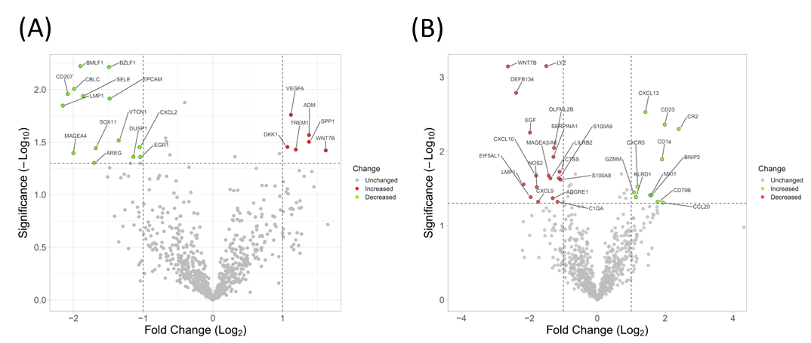
Supplemental Figure 1. Differential expression of genes between groups. (A) Volcano plot showing genes upregulated or downregulated between favorable (left, green) and unfavorable (right, red) cHL patients (absolute log₂-fold change >1 and a significant FDR (<0.05)). (B) Volcano plot showing differential expressed genes between relapsed (left, red) and non-relapsed (right, green) cHL patients (absolute log₂-fold change >1 and a significant FDR (<0.05)). Both were generated using the VolcaNoseR open-source website (https://huygens.science.uva.nl/VolcaNoseR/).

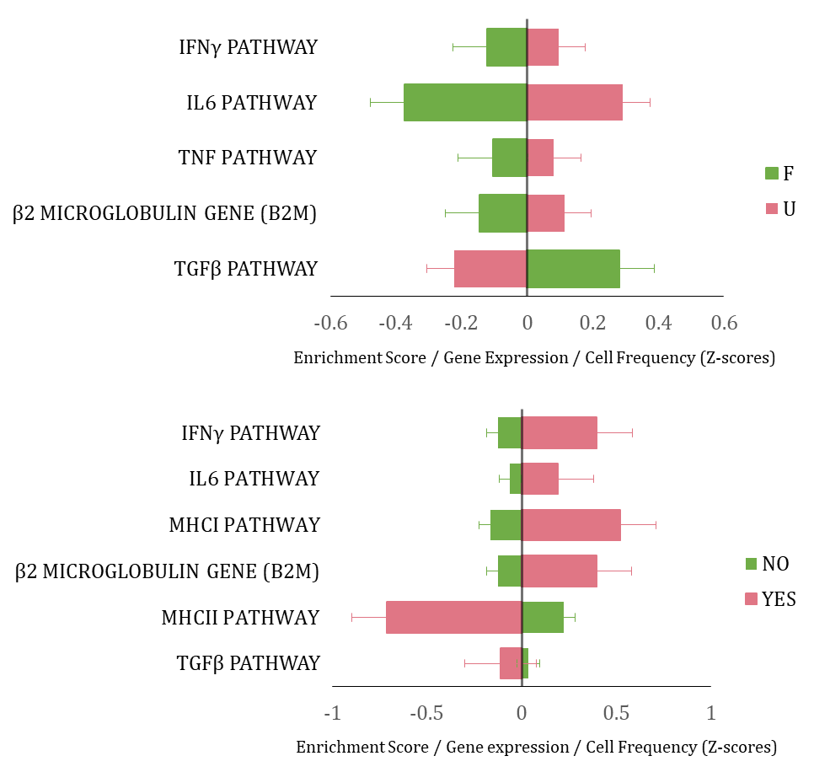
Supplemental Figure 2. Bar graphs of inflammation balance and MHC molecules. Above, comparison of enrichment scores, gene-expression values, or cell frequencies in favorable and unfavorable patient groups. Below, comparison of patients who relapsed (YES) and who did not (NO). Values are represented as Z-scores for ease of comparison (mean subtracted from value, divided by standard deviation of that element). Variables are enriched in the group of patients with a positive score.
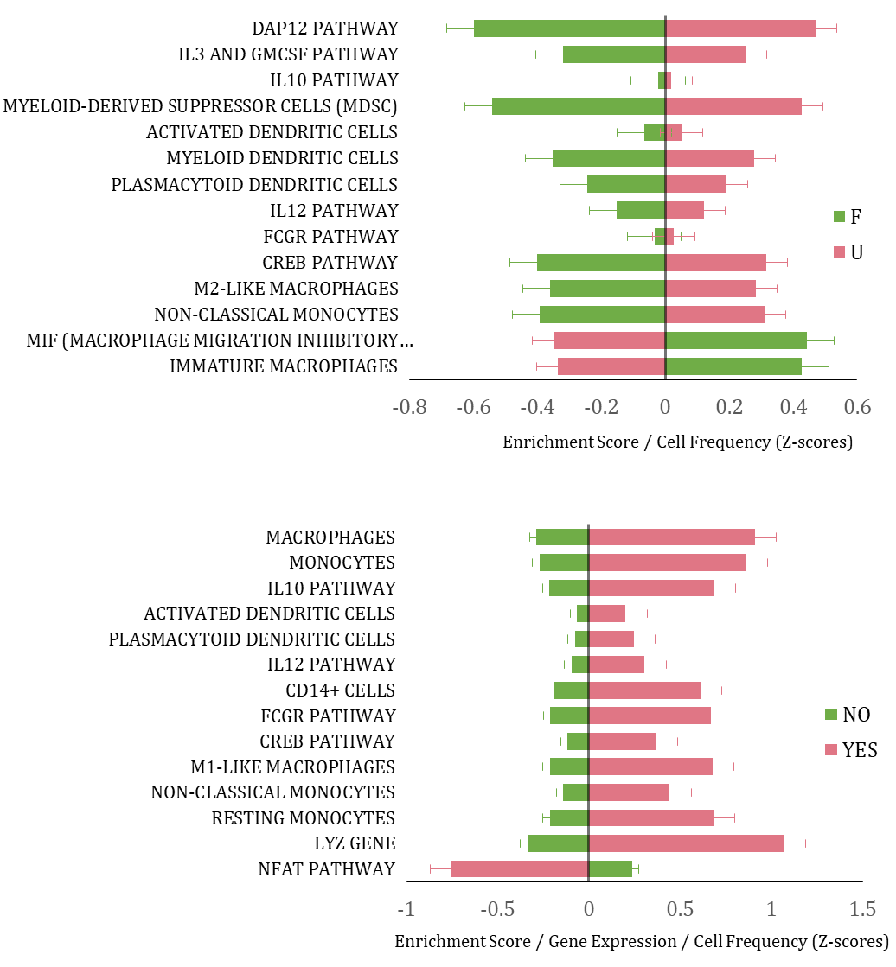
Supplemental Figure 3. Bar graphs of myeloid cells. Above, comparison of enrichment scores, gene-expression values, and cell frequencies for favorable and unfavorable patient groups. Below, comparison of patients who relapsed (YES) and who did not (NO). Values are represented as Z-scores for ease of comparison (mean subtracted from value, divided by standard deviation of that element). Variables are enriched in the group of patients with a positive score.
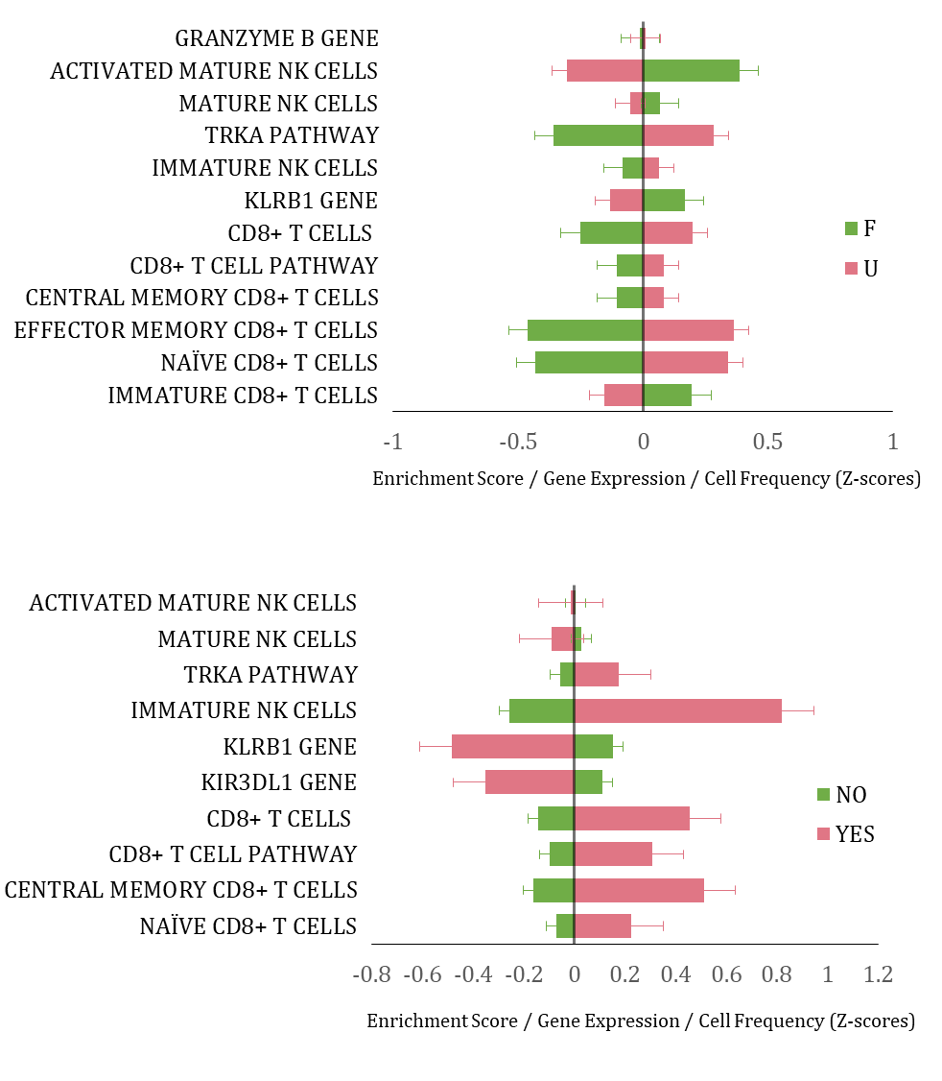
Supplemental Figure 4. Bar graphs for cytotoxic cells. Above, comparison of enrichment scores, gene-expression values, and cell frequency in favorable and unfavorable patients. Below, comparison of patients who relapse (YES) and who do not (NO). Values are represented as Z-scores for ease of comparison (mean subtracted from value, divided by standard deviation of that element). Variables are enriched in the group of patients with a positive score.
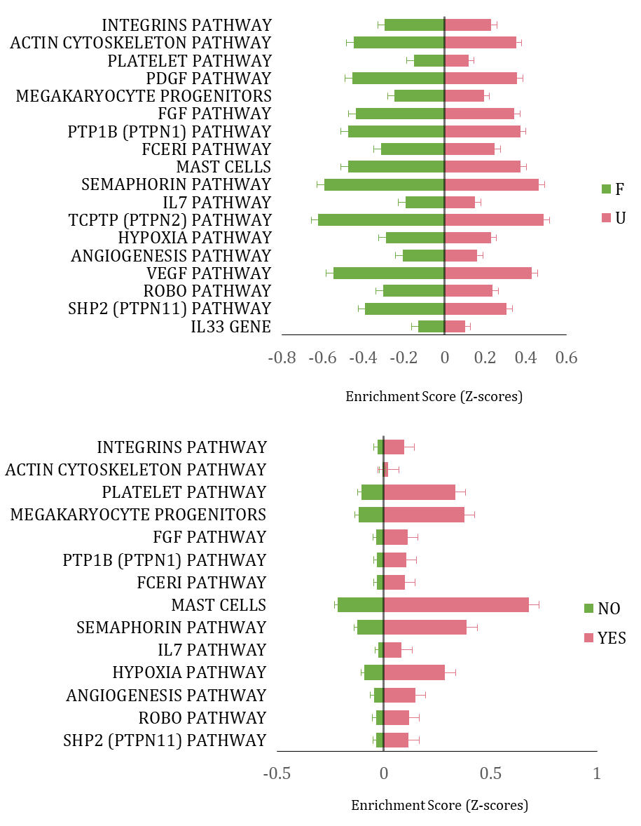
Supplemental Figure 5. Bar graphs of stromal components. Above, comparison of enrichment scores, gene-expression values, and cell frequencies between favorable and unfavorable patients. Below, comparison of patients who relapsed (YES) and who did not (NO). Values are represented as Z-scores for ease of comparison (mean subtracted from value, divided by the standard deviation of that element). Variables are enriched in the group of patients with a positive score.
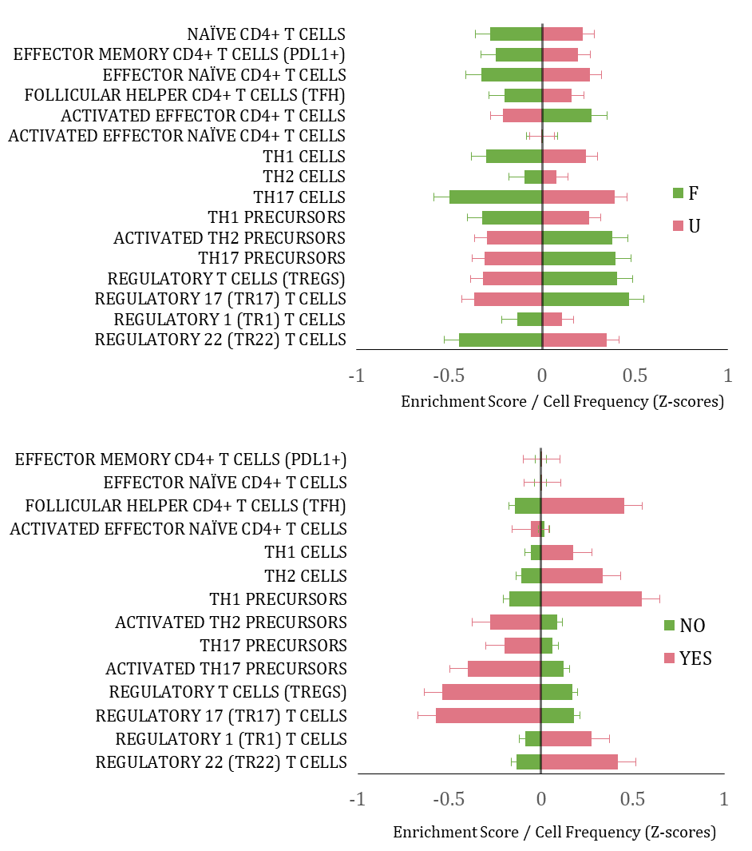
Supplemental Figure 6. Bar graphs of CD4+ T cells. Above, comparison of enrichment scores, gene-expression values, and cell frequencies of favorable and unfavorable patients. Below, comparison of patients who relapsed (YES) and who did not (NO). Values are represented as Z-scores for ease of comparison (mean subtracted from value, divided by standard deviation of that element). Variables are enriched in the group of patients with a positive score.
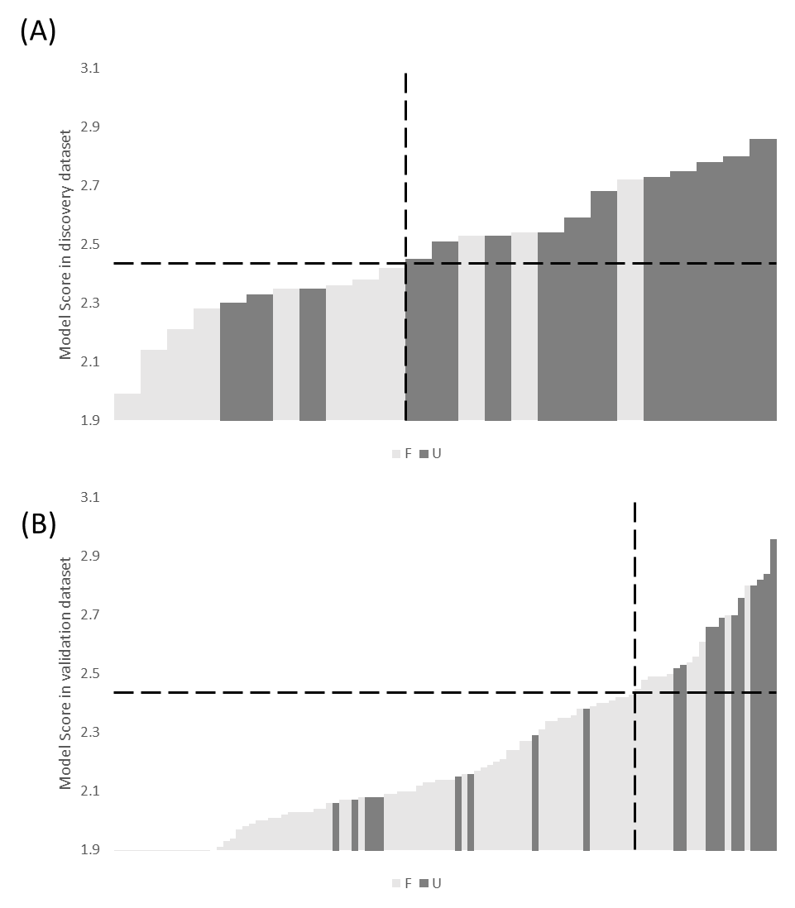
Supplemental Figure 7. Representation of model scores for discovery and validation datasets. Each column represents a single patient from the discovery (A) or validation (B) cohort, arranged in ascending order of score (left to right). The vertical dotted line divides patients into low- and high-risk groups according to the threshold predictor score, which was determined in the discovery cohort using ROC curves.

