Comparative analysis of SPL transcription factors from streptophyte algae and embryophytes reveals evolutionary trajectories of SPL family in streptophytes
Alisha Alisha, Zofia Szweykowska-Kulinska, Izabela Sierocka*
Department of Gene Expression, Institute of Molecular Biology and Biotechnology, Faculty of Biology, Adam Mickiewicz University, Poznan, Poland, Uniwersytetu Poznanskiego 6, 61-614 Poznan, Poland
*Correspondence: Izabela Sierocka, izapaste@amu.edu.pl

Supplementary Figures

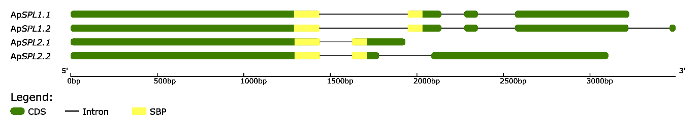
Supplementary Figure 1 Diagram of exon-intron organization of ApSPL1 and ApSPL2 gene transcript isoforms from hornwort Anthoceros punctatus. The gene structures were analyzed using gene structure display server 2.0 ⁵³ and grouped based on their phylogenetic relationships. In each gene model, exons are shown as green boxes, introns as black lines and SBP-box as yellow rectangular shading. The scale shown at the bottom represents gene lengths in base pairs.
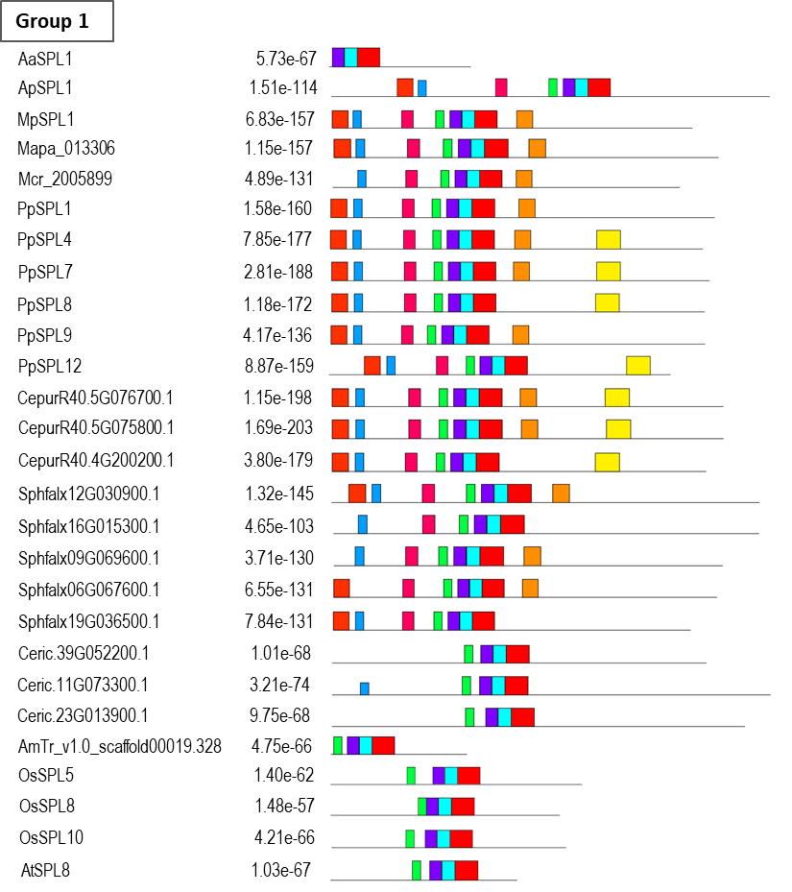

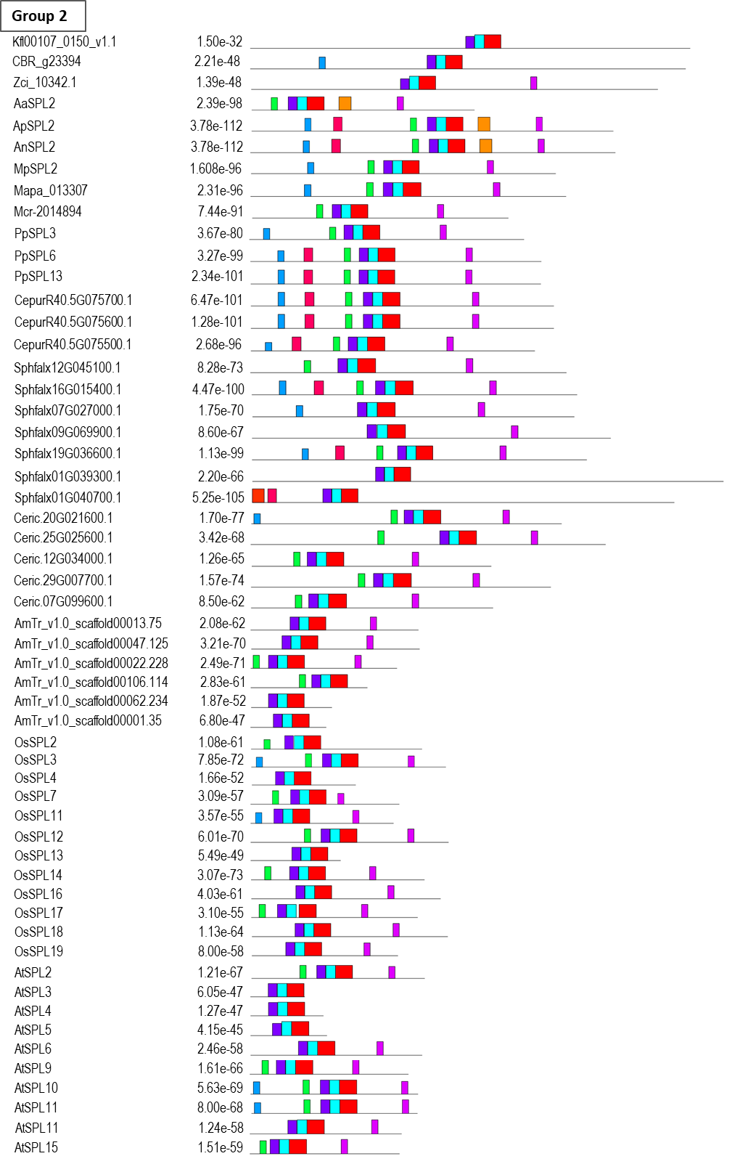
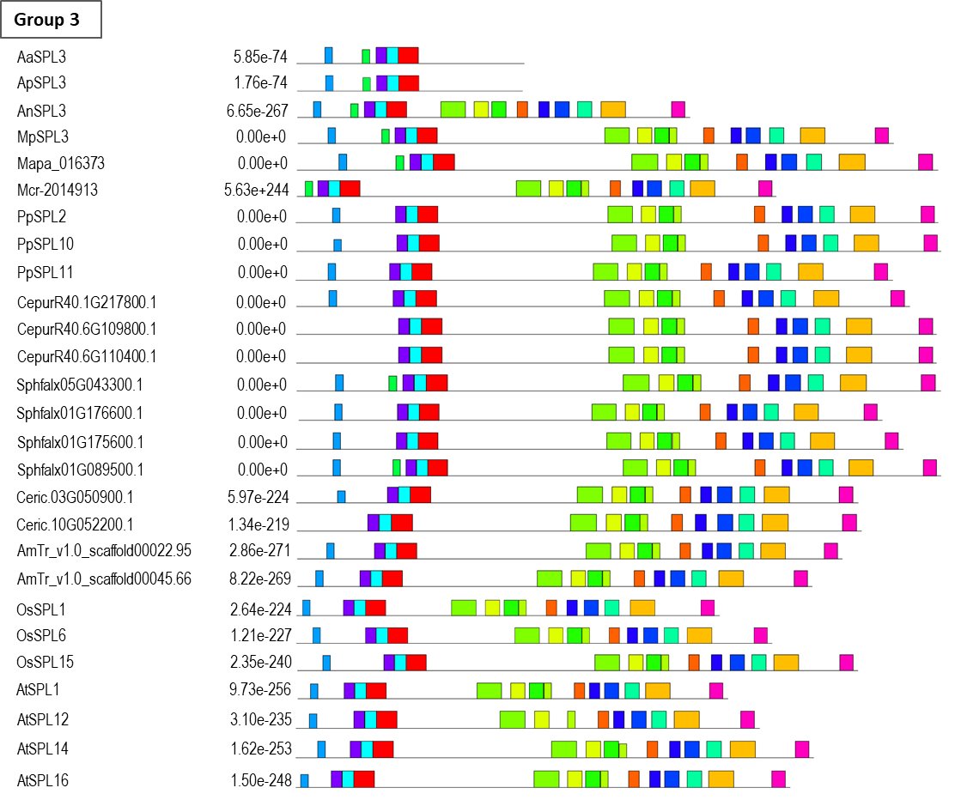
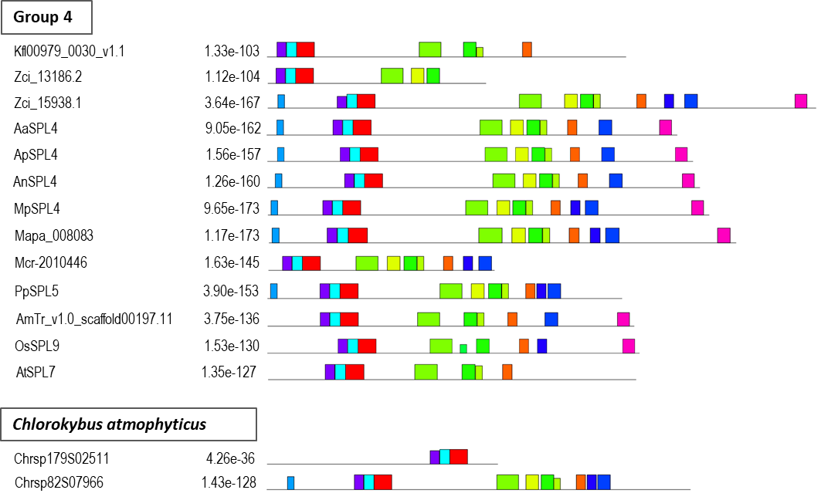
Supplementary Figure 2 Conserved motifs in SPL proteins from representatives of streptophytes algae (Chlorokybus atmophyticus, Klebsormidium nitens, Chara braunii and, Zygnema circumcarinatum), liverworts (Marchantia polymorpha, Marchantia paleacea and, Metzgeria crassipilis), mosses (Physcomitrium patens, Ceratodon purpureus and, Sphagnum fallax), hornworts (Anthoceros angustus, Anthoceros agrestis and, Anthoceros punctatus), fern (Ceratopteris richardii) and, angiosperms (Amborella trichopoda, Arabidopsis thaliana and, Oryza sativa). The SPL proteins are clustered into individual groups according to phylogenetic tree in Figure 1. The motif search was performed using MEME online tool ⁵⁴ with full length protein sequences as a query. SPL proteins are grouped according to their phylogenetic relationships. Different motifs are represented with colors shown in the legend. Motifs 1, 2 and 4 with red, blue and violet color denote SBP-box domain which is conserved amongst all SPL proteins. The consensus sequence of each motif is presented in Table S3.

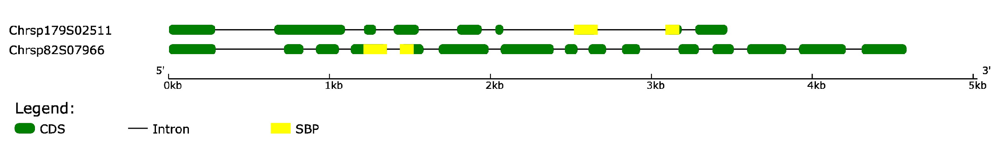
Supplementary Figure 3: Diagram of exon-intron organization of the SPL gene family from streptophytes alga Chlorokybus atmophyticus. The gene structures were analyzed using gene structure display server 2.0 ⁵³ and grouped based on their phylogenetic relationships. In each gene model, exons are shown as green boxes, introns as black lines and SBP-box as yellow rectangular shading. The scale shown at the bottom represents gene lengths in base pairs.

