Table S1. Ligands used to build atom-based 3D-QSAR model.
Sr No. | Structure | IC50 (µM) | pIC50 | Predicted Activity^{5#} | QSAR Set
1 | 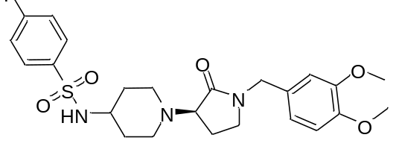 | 0.01 | 8 | 8.06398 | training
2 | 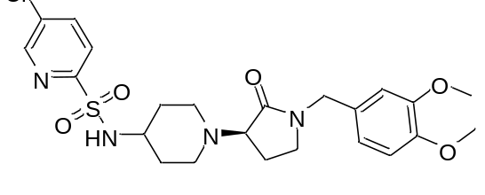 | 0.01 | 8 | 7.99922 | training
3 | 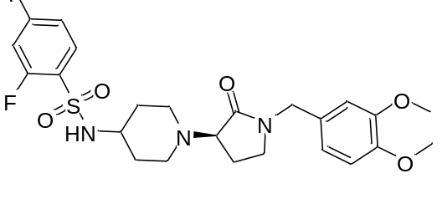 | 0.01 | 8 | 7.94539 | training
4 | 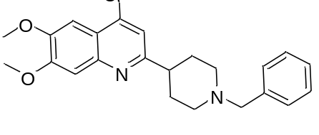 | 0.02 | 7.698 | 7.62048 | training
5 | 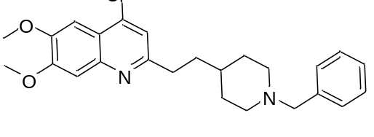 | 0.02 | 7.698 | 7.73745 | training
6 | 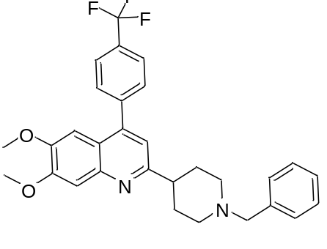 | 0.01 | 8 | 7.64993 | test
7 | 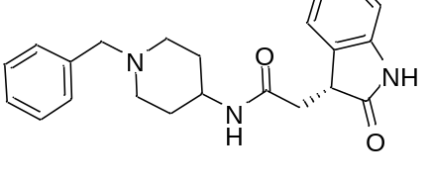 | 0.01 | 8 | 7.965 | training
8 | 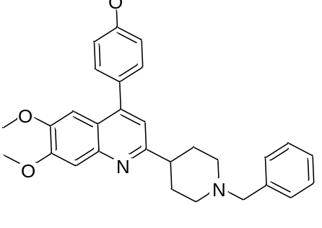 | 0.01 | 8 | 8.04471 | training
9 | 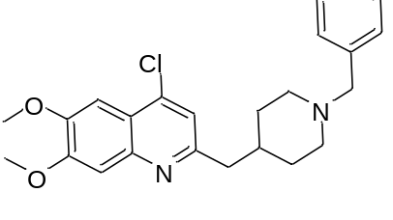 | 0.01 | 8 | 7.41003 | test
10 | 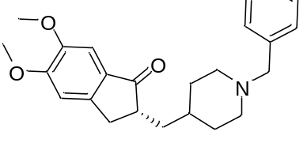 | 0.02 | 7.698 | 7.69582 | training
11 | 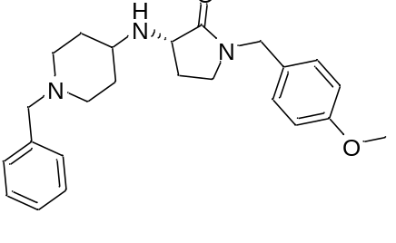 | 0.021 | 7.677 | 7.68039 | training
12 | 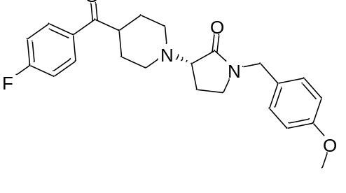 | 0.018 | 7.744 | 7.76021 | training
13 | 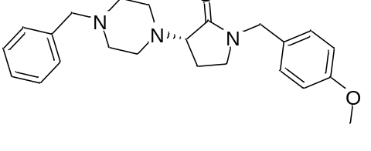 | 0.031 | 7.508 | 7.57701 | training
14 | 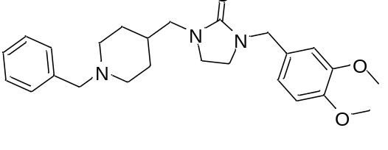 | 0.033 | 7.481 | 7.47479 | training
15 | 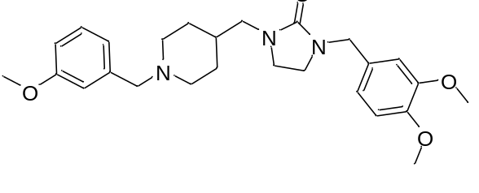 | 0.022 | 7.657 | 7.63978 | training
16 | 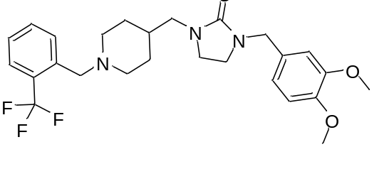 | 0.022 | 7.657 | 7.62639 | training
17 | 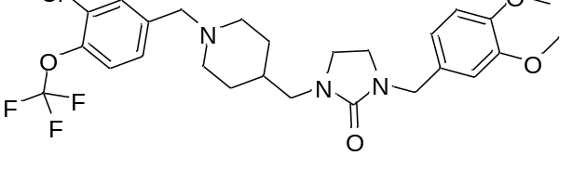 | 0.02 | 7.698 | 7.14356 | test
18 | 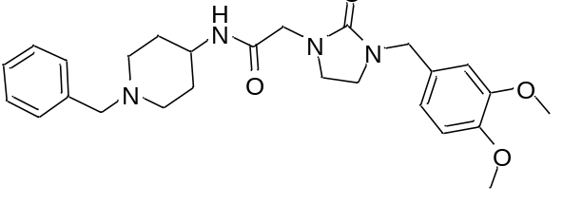 | 0.028 | 7.552 | 7.54925 | training
19 | 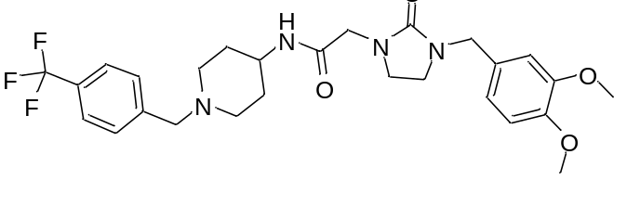 | 0.024 | 7.619 | 7.11666 | test
20 | 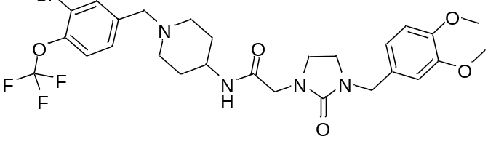 | 0.029 | 7.537 | 7.49424 | training
21 | 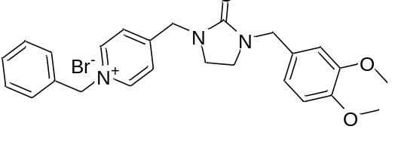 | 0.026 | 7.585 | 7.57198 | training
22 | 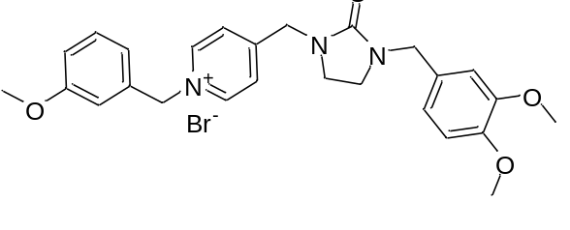 | 0.022 | 7.657 | 7.64554 | training
23 | 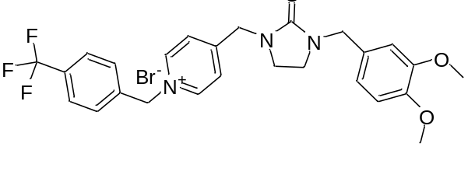 | 0.032 | 7.494 | 6.90264 | test
24 | 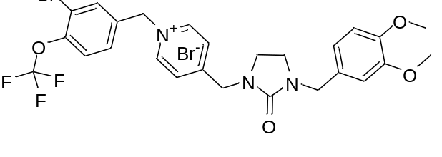 | 0.022 | 7.657 | 7.62433 | training
25 | 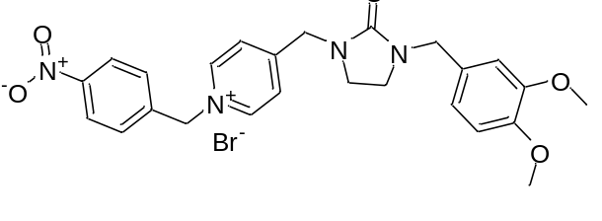 | 0.026 | 7.585 | 7.59545 | training
26 | 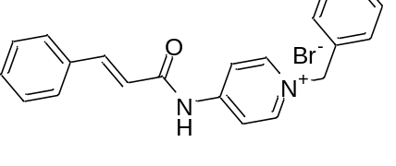 | 0.054 | 7.267 | 7.1272 | training
27 | 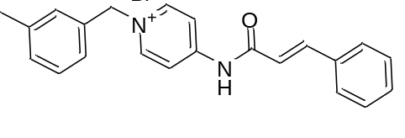 | 0.102 | 6.991 | 7.03315 | training
28 | 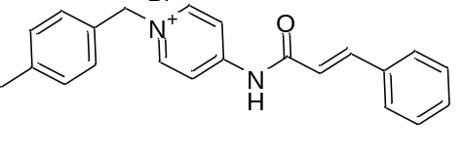 | 1.263 | 5.898 | 6.07613 | training
29 | 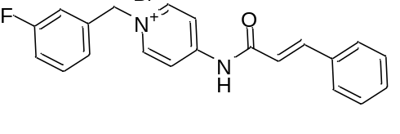 | 0.093 | 7.031 | 7.06098 | training
30 | 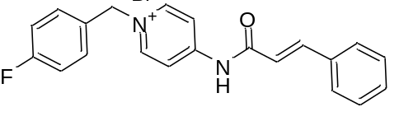 | 0.09 | 7.045 | 7.13554 | training
31 | 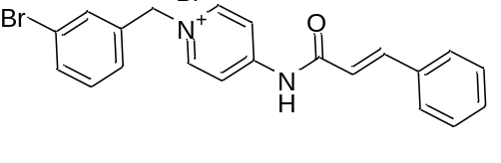 | 0.153 | 6.815 | 6.84613 | training
32 | 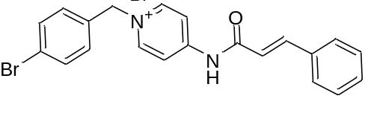 | 1.45 | 5.838 | 5.98601 | training
33 | 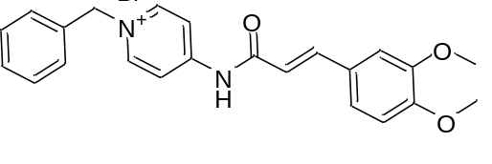 | 0.135 | 6.869 | 7.32123 | test
34 | 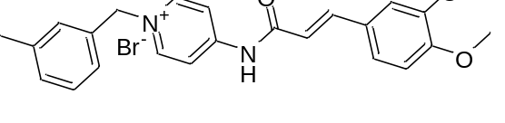 | 0.051 | 7.292 | 7.33838 | training
35 | 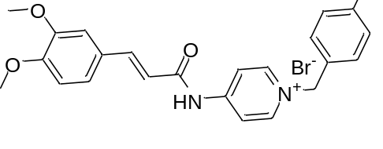 | 0.09 | 7.045 | 7.03365 | training
36 | 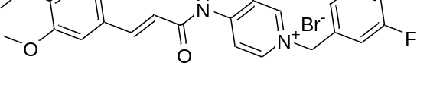 | 0.02 | 7.698 | 7.67656 | training
37 | 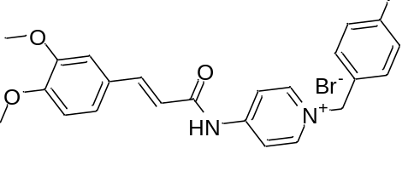 | 0.012 | 7.92 | 7.91211 | training
38 | 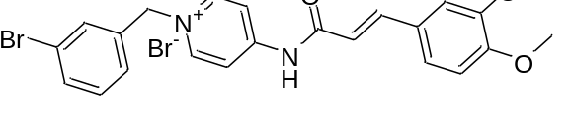 | 0.092 | 7.036 | 7.43082 | test
39 | 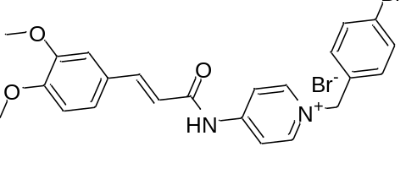 | 0.05 | 7.301 | 7.25511 | training
40 | 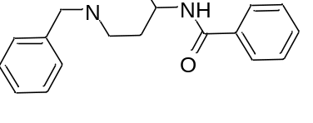 | 76.6 | 4.115 | 4.02132 | training
41 | 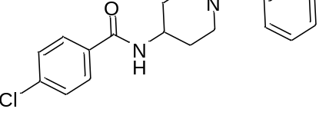 | 80.7 | 4.093 | 4.12072 | training
42 | 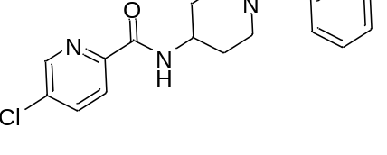 | 9.95 | 5.002 | 5.00457 | test
43 | 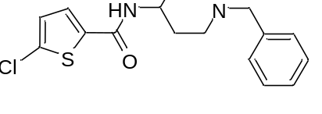 | 23.6 | 4.627 | 4.53798 | training
44 | 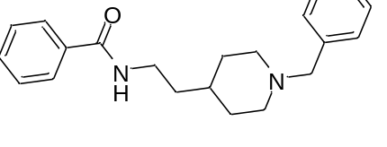 | 1.51 | 5.821 | 6.37497 | test
45 | 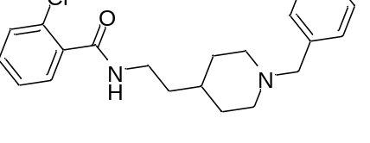 | 1.86 | 5.73 | 5.66626 | training
46 | 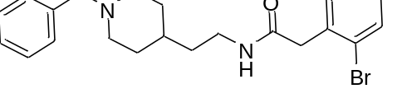 | 8.23 | 5.084 | 5.21304 | training
47 | 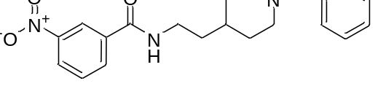 | 0.298 | 6.525 | 6.59317 | training
48 | 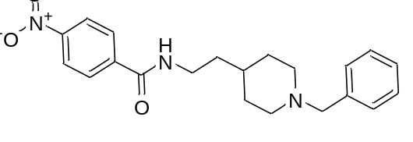 | 0.123 | 6.91 | 6.76488 | training
49 | 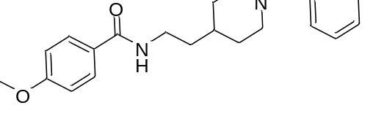 | 0.662 | 6.179 | 6.13653 | training
50 | 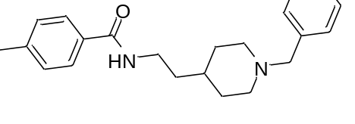 | 1.45 | 5.838 | 5.97626 | training
51 | 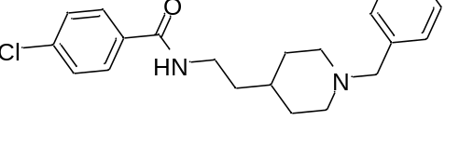 | 0.378 | 6.422 | 6.29748 | training
52 | 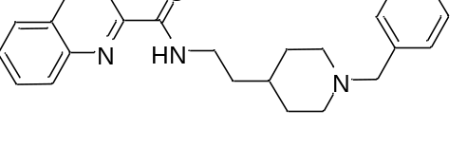 | 0.174 | 6.759 | 6.65229 | test
53 | 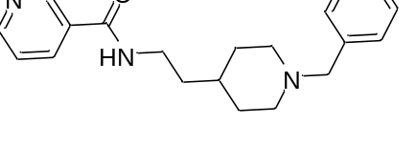 | 0.791 | 6.101 | 6.01459 | training
54 | 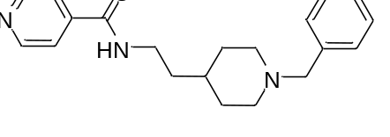 | 0.34 | 6.468 | 6.42404 | test
55 | 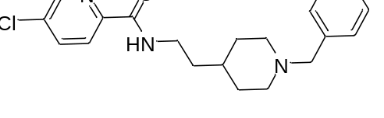 | 0.22 | 6.657 | 6.50955 | training
56 | 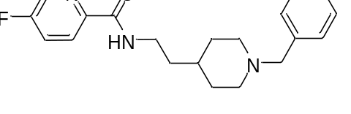 | 0.502 | 6.299 | 6.50145 | training
57 | 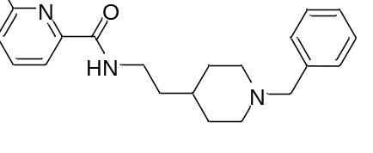 | 0.434 | 6.362 | 6.64132 | test
58 | 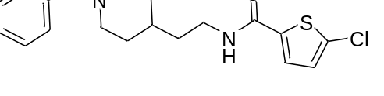 | 0.269 | 6.57 | 6.34762 | training
59 | 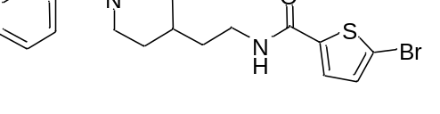 | 0.768 | 6.114 | 6.34259 | training
60 | 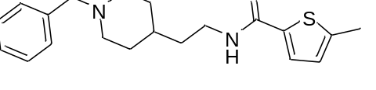 | 1.55 | 5.809 | 5.76921 | training
#Predicted activity has been shown for PLS (partial least square) factor 5.
Table S2. Docking result of donepezil and compound 9.
S.NO | Compound | XP G score (Kcal/mol) | MM-GBSA dG bind (Kcal/mol) | Interacting residues
1 | Donepezil | -16.126 | -86.39 | PHE295 (H-bond, 2.09), TRP286 (pi-pi), TYR337 (pi cation), PHE338 (pi cation), TRP86 (pi-pi, pi cation)
2 | 9 | -6.288 | -43.06 | TRP286 (pi-pi), TYR337 (pi-pi), TRP86 (pi-pi)

Table S3. Atom-type contribution towards AChE inhibition of the ligands.
# Factors | H-bond donor | Hydrophobic/non-polar | Negative ionic | Positive ionic | Electron-withdrawing
1 | 0.026 | 0.654 | 0.031 | 0.017 | 0.246
2 | 0.029 | 0.63 | 0.033 | 0.019 | 0.258
3 | 0.031 | 0.628 | 0.034 | 0.019 | 0.259
4 | 0.031 | 0.629 | 0.035 | 0.02 | 0.256
5 | 0.032 | 0.626 | 0.037 | 0.021 | 0.257

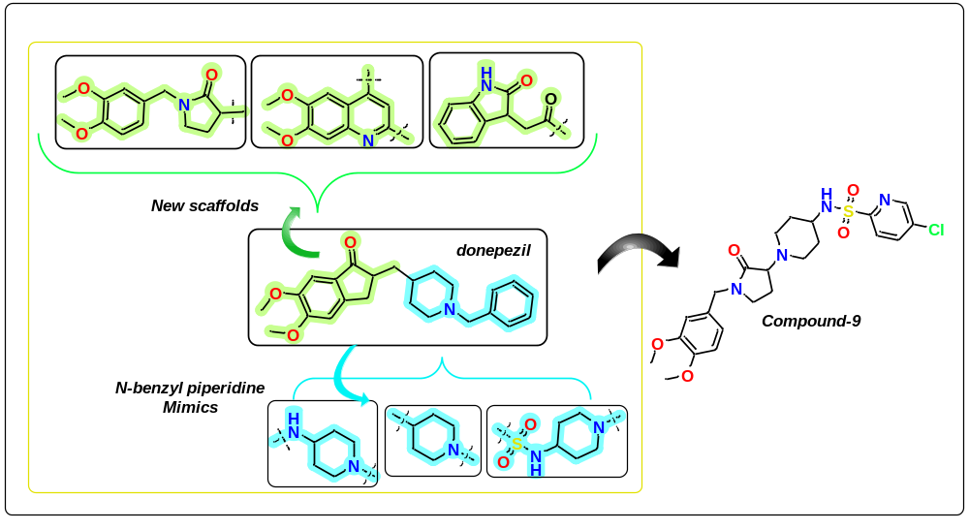
Fig. S1. Design strategy employed to get novel donepezil-based derivatives.
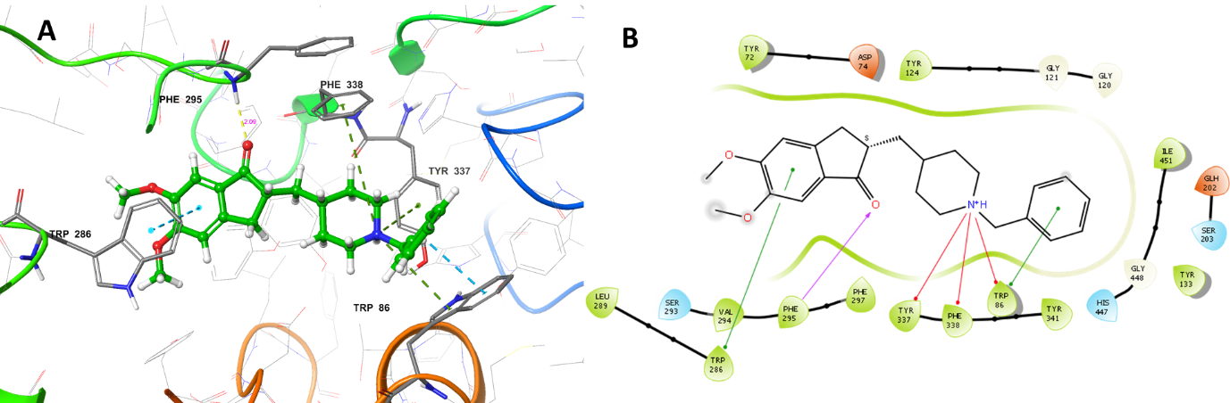
Fig. S2. Ligand interaction diagrams. (a) 3D interaction diagram of Donepezil (b) 2D interaction diagram of Donepezil
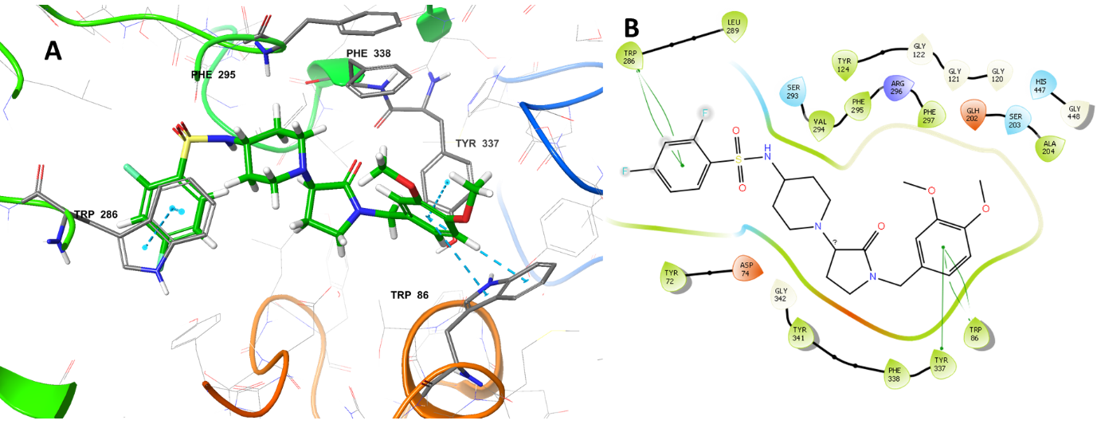
Fig. S3. Ligand interaction diagrams. 3D interaction diagram of compound 9 (d) 2D interaction diagram of compound 9.
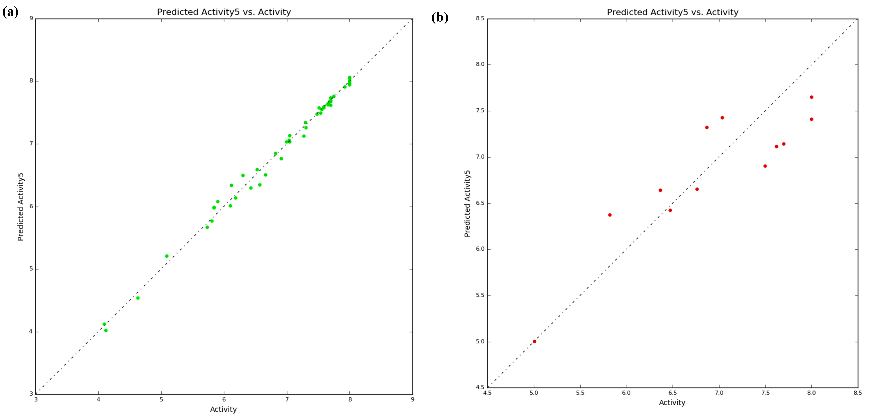
Fig. S4. Linear plot of actual activity vs. predicted activity for PLS factor 5. (a) Training set (b) Test set.

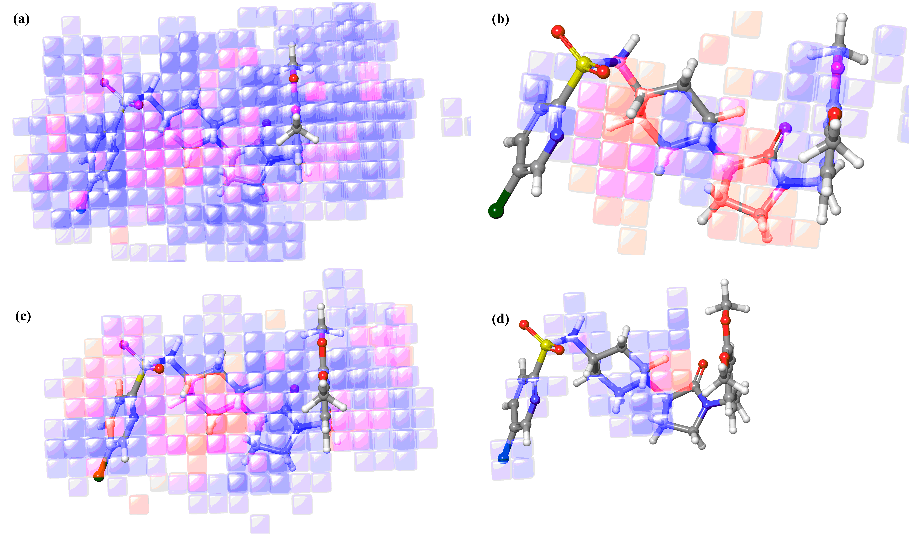
Fig. S5. Atom type contribution for compound 9. (a) Combined effect (b) Electron withdrawing effects (c) Hydrophobic/non-polar (d) H-bond donor effect.

¹H-NMR spectrum of compound-8 in DMSO-d₆
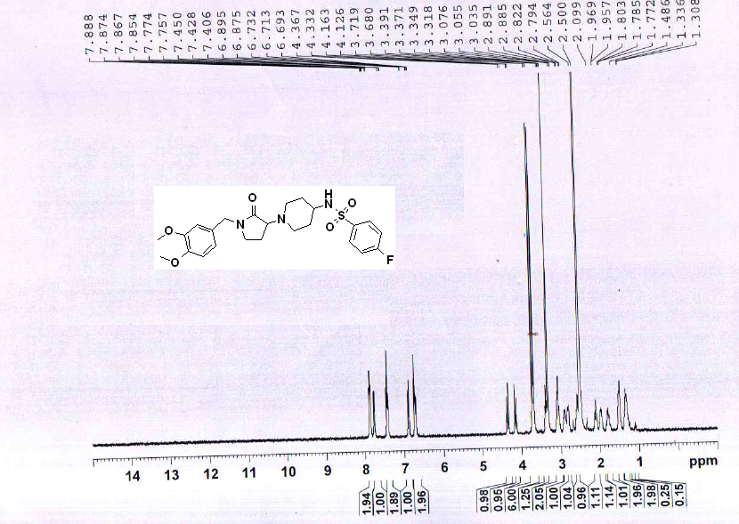
Mass spectrum of Compound-8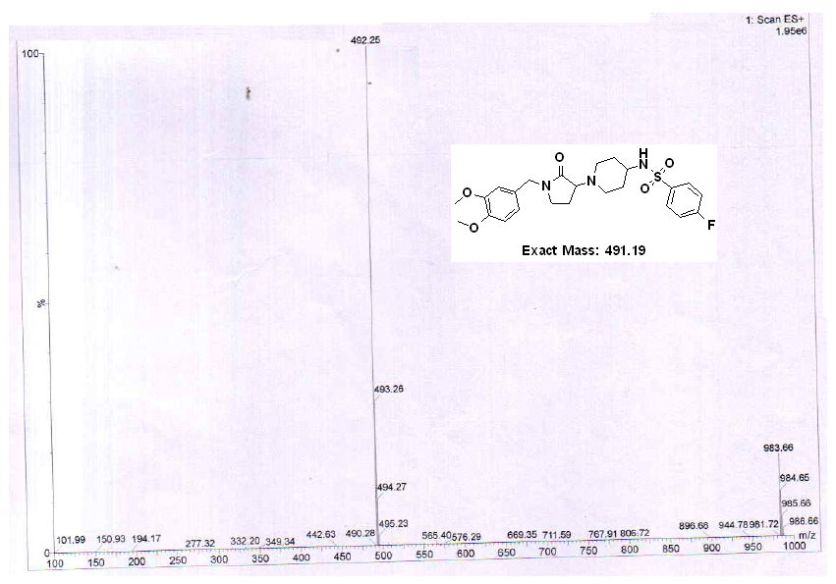
Calculated m/z | 491.19 | Ion formula | C₂₄H₃₀FN₃O₅S | Species | [M+H]⁺
Result type (ESI mode) |  |  | Target m/z
Positive ions |  |  | 492.25

¹H-NMR spectrum of compound-9 in DMSO-d₆
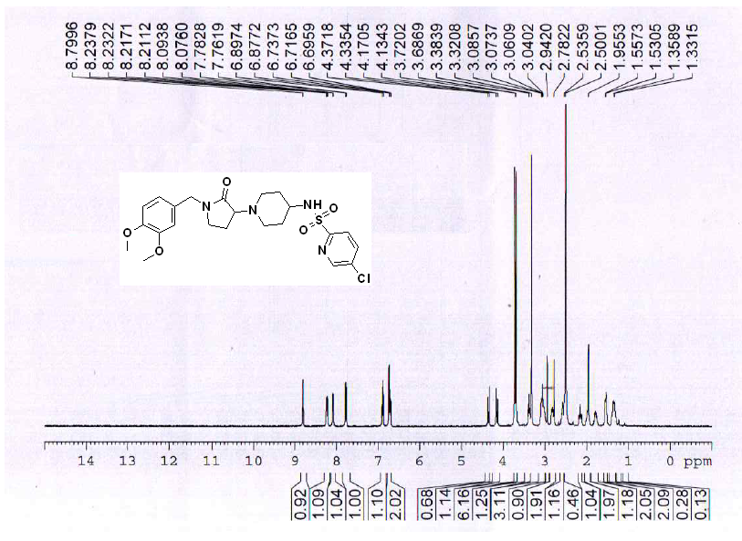
Mass spectrum of Compound-9
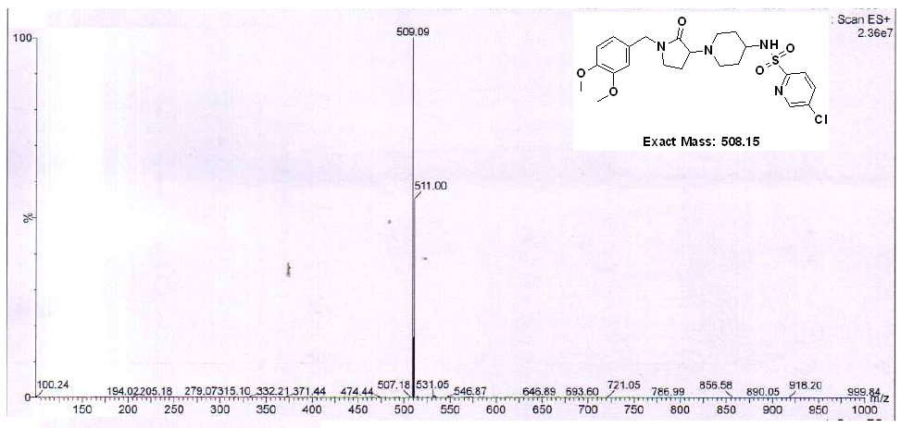
Calculated m/z | 508.15 | Ion formula | C₂₃H₂₉ClN₄O₅S | Species | [M+H]⁺
Result type (ESI mode) |  |  | Target m/z
Positive ions |  |  | 509.09

¹H-NMR spectrum of compound-10 in DMSO-d₆
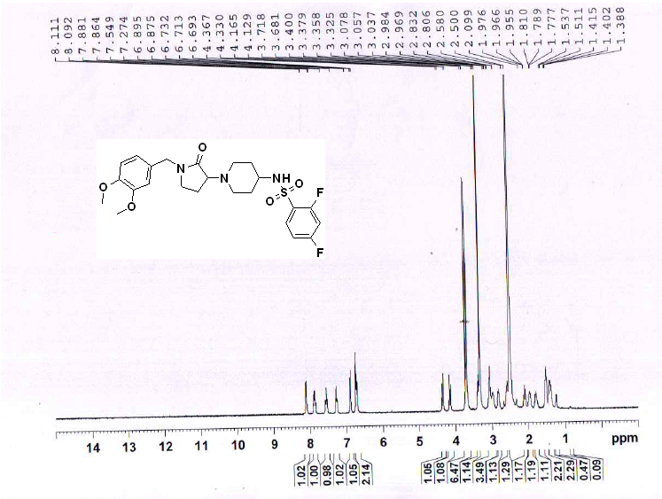
Mass spectrum of Compound-10
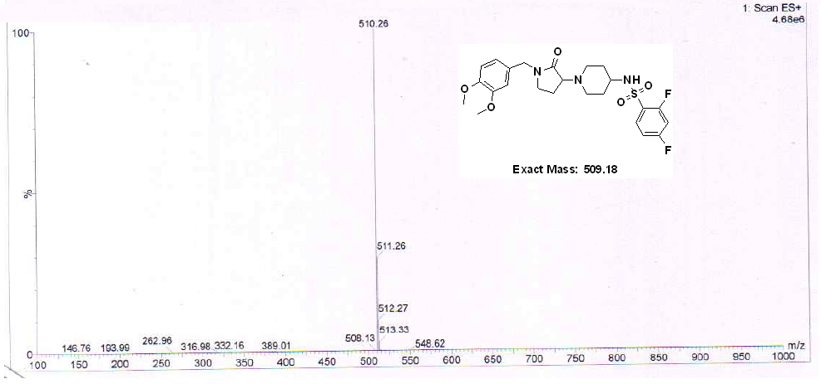
Calculated m/z | 509.18 | Ion formula | C₂₄H₂₉F₂N₃O₅S | Species | [M+H]⁺
Result type (ESI mode) |  |  | Target m/z
Positive ions |  |  | 510.26

¹H-NMR spectrum of compound-15 in DMSO-d₆
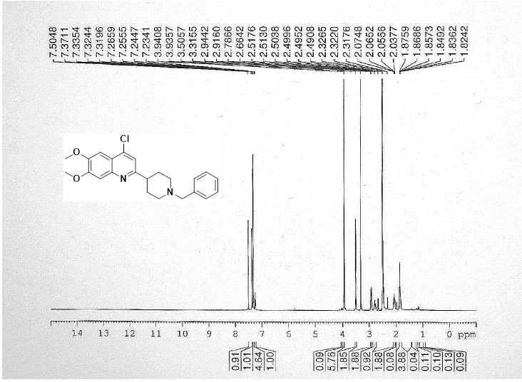
Mass spectrum of Compound-15
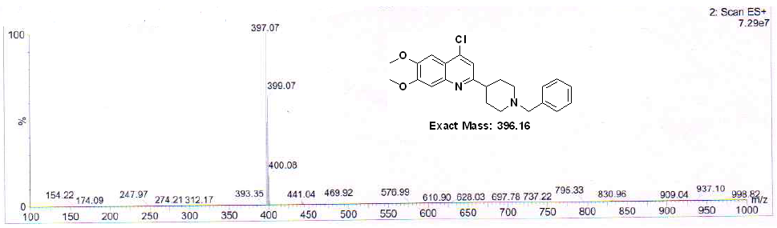
Calculated m/z | 396.16 | Ion formula | C₂₃H₂₅ClN₂O₂ | Species | [M+H]⁺
Result type (ESI mode) |  |  | Target m/z
Positive ions |  |  | 397.07

¹H-NMR spectrum of compound 16 in DMSO-d₆
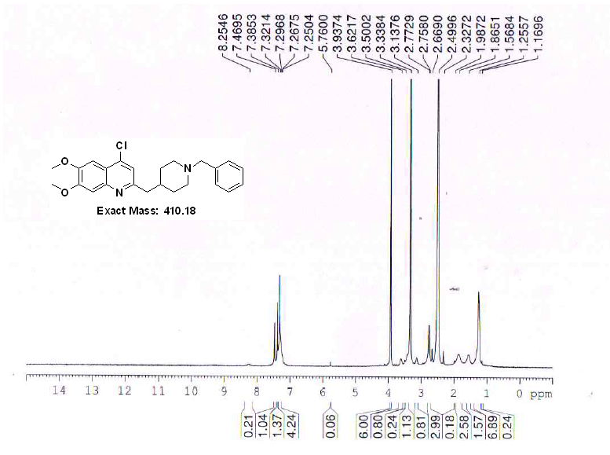
Mass spectrum of Compound-16
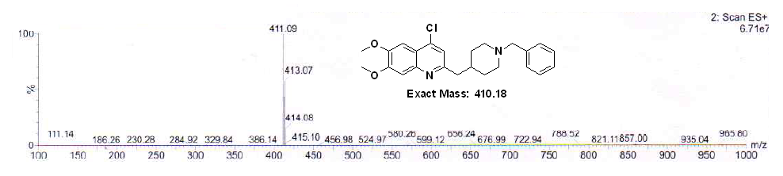
Calculated m/z | 410.18 | Ion formula | C₂₄H₂₇ClN₂O₂ | Species | [M+H]⁺
Result type (ESI mode) |  |  | Target m/z
Positive ions |  |  | 411.09

¹H-NMR spectrum of compound-17 in DMSO-d₆
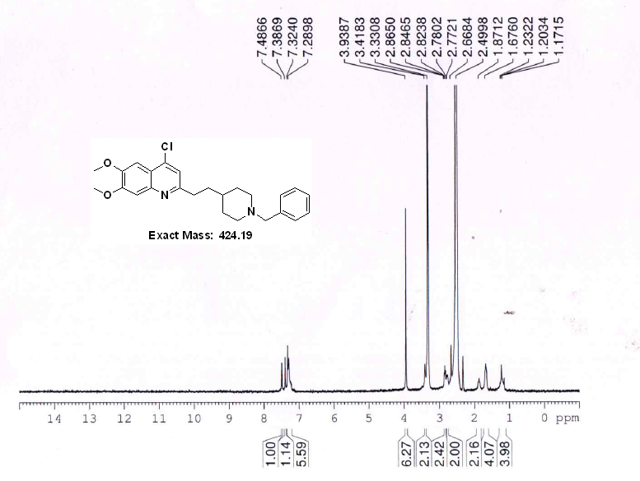
Mass spectrum of Compound-17
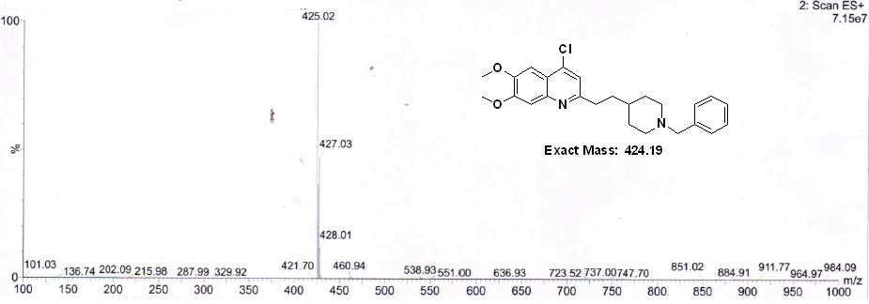
Calculated m/z | 424.19 | Ion formula | C₂₅H₂₉ClN₂O₂ | Species | [M+H]⁺
Result type (ESI mode) |  |  | Target m/z
Positive ions |  |  | 425.02

¹H-NMR spectrum of compound-18 in DMSO-d₆
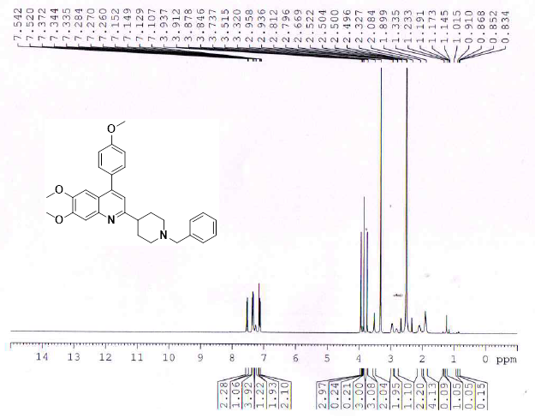
Mass spectrum of Compound-18
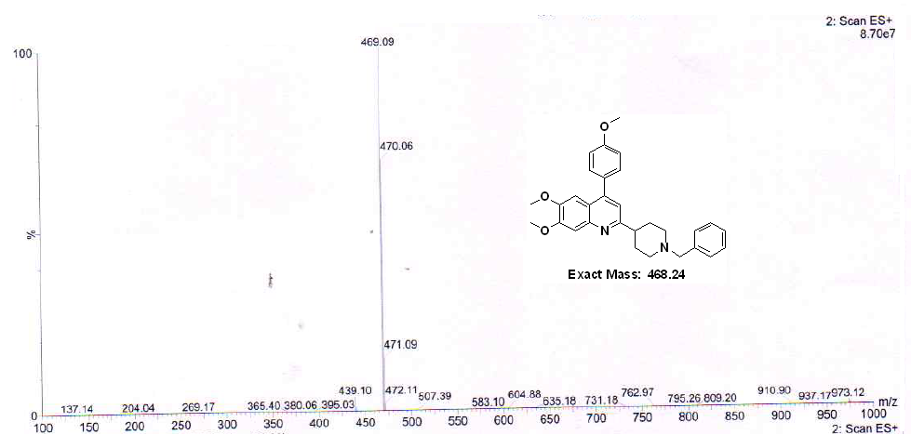
Calculated m/z | 468.24 | Ion formula | C₃₀H₃₂N₂O₃ | Species | [M+H]⁺
Result type (ESI mode) |  |  | Target m/z
Positive ions |  |  | 469.09
¹H-NMR spectrum of compound-19 in DMSO-d₆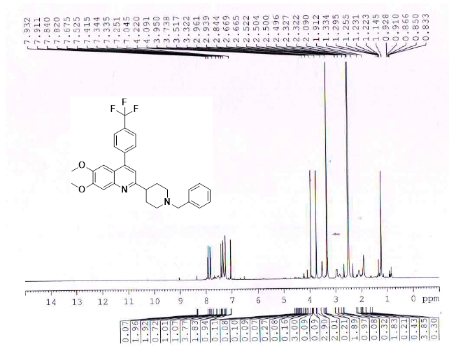
Mass spectrum of Compound-19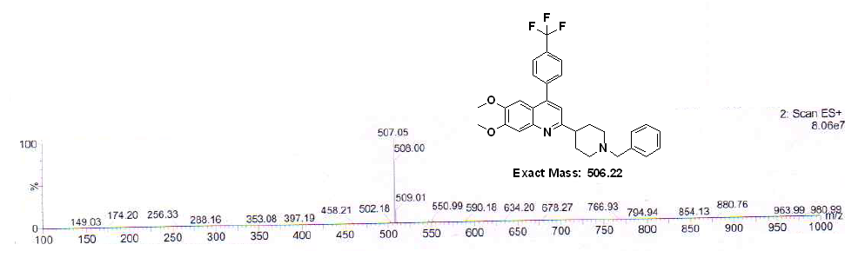
Calculated m/z | 506.22 | Ion formula | C₃₀H₂₉F₃N₂O₂ | Species | [M+H]⁺
Result type (ESI mode) |  |  | Target m/z
Positive ions |  |  | 507.05

¹H-NMR spectrum of compound-23 in DMSO-d₆
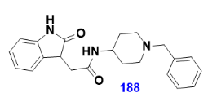
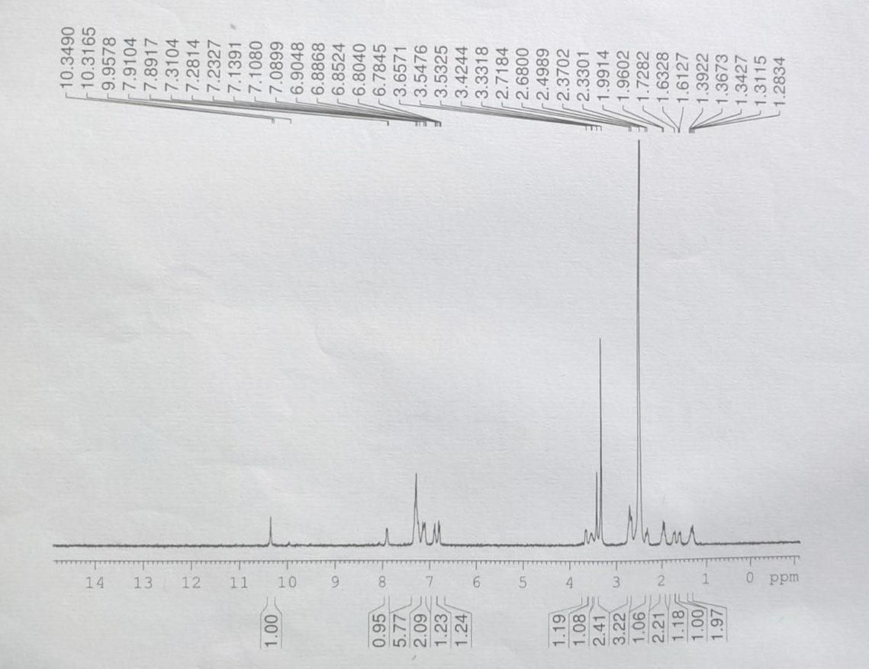
Mass spectrum of Compound-23
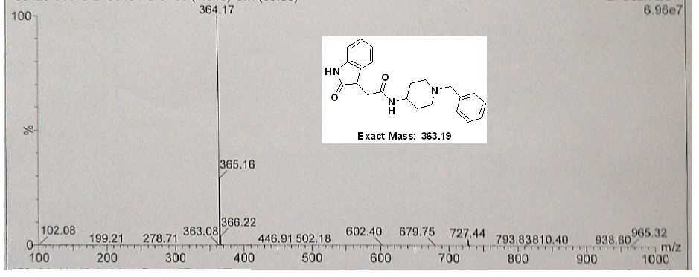
Calculated m/z | 363.19 | Ion formula | C₂₂H₂₅N₃O₂ | Species | [M+H]⁺
Result type (ESI mode) |  |  | Target m/z
Positive ions |  |  | 364.17

