Supporting Material
Multifunctional leather finishing vs. applications, through the addition of well-dispersed flower-like nanoparticles
Francesca Fierro^{a,c°}, Mariagrazia Iuliano^{b,c°}, Claudia Cirillo^{a,c°*}, Claudia Florio^{d}, Gaetano Maffei^{e}, Andrea Loi^{f}, Todor Batakliev^{g}, Renata Adamiª, Maria Sarno^{a,c}
ªDepartment of Physics “E.R. Caianiello”, University of Salerno, Via Giovanni Paolo II, 132 - 84084 Fisciano (SA), Italy
^{b}Department of Industrial Engineering, University of Salerno, Via Giovanni Paolo II, 132 - 84084 Fisciano (SA), Italy
^{c}Centre NANO_MATES, University of Salerno Via Giovanni Paolo II, 132 - 84084 Fisciano (SA), Italy
^{d}Stazione Sperimentale per l'Industria delle Pelli e delle materie concianti - SSIP (Italian National Leather Research Institute), Comprensorio Olivetti, Via Campi Flegrei, 34 - 80078 Pozzuoli (NA), Italy
^{e} Conceria DMD SOLOFRA Spa, Via Celentane, 9 - 83029 Solofra (AV) - Italy
^{f} Mario Levi Italia s.r.l., Via Arzignano, 130 - 36072 CHIAMPO (VI) - Italy
^{g}Open Laboratory on Experimental Micro and Nano Mechanics (OLEM), Institute of Mechanics, Bulgarian Academy of Sciences, Acad. G. Bonchev Str., Block 4, 1113 Sofia - Bulgaria
°These authors contribute equally
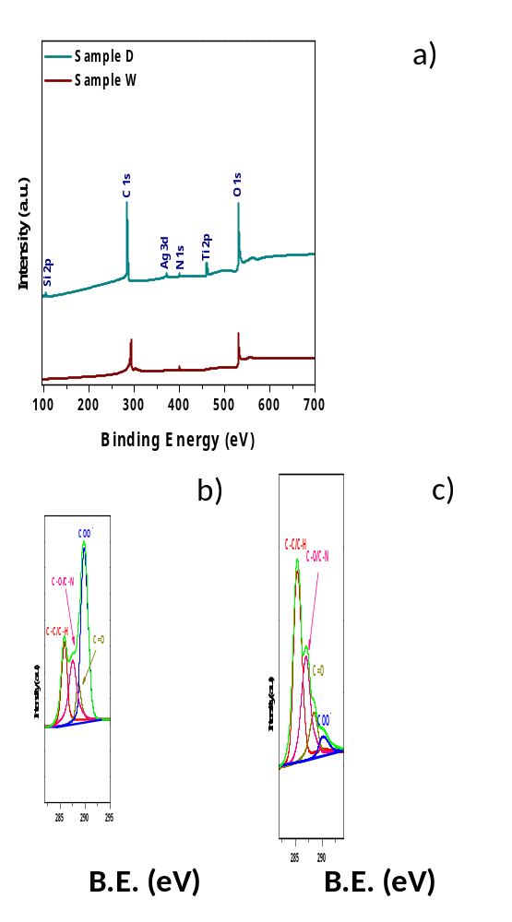
Figure S1 XPS wide scan spectra of sample W and D; High-resolution XPS spectra of C 1s for sample W (b) and sample D (c).

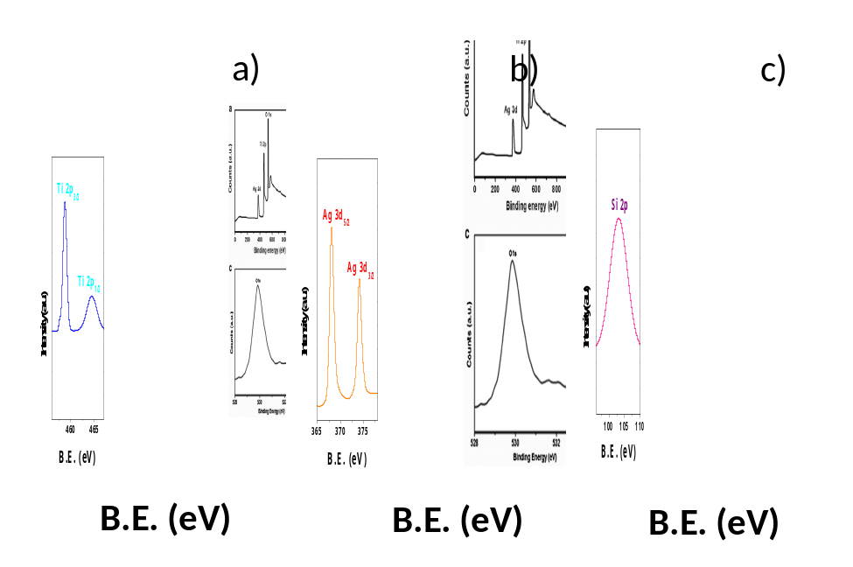
Figure S2 High-resolution XPS spectra of Ti (a); Ag (b); and Si (c) for Sample D.

