FLUORESCENT POLYMER AS A BIOSENSING TOOL FOR THE DIAGNOSIS OF MICROBIAL PATHOGENS

Selvi Krishnanª, Stephen Joseª, K Periyasamy Bhuvana ^{a*}, Angayarkanny S^{b}, and Joseph Bensingh Rª
ªCentral Institute of Petrochemical Engineering and Technology, Chennai, India.
^{b}Department of Chemistry, Anna University, Chennai, India.
*Email: kpusha27@gmail.com
Figure S1:

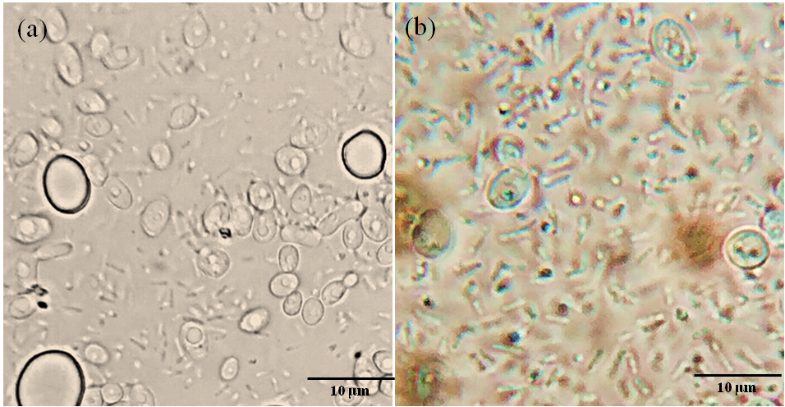
Fig S1: The microscopic examination (100x) of interaction of multimicrobial population of E. coli, S. aureus, and C. albicans without (a) and with (b) optimized MEH-PPV solution (3mg/mL).

Figure S2:

Fig S2: The microscopic examination (100x) of E. coli after incubating with 3mg/mL solution of MEH-PPV. Fig S2 (a) depicts the highest concentration of E. coli cells that is upto 10⁵ CFU/mL and Fig S2 (b) represents the lowest concentration of 10 CFU/mL.

