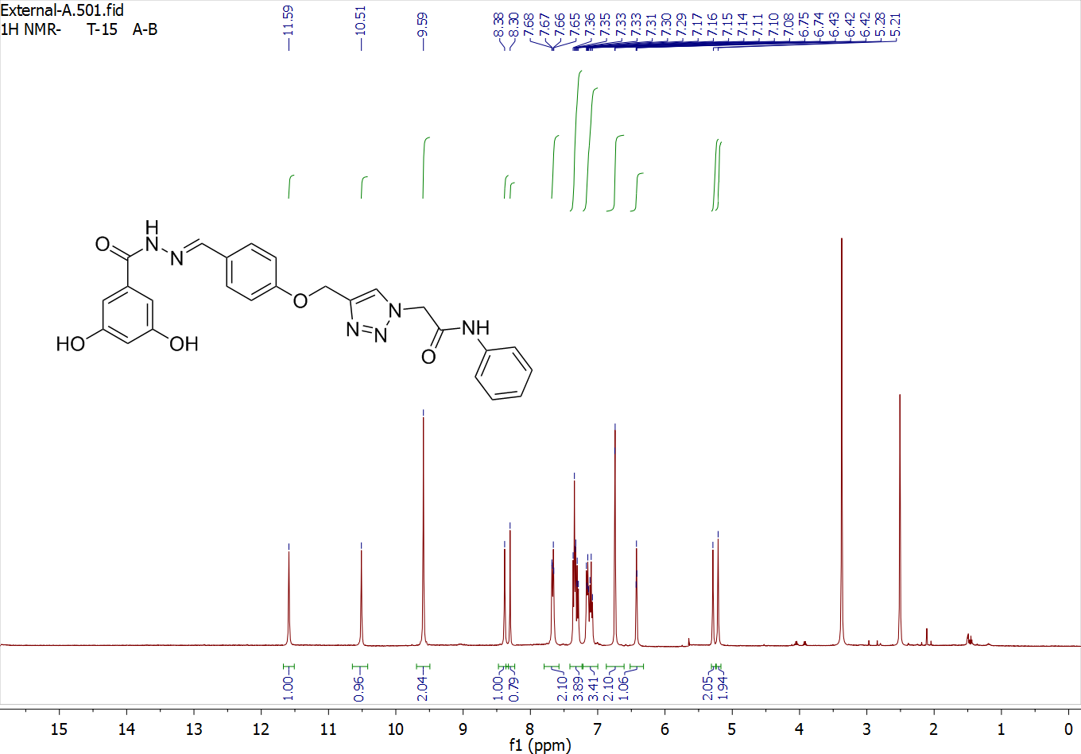
Fig. S1. ¹H-NMR of 11a
Fig. S2. ¹³C-NMR of 11a

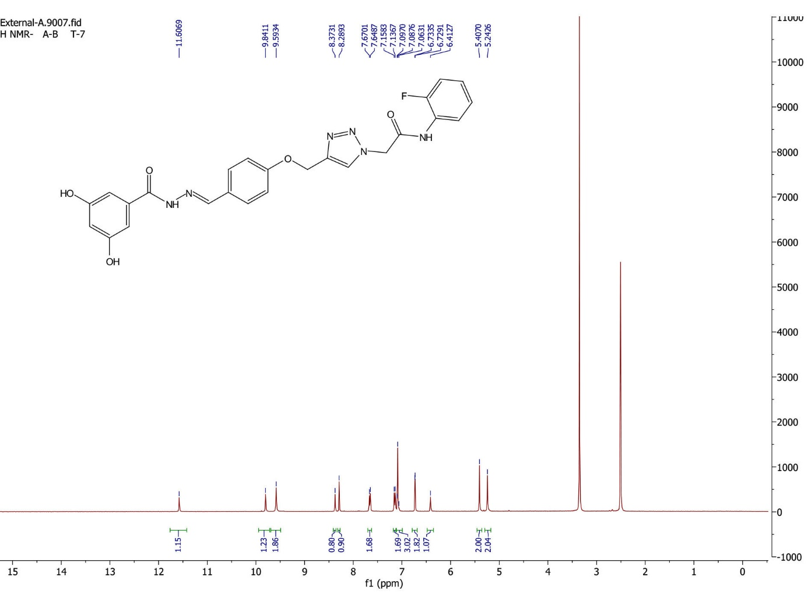
Fig. S3. ¹H-NMR of 11b

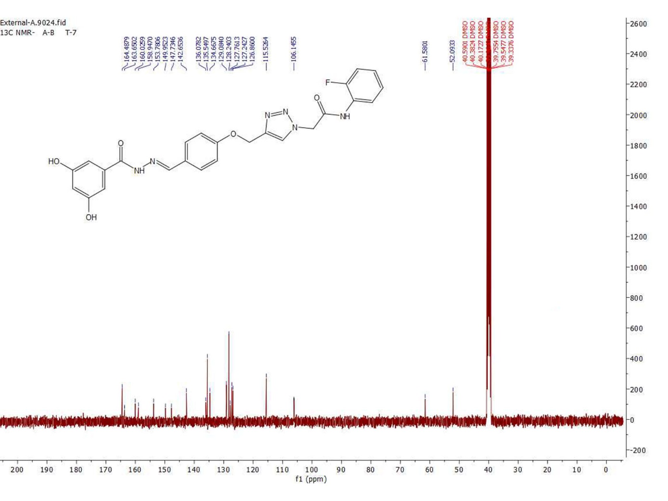
Fig. S4. ¹³C-NMR of 11b

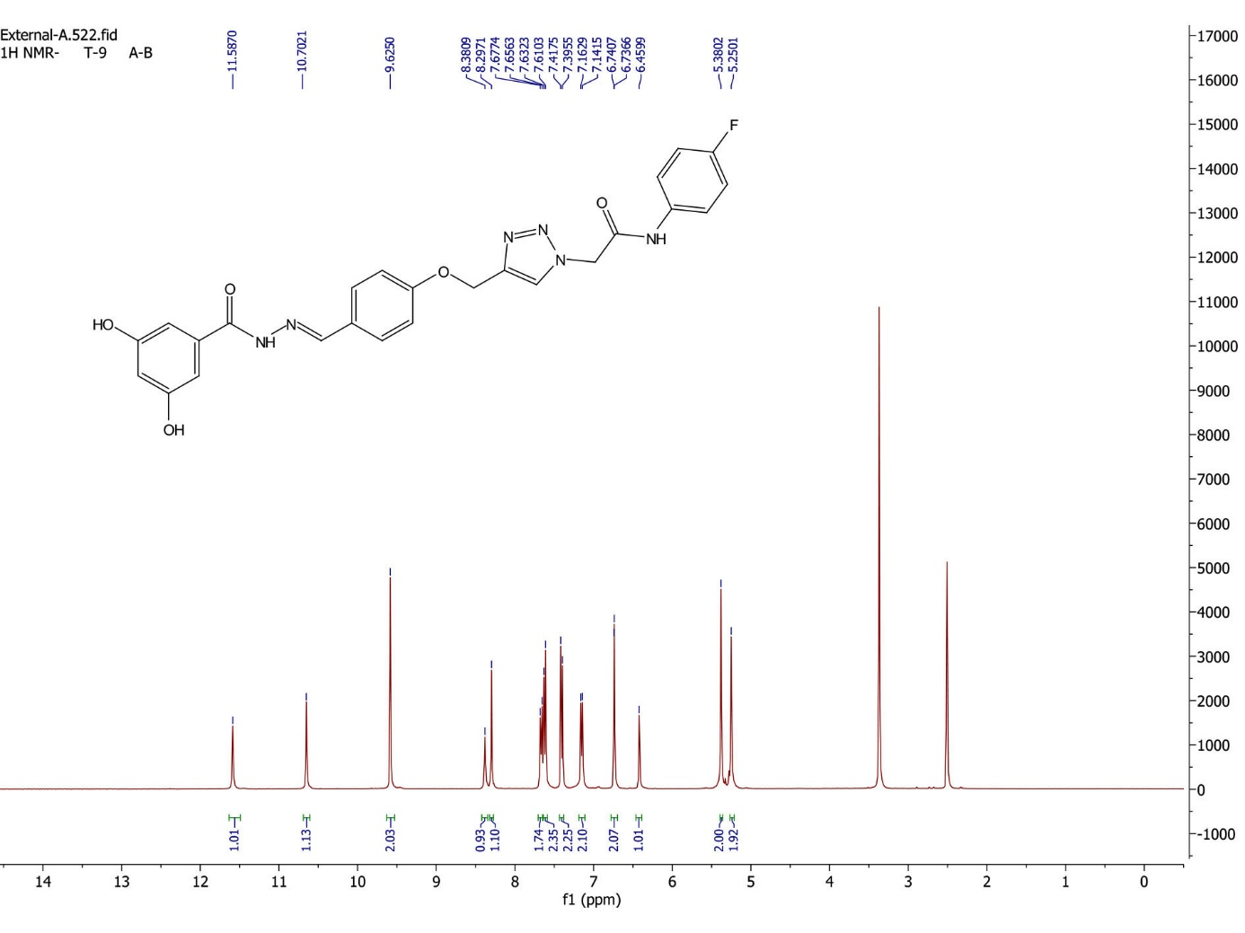
Fig. S5. ¹H-NMR of 11c

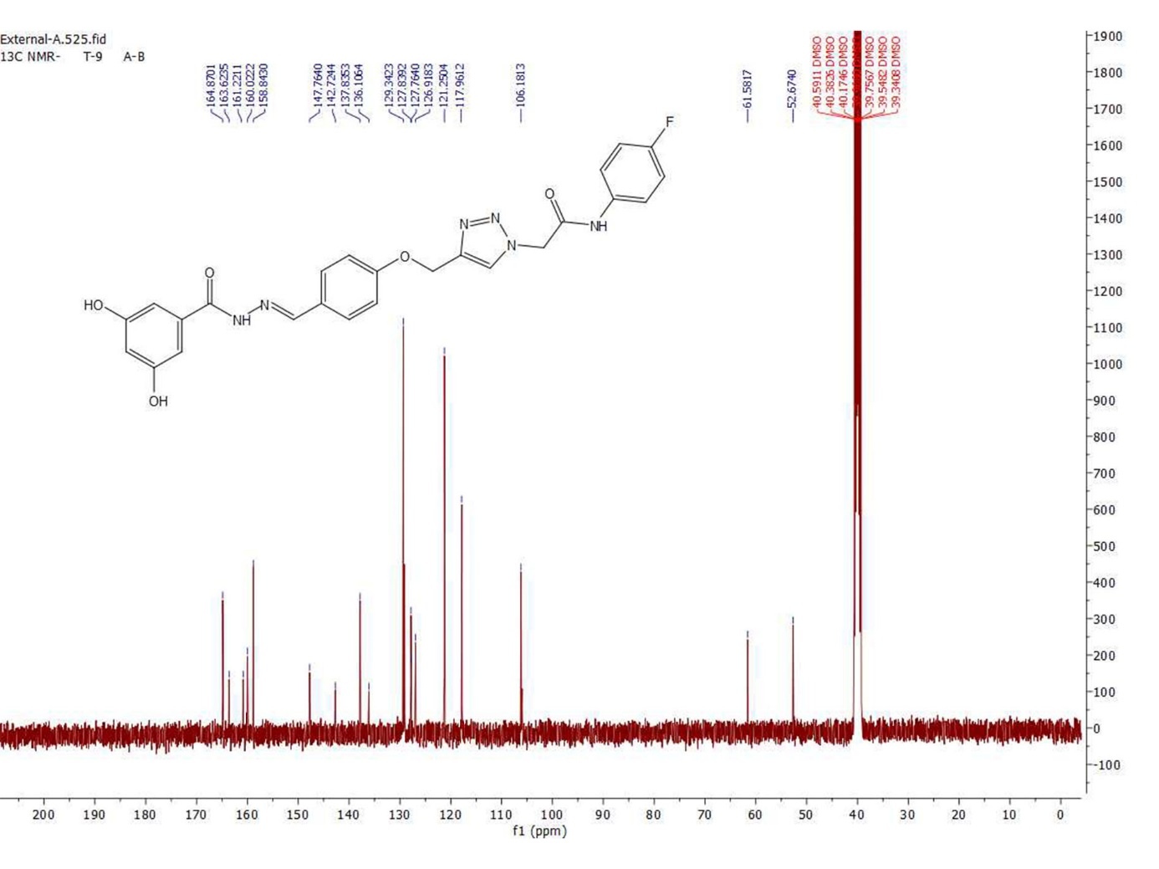
Fig. S6. ¹³C-NMR of 11c

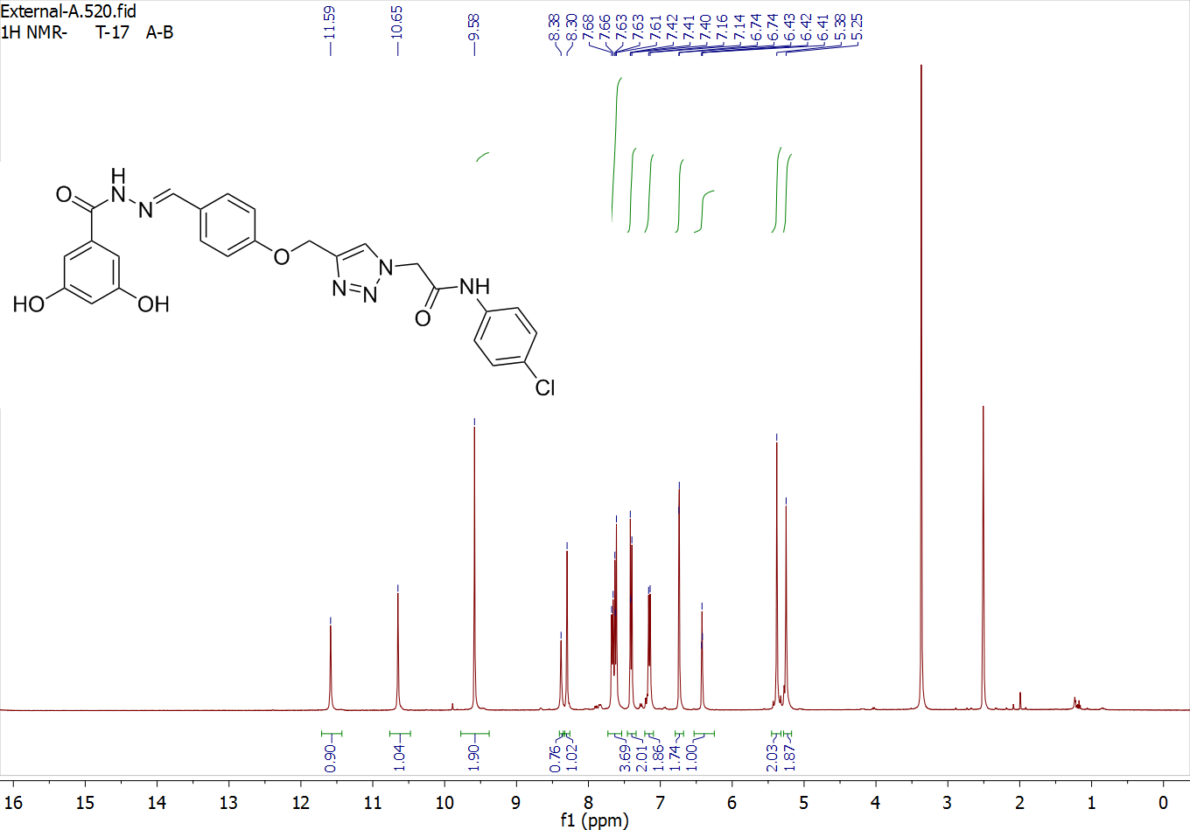
Fig. S7. ¹H-NMR of 11d

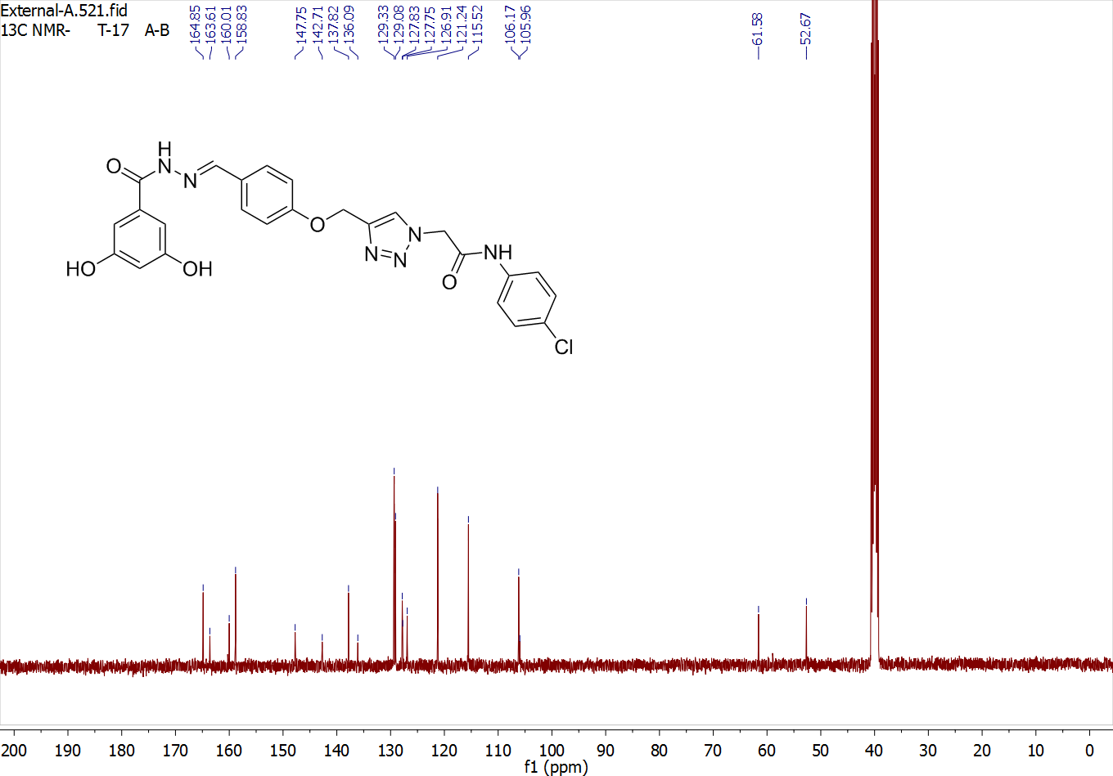
Fig. S8. ¹H-NMR of 11d

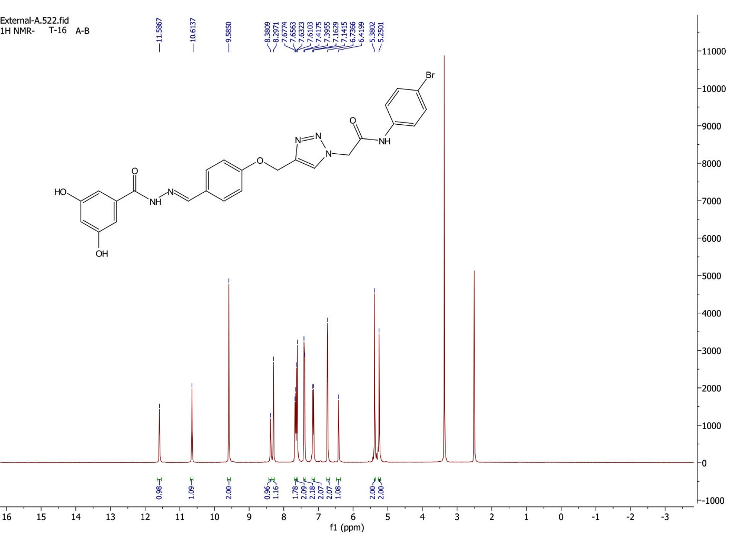
Fig. S9. ¹H-NMR of 11e

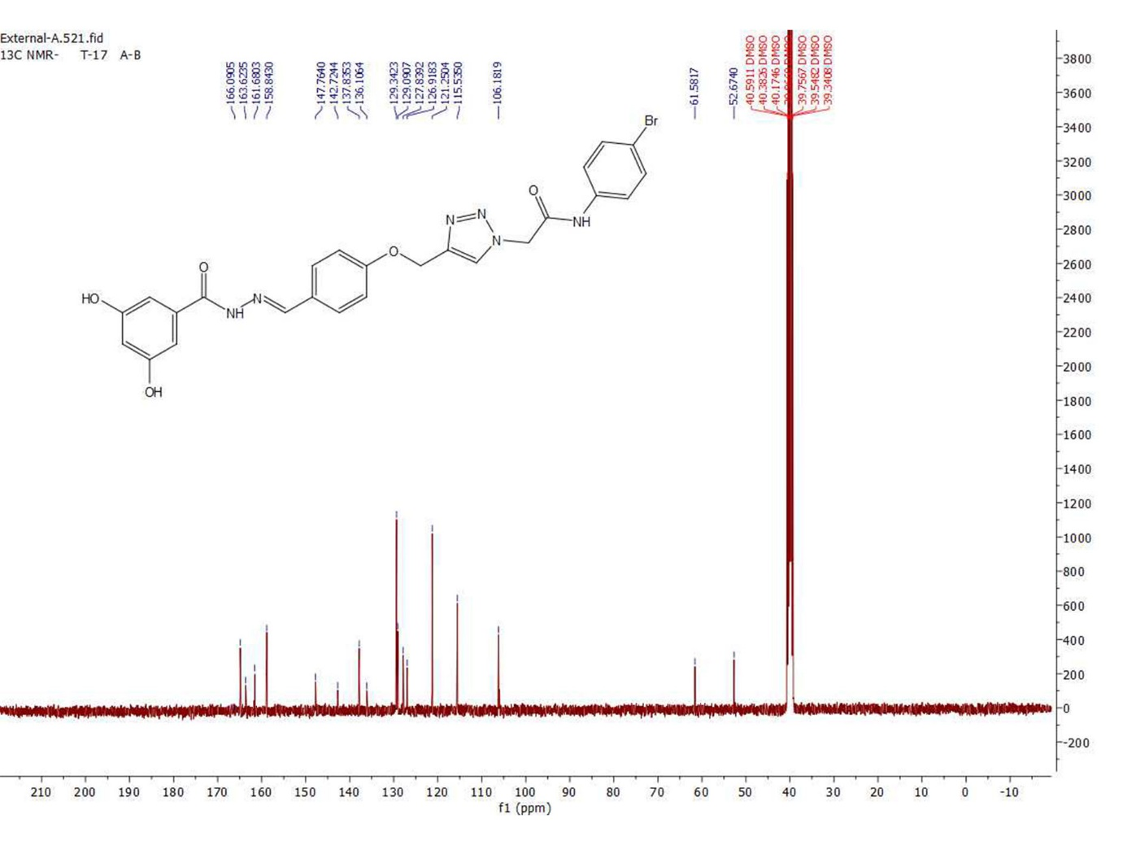
Fig. S10. ¹³C-NMR of 11e

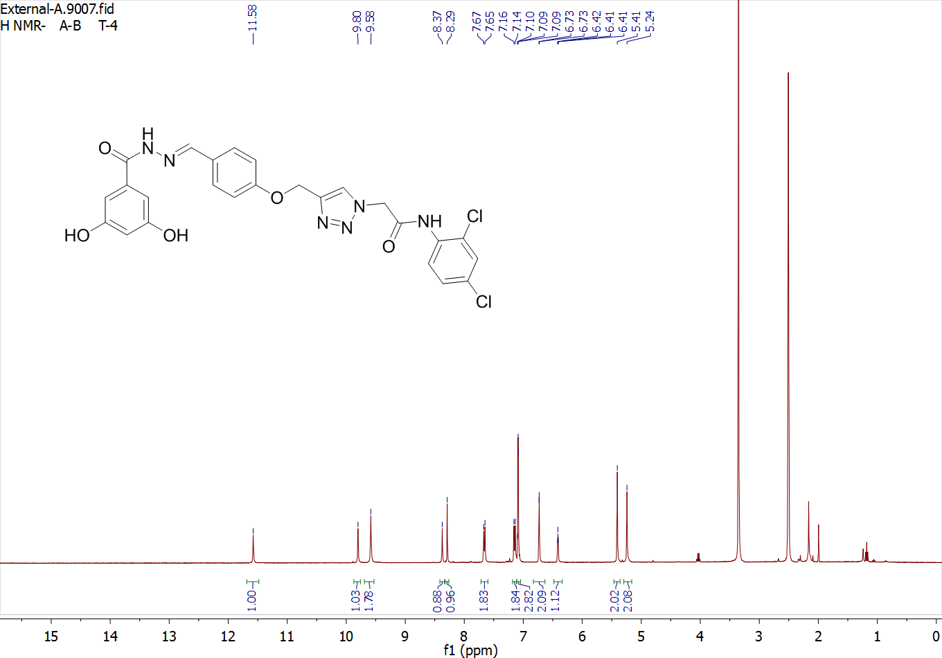
Fig. S11. ¹H-NMR of 11f

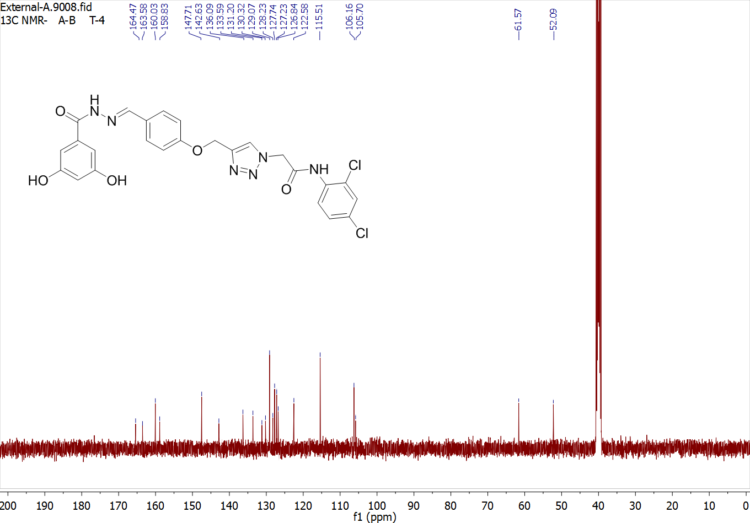
Fig. S12. ¹³C-NMR of 11f

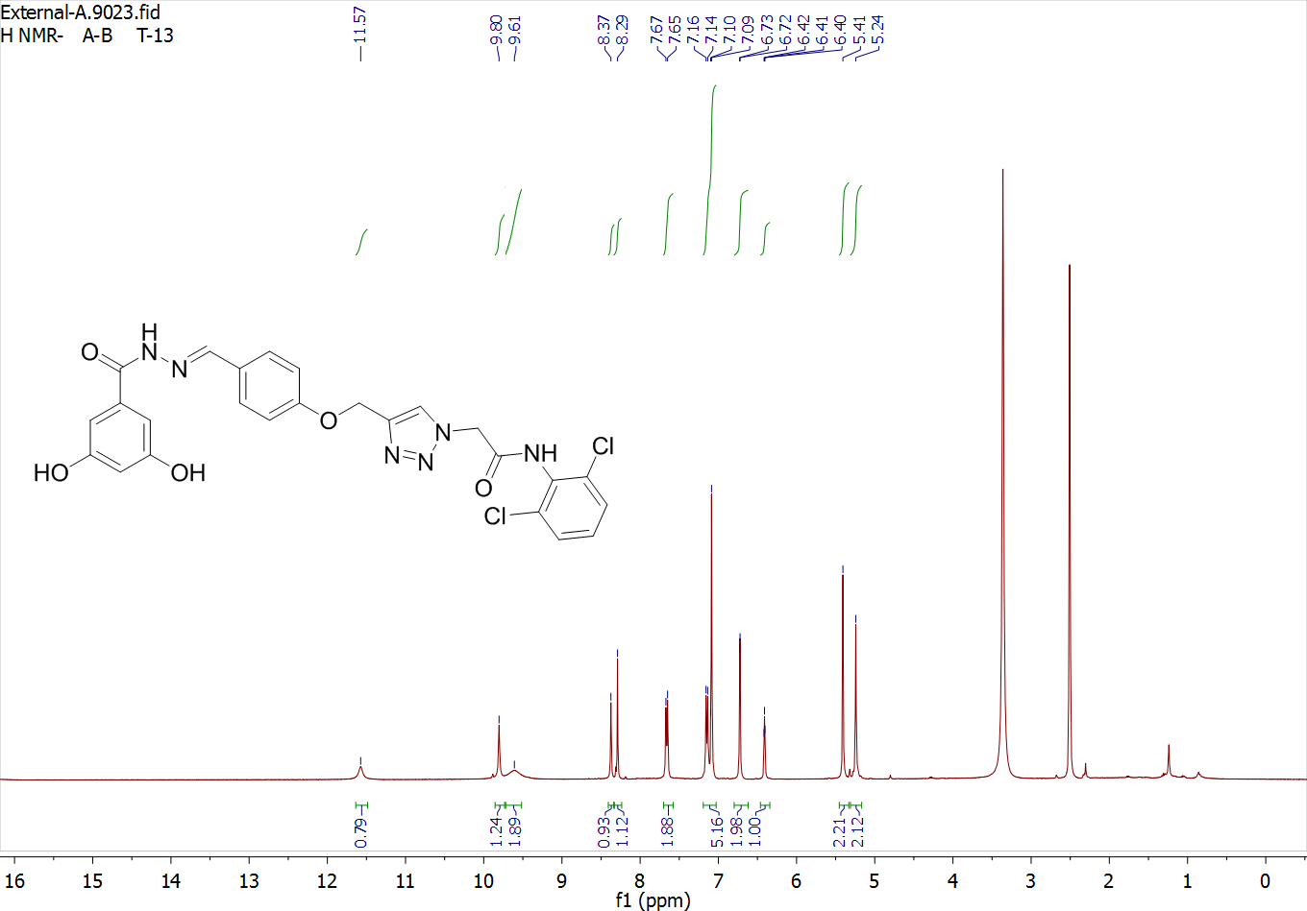
Fig. S13. ¹H-NMR of 11g

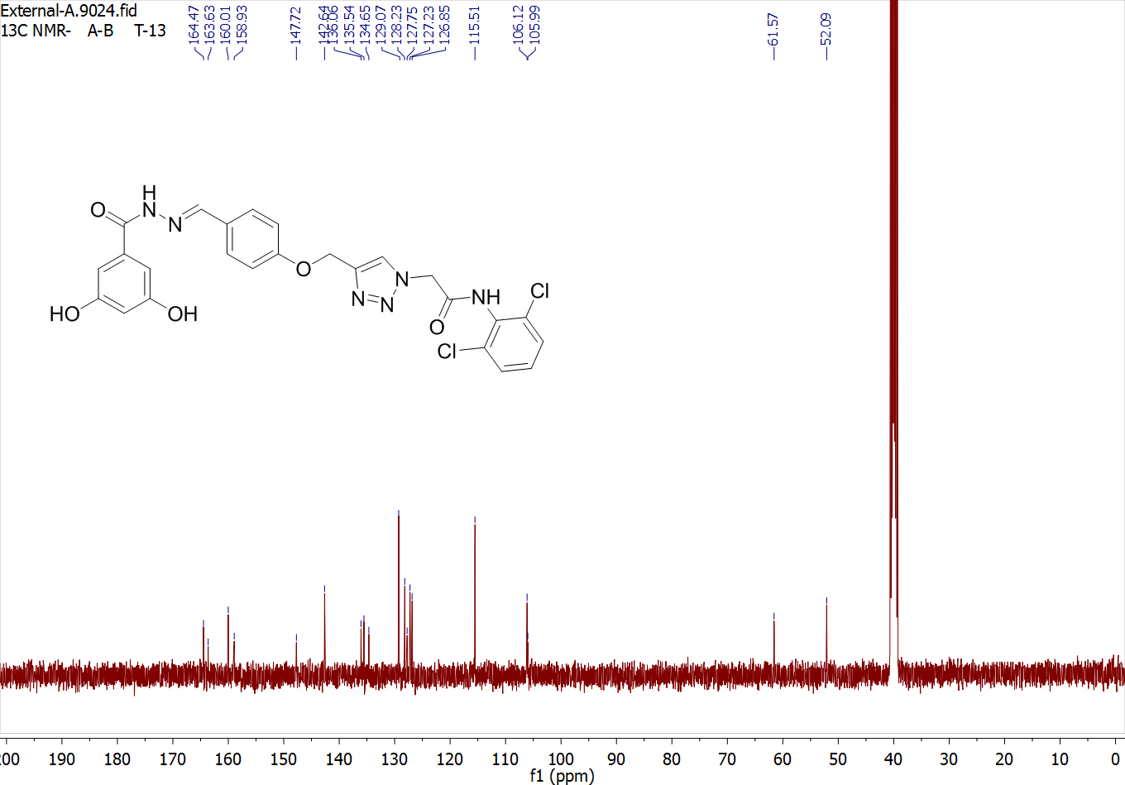
Fig. S14. ¹³C-NMR of 11g

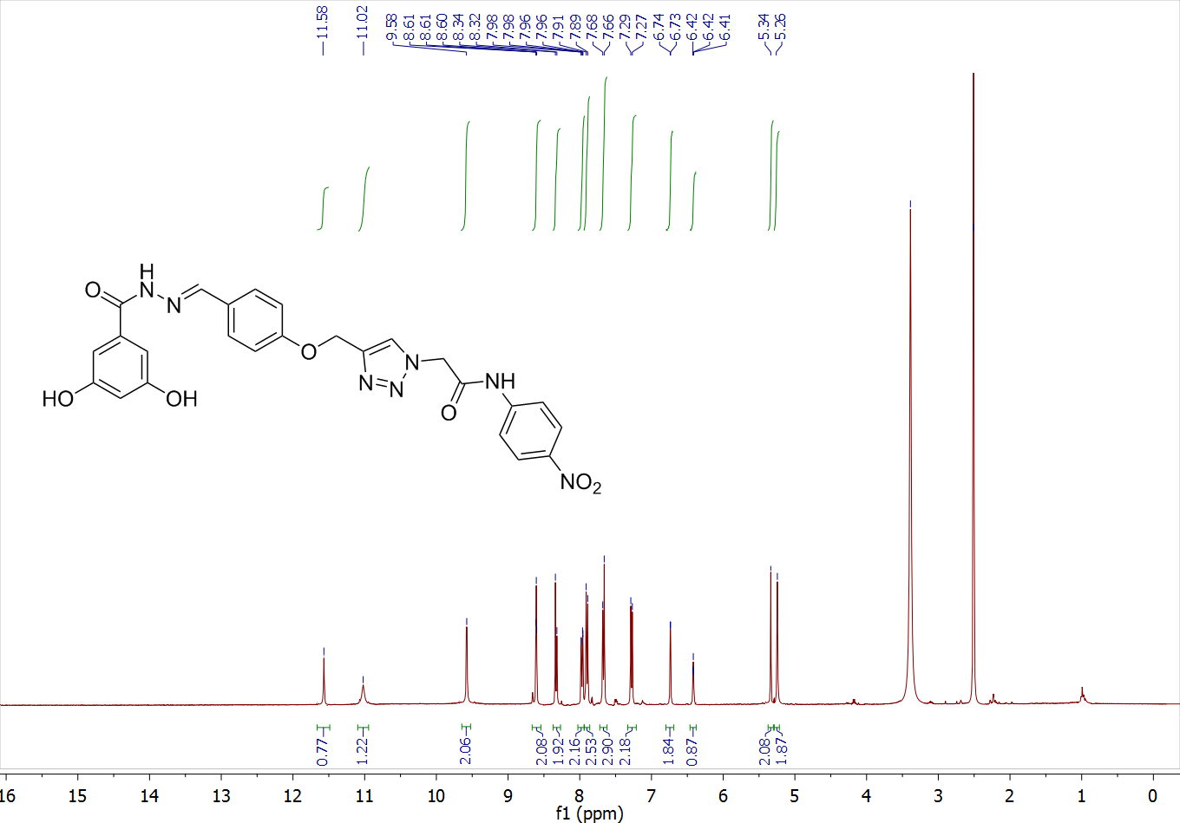
Fig. S15. ¹H-NMR of 11h

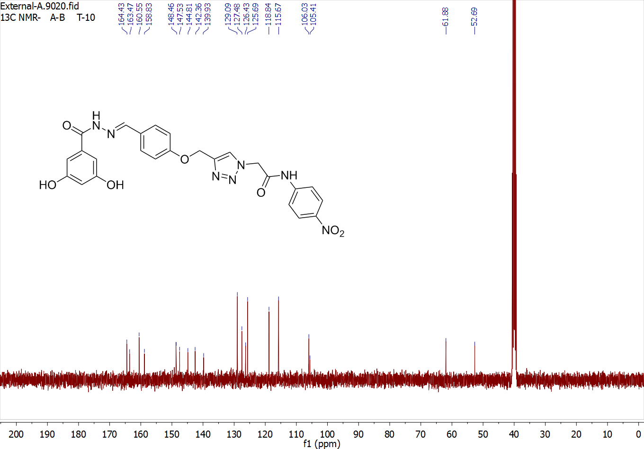
Fig. S16. ¹³C-NMR of 11h

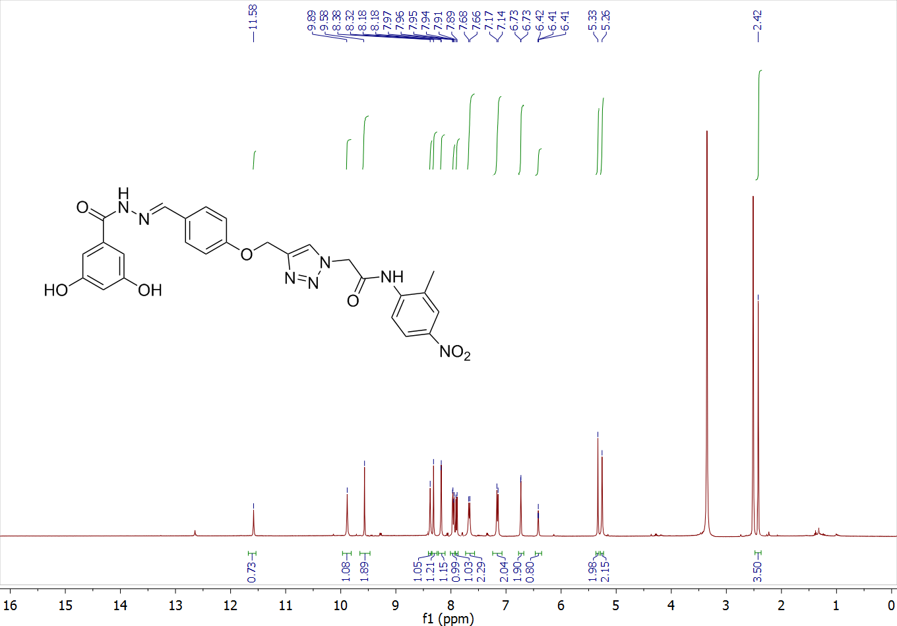
Fig. S17. ¹H-NMR of 11i

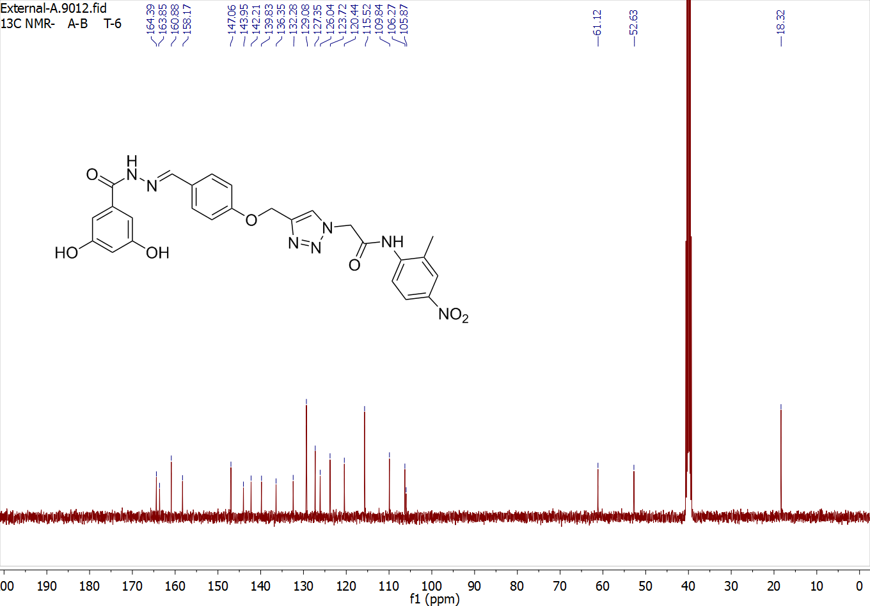
Fig. S18. ¹H-NMR of 11i

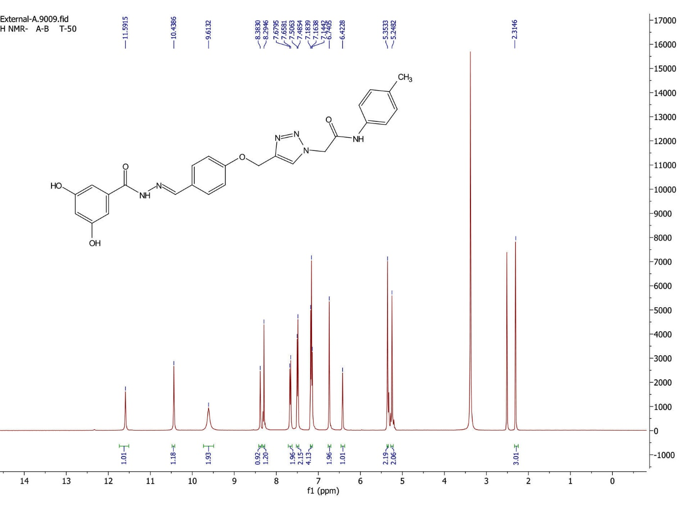
Fig. S19. ¹H-NMR of 11j

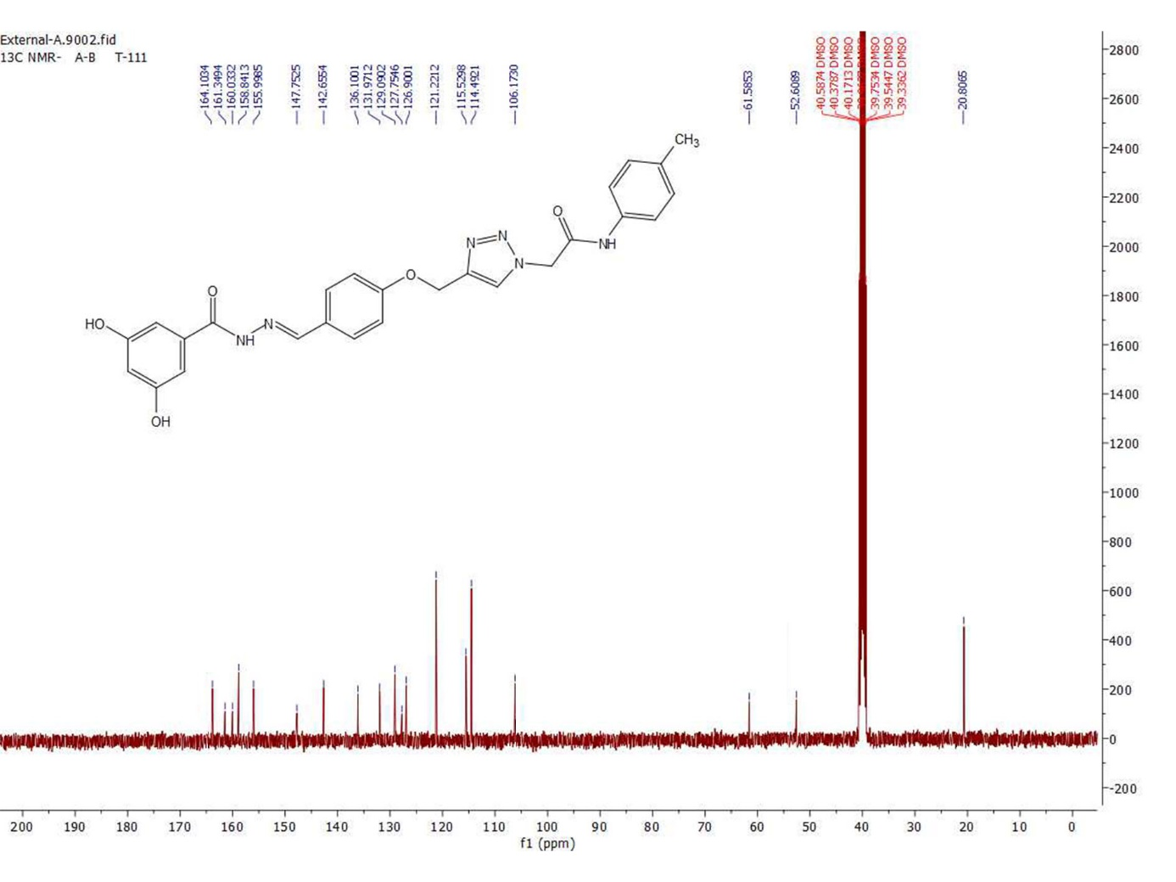
Fig. S20. ¹³C-NMR of 11j

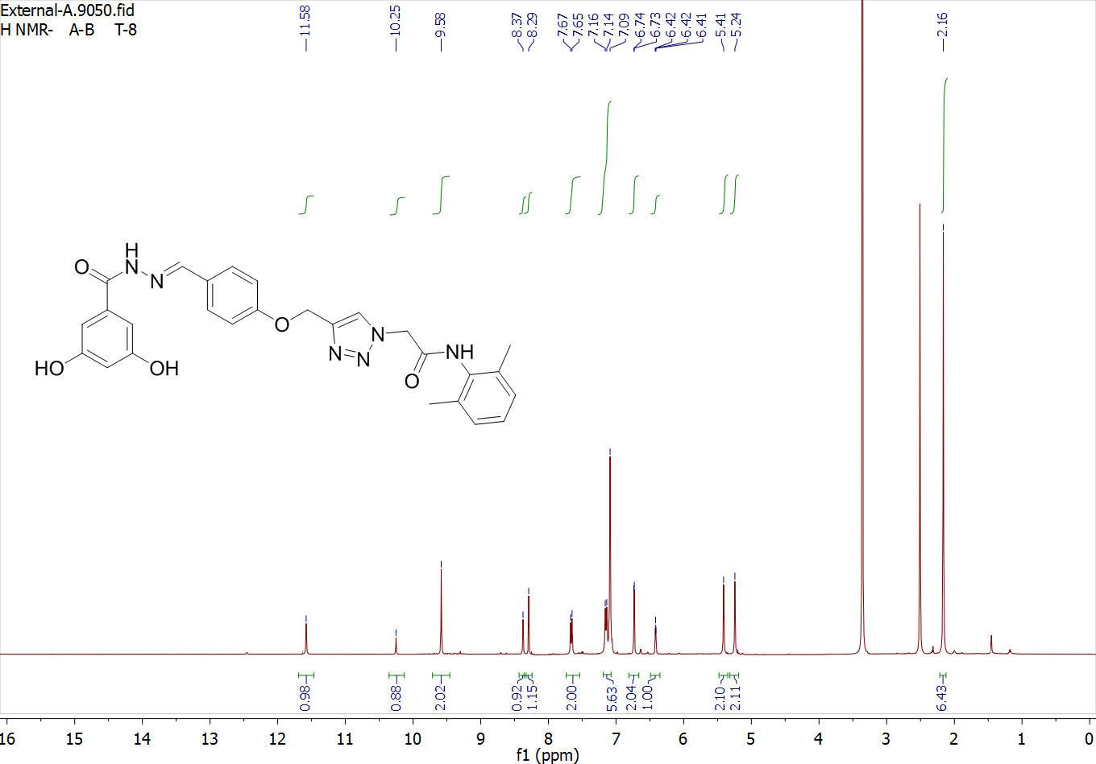
Fig. S21. ¹H-NMR of 11k

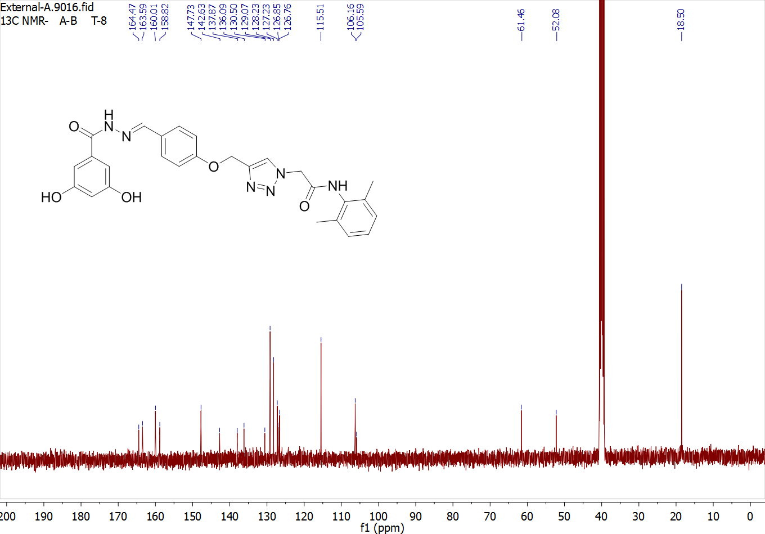
Fig. S22. ¹³C-NMR of 11k

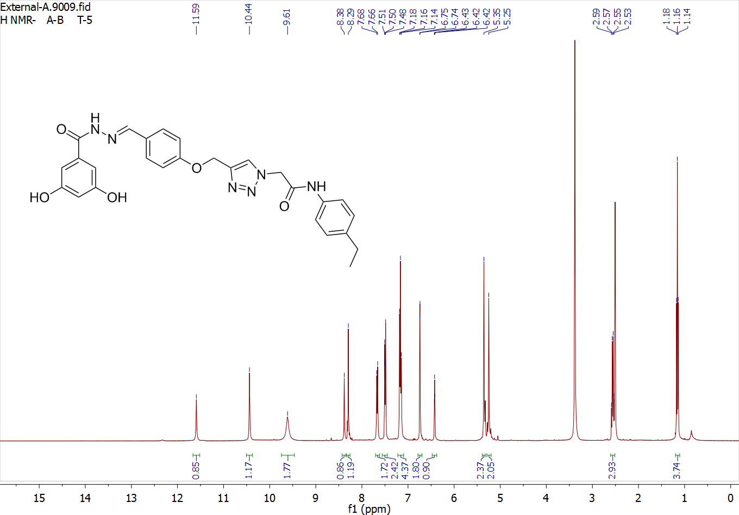
Fig. S23. ¹H-NMR of 11l

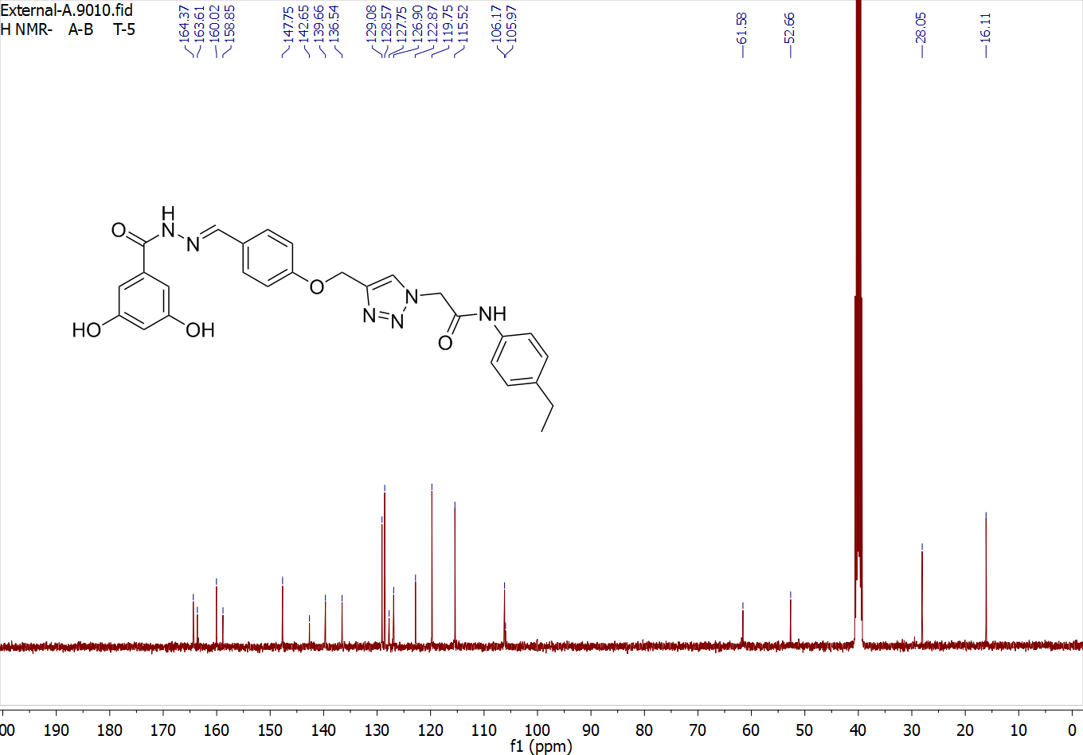
Fig. S24. ¹³C-NMR of 11l

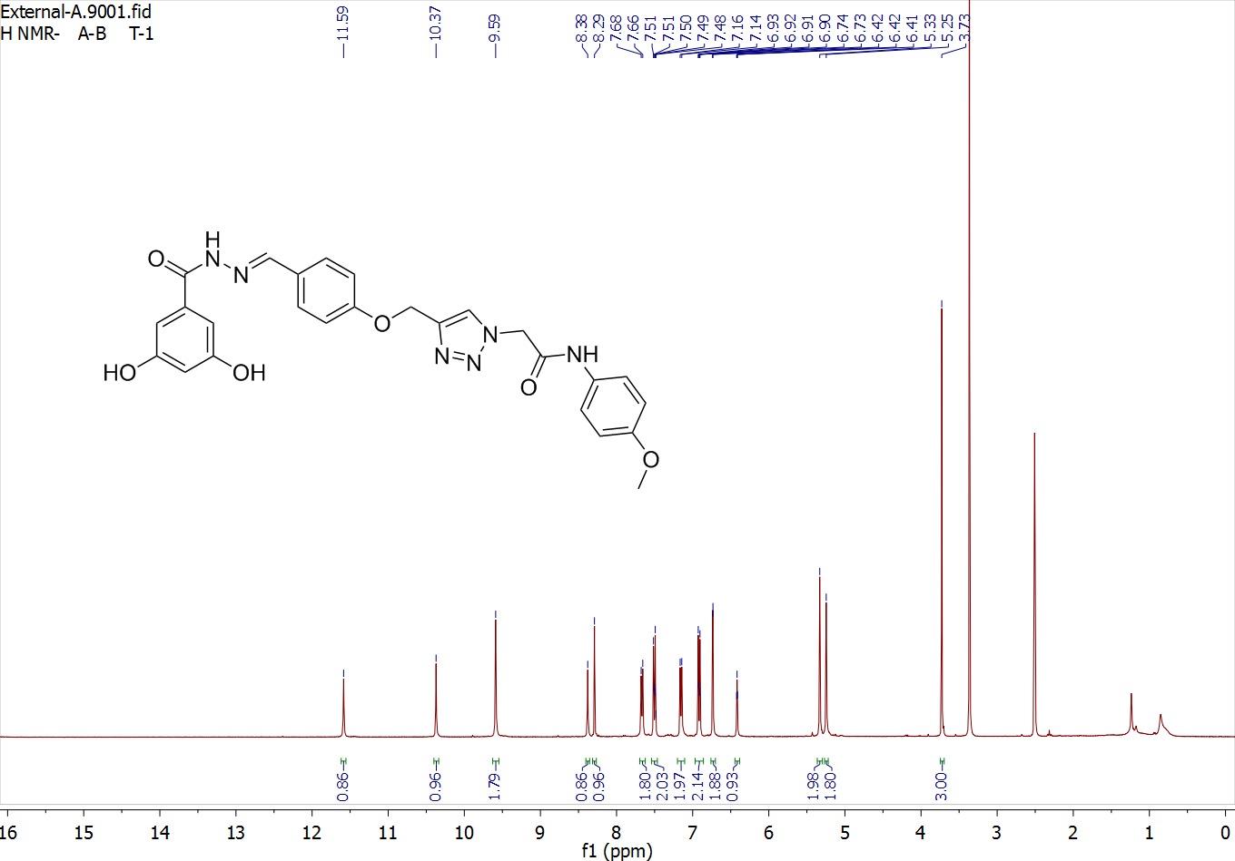
Fig. S25. ¹H-NMR of 11m

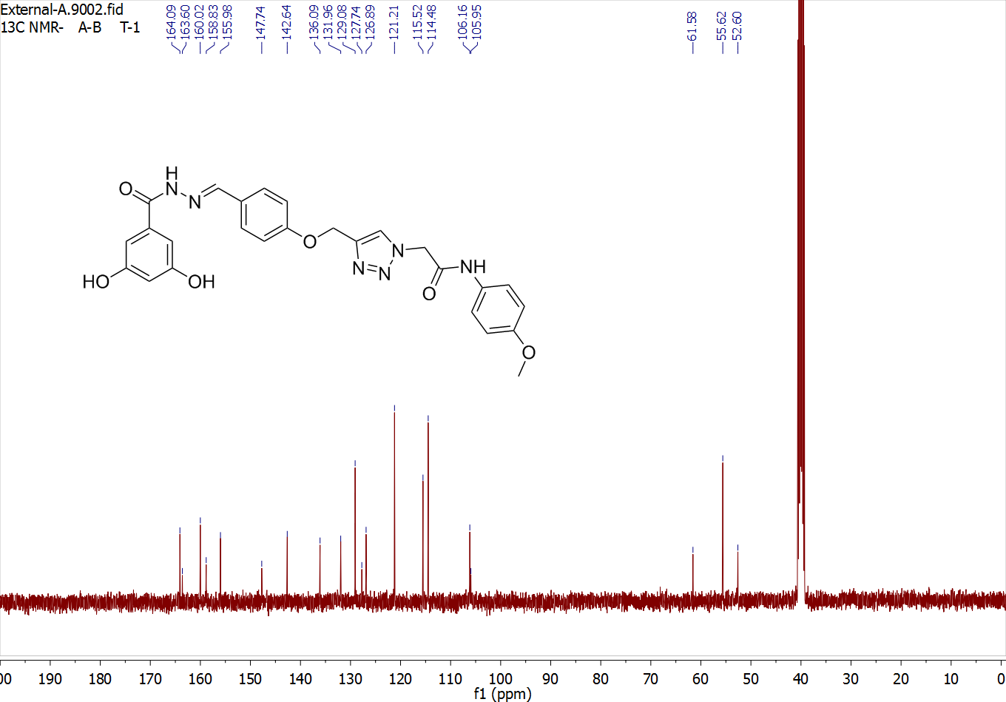
Fig. S26. ¹³C-NMR of 11m

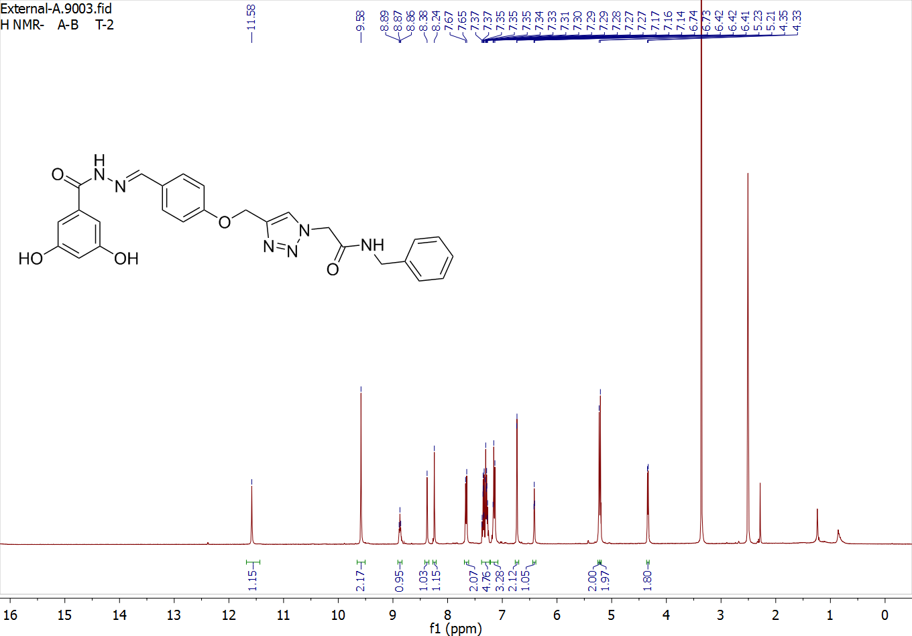
Fig. S27. ¹H-NMR of 11n

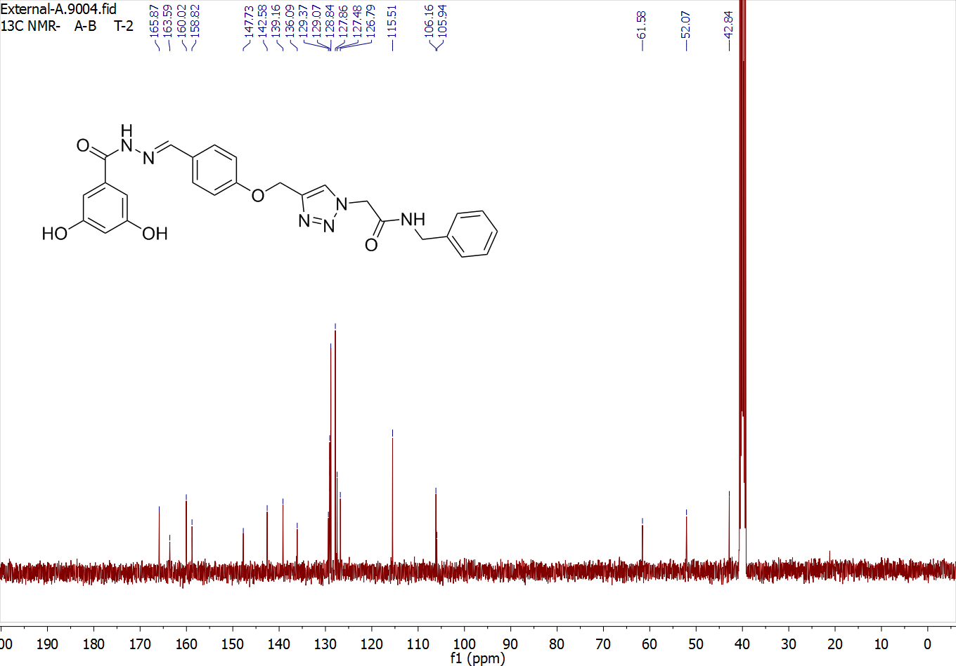
Fig. S28. ¹³C-NMR of 11m

