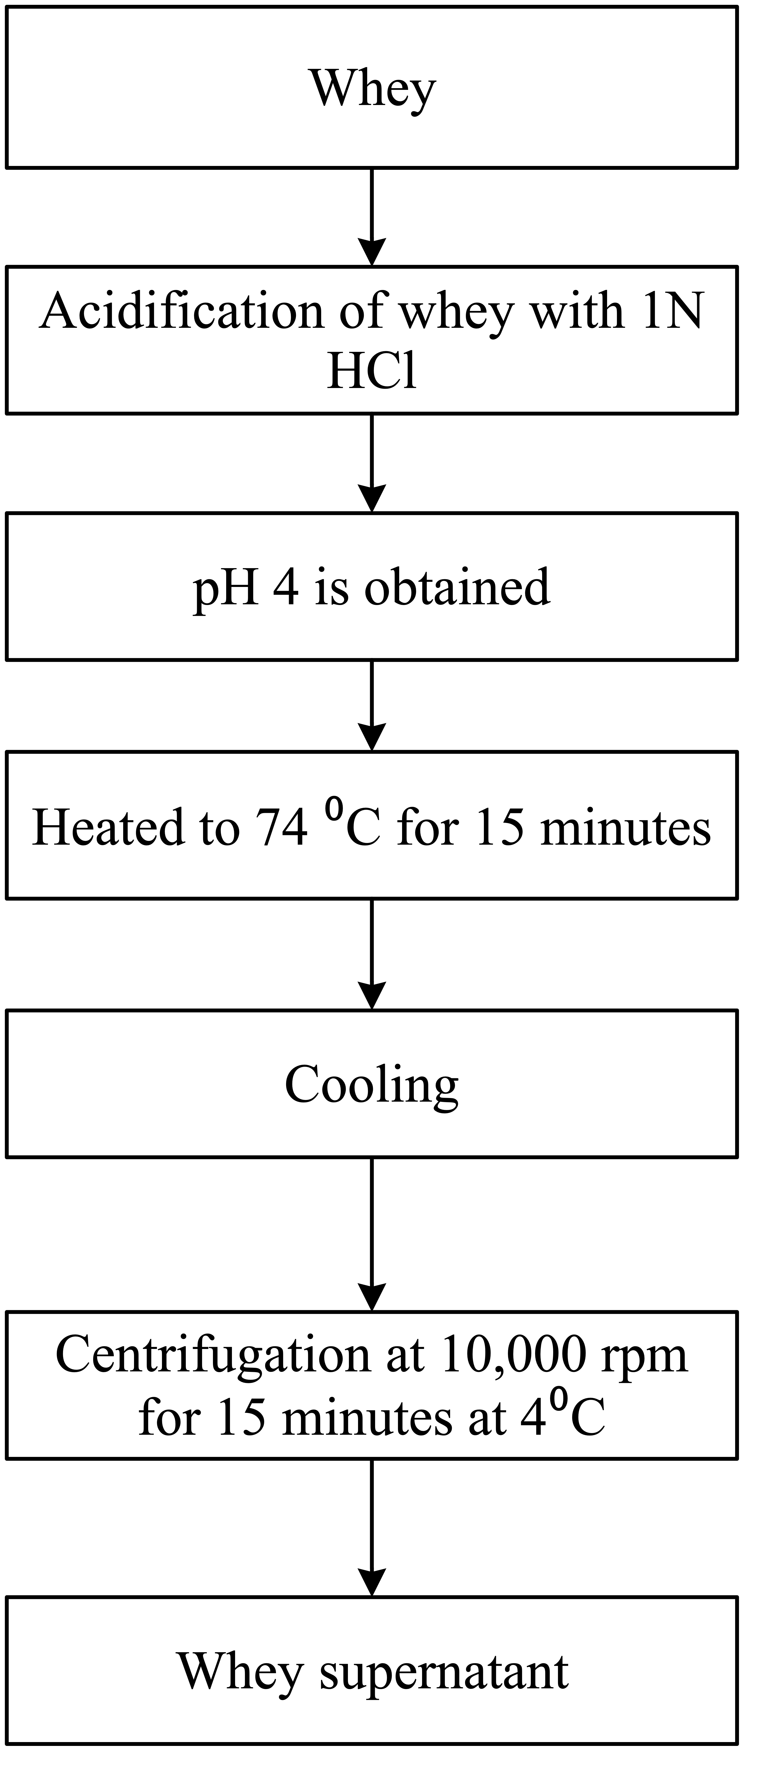
Supplementary Fig S1: Flow chart of whey pre-treatment

