Supplemental Material
Supplement 1. Causes of graft loss
Supplement 2. Kaplan-Meier curves for (A) death-censored graft survival and (B) patient survival by early statin use, excluding patients who did not use tacrolimus.
Supplement 3. Risk factors for (A) death-censored graft survival and (B) patient survival by early statin use, excluding patients who did not use tacrolimus.
Supplement 4. Kaplan-Meier curves for (A) death-censored graft survival and (B) patient survival by early statin use, excluding patients with graft loss within one year.
Supplement 5. Risk factors for (A) death-censored graft survival and (B) patient survival by early statin use, excluding patients with graft loss within one year.
Supplement 6. Kaplan-Meier curves for (A) death-censored graft survival and (B) patient survival by early statin use, extending the initiation time of statin treatment from 1-year to 2-years.
Supplement 7. Risk factors for (A) death-censored graft survival and (B) patient survival by early statin use, extending the initiation time of statin treatment from 1-year to 2-years.
Supplement 8. Kaplan-Meier curves for (A) death-censored graft survival and (B) patient survival by early statin use, including patients who discontinued statin therapy during the study period or who initiated statins more than 1-year after transplantation.
Supplement 9. Risk factors for (A) death-censored graft survival and (B) patient survival by early statin use, including patients who discontinued statin therapy during the study period or who initiated statins more than 1-year after transplantation.
Supplement 1. Causes of graft loss
Cause of graft loss | Statin (n=15) | Control (n=39) | Total (n=54)
Rejection | 13 (86.7) | 23 (59.0) | 36 (66.7)
BK virus nephropathy | 0 (0.0) | 3 (7.7) | 3 (5.6)
Poor compliance | 0 (0.0) | 2 (5.1) | 2 (3.7)
Postoperative complication | 0 (0.0) | 2 (5.1) | 2 (3.7)
Primary graft failure | 1 (6.7) | 5 (12.8) | 6 (11.1)
Others | 1 (6.7) | 4 (10.3) | 5 (9.3)
Data are presented as number (percentage).

Supplement 2. Kaplan-Meier curves for (A) death-censored graft survival and (B) patient survival by early statin use, excluding patients who did not use tacrolimus.
(A)
(B)

Supplement 3. Risk factors for (A) death-censored graft survival and (B) patient survival by early statin use, excluding patients who did not use tacrolimus.
(A)
Factors | Univariable  cHR (95% CI) | Multivariable  aHR (95% CI)
Recipient age | 1.007 (0.982-1.033)
Female | 1.478 (0.768-2.844)
Diabetes mellitus | 1.333 (0.291-6.100)
Dialysis vintage | 0.998 (0.988-1.008)
Systolic blood pressure (per 1 mmHg) | 1.008 (0.994-1.023)
Statin use prior to KT | 1.600 (0.802-3.190)
Desensitization † | 3.209 (1.587-6.487) | 2.743 (1.431-5.260)
Early statin use † | 0.181 (0.090-0.367) | 0.227 (0.118-0.438)
Deceased donor | 2.043 (0.623-6.703)
Female donor † | 2.608 (1.279-5.318) | 2.225 (1.177-4.207)
Donor age | 0.980 (0.951-1.009)
Donor hypertension † | 2.598 (1.207-5.595) | 2.260 (1.151-4.439)
Donor eGFR † | 0.988 (0.975-1.001) | 0.984 (0.974-0.994)
aHR, adjusted hazard ratio; cHR, crude hazard ratio; CI, confidence interval; eGFR, estimated glomerular filtration rate; KT, kidney transplant.
†P value <0.05

(B)
Factors | Univariable  cHR (95% CI) | Multivariable  aHR (95% CI)
Recipient age | 1.019 (0.997-1.043)
Female | 1.429 (0.802-2.545)
Diabetes mellitus | 0.750 (0.168-3.346)
Dialysis vintage | 0.998 (0.990-1.007)
Systolic blood pressure (per 1 mmHg) | 1.005 (0.993-1.018)
Statin use prior to KT † | 1.723 (0.948-3.131) | 1.860 (1.032-3.352)
Desensitization † | 3.025 (1.638-5.587) | 2.971 (1.625-5.431)
Early statin use † | 0.188 (0.102-0.344) | 0.211 (0.117-0.381)
Deceased donor † | 3.128 (1.163-8.415) | 3.313 (1.753-6.263)
Female donor † | 2.425 (1.300-4.522) | 1.972 (1.151-3.377)
Donor age | 0.990 (0.965-1.015)
Donor hypertension † | 2.580 (1.325-5.023) | 2.662 (1.505-4.711)
Donor eGFR | 0.996 (0.985-1.007)
aHR, adjusted hazard ratio; cHR, crude hazard ratio; CI, confidence interval; eGFR, estimated glomerular filtration rate; KT, kidney transplant.
†P value <0.05
Supplement 4. Kaplan-Meier curves for (A) death-censored graft survival and (B) patient survival by early statin use, excluding patients with graft loss within one year.
(A)
(B)

Supplement 5. Risk factors for (A) death-censored graft survival and (B) patient survival by early statin use, excluding patients with graft loss within one year.
(A)
Factors | Univariable  cHR (95% CI) | Multivariable  aHR (95% CI)
Recipient age | 1.000 (0.972-1.029)
Female† | 2.082 (1.027-4.218) | 2.044 (1.025-4.077)
Diabetes mellitus | 0.939 (0.119-7.394)
Dialysis vintage | 0.995 (0.983-1.008)
Systolic blood pressure (per 1 mmHg) † | 1.016 (1.000-1.032) | 1.015 (1.000-1.031)
Statin use prior to KT | 0.869 (0.378-2.001)
Desensitization † | 2.197 (1.023-4.719) | 2.173 (1.042-4.534)
Early statin use † | 0.303 (0.147-0.621) | 0.291 (0.149-0.570)
Deceased donor | 1.617 (0.432-6.062)
Female donor † | 2.534 (1.144-5.615) | 2.726 (1.290-5.761)
Donor age | 1.006 (0.974-1.040)
Donor hypertension | 1.15 (0.437-3.025)
Donor eGFR † | 0.99 (0.975-1.006) | 0.987 (0.976-0.998)
aHR, adjusted hazard ratio; cHR, crude hazard ratio; CI, confidence interval; eGFR, estimated glomerular filtration rate; KT, kidney transplant.
†P value <0.05

(B)
Factors | Univariable  cHR (95% CI) | Multivariable  aHR (95% CI)
Recipient age | 1.007 (0.983-1.033)
Female † | 1.925 (1.038-3.569) | 1.831 (1.009-3.323)
Diabetes mellitus | 0.522 (0.068-4.039)
Dialysis vintage | 0.998 (0.989-1.008)
Systolic blood pressure (per 1 mmHg) | 1.01 (0.996-1.024)
Statin use prior to KT | 0.957 (0.465-1.970)
Desensitization † | 1.894 (0.948-3.782) | 2.024 (1.021-4.011)
Early statin use † | 0.364 (0.196-0.677) | 0.378 (0.213-0.671)
Deceased donor † | 2.288 (0.805-6.507) | 2.607 (1.332-5.103)
Female donor † | 1.914 (0.972-3.766) | 1.984 (1.085-3.631)
Donor age | 1.010 (0.982-1.040)
Donor hypertension | 1.358 (0.594-3.105)
Donor eGFR | 0.999 (0.986-1.012)
aHR, adjusted hazard ratio; cHR, crude hazard ratio; CI, confidence interval; eGFR, estimated glomerular filtration rate; KT, kidney transplant.
†P value <0.05
Supplement 6. Kaplan-Meier curves for (A) death-censored graft survival and (B) patient survival by early statin use, extending the initiation time of statin treatment from 1-year to 2-years.
(A)
(B)

Supplement 7. Risk factors for (A) death-censored graft survival and (B) patient survival by early statin use, extending the initiation time of statin treatment from 1-year to 2-years.
(A)
Factors | Univariable  cHR (95% CI) | Multivariable  aHR (95% CI)
Recipient age | 1.009 (0.984-1.034)
Female | 1.432 (0.769-2.666)
Diabetes mellitus | 1.493 (0.803-2.775)
Dialysis vintage | 0.995 (0.985-1.004)
Systolic blood pressure (per 1 mmHg) | 1.008 (0.995-1.021)
Statin use prior to KT | 1.397 (0.747-2.613)
Desensitization † | 2.711 (1.421-5.175) | 2.419 (1.322-4.426)
Early statin use † | 0.191 (0.103-0.356) | 0.234 (0.131-0.419)
Deceased donor | 2.706 (0.983-7.446)
Female donor † | 2.283 (1.198-4.352) | 2.085 (1.163-3.739)
Donor age | 0.996 (0.970-1.022)
Donor hypertension † | 2.167 (1.075-4.368) | 2.155 (1.147-4.048)
Donor eGFR † | 0.992 (0.980-1.004) | 0.986 (0.976-0.996)
aHR, adjusted hazard ratio; cHR, crude hazard ratio; CI, confidence interval; eGFR, estimated glomerular filtration rate; KT, kidney transplant.
†P value <0.05

(B)
Factors | Univariable  cHR (95% CI) | Multivariable  aHR (95% CI)
Recipient age † | 1.020 (0.998-1.043) | 1.018 (0.997-1.040)
Female | 1.463 (0.845-2.532)
Diabetes mellitus † | 1.726 (1.023-2.912) | 1.706 (1.035-2.813)
Dialysis vintage | 0.996 (0.989-1.004)
Systolic blood pressure (per 1 mmHg) | 1.005 (0.994-1.017)
Statin use prior to KT | 1.456 (0.849-2.496)
Desensitization † | 2.557 (1.46-4.479) | 2.517 (1.447-4.381)
Early statin use † | 0.177 (0.103-0.304) | 0.211 (0.127-0.352)
Deceased donor † | 2.976 (1.273-6.954) | 2.499 (1.415-4.412)
Female donor † | 2.248 (1.275-3.961) | 1.785 (1.102-2.890)
Donor age | 0.996 (0.974-1.019)
Donor hypertension † | 2.158 (1.173-3.970) | 2.233 (1.300-3.835)
Donor eGFR | 0.996 (0.986-1.006)
aHR, adjusted hazard ratio; cHR, crude hazard ratio; CI, confidence interval; eGFR, estimated glomerular filtration rate; KT, kidney transplant.
†P value <0.05

Supplement 8. Kaplan-Meier curves for (A) death-censored graft survival and (B) patient survival by early statin use, including patients who discontinued statin therapy during the study period or who initiated statins more than 1-year after transplantation.
A)
(B)

Supplement 9. Risk factors for (A) death-censored graft survival and (B) patient survival by early statin use, including patients who discontinued statin therapy during the study period or who initiated statins more than 1-year after transplantation.
(A)
Factors | Univariable  cHR (95% CI) | Multivariable  aHR (95% CI)
Recipient age | 1.003 (0.983-1.024)
Male | 0.819 (0.49-1.37)
Diabetes mellitus † | 1.789 (1.093-2.929) | 2.189 (1.251-3.829)
Dialysis vintage | 1 (0.995-1.006)
Systolic blood pressure (per 1 mmHg) | 1.007 (0.995-1.019)
Statin use prior to KT | 0.894 (0.526-1.518)
Desensitization † | 1.429 (0.841-2.428) | 1.91 (1.068-3.415)
Early statin use † | 0.352 (0.203-0.61) | 0.343 (0.195-0.604)
Living donor | 0.508 (0.305-0.844)
Female donor † | 1.557 (0.958-2.53) | 2.434 (1.375-4.311)
Donor age | 1.012 (0.991-1.033)
Donor hypertension † | 2.528 (1.475-4.333) | 2.285 (1.192-4.382)
Donor eGFR | 0.993 (0.985-1.001)
aHR, adjusted hazard ratio; cHR, crude hazard ratio; CI, confidence interval; eGFR, estimated glomerular filtration rate; KT, kidney transplant.
†P value <0.05

(B)
Factors | Univariable  cHR (95% CI) | Multivariable  aHR (95% CI)
Recipient age † | 1.064 (1.029-1.101) | 1.057 (1.018-1.098)
Male | 0.542 (0.246-1.192)
Diabetes mellitus | 1.805 (0.909-3.584)
Dialysis vintage | 1.006 (1.001-1.012)
Systolic blood pressure (per 1 mmHg) | 0.997 (0.981-1.015)
Statin use prior to KT | 0.799 (0.374-1.704)
Desensitization | 1.093 (0.496-2.407)
Early statin use † | 0.363 (0.170-0.775) | 0.345 (0.152-0.786)
Living donor | 0.605 (0.290-1.261)
Female donor | 1.530 (0.778-3.010)
Donor age | 1.018 (0.989-1.048)
Donor hypertension | 2.069 (0.940-4.555)
Donor eGFR | 1.002 (0.990-1.014)
aHR, adjusted hazard ratio; cHR, crude hazard ratio; CI, confidence interval; eGFR, estimated glomerular filtration rate; KT, kidney transplant.
†P value <0.05
Supplement 10. Kaplan-Meier curves for (A) death-censored graft survival and (B) patient survival by early statin use, excluding patients who had the history of MACE prior to KT.
A)
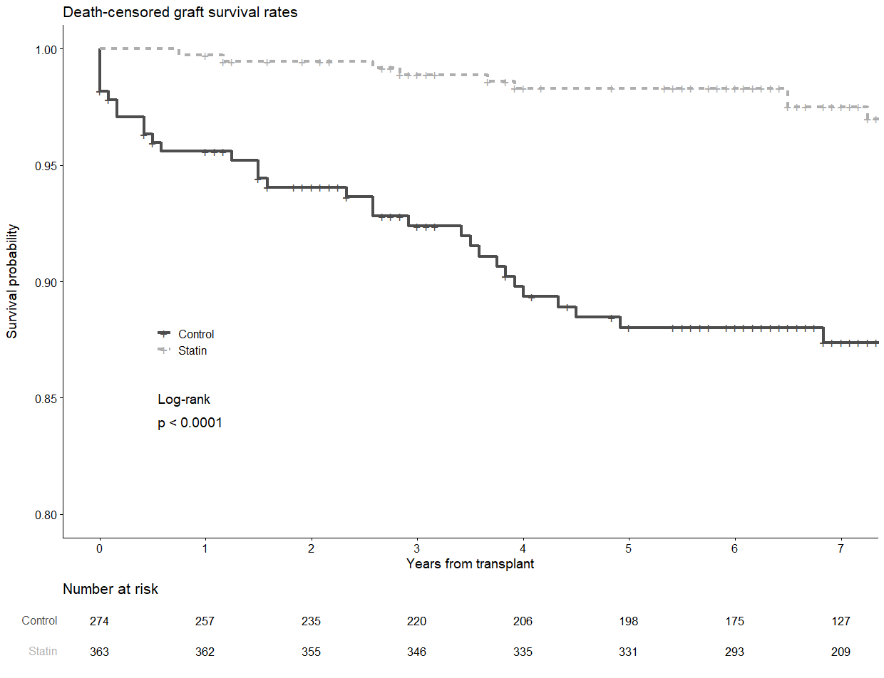
(B)
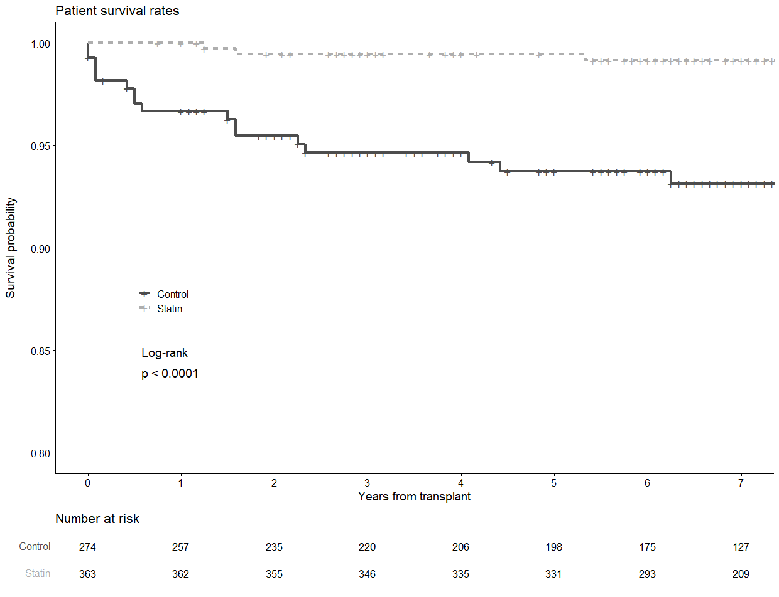

Supplement 11. Risk factors for (A) death-censored graft survival and (B) patient survival by early statin use, excluding patients who had the history of MACE prior to KT.
(A)
Factors | Univariable  cHR (95% CI) | Multivariable  aHR (95% CI)
Recipient age | 0.995 (0.971-1.020)
Male | 1.096 (0.595-2.018)
Diabetes mellitus | 1.230 (0.623-2.429)
Dialysis vintage | 1.002 (0.996-1.009)
Systolic blood pressure (per 1 mmHg) | 1.010 (0.995-1.025) | 1.009 (0.994-1.023)
Desensitization † | 1.789 (0.971-3.295) | 2.645 (1.322-5.292)
Early statin use † | 0.213 (0.108-0.420) | 0.214 (0.108-0.427)
Living donor | 0.437 (0.232-0.821) | 0.540 (0.218-1.339)
Male donor | 0.684 (0.377-1.243) | 0.595 (0.300-1.181)
Donor age | 1.023 (0.997-1.050) | 1.002 (0.973-1.032)
Donor hypertension | 2.334 (1.156-4.715) | 1.311 (0.558-3.076)
Donor eGFR | 0.991 (0.982-1.001) | 0.990 (0.977-1.003)
aHR, adjusted hazard ratio; cHR, crude hazard ratio; CI, confidence interval; eGFR, estimated glomerular filtration rate; KT, kidney transplant.
†P value <0.05

(B)
Factors | Univariable  cHR (95% CI) | Multivariable  aHR (95% CI)
Recipient age † | 1.06 (1.018-1.105) | 1.063 (1.016-1.113)
Male | 2.727 (0.923-8.058) | 1.018 (0.290-3.571)
Diabetes mellitus | 1.734 (0.707-4.254) | 1.600 (0.566-4.524)
Dialysis vintage | 1.007 (1.000-1.015) | 0.996 (0.983-1.009)
Systolic blood pressure (per 1 mmHg) | 0.999 (0.977-1.021) | 0.991 (0.969-1.014)
Desensitization † | 0.198 (0.073-0.536) | 3.642 (1.174-11.300)
Early statin use † | 0.350 (0.147-0.836) | 0.157 (0.049-0.504)
Living donor † | 0.390 (0.152-0.996) | 0.126 (0.026-0.605)
Male donor | 1.027 (0.989-1.065) | 0.473 (0.156-1.437)
Donor age | 1.780 (0.602-5.260) | 0.999 (0.961-1.037)
Donor hypertension | 1.005 (0.989-1.021)
Donor eGFR | 1.060 (1.018-1.105)
aHR, adjusted hazard ratio; cHR, crude hazard ratio; CI, confidence interval; eGFR, estimated glomerular filtration rate; KT, kidney transplant.
†P value <0.05

