Supplementary material – file 1
-
Projecting malaria risk considering vector control interventions under climate change scenarios -
Margaux L. Sadoine, Kate Zinszer, Ying Liu, Philippe Gachon, Michel Fournier, Guillaume Dueymes, Grant Dorsey, Ana Llerena, Jane Frances Namuganga, Bouchra Nasri, and Audrey Smargiassi

Table S1. Annual distributions of meteorological factors from 14 Regional Climate Models (RCMs) under historical (1975-2004) and future (2036-2065) periods
Period | Descriptive statistics | Rainfall (mm) | Maximum temperature (°C) | Minimum temperature (°C) | Specific humidity (kg.kg-1)
Historical  (1975-2004) | Mean (SD) | 288 (238) | 26.3 (3.59) | 15.8 (2.62) | 0.0111 (0.00211)
Historical  (1975-2004) | Median [Min, Max] | 239 [0, 1820] | 26.9 [17.1, 36.7] | 16.0 [6.78, 22.4] | 0.0113 [0.00339, 0.0170]
Future – RCP 4.5  (2036-2065) | Mean (SD) | 279 (218) | 28.3 (3.52) | 17.7 (2.52) | 0.0122 (0.00226)
 | Median [Min, Max] | 241 [0, 1840] | 28.6 [18.8, 38.1] | 17.9 [8.96, 24.8] | 0.0124 [0.00407, 0.0186]
Future – RCP 8.5  (2036-2065) | Mean (SD) | 290 (236) | 28.8 (3.62) | 18.3 (2.61) | 0.0126 (0.00233)
 | Median [Min, Max] | 242 [0, 1810] | 29.1 [19.3, 39.1] | 18.5 [9.43, 25.9] | 0.0129 [0.00406, 0.0197]

Table S2. Distribution of the weekly number of both malaria cases and visits, and enhanced vegetation index (EVI) averaged per season and malaria reference center (MRC), and the average income per site over the period 2010-2018
Descriptive statistics | Average number of malaria cases at the MRC | Average number of visits at the MRC | Average Enhanced vegetation index (EVI) | Average income  (Ugandan Shilling)
Mean (SD) | 73.3 (17.9) | 426 (123) | 0.407 (0.0420) | 309 000 (102 000)
Median [Min, Max] | 72.2 [26.1, 98.5] | 400 [134, 757] | 0.410 [0.300, 0.480] | 350 000 [142 000, 420 000]

Table S3. Annual malaria cases (based on weekly sums) predicted over the reference period and for 2050s for the model without interaction
Period | Intervention | Median | Min – Max | Absolute difference between the median predictions with interventions compared to the median without intervention, in each period | Relative difference between the median predictions with intervention compared to the median without intervention, in each period (%)
Historical  (1975-2004) | No IRS / No LLIN | 16 785 | 9 902 – 74 382
Historical  (1975-2004) | IRS / LLIN | 3 946 | 2 328 – 17 487 | 12 839 | -76.49
Historical  (1975-2004) | IRS / No LLIN | 6 084 | 3 589 – 26 965 | 10 701 | -63.75
Historical  (1975-2004) | No IRS / LLIN | 10 885 | 6 422 – 48 239 | 5 900 | -35.15
Future – RCP 4.5  (2036-2065) | No IRS / No LLIN | 21 289 | 11 796 – 70 606
Future – RCP 4.5  (2036-2065) | IRS / LLIN | 5 005 | 2 773 – 16 600 | 16 284 | -76.49
Future – RCP 4.5  (2036-2065) | IRS / No LLIN | 7 718 | 4 276 – 25 596 | 13 571 | -63.75
Future – RCP 4.5  (2036-2065) | No IRS / LLIN | 13 807 | 7 650 – 45 790 | 7 482 | -35.15
Future – RCP 8.5  (2036-2065) | No IRS / No LLIN | 20 910 | 12 948 – 64 524
Future – RCP 8.5  (2036-2065) | IRS / LLIN | 4 916 | 3 044 – 15 170 | 15 994 | -76.49
Future – RCP 8.5  (2036-2065) | IRS / No LLIN | 7 580 | 4 694 – 23 391 | 13 330 | -63.75
Future – RCP 8.5  (2036-2065) | No IRS / LLIN | 13 561 | 8 397 – 41 846 | 7 349 | -35.15
LLIN = long-lasting insecticidal nets; IRS = Indoor residual spraying

Table S4. Annual malaria cases (based on weekly sums) predicted over the reference period and for 2050s for the model with interactions
Period | Intervention | Median | Min – Max | Absolute difference between the median predictions with interventions compared to the median without intervention, in each period | Relative difference between the median predictions with interventions compared to the median without intervention, in each period (%)
Historical  (1975-2004) | No IRS / No LLIN | 14 918 | 7 994 – 146 869
Historical  (1975-2004) | IRS / LLIN | 4 103 | 1 7997 – 12 778 | 10 815 | -72.49
Historical  (1975-2004) | IRS / No LLIN | 5 849 | 2 230 – 78 384 | 9 069 | -60.79
Historical  (1975-2004) | No IRS / LLIN | 10 969 | 5 456 – 27 548 | 3 949 | -26.47
Future – RCP 4.5  (2036-2065) | No IRS / No LLIN | 19 290 | 9 781 – 124 712
Future – RCP 4.5  (2036-2065) | IRS / LLIN | 5 954 | 2 500 – 13 162 | 13 336 | -69.13
Future – RCP 4.5  (2036-2065) | IRS / No LLIN | 6 838 | 2 852 – 63 922 | 12 452 | -64.55
Future – RCP 4.5  (2036-2065) | No IRS / LLIN | 15 190 | 7 914 – 31 541 | 4 100 | -21.25
Future – RCP 8.5  (2036-2065) | No IRS / No LLIN | 19 391 | 10 385 – 113 207
Future – RCP 8.5  (2036-2065) | IRS / LLIN | 6 293 | 2 780 – 14 471 | 13 098 | -67.55
Future – RCP 8.5  (2036-2065) | IRS / No LLIN | 6 987 | 3 294 – 50 096 | 12 404 | -63.97
Future – RCP 8.5  (2036-2065) | No IRS / LLIN | 16 033 | 9 158 – 34 615 | 3 358 | -17.32
LLIN = long-lasting insecticidal nets; IRS = Indoor residual spraying

Table S5 - Equations of a generalized linear models (GLM) based on a negative binomial distribution used for predicting malaria risk in Uganda
Pooled model 1 (no interaction between environmental variables and interventions)
$$\log{(E\left(Y_{i}\right))}= β_{0 }+s\left(rainfall, df=2\right)+s\left(minimum temperature, df=2\right)+s\left(maximum temperature, df=2\right)+s\left(humidity, df=2\right)+s\left(EVI, df=2\right)+β_{1}IRS+β_{2}LLIN+β_{3}Average income+β_{4}site(df=5)+ offset(\log\left(Number of visits\right))$$

Pooled model 1 (with interactions between environmental variables and interventions)
$$\log{(E\left(Y_{i}\right))}= β_{0 }+s\left(rainfall, df=2\right)+s\left(minimum temperature, df=2\right)+s\left(maximum temperature, df=2\right)+s\left(Humidity, df=6\right)+s\left(EVI, df=2\right)++β_{1}IRS+β_{2}LLIN+β_{3}Average income+β_{4}site(df=5)+s\left(minimum temperature, df=2\right)*IRS + s(EVI, df=2)*IRS + s(humidity, df=2)*IRS + s(rainfall, df=2)*LLIN + s(minimum temperature, df=2)*LLIN + s(maximum temperature, df=2)*LLIN + s(EVI, df=2)*LLIN+ offset(\log\left(Number of isits\right))$$

E(Y) is the expected number of malaria cases, α is the intercept, s represents a smooth function using a smoothing spline.
GLMs are used when the response variable is not distributed normally and consist of non-negative integers. GLMs are made up of linear predictors that can be written as $y_{i}= β_{0}+ β_{1}x_{1i}+…+β_{p}x_{p}+ε_{i}$, where the response $y_{i} , i=1, …., n$ is modelled by a linear function of explanatory variables, plus an error term. The negative binomial distribution is used to deal with overdispersion in count data as it allows the conditional variance of the outcome variable to be greater than its conditional mean, which offers greater flexibility in model fitting.
Table S6 - Summary of GLM negative binomial model without interaction
 | Malaria weekly cases
Predictors | Incidence Rate Ratios | 95% CI | p
IRS [Yes] | 0.37 | 0.33 – 0.40 | < 2.20 e⁻¹⁶
LLIN [Yes] | 0.65 | 0.62 – 0.68 | < 2.20 e⁻¹⁶
Average income | 9.99 e⁻⁰¹ | 9.99 e⁻⁰¹– 9.99 e⁻⁰¹ | < 2.20 e⁻¹⁶
Rainfall (mm) - 1 | 1.00 | 0.99 – 1.00 | 0.104
Rainfall (mm) - 2 | 1.00 | 0.99 – 1.00 | 0.4339
Minimum temperature (°C) - 1 | 1.40 | 1.27 – 1.55 | 1.23 e⁻¹⁰
Minimum temperature (°C) - 2 | 0.81 | 0.74 – 0.90 | 0.000
Maximum temperature (°C) - 1 | 0.70 | 0.64 – 0.77 | 5.50 e⁻¹⁶
Maximum temperature (°C) - 2 | 1.14 | 1.08 – 1.21 | 4.96 e⁻⁰⁶
Specific humidity (kg.kg-1) - 1 | 6.88 e⁰⁷ | 2.28 e⁻⁰⁷ – 2.28 e²² | 0.278
Specific humidity (kg.kg-1) - 2 | 9.99 e¹⁴ | 44.38 –2.07 e²⁸ | 0.028
EVI -1 | 42.8 | 15.63 – 117.46 | 3.07 e⁻¹³
EVI - 2 | 0.15 | 0.04 – 0.48 | 0.001
MRCª  Kamwezi | 0.24 | 0.17 – 0.34 | < 2.20 e⁻¹⁶
Kasambya | 1.01 | 0.79 – 1.29 | 0.934
Kihihi | 0.83 | 0.63 – 1.09 | 0.175
Nagongera | 0.75 | 0.59 – 0.95 | 0.019
Walukuba | 0.28 | 0.24 – 0.33 | < 2.20 e⁻¹⁶
Observations  R² Nagelkerke | 2787  0.661
ªAduku is the reference
LLIN = long-lasting insecticidal nets; IRS = Indoor residual spraying; EVI = enhanced vegetation index
Table S7 - Summary of GLM negative binomial model with interaction interactions
 | Malaria weekly cases
Predictors | Incidence Rate Ratios | 95% CI | p
IRS [Yes] | 0.89 | 0.00 – 1.57 | >0.9
LLIN [Yes] | 0.00 | 0.00 – 0.00 | <0.001
Average income | 1.00 | 1.00 – 1.00 | <0.001
Rainfall (mm) - 1 | 1.00 | 1.00 – 1.00 | <0.001
Rainfall (mm) - 2 | 1.00 | 1.00 – 1.00 | 0.027
Minimum temperature (°C) - 1 | 1.75 | 1.59 – 1.96 | <0.001
Minimum temperature (°C) - 2 | 0.68 | 0.61 – 0.77 | <0.001
Maximum temperature (°C) - 1 | 0.57 | 0.52 – 0.63 | <0.001
Maximum temperature(°C) - 2 | 1.25 | 1.18 – 1.34 | <0.001
Specific humidity (kg.kg-1) - 1 | 0.00 | 0.00 – 0.00 | <0.001
Specific humidity (kg.kg-1) - 2 | 1.01e⁵⁷ | 1.54e⁴³ – 7.65e⁷⁰ | <0.001
EVI -1 | 4.55 | 0.95 – 21.4 | 0.060
EVI - 2 | 0.45 | 0.08 – 2.47 | 0.4
MRCª  Kamwezi | 0.33 | 0.23 – 0.47 | <0.001
Kasambya | 1.21 | 0.95 – 1.54 | 0.13
Kihihi | 1.11 | 0.85 – 1.45 | 0.4
Nagongera | 0.99 | 0.77 – 1.27 | >0.9
Walukuba | 0.29 | 0.25 – 0.35 | <0.001
IRS* Minimum temperature - 1 | 0.71 | 0.45 – 1.10 | 0.2
IRS* Minimum temperature - 2 | 1.52 | 1.06 – 2.19 | 0.049
IRS*EVI -1 | 1.33 | 0.19 – 9.41 | 0.8
IRS*EVI -2 | 31.5 | 2.15 – 474 | 0.013
IRS*humidity -1 | 3.80e¹⁶⁶ | 7.32e¹²³ –1.14e²⁰⁹ | <0.001
IRS*humidity - 2 | 0.00 | 0.00 – 0.00 | <0.001
LLIN*Rainfall - 1 | 1.00 | 1.00 – 1.00 | <0.001
LLIN*Rainfall - 2 | 1.00 | 1.00 – 1.00 | <0.001
LLIN*Minimum temperature - 1 | 0.97 | 0.84 – 1.14 | 0.7
LLIN*Minimum temperature - 2 | 0.99 | 0.86 – 1.14 | 0.9
LLIN*Maximum temperature - 1 | 1.39 | 1.22 – 1.57 | <0.001
LLIN* Maximum temperature - 2 | 0.87 | 0.79 – 0.96 | 0.003
LLIN*EVI - 1 | 20.3 | 2.90 – 143 | 0.003
LLIN*EVI - 2 | 0.24 | 0.02 – 2.40 | 0.2
Observations  R² Nagelkerke | 2787  0.750
ªAduku is the reference center
LLIN = long-lasting insecticidal nets; IRS = Indoor residual spraying; EVI = enhanced vegetation index
Table S8 - Calculation of over-optimism to assess the risk of overfitting
Pooled model 1 (no interaction between environmental variables and interventions)
RMSE | 41.7081
Optimism | 0.0048
Optimism corrected RMSE | 41.713
Pooled model 1 (with interactions between environmental variables and interventions)
RMSE | 39.686
Optimism | 0.223
Optimism corrected RMSE | 39.908
RMSE : root mean square error

Procedure for calculating optimism with cross-validation:
- Randomly divide the data into 10 parts
- Estimate the model on 9/10 and calculate the RMSE on the remaining 1/10
- Repeat previous step for every 1/10
- Repeat this process (steps 1 to 3) 100 times
Optimism = (average RMSE over the 1000 values) - RMSE of the original model
Optimism corrected RMSE = original RMSE + optimism
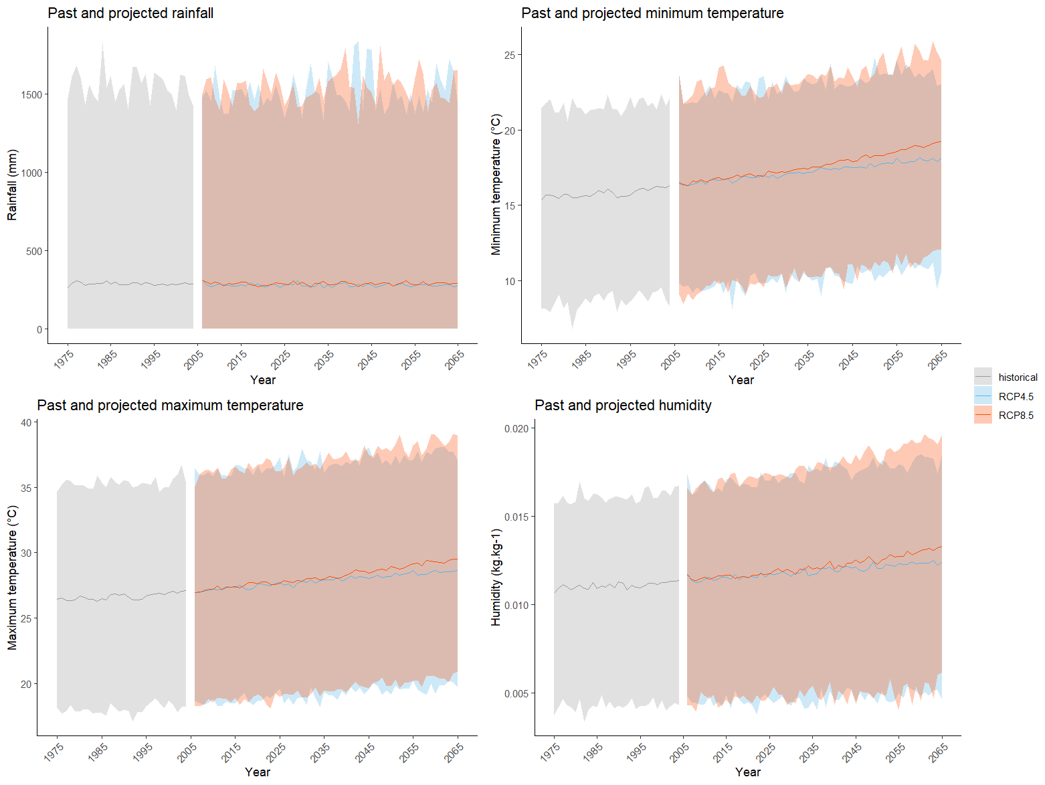
Figure S1. Annual trends (based on weekly data) of environmental variables for the historical (1975-2004) and future periods (2036-2065)
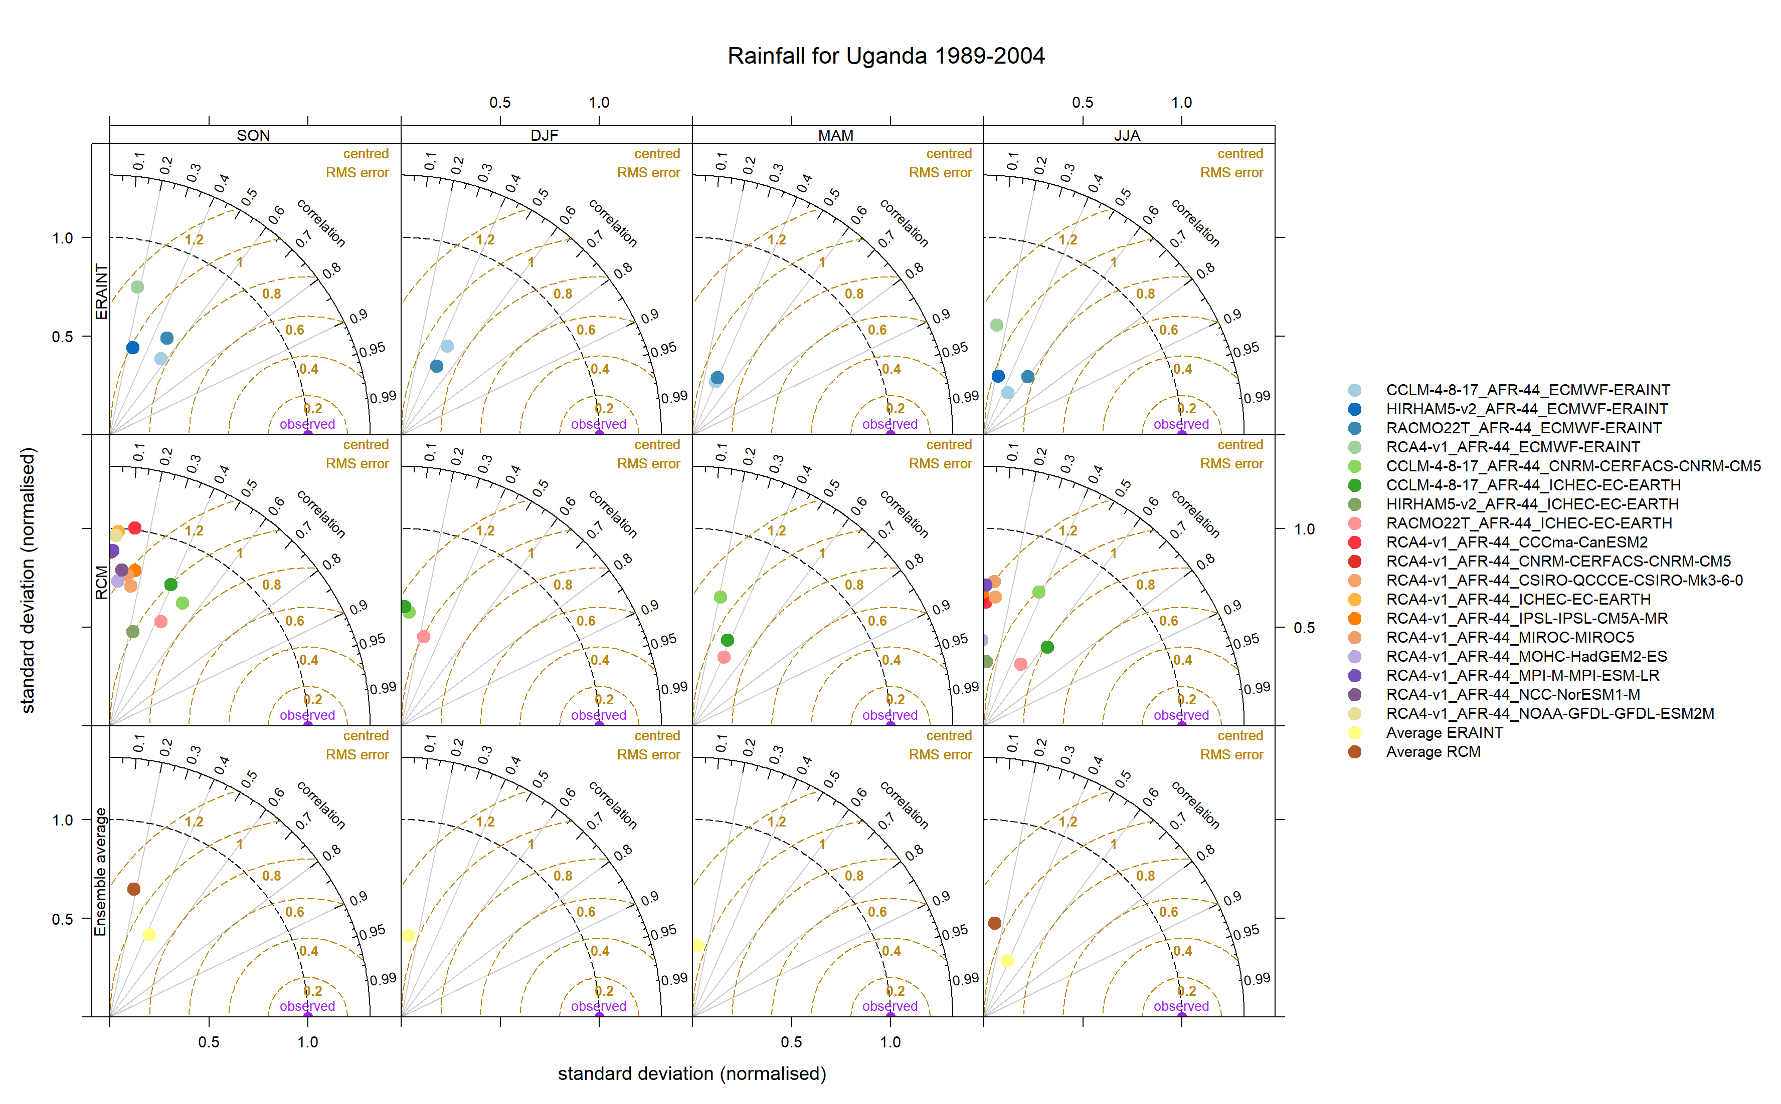
Figure S2. Taylor diagrams showing seasonal precipitation for Uganda from 1989 to 2004
Neither the GCM-driven RCMs and ERA-interim driven RCMs nor the ensemble average show a good correlation with the observed data (R < 0.6). Comparing normalized standardized standard deviations reveals that almost all GCM-driven RCMs and and ERA-interim driven RCMs exhibit an underestimation of the spatial variability of precipitations, implying that all models exhibit a lower seasonal fluctuation compared to the observed data. It should be noted that GCMs-driven RCMs, unlike ERA-interim driven RCMs, are not designed to analyze high-frequency variability (such as seasonal variability presented here) but to describe the global characteristics of the climate. This could explain the low performance of these models to simulate rainfall.

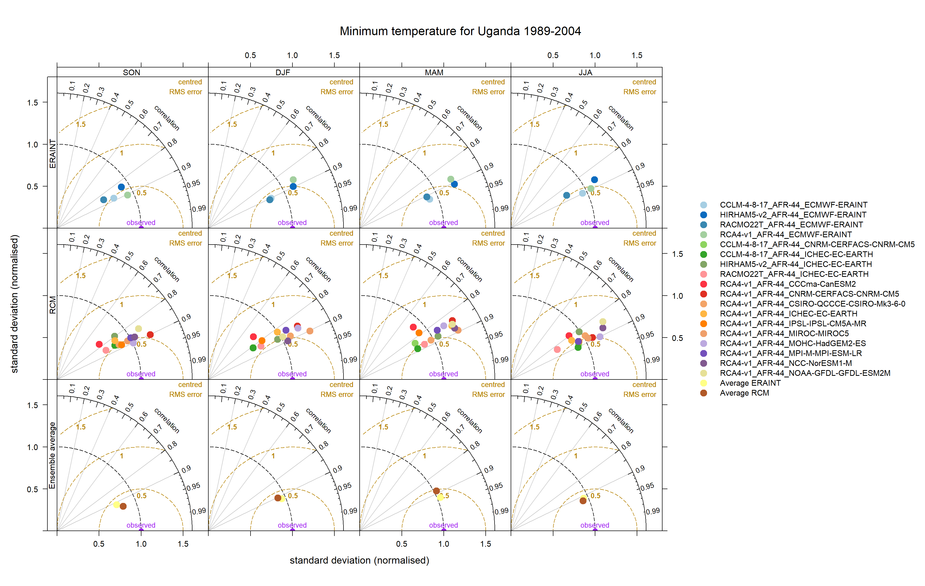Figure S3. Taylor diagrams showing seasonal minimum temperature for Uganda from 1989 to 2004
Both GCM-driven RCMs and ERA-interim driven RCMs exhibit relatively high Pearson's Correlation coefficients (R > 0.8) and a low centred RMSE (+/- 0.5). Half of GCM-driven RCMs and ERA-interim-driven RCMs tended to overestimate maximum temperature variability as they are located above the standard deviation of the observed data. Given that GCMs-driven RCMs are not designed to analyze high-frequency variability (such as seasonal variability presented here), the good performance observed of these models is probably due to chance.

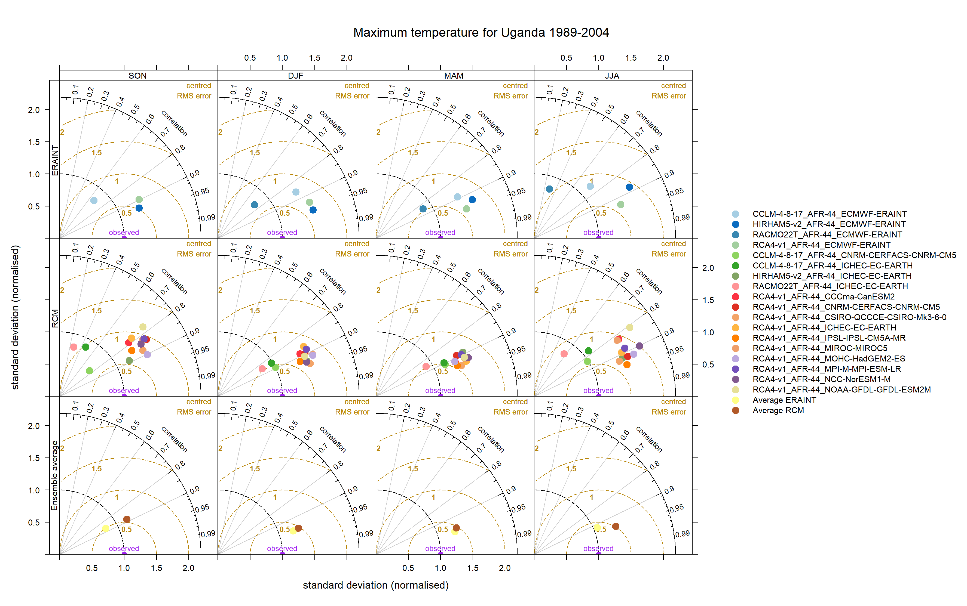
Figure S4. Taylor diagrams showing seasonal maximum temperature for Uganda from 1989 to 2004
Both GCM-driven RCMs and ERA-interim driven RCMs exhibit relatively high Pearson's Correlation coefficients (R > 0.8) and a low centred RMSE (+/- 0.5). Half of GCM-driven RCMs and ERA-interim-driven RCMs tended to overestimate maximum temperature variability as they are located above the standard deviation of the observed data. Given that GCMs-driven RCMs are not designed to analyze high-frequency variability (such as seasonal variability as presented here), the good performance observed of these models is probably due to chance.
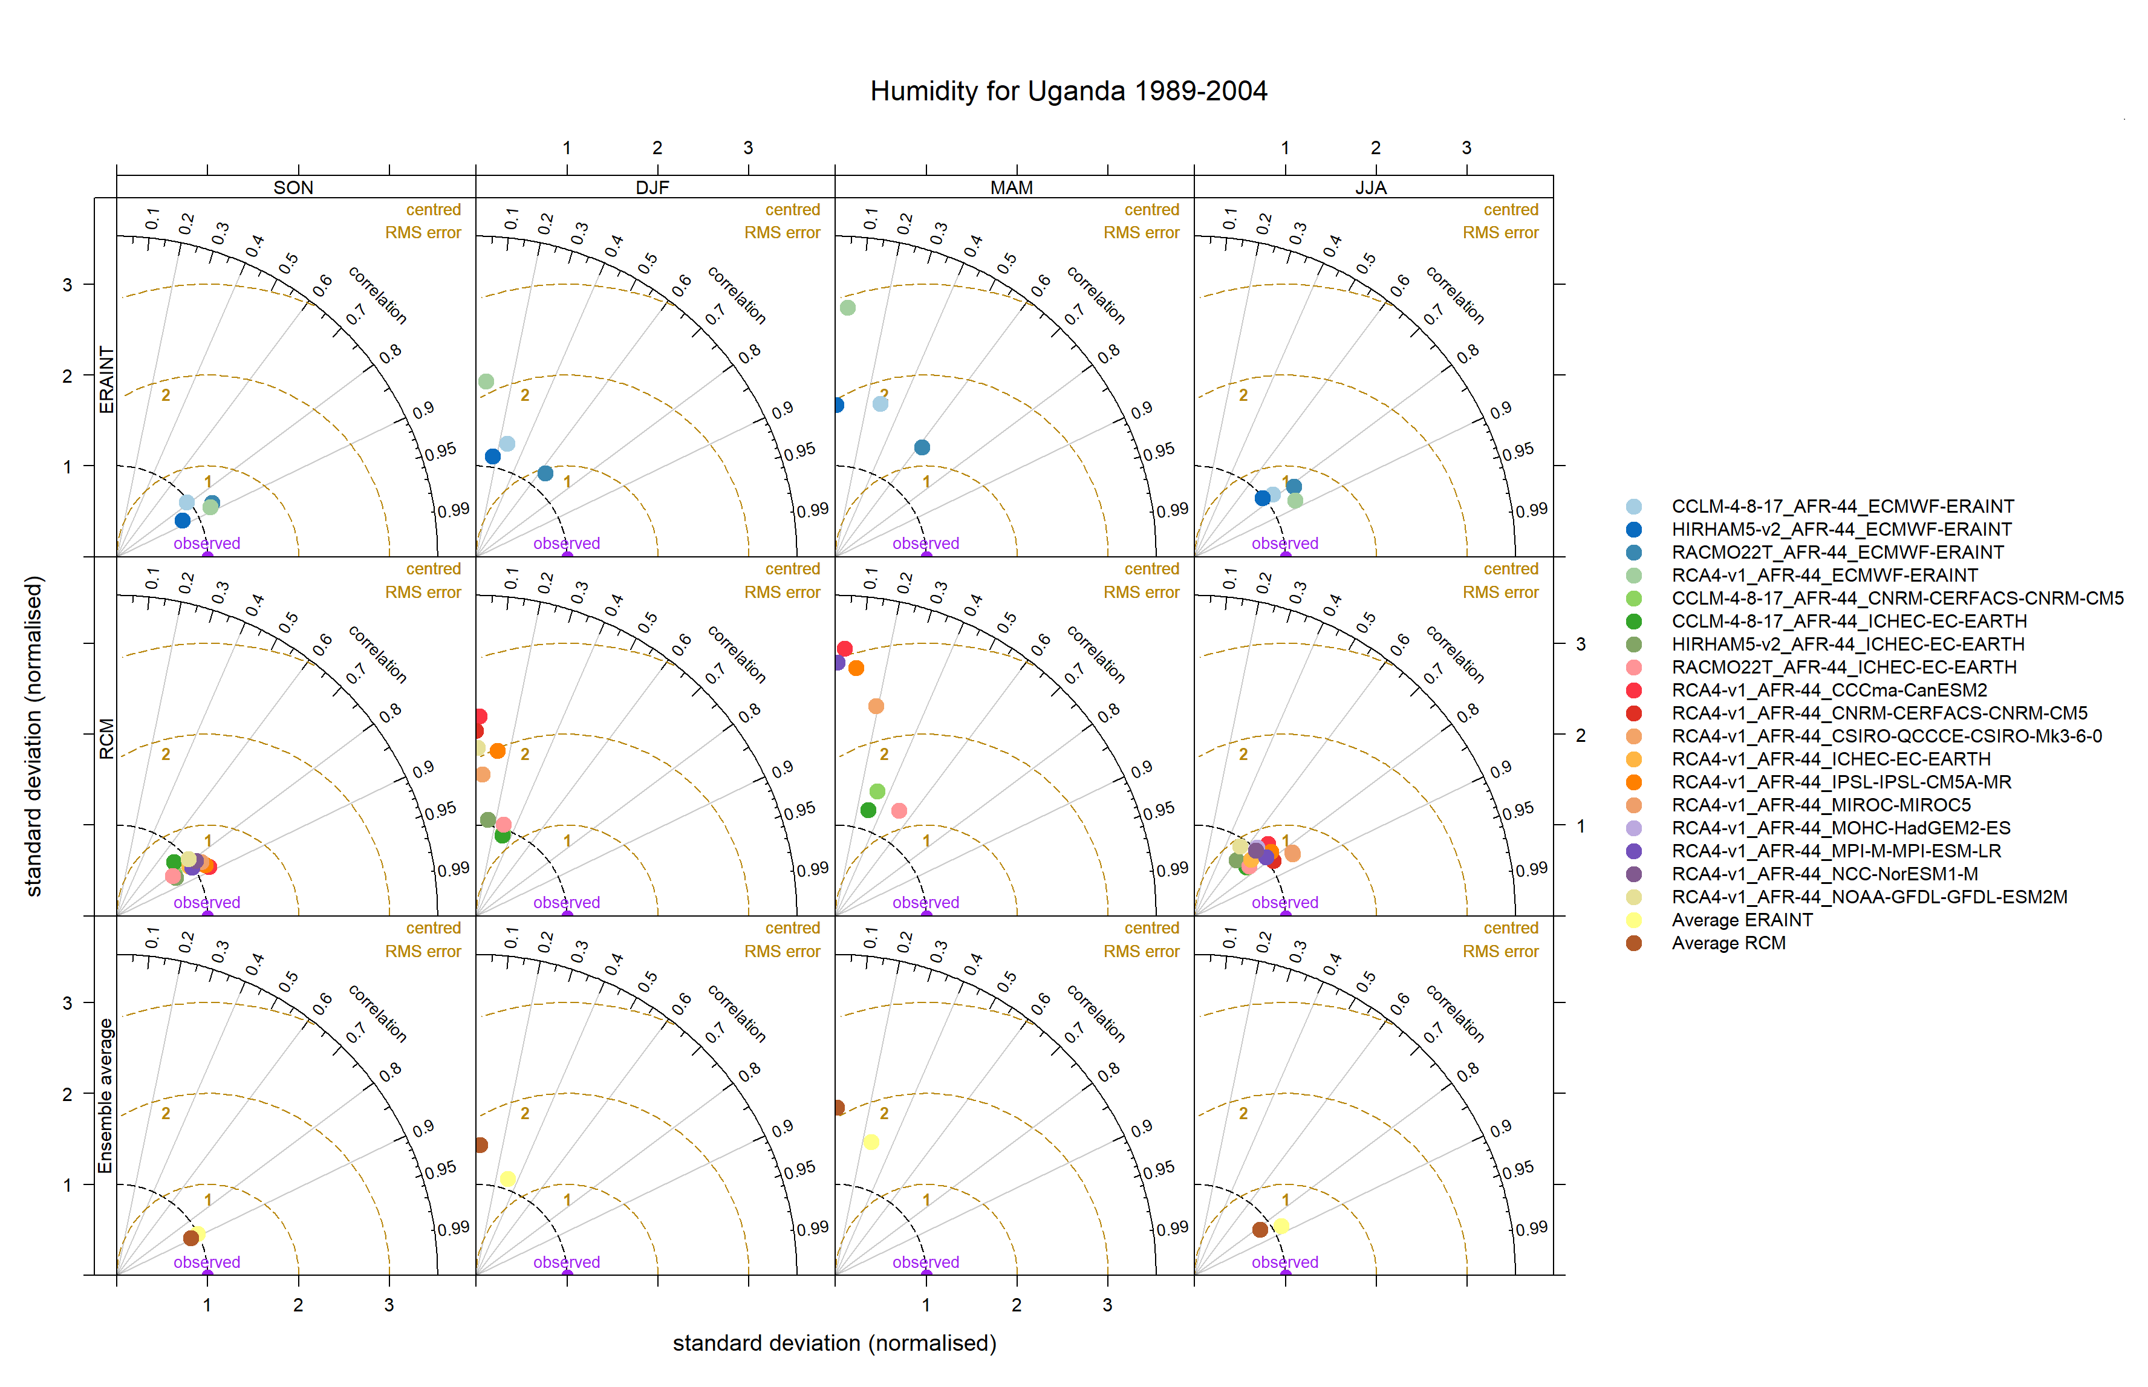
Figure S5. Taylor diagrams showing seasonal specific humidity for Uganda from 1989 to 2004
Models performances was seasonally variable, with both GCM-driven RCMs and ERA-interim driven RCMs showing better performance overall (i.e., higher Pearson’s Correlation coefficients, smaller centred RMSE, and standard deviation closer to observations) for periods between September-November and June-August. It should be noted that GCMs-driven RCMs, unlike ERA-interim driven RCMs, are not designed to analyze high-frequency variability (such as seasonal variability presented here).
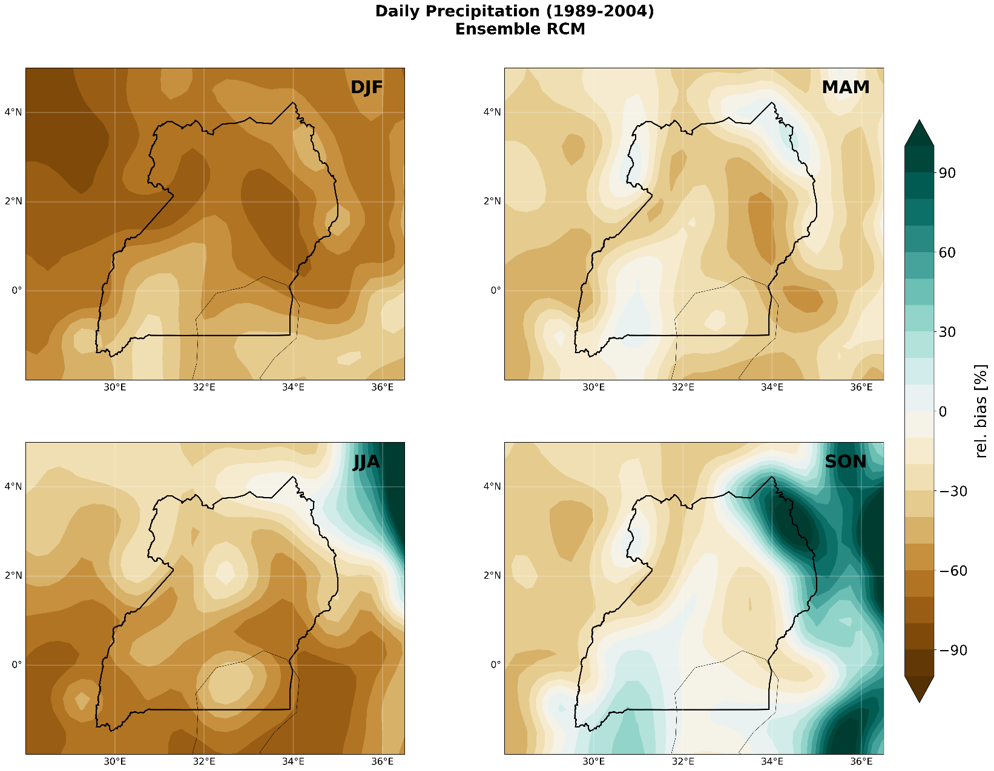
Figure S6 - Comparison of seasonal relative biases of rainfall over Uganda from 1989 to 2004
Relatively high dry biases (>50%) are observed over the northern part of Uganda between December and February (DJF) and more in the southern part between June and August (JJA), while a wet bias (>70%) is present in the northeastern extremity of the country between September and November (SON). The March to May (MAM) and September to November (SON) periods have the least bias. Wet biases indicate that precipitation simulated by GCM-driven RCMs is higher than the precipitation observed by ERA5, while dry biases indicate that precipitation simulated by GCM-driven RCMs is lower than that of ERA5
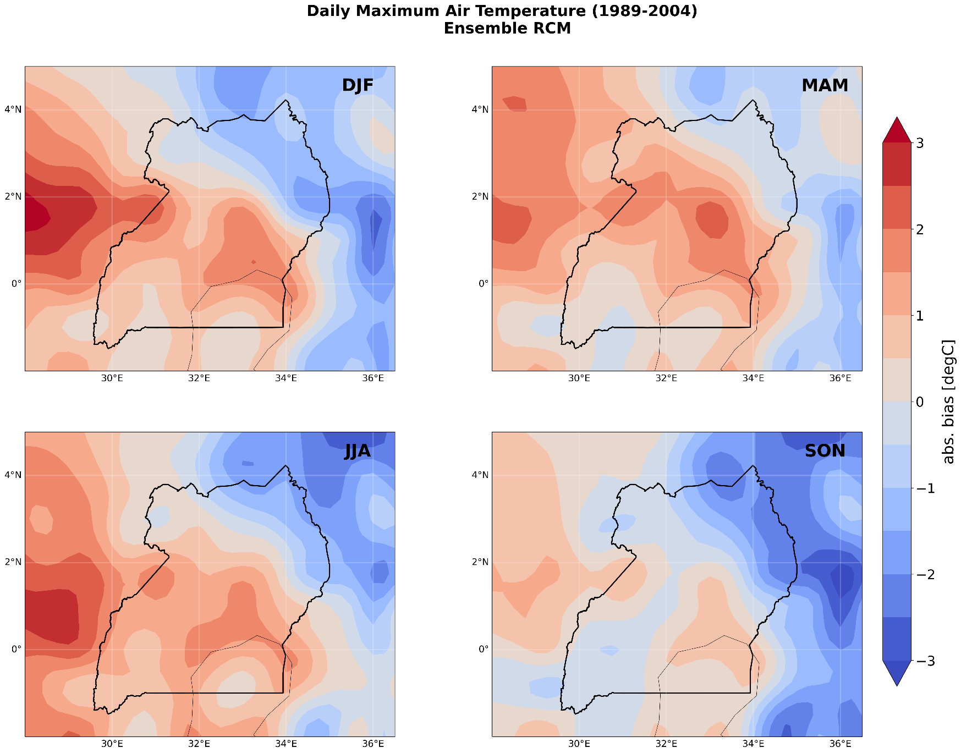
Figure S7 – Comparison of seasonal absolute biases of maximum temperature over Uganda from 1989 to 2004
The east-central part of Uganda has a greater warm bias (between +1.5°C and +2°C) for most seasons, while a cold bias (-0.5°C to -2°C) is present in the north-eastern extremity of the country. A warm bias indicates that the maximum temperatures simulated by the GCM driven RCM are higher than the maximum temperatures observed by ERA5, and a cold bias indicates that the maximum temperatures simulated by GCM driven RCM are lower than those observed by ERA5
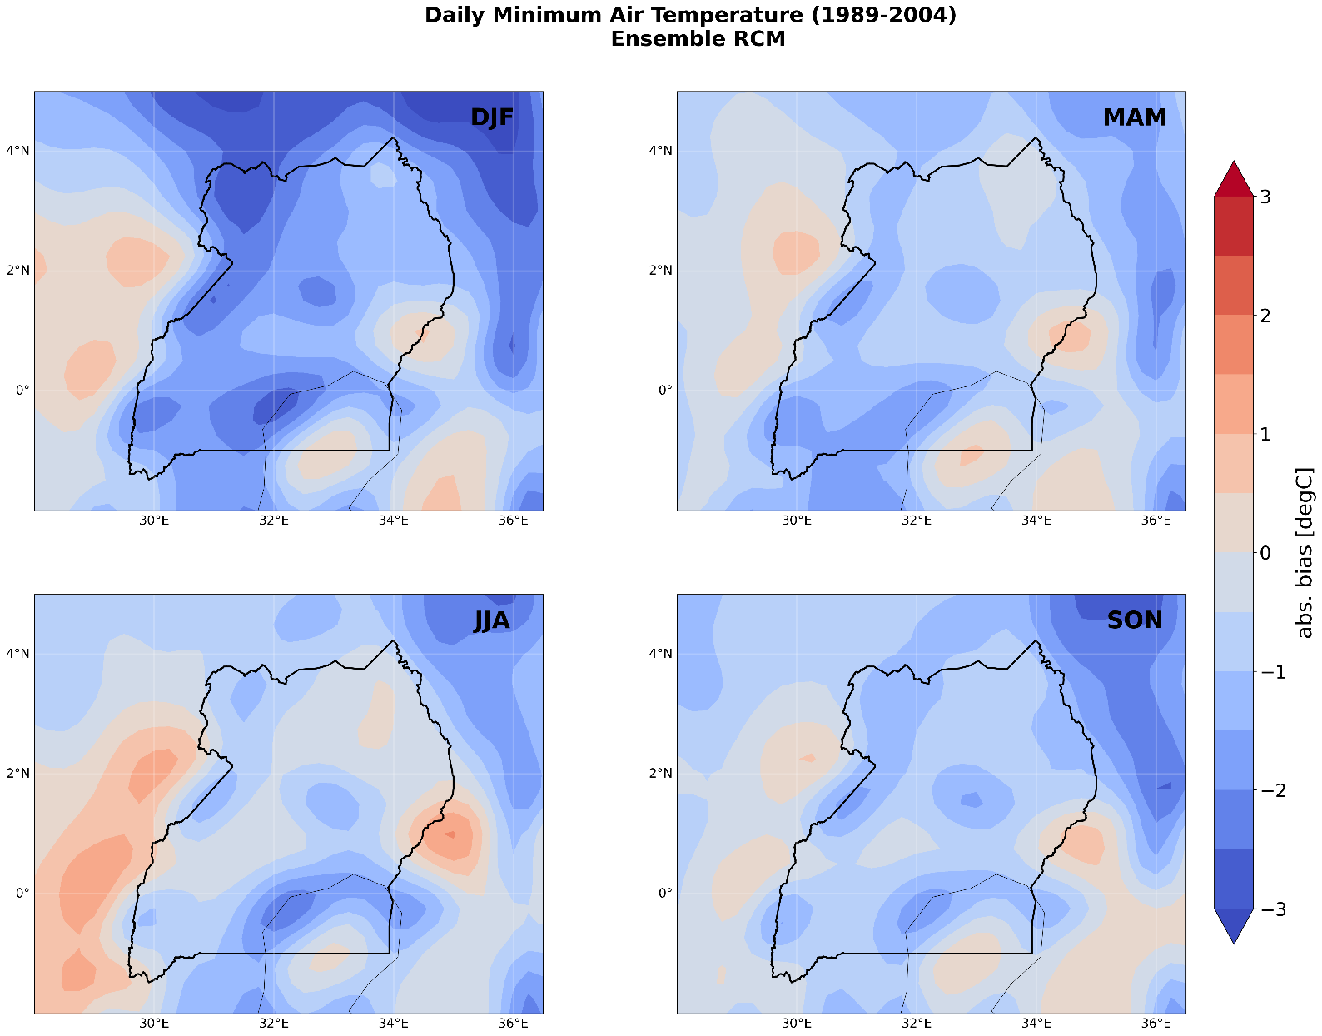
Figure S8 - Comparison of seasonal absolute biases of minimum temperature over Uganda from 1989 to 2004
The majority of biases observed across Uganda for minimum temperatures are cold biases, the largest of which (up to -2.5°C) are observed for the period December to February (DJF). A cold bias indicates that the minimum temperatures simulated by the GCM driven RCM are lower than those observed by ERA5
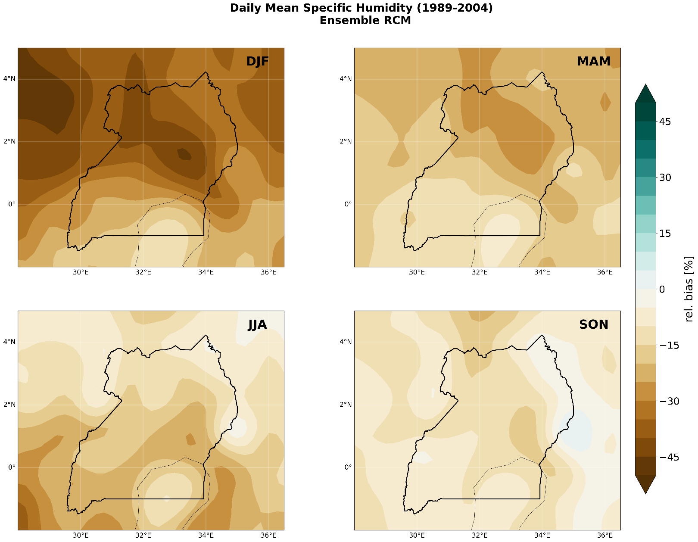
Figure S9 - Comparison of seasonal relative biases of humidity over Uganda from 1989 to 2004
For specific humidity, only dry biases are observed for the different seasons. A relatively significant dry bias (>40% and more) is present over the central and northwestern part of Uganda between December and February (DJF). Low biases (between -5 and -15%) are observed across Uganda between September and November (SON). The dry biases indicate that the specific humidity simulated by the GCM-driven RCMs is lower than the humidity observed by ERA5
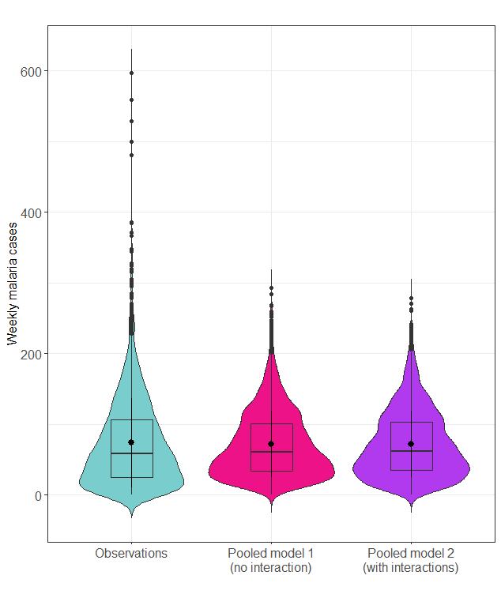
Figure S10. Comparison of observed and predicted malaria weekly cases over 2010-2018 from negative binomial GLMs; The mean of the distributions is represented by the black dots (N=53 weeks*6 regions *9 years)
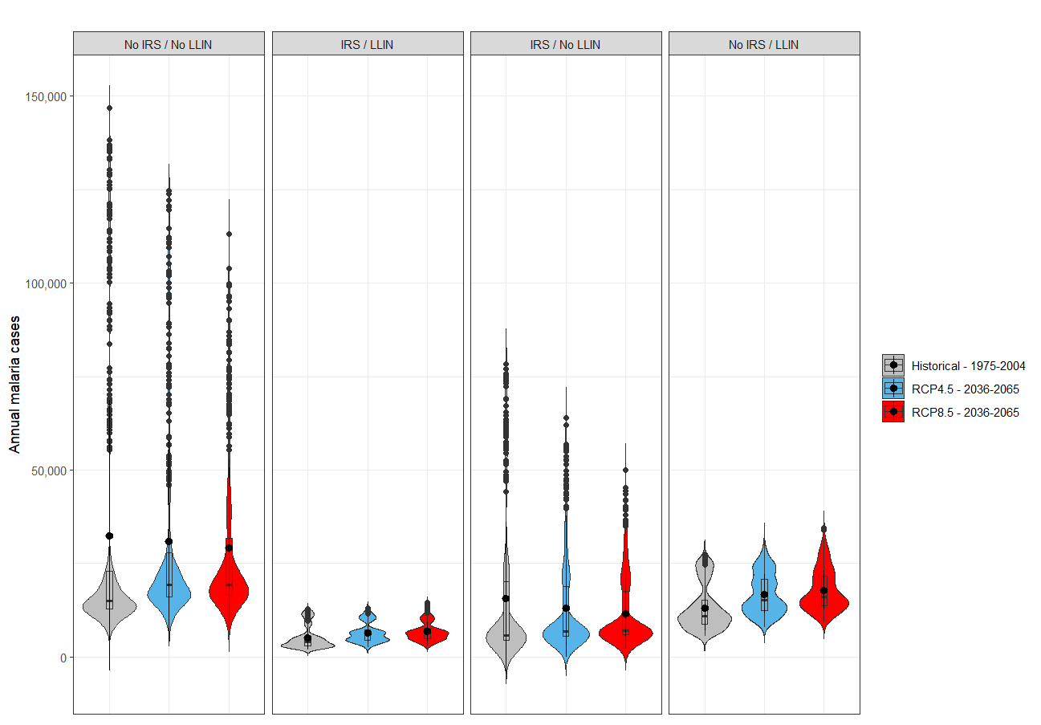
Figure S11. Distribution of annual sum of weekly malaria cases predicted for the past (1975-2004) and the future (2036-2065) periods; Predictions from the negative binomial GLM considering significant interactions between environmental variables and vector control interventions; The mean of the distributions is represented by the black dots; (N=30 years*14 climate models*4 interventions*3 periods) ; LLIN = long-lasting insecticidal nets; IRS = Indoor residual spraying
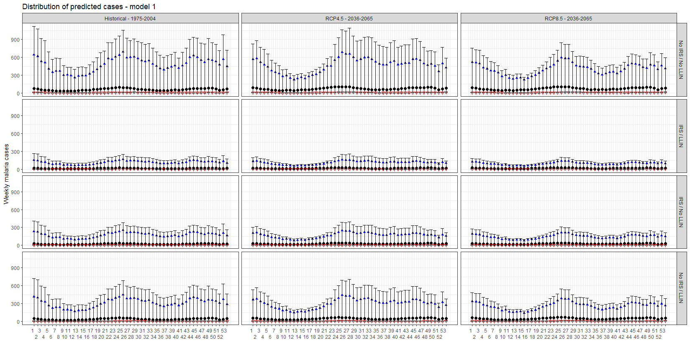Figure S12. Distribution of weekly malaria cases predicted for the past (1975-2004) and the future (2036-2065) periods for the model with no interaction; The median, the maximal and minimal prediction are represented by the black dot, the blue triangle and the red triangle, respectively; the 95% CI of the maximum and minimum predicted cases is presented; (N= 53 weeks*6 health centers*14 climate models*4 interventions*30 years*3 periods) ; LLIN = long-lasting insecticidal nets; IRS = Indoor residual spraying

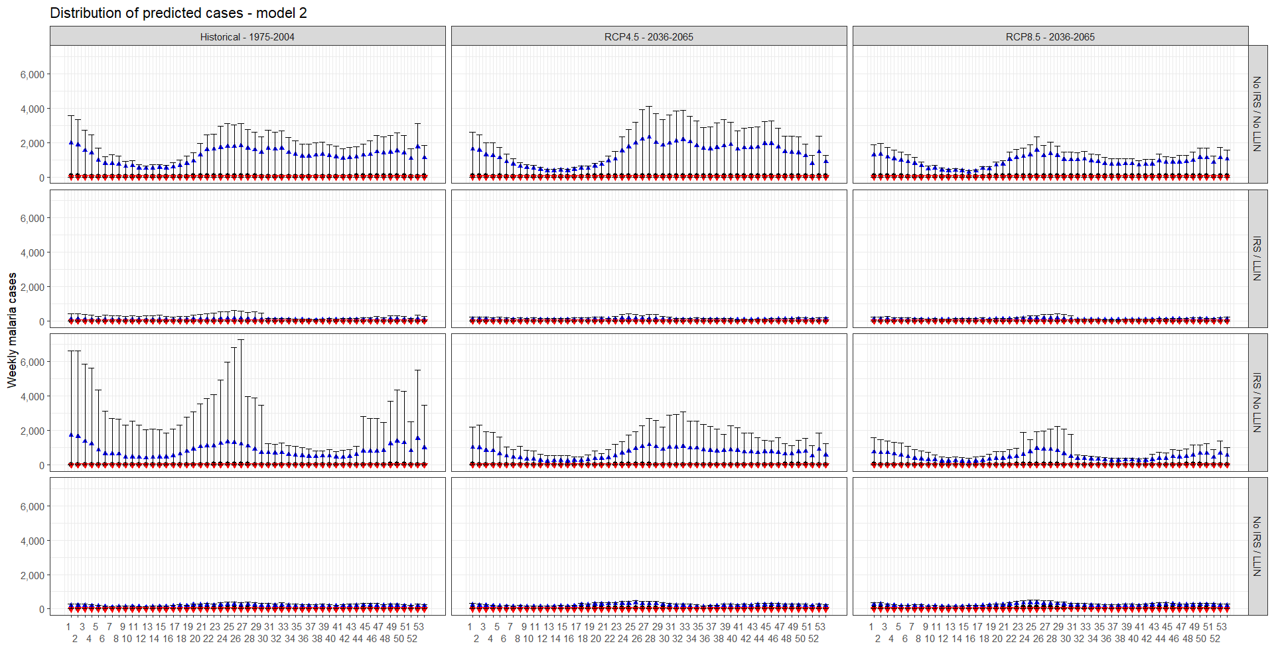
Figure S13. Distribution of weekly malaria cases predicted for the past (1975-2004) and the future (2036-2065) periods for the model with interaction; The median, the maximal and minimal prediction are represented by the black dot, the blue triangle and the red triangle, respectively; the 95% CI of the maximum and minimum predicted case is presented; (N= 53 weeks*6 health centers*14 climate models*4 interventions*30 years*3 periods) ; LLIN = long-lasting insecticidal nets; IRS = Indoor residual spraying

Data are described in Sadoine, M. L., Smargiassi, A., Liu, Y., Gachon, P., Fournier, M., Dueymes, G., ... & Zinszer, K. (2023). Differential Influence of Environmental Factors on Malaria Due to Vector Control Interventions in Uganda. International Journal of Environmental Research and Public Health, 20(22), 7042.
Data used for this model are described in Sadoine, M. L., Smargiassi, A., Liu, Y., Gachon, P., Fournier, M., Dueymes, G., ... & Zinszer, K. (2023). Differential Influence of Environmental Factors on Malaria Due to Vector Control Interventions in Uganda. International Journal of Environmental Research and Public Health, 20(22), 7042.
Data used for this model are described in Sadoine, M. L., Smargiassi, A., Liu, Y., Gachon, P., Fournier, M., Dueymes, G., ... & Zinszer, K. (2023). Differential Influence of Environmental Factors on Malaria Due to Vector Control Interventions in Uganda. International Journal of Environmental Research and Public Health, 20(22), 7042.

