Supplemental Figure 1. Calculation of the inter-electrode distance, D
Supplemental Figure 2. Optimized electrode montage for subject S3 and S13
Supplemental Figure 3. No correlation of target electric field induced by tDCS and initial FMA-UE score
Supplemental Table 1. Number of mesh elements for each head model
Supplemental Table 2. Distance between conventional tDCS electrodes and optimized tDCS electrodes
Supplemental Table 3. Electric field intensity at target region in conventional and optimized tDCS

Supplemental Figure 1. Calculation of the inter-electrode distance, D
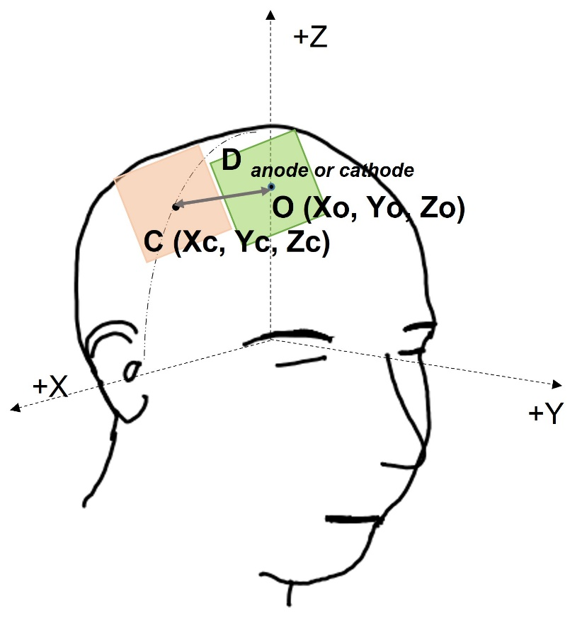
The orange electrode is the conventional tDCS electrode, and the green electrode is the optimized tDCS electrode. The inter-electrode distance, D was calculated using the following formula
D= $\sqrt{({X{c-Xo)}^{2}+{(Yc-Yo)}^{2}+(Zc-Zo)}^{2}}$,
where Xo, Yo, and Zo are NIfTI coordinate values for the center of the optimized tDCS electrode, and Xc, Yc, and Zc are NIfTI coordinate values for the center of the conventional tDCS electrode. D_{anode} represents the Euclidian distance from the center of the conventional tDCS anode to the center of the optimized tDCS anode. D_{cathode} represents the Euclidian distance from the center of the conventional tDCS cathode to the center of the optimized tDCS cathode. The sum of D_{anode} and D_{cathode} is defined as the distance D, which represents the discrepancy of electrode positions between conventional tDCS and optimized tDCS.

Supplemental Figure 2. Optimized electrode montage for subject S3 and S13
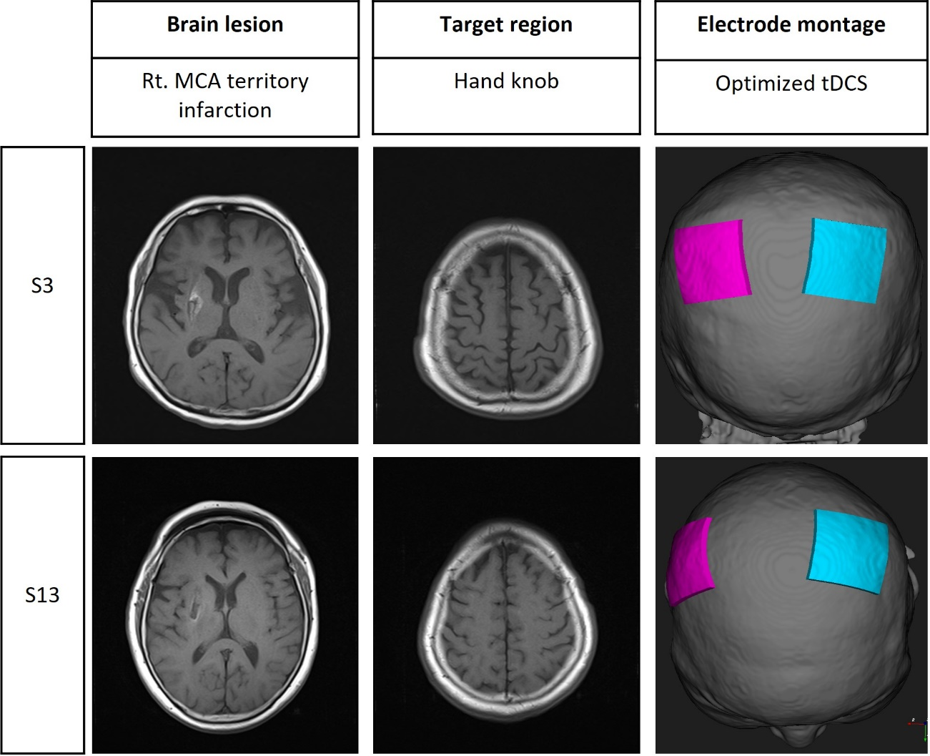
Left column shows MRI image of scar remaining after right middle cerebral artery territory infarction. Middle column shows MRI image corresponding to the hand knob area, which is the target of tDCS. Right column shows the montage pairs of optimized tDCS. The pink electrode represents the anode and the cyan electrode represents the cathode.

Supplemental Figure 3. No correlation of target electric field induced by tDCS and initial FMA-UE score

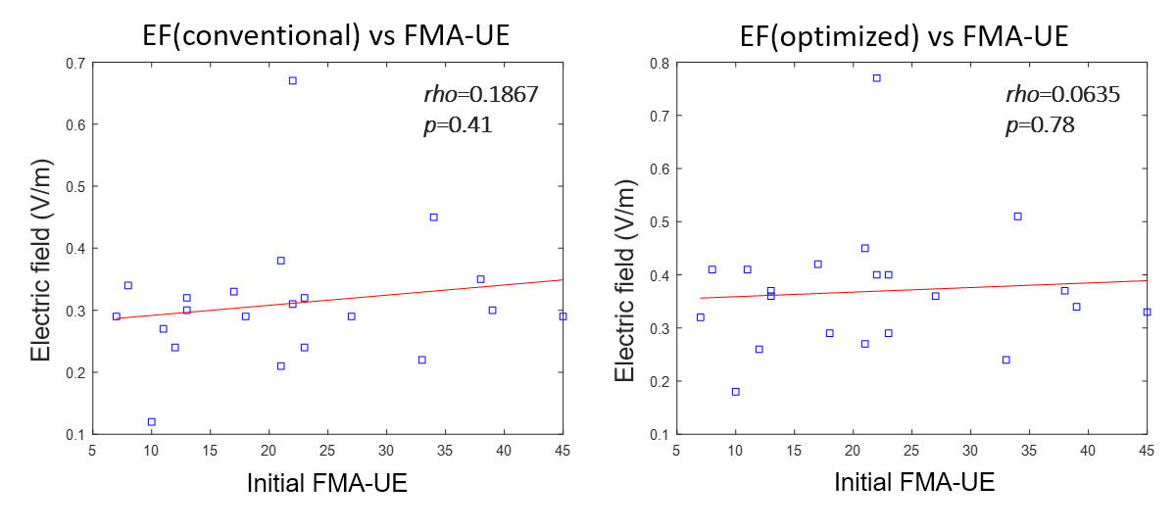
Supplemental Table 1. Number of mesh elements for each head model
Patient | Mesh elements
S1 | 4,733,814
S2 | 4,950,951
S3 | 4,657,418
S4 | 4,721,610
S5 | 4,388,246
S6 | 4,751,685
S7 | 4,250,296
S8 | 4,669,387
S9 | 3,912,159
S10 | 4,772,203
S11 | 4,163,605
S12 | 4,663,435
S13 | 3,750,594
S14 | 4,158,070
S15 | 4,752,094
S16 | 4,324,572
S17 | 4,626,978
S18 | 5,001,684
S19 | 4,387,535
S20 | 4,816,512
S21 | 4,102,843
Average  [SD] | 4,502,652  [344,194]

Supplemental Table 2. Distance between conventional tDCS electrodes and optimized tDCS electrodes
Patient | D_{cathode} (mm) | D_{anode} (mm) | D (mm)
S1 | 34.76 | 32.19 | 66.95
S2 | 46.40 | 26.98 | 73.38
S3 | 44.44 | 36.37 | 80.81
S4 | 38.24 | 23.13 | 61.37
S5 | 37.24 | 20.16 | 57.39
S6 | 41.45 | 16.66 | 58.10
S7 | 27.89 | 16.12 | 44.02
S8 | 32.60 | 31.21 | 63.80
S9 | 32.12 | 27.76 | 59.89
S10 | 44.69 | 18.46 | 63.15
S11 | 37.88 | 41.72 | 79.60
S12 | 28.87 | 29.42 | 58.29
S13 | 41.67 | 30.99 | 72.66
S14 | 42.07 | 23.28 | 65.35
S15 | 31.41 | 19.99 | 51.40
S16 | 30.57 | 29.67 | 60.23
S17 | 29.56 | 7.28 | 36.84
S18 | 42.43 | 17.77 | 60.20
S19 | 40.05 | 17.10 | 57.15
S20 | 27.96 | 26.04 | 54.01
S21 | 38.63 | 15.48 | 54.12
median  [IQR] | 37.87  [31.19-41.76] | 23.28  [17.60-29.99] | 60.21  [57.14-66.94]

D_{anode} represents the Euclidian distance from the center of conventional tDCS anode to the center of optimized tDCS anode. D_{cathode} represents the Euclidian distance from the center of conventional tDCS cathode to the center of optimized tDCS cathode. D is the sum of D_{cathode} and D_{anode}. IQR, interquartile range.
Supplemental Table 3. Electric field intensity at target region in conventional and optimized tDCS
Patient | Conventional EF (V/m) | Optimized EF (V/m) | Improvement (%)
S1 | 0.27 | 0.41 | 52
S2 | 0.32 | 0.37 | 16
S3 | 0.24 | 0.26 | 8
S4 | 0.38 | 0.45 | 18
S5 | 0.29 | 0.36 | 24
S6 | 0.3 | 0.36 | 20
S7 | 0.67 | 0.77 | 15
S8 | 0.21 | 0.27 | 29
S9 | 0.32 | 0.40 | 25
S10 | 0.24 | 0.29 | 21
S11 | 0.12 | 0.18 | 50
S12 | 0.29 | 0.33 | 14
S13 | 0.31 | 0.40 | 29
S14 | 0.34 | 0.41 | 21
S15 | 0.35 | 0.37 | 6
S16 | 0.33 | 0.42 | 27
S17 | 0.45 | 0.51 | 13
S18 | 0.29 | 0.32 | 10
S19 | 0.22 | 0.24 | 9
S20 | 0.29 | 0.29 | 0
S21 | 0.30 | 0.34 | 13
median [IQR] | 0.30  [0.26-0.33] | 0.36  [0.29-0.41] | P value <0.001

Improvement (%) was calculated as ((electric field during optimized tDCS minus electric field during conventional tDCS)/electric field during conventional tDCS) x 100%. P value was derived from Wilcoxon signed rank test. IQR, interquartile range, EF, electric field intensities.

