Genome Wide Association Study of Seedling and Adult Plant Leaf Rust Resistance in two subsets of barley genetic resources

Mariam Amouzoune^{1, 2*}, Sajid Rehman^{2,3}, Rachid Benkirane¹, Sripada Udupa², Sujan Mamidi⁴, Zakaria Kehel², Muamer Al-Jaboobi², Ahmed Amri²

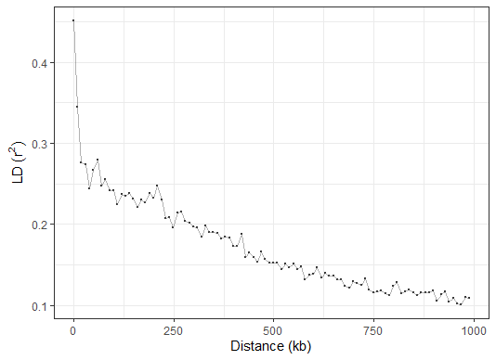
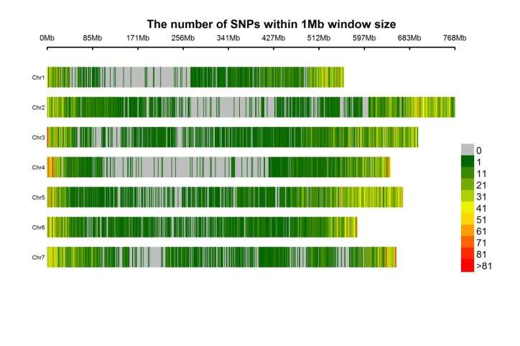

Supplementary Figure S1. SNP marker density plot per chromosome of 32,686 SNPs of both FIGS-LR and GCP subsets based on their physical position. The horizontal axis shows the length of the chromosome (Mb). Color gradient scale on the right indicates the SNP density.
Supplementary Figure S2. Linkage disequilibrium (LD) decay in 218 barley genotypes of FIGS-LR and GCP subsets by plotting r² values against physical position (kb).

Supplementary Figure S3. QQ plots for LR resistance at the seedling (ISO-MRC, ISO-SAT) and the adult plant stages (SAT2017, SAT2018, SAT2019, and GUICH2018) using all GAPIT models in both barley subsets FIGS-LR and GCP.

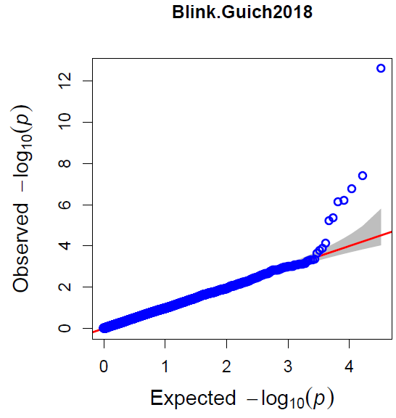
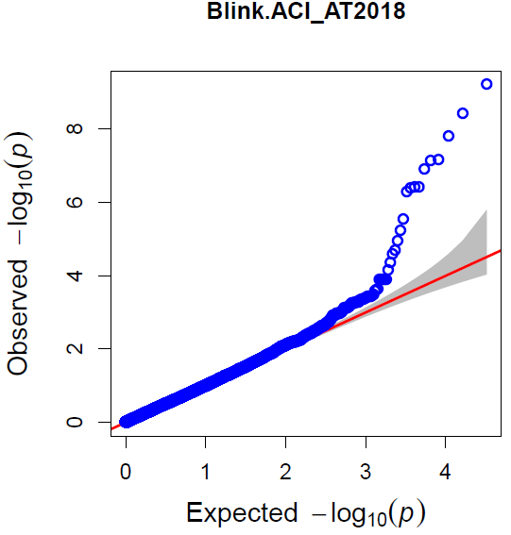
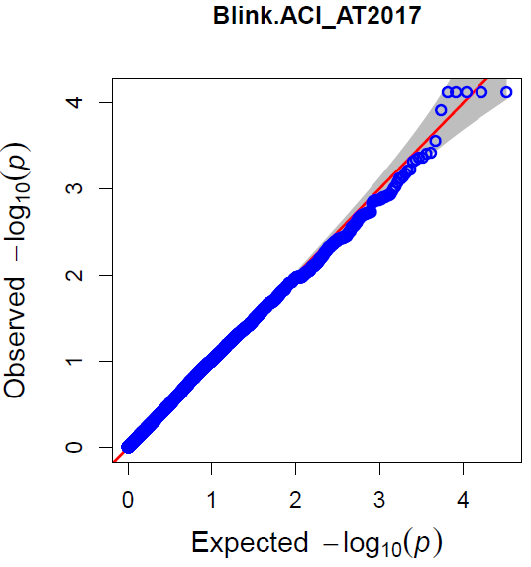
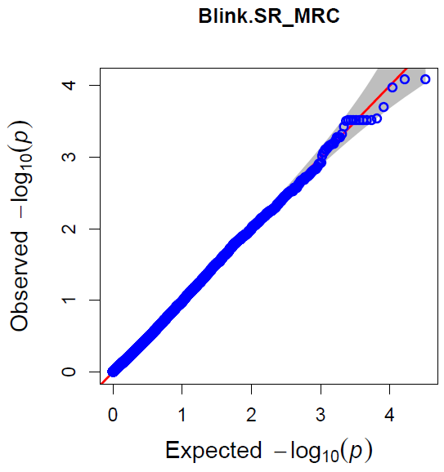
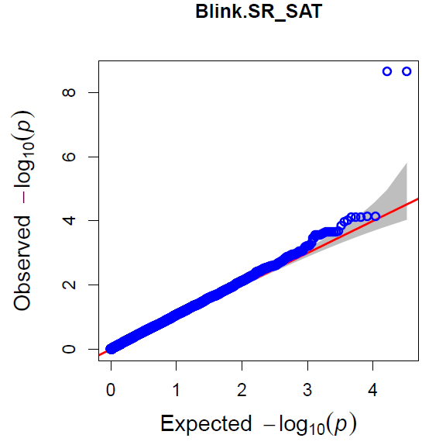
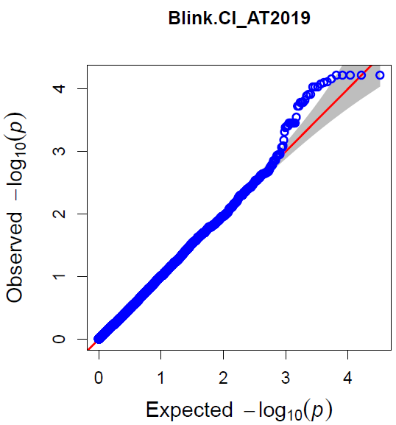
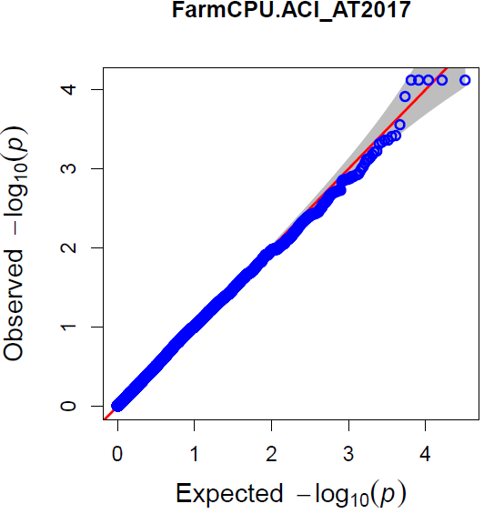
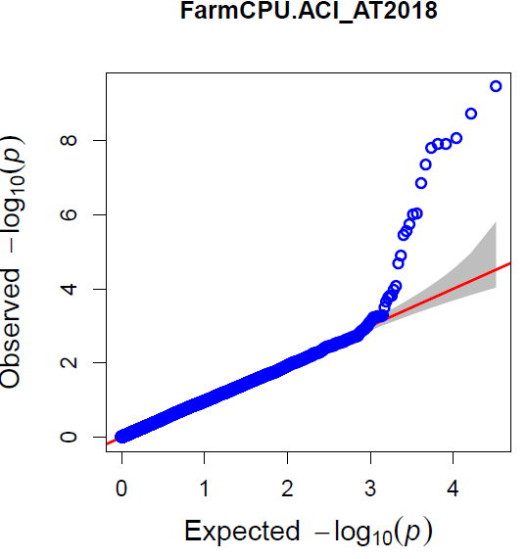
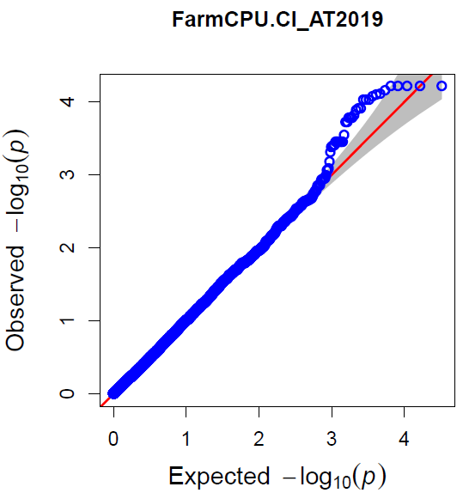
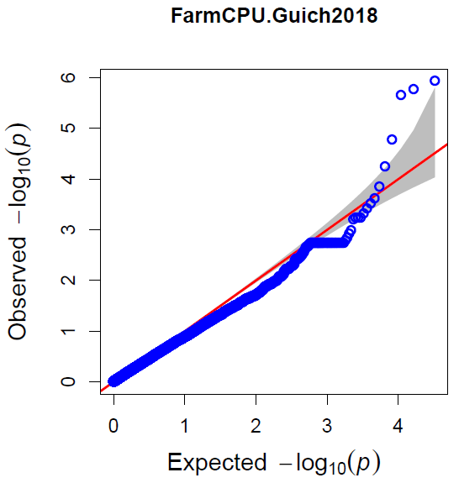
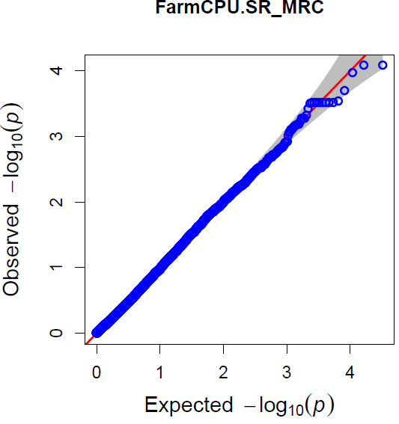
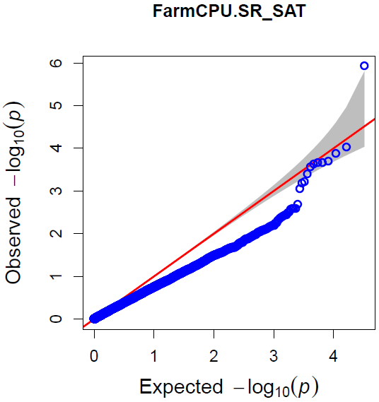
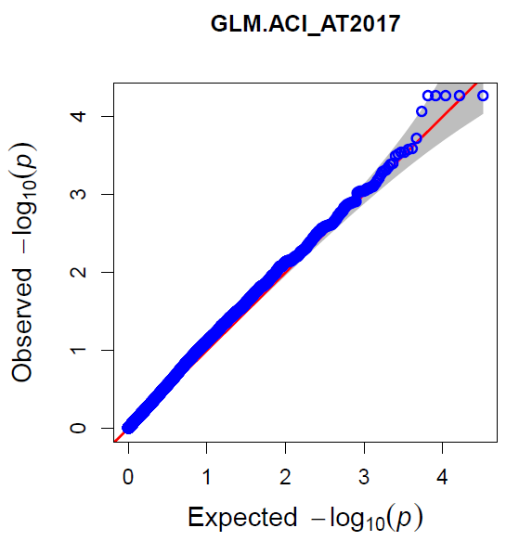
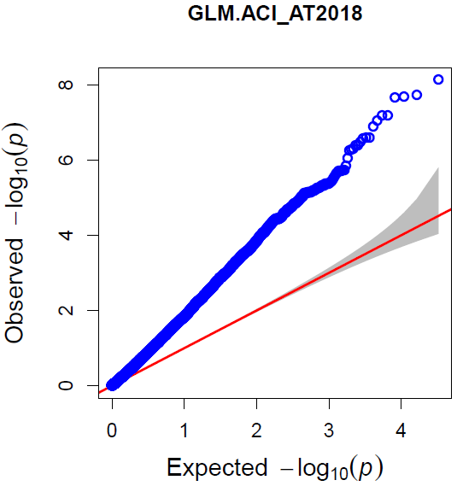
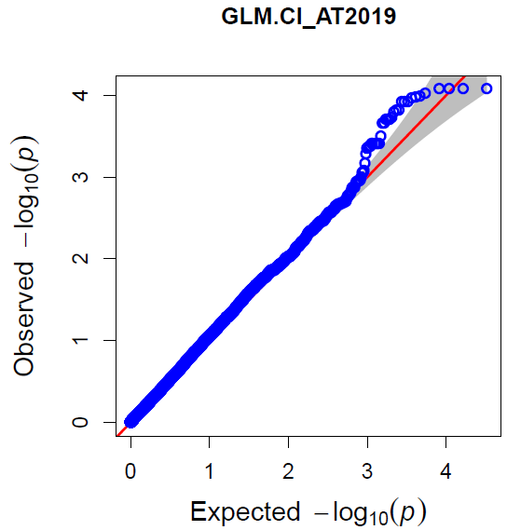
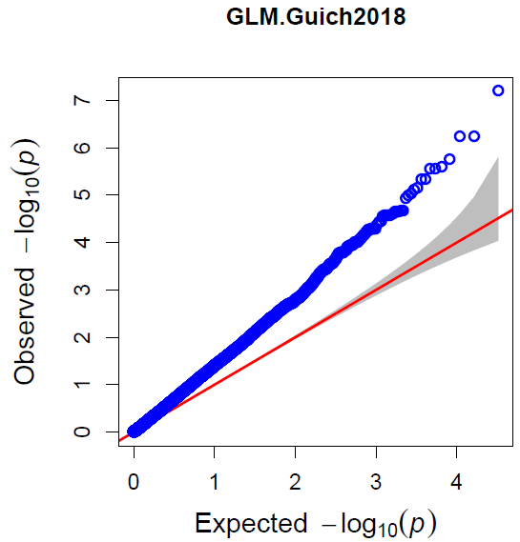
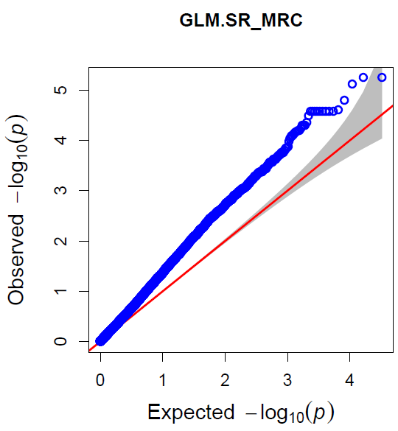
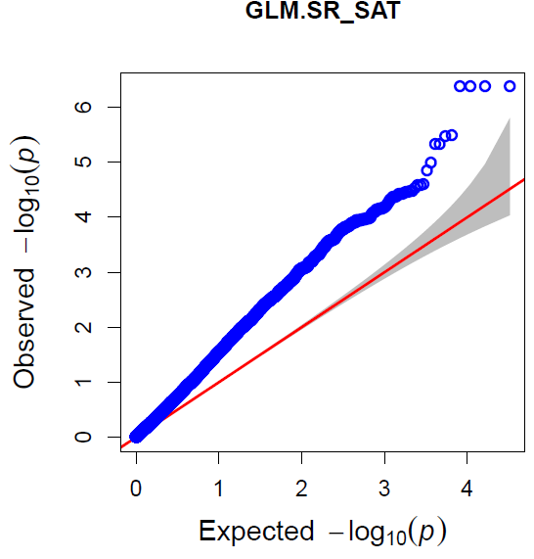
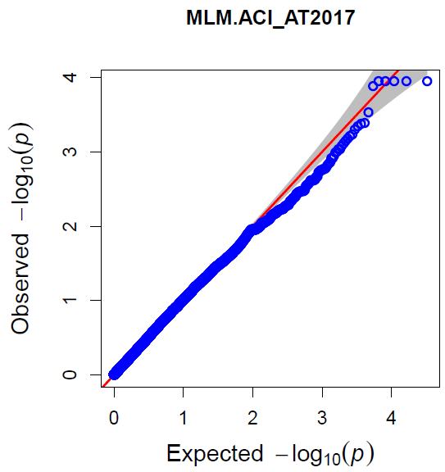
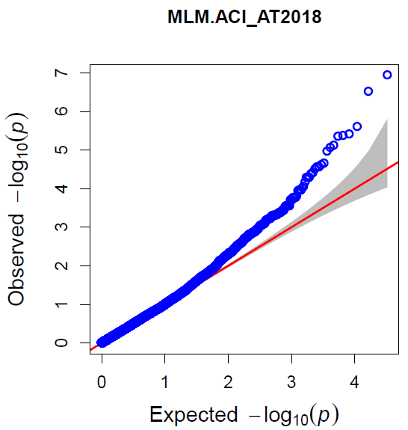
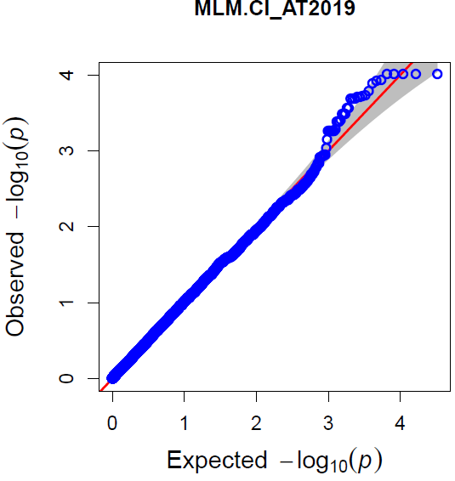
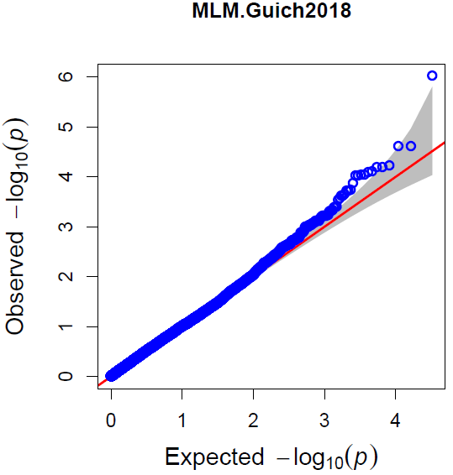
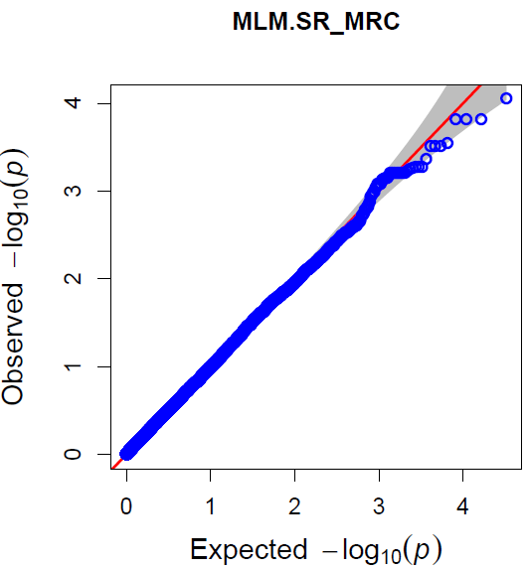
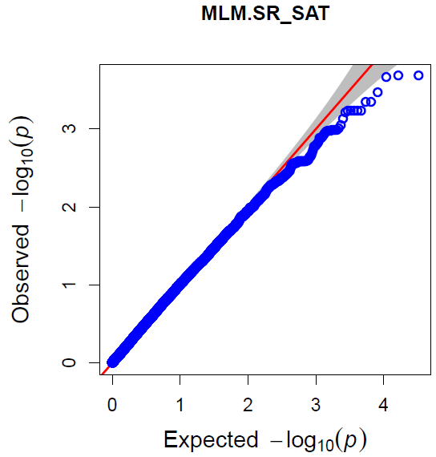
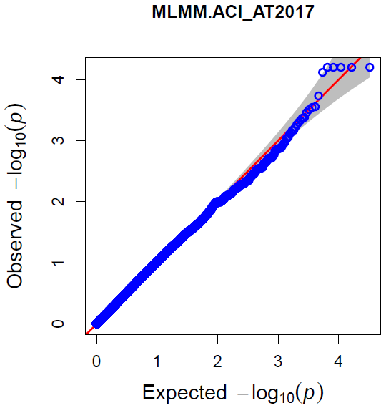
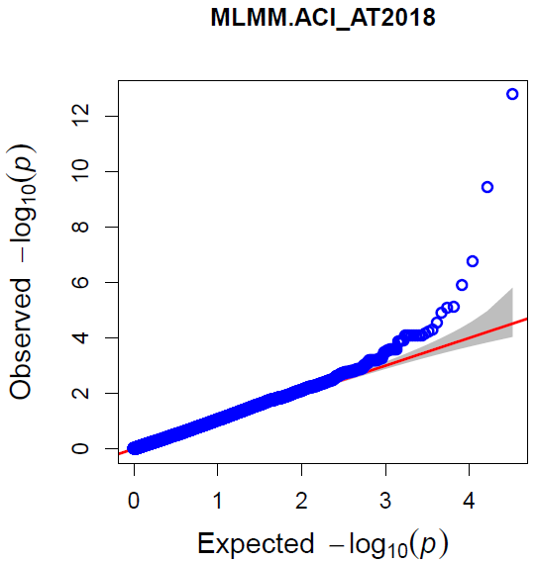
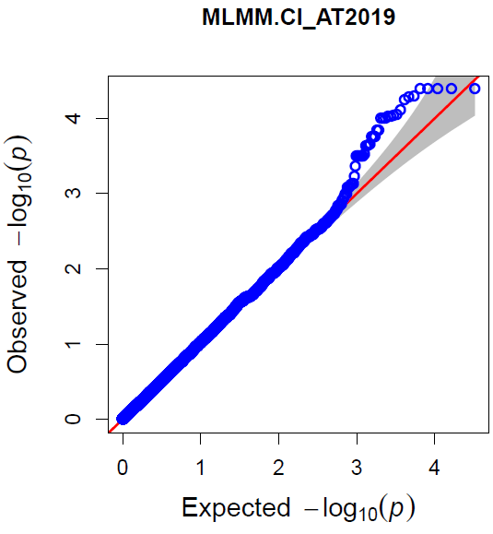
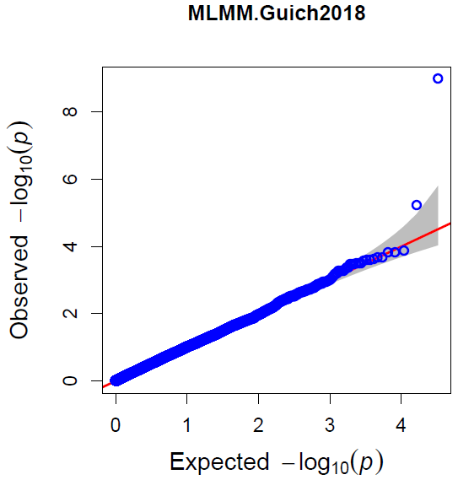
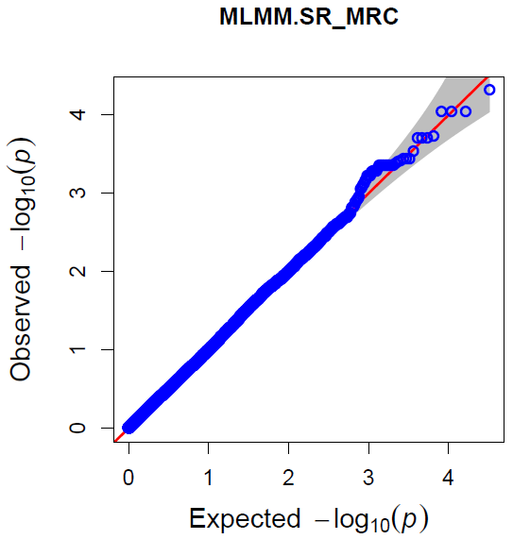
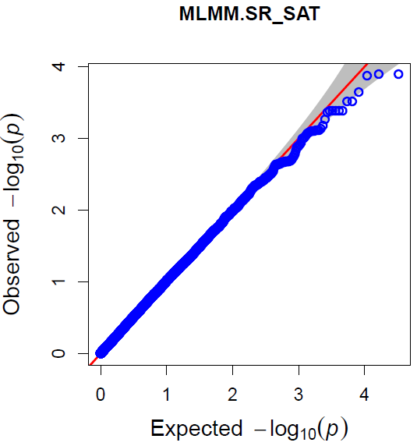
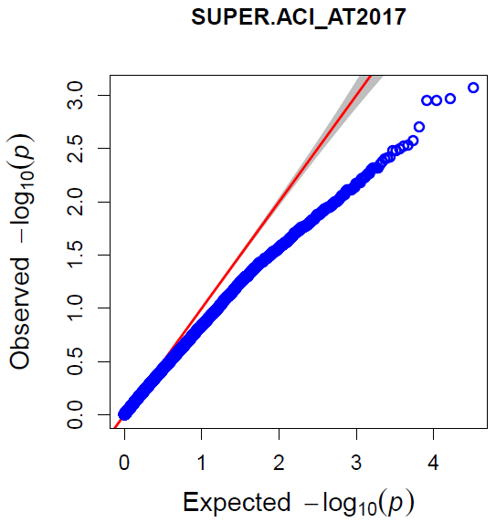
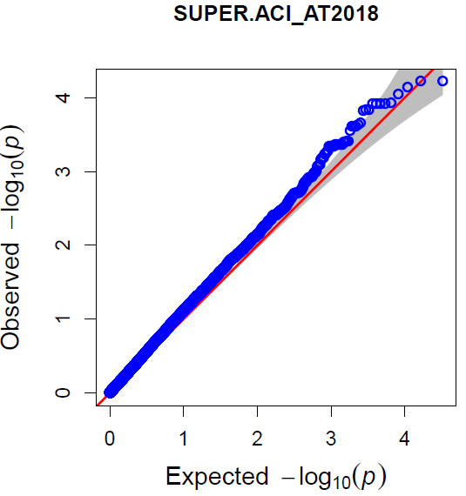
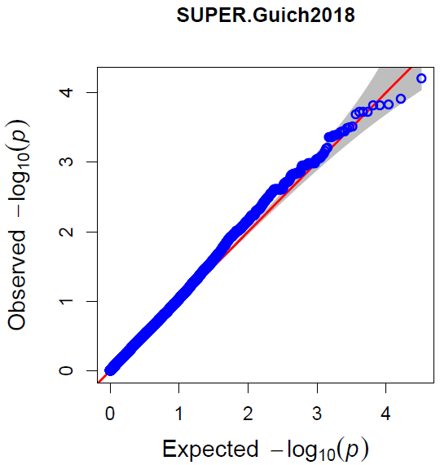
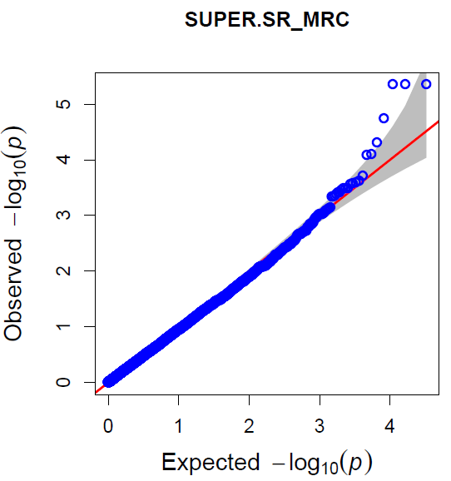
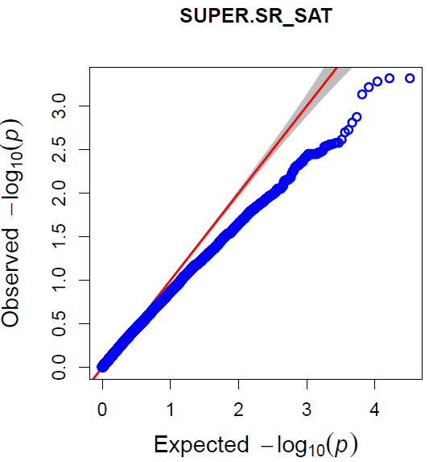
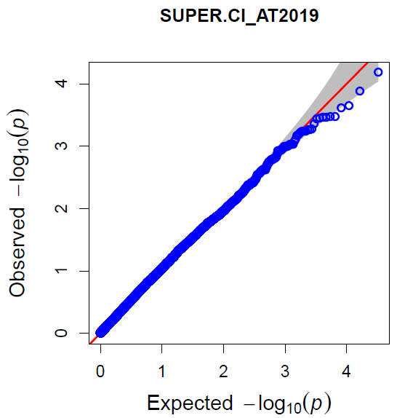

Supplementary Figure S4. Genome-wide association mapping of barley leaf rust resistance at the seedling (ISO-MRC, ISO-SAT) and adult plant stages (SAT2017, SAT2018, SAT2019, and GUICH2018) using the MLM (PCA+K) model in GAPIT3. (a) Quantile-Quantile (Q-Q) plots of marker-trait association; (b) Manhattan plots shows –log10 of p-values from genome-wide association mapping against the positions of SNPs on all chromosomes of both barley subsets (FIGS-LR and GCP). The p-value threshold (-log10 p-value (0.0005) ≥ 3.3) was used to declare significant QTL.
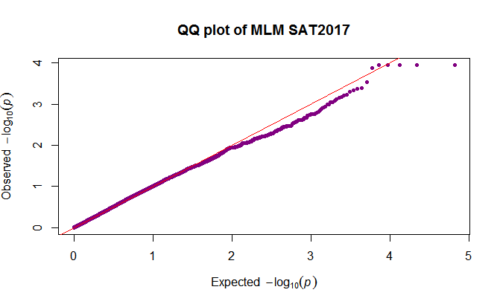
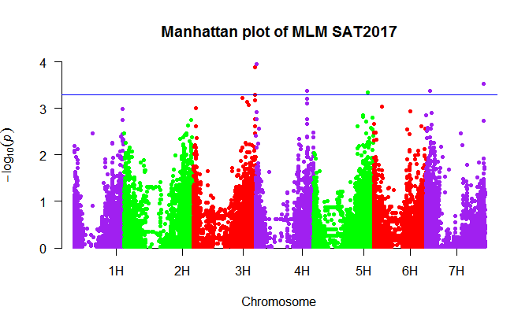
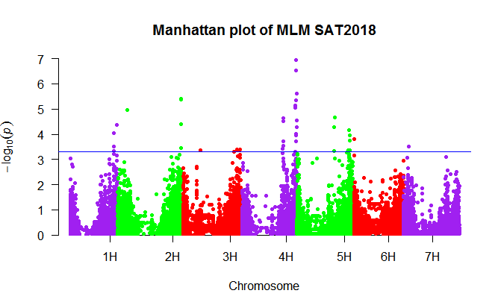
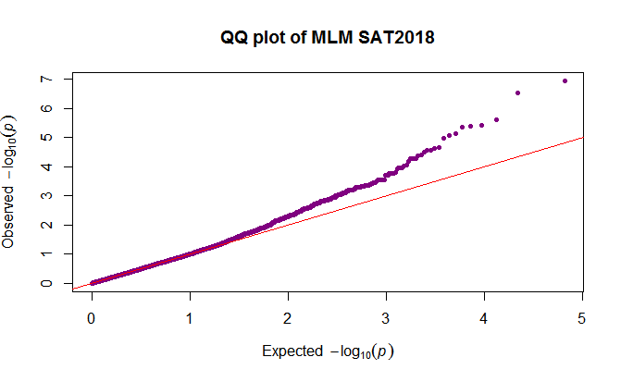
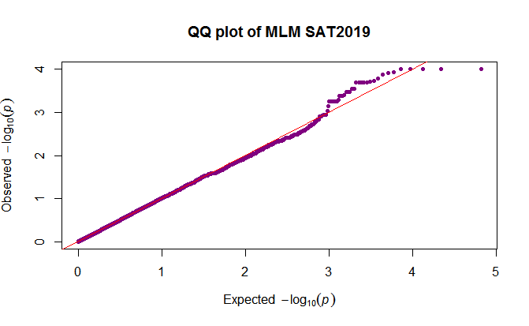
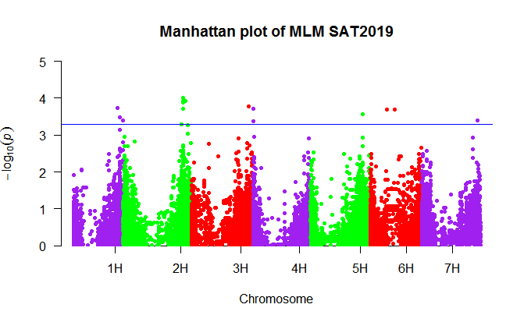
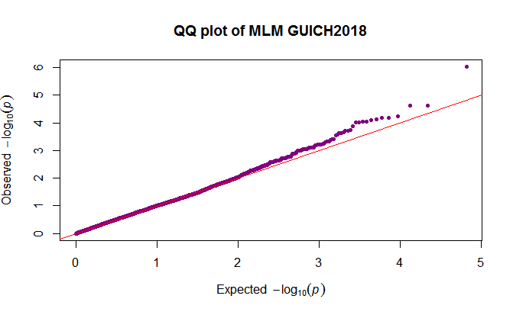
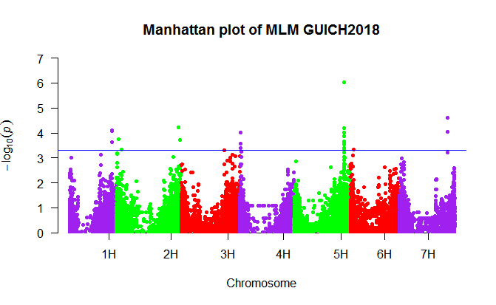
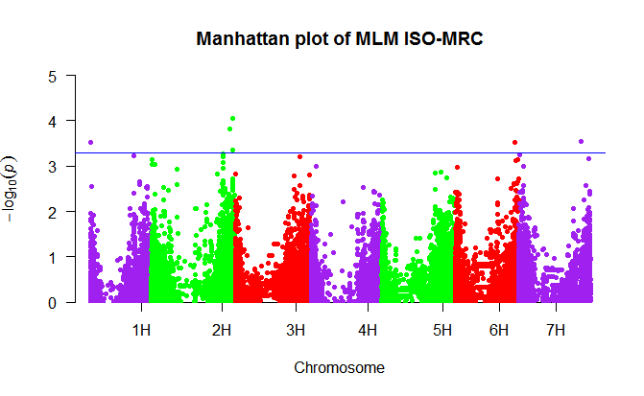
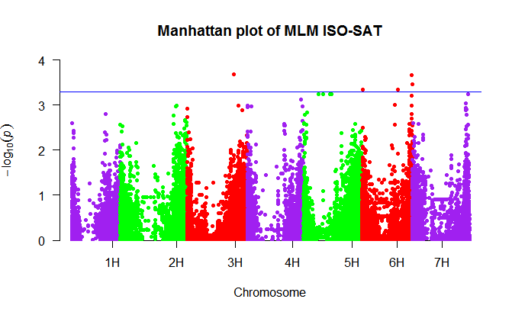
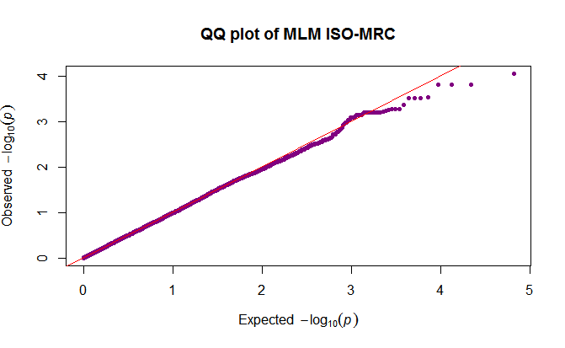
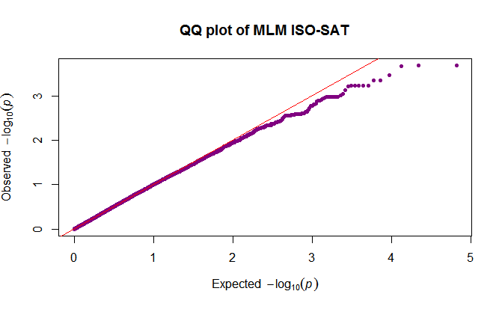
a)
b)

Supplementary Table S1: Evaluation of the two barley subsets (FIGS-LR and GCP) for the resistance to P. hordei at the seedling and at adult plant stages.
IG | Subset | RT | Origin | ISO-SAT | ISO-MRC | SAT2017 | SAT2018 | GUICH  2018 | SAT2019
16875 | FIGS-LR | 6 | RUS | 2 | 1 | 47 | 0.3 | 3.2 | 10
16880 | FIGS-LR | 6 | RUS | 2 | 3 | 36 | 2 | 0.2 | NA
16883 | FIGS-LR | 6 | RUS | 2 | 2 | 27 | 2.1 | 26 | NA
17396 | FIGS-LR | 6 | MNE | 2 | 1 | 53 | 0.4 | 7.23 | NA
17398 | FIGS-LR | 6 | MNE | 3 | 3 | 20 | 0.4 | 0.4 | NA
17424 | FIGS-LR | 2 | MNE | 2 | 2 | 24 | 2 | 27.2 | NA
18755 | FIGS-LR | 6 | TUR | 2 | 2 | 51 | 0.3 | 2.2 | NA
18798 | FIGS-LR | 6 | TUR | 2 | 2 | 15 | 0.5 | 3.55 | 20
18938 | FIGS-LR | 6 | GRC | 2 | 2 | 3 | 0.2 | 2.2 | 30
18953 | FIGS-LR | 6 | GRC | 1 | 2 | 34.5 | NA | 8 | 6
18955 | FIGS-LR | 6 | GRC | 1 | 2 | 28 | 0.2 | 11.1 | 30
19037 | FIGS-LR | 6 | GRC | 1 | 2 | 16 | 0.5 | 1.25 | NA
19095 | FIGS-LR | 6 | GRC | 2 | 2 | 8.1 | 0.25 | NA | NA
19209 | FIGS-LR | 6 | TUR | 2 | 2 | 16 | 1.7 | 5.45 | 10
19617 | FIGS-LR | 6 | GRC | 2 | 2 | 3.2 | 0.3 | 10.15 | NA
21781 | FIGS-LR | 6 | ETH | 4 | 2 | 40.1 | NA | 2.95 | 30
21867 | FIGS-LR | 2 | ETH | 3 | 3 | 40 | 48 | 2.2 | 6
21976 | FIGS-LR | 2 | ETH | 4 | 2 | 45 | 60 | 5.3 | 18
21978 | FIGS-LR | 6 | ETH | 3 | 3 | 50 | 12 | 3.8 | NA
22046 | FIGS-LR | 2 | ETH | 2 | 2 | 4 | 60 | 0.4 | NA
22319 | FIGS-LR | 6 | ETH | 3 | 2 | 70 | 45 | 12.45 | 8
22488 | FIGS-LR | 2 | ETH | 4 | 2 | 70 | 60 | 0.73 | NA
22489 | FIGS-LR | 6 | ETH | 2 | 2 | 65 | 40 | 7.45 | 27
22496 | FIGS-LR | 2 | ETH | 3 | 2 | 60 | 40 | 5.55 | NA
22503 | FIGS-LR | 6 | ETH | 3 | 2 | 24 | 60 | 6.7 | NA
22539 | FIGS-LR | 6 | ETH | 3 | 2 | 53 | 50 | NA | NA
22848 | FIGS-LR | 2 | ETH | 3 | 2 | 61 | 12 | 18.6 | NA
23042 | FIGS-LR | 6 | ETH | 3 | 2 | 52 | 60 | NA | 16
23112 | FIGS-LR | 2 | ETH | 3 | 2 | 60 | 40 | 6.5 | NA
23425 | FIGS-LR | 6 | ETH | 3 | 2 | 70 | 30 | 13.5 | 30
23584 | FIGS-LR | 6 | MKD | 3 | 3 | 20 | 0.4 | 9 | NA
23597 | FIGS-LR | 6 | MKD | 4 | 3 | 9 | 3.2 | 1.3 | 10
25306 | FIGS-LR | 6 | UKR | 2 | 1 | 14 | NA | NA | 16
25530 | FIGS-LR | 6 | PSE | 2 | 1 | 20 | NA | 7.15 | NA
28367 | FIGS-LR | 6 | IND | 3 | 2 | 24 | 2 | 12.1 | 30
28425 | FIGS-LR | 6 | IND | 2 | 2 | 30 | 49 | 5.43 | 30
28556 | FIGS-LR | 6 | TUR | 3 | 3 | 33 | 34 | 3.3 | NA
28613 | FIGS-LR | 6 | TUR | 2 | 2 | 12.1 | 0.2 | 9.03 | 10
28615 | FIGS-LR | 6 | TUR | 3 | 3 | 8 | 1.2 | 4.8 | NA
28621 | FIGS-LR | 6 | TUR | 2 | 2 | 21 | 5.2 | 2.93 | NA
28624 | FIGS-LR | 2 | TUR | 3 | NA | 18 | 1.1 | 1.65 | NA
28626 | FIGS-LR | 6 | TUR | 1 | 2 | 10 | 0.3 | 4.6 | 16
28628 | FIGS-LR | 6 | TUR | 2 | 3 | 40 | 0.2 | 0.6 | 30
28636 | FIGS-LR | 2 | TUR | 2 | 2 | 6 | 1.1 | 4.95 | 5
28639 | FIGS-LR | 2 | TUR | 2 | 3 | 22.7 | 7 | 0.45 | 6
28643 | FIGS-LR | 6 | TUR | 2 | 2 | 20 | 1.2 | 1.5 | 12
28647 | FIGS-LR | 6 | TUR | 3 | 2 | 6.1 | 4.1 | 0.7 | 8
28648 | FIGS-LR | 6 | TUR | 2 | 2 | 17 | 6.1 | 0.47 | 20
28674 | FIGS-LR | 6 | TUR | 3 | 3 | 60 | 58 | 10.85 | NA
29088 | FIGS-LR | 6 | JOR | 2 | 2 | 2 | NA | 0.53 | 20
31545 | FIGS-LR | 6 | JOR | NA | NA | NA | NA | NA | NA
32711 | FIGS-LR | 6 | SYR | 3 | 2 | 11 | NA | 1.4 | 8
32734 | FIGS-LR | 6 | SYR | NA | NA | NA | NA | NA | NA
33039 | FIGS-LR | 6 | DZA | 2 | 2 | 4.2 | 0.4 | 6.7 | 0.2
35331 | FIGS-LR | 6 | SYR | 1 | 2 | 4.7 | 0.3 | 7.7 | NA
35542 | FIGS-LR | 6 | SYR | 2 | 3 | 19 | 0.4 | 2.45 | 30
36497 | FIGS-LR | 2 | ETH | 2 | 2 | 21.5 | 0.6 | 0.83 | NA
36667 | FIGS-LR | 6 | IND | 2 | 3 | 8.2 | NA | 2.63 | 8
36688 | FIGS-LR | 6 | IND | 2 | 2 | 16 | NA | 3.5 | 40
36691 | FIGS-LR | 6 | IND | 2 | 2 | 24 | NA | 3.1 | 8
36714 | FIGS-LR | 6 | IND | 2 | 2 | 2 | NA | 2.07 | 0.2
36726 | FIGS-LR | 6 | IND | 2 | 3 | 75 | NA | 2.2 | NA
36727 | FIGS-LR | 6 | IND | 3 | 2 | 24 | NA | 4.47 | 12
36729 | FIGS-LR | 6 | IND | 3 | 2 | 16 | NA | 1 | 20
36730 | FIGS-LR | 6 | IND | 3 | 4 | 16 | NA | 3.47 | 4
37541 | FIGS-LR | 6 | LBY | 3 | 3 | 16 | NA | 0.8 | NA
37545 | FIGS-LR | 6 | LBY | 2 | 2 | 32 | NA | 2.47 | NA
38493 | FIGS-LR | 2 | ETH | 2 | 3 | 60 | 16 | 3 | 6
112497 | FIGS-LR | 2 | GEO | 2 | 3 | 30.2 | 0.4 | 2.5 | 16
112527 | FIGS-LR | 6 | GRC | 3 | 3 | 16.1 | 3.2 | 8.8 | 12
112590 | FIGS-LR | 2 | GRC | 2 | 2 | 20.1 | 0.2 | 1.2 | 20
120512 | FIGS-LR | 6 | GEO | 3 | 2 | 40 | NA | 9.85 | NA
120605 | FIGS-LR | 6 | RUS | 2 | 2 | NA | 2.7 | 40 | 4
120639 | FIGS-LR | 6 | RUS | 3 | 2 | 12.2 | 40 | 18.7 | 10
125781 | FIGS-LR | 6 | PSE | 3 | 2 | 8.2 | 0.2 | 15.33 | NA
138196 | FIGS-LR | 2 | ERI | 4 | 4 | 24 | 16 | 26.95 | 27
143864 | GCP | 6 | TUN | 3 | 1 | 16 | 0.4 | 8.27 | 30
143867 | GCP | 6 | USA | 3 | 2 | 22 | 5.2 | 4.2 | NA
143872 | GCP | 6 | USA | 4 | 1 | 32 | 0.4 | 4.67 | NA
143873 | GCP | 6 | USA | 3 | 2 | 20 | 0.4 | 4.47 | 16
143874 | GCP | 6 | USA | 2 | 1 | 5 | 0.2 | 22.7 | 16
143875 | GCP | 6 | USA | 2 | 1 | NA | 0.7 | 27 | 4
143876 | GCP | 6 | TUR | 1 | 1 | 16 | 0.8 | 3.73 | NA
143877 | GCP | 6 | TUR | 3 | 2 | 20 | 4.2 | 5.7 | 30
143878 | GCP | 6 | TUR | 2 | 1 | 37 | 0.2 | 0.6 | 16
143879 | GCP | 2 | TUR | 4 | 3 | 28 | 7 | 2.3 | 50
143880 | GCP | 6 | TUR | 3 | 2 | 20 | 1.7 | 0.8 | 10
143882 | GCP | 6 | ETH | 3 | 2 | 28 | 27 | 3.3 | 16
143883 | GCP | 6 | GRC | 2 | 1 | 45 | 12.2 | NA | NA
143884 | GCP | 2 | NLD | 2 | 1 | NA | 0.4 | 0.6 | 2
143886 | GCP | 6 | ETH | 1 | 1 | 50 | 20 | 1.6 | NA
143887 | GCP | 2 | TUR | 4 | 2 | 60 | NA | 5.33 | NA
143888 | GCP | 2 | TUR | 3 | 2 | 40 | 75 | 37.5 | NA
143889 | GCP | 6 | AFG | 2 | 2 | 8 | 33 | 19.5 | 10
143890 | GCP | 6 | AFG | 3 | 1 | 24 | 8 | 5 | 12
143893 | GCP | 2 | UKR | 1 | 2 | 24 | 10 | 0.6 | 16
143894 | GCP | 2 | MKD | 2 | 2 | 26 | NA | 1.4 | 10
143901 | GCP | 6 | ETH | 2 | 2 | 70 | 10 | 3 | 16
143905 | GCP | 6 | IND | 3 | 2 | 12 | 30 | 9.33 | NA
143906 | GCP | 2 | JPN | 1 | 1 | 32 | NA | 5 | 16
143907 | GCP | 6 | JPN | 3 | 2 | 47 | NA | 0.4 | 8
143909 | GCP | 6 | RUS | 2 | 2 | 69 | 25 | 15 | 2
143911 | GCP | 2 | ETH | 3 | 2 | 65 | 1 | 0.4 | 2
143912 | GCP | 6 | ETH | 2 | 2 | 36 | 70 | 4.33 | 16
143913 | GCP | 6 | ETH | 2 | 2 | 18 | 70 | 5.33 | 3
143915 | GCP | 6 | ETH | 2 | 3 | 8 | NA | 23 | 30
143916 | GCP | 6 | ETH | 2 | 2 | 32 | 28 | 3.07 | 20
143918 | GCP | 6 | ETH | 3 | 2 | 40 | 34 | 4.33 | 16
143919 | GCP | 6 | ETH | 2 | 2 | 32 | 75 | 5.3 | NA
143921 | GCP | 6 | ETH | 2 | 2 | 24 | 52 | 6.6 | 9
143923 | GCP | 2 | UKR | 1 | 2 | 40 | 2 | 2.45 | NA
143924 | GCP | 6 | MKD | 2 | 2 | 16 | 20.1 | 7.6 | 4
143926 | GCP | 6 | DEU | 3 | 2 | 33 | 10 | 0.4 | NA
143927 | GCP | 6 | DEU | 2 | 2 | 16 | 18.2 | 17 | 4
143929 | GCP | 2 | DEU | 1 | 1 | 14 | 0.4 | 0.2 | 10
143930 | GCP | 2 | NLD | 2 | 1 | 18 | 0.4 | 4.95 | 20
143932 | GCP | 2 | MKD | 2 | 2 | 14 | 6 | 12.45 | 24
143933 | GCP | 6 | MKD | 3 | 2 | 13 | 1.1 | 0.47 | NA
143934 | GCP | 6 | DEU | 3 | NA | 40 | 0.3 | NA | 12
143936 | GCP | 6 | PAK | 4 | 2 | 16 | 2.2 | 1.7 | 20
143938 | GCP | 2 | DNK | 1 | 2 | 32 | 4.2 | 0.33 | 18
143943 | GCP | 6 | ETH | 2 | 2 | 47 | 13 | 2.8 | 16
143945 | GCP | 6 | DZA | 2 | 2 | 8 | 6.2 | 2.5 | 6
143949 | GCP | 6 | USA | 2 | 3 | 8 | 0.2 | 0.2 | 18
143950 | GCP | 6 | USA | 2 | 2 | 22 | 10.2 | 0.6 | 16
143952 | GCP | 6 | DZA | 2 | NA | 32 | 0.4 | 2.95 | 16
143953 | GCP | 6 | DZA | 2 | 2 | 24 | 14.5 | 6.05 | 30
143954 | GCP | 6 | USA | 2 | 2 | 12 | 5.5 | 6.3 | 40
143955 | GCP | 6 | USA | 2 | 3 | 22 | 1.2 | 8.1 | NA
143958 | GCP | 6 | ETH | 2 | 3 | 40 | 7 | 41.5 | 27
143963 | GCP | 6 | USA | 1 | 3 | 32 | 31 | 28.95 | 4
143965 | GCP | 6 | IND | 3 | 3 | 4 | 0.8 | 15.15 | NA
143966 | GCP | 6 | USA | 3 | 4 | 16 | 8.2 | 8.55 | 30
143967 | GCP | 6 | IND | 2 | 2 | 27 | 2.5 | NA | 9
143969 | GCP | 6 | ISR | 3 | 2 | 39 | 0.35 | 2.9 | 2
143971 | GCP | 6 | USA | 3 | NA | 29 | 0.6 | 0.6 | 16
143973 | GCP | 2 | USA | 2 | 2 | 21 | 2 | 13.6 | 10
143974 | GCP | 6 | DZA | 3 | 2 | 32 | 0.2 | 32 | NA
143976 | GCP | 6 | DZA | 2 | 1 | 22 | 0.6 | 0.27 | 16
143977 | GCP | 6 | USA | 2 | 2 | 50 | 0.2 | 4.05 | 16
143978 | GCP | 6 | EGY | 3 | 1 | 32 | 0.3 | 1.7 | 12
143980 | GCP | 6 | EGY | 2 | 2 | 24 | 0.4 | 3.2 | 8
143984 | GCP | 6 | AFG | 3 | 1 | 51 | 0.3 | 1.73 | NA
143986 | GCP | 6 | USA | 2 | 3 | 42 | 0.6 | 6.48 | 12
143990 | GCP | 6 | AZE | 1 | 2 | 46 | 0.4 | 1.67 | 40
143991 | GCP | 6 | MAR | 1 | 2 | 43 | 1.1 | 0.87 | NA
143992 | GCP | 6 | USA | 3 | 2 | 25 | 0.5 | 2.2 | NA
143994 | GCP | 6 | USA | 3 | 2 | 56 | 0.4 | 0.8 | NA
143996 | GCP | 6 | USA | 2 | 2 | 43 | 0.2 | 0.4 | 30
143997 | GCP | 6 | USA | 2 | 2 | 53 | 2.2 | 7.55 | 16
143998 | GCP | 6 | USA | 1 | 1 | 24 | 0.4 | 1.6 | 4
143999 | GCP | 6 | USA | 1 | 1 | 62 | 2.1 | 5.3 | NA
144000 | GCP | 6 | AZE | 2 | 2 | 12 | 2 | 6.8 | 4
144004 | GCP | 6 | USA | 3 | 2 | 32 | 4.2 | 2.4 | 30
144006 | GCP | 2 | CAN | 3 | 1 | 8 | 0.2 | 0.33 | 4
144007 | GCP | 6 | USA | 2 | 2 | 27 | 3.2 | 2.5 | NA
144008 | GCP | 6 | USA | 2 | 3 | 25 | 0.25 | 2.9 | NA
144011 | GCP | 2 | USA | 2 | NA | 46 | NA | NA | NA
144013 | GCP | 2 | TUR | 2 | 3 | 70 | 16.4 | 20.2 | 24
144016 | GCP | 2 | TUR | 4 | 3 | 66 | 10 | 30.25 | 50
144019 | GCP | 2 | TUR | 2 | 1 | 54 | 0.8 | 14 | 30
144020 | GCP | 6 | AFG | 2 | 2 | 54 | 60 | 23.67 | 30
144021 | GCP | 6 | USA | 2 | 2 | 48 | 26 | 6.6 | 16
144023 | GCP | 2 | RUS | 3 | 2 | 32 | 55 | 10.2 | NA
144024 | GCP | 6 | IRN | 4 | 4 | 45 | 55 | 15.25 | NA
144025 | GCP | 2 | IRN | 2 | 3 | 80 | 10 | 8 | 20
144029 | GCP | 6 | IRN | 3 | 1 | 52 | NA | 4.87 | 6
144030 | GCP | 2 | IRN | 2 | 2 | 53 | NA | 4 | NA
144031 | GCP | 6 | CAN | 2 | 2 | 61 | 3 | 0.27 | 10
144033 | GCP | 6 | USA | 2 | 1 | 75 | 2 | 5.93 | 2
144034 | GCP | 6 | USA | 2 | 2 | 40 | 2 | 28 | 12
144035 | GCP | 2 | ETH | 2 | 2 | 62 | NA | 25 | NA
144036 | GCP | 6 | USA | 3 | 2 | 40 | 9.5 | 13.15 | 10
144039 | GCP | 6 | TUR | 2 | 2 | 85 | 2 | 6.27 | 6
144040 | GCP | 6 | TUR | 2 | 2 | 52 | 18 | 4.85 | NA
144043 | GCP | 2 | TUR | 2 | 2 | 0.2 | 8 | 4.93 | NA
144045 | GCP | 2 | TUR | 2 | 2 | 26 | 30 | 12.25 | 50
144046 | GCP | 6 | TUR | 3 | 2 | 26 | 4 | 0.3 | 4
144047 | GCP | 6 | USA | 2 | 2 | 26 | 13 | 0.6 | 16
144048 | GCP | 6 | JOR | 1 | 2 | 32 | 20 | 2.33 | NA
144049 | GCP | 2 | JOR | 2 | 2 | 48 | 3 | 0.2 | 16
144050 | GCP | 6 | JOR | 2 | 3 | 66 | 0.4 | 0.4 | 16
144056 | GCP | 6 | MAR | 1 | 2 | 20.1 | 2.1 | 0.3 | 8
144059 | GCP | 6 | MAR | 1 | 2 | 57 | 15.1 | 0.3 | NA
144062 | GCP | 6 | MAR | 3 | 3 | 30 | 1.1 | 1.47 | 6
144064 | GCP | 6 | MAR | 1 | 1 | 2 | 0.2 | 0.4 | 6
144068 | GCP | 6 | MAR | 2 | 2 | 36 | 15.2 | NA | 8
144070 | GCP | 6 | MAR | 1 | 2 | 36 | 4 | 10.6 | 12
144071 | GCP | 6 | MAR | 1 | 2 | 55 | 0.4 | 7.27 | 30
144075 | GCP | 6 | CHN | 3 | 2 | 36 | 0.3 | 4.93 | 16
144076 | GCP | 6 | CHN | 1 | 1 | 24 | NA | 2.13 | 8
144077 | GCP | 6 | CHN | 3 | 1 | 65 | NA | 9.75 | 16
144078 | GCP | 2 | CHN | 3 | 2 | 48 | 19.5 | 0.87 | 40
144079 | GCP | 6 | CHN | 2 | 3 | 77 | 32 | 18 | 20
144081 | GCP | 6 | CHN | 3 | 2 | 53 | 0.9 | 0.33 | NA
144084 | GCP | 6 | CHN | 2 | 2 | 36 | 8.4 | 11.33 | NA
144085 | GCP | 6 | IRQ | 2 | 1 | 47 | 5.5 | 8.2 | 30
144088 | GCP | 2 | DZA | 1 | 2 | 36 | 0 | 1.73 | NA
144090 | GCP | 6 | JOR | 3 | 1 | 32 | 1.2 | 0.5 | 8
144091 | GCP | 2 | JOR | 2 | 2 | 24 | 0.2 | 4 | 8
144095 | GCP | 2 | JOR | 2 | 2 | 36 | 0.5 | 2.73 | 16
144097 | GCP | 2 | CZE | 2 | 2 | 41 | 3.5 | 0.27 | 60
144098 | GCP | 2 | IND | 3 | 2 | 8 | 2.2 | 0.4 | 16
144100 | GCP | 2 | MKD | 2 | 2 | 16 | 0.4 | 12 | 30
144104 | GCP | 2 | YEM | 3 | 2 | 61 | 0.6 | 0.5 | 16
144105 | GCP | 6 | TUN | 3 | 2 | 4.2 | 0.4 | 1.07 | 12
144107 | GCP | 6 | TUN | 3 | 2 | 32 | 0.3 | 4.4 | 8
144108 | GCP | 6 | TUN | 1 | 1 | 52 | 1.7 | 16.93 | 16
144135 | GCP | 6 | IRQ | 2 | 1 | 43 | 7 | 3.53 | 16
144140 | GCP | 6 | GRC | 2 | 2 | 4.1 | 0.3 | 12.35 | 12
144141 | GCP | 6 | IRN | 1 | 2 | 37 | 0.6 | 4 | 16
144144 | GCP | 2 | IRN | 3 | 2 | 16 | NA | 32.67 | 16
144145 | GCP | 2 | IRN | 2 | 2 | 0.4 | 4 | 24 | 10
144146 | GCP | 2 | IRN | 4 | 2 | 57 | 37.25 | 41.25 | 12
144147 | GCP | 6 | IRN | 3 | 2 | 60 | 22.25 | 43.5 | 20
144148 | GCP | 6 | IRQ | 2 | 1 | 75 | 5.5 | 29.95 | 30
144150 | GCP | 2 | AFG | 2 | 2 | 60 | NA | 15.2 | NA
144151 | GCP | 6 | EGY | 2 | 1 | 28 |  | 7 | 40

