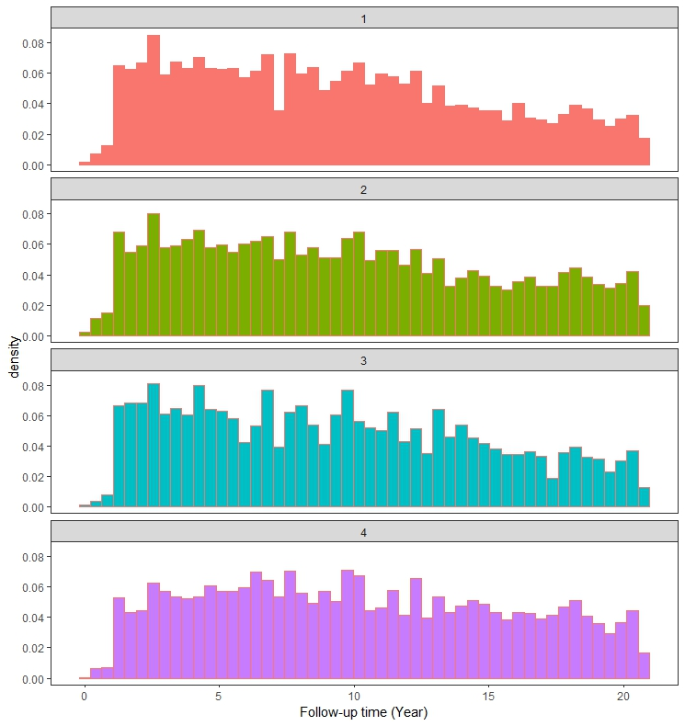
Supplementary Figure 1. Distribution of follow-up time for four metabolic obesity phenotypes. 1: Metabolically unhealthy obese; 2: Metabolically unhealthy non-obesity; 3: Metabolically healthy obesity; 4: Metabolically healthy non-obesity.

