Appendix A: Rainfall Data

Supplementary Table S1: The rainfall (mm) data collected by storage rain gauge from 14th May 2019 to 6th June 2019 and Adcon RG1 rain gauge from 3rd to 28th May 2019 in the BC study site.

Storage rain gauge |  | Adcon RG1 rain gauge
Date | Rain (mm) | Date | Rain (mm)
14/05/2019 | 40.75 | 03/05/2019 | 0.75
15/05/2019 | 2.25 | 04/05/2019 | 7.25
16/05/2019 | 7.75 | 05/05/2019 | 29.25
17/05/2019 | 17.5 | 06/05/2019 | 36.25
18/05/2019 | 2.25 | 07/05/2019 | 13.50
19/05/2019 | 8.75 | 08/05/2019 | 12.25
20/05/2019 | 40.00 | 09/05/2019 | 22.25
21/05/2019 | 4.00 | 10/05/2019 | 15.25
22/05/2019 | 38.75 | 11/05/2019 | 0.50
23/05/2019 | 0.50 | 12/05/2019 | 0.00
24/05/2019 | 36.75 | 13/05/2019 | 19.75
25/05/2019 | 5.00 | 14/05/2019 | 21.25
26/05/2019 | 8.50 | 15/05/2019 | 7.00
27/05/2019 | 12.50 | 16/05/2019 | 14.75
28/05/2019 | 29.75 | 17/05/2019 | 5.75
29/05/2019 | 0.50 | 18/05/2019 | 4.75
30/05/2019 | 12.25 | 19/05/2019 | 6.00
31/05/2019 | 16.00 | 20/05/2019 | 41.00
01/06/2019 | 3.48 | 21/05/2019 | 10.00
02/06/2019 | 0.00 | 22/05/2019 | 32.25
03/06/2019 | 20.91 | 23/05/2019 | 23.00
04/06/2019 | 10.45 | 24/05/2019 | 14.00
05/06/2019 | 20.91 | 25/05/2019 | 11.00
06/06/2019 | 13.94 | 26/05/2019 | 7.00
 |  | 27/05/2019 | 22.00
 |  | 28/05/2019 | 16.00

Appendix B: River Discharge and DOC Flux Calculations

The BC river discharge for the whole study period was calculated from an empirical correlation between the measured discharge and river stage (rating curve) which is as follows:
$$Q=2.309 {(S-0.57)}^{1.575}$$ | (1)
where Q is river discharge (m³ s⁻¹) and S is the river stage (m). The riverine DOC flux for BC was calculated using the following equation:
$$F=Q C$$ | (2)
where C is the DOC concentration (mg l⁻¹) and F is the DOC Flux (g s⁻¹). As the DOC concentration responds linearly to river discharge in the second half of the study period (Phase 3 and 4), the riverine DOC flux had a quadratic relationship with the river discharge (shown in Table S2) which is as follows:
$$F=aQ^{2}+bQ$$ | (3)
where a and b are arbitrary constants.
Supplementary Table S2: The dissolved organic carbon (DOC) concentration (mg l⁻¹) and discharge (Q (m³ s⁻¹) relationship for periods of steady river discharge trend (falling (F)/raising (R)/constant (C) water discharge trend at BC.

Relationship | R² | Date | Number of Samples | P-Value | F/R/C
$$DOC=-34.86 Q+29.64$$ | 0.48 | 5th May | 10 | 0.027 | C
$$DOC=-6.92 Q+25.73$$ | 0.15 | 6th May | 4 | 0.630 | R
$$DOC=-0.13 Q+23.46$$ | 6E-5 | 7th May | 7 | 0.990 | R
$$DOC=2..01 Q+22.68$$ | 0.05 | 8th May | 10 | 0.540 | C
$$DOC=18.34+14.70$$ | 0.67 | 9th May | 11 | 0.002 | F
$$DOC=3.58 Q+20.23$$ | 0.04 | 13th till mid-14th May | 15 | 0.475 | C
$$DOC=-5.44 Q+20.88$$ | 0.28 | Second half of 14th May | 5 | 0.358 | C
$$DOC=0.27 Q+20.51$$ | 0.01 | 15th May | 12 | 0.757 | F
$$DOC=1.85 Q+19.59$$ | 0.02 | 16th May | 9 | 0.719 | C
$$DOC=7.02 Q+13.4$$ | 0.64 | 17th May | 9 | 0.010 | R
$$DOC= 3.57 Q+15.77$$ | 0.99 | 21st till mid-22nd May | 13 | <0.001 | F
$$DOC=2.20 Q+15.98$$ | 0.93 | Mid-22nd till end of 23rd May | 11 | <0.001 | R
$$DOC=3.81 Q+7.24$$ | 0.82 | 24th May | 12 | <0.001 | R
$$DOC=1.29 Q+16.42$$ | 0.79 | 25th till the end of 27th May | 14 | <0.001 | F
$$DOC=2.20 Q+13.98$$ | 0.61 | 31st May | 18 | <0.001 | R
$$DOC=2.71 Q+12.33$$ | 0.94 | 1st till mid-3rd June | 13 | <0.001 | F
$$DOC=3.65 Q+10.27$$ | 0.82 | Second half of 3rd June | 20 | <0.001 | R
$$DOC=-0.008+17.92$$ | 1E-5 | 4th June | 11 | 0.998 | F and R
$$DOC=2.48 Q+12.95$$ | 0.56 | 5th June | 16 | <0.001 | R
$$DOC=2.43Q+12.49$$ | 0.97 | 6th June | 4 | 0.020 | F

Appendix C: Groundwater Wells

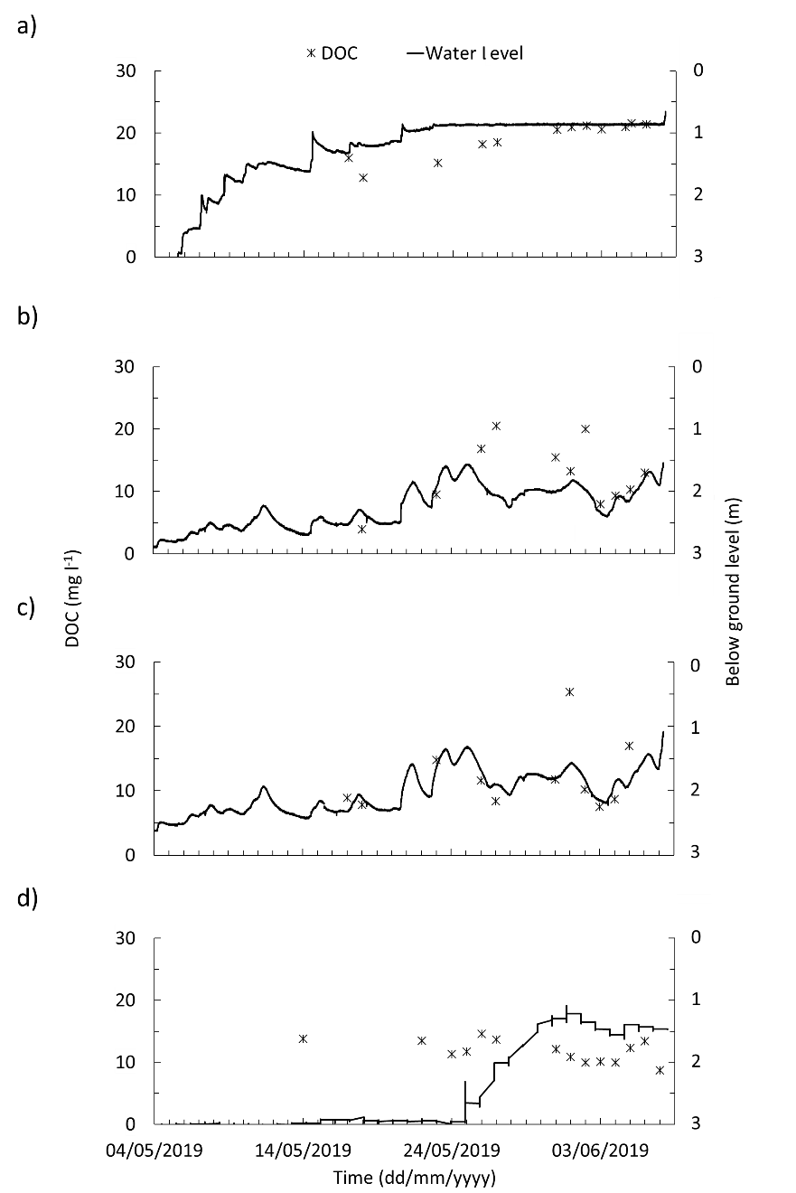

Supplementary Figure S1: Dissolved organic carbon (DOC) concentration and water level of a) upstream, b) midstream and c) downstream groundwater wells at Blackwater Creek (BC) and d) groundwater well at Burro-Burro River (BBR).

Appendix D: DOC Concentration and CDOM Proxies

Supplementary Table S3: The dissolved organic carbon (DOC) concentration (mg l⁻¹), SUVA₂₅₄ (l mg⁻¹ m⁻¹), E₂:E₃, S_{R} and invisible DOC (iDOC) percentage of total DOC mean, standard error and range for BC river, rain and groundwater.

Mean +/-standard error
(min - max)
 | DOC | SUVA₂₅₄ | E₂:E₃ | S_{R} | iDOC
 | mg l⁻¹ | l mg⁻¹ m⁻¹ | E₂:E₃ | S_{R} | % of total DOC
River | 20.23 +/-0.14  (13.60 - 26.41) | 4.9 +/- 0.01 (4.1 - 5.7) | 3.16 +/-0.01 (2.64 - 3.55) | 0.69 +/-0.003 (0.61 - 0.85) | 6.04 +/-0.18  (0 - 17.21)
Groundwater - upper reach | 18.99 +/-0.84  (12.8 0- 21.60) | 4.6 +/-0.001 (4.1 - 4.9) | 2.88 +/-0.06 (2.49 - 3.12) | 0.73 +/-0.013 (0.65 - 0.80) | 16.75 +/-11.23 (0 - 100)
Groundwater - lower reach | 12.64 +/-1.60  (7.50 - 25.30) | 4.6 +/-0.001 (3.9 - 5.3) | 2.77 +/-0.06 (2.27 - 3.04) | 0.77 +/-0.02 (0.71 - 0.91) | 30.95 +/-12.72 (0 - 100)
Rainwater – under-canopy | 3.33 +/-0.60  (1.24 - 4.54) | 2.3 +/-0.4  (0.7 - 3.1) | 4.41 +/-1.06 (2.28 - 8.40) | 0.71 +/-0.12 (0.56 - 0.94) | 93.16 +/-6.84 (65.80 -100)
Rainwater –  open | 2.09 +/-0.19  (0.72 - 2.99) | 2.5 +/-0.6  (0.2 - 8.8) | 2.37 +/-0.12 (1.77 - 3.04) | 0.60 +/- 0.06 (0.28 - 0.77) | 92.39 +/-7.61 (8.72 - 100)

Supplementary Table S4: The dissolved organic carbon (DOC) concentration (mg l⁻¹), SUVA₂₅₄ (l mg⁻¹ m⁻¹), E₂:E₃, S_{R} and invisible DOC (iDOC) percentage of total DOC mean, standard error and range for BBR river, rain and groundwater.

Mean +/-standard error
(min - max)
 | DOC | SUVA₂₅₄ | E₂:E₃ | S_{R} | iDOC
 | mg l⁻¹ | l mg⁻¹ m⁻¹ | E₂:E₃ | S_{R} | % of total DOC
River | 14.57 +/-0.26 (6.66 - 18.22) | 4.9 +/-0.02 (3.8 - 5.6) | 3.14 +/-0.02 (2.69 - 3.84) | 0.72 +/-0.005 (0.46 - 0.92) | 3.55 +/-0.33  (0 - 30.14)
Groundwater - upper reach | 11.86 +/-0.48 (8.70 - 14.60) | 7.4 +/-0.9  (4.8 - 15.7) | 2.42 +/-0.08 (1.83 -2.77) | 0.92 +/-0.02 (0.79 - 1.00) | 41.63 +/-12.17 (0 - 100)
Rainwater – under-canopy | 8.09 +/-1.94 (2.82 - 16.00) | 4.0 +/-0.3  (3.2 - 5.7) | 2.68 +/-0.21 (1.51 - 3.19) | 0.84 +/-0.07 (0.48 - 1.00) | 71.43 +/-18.44 (0 - 100)

