Use of stable isotopes to reveal trophic relationships and transmission of a food-borne pathogen
Émilie Bouchard, Michaël Bonin, Rajnish Sharma, Adrián Hernández-Ortiz, Géraldine-G. Gouin, Audrey Simon, Patrick Leighton & Emily Jenkins

Supplementary material

Table S1. Carbon (δ¹³C) and nitrogen (δ¹⁵N) isotopic ratios (‰, mean ± SD) of food sources used in stable isotope analyses of foxes with corresponding tissue types and sample sizes.
Food sources | Dietary endpoints | δ¹³C, ‰ | δ¹⁵N, ‰ | Tissue type | Sample size
Lemming | Terrestrial | -25.52 ± 0.7 | 2.76 ± 1.5 | Hair | 3
Goose | Migratory | -22.53 ± 1.3 | 6.45 ± 1.0 | Muscle | 26
Fish | Aquatic | -18.2 ± 1.5 | 14.71 ± 0.9 | Muscle | 13

Table S2. A) Summary of seasonal stable isotope analyses between regions in both species of foxes from Nunavik, QC. Results are given as mean proportion of dietary endpoints in the diet of foxes at the population scale.
 | Fall diet |  |  |  | Winter diet
Dietary endpoints | Red fox |  | Arctic fox |  | Red fox |  | Arctic fox
 | x̄ | CI_{95%} | x̄ | CI_{95%} | x̄ | CI_{95%} | x̄ | CI_{95%}
Ungava Bay | n=99 |  | n=12 |  | n=143 |  | n=19
Terrestrial | 88 | (82-91) | 82 | (66-93) | 86 | (81-90) | 67 | (43-82)
Migratory | 4 | (1-11) | 11 | (2-30) | 6 | (1-14) | 20 | (3-52)
Aquatic | 8 | (5-10) | 6 | (1-13) | 8 | (5-10) | 13 | (3-22)
Hudson Bay | n=30 |  | n=12 |  | n=38 |  | n=21
Terrestrial | 84 | (73-92) | 75 | (58-87) | 77 | (63-86) | 56 | (36-70)
Migratory | 9 | (1-23) | 16 | (2-37) | 14 | (2-15) | 22 | (3-52)
Aquatic | 7 | (2-12) | 9 | (2-16) | 9 | (3-15) | 22 | (11-30)

Table S2. B) Summary of seasonal stable isotope analyses between Toxoplasma gondii exposure status in both species of foxes from Nunavik, QC. Results are given as mean proportion of dietary endpoints in the diet of foxes at the population scale.
 | Fall diet |  |  |  |  |  | Winter diet
Dietary endpoints | Red fox |  |  | Arctic fox |  |  | Red fox |  | Arctic fox
 | x̄ | CI_{95%} |  | x̄ |  | CI_{95%} | x̄ | CI_{95%} | x̄ | CI_{95%}
Positive foxes | n=50 |  | n=11 |  |  |  | n=69 |  | n=19
Terrestrial | 82 | (72-88) | 72 |  | (55-85) |  | 76 | (64-84) | 56 | (35-70)
Migratory | 8 | (1-23) | 18 |  | (3-40) |  | 13 | (2-33) | 24 | (3-54)
Aquatic | 10 | (5-15) | 9 |  | (2-17) |  | 10 | (4-15) | 20 | (10-29)
Negative foxes | n=79 |  | n=13 |  |  |  | n=112 |  | n=21
Terrestrial | 91 | (85-95) | 82 |  | (67-93) |  | 89 | (84-92) | 64 | (41-80)
Migratory | 4 | (1-11) | 12 |  | (2-29) |  | 5 | (1-13) | 22 | (3-54)
Aquatic | 5 | (2-8) | 6 |  | (1-13) |  | 6 | (3-8) | 14 | (4-24)

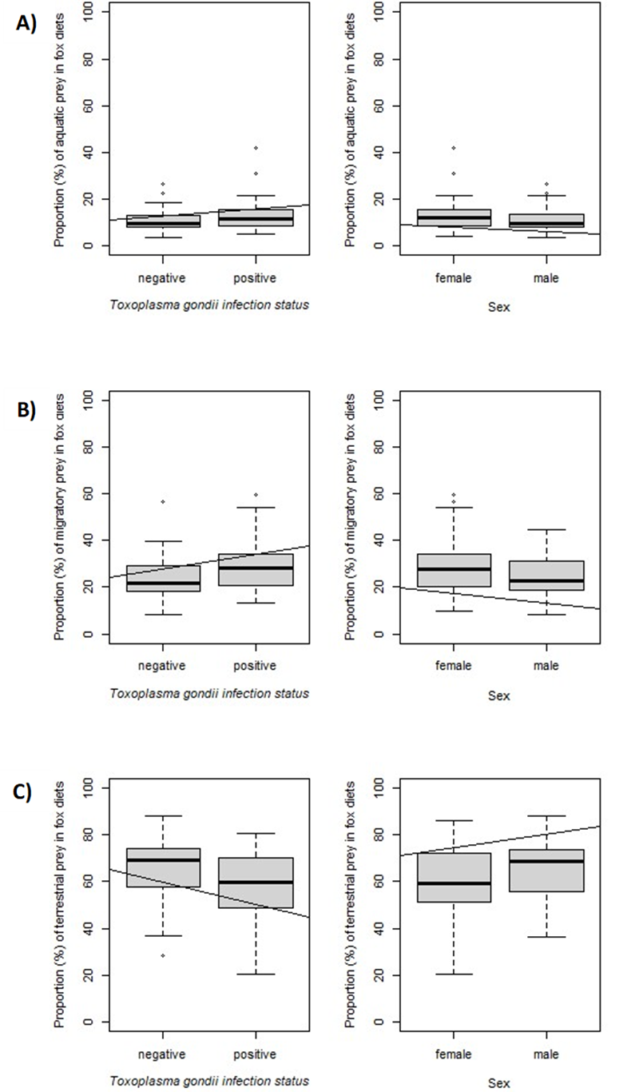
Figure S1. Proportion values of each dietary endpoints (aquatic prey (A), migratory prey (B), and terrestrial prey (C)) to the diet of foxes with status of infection or sex as response variables.

