Growth, productivity and phytochemicals of Coriander in responses to foliar application of Acacia saligna fruit extract as a biostimulant under field conditions
Alkharpotly, A. A. ^{1,2}, Doaa Y. Abd-Elkader ³, Mohamed Z. M. Salem ^{4,}*, and Hanaa S. Hassan ³
¹ Horticulture Department, Faculty of Agriculture and Natural Resources, Aswan University, Aswan, Egypt. alkharpotly@agr.aswu.edu.eg
² Horticulture Department, Faculty of Desert and Environmental Agriculture, Matrouh University, Marsa Matrouh, Egypt.
³ Department of Vegetable, Faculty of Agriculture (EL-Shatby), Alexandria University, Alexandria 21545, Egypt; doaa.abdelkader@alexu.edu.eg (D.Y.A.-E.); hanaa.saad@alexu.edu.eg (H.S.H.)
⁴ Forestry and Wood Technology Department, Faculty of Agriculture (El-Shatby), Alexandria University, Alexandria 21545, Egypt; mohamed-salem@alexu.edu.eg

Corresponding author: mohamed-salem@alexu.edu.eg

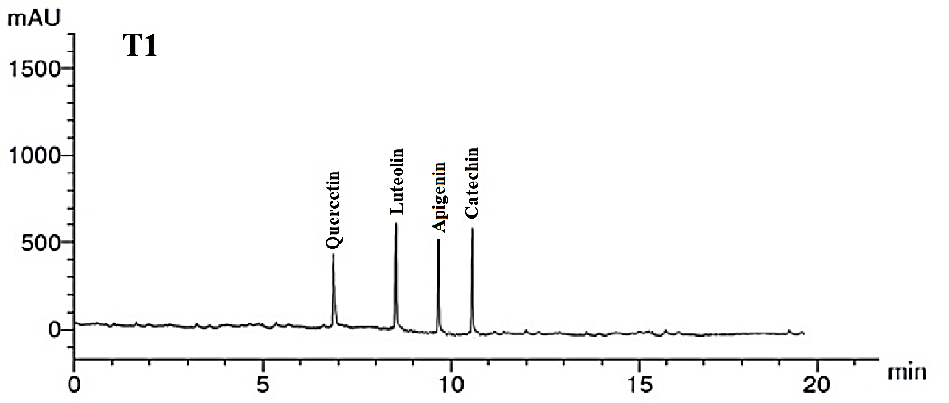
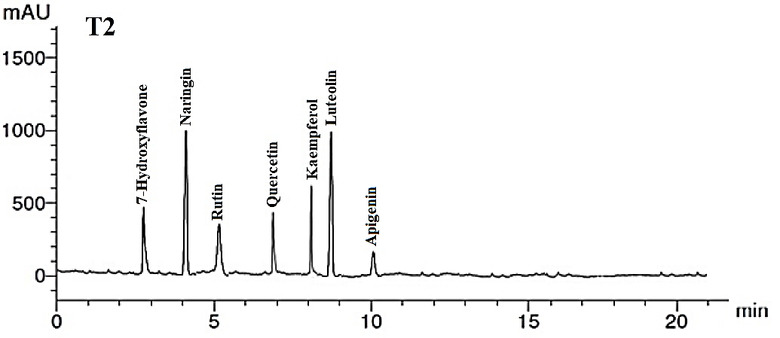
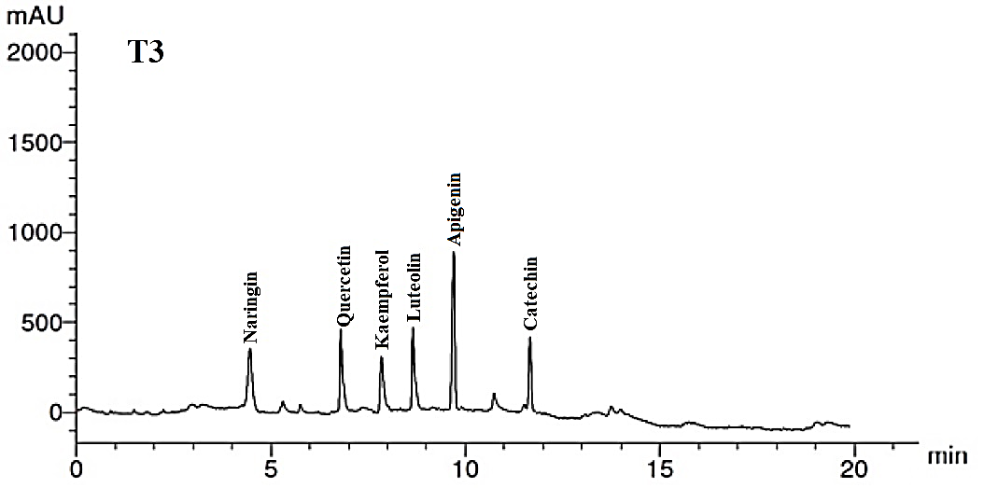
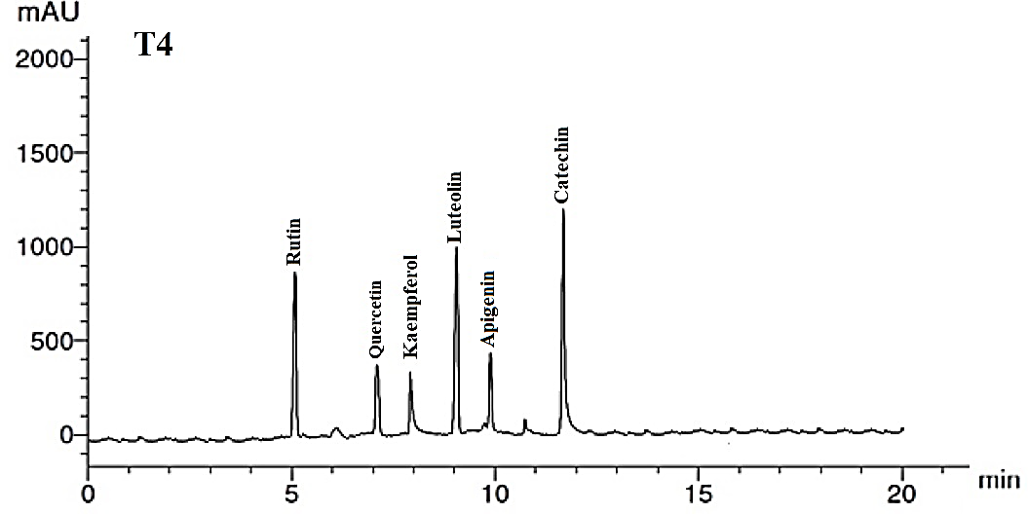

Figure S1. The identified flavonoid compounds from the methanol extract of C. sativum leaves by HPLC analysis. T1: Control; T2: A. saligna FAE 2% + 50% N fertilizer; T3: A. saligna FAE 4% + 50% N fertilizer; T4: A. saligna FAE 6% + 50% N fertilizer.

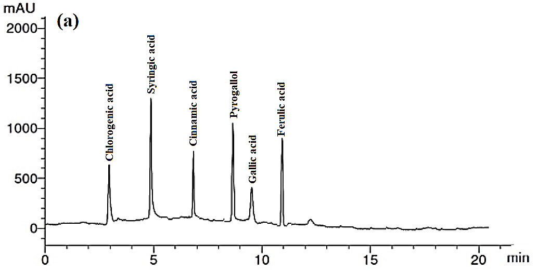

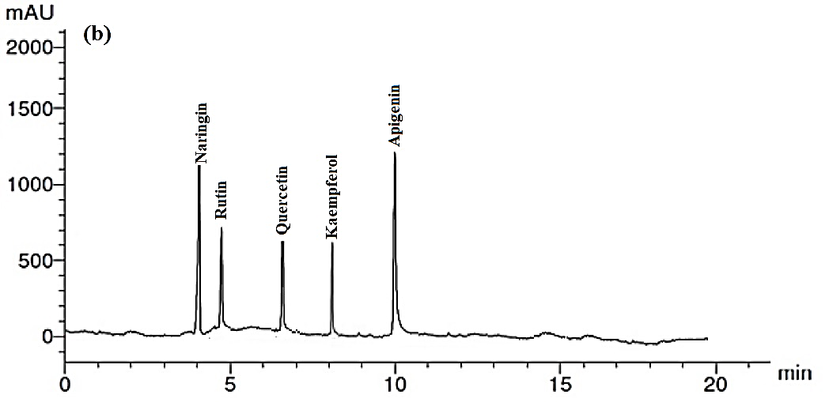
Figure S2. The identified phenolic (a) and flavonoid (b) compounds in Acacia saligna FAE by HPLC analysis

