Supplementary Figure

Supplementary Figure 1. Riskscores, gene expression, ROC curves, and KM survival curves in different CGGA databases. Risk score, survival status, and 4 gene expression in the CGGA-mRNA-array_301 database (A), the CGGA-mRNAseq_325 database (D), and the CGGA-mRNAseq_693 database (G). ROC curves and AUCs for the 4 gene features in the CGGA-mRNA-array_301 database (B), the CGGA-mRNAseq_325 database (E), and the CGGA-mRNAseq_693 database (H). Distribution of KM survival curves for the 4 gene features in the CGGA-mRNA-array_301 database (C), the CGGA-mRNAseq_325 database (F), and the CGGA-mRNAseq_693 database (I).

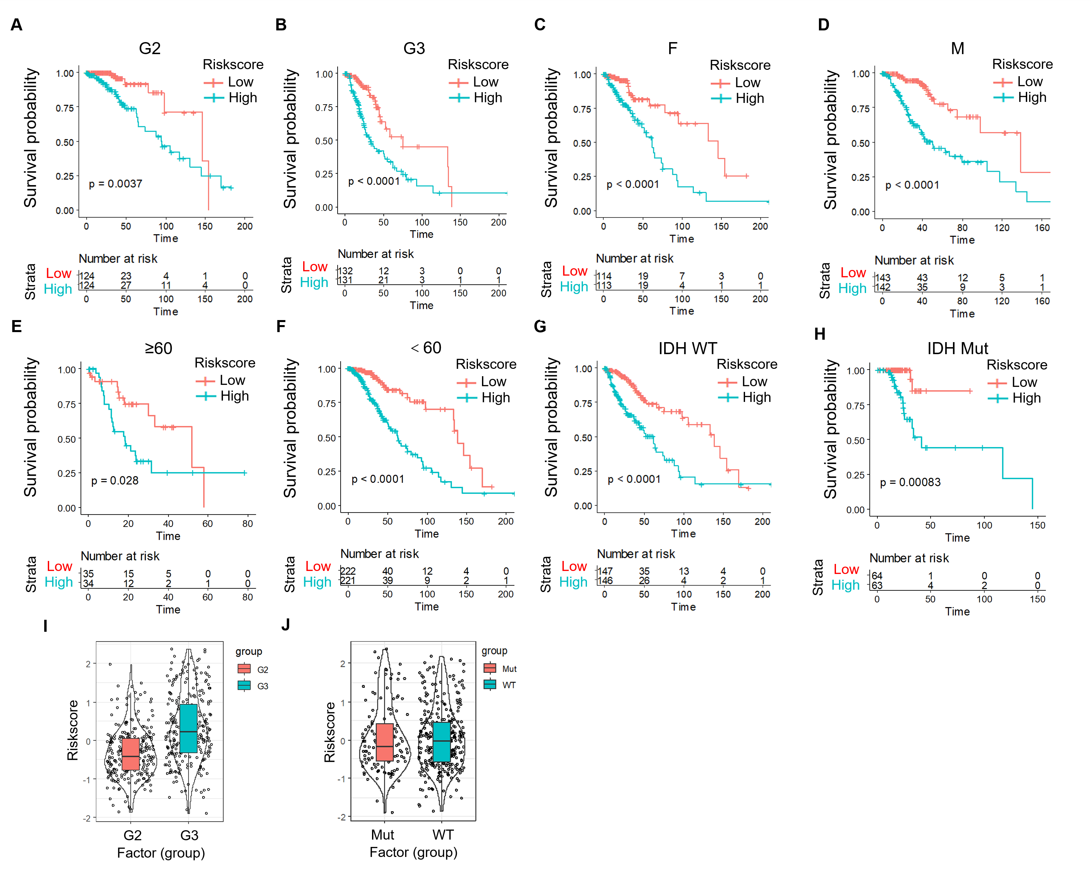
Supplementary Figure 2. Prognostic performance analysis of risk models based on clinical characteristics. A. According to RiskScore, the patients in the G2 group were divided into two groups with significant prognosis. B. According to RiskScore, patients in the G3 group were divided into two groups with significant prognosis. C. According to RiskScore, the female group was divided into two groups with significant prognosis. D. Patients in the male group were divided into two groups according to RiskScore. E. Patients aged ≥60 years were divided into two groups with significant prognosis according to RiskScore. F. According to RiskScore, patients with ages < 60 were divided into two groups with significant prognosis. G. Patients in IDH WT group were divided into two groups according to RiskScore, and the prognosis was significant. H. Patients with IDH mutation were divided into two groups according to RiskScore, and the prognosis was significant. I. RiskScore scores in G2 and G3. J. RiskScore scores in IDH WT and IDH mutation groups.

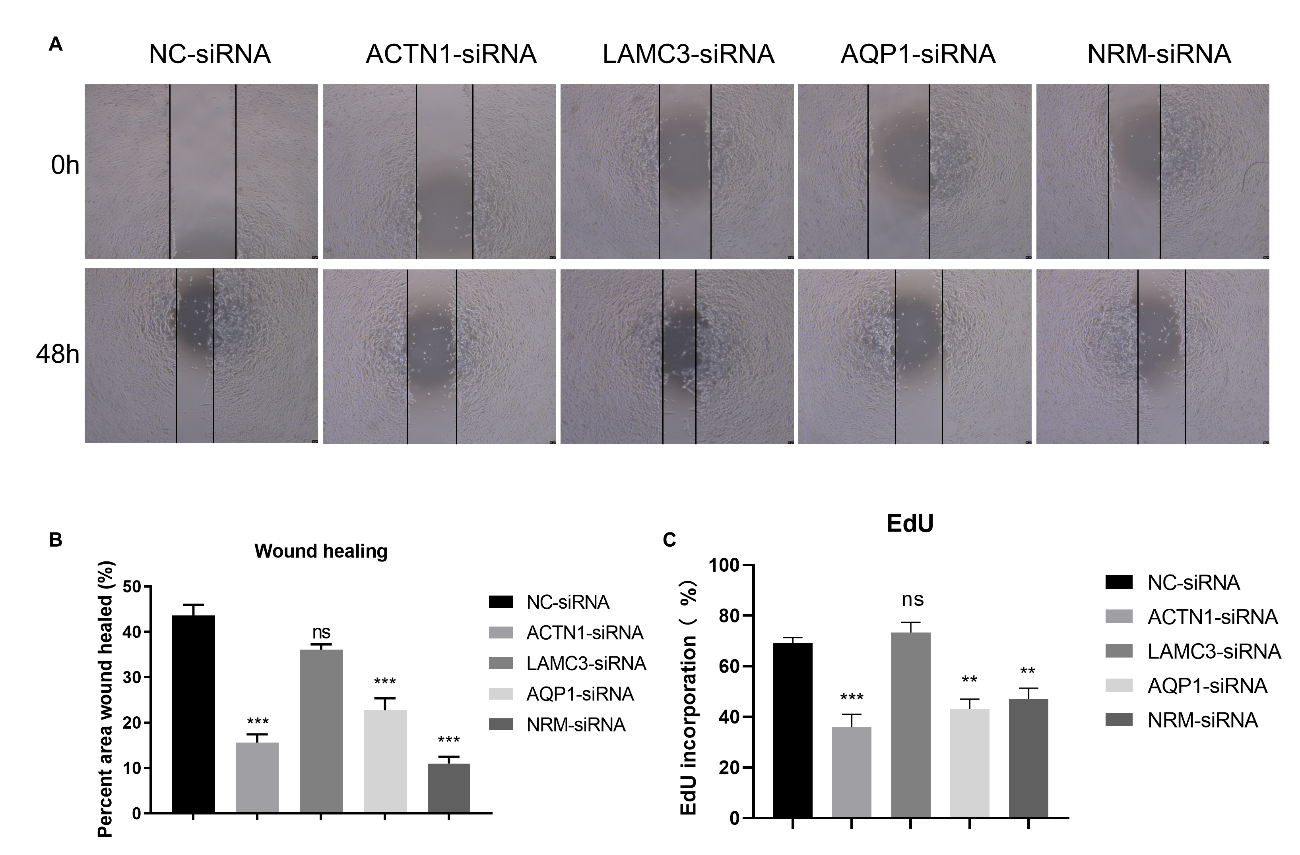
Supplementary Figure 3. Functions of ACTN1, LAMC3, AQP1, and NRM in proliferation and migration of grade II/III glioma cells. A. Effects of knockdown of indicated genes on cell migratory abilities by wound healing assays in SW1733 cells. B. Statistical results of wound healing assays in (A). C. Effects of knockdown of indicated genes on cell proliferation by EdU assay in SW1733 cells for 24 h.

Supplementary Figure 4. Correlation analysis: PDCD1 with ACTN1, LAMC3, AQP1, NRM, and exhaustion-related molecules in TCGA samples. A. Correlation between PDCD1 and ACTN1. B. Correlation between PDCD1 and LAMC3. C. Correlation between PDCD1 and AQP1. D. Correlation between PDCD1 and NRM. E. Heatmap of the correlation between ACTN1, LAMC3, AQP1, and NRM and the expression of 39 exhaustion-related molecules, TCGA samples sorted by PDCD1 expression.

Table S1. List of 132 EMT-associated genes related to grade II/III gliomas prognosis. The expression profiles of 200 EMT-associated genes were extracted from TCGA LGG data. Univariate Cox regression analysis was performed using the coxph function in R to identify genes significantly associated with grade II/III gliomas prognosis (P < 0.05). This table lists the 132 EMT-associated genes that were found to be significantly related to prognosis in grade II/III gliomas patients.

Table S2. Differentially expressed genes (DEGs) between C1 and C2 molecular subtypes. Gene expression profiles of C1 and C2 molecular subtypes were compared using the limma package in R. Genes with |log2FC| > 1 and FDR < 0.01 were considered differentially expressed. A total of 1535 DEGs were identified, including 1291 up-regulated and 244 down-regulated genes in C1 compared to C2 subtypes. The table lists the DEGs along with their log2FC and FDR values.

Table S3. Prognosis-related genes identified by univariate Cox regression analysis. To identify genes associated with prognosis, univariate Cox regression analysis was performed on the survival data using a threshold of P < 0.01. A total of 874 prognosis-related genes were identified at this significance level. The table lists the genes along with their hazard ratios, confidence intervals and P values from the univariate Cox regression model.

