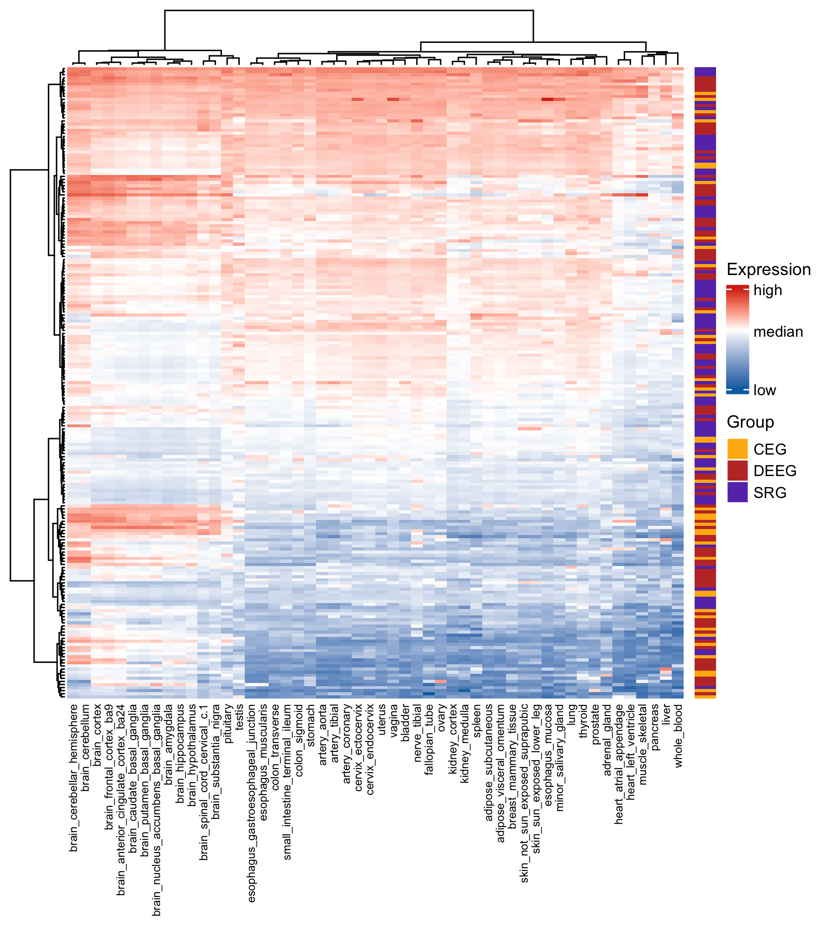

Supplemental Figure 4. Expression of the three groups of epilepsy-associated genes in human tissues with hierarchical clustering across genes and tissues.

