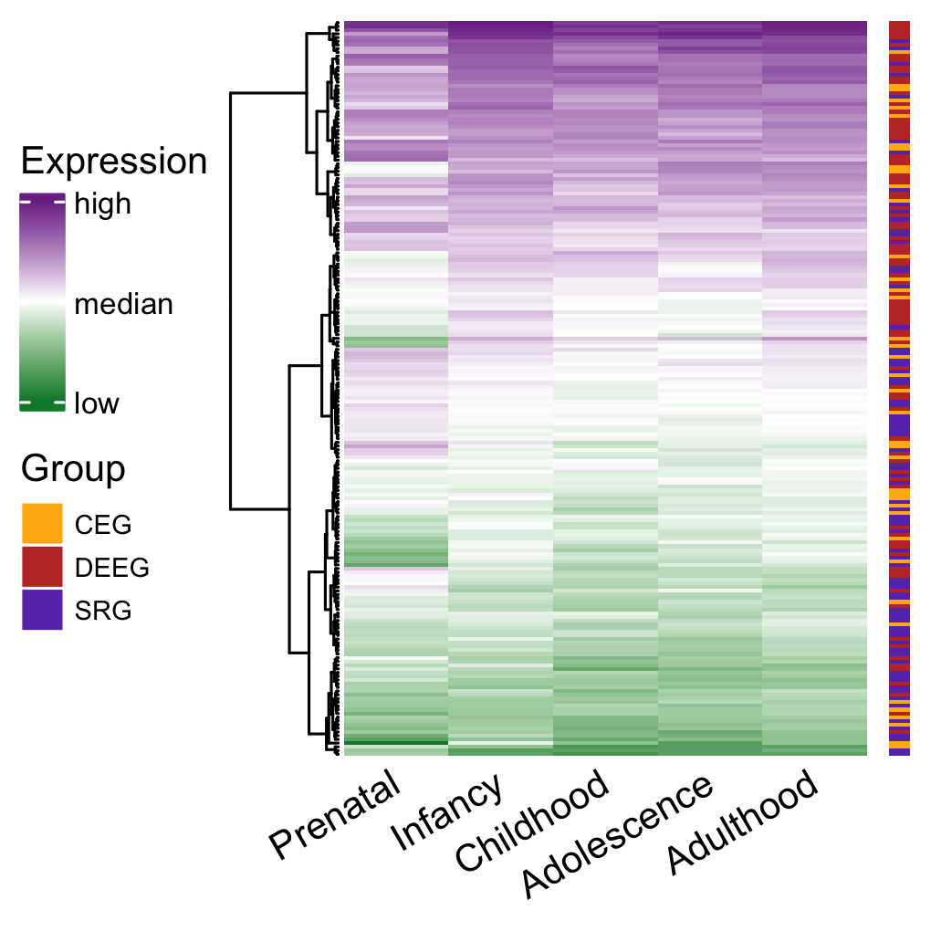

Supplemental Figure 5. Expression of the three groups of epilepsy-associated genes in the hippocampus with hierarchical clustering across genes.

