Antimicrobial potential of Streptomyces coeruleofuscus SCJ isolated from microbiologically unexplored garden soil in Northwest Morocco

Said Rammali^{a,}*, Abdellatif Rahim^{b}, Mohamed El Aalaoui^{c}, Khadija Dariª, Bouchaib Bencharkiª, Aicha Habach^{d} , Lamiri Abdeslam^{e}, Abdelkrim khattabiª

ªLaboratory of Agro-Alimentary and Health, Faculty of Sciences and Techniques, Hassan First University of Settat, B.P. 539, Settat 26000, Morocco

^{b}Laboratory of Biochemistry, Neurosciences, Natural Ressources and Environment, Faculty of Sciences and Techniques, Hassan First University of Settat, B.P. 539, Settat 26000, Morocco

^{c}Regional Center of Agronomic Research of Settat, Tertiary Road 1406, At 5 Km from Settat,
Settat 26400, Morocco

^{d}Biotechnology Unit, National Institute of Agronomic Research of Rabat, Rabat, Morocco, Av. Annasr, Rabat 10000

^{e}Applied Chemistry & Environment Laboratory, Faculty of Sciences and Techniques, Hassan First University of Settat, B.P. 539, Settat 26000, Morocco

* Corresponding authors:
rammali_fst@hotmail.fr / s.rammali@uhp.ac.ma (Said RAMMALI)

SUMMARY
1. General methods
1.1 Recommended media for Actinobacteria isolation 1
1.2 Recommended media for testing antimicrobial activity............................................................1
1.3 Recommended medium for testing NaCl tolerance...................................................................1
1.4 Recommended medium for the production of melanin pigment.................................................1
1.5 Other media used in this study....................................................................................................2
2. Supplementary figures
Figure S1. Scanning electron microscope (SEM) analysis of minerals...........................................3
Figure S2. Actinobacteria isolated on M₂ medium……………………….......................................4
Figure S3. Microscopic and morphological characterization of the SCJ isolate following incubation on various media, including melanoid pigment production on GYEA(C) medium......5
Figure S4. Agarose gel electrophoresis for amplification of genes coding for 16S rRNA of Streptomyces sp. SCJ strain ……………………………………………………………………………….6
Figure S5. Kinetics of secondary metabolite production by the SCJ strain against Bacillus cereus ATCC 14579………………………………………………………………………………………7
Figure S6. Antifungal activity of SCJ isolate using disk diffusion method against A: Fusarium sp. MN944568, B: Fusarium sp. MN944570, C: Fusarium sp. MN944577, D: Candida albicans ATTC 60193……...………………………………………..……...................................................8
Figure S7. UV-visible spectra of the crude ethyl acetate extract of Streptomyces sp. SCJ…………9
Figure S8. GC-MS of Ethyl acetate crude extract of Streptomyces sp. strain SCJ with peaks indicating the presence of bioactive compounds (according to the NIST database) ……………10
3. Supplementary tables
Supplementary Table 1. Physico-chemical analysis of soil samples...............................................11
Supplementary Table 2. Total number of Actinobacteria isolates recovered from site A according to the culture media used................................................................................................................12
Supplementary Table 3. Morphological and cultural characteristics of a SCJ Actinobacteria isolate using solid ISP media.....................................................................................................................13
Supplementary Table 4. Molecular identification of the selected SCJ Actinobacteria isolate based on 16S rRNA gene sequencing…………………………………………………….......................14
References.…………………………………………………….....................................................15

1. General methods
1.1 Recommended media for Actinobacteria isolation
M2: 10 g of starch, 0.3 g of casein, 2 g of KNO_{3,}2 g of NaCl, 0.05 g of MgSO₄,7H₂O, 2 g of K₂HPO_{4,}0.02 g of CaCO₃, 0.01 g of FeSO₄, 7H₂O, 1 g of glucose, 15 g of agar, 1L distilled water, and pH adjusted at 7. 2¹.
GA: 10 g of Glucose, 0.5 g of asparagine, 0.5 g of K₂HPO₄, 15 g of agar, 1L distilled water, and pH adjusted at 6¹.
GLM: 10 g of glucose, 3 g of yeast extract, 3 g of malate extract, 5 g of tryptone, 15 g of agar, 1L distilled water, and pH adjusted at 7.2^{2,3}.
Bennett : 10 g of glucose, 2 g of yeast extract, 1 g of meat extract, 2 g of tryptone, 15 g of agar, 1L distilled water, and pH adjusted at 7.2⁴.
1.2 Recommended media for testing antimicrobial activity⁵
ISP1: 3 g of yeast extract, 5 g of tryptone, 16 g of agar, 1L of distilled water, and pH adjusted at 7.15.
ISP2: 4 g of yeast extract, 4 g of glucose, 10 g of malate extract, 16 g of agar, 1L of distilled water, and pH adjusted at 6.51.
GYEA: 10 g of yeast extract, 10 g of glucose, 16 g of agar, 1L of distilled water, and pH adjusted at 6.96.
Bennett: 10 g of glucose, 2 g of yeast extract, 1 g of meat extract, 2 g of tryptone, 15 g of agar, 1L distilled water, and pH adjusted at 7.2.
1.3 Recommended medium for testing NaCl tolerance
YEA medium: 3 g of yeast extract, 5 g of peptone, 15 g of agar, 1L of distilled water, and pH adjusted at 7.2.
1.4 Recommended medium for the production of melanoid pigment
ISP9: 2.64 g of (NH₂) SO₄, 2.38 g of KH₂PO₄, 5.65 g of K₂HPO₄, 1 g of MgSO₄, 7H₂O, 20 g of agar, and 1L of distilled water.
100 mL salt solution: 4 g of CuSO₄, 5H₂O, 1.1 g of FeSO₄, 7H₂O, 7.9 g of MnCl₂, 4H₂O, 1.5 g of ZnSO₄, 7H2O.
GYEA: 10 g of yeast extract, 10 g of glucose, 16 g of agar, 1L of distilled water, and pH adjusted at 6.96.
1.5 Other media used in this study
PDA medium: 4 g of potato extract 20 g of glucose, 15 g of agar, 1L distilled water, and pH adjusted at 7.5.
Muller Hinton Agar medium: Ready to use
CLED medium: Ready to use.

2. Supplementary figures

Figure S1. Scanning electron microscope (SEM) analysis of minerals

Figure S2. Actinobacteria isolated on M₂ medium

Figure S3. Microscopic and morphological characterization of the SCJ isolate following incubation on various media, including melanoid pigment production on GYEA(C) medium

Figure S4. Agarose gel electrophoresis for amplification of genes coding for 16S rRNA of Streptomyces sp. SCJ strain
E16: Streptomyces sp. SCJ strain, E14, E15-E42: other isolates, T-: Negative Control, Bands were visualised by the photo documentation system " G Box ".

Figure S5. Kinetics of secondary metabolite production by the SCJ strain against Bacillus cereus ATCC 14579

Figure S6. Antifungal activity of SCJ isolate using disk diffusion method against A: Fusarium sp. MN944568, B: Fusarium sp. MN944570, C: Fusarium sp. MN944577, D: Candida albicans ATTC 60193

Figure S7. UV-visible spectra of the crude ethyl acetate extract of Streptomyces sp. SCJ

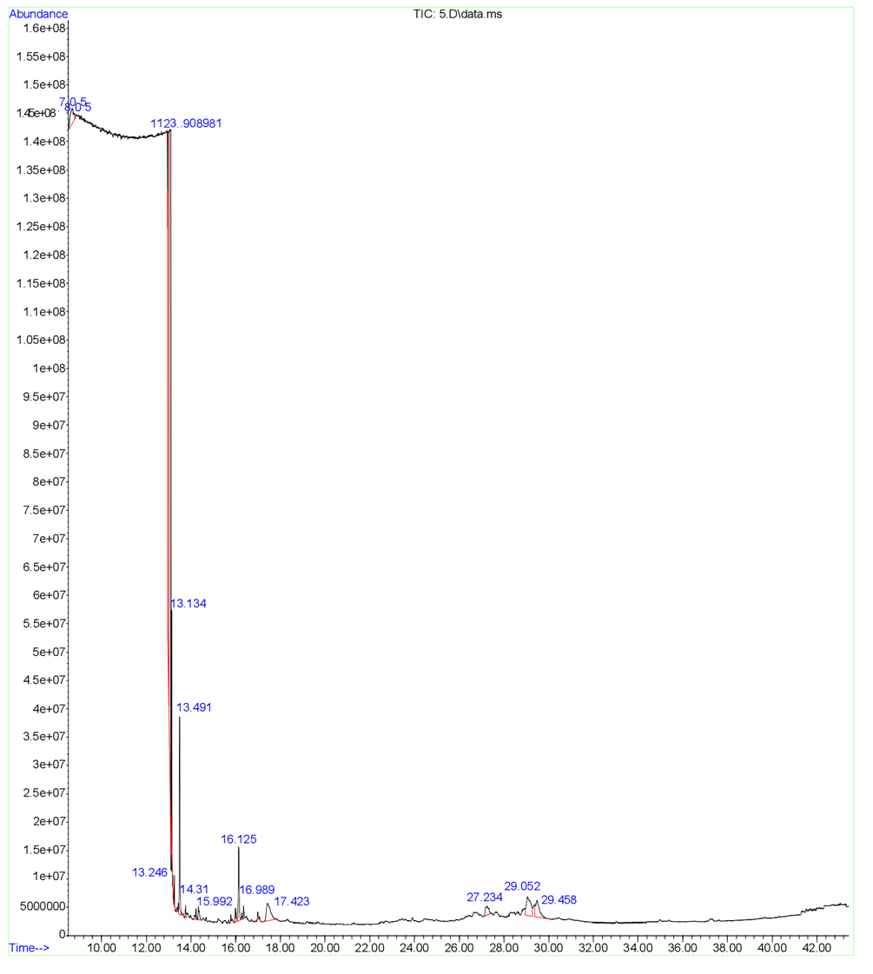

Figure S8. GC-MS of Ethyl acetate crude extract of Streptomyces sp. strain SCJ with peaks indicating the presence of bioactive compounds (according to the NIST database)

3. Supplementary tables

Supplementary Table S1: Physico-chemical analysis of soil samples (EC) Electrical
conductivity; (OM) Organic matter; (TN) Total Nitrogen
Physico-chemical parameters | Site (Tit Mellil Garden Casablanca)
Textural soil types | Sandy- silty
Clay (%) | 5.00
Sand (%) | 75.0
Silt (%) | 19.9
pH | 7.71
EC (ds/m) | 0.32
OM (%) | 2.43
TN (%) | 0.10
Mg (%) | 0.35
K (%) | 1.04
Ca (%) | 14.3
S (%) | 0.87
Cl (%) | 0.51
P (%) | 0.28
Fe (%) | 5.44
Mn (%) | 0.05
Cu (%) | 0.01
Zn (%) | 0.01

Soil collection site | Number of Actinobacteria colonies in different isolation media 10³ CFU/mL) |  |  |  | Total number of Actinobacteria colonies  (10³ CFU/mL) | Number of colonies with morphological characteristics in each medium |  |  |  | Number total of isolates
Soil collection site | M₂ | Ben | GLM | GA | Total number of Actinobacteria colonies  (10³ CFU/mL) | M₂ | Ben | GLM | GA | Number total of isolates
Site A | 4 | 0 | 0 | 0 | 4 | 1 | 0 | 0 | 0 | 1
Supplementary Table S2: Total number of Actinobacteria isolates recovered from site A according to the culture media used
(Site A) Garden Tit Mellil Casablanca.
Supplementary Table S3. Morphological and cultural characteristics of a SCJ Actinobacteria isolate using solid ISP media
Actinobacteria isolate | Growing media | Cultural characteristics
Actinobacteria isolate | Growing media | Growth | Colony aspect | Aerial mycelium | Substrate mycelium | Diffusible pigment
SCJ | ISP₁ | +++ | Circular | White, powdery, unstarred | Yellowish | Absence
SCJ | ISP₂ | +++ | Circular, irregular | White, powdery | Brown | Brown
SCJ | ISP₄ | +++ | Circular | White, powdery | Violet | Violet
SCJ | ISP₅ | +++ | Punctiform | White, powdery | Pale yellowish | Absence
SCJ | GYEA | +++ | Circular | White, starry | Violet-brown | Violet

(+++) Abondant.

Supplementary Table S4. Molecular identification of the selected SCJ Actinobacteria isolate based on 16S rRNA gene sequencing
Isolate Name | Query  Length  (bp) | Nearest known speciesª | Percent identity  (%) | Identification^{b}  (Scientific Name) | NCBI GenBank accession number
SCJ | 1389 | Streptomyces coeruleofuscus YR-42 (T)(KY753282.1) | 99.78 | Streptomyces coeruleofuscus | OP101646

ªNCBI's nucleotide BLAST program was used to find the closest match against the non-redundant reference RNA sequence database (refseqrna). The strain number, strain type (T), and GenBank accession number are all listed after the species name.
^{b}Isolates with a greater percentage of identity than 98.78% and only one closest match for the same identity characteristics are classified up to the species level.
To assess the reliability of a phylogenetic tree, MEGA provides the Bootstrap test. This test uses the bootstrap re-sampling strategy, so you need to enter the number of replicates. For a given data set, applicable tests and the phylogeny inference method are enabled. Neighbor joining has an additional test (Interior Branch), which requires the same input as bootstrap.

References
1. Bouaziz, S. et al. Antifungal activity of Streptomyces sp.14 strain isolated from Ouargla (Southeast of Algeria): identification, production and characterization of the active substance. Int. J. Biosci. 9, 45–56 (2016).
2. Das, R., Romi, W., Das, R., Sharma, H. K. & Thakur, D. Antimicrobial potentiality of Actinobacteria isolated from two microbiologically unexplored forest ecosystems of Northeast India. BMC Microbiol. 18, 1–16 (2018).
3. Thakur, D., Yadav, A., Gogoi, B. K. & Bora, T. C. Isolation and screening of Streptomyces in soil of protected forest areas from the states of Assam and Tripura, India, for antimicrobial metabolites. J. Mycol. Med. 17, 242–249 (2007).
4. Lee, E. J., Hwang, K. Y., Lee, H. S. & Chung, N. Characterization of a new Streptomyces sp. a1022 as a potential biocontrol agent. J. Appl. Biol. Chem. 54, 488–493 (2011).
5. Badji, B., Riba, A., Mathieu, F., Lebrihi, A. & Sabaou, N. Activité antifongique d’une souche d'Actinomadura d'origine saharienne sur divers champignons pathogènes et toxinogènes. J. Mycol. Med. 15, 211–219 (2005).
6. Rossi-Tamisier, M., Benamar, S., Raoult, D. & Fournier, P. E. Cautionary tale of using 16s rRNA gene sequence similarity values in identification of human-associated bacterial species. Int. J. Syst. Evol. Microbiol. 65, 1929–1934 (2015).

