Table. S2

Characteristics of song | Abbreviation  (if used) | Definition
Note | N or N_{x} where subscript reflects number of note within song phrase | a continuous line on a spectrogram, which is also referred to as an element; called element; in the case of the studied species, notes are heard as separate sounds, hence, are also equivalent to syllables in other species
Pause | P or P_{x} (as above) | duration of time between neighbouring notes;
Song phrase |  | the entire sequence of notes building the song, usually repeated with very stereotyped manner and with gaps between phrases much longer than between notes within phrases
Duration (s) |  | total time of the song phrase, i.e. from the beginning of the first note to the end of the last note
Number of notes |  | total number of notes within song phrase
Peak frequency of notes (Hz) | PF or PF_{x} (as above) | the frequency of the maximum amplitude of a single note spectrum
Pulse-to-pulse duration (s) | PTP or PTP_{x-y} (as above) | time between peak frequencies of adjacent notes
Frequency spectrum characteristics of the entire song phrases¹

Peak frequency (Hz) | the frequency of the maximum amplitude of the spectrum (where spectrum is measured for the whole song phrase)
Lower quartile (Hz) | the frequency below which 25% of the total energy of the spectrum is located
Mean frequency (Hz) | the frequency below which 50% of the total energy of the spectrum is located
Upper quartile (Hz) | the frequency below which 75% of the total energy of the spectrum is located
Spectral centroid (Hz) | the weighted mean of the spectrum with the magnitudes as the weights
Minimum frequency, Maximum frequency (Hz) | frequencies at which the amplitude falls short of the maximum of the spectrum minus the threshold; the threshold used in our measurements was set to -18 dB (see figure below)
Bandwidth (Hz) | the difference between the maximum and minimum frequency

¹More details presented here: http://www.avisoft.com/Help/SASLab/menu_curve_display_spectral_characteristics.htm
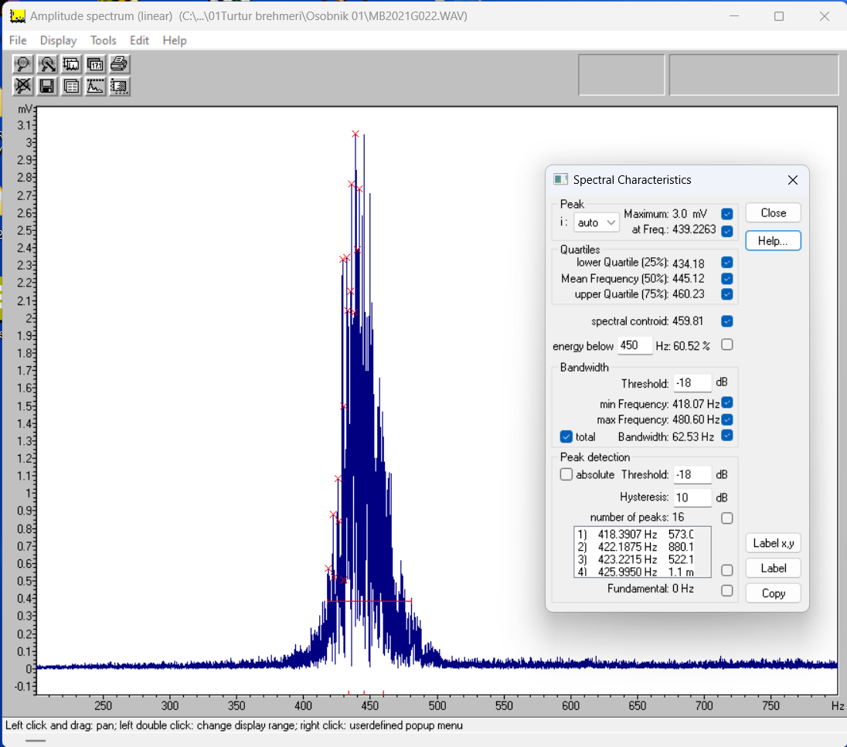
The amplitude spectrum window illustrates frequency spectrum measurements taken in Avisoft SAS Lab Pro.

