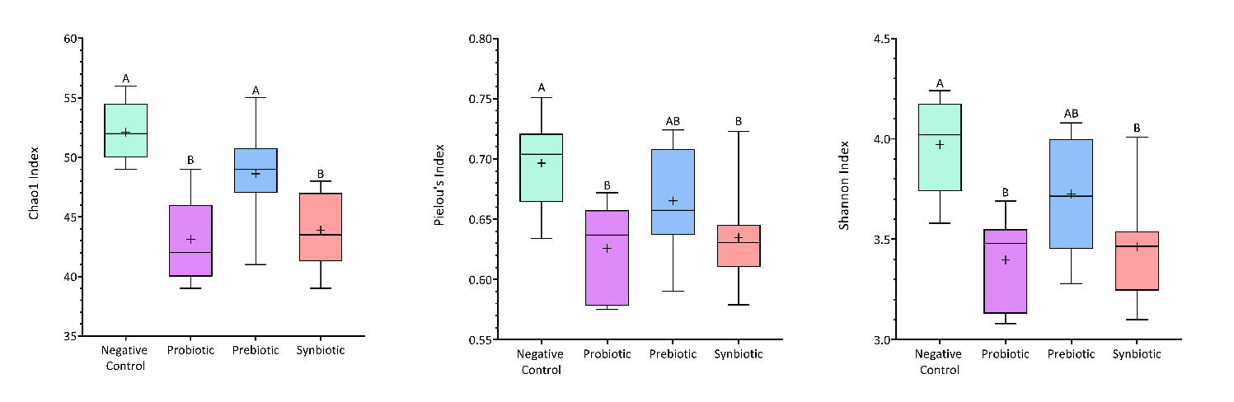
Figure S1 The alpha diversity of gut microbiota in each treatment. The horizontal line represents the median value, while the ‘+’ represents the mean value. Different letters indicated significant difference of concentration numbers between the three treatments (p < 0.05).

