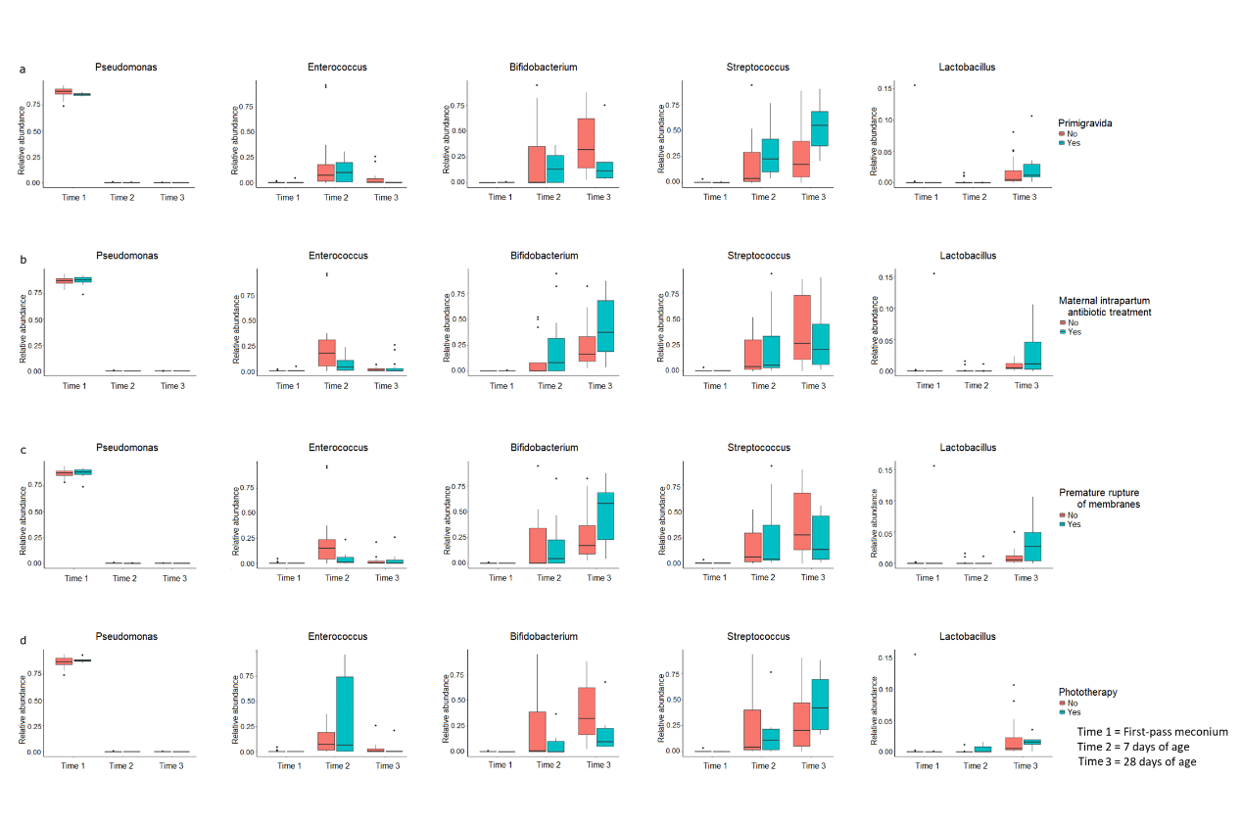
Supplementary Figure 1. Influence of each perinatal factor on the relative abundances of the five dominant genera over time. (a) Gravidity. (b) Maternal intrapartum antibiotic treatment. (c) Premature rupture of membranes. (d) Postnatal phototherapy for neonatal jaundice. The box was drawn from the first quartile to the third quartile with a horizontal line in the middle to denote the median. The whiskers indicated variability outside the upper and lower quartiles.

