Figure S1 A: Correction results of samples in GSE3189 dataset. B: Heatmap of DEGs in GSE3189 dataset. C: Correction results of samples in GSE46517 dataset. D: Heatmap of DEGs in GSE46517 dataset. Heat map: Horizontal representation of genes, each column is a sample, red represents high expression genes, blue represents low expression genes.
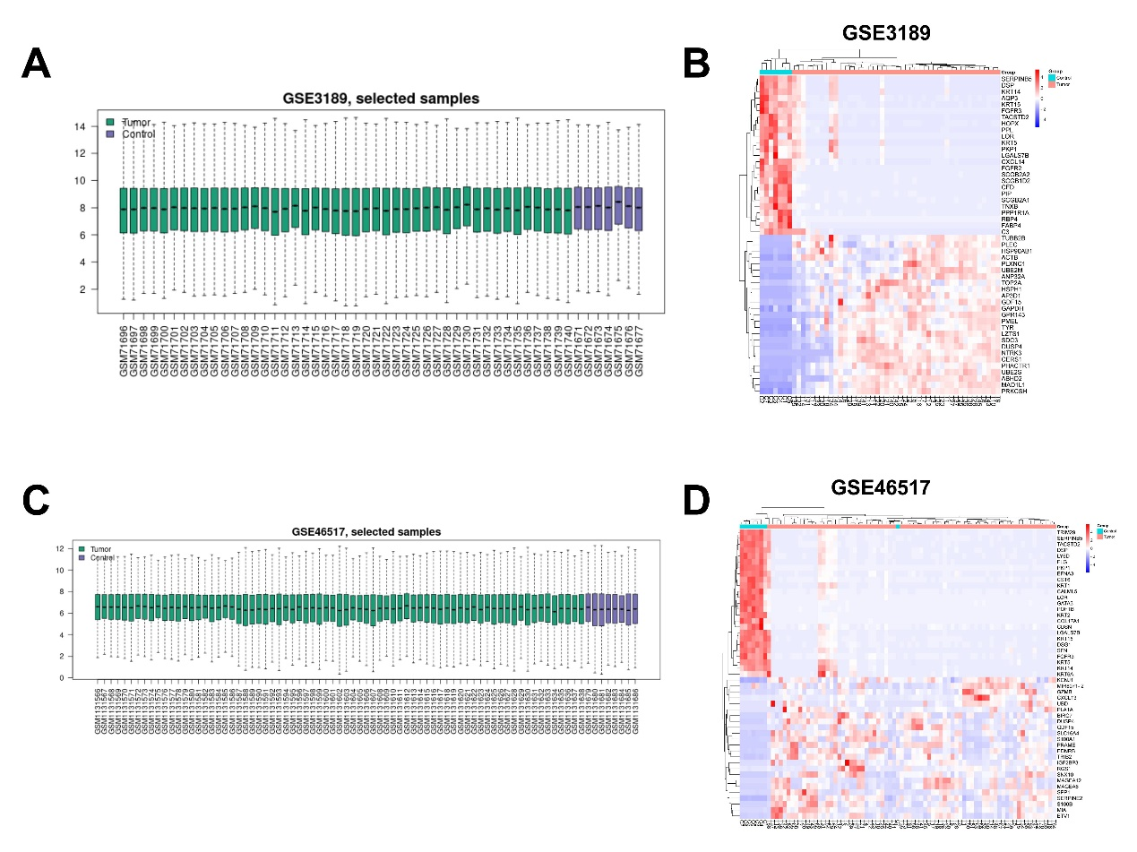
Figure S2: A: Protein-protein interaction network; B: Hub genes identified based on MCODE analysis. The lines between the nodes represent the interactions between genes. 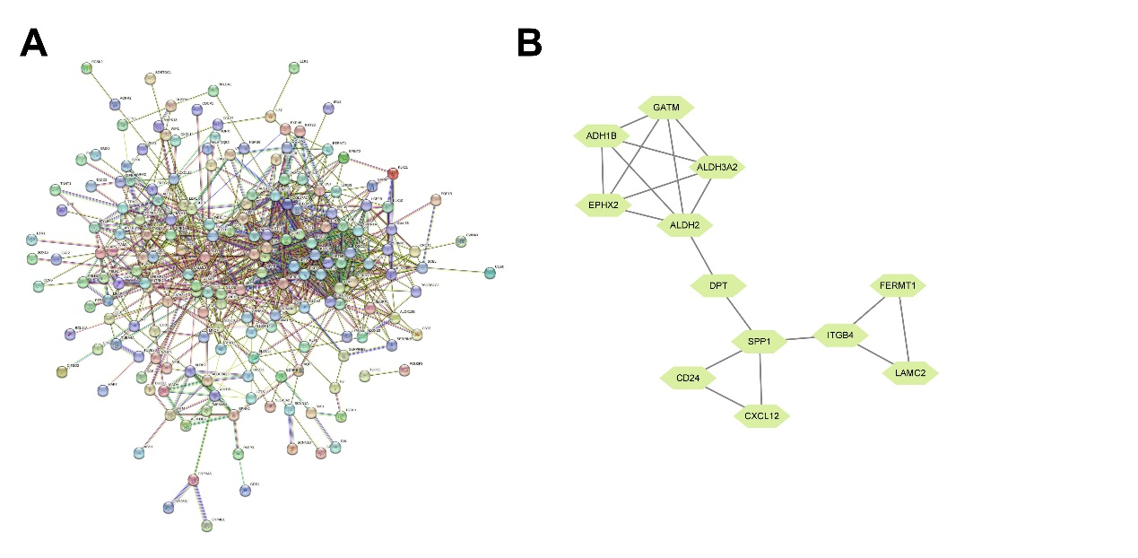

Figure S3 Analysis of hub genes A: The correlation coefficient of hub gene expression in the datasets. B: Principal component analysis of hub gene. Axes of PC1 and PC2 in the figure are the first and second principal components (i.e., the explanation rate of differences by potential variables); Dots represent samples, and different colors represent different groups. C: The expression of ridge map of hub genes. The horizontal coordinate is gene expression, the shape of the mountain represents the dispersion between a set of data, and the height is the number of samples corresponding to the gene expression.
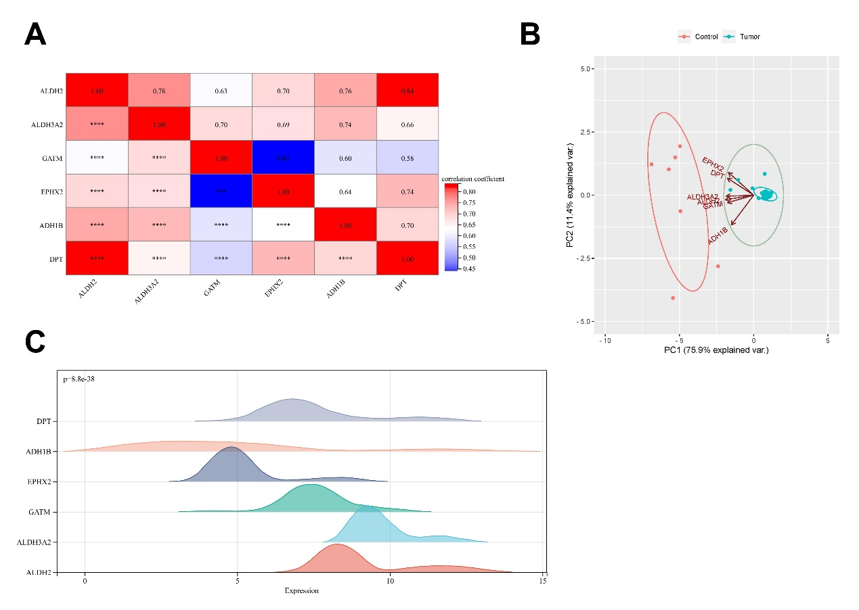
Figure S4 The Gene Expression Profiling Interactive Analysis 2 database verified that the difference of ALDH2 expression had significant differences in the prognosis of SKCM patients.
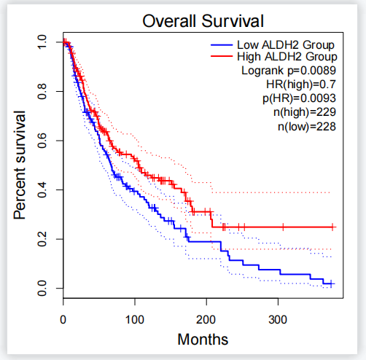

Figure S5 Immune infiltration of ALDH. The coloration of ALDH2 in melanoma cells and infiltration of B cell, CD8+T cell, CD4+T cell, Macrophage, Neutrophil, Dendritic cell.