- Supplementary Material

Figure 1. Density plots of the scales

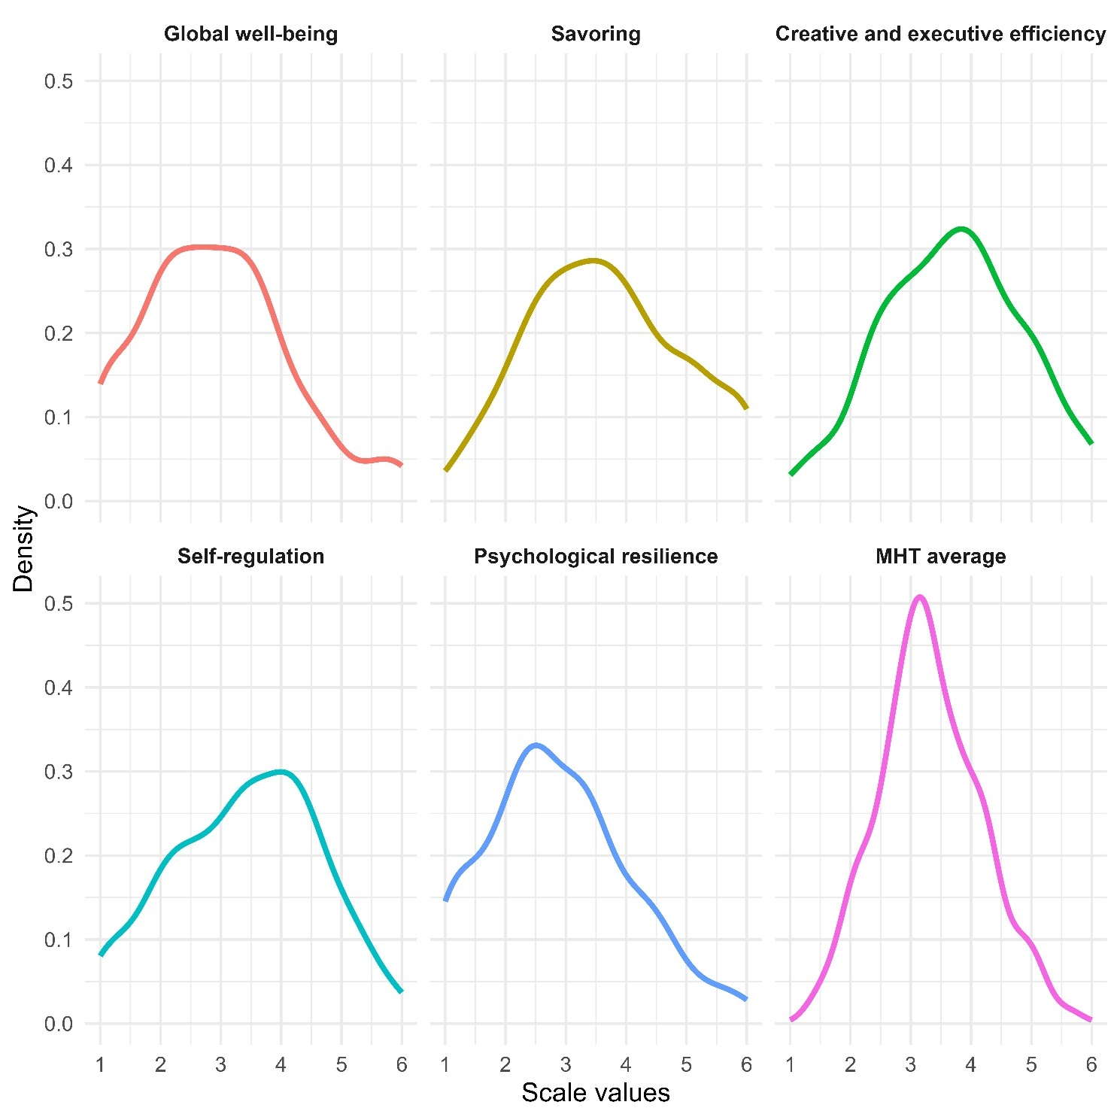

Table 1. Details of measures

Name of the measure | Description of the measure
Mental Health Test¹⁴ | The 17-item self-report test operationalises the Maintainable Positive Mental Health Theory^{13,14} and measures five mental health capacities and competencies in adult population: Global Well-being, Savoring, Resilience, Self-regulation, and Creative and Executive Efficiency. Respondents rate 17 items on a 7-point Likert scale from 1 (strongly disagree) to 7 (strongly agree). The MHT score is defined as the average of the scores for the five subscales, which provide a comprehensive picture of the respondent’s level of mental health capacities. The detailed instructions for the scaling guide are given in Table 2 in the Appendices.
Global Well-being Scale¹⁵ | This self-report questionnaire operationalises the bio-psycho-socio-spiritual model of well-being, which emphasises that the condition for complete well-being is to function well in the emotional, psychological, social and spiritual domains of one's human nature. The 17 statements in the questionnaire are rated on a 7-point Likert scale from 1 (strongly disagree) to 7 (strongly agree).
PERMA-profiler²⁷ | The five-pillar model measures positive emotions, engagement, positive relationship, meaning, accomplishment which reinforce one another in creating and maintaining a state of well-being. The self-report 23-items are rated on a 10-point Likert scale from 1 (strongly disagree) to 10 (strongly agree).
Psychological Well-being Scale³ | This widely used self-report scale operationalises an improved version of Diener's concept of subjective well-being, which emphasises the need for competence, optimism, contribution to the well-being of others, purpose in life, self-esteem, and positive relationships, in addition to life satisfaction and the dominance of positive emotions. The 8 statements in the questionnaire are rated on a 7-point Likert scale from 1 (strongly disagree) to 7 (strongly agree).
Satisfaction with Life Scale²⁸ | This self-report scale measures overall life satisfaction by rating five items on a seven-point Likert scale from 1 (strongly disagree) to 7 (strongly agree).
Positivity Scale⁶ | Respondents rate the eight items on a 5-point scale from 1 (strongly disagree) to 5 (strongly agree) that measure the individual's tendency to view their life and experiences in a positive way.
Symptom Checklist-90, revised²⁹ | This self-report inventory measures the presence and degree of severity of psychological symptoms on 9 scales: somatization, compulsivity, interpersonal sensitivity, depression, anxiety, hostility, phobia, paranoia, psychoticism, and a group of additional items not included in any of the scales. The Global Severity Index, in contrast to the problem-specific scales, provides an overall picture of the general severity of mental disorder symptoms. The 90 statements in the questionnaire are rated on a 5-point Likert scale.

Table 2. Descriptive statistics of the other well-being scales in the study
Subscale | Mean | Median | SD | Skewness | Kurtosis | Range | N
PERMA-profiler | 5.59 | 5.52 | 1.64 | 0.12 | -0.44 | 1.71–9.57 | 309
Psychological Well-being Scale | 4.25 | 4.25 | 1.47 | -0.06 | -0.72 | 1–7 | 321
Positive Experience % | 5.07 | 5.00 | 2.68 | 0.10 | -1.16 | 1–10 | 329
Global Well-being Scale | 3.19 | 3.11 | 1.22 | 0.2 | -0.61 | 1–6 | 305
Satisfaction with Life Scale | 3.42 | 3.20 | 1.55 | 0.30 | -0.87 | 1–7 | 322
Positivity Scale | 3.12 | 3.12 | 0.87 | 0.01 | -0.77 | 1–5 | 316
Symptom Checklist-90 | 1.12 | 1.02 | 0.69 | 0.61 | -0.12 | 0.01–3.15 | 235

Table 3. Measures of reliability for the other well-being scales and measures

Subscale | Number of items / subscales | Cronbach’s α | McDonald’s ω | N
PERMA-profiler | 7 | 0.86  (0.83–0.88) | 0.87  (0.85–0.89) | 309
Psychological Well-being Scale | 8 | 0.91  (0.89–0.93) | 0.91  (0.89–0.93) | 321
Positive Experience % | 1 | - | - | 329
Global Well-being Scale | 4 | 0.91  (0.89–0.93) | 0.91  (0.89–0.93) | 305
Satisfaction with Life Scale | 5 | 0.87  (0.84–0.89) | 0.87  (0.84–0.89) | 322
Positivity Scale | 8 | 0.83  (0.81–0.86) | 0.86  (0.84–0.88) | 316
Symptom Checklist-90 | 9 | 0.93  (0.92–0.95) | 0.94  (0.92–0.95) | 235
Table 4. Descriptive statistics of the MHT subscales (n = 331)

Subscale | Mean | Median | SD | Skewness | Kurtosis | Range
Global well-being | 2.91 | 3.00 | 1.21 | 0.45 | -0.21 | 1–6
Savoring | 3.67 | 3.67 | 1.26 | 0.14 | -0.79 | 1–6
Creative and executive efficiency | 3.69 | 3.80 | 1.15 | -0.04 | -0.56 | 1–6
Self-regulation | 3.41 | 3.33 | 1.22 | -0.12 | -0.72 | 1–6
Psychological resilience | 2.89 | 2.67 | 1.18 | 0.41 | -0.34 | 1–6
MHT score | 3.32 | 3.25 | 0.84 | 0.22 | -0.22 | 1.35–5.67

Table 5. Descriptive statistics of the single items of the MHT scale (n = 331)
Item | Mean | Median | SD | Skewness | Kurtosis | Range | Cronbach’s α of the given subscale if item is deleted
01W | 2.95 | 3.00 | 1.43 | 0.46 | -0.53 | 1–6 | 0.82  (0.77–0.87)
13W | 2.80 | 3.00 | 1.42 | 0.56 | -0.39 | 1–6 | 0.76  (0.68–0.83)
17W | 3.01 | 3.00 | 1.31 | 0.23 | -0.49 | 1–6 | 0.74  (0.66–0.80)
03S | 3.74 | 4.00 | 1.51 | 0.05 | -1.02 | 1–6 | 0.64  (0.54–.72)
09S | 3.95 | 4.00 | 1.53 | -0.20 | -0.98 | 1–6 | 0.68  (0.59–0.75)
11S | 3.31 | 3.00 | 1.57 | 0.20 | -0.93 | 1–6 | 0.72  (0.63–0.79)
05C | 3.50 | 4.00 | 1.52 | -0.05 | -0.82 | 1–6 | 0.79  (0.74–0.83)
06C | 3.66 | 4.00 | 1.51 | -0.10 | -0.87 | 1–6 | 0.78  (0.72–0.82)
08C | 3.51 | 4.00 | 1.41 | -0.06 | -0.58 | 1–6 | 0.82  (0.77–0.85)
14C | 3.74 | 4.00 | 1.52 | -0.05 | -0.94 | 1–6 | 0.82  (0.78–0.85)
16C | 4.06 | 4.00 | 1.34 | -0.27 | -0.55 | 1–6 | 0.84  (0.81–0.87)
02SR | 3.38 | 3.00 | 1.51 | -0.05 | -0.95 | 1–6 | 0.57  (0.45–0.66)
07SR | 3.81 | 4.00 | 1.62 | -0.33 | -1.00 | 1–6 | 0.63  (0.53–0.72)
15SR | 3.97 | 4.00 | 1.47 | -0.19 | -0.90 | 1–6 | 0.64  (0.54–0.71)
04PR | 3.01 | 3.00 | 1.44 | 0.43 | -0.56 | 1–6 | 0.68  (0.59–0.76)
10PR | 2.77 | 3.00 | 1.45 | 0.64 | -0.36 | 1–6 | 0.59  (0.47–0.68)
12PR | 2.88 | 3.00 | 1.35 | 0.28 | -0.61 | 1–6 | 0.83  (0.78–0.87)
Note. The numbering of the items correspond to the questions presented in table 2 of the supplementary material. W = Global well-being; S = Savoring; C = Creative and executive efficiency; SR = Self-regulation; PR = Psychological resilience.

Table 6. Correlation of the Symptom Checklist-90 subscales in the sample (n = 235)

Subscale | Somatization | Obsessive-Compulsive | Interpersonal Sensitivity | Depression | Anxiety | Hostility | Phobic Anxiety | Paranoid Ideation | Psychotism
Somatization |  | 0.46**  (0.33–0.57) | 0.45**  (0.34–0.56) | 0.58**  (0.49–0.67) | 0.68**  (0.60–0.75) | 0.42**  (0.28–0.55) | 0.50**  (0.39–0.61) | 0.43**  (0.29–0.55) | 0.48**  (0.33–0.58)
Obsessive-Compulsive |  |  | 0.72**  (0.66–0.78) | 0.75**  (0.59–0.80) | 0.76**  (0.69–0.82) | 0.53**  (0.44–0.61) | 0.59**  (0.50–0.69) | 0.61**  (0.51–0.69) | 0.72**  (0.64–0.79)
Interpersonal Sensitivity |  |  |  | 0.73**  (0.68–0.79) | 0.74**  (0.68–0.79) | 0.60**  (0.50–0.69) | 0.56**  (0.47–0.65) | 0.77**  (0.71–0.83) | 0.74**  (0.67–0.80)
Depression |  |  |  |  | 0.80**  (0.75–0.85) | 0.49**  (0.40–0.59) | 0.52**  (0.42–0.60) | 0.60**  (0.51–0.68) | 0.65**  (0.57–0.71)
Anxiety |  |  |  |  |  | 0.64**  (0.56–0.72) | 0.71**  (0.64–0.77) | 0.66**  (0.58–0.74) | 0.68**  (0.61–0.75)
Hostility |  |  |  |  |  |  | 0.46**  (0.36–0.56) | 0.62**  (0.53–0.70) | 0.56**  (0.46–0.65)
Phobic Anxiety |  |  |  |  |  |  |  | 0.54**  (0.44–0.64) | 0.51**  (0.41–0.61)
Paranoid Ideation |  |  |  |  |  |  |  |  | 0.70**  (0.63–0.77)
Psychotism
Results are from Spearman’s robust rank-based correlation, as normality was violated and the difference between the Pearson’s and Spearman’s correlation values were major. Values indicate the correlation coefficient, with the 95% bootstrapped (10,000 runs) confidence interval in parentheses.
***p < 0.001; **p < 0.01; *p < 0.05.

Table 7. The Mental Health Test (MHT)

The following statements are designed to obtain information about your perceptions of wellness. Please consider each statement carefully and thoughtfully, then enter an X to indicate the response option with which you most agree. There are no right or wrong answers.

 | Strongly disagree | Disagree | Slightly disagree | Slightly agree | Agree | Strongly agree
1. Joy is present more than sorrow in my daily life. (W)
2. I easily become impatient. (SR)
3. It’s easy for me to revive my joy from pleasant memories. (S)
4. I tend to bounce back quickly after hard times. (PR)
5. I often have ideas that are taken further by others. (C)
6. Others describe me as a problem solver. (C)
7. I am impulsive: I act first and think second. (SR)
8. I can successfully achieve targets which I set for myself. (C)
9. I like to store memories of fun times that I go through so that I can recall them later. (S)
10. It does not take me long to recover from a stressful event. (PR)
11. I can make myself feel good by imagining what a happy time that is about to happen will be like. (S)
12. I tend to take a long time to get over setbacks in my life. (PR)
13. My general psychological state is good. (W)
14. I am good at jobs that need new and original ideas. (C)
15. I become frustrated when something does not happen the way I planned it. (SR)
16. I often know how people think and feel. (C)
17. How do you feel about your life as a whole?
(1: Very badly, 6: Very well) (W)
Note. W = Global well-being; S = Savoring; C = Creative and executive efficiency; SR = Self-regulation; PR = Psychological resilience.

Scaling guide:
Well-being: The average of the scores for items 1, 13, and 17
Savoring: The average of the scores for items 3, 9, and 11
Creative and executive efficiency: The average of the scores for items 5, 6, 8, 14, and 16
Self-regulation: The average of the scores for reversed items 2, 7 and 15
Psychological resilience: The average of the scores for items 4 and 10 and the reversed score for item 12
The total score for the Mental Health Test is defined as the average of the scores for the five subscales.

Table 8. Mentális Egészség Teszt (MET)

Az alábbi állítások az emberek általános életérzését, jellemző tulajdonságait és életfelfogását írják le. Nincsenek jó vagy rossz válaszok. Kérem, legyen olyan őszinte, amennyire csak tud és jelezze minden tételnél a megfelelő szám bekarikázásával, hogy milyen mértékben jellemző Önre az állítás!

 | egyáltalán nem jellemző | nem jellemző | kicsit jellemző | jellemző | nagyon jellemző | teljes mértékben jellemző
1. Mindennapjaimban érezhetően több az öröm, mint a bánat. (J) | 1 | 2 | 3 | 4 | 5 | 6
2. Könnyen válok türelmetlenné. (Ö) | 1 | 2 | 3 | 4 | 5 | 6
3. Könnyen fel tudom eleveníteni a múlt kellemes emlékeinek örömét. (S) | 1 | 2 | 3 | 4 | 5 | 6
4. Nehéz idők után hamar magamhoz térek. (R) | 1 | 2 | 3 | 4 | 5 | 6
5. Gyakran vannak olyan ötleteim, amelyekhez mások eredményesen tudnak kapcsolódni és továbbgondolkodásra készteti őket. (AV) | 1 | 2 | 3 | 4 | 5 | 6
6. Mások szerint is jó problémamegoldó vagyok. (AV) | 1 | 2 | 3 | 4 | 5 | 6
7. Hirtelen természetű vagyok (előbb cselekszem, utána gondolkodom). (Ö) | 1 | 2 | 3 | 4 | 5 | 6
8. Sikeresen el tudom érni a magam elé kitűzött célokat. (AV) | 1 | 2 | 3 | 4 | 5 | 6
9. Szeretem elraktározni az átélt örömteli idők emlékét, hogy később felidézhessem őket. (S) | 1 | 2 | 3 | 4 | 5 | 6
10. A lelki megrázkódtatások után elég gyorsan felépülök. (R) | 1 | 2 | 3 | 4 | 5 | 6
11. Jó kedvre tudom hangolni magam, ha elképzelem, milyen lesz egy közelgő boldog idő. (S) | 1 | 2 | 3 | 4 | 5 | 6
12. Rendszerint eltart egy ideig, amíg továbblépek életem egy-egy nehéz pillanatán. (R) | 1 | 2 | 3 | 4 | 5 | 6
13. Lelki állapotom jónak mondható. (J) | 1 | 2 | 3 | 4 | 5 | 6
14. Jó vagyok az olyan munkákban, ahol új és eredeti ötletek kellenek. (AV) | 1 | 2 | 3 | 4 | 5 | 6
15. Ideges leszek, ha valami nem úgy alakul, ahogy terveztem. (Ö) | 1 | 2 | 3 | 4 | 5 | 6
16. Gyakran jók a megsejtéseim arról, hogy hogyan gondolkoznak és éreznek az emberek. (AV) | 1 | 2 | 3 | 4 | 5 | 6
17. Mindent összevetve mennyire mondaná magát boldognak (1: nagyon nem, 6: nagyon igen)? (J)
1 2 3 4 5 6
Megjegyzés: J = Jóllét; S = Savoring; AV = Alkotó–végrehajtó hatékonyság; Ö = Önreguláció; R = Reziliencia.

Skálaképzési útmutató:
Jóllét (J): 1, 13 és17 tételek pontszámainak átlaga
Savoring (S): 3, 9 és 11 tételek pontszámainak átlaga
Alkotó–végrehajtó hatékonyság (AV): 5, 6, 8, 14 és 16 tételek pontszámainak átlaga
Önreguláció (Ö): 2, 7 és 15 fordított tételek pontszámainak átlaga
Reziliencia (R): 4 és 10 tételek pontszámainak és a 12 fordított tétel pontszámának átlaga
A Mentális Egészség Teszt összpontszáma az öt alskála pontszámainak átlaga.

