Supplementary Material

First detection and genetic characterization of canine bufavirus in domestic dogs, Thailand

Kamonpan Charoenkul^{1,2}, Yu Nandi Thaw², Eaint Min Phyu², Waleemas Jairak^{1,2}, Chanakarn Nasamra^{1,2}, Ekkapat Chamsai¹, Supassama Chaiyawong^{1,2},

and Alongkorn Amonsin^{1,2*}

¹ Center of Excellence for Emerging and Re-emerging Infectious Diseases in Animals, Faculty of Veterinary Science, Chulalongkorn University, Bangkok, Thailand
² Department of Veterinary Public Health, Faculty of Veterinary Science, Chulalongkorn University, Bangkok, Thailand

*Corresponding author: Professor Dr. Alongkorn Amonsin
Mailing address: Department of Veterinary Public Health, Faculty of Veterinary Science, Chulalongkorn University, Bangkok, Thailand 10330
Phone: +66 2218 9578 Fax: +66 2218 9577

E-mail: Alongkorn.a@chula.ac.th

Keywords: Canine Bufavirus, Characterization, Dog, Genetic, Thailand

Running Head:
Characterization of CBuV in Thailand
Supplement Tables
Supplement Table 1. Percentage of positive CBuVs by clinical signs and age groups
Supplement Table 2. Percentage of positive CBuVs by months and seasons
Supplement Table 3. Pairwise comparison of whole genome sequences of Thai CBuV (CU_FS231) with reference parvoviruses
Supplement Table 4. Genetic analysis of VP2 gene between Thai CBuVs and reference CBuVs.
Supplement Table 5. Prediction of antigenic epitopes of Thai CBuV strain CU_FS20141 and CU_FS28678
Supplement Table 6. Evidence for positive and negative selection using various detection methods for CBuVs
Supplement Table 7. Recombinant analysis: CBuV strain CU_FS28678
Supplement Table 8. Nucleotide sequences of primers used for CBuV detection and sequencing in this study.

Supplement Figure
Supplement Figure 1 Location of sample collection and CBuVs detected by provinces in this study (Map of Thailand with permission by World Trade Press)
Supplement Figure 2 Genome structure of Canine parvoviruses and BuVs
Supplement Figure 3 Phylogenetic analysis of VP1 gene of Thai CBuV, the phylogenetic tree was constructed by using MEGA v.7.0 with neighbor-joining algorithm with Kimura-2 parameter model with 1,000 replications of bootstrap analysis. The pink circle represents Thai CBuVs.
Supplement Figure 4 Phylogenetic analysis of VP2 gene of Thai CBuV, the maximum likelihood tree constructed by using IQ-TREE version 2.1.3 (http://www.iqtree.org/) using the TVMe +IG4 model of nucleotide substitution, default heuristic search options, and ultrafast bootstrapping with 1000 replicates. Tree was visualized by iTOL version 6.0 (https://itol.embl.de/). The pink circles indicate the Thai CBuVs.

Supplement Table 1. Percentage of positive CBuVs by clinical signs and age groups
Year | Percentage of positive CBuVs
Year | Clinical signs (%) |  | Age groups (%)
Year | Healthy | Symptomatic | < 1 year | 1-5 years | >5 years
2016 | 1/22 (4.55) | 4/40 (10.00) | 2/26 (7.69) | 1/27 (3.70) | 2/9 (22.22)
2017 | 0/22 (0.00) | 16/91 (17.8) | 16/77 (20.78) | 0/23 (0.00) | 0/13 (0.00)
2018 | 0/2 (0.00) | 4/88 (4.55) | 4/47 (8.51) | 0/20 (0.00) | 0/23 (0.00)
2019 | 0/0 (0.00) | 3/67 (4.48) | 3/47 (6.38) | 0/16 (0.00) | 0/4 (0.00)
2020 | 1/53 (1.89) | 0/0 (0.00) | 0/28 (0.00) | 0/12 (0.00) | 1/13 (7.69)
2021 | 9/50 (18.00) | 0/4 (0.00) | 0/9 (0.00) | 8/30 (26.67) | 1/15 (6.67)
2022 | 8/67 (11.94) | 4/25 (16.00) | 7/20 (33.33) | 4/49 (8.16) | 1/23 (4.35)
Total | 19/216 (8.80) | 31/315 (9.84) | 32/254 (12.60) | 13/177 (7.34) | 5/100 (5.00)
- Fisher exact test; p=0.7629 (p <0.05) not statistical significance when compared to the healthy and symptomatic.
- Fisher exact test; p= 1 (p <0.05) not statistical significance when compared to < 1 year and 1-5 years
- Fisher exact test; p= 0.0196 (p <0.05) statistical significance when compared to < 1 year and >5 years
- Fisher exact test; p= 0.0345 (p <0.05) statistical significance when compared to 1-5 year and >5 years

Supplement Table 2. Percentage of positive CBuVs by months and seasons
- Percentage of positive CBuVs by months
Year | Month | Total samples | Number positive for CBuVs (%)
2016 | Sep | 7 | 3 (42.86)
 | Oct | 25 | 2 (8.00)
 | Nov | 12 | 0
 | Dec | 18 | 0
2017 | Jan | 17 | 2 (11.76)
 | Feb | 22 | 2 (9.09)
 | Mar | 6 | 4 (66.67)
 | Apr | 7 | 0
 | May | 3 | 1 (33.33)
 | June | 12 | 1 (8.33)
 | July | 10 | 1 (10.00)
 | Aug | 4 | 0
 | Sep | 15 | 1 (6.67)
 | Oct | 4 | 0
 | Nov | 3 | 3 (100.00)
 | Dec | 10 | 1 (10.00)
2018 | Jan | 10 | 0
 | Feb | 6 | 0
 | Mar | 6 | 1 (16.67)
 | Apr | 11 | 0
 | May | 12 | 0
 | June | 8 | 0
 | July | 3 | 0
 | Aug | 3 | 0
 | Sep | 0 | 0
 | Oct | 0 | 0
 | Nov | 8 | 1 (12.50)
 | Dec | 23 | 2 (8.70)
2019 | Jan | 14 | 0
 | Feb | 30 | 1 (3.33)
 | Mar | 11 | 1 (9.90)
 | Apr | 9 | 1 (11.11)
 | May | 3 | 0
 | June | 0 | 0
 | July | 0 | 0
 | Aug | 0 | 0
 | Sep | 0 | 0
 | Oct | 0 | 0
 | Nov | 0 | 0
 | Dec | 0 | 0
2020 | Jan | 0 | 0
 | Feb | 0 | 0
 | Mar | 0 | 0
 | Apr | 0 | 0
 | May | 0 | 0
 | June | 0 | 0
 | July | 0 | 0
 | Aug | 13 | 0
 | Sep | 5 | 0
 | Oct | 8 | 0
 | Nov | 6 | 0
 | Dec | 21 | 1 (4.76)
2021 | Jan | 41 | 9 (21.95)
 | Feb | 0 | 0
 | Mar | 9 | 0
 | Apr | 0 | 0
 | May | 0 | 0
 | June | 1 | 0
 | July | 0 | 0
 | Aug | 0 | 0
 | Sep | 2 | 0
 | Oct | 1 | 0
 | Nov | 0 | 0
 | Dec | 0 | 0
2022 | Jan | 0 | 0
 | Feb | 8 | 0
 | Mar | 21 | 0
 | Apr | 18 | 8 (5.56)
 | May | 20 | 2 (5.00)
 | June | 0 | 0
 | July | 7 | 2 (14.29)
 | Aug | 0 | 0
 | Sep | 0 | 0
 | Oct | 18 | 0
Total |  | 531 | 50 (9.42)
- Percentage of positive CBuVs by seasons
Seasons |  | Total samples | Number positive for CBuVs (%)
Winter (November-January) |  | 183 | 19 (10.38)
Summer (February-May) |  | 202 | 21 (10.39)
Rainy (June-October) |  | 146 | 10 (6.84)
Total |  | 531 | 50 (9.42)

- Fisher exact test; p= 1 (p <0.05) not statistical significance when compared between Winter and Summer seasons
- Fisher exact test; p= 0.3288 (p <0.05) not statistical significance when compared between Winter and Rainy seasons
- Fisher exact test; p= 0.3405 (p <0.05) not statistical significance when compared between Summer and Rainy seasons

Supplement Table 3. Pairwise comparison of whole genome sequences of Thai CBuV (CU_FS231) with reference parvoviruses
Virus | Host | Accession number | Country | Year | Genome size | % Nucleotide identities (% Amino acid identities)
 |  |  |  |  |  | WGS | NS1 | VP1 | VP2
This study
CU_FS231 | Dog | OQ730242 | Thailand | 2017 | 4214 | 100.00  (100.00) | 100.00  (100.00) | 100.00  (100.00) | 100.00  (100.00)
CU_FS53 | Dog | OQ730240 | Thailand | 2016 | 4214 | 99.40  (99.90) | 99.10  (100.00) | 99.70  (99.90) | 99.80  (99.80)
CU_FS70 | Dog | OQ730241 | Thailand | 2016 | 1664 | N/A | N/A | N/A | 99.90  (100.00)
CU_FS232 | Dog | OQ730243 | Thailand | 2017 | 4214 | 100.00  (100.00) | 100.00  (100.00) | 100.00  (100.00) | 100.00  (100.00)
CU_FS235 | Dog | OQ730244 | Thailand | 2017 | 4214 | 100.00  (100.00) | 100.00  (100.00) | 100.00  (100.00) | 100.00  (100.00)
CU_FS236 | Dog | OQ730245 | Thailand | 2017 | 4214 | 100.00  (100.00) | 100.00  (100.00) | 100.00  (100.00) | 100.00  (100.00)
CU_FS20141 | Dog | OQ730246 | Thailand | 2017 | 4214 | 100.00  (100.00) | 99.90  (100.00) | 100.00  (100.00) | 100.00  (100.00)
CU_FS20932 | Dog | OQ730247 | Thailand | 2018 | 4214 | 99.80  (99.90) | 99.80  (99.80) | 99.70  (99.90) | 99.80  (99.80)
CU_FS22734 | Dog | OQ730248 | Thailand | 2018 | 4214 | 100.00  (100.00) | 100.00  (100.00) | 100.00  (100.00) | 100.00  (100.00)
CU_FS23266 | Dog | OQ730249 | Thailand | 2018 | 4214 | 99.50  (99.60) | 99.70  (99.80) | 99.30  (99.30) | 99.10  (99.30)
CU_FS23631 | Dog | OQ730250 | Thailand | 2019 | 839 | N/A | N/A | N/A | 100.00  (100.00)
CU_FS26352 | Dog | OQ730251 | Thailand | 2021 | 4214 | 99.80  (99.80) | 99.90  (100.00) | 99.60  (99.60) | 99.60  (99.70)
CU_FS26336 | Dog | OQ730252 | Thailand | 2021 | 2550 | N/A | N/A | 99.20  (99.40) | 99.50  (99.50)
CU_FS26340 | Dog | OQ730253 | Thailand | 2021 | 4214 | 99.60  (99.80) | 99.60  (99.70) | 99.60  (99.90) | 99.80  (99.80)
CU_FS26359 | Dog | OQ730254 | Thailand | 2021 | 2550 | N/A | N/A | 99.30  (99.40) | 99.60  (99.60)
CU_FS28678 | Dog | OQ730255 | Thailand | 2022 | 4214 | 95.20  (98.10) | 99.80  (100.00) | 91.00  (96.30) | 88.80  (95.40)
CU_FS28683 | Dog | OQ730256 | Thailand | 2022 | 4214 | 95.20  (98.00) | 99.80  (99.80) | 91.10  (96.30) | 88.90  (95.40)
CU_FS28696 | Dog | OQ730257 | Thailand | 2022 | 4214 | 99.70  (99.70) | 99.90  (100.00) | 99.40  (99.40) | 99.50  (99.50)
CU_FS28961 | Dog | OQ730258 | Thailand | 2022 | 4214 | 99.60  (99.70) | 99.70  (99.80) | 99.50  (99.60) | 99.50  (99.50)
CU_FS29327 | Dog | OQ730259 | Thailand | 2022 | 845 | N/A | N/A | N/A | 99.60  (99.60)
Reference CBuV
ITA/2015/297 | Dog | MF198244 | Italy | 2015 | 4219 | 99.70  (99.90) | 99.90  (100.00) | 99.60  (99.90) | 99.70  (99.80)
HUN/2012/22 | Dog | MF198245 | Hungary | 2012 | 4219 | 99.50  (99.70) | 99.70  (99.80) | 99.50  (99.70) | 99.60  (99.60)
HUN/2012/126 | Dog | MF198246 | Hungary | 2012 | 4219 | 99.60  (99.80) | 99.80  (100.00) | 99.50  (99.70) | 99.60  (99.60)
CBuV-88 | Dog | MH645362 | China | 2015 | 4249 | 99.40  (99.40) | 99.80  (100.00) | 98.90  (99.20) | 98.80  (98.90)
GXNN02-2018 | Dog | MK404087 | China | 2018 | 4219 | 99.20  (99.10) | 99.10  (98.10) | 99.50  (99.60) | 99.80  (100.00)
CaBuV/62/2017 | Dog | MT154050 | Italy | 2020 | 4219 | 99.20  (99.70) | 98.90  (99.40) | 99.60  (99.90) | 99.80  (100.00)
Henan38 | Dog | MT364251 | China | 2019 | 4219 | 99.60  (99.90) | 99.50  (99.80) | 99.80  (100.00) | 99.80  (100.00)
Henan44 | Dog | MT364252 | China | 2019 | 4219 | 99.50  (99.60) | 99.40  (99.40) | 99.60  (99.70) | 99.70  (99.80)
AH-001 | Dog | MT542982 | China | 2019 | 4219 | 99.20  (99.80) | 98.90  (99.50) | 99.70  (99.90) | 99.80  (100.00)
AH-002 | Dog | MT542983 | China | 2019 | 4219 | 99.50  (100.00) | 99.30  (100.00) | 99.70  (100.00) | 99.70  (100.00)
AH-003 | Dog | MT577645 | China | 2019 | 4219 | 98.80  (98.50) | 98.90  (99.50) | 98.80  (98.20) | 98.70  (97.90)
NWT-W25 | wolf | OK546094 | Canada | 2011 | 4234 | 99.00  (99.10) | 98.70  (99.10) | 99.40  (99.20) | 99.50  (99.10)
NWT-W116 | wolf | OK546096 | Canada | 2011 | 4234 | 99.00  (99.60) | 98.70  (99.20) | 99.60  (99.90) | 99.60  (99.80)
Human and primate
BF.86 | Human | JX027296 | Burkina Fas | 2009 | 4822 | 61.60  (55.10) | 62.60  (55.10) | 71.40  (64.40) | 70.50  (65.40)
Bufavirus 1-BF.7 | Human | JX027295 | Burkina Fas | 2008 | 4822 | 60.60  (54.50) | 62.50  (54.50) | 69.60  (64.00) | 69.20  (64.20)
Bufavirus 1-BJ133 | Human | KM580347 | China | 2014 | 4882 | 60.90  (55.20) | 62.90  (55.20) | 69.20  (63.60) | 68.90  (63.80)
Bufavirus 1-BF.96 | Human | JQ918261 | Burkina Fas | 2009 | 4912 | 60.60  (54.80) | 62.60  (54.80) | 69.60  (64.30) | 69.20  (64.50)
Bufavirus 2-BF.39 | Human | JX027297 | Burkina Fas | 2009 | 4562 | 60.50  (55.50) | 62.60  (55.50) | 67.50  (61.90) | 66.90  (61.40)
Bufavirus 3-AHP-74 | Human | AB982222 | Turkey | 2010 | 4745 | 60.70  (54.80) | 62.60  (54.80) | 67.70  (62.20) | 66.90  (61.90)
Bufavirus 3-BTN-310 | Human | AB847989 | Bhutan | 2011 | 4766 | 60.70  (55.10) | 62.50  (55.10) | 67.70  (62.50) | 66.90  (61.70)
Bufavirus 3-BTN-109 | Human | AB847988 | Bhutan | 2011 | 4734 | 60.80  (55.20) | 62.60  (55.20) | 67.70  (62.50) | 66.80  (61.70)
Wuharv parvovirus | Rhesus monkey | JX627576 | USA | 2010 | 4909 | 65.20  (60.50) | 67.10  (60.50) | 68.50  (68.60) | N/A
Porcine and rat bufavirus
GD015 | Swine | MK279317 | China | 2017 | 4189 | 45.60  (34.80) | 68.40  (66.80) | 71.80  (69.60) | 70.70  (69.50)
GD030 | Swine | MK279318 | China | 2017 | 4189 | 45.20  (34.90) | 67.80  (66.80) | 71.60  (68.90) | 70.60  (68.60)
GDHY-1 | swine | MK279319 | China | 2017 | 4189 | 45.50  (35.10) | 68.20  (67.40) | 71.20  (68.40) | 70.30  (68.60)
ZM38 | Crocidura hirta | NC026815 | Zambia | 2012 | 4613 | 43.90  (32.30) | 65.20  (61.50) | 57.80  (52.90) | 56.90  (53.30)
SY-2015 isolate 791102 | wild rat | NC028650 | China | 2014 | 4634 | 43.20  (31.80) | 66.00  (62.20) | 58.00  (53.90) | 56.30  (52.10)
Feline bufavirus
GD4 | Cat | MW970061 | China | 2020 | 594 | N/A | N/A | N/A | 100.00  (100.00)
GD6 | Cat | MW970062 | China | 2020 | 594 | N/A | N/A | N/A | 100.00  (100.00)
GD7 | Cat | MW970063 | China | 2020 | 594 | N/A | N/A | N/A | 100.00  (100.00)
GD8 | Cat | MW970064 | China | 2020 | 594 | N/A | N/A | N/A | 100.00  (100.00)
GD13 | Cat | MW970065 | China | 2020 | 594 | N/A | N/A | N/A | 100.00  (100.00)
GD18 | Cat | MW970066 | China | 2020 | 594 | N/A | N/A | N/A | 100.00  (100.00)
GD21 | Cat | MW970067 | China | 2020 | 594 | N/A | N/A | N/A | 100.00  (100.00)
GD64 | Cat | MW970069 | China | 2020 | 594 | N/A | N/A | N/A | 99.80  (100.00)
GD87 | Cat | MW970070 | China | 2020 | 594 | N/A | N/A | N/A | 99.80  (100.00)
GD 123 | Cat | MW970072 | China | 2020 | 594 | N/A | N/A | N/A | 99.80  (99.990)
GD 131 | Cat | MW970074 | China | 2020 | 594 | N/A | N/A | N/A | 99.80  (99.90)
Bat Bufavirus
Ms-PV/Shaanxi2011 | Bat | KC154061 | China | 2011 | 3403 | 61.30  (48.30) | 64.90  (61.10) | 64.90  (59.50) | 64.20  (58.70)
Mr-PV/Shaanxi201 | Bat | KC154060 | China | 2011 | 3891 | 61.50  (49.20) | 66.10  (61.40) | 65.70  (60.90) | 63.7  (58.50)
BtBV/V7/HUN/2013 | Bat | KR078344.1 | Hungary | 2013 | 3411 | 62.40  (49.00) | 67.2  (64.40) | 65.70  (60.80) | 65.60  (59.80)
Other parvoviruses
Feline parvovirus
FPV-kai.us.06 | Cat | EU659115.1 | USA | 2006 | 4269 | 57.80  (43.80) | 57.00  (45.80) | 52.70  (37.90) | 51.70  (35.00)
FPV-4.us_64 | Cat | EU659112.1 | USA | 1964 | 4269 | 57.80  (43.70) | 57.10  (45.60) | 52.60  (38.10) | 51.60  (35.00)
Canine parvovirus
CPV-2C -CU 24 | Dog | MH711894. | Thailand | 2016 | 4269 | 58.00  (43.80) | 57.10  (45.80) | 52.70  (37.80) | 51.50  (34.90)
CPV-5.us.79 | Dog | EU659116 | USA | 1979 | 4269 | 57.90  (43.70) | 57.10  (45.80) | 52.60  (37.90) | 51.40  (34.90)
Canine bocavirus
CBoV-2-GZHD15 | Dog | KY038922. | China | 2015 | 5041 | 37.80  (20.20) | 39.50  (21.70) | 42.30  (21.10) | 40.60  (16.50)
CBoV-2-17CC0312 | Dog | MH626633 | China | 2017 | 5069 | 38.50  (20.80) | 39.20  (21.70) | 42.90  (21.50) | 41.20  (16.70)
CBoV-1-HK831F | Dog | JQ692591 | China | 2010 | 5054 | 39.00  (21.30) | 40.70  (21.70) | 43.30  (21.50) | 41.40  (16.70)

Supplement Table 4. Genetic analysis of VP2 gene between Thai CBuVs and reference CBuVs.
Virus | Country/Year | Accession number | VP2 gene
 |  | Accession number | 54 | 70 | 91 | 93 | 175 | 228 | 230 | 236 | 264 | 271 | 302 | 370 | 418 | 426 | 477 | 508
Type A
CU_FS53 | Thailand/2016 | OQ730240 | T | S | Q | Q | L | G | Q | K | D | I | E | T | S | A | K | A
CU_FS231 | Thailand/2017 | OQ730242 | . | . | . | . | . | . | . | . | . | . | . | . | . | . | . | .
CU_FS232 | Thailand/2017 | OQ730243 | . | . | . | . | . | . | . | . | . | . | . | . | . | . | . | .
CU_FS235 | Thailand/2017 | OQ730244 | . | . | . | . | . | . | . | . | . | . | . | . | . | . | . | .
CU_FS236 | Thailand/2017 | OQ730245 | . | . | . | . | . | . | . | . | . | . | . | . | . | . | . | .
CU_FS20141 | Thailand/2017 | OQ730246 | . | . | . | . | . | . | . | . | . | . | . | . | . | . | . | .
CU_FS20932 | Thailand/2018 | OQ730247 | . | . | . | . | . | . | . | . | . | . | . | . | . | . | . | .
CU_FS22734 | Thailand/2018 | OQ730248 | . | . | . | . | . | . | . | . | . | . | . | . | . | . | . | .
CU_FS23266 | Thailand/2018 | OQ730249 | . | . | . | . | . | E | . | . | . | . | . | . | . | . | . | .
CU_FS26352 | Thailand/2021 | OQ730251 | . | . | . | . | . | . | . | . | . | . | . | . | . | . | . | .
CU_FS26340 | Thailand/2021 | OQ730253 | . | . | . | . | . | . | . | . | . | . | . | . | . | . | . | .
CU_ FS28696 | Thailand/2022 | OQ730257 | . | . | . | . | . | . | . | . | . | . | . | . | . | . | . | .
CU_ FS28961 | Thailand/2022 | OQ730258 | . | . | . | . | . | . | . | . | . | . | . | . | . | . | . | .
Henan38 | China/2019 | MT364251 | . | . | . | . | . | . | . | . | . | . | . | . | . | . | . | .
Henan44 | China/2019 | MT364252 | . | . | . | . | . | . | . | . | . | . | . | . | . | . | . | .
GXNN01 | China/2018 | MK404086 | . | . | . | . | . | . | . | . | . | . | . | . | . | . | . | .
GXNN02 | China/2018 | MK404087 | . | . | . | . | . | . | . | . | . | . | . | . | . | . | . | .
CBuV-88 | China/2015 | MH645362 | . | . | . | . | . | . | . | . | . | . | . | . | . | . | . | .
AH-001 | China/2019 | MT542982 | . | . | . | . | . | . | . | . | . | . | . | . | . | . | . | .
AH-002 | China/2019 | MT542983 | . | . | . | . | . | . | . | . | . | . | . | . | . | . | . | .
AH-003 | China/2019 | MT577645 | . | . | . | . | . | . | . | . | . | . | . | . | . | . | . | .
Dog/62 | Italy/2017 | MT154050 | . | . | . | . | . | . | . | . | . | . | . | . | . | . | . | .
Dog/297 | Italy/2015 | MF198244 | . | . | . | . | . | . | . | . | . | . | . | . | . | . | . | .
Dog/22 | Hungary/2012 | MF198245 | . | . | . | . | . | . | . | . | . | . | . | . | . | . | . | .
Dog/126 | Hungary/2012 | MF198246 | . | . | . | . | . | . | . | . | . | . | . | . | . | . | . | .
NWT-W25 | Canada/2011 | OK546094 | . | . | . | . | . | . | . | . | N | . | . | . | . | . | . | .
NWT-W116 | Canada/2011 | OK546096 | . | . | . | . | . | . | . | . | . | . | . | . | . | . | . | .
Type B
FS28678 | Thailand/2022 | OQ730255 | I | T | T | H | I | Q | E | Q | I | N | V | S | T | D | N | G
FS28683 | Thailand/2022 | OQ730256 | I | T | T | H | I | Q | E | Q | I | N | V | S | T | D | N | G
9AS | Italy/20015 | MT154051 | I | T | T | H | I | Q | E | Q | I | N | V | S | T | D | N | G
35 | Italy/2016 | MT154052 | I | T | T | H | I | Q | E | Q | I | N | V | S | T | D | N | G
Supplement Table 5. Prediction of antigenic epitopes of Thai CBuV strain CU_FS20141 and CU_FS28678
- Prediction of antigenic epitopes of Thai CBuV strain CU_FS20141
Rank | Location | Epitope | Score | Recommend*
1 | 239 - 258 | KFDDIQFITVENCVPIELLR | 1.000 | 
2 | 99 - 118 | NDSYHAKVETPWSLLHANCW | 0.845
3 | 42 - 61 | NRTEFHYHNGEVTIVCHATR | 0.775
4 | 301 - 320 | GEGQNFEMVNTWQWGDRDTP | 0.762
5 | 373 - 392 | ASEKAVFDYAHGEMSPNEKD | 0.724
6 | 504 - 523 | IVTYATFWWSGTLVFKGKLR | 0.582
7 | 322 - 341 | AAATKVDNFHIGYQWPEWHF | 0.532
- Prediction of antigenic epitopes of Thai CBuV strain CU_FS28678

Rank | Location | Epitope | Score | Recommend*
1 | 90 - 109 | QTLHGRDTINDSYHAKVETP | 1.000
2 | 239 – 258 | KYDDIQFITVENCVPIELLR | 0.855
3 | 301 - 320 | GVGQNFEMVNTWQWGDRDTP | 0.587
4 | 25 - 44 | GGGGGGSGVGHSTGAFNNRT | 0.531
5 | 322 - 341 | AAATRVNNFHIGYQWPEWHF | 0.454
6 | 370 - 389 | STGASEKAVFDYNHGEMSPN | 0.444
7 | 116 - 135 | NCWGVWFNPADFQHMTAICN | 0.356

Supplement Table 6. Evidence for positive and negative selection using various detection methods for CBuVs
BuV  genome | Selection pressure analysis | Program
BuV  genome | Selection pressure analysis | FEL | FUBAR | MEME
NS1 | Positive selection | 0 | 3  (112, 116, 512) | 7  (207, 382, 415, 512, 514, 515, 600)
NS1 | Negative | 160 | 184
NS1 | Threshold | 0.1 | posterior probability of 0.9 | 0.1
NS1 | Rate distribution |  |  | 0.0827
VP1 | Positive selection | 1  (256) | 1  (256) | 8  (28, 78, 149, 199, 256, 430, 500, 660)
VP1 | Negative | 161 | 198
VP1 | Threshold | 0.1 | posterior probability of 0.9 | 0.1
VP1 | Rate distribution |  |  | 0.0971
VP2 | Positive selection | 2 (22, 113) | 2 (22,113) | 5 (14, 56, 248, 517, 557)
VP2 | Negative | 203 | 221
VP2 | Threshold | 0.1 | posterior probability of 0.9
VP2 | Rate distribution |  |  | 0.103

Supplement Table 7. Recombinant analysis of Thai CBuV strain CU_FS28678
Major parent: Thai CBuV strain CU_FS28696 (CBuV-subgroup A)
Minor parent: CBuV strain 9AS from Italy (MT154051; CBuV-subgroup B)

Methods | Av P-val
RDP | 1.067 x 10 ⁻⁰⁷
GENECONV | 5.806 x 10 ⁻⁰⁶
BootScan | 4.323 x 10 ⁻⁰⁵
Maxchi | 1.144 x 10 ⁻⁰⁹
Chimaera | 8.612 x 10 ⁻⁰³
SiScan | 7.014x 10 ⁻³⁰
3Seq | 2.222x 10 ⁻²¹

Supplement table 8. Nucleotide sequences of primers used for CBuV detection and sequencing in this study.
Primer name | Nucleotide sequence (5’-3’) | Position * | Product size | Reference
Primer detection
CPPV 165F | CTGGTTTAATCCAGCAGACT | 2923-2942 | 208 | ¹
CPPV 371R | TGAAGACCAAGGTAGTAGGT | 3111-3130
Primer sequencing
CBV_NV1F | GCAGTAAATTTGATACTTCATCTTG | 1-25 | 1052 | This study
BUFA-R1 | GCTTTGATGATAGTTTCACCACCTG | 1028-1052 | 1052 | ¹
CBV_N2F | ACACAAGAAAAATGGATGCTAGGAG | 970-994 | 720 | This study
CBV_N2R | CTATTTTTGAGTTCAATTCTGACACA | 1601-1626 | 720 | This study
CBV_N3F | CAGACTTGATCAAAAAGGCAAAGGCAGC | 1461-1488 | 731 | This study
CBV_N3R | GTAATTGTAGCCAGGAGGAACCCAACC | 2165-2191 | 731 | This study
CBV_N4F | GCCTCCGACTAATCGACCACG | 1957-1977 | 1200 | This study
CBV_N4R | CCTAGAGAGTCTATGTACATRTTGTC | 3131-3156 | 1200 | This study
CBV_N5F | TGGGGAGTCTGGTTTAATCCAGC | 2915-2937 | 688 | This study
CBV_N6R | CACCACTGCTGTAGTGGAAGTGCCA | 3578-3602 | 688 | This study
CBV_N7F | CTCAAYTAGAATACCACTGGCAATCT | 3387-3412 | 496 | This study
CBV_N7R | GTGAATGGTCCGAATGTGTTGTGGTATG | 3855-3882 | 496 | This study
CBV_N8F | CAACAAATGACAGGACAAACAGACTACAC | 3759-3786 | 512 | This study
BUFA-R5 | TTATAGAGTAATATTAGGCATAGCT | 4246-4270 | 512 | ^{1,2}
*Position based on CBuV strain CBuV-88/China/2015_(MH645362)

Supplement Figure
Supplement Figure 1 Location of sample collection and CBuVs detected by provinces in this study (Map of Thailand with permission by World Trade Press)
Supplement Figure 2 Genome structure of Canine parvoviruses and BuVs
Supplement Figure 3 Phylogenetic analysis of VP1 gene of Thai CBuV, the phylogenetic tree was constructed by using MEGA v.7.0 with neighbor-joining algorithm with Kimura-2 parameter model with 1,000 replications of bootstrap analysis. The pink circle represents Thai CBuVs.
Supplement Figure 4 Phylogenetic analysis of VP2 gene of Thai CBuV, the maximum likelihood tree constructed by using IQ-TREE version 2.1.3 (http://www.iqtree.org/) using the TVMe +IG4 model of nucleotide substitution, default heuristic search options, and ultrafast bootstrapping with 1000 replicates. Tree was visualized by iTOL version 6.0 (https://itol.embl.de/). The pink circles indicate the Thai CBuVs.

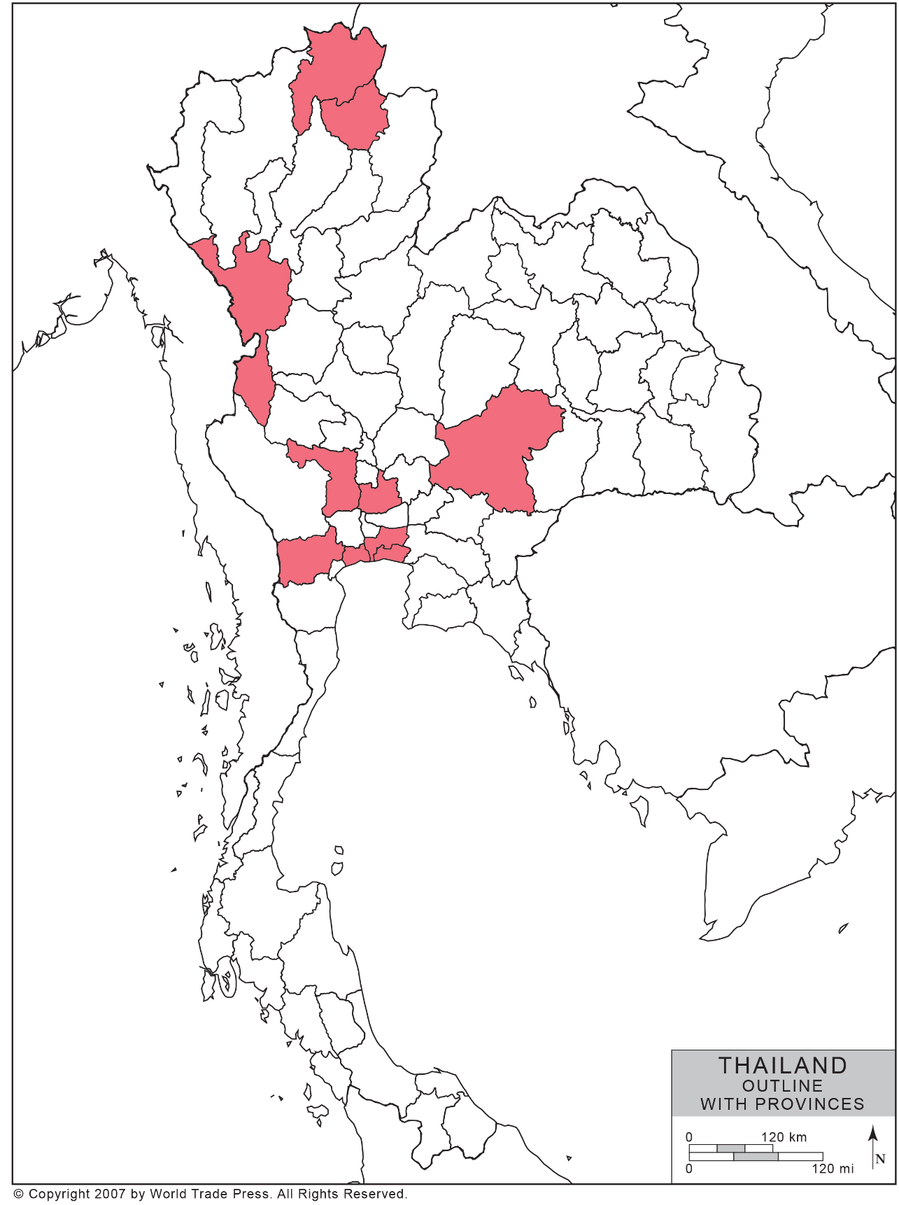
Supplement Figure 1 Location of sample collection and CBuVs detected by provinces in this study (Map of Thailand with permission by World Trade Press)

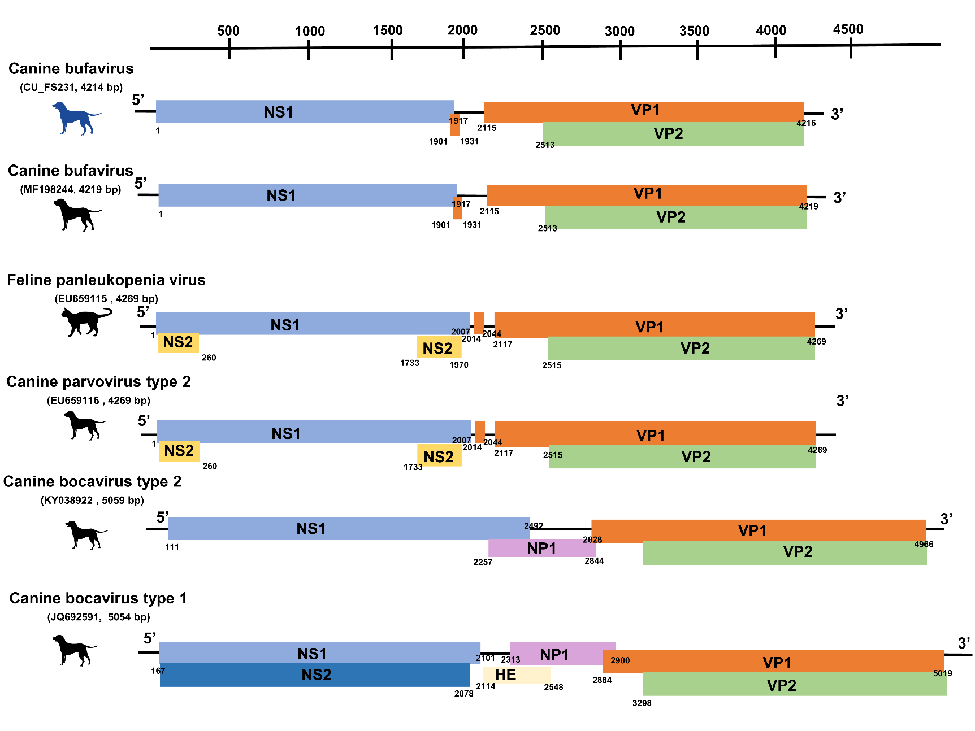
Supplement Figure 2 Genome structure of Canine parvoviruses & BuV

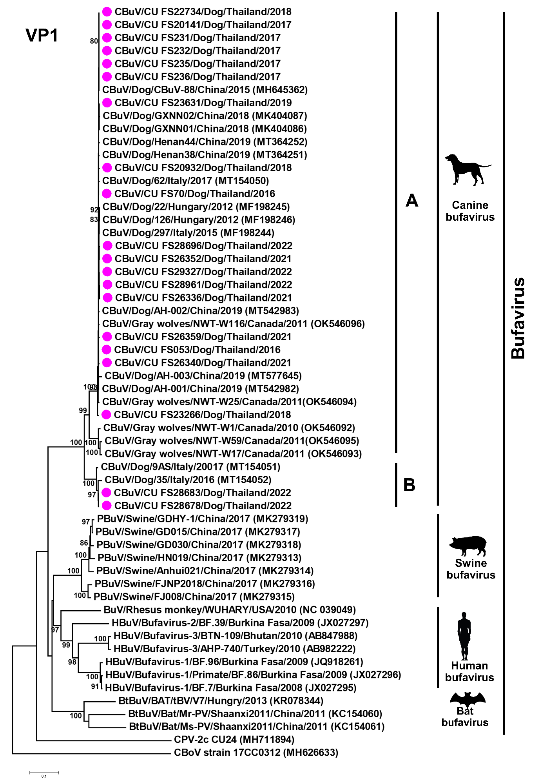
Supplement Figure 3. Phylogenetic analysis of VP1 gene of Thai CBuV
Supplement Figure 4. Phylogenetic analysis of VP2 gene of Thai CBuV
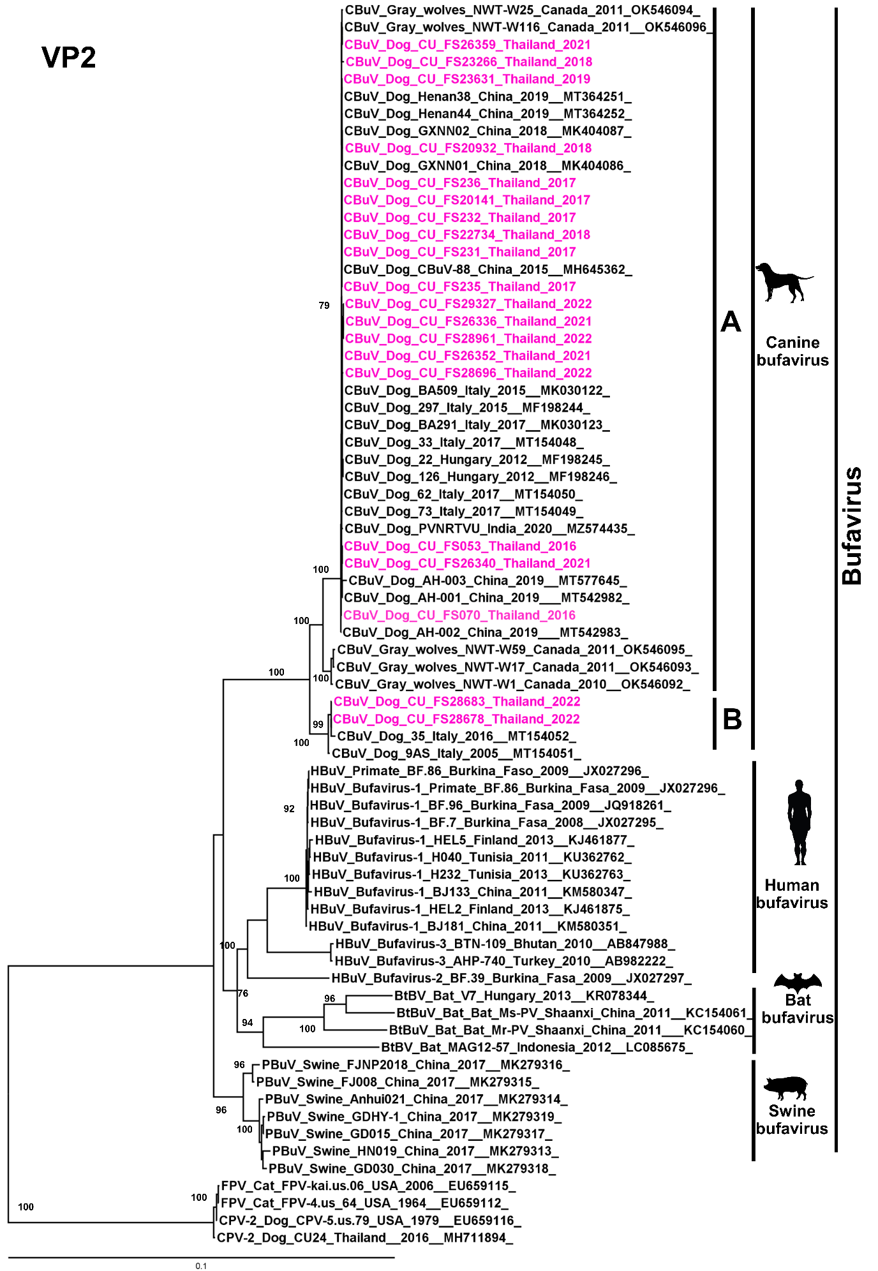

Reference
1 Wang, Y. et al. Genetic and phylogenetic analysis of canine bufavirus from Anhui Province, Eastern China. Infection, Genetics and Evolution 86, 104600 (2020).
2 Sun, W. et al. First identification of a novel parvovirus distantly related to human bufavirus from diarrheal dogs in China. Virus Res 265, 127-131, doi:10.1016/j.virusres.2019.03.020 (2019).

