Supplementary
Tuning the plasmonic bandwidth in TiN refractory metal
Anchal Rana¹, Neeraj Kumar Sharma¹, Sambhunath Bera¹, Aditya Yadav², Govind Gupta², Abhimanyu Singh Rana¹*
¹Centre for Advanced Materials and Devices, School of Engineering and Technology, BML Munjal University, Sidhrawali, Gurugram-122413, Haryana, India
²CSIR-National Physical Laboratory, K.S. Krishnan Marg, New Delhi, 110012, India
rana.abhimanyu@gmail.com

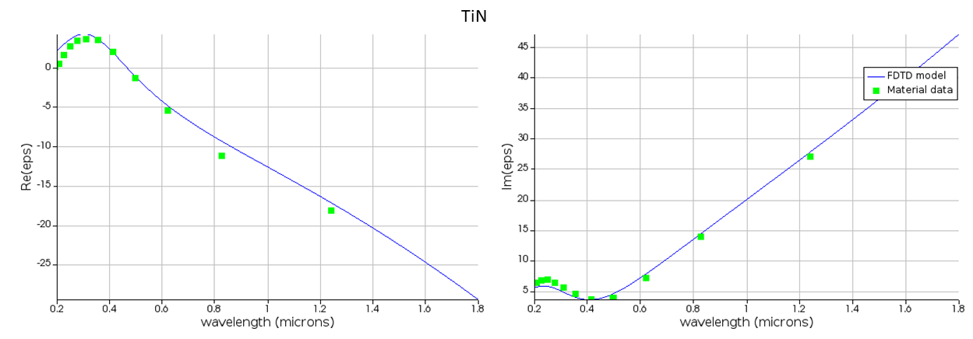
(a)
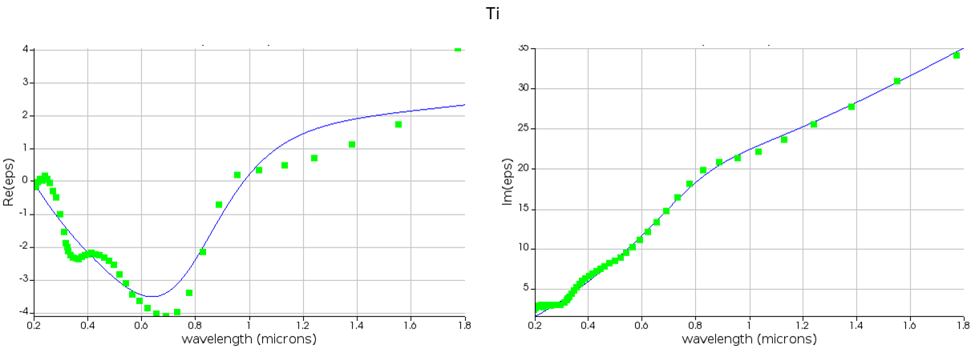
(b)
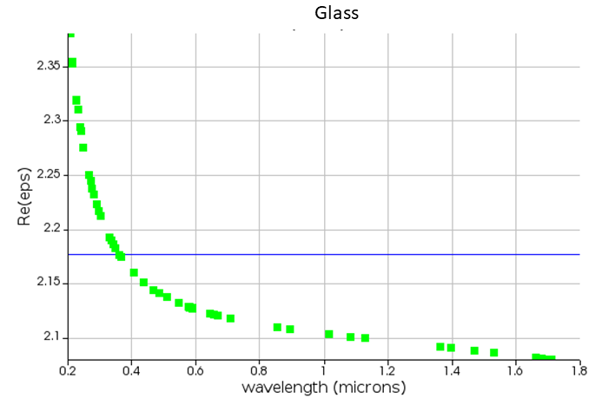
(c)

Figure S1: Wavelength dependent refractive index data used in simulation for Ti, TiN and glass

