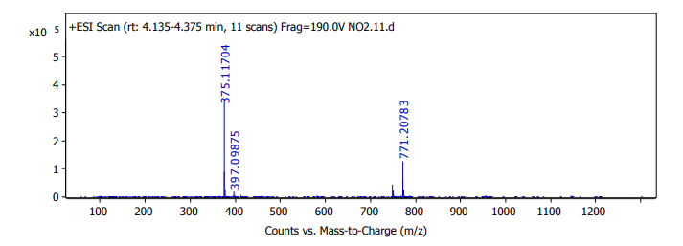
Chart 1: high resolution mass (HRMS) of compound 5a (C₂₂H₁₈N₂O₂S)
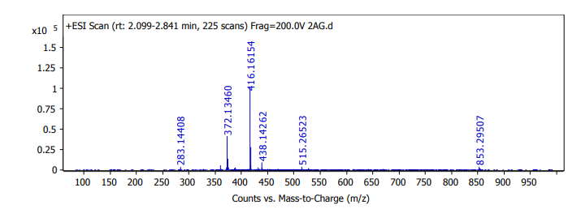
Chart 2: high resolution mass (HRMS) of compound 9b (C₂₄H₂₁N₃O₄)

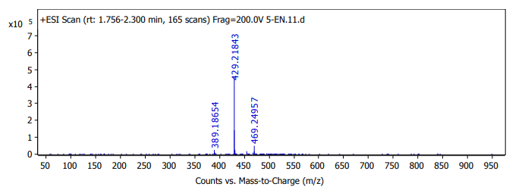
Chart 3: high resolution mass (HRMS) of compound 10c (C₂₄H₂₄N₂O₃)

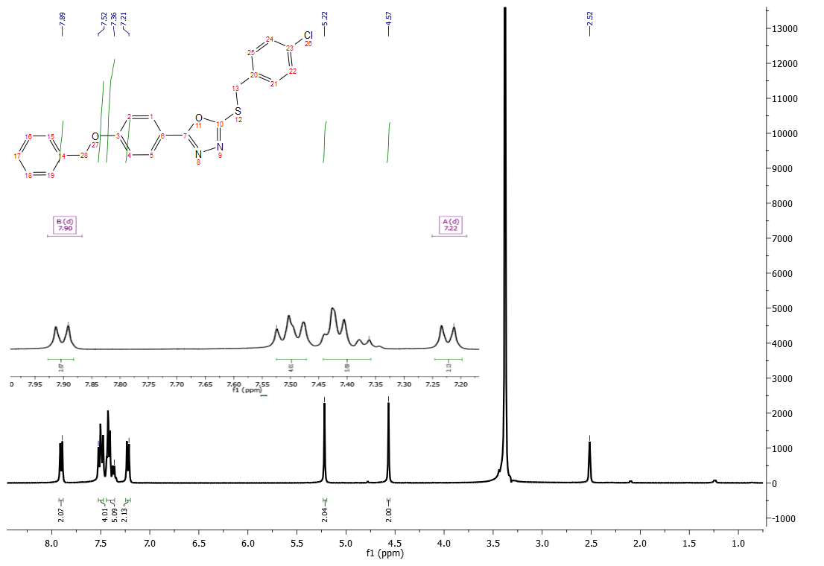
Chart 4: ¹H NMR (DMSO d6, 400 MHz) of compound 5b

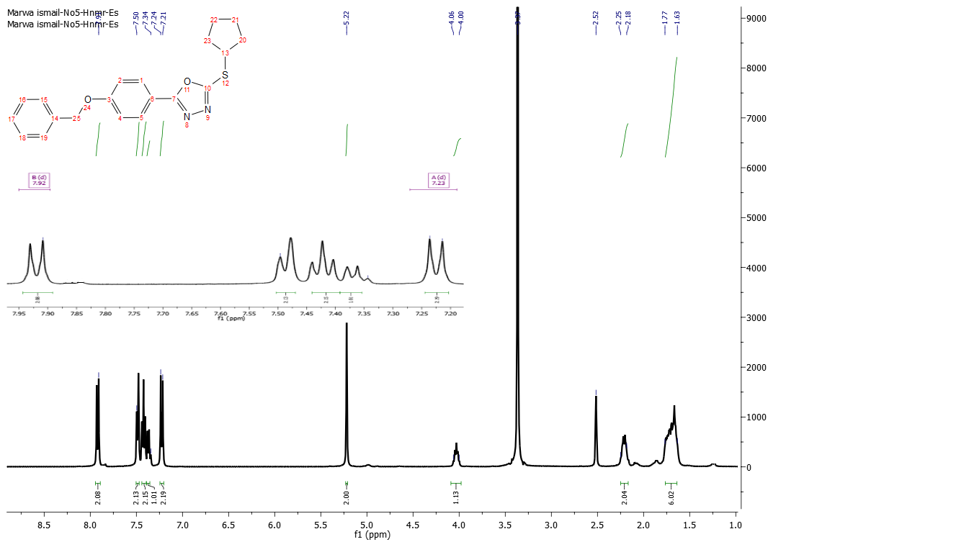Chart 5: ¹H NMR (DMSO d6, 400 MHz) of compound 5e

Chart 6: ¹H NMR (DMSO d6, 400 MHz) of compound 5f
Chart 7: ¹³C NMR (DMSO d6) of compound 5a
Chart 8: ¹³C NMR (DMSO d6) of compound 5b

Chart 9: ¹³C NMR (DMSO d6) of compound 5f

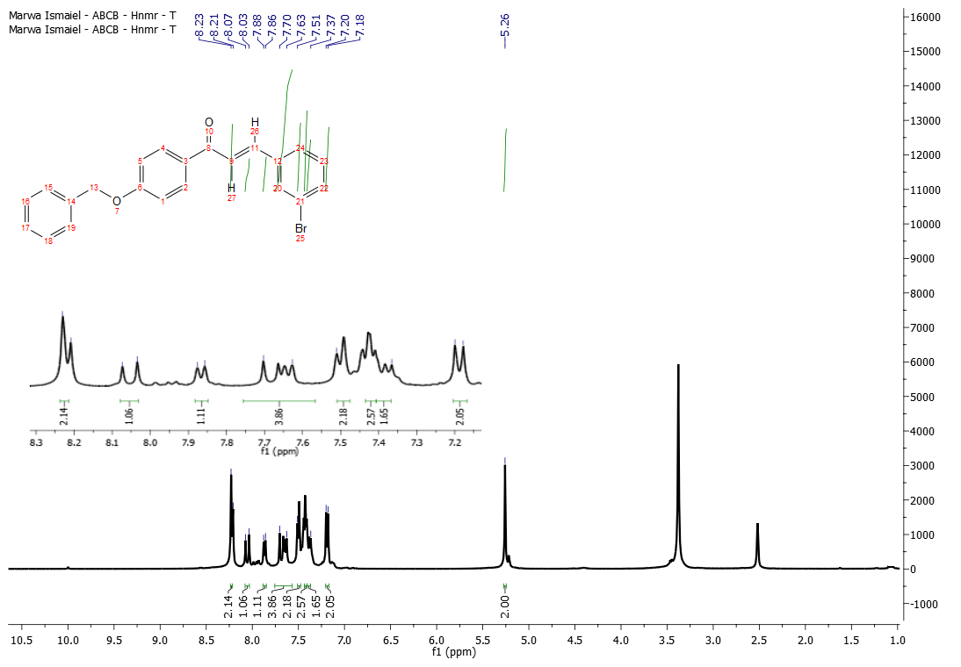Chart 10: ¹H NMR (DMSO d6, 400 MHz) of compound 8a

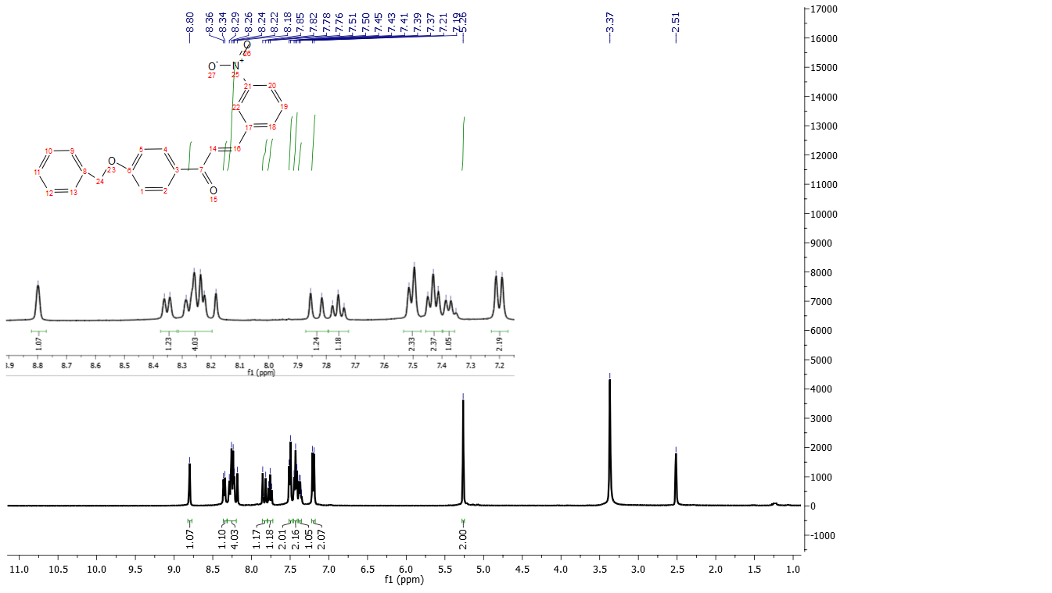
Chart 11: ¹H NMR (DMSO d6, 400 MHz) of compound 8b
Chart 12: ¹H NMR (DMSO d6, 400 MHz) of compound 8c

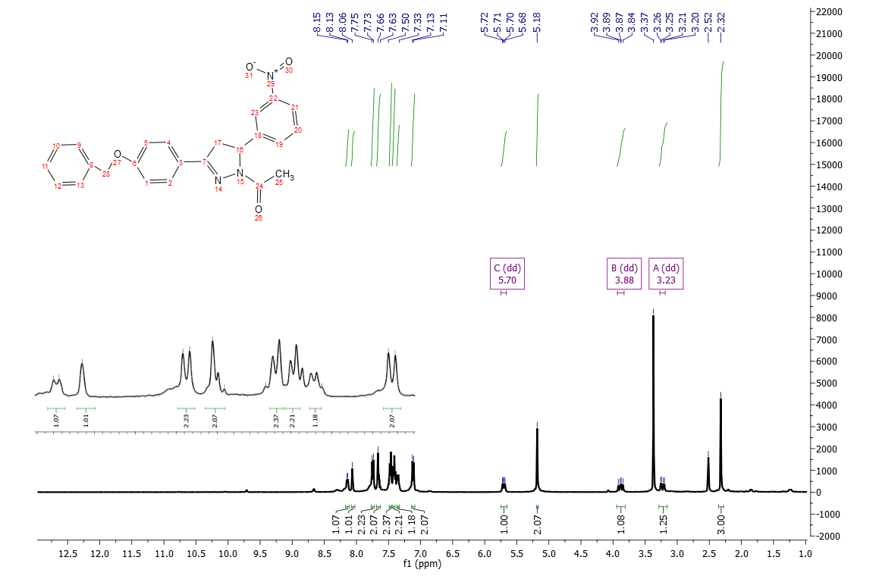
Chart 13: ¹H NMR (DMSO d6, 400 MHz) of compound 9b

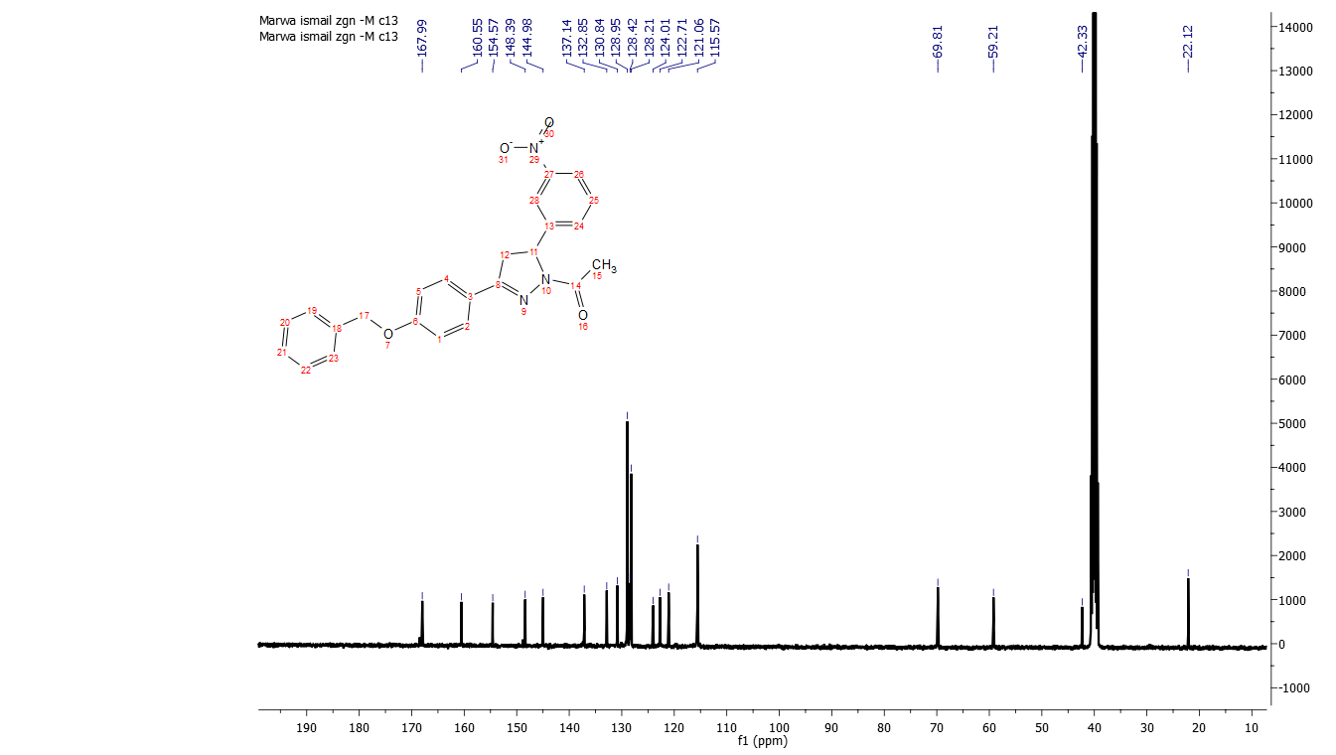
Chart 14: ¹³C NMR (DMSO d6) of compound 9b
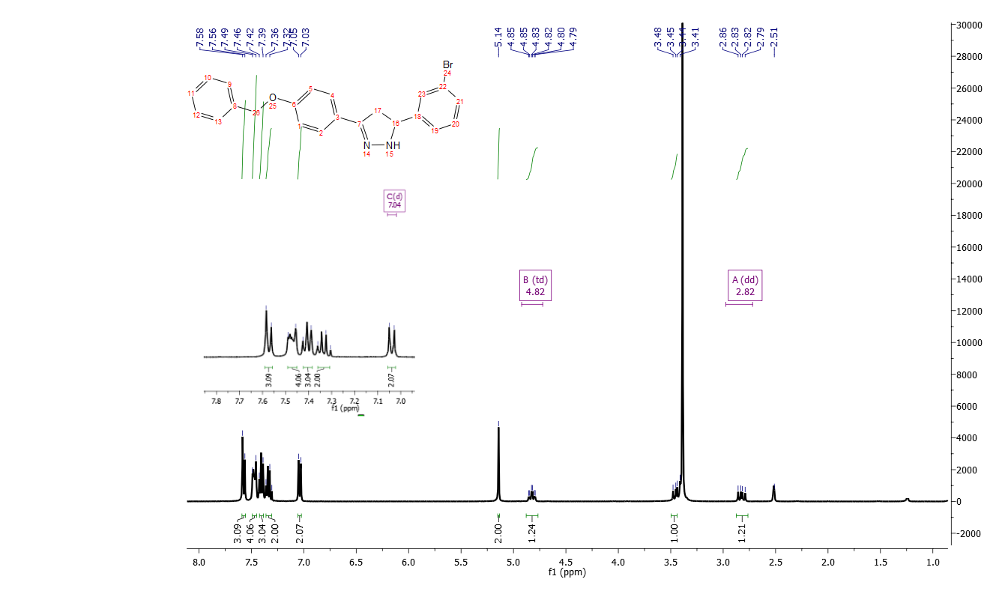Chart 15: ¹H NMR (DMSO d6, 400 MHz) of compound 10a

Chart 16: ¹³C NMR (DMSO d6) of compound 10b

Chart 17: ¹H NMR (DMSO d6, 400 MHz) of compound 10c

