Supplementary Data
Enhanced bone regeneration in rat calvarial defects through BMP2 release from engineered poly(ethylene glycol) hydrogels
Queralt Vallmajo-Martin^{1,2}, Christopher Millan³, Ralph Müller⁴, Franz E. Weber⁵, Martin Ehrbar*¹ and Chafik Ghayor*⁴

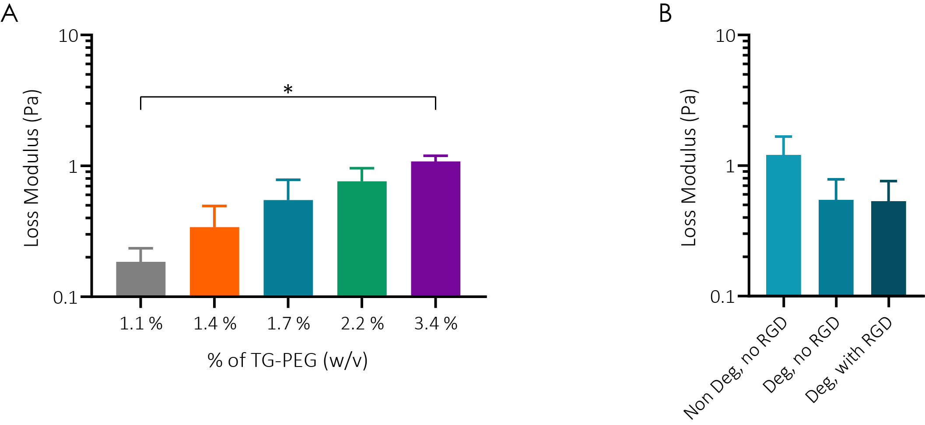
Figure S1. Mechanical and physical characterization of TG-PEG hydrogels
a-b) Loss moduli of hydrogels after reaching a plateau at 30 min a) at different polymer concentrations (n = 3) or b) at a fixed 1.7% (w/v) polymer concentration containing MMP_{non-degradable} (Non Deg) or MMP_{sensitive} (Deg) cross-links, and with or without RGD adhesion sites (n = 3). All data are reported as mean ± standard error. ANOVA with Tukey’s post hoc test * P < 0.05.
Figure S2. hBMSCs viability in various TG-PEG hydrogel conditions
Human bone marrow-derived stromal cells (hBMSCs) were encapsulated at 1.5·10⁶ cells per ml of TG-PEG hydrogels. TG-PEG hydrogels at different stiffnesses (75, 450 or 3000 Pa) containing MMP_{sensitive} degradable sites and RGD cell adhesion sites were tested, as well as TG-PEG gels at a fixed stiffness of 450 Pa lacking either the MMP_{sensitive} site (Non Deg) or the RGD peptide (no RGD). Representative images of live and dead staining on hBMSCs over time encapsulated in different hydrogel conditions (live cells stained by calcein are in green, while dead cells stained in ethidium bromide are in red; scale bar: 200 µm).

