Supplementary Figure S01. EOG and EEG electrode locations.
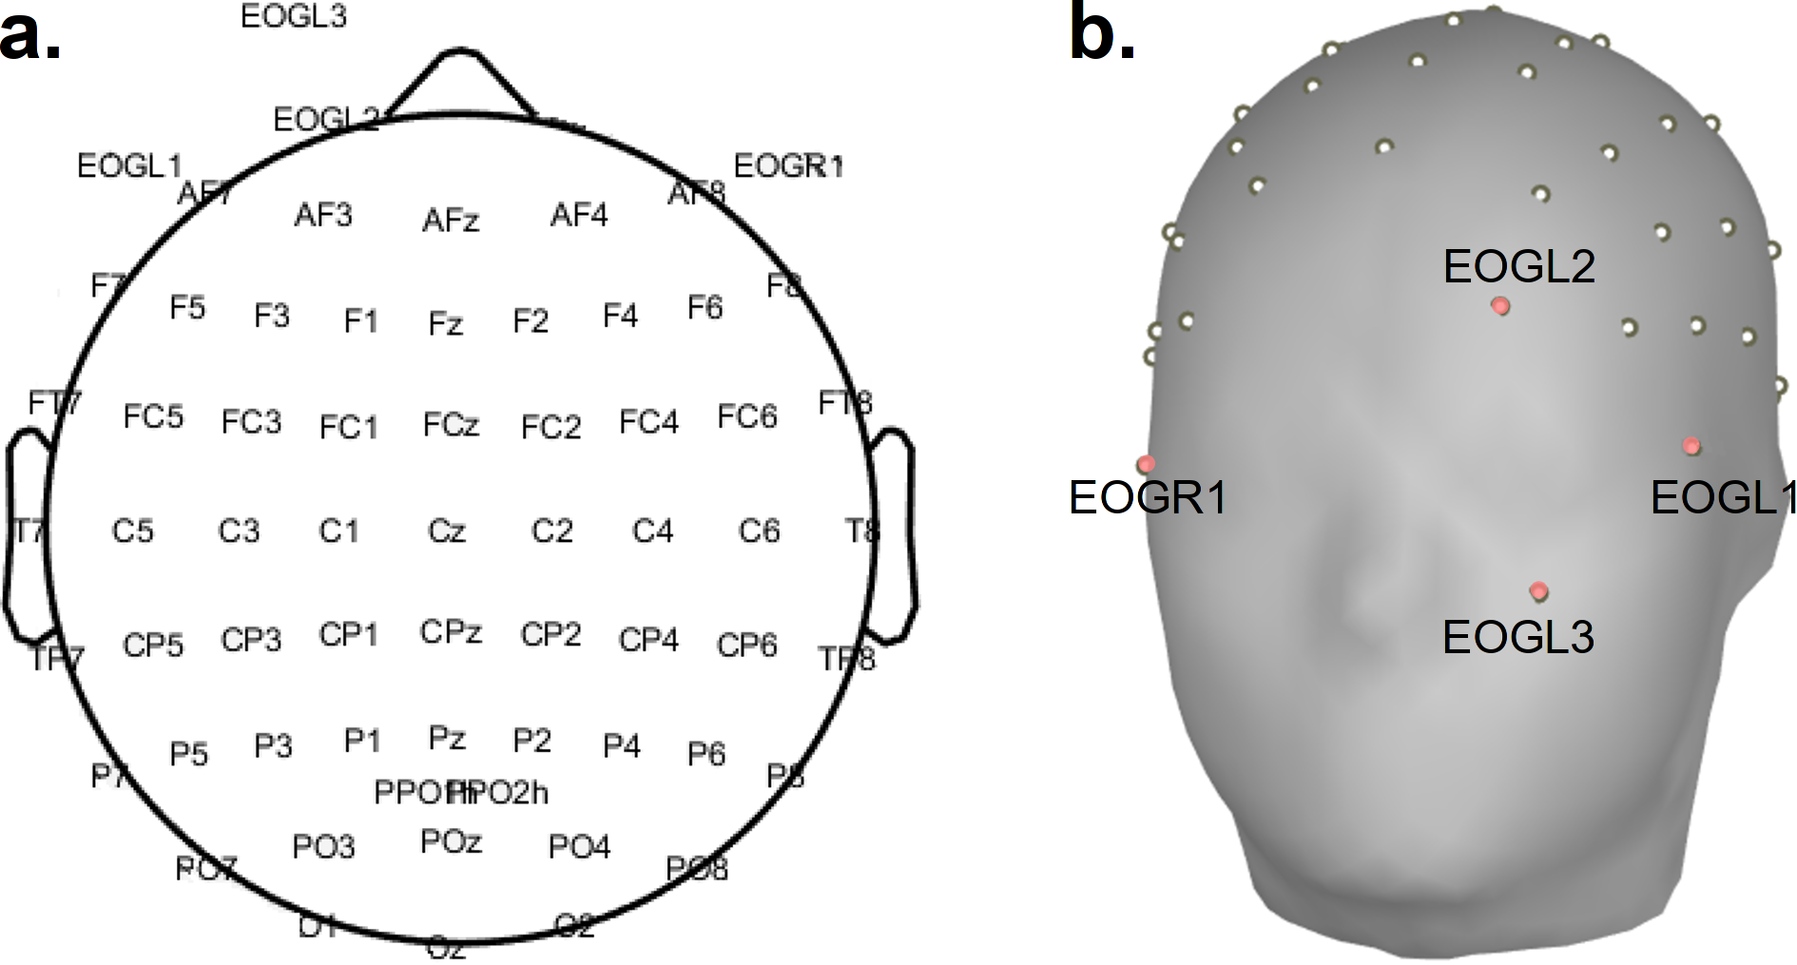

Supplementary Figure S02. Block diagram describing the online operation of the three decoding models (and as detailed in section 2.3.2).

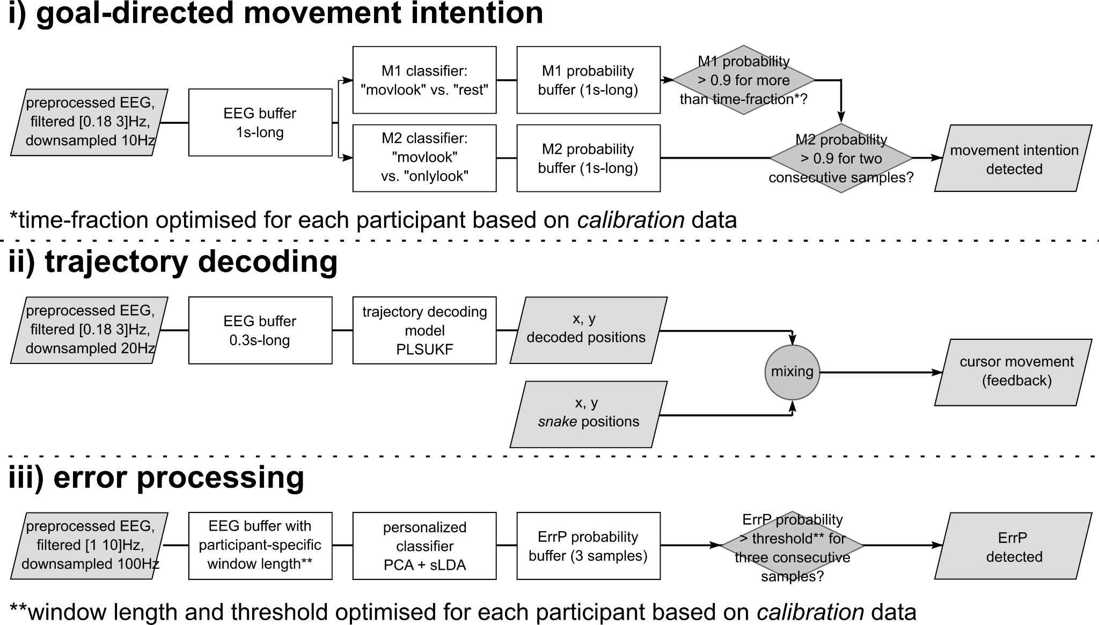

Supplementary Figure S03. Definition of the regions of interest (ROIs).

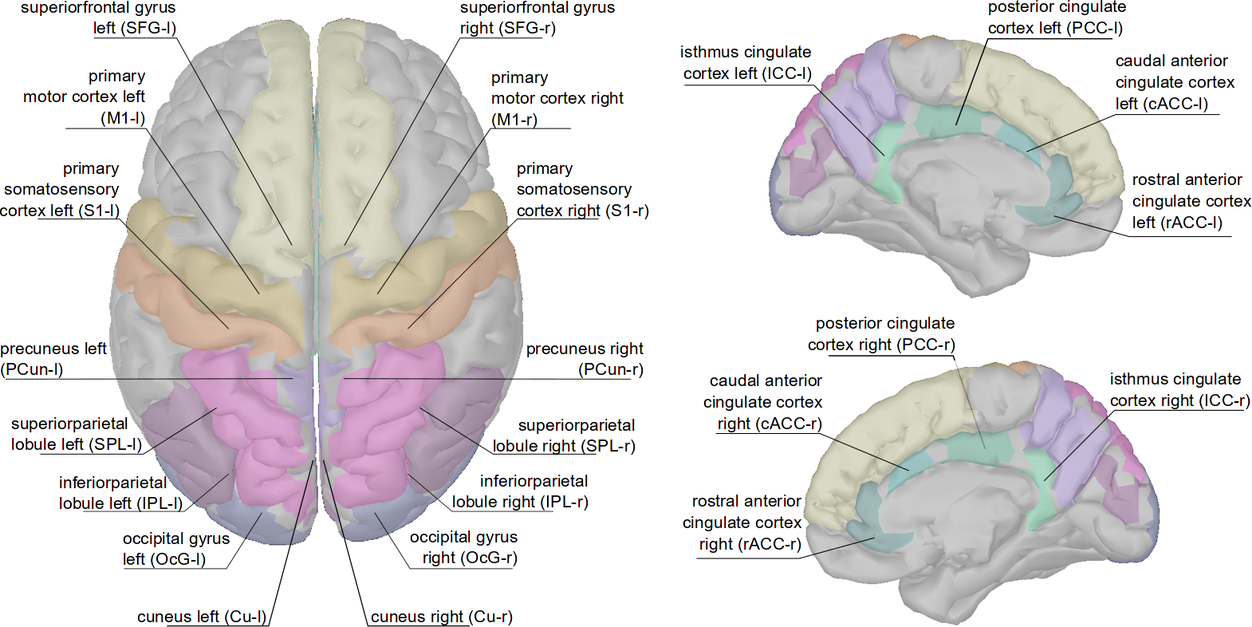

Supplementary Figure S04. Goal-directed movement intention, movlook vs. onlylook (mean ± alpha = 0.05 confidence interval, electrode Cz, calibration trials) for each participant.
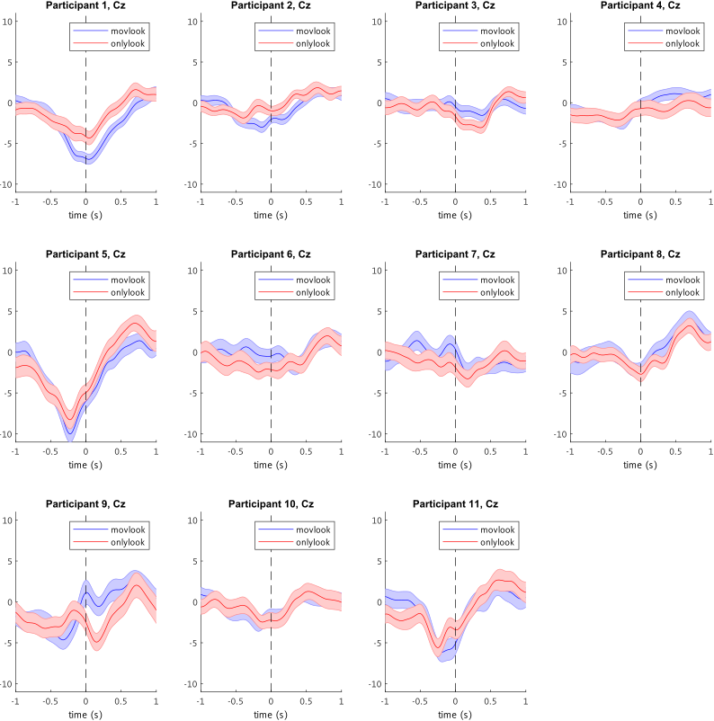

Supplementary Figure S05. Goal-directed movement intention, average sensor space potentials time-locked to the detection in the “movlook” online runs. The “0s” time-point corresponds to the MRCP detection, according to the classifier.
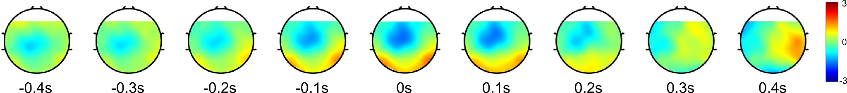

Supplementary Figure S06. Goal-directed movement intention, source space analysis of “movlook” vs “onlylook” activity, at all time-points [-0.9 0.9]s with respect to saccade onset.
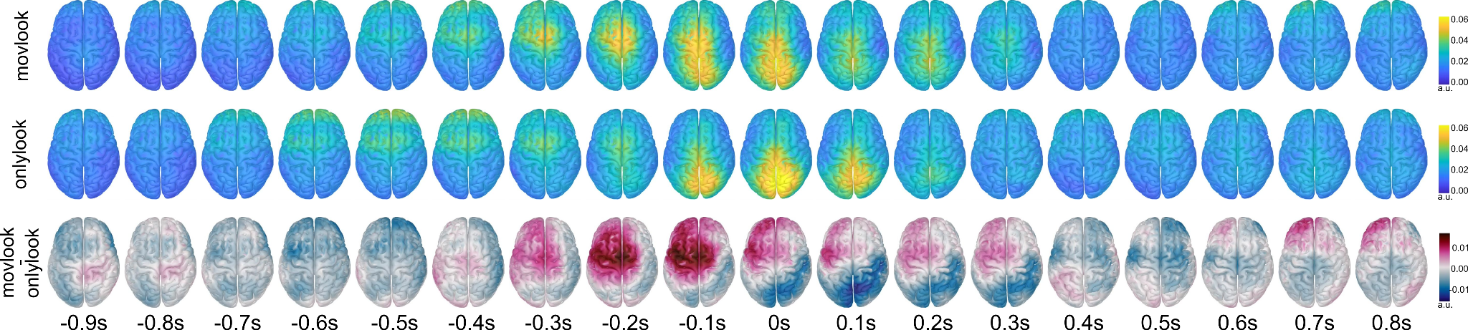

Supplementary Figure S07. Trajectory decoding, activation patterns in source space, at all time-lags used for decoding. As described in the methods, the time-lags correspond to the current and previous six downsampled EEG samples {t_{k-6}, t_{k-5}, t_{k-4}, t_{k-3}, t_{k-2}, t_{k-1}, t_{k}} with respect to the current time-point of the decoded trajectories. As the EEG was downsampled to 20 Hz for decoding, these correspond to the time-points {-0.3s, -0.25s, -0.2s, -0.15s, -0.01s, -0.05s, 0s} with respect to the current time-point of the decoded movements.
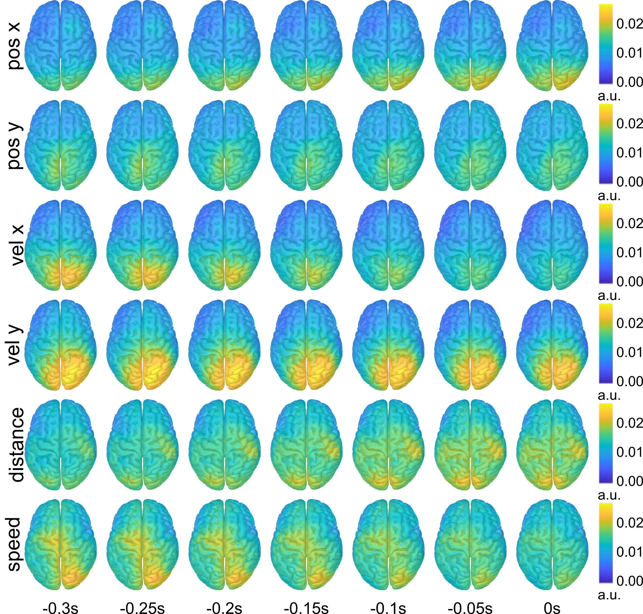

Supplementary Table ST06. Statistical analyses for trajectory decoding activation patterns. ROIs with significantly stronger activity in the decoder’s pattern with respect to the corresponding chance level pattern (alpha = 0.05, FDR corrected) are marked in white and with an “x”.
 | superiorfrontal L (SFG-l) | primary motor cortex left (M1-l) | primary somatosensory cortex left (S1-l) | precuneus left (PCun-l) | superiorparietal lobule left (SPL-l) | inferiorparietal lobzle left (IPL-l) | occipital gyrus left (OcG-l) | cuneus left (Cu-l) | cuneus right (Cu-r) | occipital gyrus left (OcG-r) | inferiorparietal lobzle left (IPL-r) | superiorparietal lobule left (SPL-r) | precuneus right (PCun-r) | primary somatosensory cortex left (S1-r) | primary motor cortex left (M1-r) | superiorfrontal L (SFG-r)
pos x
vel x |  |  | x | x | x | x | x | x | x | x | x | x | x
pos y
vel y |  |  |  | x | x | x | x | x | x | x | x | x | x | x | x
dist
speed

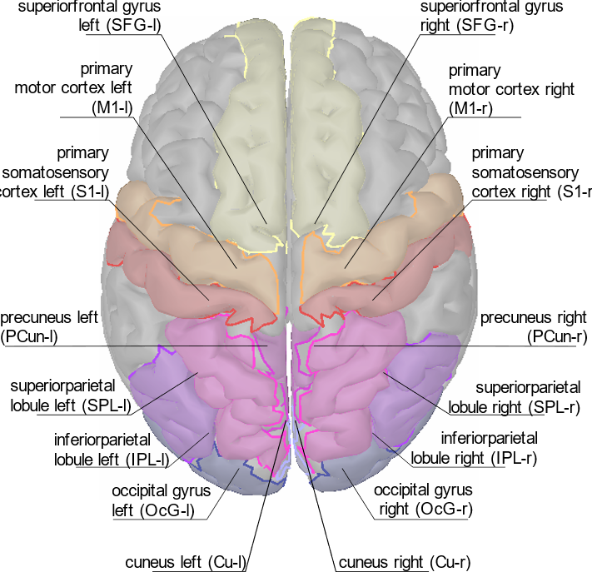

Supplementary Figure S08. Error processing part, error vs. correct (mean ± s.e.m, electrode FcZ, calibration trials) for each participant. Errors displayed in blue, correct in pink.
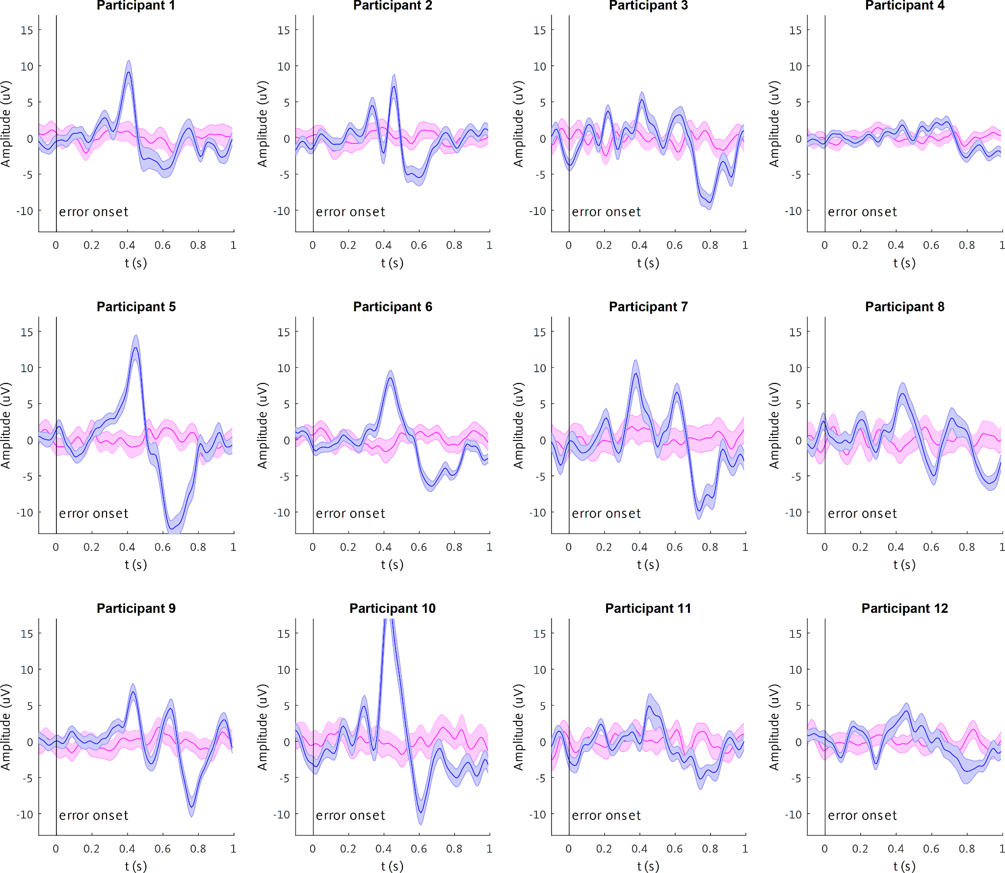

Supplementary Table ST07. Pe and late ERN peaking time in the calibration trials for each participant. The participant-specific time windows and thresholds for the personalised classifier are also reported. Some participants, namely [P02, P07, P08, P09], displayed two peaks for the Pe, and two peaks for the late ERN, instead of a single peak.

participant | Pe | late ERN | classifier window | window length | threshold
P01 | 0.41s | 0.60s | [0.35 0.65]s | 0.30s | 0.9
P02 | [0.33 0.46]s | [0.40 0.60]s | [0.45 0.75]s | 0.30s | 0.9
P03 | 0.41s | 0.79s | [0.60 0.95]s | 0.35s | 0.95
P04 | 0.43s | 0.79s | [0.55 0.90]s | 0.35s | 0.95
P05 | 0.45s | 0.65s | [0.35 0.75]s | 0.40s | 0.9
P06 | 0.44s | 0.67s | [0.30 0.80]s | 0.50s | 0.9
P07 | [0.38 0.61]s | [0.50 0.74]s | [0.50 0.85]s | 0.35s | 0.9
P08 | [0.44 0.71]s | [0.61 0.92]s | [0.40 0.90]s | 0.50s | 0.95
P09 | [0.43 0.64]s | [0.53 0.76]s | [0.50 0.90]s | 0.40s | 0.9
P10 | 0.43s | 0.61s | [0.40 0.80]s | 0.40s | 0.9
P11 | 0.45s | 0.75s | [0.50 0.85]s | 0.35s | 0.975
P12 | 0.46s | 0.8s | [0.40 0.85]s | 0.45s | 0.95
mean ± s.d. | [0.45 ± 0.053]s | [0.68 ± 0.095]s | [0.44 0.82]s ± [0.091 0.080]s | 0.39 ± 0.065 | 0.92 ± 0.029

Supplementary Figure S09. Error processing part, cortical activity for the grand-average “error” vs. “correct” condition in source space.
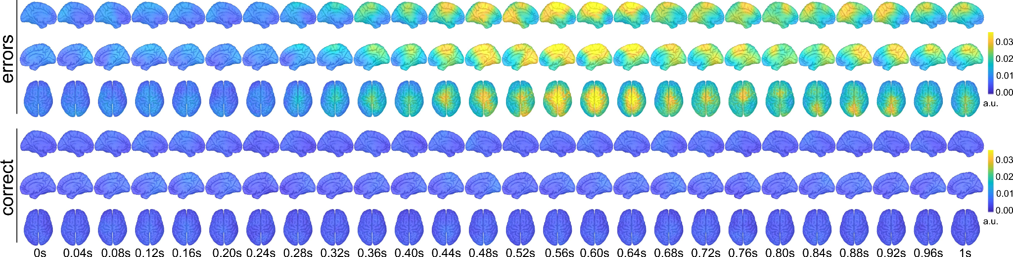

Supplementary Figure S10. Error processing part, statistical analyses in source space. ROIs with significantly stronger activity in the “error” with respect to the “correct” condition (p < 0.01, FDR corrected) are marked in white in the figure, non-significants in black.

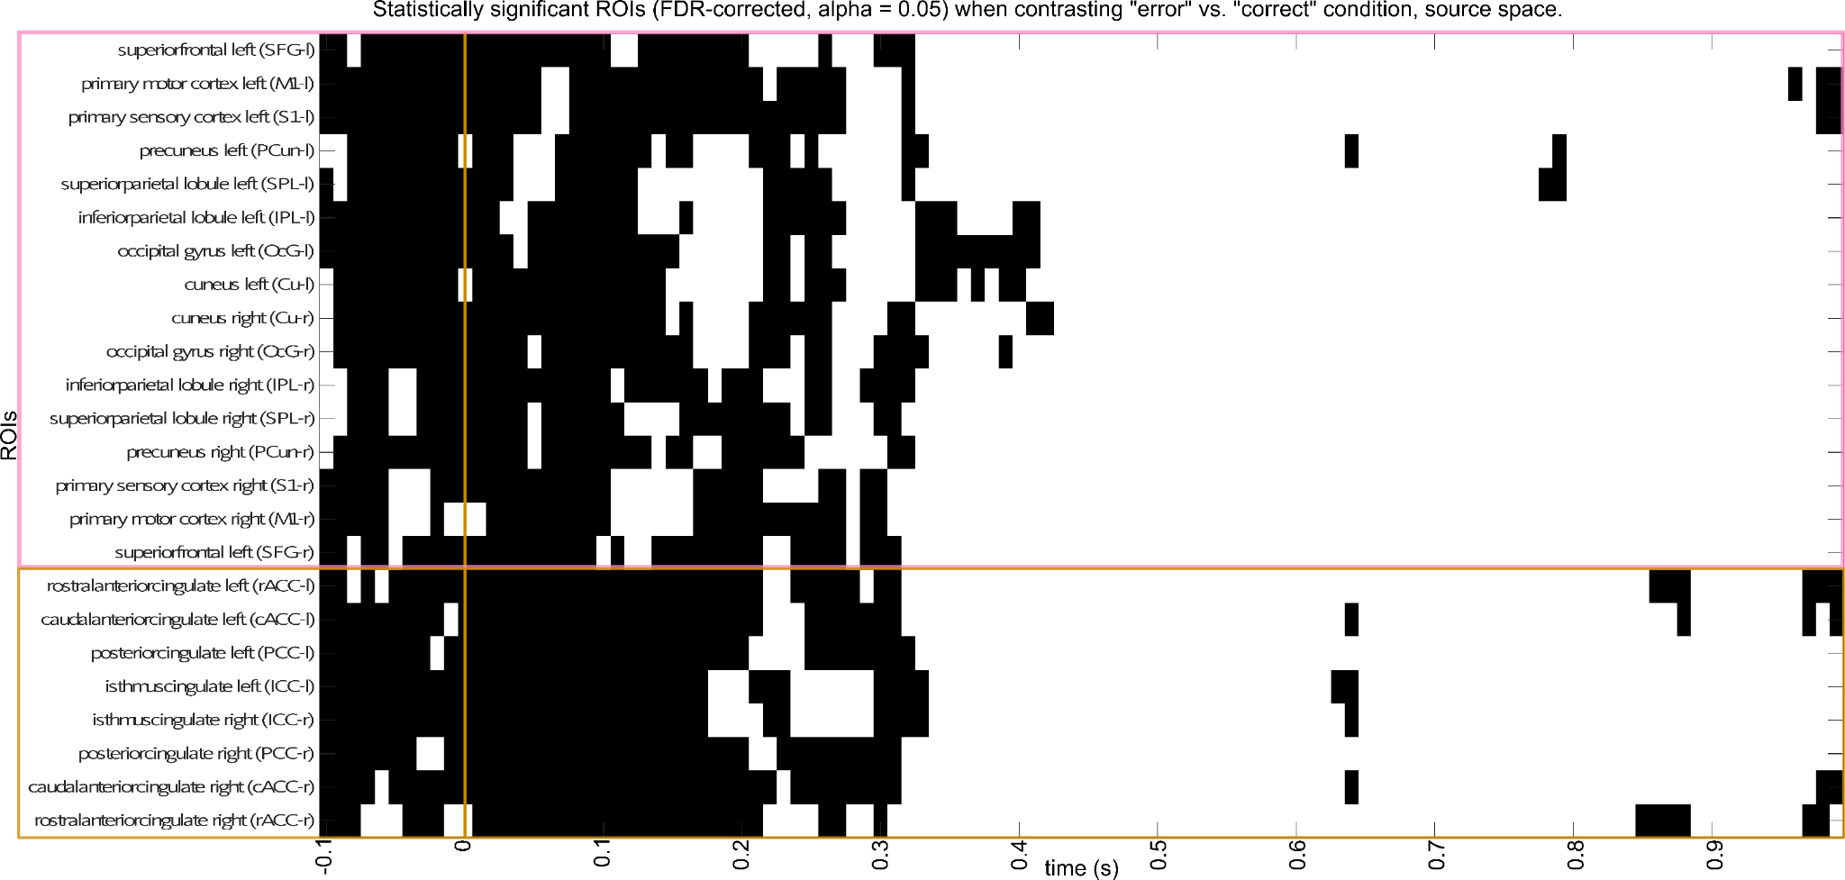

Supplementary Figure S11. Spinal cord injured (SCI) participant, goal-directed movement intention; average scalp potentials in sensor space for the“movlook” vs “onlylook” activity during the calibration runs. The “0s” time-point marks the saccade onset.
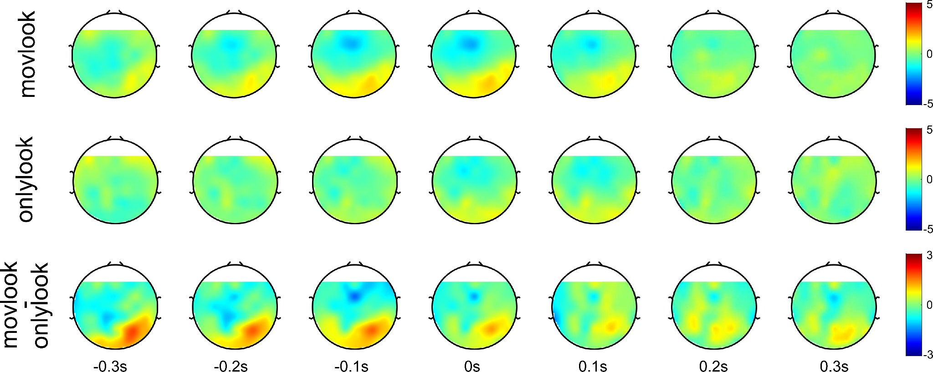

Supplementary Figure S12. Spinal cord injured (SCI) participant, goal-directed movement intention; source space analysis of “movlook” vs “onlylook” activity during the calibration runs. The “0s” time-point marks the saccade onset.
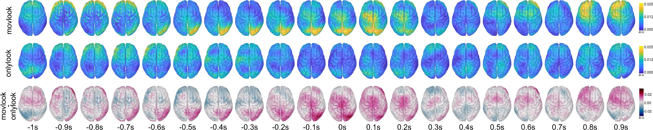

Supplementary Figure S13. SCI participant, trajectory decoding; activation patterns in source space, at all time-points.
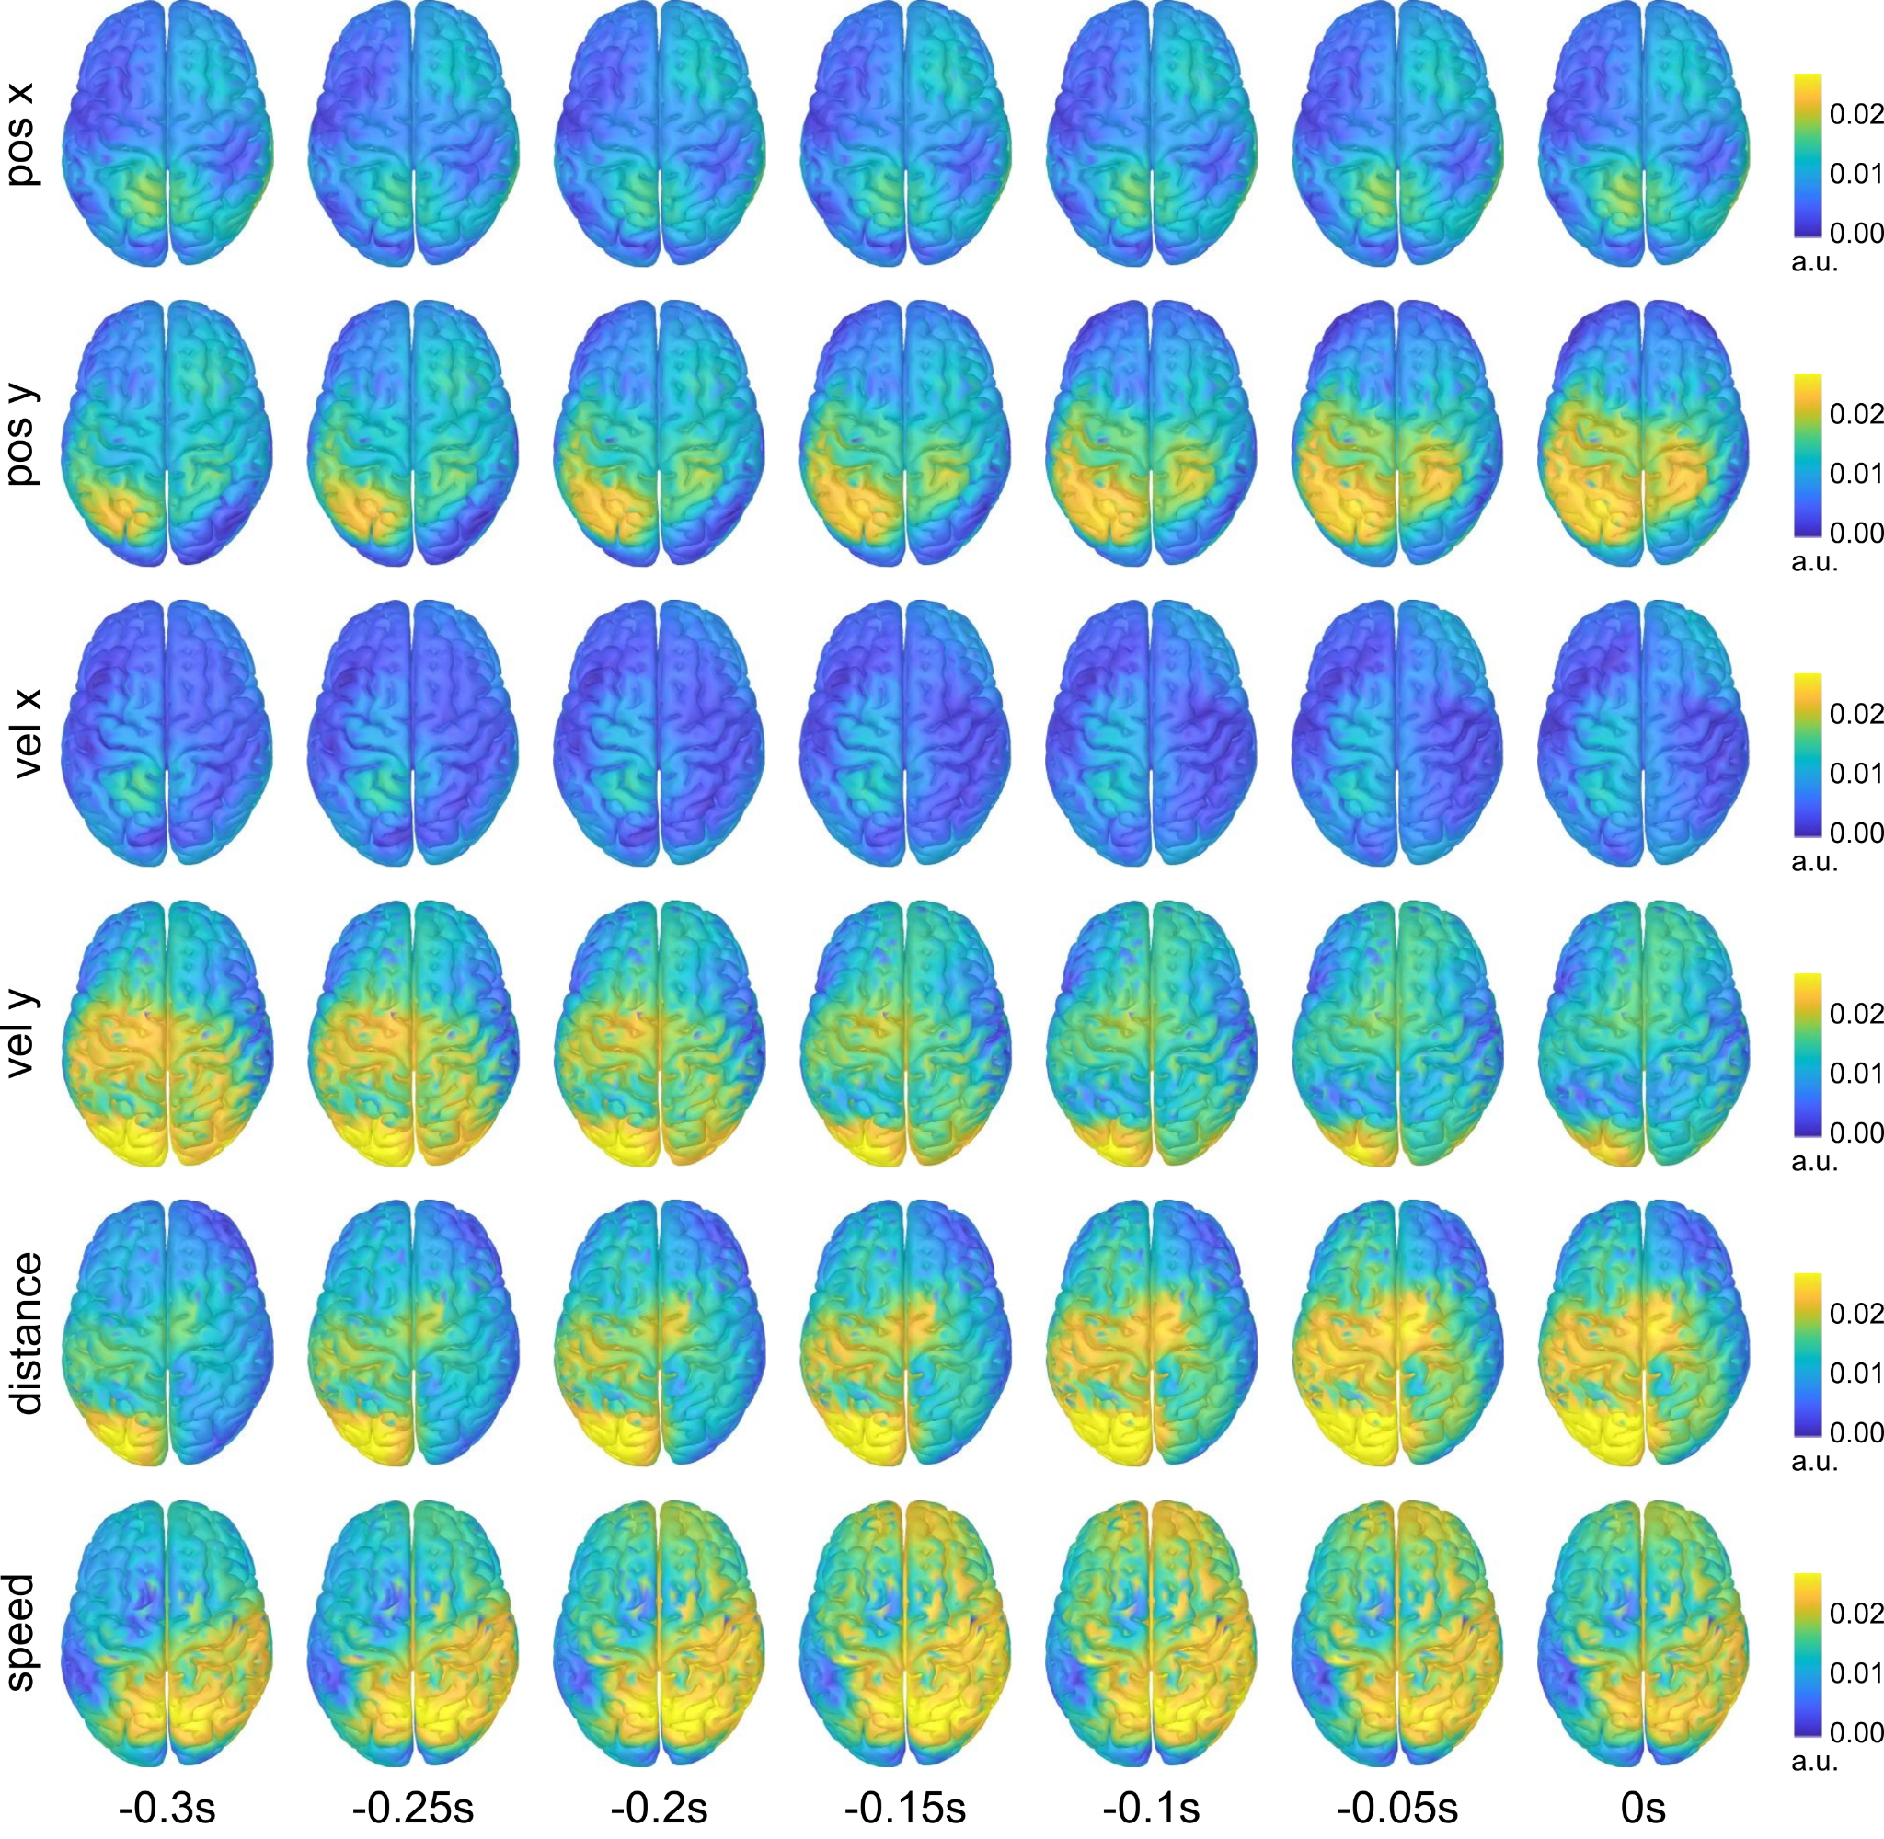
Supplementary Figure S14. SCI participant, error processing part, error vs. correct (mean ± s.e.m) at electrode FcZ, calibration trials.Errors displayed in blue, correct in pink.
