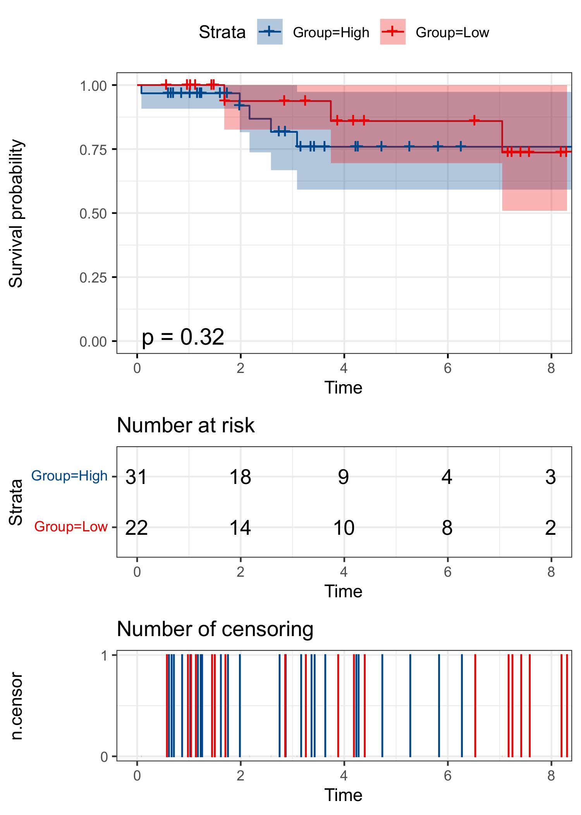
Figure S2
Figure S2. The prognostic performance of the 11 TANRG signature in the Luminal breast cancer.

