Supplementary Information
Extraction and separation of astaxanthin with the help of pre-treatment of Haematococcus pluvialis microalgae biomass using aqueous two-phase systems based on deep eutectic solvents

Neda Nemani ª, Seyed Mohsen Dehnavi ^{b}, Gholamreza Pazuki ^{a, *}

ª Department of Chemical Engineering, Amirkabir University of Technology (Tehran Polytechnic), Tehran, Iran
^{b} Department of Cell and Molecular Biology, Faculty of Life Science and Biotechnology, Shahid Beheshti University, P.O. Box 1983969411, Tehran, Iran.
* Corresponding author: ghpazuki@aut.ac.ir ,Tel: +98-021-64543159, Fax: +98-021-66405847

Table S1. Materials used to make Bold's Basal medium (BBM) culture medium
Mg/L | material
250 | NaNO₃
75 | MgSO₄.7H₂O
75 | K₂HPO₄
175 | KH₂PO₄
25 | NaCl
25 | CaCL₂.2H₂O
4.98 | FeSO₄.7H₂O
50 | EDTA
31 | KOH
0.49 | CO(NO₃)₂.6H₂O
8.82 | ZnSO₄.4H₂O
1.44 | MnCL₂.4H₂O
0.71 | MoO₃
1.57 | CuSO₄.5H₂O
11.42 | H₃BO₃

Table S2. The results of Karl Fischer titrator analysis

Sample water content (%) | System
1.428±0.43 | Ch. Cl/Urea
1.798±0.21 | Ch. Cl/Glucose

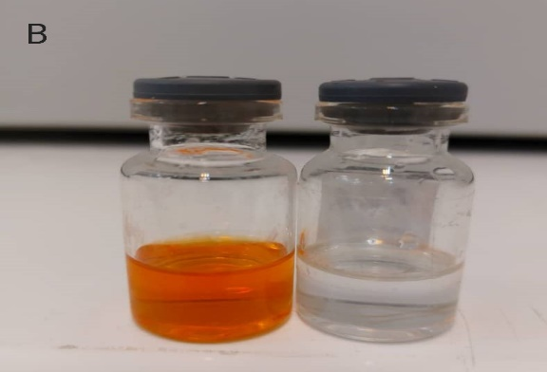
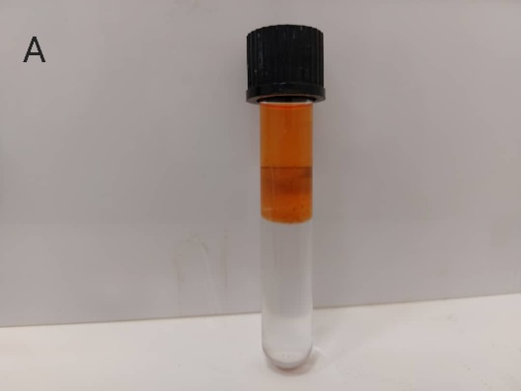

Figure S1. The liquid-liquid extraction process of astaxanthin a) after 24 hours of standing in the laboratory environment b) after separating each of the phases by syringe

Table S3. Binodal curve data for both systems in terms of total weight percentage for components

DES (Ch. Cl/Glucose) + K₂HPO₄ |  |  | DES (Ch. Cl/Urea) + K₂HPO₄
W_{water} (%) | W_{K2HPO4} (%) | W_{DES} (%) | W_{water} (%) | W_{K2HPO4} (%) | W_{DES} (%)
33.6 | 16 | 50.4 | 32.2 | 13.4 | 54.4
34.5 | 17 | 48.5 | 34.86 | 14.2 | 50.94
35.27 | 18.5 | 46.23 | 35.69 | 15.16 | 49.15
35.3 | 19.3 | 44.4 | 36.64 | 16.05 | 47.31
36.3 | 19.9 | 43.8 | 37.02 | 16.76 | 46.22
35.8 | 20.1 | 43.1 | 37.85 | 17.83 | 44.32
37.4 | 20.6 | 42 | 38.84 | 19.36 | 41.8
38.44 | 23.56 | 38 | 38.47 | 19.59 | 41.94
38.86 | 24.14 | 37 | 38.48 | 20 | 41.52
39.3 | 24.6 | 36.1 | 38.77 | 21.11 | 40.12
39.9 | 25.3 | 34.8 | 39.02 | 21.64 | 39.34
40.15 | 26.13 | 33.72 | 39.15 | 22.15 | 38.7
40.36 | 26.8 | 32.84 | 39.94 | 22.83 | 37.23
40.84 | 27.93 | 31.23 | 40.01 | 23.26 | 36.73
41.5 | 29.1 | 29.4 | 40.15 | 23.88 | 35.97
42.08 | 30.62 | 27.3 | 40.15 | 24.16 | 35.69
41.85 | 31.65 | 26.5 | 40.18 | 24.41 | 35.41
42.63 | 33.25 | 24.12 | 40.12 | 24.71 | 35.17
42.5 | 34.5 | 23 | 40.16 | 24.96 | 34.88
41.34 | 36.76 | 21.9 | 41.02 | 25.85 | 33.13
41.36 | 38.44 | 20.2 | 41.36 | 26.43 | 32.21
41.15 | 40.73 | 18.12 | 41.91 | 27.99 | 30.1
40.88 | 42.58 | 16.54 | 42.07 | 28.71 | 29.22
38.35 | 47.6 | 14.05 | 42.35 | 29.44 | 28.21
35.97 | 53.03 | 11 | 42.58 | 30.02 | 27.4
 |  |  | 42.73 | 30.38 | 26.89
 |  |  | 42.78 | 30.79 | 26.43
 |  |  | 42.86 | 31.15 | 25.99
 |  |  | 43.08 | 31.46 | 25.46
 |  |  | 42.87 | 32 | 25.13
 |  |  | 42.71 | 32.48 | 24.81
 |  |  | 43.01 | 33.41 | 23.58
 |  |  | 43 | 33.95 | 23.05
 |  |  | 42.88 | 35.01 | 22.11
 |  |  | 43.13 | 35.98 | 20.89
 |  |  | 42.92 | 37.49 | 19.59
 |  |  | 42.79 | 39.76 | 17.45
 |  |  | 42.53 | 41.36 | 16.11
 |  |  | 42.08 | 44.25 | 13.67
 |  |  | 39.7 | 49 | 11.3
 |  |  | 39.42 | 50 | 10.58

Figure S2. Determination of the maximum absorption wavelength for astaxanthin by spectrophotometer

Figure S3. Standard curve of astaxanthin in 2-propanol

