Supplementary Material to

Feasibility of a Two-Minute Eye-Tracking Protocol to Support the Early Identification of Autism
Lacey Chetcuti¹, Kandice J. Varcin^{2,3}, Maryam Boutrus³, Jodie Smith^{1,4},
Catherine A. Bent¹, Andrew J.O. Whitehouse³, Kristelle Hudry¹*

¹Department of Psychology, Counselling and Therapy, School of Psychology and Public Health, La Trobe University, Bundoora, Victoria 3086 Australia.
²Telethon Kids Institute, The University of Western Australia, Nedlands, Western Australia 6009 Australia.
³School of Psychological Science, University of Western Australia, Crawley, Western Australia 6009, Australia.
⁴Macquarie School of Education, Macquarie University, North Ryde, New South Wales 2109, Australia.
⁵School of Allied Health, Human Services and Sport, La Trobe University, Bundoora, Victoria 3086 Australia.
⁶St Giles Society Limited, Burnie, Tasmania 7320 Australia.
⁷JVCKENWOOD Corporation, 3-12 Moriya-cho, Kanagawa-ku, Yokohama-shi, Kanagawa, 221-0022, Japan.

*Corresponding author: A/Prof. Kristelle Hudry, Department of Psychology, Counselling and Therapy, School of Psychology and Public Health, La Trobe University, Bundoora, Victoria 3086 Australia, Email: k.hudry@latrobe.edu.au, Phone: +61 3 9479 5649.

Supplementary Material Contents

Section | Page
Figure S1. Procedural tree illustrating the original Gazefinder calibration procedure (first n=24) | S2
Figure S2. Procedural tree illustrating the revised Gazefinder calibration procedure (subsequent n=30) | S3
Table S1. Specifications following Holmsqvist et al.’s (2023) reporting guidelines. | S4
Details of Gazefinder Apparatus and Assessment
Figure S3. Specifications from product Gazefinder Instruction Manual¹ (p. 59 & 62). | S5
Figure S4. Description of gaze detection technology from Gazefinder Instruction Manual¹ (p. 18) and product Instruction Manual: Operation² (p. 51-52). | S6
Figure S5. Device setup and viewer positioning guidance from product Instruction Manual: Operation (p. 10-11) | S6
Figure S6. Guidance for checking positioning and calibration from Gazefinder Instruction Manual¹ (p. 27-30) and product Instruction Manual: Operation² (p. 19-20). | S7
Figure S7. Key stimuli within ‘Scene 1S4’ showing all pre-specified Regions of Interest (ROIs) | S8
Table S2. Detailed specifications of ROIs for initial calibration check | S8
Table S3. Detailed specifications of pre-specified ‘Scene 1S4’ ROIs | S9
Table S4. Associations between gaze data to pre-specified ROIs and scores on clinical/behavioural phenotyping measures for 47 infants with >30% Tracking Rate | S11
Table S5. Associations between gaze data to proportionate gaze data to social vs. non-social ROIs or more vs. less socially-salient ROIs and scores on clinical/behavioural phenotyping measures for 47 infants with >30% Tracking Rate | S12

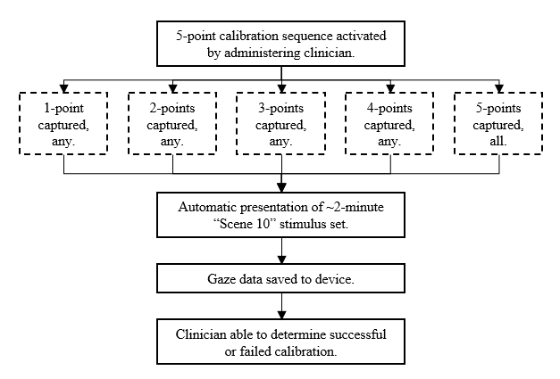
Figure S1. Procedural tree illustrating the original Gazefinder calibration procedure (first n = 24).

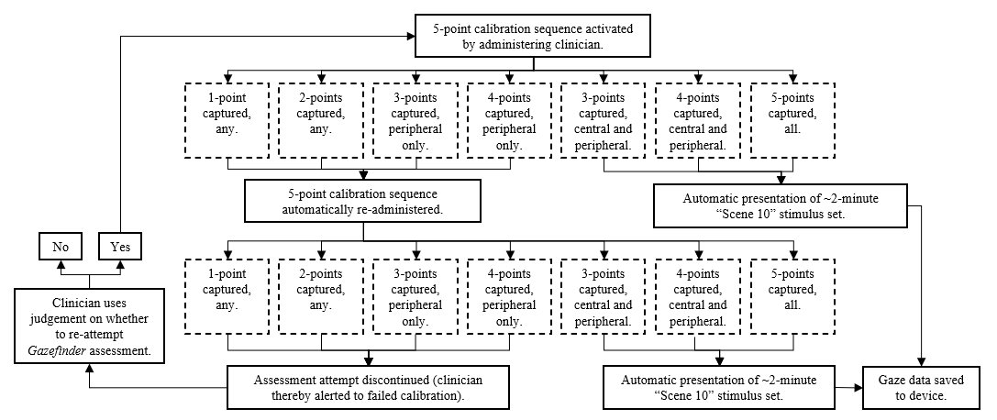
Figure S2. Procedural tree illustrating the revised Gazefinder calibration procedure (subsequent n = 30).

Table S1. Specifications following Holmsqvist et al.’s (2023) reporting guidelines.
Reporting aspect | Manuscript Main Text | Supplementary Materials
- Details about the eye-tracker | pg. 3-4 | Figures S3, S4
- Sampling frequency | pg. 3 | Figure S3
- Description of the setup and geometry | pg. 4 | Figures S3-S5
- Description of the recording environment | pg. 4 | Figure S5
- The instruction given to participants | pg. 4 | -
- Empirically determined data quality for the analysed eye-tracker signals | pg. 5 | Figure S6  Table S2
- Description of the data processing and analysis steps | pg. 4-5 | -
- Firmware and software versions | pg. 3-4 | Figures S3, S7
- Exclusion criteria, pre- and post-recording | pg. 3, 5 | -

Details of Gazefinder Apparatus and Assessment
Figures S3 through S6 show details of the Gazefinder apparatus (Model GP-100 EA) and guidelines for device setup and participant/viewer positioning, calibration etc. These are taken from the Gazefinder Instruction Manual: Gaze Tracking and Diagnostic System Model GP-100EA¹ and product Instruction Manual: Operation².

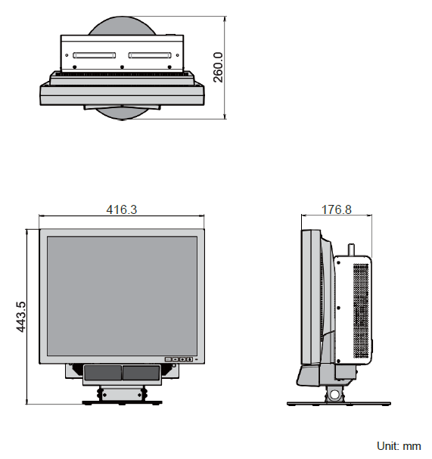
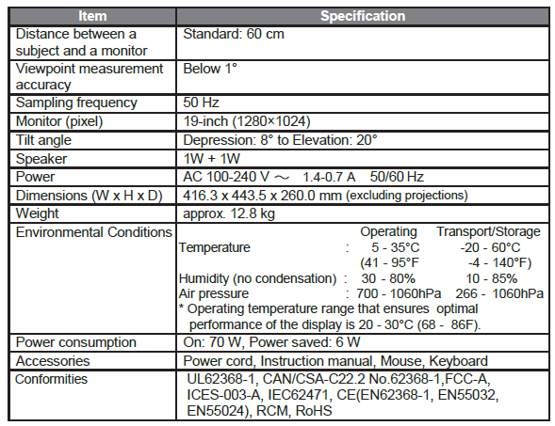
Gazefinder apparatus description and specifications

Figure S3. Specifications from Gazefinder Instruction Manual: Gaze Tracking and Diagnostic System Model GP-100EA¹ (p. 59 & 62).
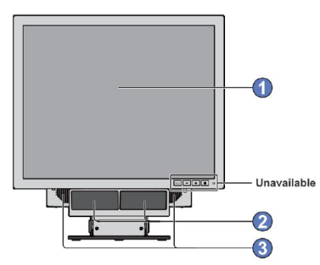
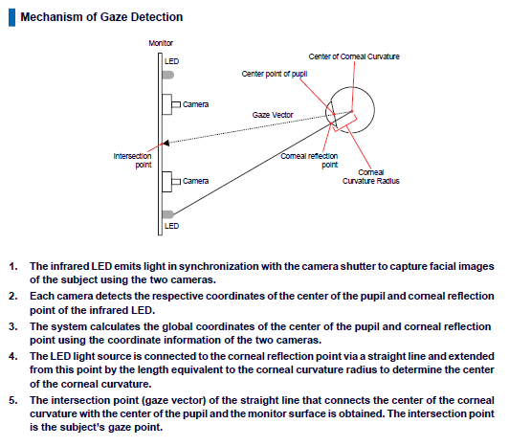
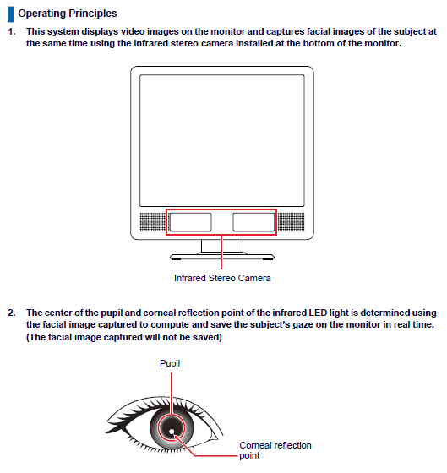
Determination of gaze fixations and movement saccades
Screen
Stereo Camera/Infrared LED

Speaker

Figure S4. Description of gaze detection technology from Gazefinder Instruction Manual: Gaze Tracking and Diagnostic System Model GP-100EA¹ (p. 18) and product Instruction Manual: Operation² (p. 51-52).

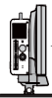
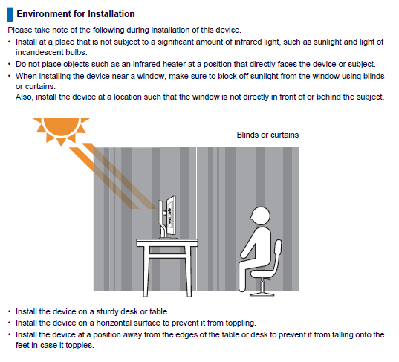
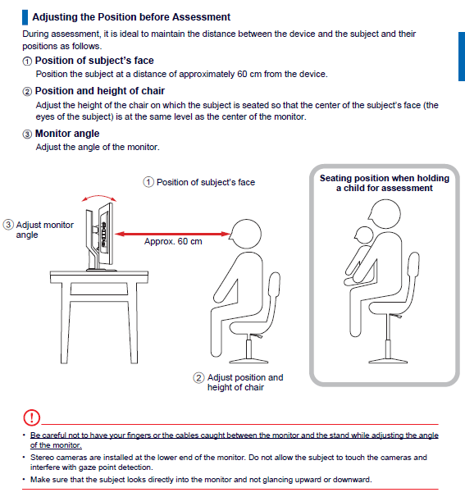
Set-up, positioning check, and five-point calibration procedure

Figure S5. Device setup and viewer positioning guidance from product Instruction Manual: Operation² (p. 10-11).

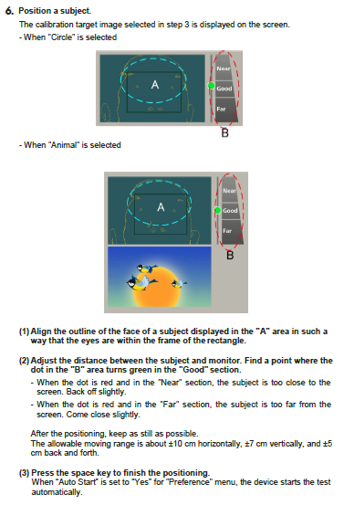
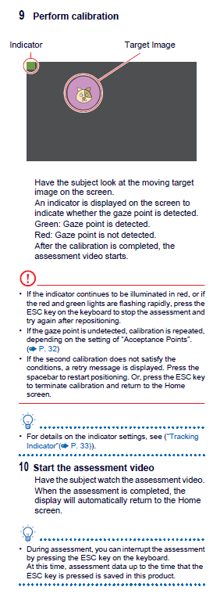
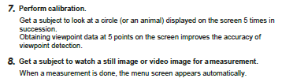
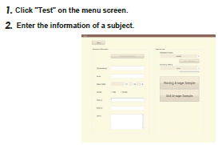
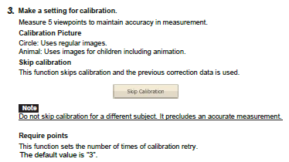

Figure S6. Guidance for checking proper positioning and calibration from Gazefinder Instruction Manual: Gaze Tracking and Diagnostic System Model GP-100EA¹ (p. 27-30) and product Instruction Manual: Operation² (p. 19-20).

Sources
- JVCKENWOOD Corporation (2019). Gazefinder Instruction Manual: Gaze Tracking and Diagnostic System Model GP-100EA. Kanagawa, Japan. Author
- JVCKENWOOD Corporation (2022). Gazefinder Instruction Manual: Operation (GP-200). Kanagawa, Japan. Author

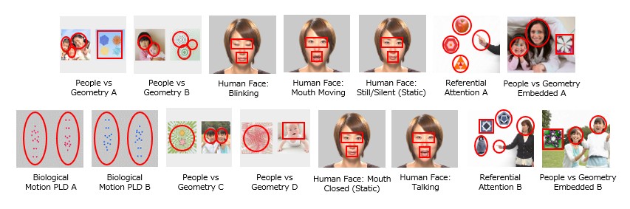
Figure S7. Key stimuli within ‘Scene 1S4’ showing all pre-specified Regions of Interest (ROIs). We confirm the permission from actors to appear in these images or that images were purchased by JKC for this use (including in open-access publication), and that we have the permission of JKC to include the images presented here (and in Supplementary Materials) for illustrative purposes including in open-access publication.

Table S2. Detailed specifications of ROIs for initial calibration check
Order | Onset Time (ms) | ROI Duration (ms) | ROI Shape | ROI Parameters (pixels) |  |  |  | Thumbnail Image | ROI Content Summary
 |  |  |  | x-axis | y-axis | width | height | Thumbnail Image | ROI Content Summary
1 | 0 | 2,000 | Five Squares | 580 | 454 | 115 | 115 | 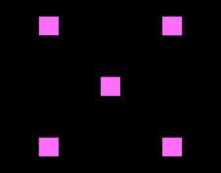 | Centre
2 | 3,000 | 2,000 | Five Squares | 225 | 98 | 115 | 115 |  | Top Left
3 | 6,000 | 2,000 | Five Squares | 225 | 813 | 115 | 115 |  | Bottom Left
4 | 9,000 | 2,000 | Five Squares | 940 | 813 | 115 | 115 |  | Bottom Right
5 | 12,000 | 3,000 | Five Squares | 940 | 98 | 115 | 115 |  | Top Right

Table S3. Detailed specifications of pre-specified ‘Scene 1S4’ ROIs
ROI # | Trial/Segment Label | Onset Time (ms) | Stimulus/ROI Duration (ms) | ROI Shape | ROI Parameters (pixels) |  |  |  | Thumbnail Images | ROI Content Summary
 |  |  |  |  | x-axis | y-axis | width | height | Thumbnail Images | ROI Content Summary
1 | People vs. Geometry (Same Size) A | 5,000 | 5,000 | Three Circles | 28 | 384 | 188 | 247 |  | People
2 |  |  |  |  | 136 | 478 | 199 | 256 |  | People
3 |  |  |  |  | 213 | 278 | 308 | 333 |  | People
4 | People vs. Geometry (Same Size) A | 5,000 | 5,000 | Rectangle | 738 | 301 | 493 | 450 |  | Geometry
5 | People vs. Geometry (Same Size) B | 10,300 | 4,700 | Two Circles | 118 | 365 | 229 | 248 |  | People
6 |  |  |  |  | 288 | 465 | 220 | 237 |  | People
7 | People vs. Geometry (Same Size) B | 10,300 | 4,700 | Three Circles | 757 | 280 | 280 | 280 |  | Geometry
8 |  |  |  |  | 832 | 517 | 260 | 260 |  | Geometry
9 |  |  |  |  | 991 | 433 | 220 | 220 |  | Geometry
10 | Blinking | 17,000 | 5,000 | Two Rectangles | 426 | 397 | 420 | 210 |    | Eyes
11 |  |  |  |  | 527 | 652 | 210 | 210 |  | Mouth
12 | Mouth Moving | 22,000 | 2,000 | Two Rectangles | 435 | 373 | 426 | 213 |  | Eyes
13 |  |  |  |  | 535 | 662 | 213 | 213 |  | Mouth
14 | Static/Silent | 27,000 | 5,000 | Two Rectangles | 431 | 373 | 426 | 213 |  | Eyes
15 |  |  |  |  | 532 | 647 | 213 | 213 |  | Mouth
16 | Referential Attention A | 34,000 | 4,000 | Square | 1080 | 140 | 200 | 200 | 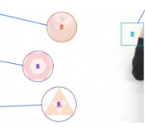 | Pointing Finger
17 | Referential Attention A | 34,000 | 4,000 | Circle | 419 | 42 | 268 | 268 |  | Target Object
18 | Referential Attention A | 34,000 | 4,000 | Two Circles | 204 | 388 | 274 | 274 |  | Two Distractors
19 |  |  |  |  | 373 | 707 | 310 | 310 |  | Two Distractors
20 | Referential Attention A | 34,000 | 4,000 | Two Circles | 760 | 270 | 320 | 320 | 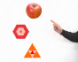 | Pointing Finger
21 |  |  |  |  | 419 | 42 | 268 | 268 |  | Target Object
22 | Referential Attention A | 34,000 | 4,000 | Two Circles | 204 | 388 | 274 | 274 |  | Two Distractors
23 |  |  |  |  | 373 | 707 | 310 | 310 |  | Two Distractors
24 | People vs. Geometry (Embedded) A | 40,000 | 8,000 | Square | 910 | 350 | 320 | 320 | 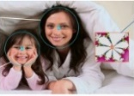  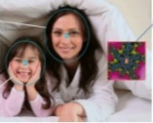 | Geometry
25 | People vs. Geometry (Embedded) A | 40,000 | 8,000 | Two Circles | 55 | 341 | 329 | 373 |  | People
26 |  |  |  |  | 379 | 75 | 375 | 447 |  | People
27 | People vs. Geometry (Embedded) A | 40,000 | 8,000 | Square | 910 | 350 | 320 | 320 |  | Geometry
28 | People vs. Geometry (Embedded) A | 40,000 | 8,000 | Two Circles | 55 | 341 | 329 | 373 |  | People
29 |  |  |  |  | 379 | 75 | 375 | 447 |  | People
(continues…)
(continuation)
ROI # | Trial/Segment Label | Onset Time (ms) | Stimulus/ROI Duration (ms) | ROI Shape | ROI Parameters (pixels) |  |  |  | Thumbnail Images | ROI Content Summary
 |  |  |  |  | x-axis | y-axis | width | height | Thumbnail Images | ROI Content Summary
30 | Biological Motion A | 52,000 | 5,000 | Two Circles | 145 | 120 | 420 | 780 | 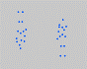  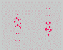 | Upright Figure
31 |  |  |  |  | 770 | 120 | 420 | 780 |  | Inverted Figure
32 | Biological Motion B | 57,000 | 6,000 | Two Circles | 100 | 90 | 420 | 780 |  | Inverted Figure
33 |  |  |  |  | 715 | 130 | 420 | 780 |  | Upright Figure
34 | People vs. Geometry (Same Size) C | 65,000 | 5,000 | Three Circles | 74 | 282 | 470 | 470 |  | Geometry Panel
35 |  |  |  |  | 761 | 337 | 241 | 265 |  | People Panel
36 |  |  |  |  | 963 | 354 | 232 | 272 |  | People Panel
37 | People vs. Geometry (Same Size) D | 70,300 | 4,700 | Circle | 72 | 275 | 470 | 470 | 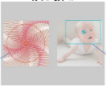  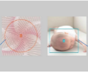 | Geometry Panel
38 | People vs. Geometry (Same Size) D | 70,300 | 4,700 | Rectangle | 719 | 408 | 415 | 344 |  | People Panel
39 | People vs. Geometry (Same Size) D | 70,300 | 4,700 | Circle | 72 | 275 | 470 | 470 |  | Geometry Panel
40 | People vs. Geometry (Same Size) D | 70,300 | 4,700 | Rectangle | 799 | 231 | 431 | 288 |  | People Panel
41 | Mouth Closed (Static) | 80,000 | 4,000 | Rectangle | 444 | 397 | 420 | 210 |  | Eyes Region
42 | Mouth Closed (Static) | 80,000 | 4,000 | Square | 541 | 651 | 210 | 210 |  | Mouth Region
43 | Talking | 84,000 | 7,000 | Rectangle | 425 | 382 | 432 | 216 |  | Eyes Region
44 | Talking | 84,000 | 7,000 | Square | 533 | 661 | 216 | 216 |  | Mouth Region
45 | Referential Attention B | 93,000 | 4,000 | Circles | 760 | 300 | 210 | 210 | 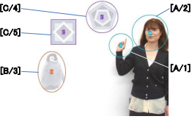 | Referential Agent (Hand & Face)
46 |  |  |  |  | 961 | 137 | 316 | 319 |  | Referential Agent (Hand & Face)
47 | Referential Attention B | 93,000 | 4,000 | Oval | 139 | 456 | 243 | 361 |  | Target Object
48 | Referential Attention B | 93,000 | 4,000 | Circle & Square | 561 | 17 | 280 | 280 |  | Two Distractors
49 |  |  |  |  | 255 | 179 | 219 | 219 |  | Two Distractors
50 | Referential Attention B | 93,000 | 4,000 | Circles | 520 | 560 | 210 | 210 | 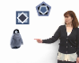 | Referential Agent (Hand & Face)
51 |  |  |  |  | 961 | 137 | 316 | 319 |  | Referential Agent (Hand & Face)
52 | Referential Attention B | 93,000 | 4,000 | Oval | 139 | 456 | 243 | 361 |  | Target Object
53 | Referential Attention B | 93,000 | 4,000 | Circle & Square | 561 | 17 | 280 | 280 |  | Two Distractors
54 |  |  |  |  | 255 | 179 | 219 | 219 |  | Two Distractors
55 | People vs. Geometry (Embedded) B | 99,000 | 8,000 | Square | 50 | 350 | 320 | 320 |  | Geometry Panel
56 | People vs. Geometry (Embedded) B | 99,000 | 8,000 | Two Circles | 501 | 320 | 261 | 282 |  | Adult’s Face
57 |  |  |  |  | 874 | 103 | 278 | 297 |  | Child’s Face
Note. For ROI Parameters, origin of x- and y- axes is top-left corner of screen, and width and height parameters for circles/ovals representing maximal points. We confirm the permission from actors to appear in these images or that images were purchased by JKC for this use (including in open-access publication), and that we have the permission of JKC to include the images presented here (and in Supplementary Materials) for illustrative purposes including in open-access publication.
Table S4. Associations between gaze data to pre-specified ROIs and scores on clinical/behavioural phenotyping measures for 47 infants with >30% Tracking Rate.
 |  | AOSI |  | MSEL |  | VABS |  |  | MSEL
Scene/Trial Type | ROI | Total ^{[S]} | q | NVDQ | q | ABC SS | q |  | Receptive AE |  | q |  | Expressive AE |  | q
Human Face
Blinking | Eyes | .27 | .226 | -.03 | .967 | .33 | .450 |  | -.12 |  | .601 |  | .07 |  | .678
 | Mouth ^{[S]} | -.21 | .371 | .07 | .895 | -.13 | .813 |  | .14 |  | .551 |  | .15 |  | .609
Mouth Moving | Eyes ^{[S]} | .20 | .422 | -.09 | .895 | .10 | .813 |  | -.30 |  | .354 |  | .04 |  | .840
 | Mouth | -.24 | .298 | -.03 | .967 | .01 | .944 |  | .13 |  | .601 |  | .13 |  | .590
Silent/Still (Static) | Eyes | .09 | .746 | -.13 | .967 | .23 | .459 |  | -.22 |  | .403 |  | -.13 |  | .590
 | Mouth ^{[S]} | -.03 | .957 | .06 | .895 | -.16 | .813 |  | .28 |  | .354 |  | .19 |  | .518
Mouth Closed (Static) | Eyes | .12 | .674 | .14 | .967 | .28 | .459 |  | .05 |  | .790 |  | .22 |  | .590
 | Mouth ^{[S]} | .12 | .674 | -.27 | .895 | -.13 | .813 |  | -.04 |  | .778 |  | -.11 |  | .634
Talking | Eyes ^{[S]} | .08 | .783 | -.17 | .895 | .12 | .813 |  | -.11 |  | .584 |  | -.09 |  | .710
 | Mouth | .02 | .967 | .02 | .967 | -.01 | .944 |  | .13 |  | .601 |  | .09 |  | .678
People vs. Geometry
Same-size | People | -.31 | .133 | .01 | .967 | .10 | .639 |  | .33 |  | .202 |  | .14 |  | .590
 | Geometry ^{[S]} | .56* | <.050 | -.01 | .947 | -.05 | .881 |  | -.26 |  | .354 |  | -.13 |  | .634
Embedded | People | -.39 | .054 | -.14 | .967 | .15 | .525 |  | .13 |  | .601 |  | .14 |  | .590
 | Geometry ^{[S]} | .48* | <.050 | .07 | .895 | -.28 | .813 |  | -.15 |  | .547 |  | -.23 |  | .372
Biological Motion PLDs | Upright Figure | .11 | .674 | -.26 | .800 | .11 | .629 |  | -.22 |  | .403 |  | .05 |  | .739
Biological Motion PLDs | Inverted Figure | -.12 | .674 | .01 | .967 | -.30 | .450 |  | .09 |  | .705 |  | -.17 |  | .590
Referential Attention | Agent (Face/Hand) | -.12 | .674 | -.21 | .800 | .18 | .508 |  | -.08 |  | .705 |  | -.18 |  | .590
 | Target | -.04 | .928 | .22 | .800 | -.18 | .508 |  | .35 |  | .202 |  | .35 |  | .240
 | Distractors ^{[S]} | .30 | .150 | -.06 | .895 | .04 | .881 |  | -.10 |  | .610 |  | -.25 |  | .368
Note. All correlations are partial, controlling for % tracking within each stimulus type, with FDR corrected p-values. Pearson’s correlations except [S]=Spearman; ROI=Region of Interest; AOSI=Autism Observation Scale for Infants; MSEL=Mullen Scales of Early Learning; NVDQ=Non-Verbal Developmental Quotient; VABS=Vineland Adaptive Behavior Scales; ABC = Adaptive Behaviour Composite; SS=Standard Score. * FDR corrected q<.05.
Table S5. Associations between proportionate gaze data to social vs. non-social ROIs or more vs less socially-salient ROIs and scores on clinical/behavioural phenotyping measures for 47 infants with >30% Tracking Rate.
 |  | AOSI |  | MSEL |  | VABS |  |  | MSEL
Scene/Trial Type | ROI | Total ^{[S]} | q | NVDQ | q | ABC SS | q | Receptive AE |  | q | Expressive AE | q
Human Face
Blinking | Eyes v. Mouth ^{[S]} | .23 | .328 | -.10 | .967 | .13 | .581 | -.13 |  | .601 | -.16 | .590
Mouth Moving | Eyes v. Mouth ^{[S]} | .32 | .133 | -.12 | .895 | .12 | .813 | -.18 |  | .519 | -.05 | .840
Silent/Still (Static) | Eyes v. Mouth | .04 | .928 | -.01 | .967 | .24 | .459 | -.23 |  | .403 | -.07 | .678
Mouth Closed (Static) | Eyes v. Mouth | -.01 | .967 | .03 | .967 | .18 | .508 | -.04 |  | .790 | .24 | .590
Talking | Eyes v. Mouth ^{[S]} | .04 | .928 | -.14 | .895 | .10 | .813 | -.04 |  | .778 | .00 | .987
People vs. Geometry
Same-size | People v. Geom ^{[S]} | -.45* | <.050 | -.07 | .895 | .01 | .958 | .23 |  | .354 | .11 | .634
Embedded | People v. Geom ^{[S]} | -.46* | <.050 | -.06 | .895 | .23 | .813 | .12 |  | .566 | .18 | .538
Biological Motion PLDs | Upright v. Inverted | .11 | .674 | -.11 | .967 | .16 | .508 | -.21 |  | .403 | .09 | .678
Referential Attention
Target/Person vs Distractors ^{[S]} |  | -.33 | .133 | -.02 | .947 | .13 | .813 | .17 |  | .519 | .29 | .250
Target vs Person/ Distractors ^{[S]} |  | .01 | .967 | .19 | .895 | -.08 | .829 | .25 |  | .354 | .34 | .250
Target vs Distractors ^{[S]} |  | -.31 | .133 | .03 | .947 | .05 | .881 | .19 |  | .519 | .29 | .250
Note. All correlations are partial, controlling for % tracking within each stimulus type, with FDR corrected p-values. Pearson’s correlations except [S]=Spearman; ROI=Region of Interest; AOSI=Autism Observation Scale for Infants; MSEL=Mullen Scales of Early Learning; NVDQ=Non-Verbal Developmental Quotient; VABS=Vineland Adaptive Behavior Scales; ABC = Adaptive Behaviour Composite; SS=Standard Score. * FDR corrected q<.05.

