Supplement Materials
Fukuhara et al.
Rethinking the four-wing problem in plesiosaur swimming using bio-inspired decentralized control

- Supplemental materials describe details about S1) the PIV system, S2) the evaluation of the flow tank, S3) the calibration process of force sensor unit, S4) the determination of the control parameters, and S5) the analysis of the proposed control model.
- Movie M01.mov: Spontaneous gait transition of a plesiosaur-inspired robot via decentralized control mechanism. The Movie file M01 shows that the plesiosaur-inspired robot spontaneously changes its inter-flipper coordination in response to an increase in the flapping frequency. The proposed decentralized control mechanism controls the flapping motion of each flipper unit. When the intrinsic angular velocity ω changed from 1.08π to 1.8π [rad/s], the phase difference between the flippers Δϕ changed from 0.2π to 0.8π [rad].
- Movie file M2.mov: Adaptation of a plesiosaur-inspired robot to different distance between flippers via a decentralized control mechanism. The Movie file M02 shows the flexibility in the locomotor patterns of the plesiosaur-inspired robot at different distances between flippers. Depending on the distance between flippers D of the plesiosaur-inspired robot, the phase difference between flippers Δϕ converged to different values, achieving efficient thrust force.

S1. PIV system for the developed robot platform
In this section, the details of the PIV system for the development robot platform are described. Figure A1 shows a schematics of capture system for PIV analysis. The PIV system consists of the custom flow tank, a sheet laser (PIV Laser G1000, KATO KOKEN), and a high-speed camera (HAS-U2, DITECT) capturing images at the rate of 250 fps. The flow tank contains fresh water with tracer particles (DIAION HP20, MITSUBISHI CHEMICAL). The sheet laser is cast from the observation window to generate a cross section for measurement, and the high-speed camera captures the measurement section from the bottom of the flow tank. For PIV analysis, we use the software, Flownizer (version 1.2.17.0, DITECT).

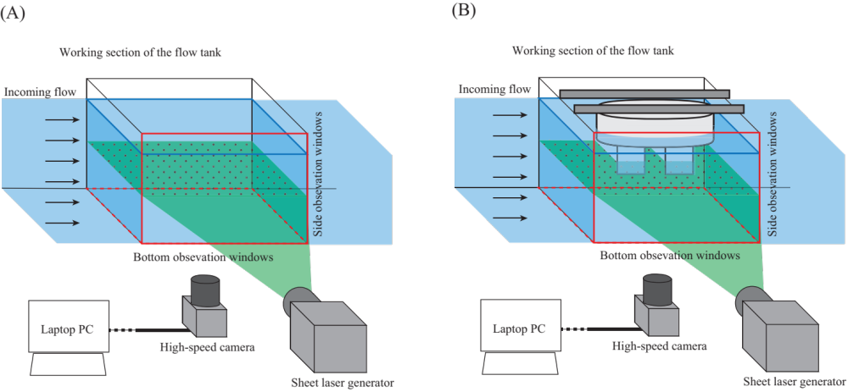
Figure A1. PIV system for the developed robot platform. (A) Setup for measurement of background flow of the flow tank. (B) Setup for measurement of flow around the robot.

S2. Evaluation of the flow tank background
In this section, the evaluation of the background flow in the developed experimental flow tank is described. Because the environmental flow in the experimental tank may affect the physical interactions between the vortices generated by the flippers, it is required to evaluate the background flow in the developed flow tank. In the present study, we measured the background by using PIV system as shown in Fig. A1 (A). The laser casts a measurement cross section in XZ plane in the working section, and the high-speed camera captures the cross section from the bottom of the flow tank. Electric Speed Controllers (ESCs) control the speed of six Thrusters through Pulse Width Modulation (PWM) signal. In all experiments in the main text, the PWM signal is fixed.

Figure A2 shows the flow in the cross section. Although the flow speed along the wall decreases, the flow speed in the middle of the working area is consistent. In the measurement section as shown in Fig. A2, the average speed at the middle of the measurement section is 23.5 [cm/s], and the standard deviation at each computational point is under 0.02. Because the robot flipper excursion is 10 [cm], the flow tank allows the robot flippers to interact each other via vortices that are mainly generated by flippers.

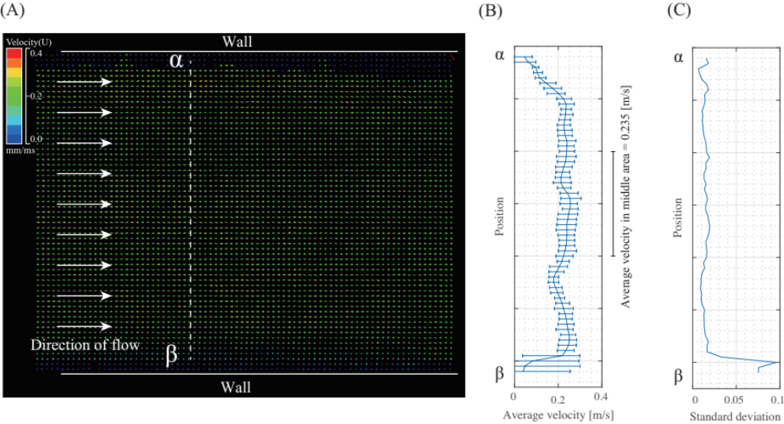
Figure A2. Background flow in the working section of the flow tank by PIV analysis. (A) Velocity distribution in the X-Z plane. The colour of the vectors represents the velocity of flow at each computational mesh. (B) The velocity distribution and (C) standard deviation of computational mesh along the $α- β$ section in (A).

S3. Calibration process for 2D force sensor units
To measure the physical interaction between flippers and the environment, we develop a 2D force sensor unit by combining two load cell sensors (CZL616C, Phidgets) that are oriented orthogonally to each other. We calibrated the relationship between sensory values of the load cell sensor and loaded weights by a developed system, as shown in Fig. A3 (A). As the load cells are oriented orthogonally to each other (Fig. A3 (B)), we measure the sensory value for each orientation. Reference weights are loaded on a calibration stage (Fig. A3 (C)), and the 2D force sensor unit is pulled along one direction.
As a result of the calibration process, the sensor value of the load cell exhibits linear relationships with the loaded weight value (Fig. A4). The values of loaded forces in the 2D force sensors are estimated as follows:
$$N_{fore}^{ht}=4.27×{10}^{-4} x_{fore}^{ht}-3.61×{10}^{3}$$ | (A1)
$$N_{fore}^{ht}=4.41×{10}^{-4} x_{fore}^{ht}-3.69×{10}^{3}$$ | (A2)
$$N_{fore}^{ht}=4.48×{10}^{-4} x_{fore}^{ht}-3.74×{10}^{3}$$ | (A3)
$$N_{fore}^{ht}=4.40×{10}^{-4} x_{fore}^{ht}-3.73×{10}^{3}$$ | (A4)

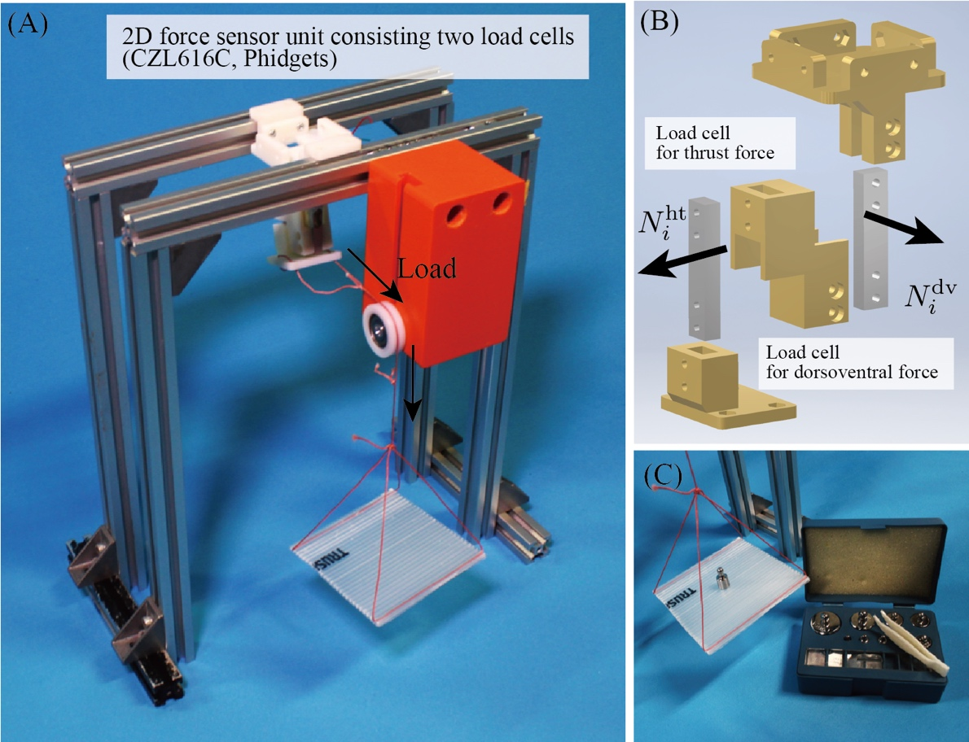
Figure A3 Calibration system of the load cell sensors in the robot’s force sensor units. (A) Overview of the calibration system. (B) Location and orientation of two load cells. (C) Weight on a calibration stage.

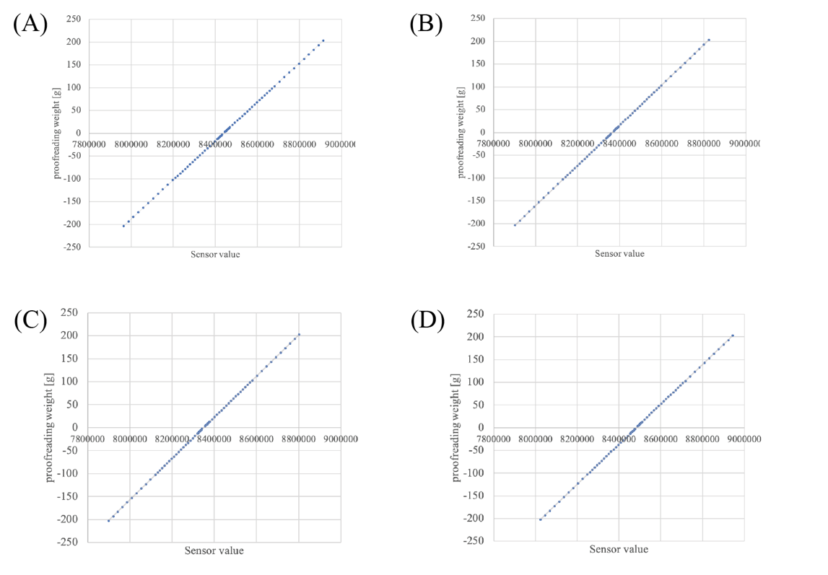
Figure A4. Relationships between sensory value and load in the load cells for (A) fore-aft and (B) dorsoventral directions of the fore flipper units and (C) fore-aft and (D) dorsoventral directions of the hind flippers.

S4. Determination of the control parameters for bio-inspired decentralized control mechanism
Because the sensory feedback mechanism allows the plesiosaur-like robot to generate high quality inter-flipper coordination patterns via physical interaction between the flippers and vortices, the control gain parameter for sensory feedback, $σ_{i}$ is a key parameter that affects the inter-flipper coordination. Therefore, before evaluation about the robot’s adaptive capability, we first determined the essential control parameters of the feedback mechanism so that the robot can generate feasible inter-flipper coordination in a range of locomotor conditions.
To achieve this, we set an initial locomotor condition where the locomotor frequency was 0.6 [Hz] and the flipper distance was 4 chord length (24 [cm]), and turned the parameters ($ω$, and $σ_{i}$) as shown in Table 1. Consequently, the phase difference $Δϕ$ converges to the high-thrust value as shown in Fig. 4(A). The parameter was heuristically adjusted, considering the following two points:

Point 1: Balance between $σ_{i}$ and $ω$
In the proposed model, the local sensory feedback term plays the essential role in generating flexible inter-flipper coordination, and the magnitude of $σ_{i}$ affects the flexibility and stability of locomotor patterns. For example, when$σ_{i}$ is small and the sensory feedback term affects weakly, the phase difference between flippers $Δϕ$ cannot vary very far from the initial value, resulting in less flexibility in the inter-flipper coordination. In contrast, when $σ_{i}$ is large and the sensory feedback term has a strong effect, the flipper controller becomes too sensitive, resulting in instability in the locomotor patterns. Therefore, the value of $σ_{i}$ needs to be adjusted to be appropriate for the magnitude of sensory signal $N_{i}^{\text{dv}}$.

Furthermore, we need to adjust the control parameter $ω$ to specify the locomotor patterns before the application of local sensory feedback. Basically, the sensory feedback term works as phase advances in both up-stroke and down-stroke. Consequently, the resultant locomotor frequency via the feedback mechanism becomes higher than that via the intrinsic angular velocity $ω$ alone. Therefore, to allow adjustment of the resultant locomotor frequency to the changes in conditions, the intrinsic angular velocity $ω$ should be smaller than the target locomotor frequency: $ω< 2πf$, where $f$ is a target frequency.

Point 2: Balance between $σ_{fore}$ and $σ_{hind}$
In the proposed model, the feedback gains $σ_{fore}$ and $σ_{hind}$ are should be balanced to converge to high-thrust inter-flipper coordination. The phase difference between the fore and hind flippers $Δϕ$ changes in response to the difference between ${\dot{ϕ}}_{fore}$ and ${\dot{ϕ}}_{hind}$ as follows:
$$Δ\dot{ϕ}={\dot{ϕ}}_{fore}-{\dot{ϕ}}_{hind}$$ | (A5)
When the two flippers converge on a specific inter-flipper coordination patterns ($∆\dot{ϕ}=0$), changes in the phase of the fore flipper oscillator corresponds to the hind one (${\dot{ϕ}}_{fore}={\dot{ϕ}}_{hind}$). According to Equation (1), both controllers are given a common intrinsic angular velocity $ω$ Therefore, convergence of $Δϕ$ occurs when the amount of sensory feedback modulation in both fore and hind flipper are corresponded to each other as follow:
$$\int^{T}{\left(-σ_{fore}N_{fore}^{\text{dv}}\cos{ϕ_{fore}}\right)}dt=\int^{T}{\left(-σ_{hind}N_{hind}^{\text{dv}}\cos{ϕ_{hind}}\right)dt}$$ | (A6)
Note that the magnitude of the hind flipper’s reaction force (e.g., $N_{hind}^{dv}$ and $N_{hind}^{dt}$) increases in the high-thrust coordination while the fore flipper’s reaction force (e.g., $N_{fore}^{dv}$ and $N_{fore}^{dt}$) is not affected by inter-flipper coordination patterns. Based on the magnitude of the reaction force at the fore and hind flippers, we adjust the balance of the control gain $σ_{i}$ so that the robot can generate high-thrust inter-flipper coordination patterns in the locomotor condition where the locomotor frequency is 0.6 [Hz] and the flipper distance is 4 chord length (24 [cm]).
S5. Return map analysis of the proposed model
To understand how the high-thrust coordination emerges, we apply first-return map analysis¹ to the swimming experiment with the proposed control model. To describe changes in the phase difference between flippers, we measure $Δϕ_{n}$, that is the phase difference between flippers at the moment when the fore flipper strokes up $\cos{ϕ_{fore}}=1$ in the $n$th stride cycle. We obtain the return map by plotting the relationship between $Δϕ_{n}$ and $∆ϕ_{n+1}$. By drawing the return map, the equilibrium point is visualized as a point where $∆ϕ_{n+1}=Δϕ$.

For the experimental setup, we determined the control parameters as shown Table 1: $ω$ is 1.08 [rad/s], $σ_{fore}$ is $1.56×{10}^{-2}$, and $σ_{hind}$ is $1.00×{10}^{-2}$ for high-thrust coordination in the locomotor condition. For the locomotor condition, the locomotor frequency is 0.6 [Hz], and the flipper distance is 4 chord length (24 [cm]). Furthermore, to obtain the map with various phase differences $Δϕ$, we conducted the swimming experiment with altered initial phase differences:$Δϕ=0,\frac{1}{12}π, \frac{2}{12}π, ⋯,\frac{11}{12}π$.

Figure A3 shows the return map for the robot platform with the proposed inter-flipper coordination mechanism. According to the map, when the $Δϕ_{n}$ is around 0.24$π$ [rad], $Δϕ_{n}$ is corresponds almost exactly to the values of ${∆ϕ}_{n+1}$, and consequently, the robot system is at the equilibrium point. In the coloured regions in Fig. A3, the robot converges on the high-thrust inter-flipper coordination as shown in Fig. 7. However, outside this region (e.g., in the low-thrust coordination area), $Δϕ_{n+1}$ is larger than $Δϕ_{n}$. Therefore, the phase difference $Δϕ$ becomes larger during swimming. This changes in the phase difference is because of the balance of the feedback terms: in low-thrust coordination, the hind flipper generates lower reaction force during one locomotor cycle than the fore flippers ($\int{N_{\text{hin}d}^{\text{dv}}dt}<\int{N_{\text{fore}}^{\text{dv}}dt}$), and the feedback gain of the hind flipper is lower than the fore flipper as shown in Table 1 ($σ_{\text{hind}}<σ_{\text{fore}}$). The phase advance of the sensory feedback term for the fore flipper has a greater affect than that for the hind flipper, and consequently $Δϕ_{n+1}$ becomes larger than $Δϕ_{n}$ as shown in Fig. A3. These mechanism of the convergence to the high-thrust coordination exploits the relationship between the thrust force and $Δϕ$ that emerges from interaction between flippers and vortices. Therefore, the proposed mechanism can adapt to changes in locomotor conditions (e.g., locomotor frequency and flipper distance) to generate high-thrust coordination patterns without changing the control parameters once they have been selected properly.

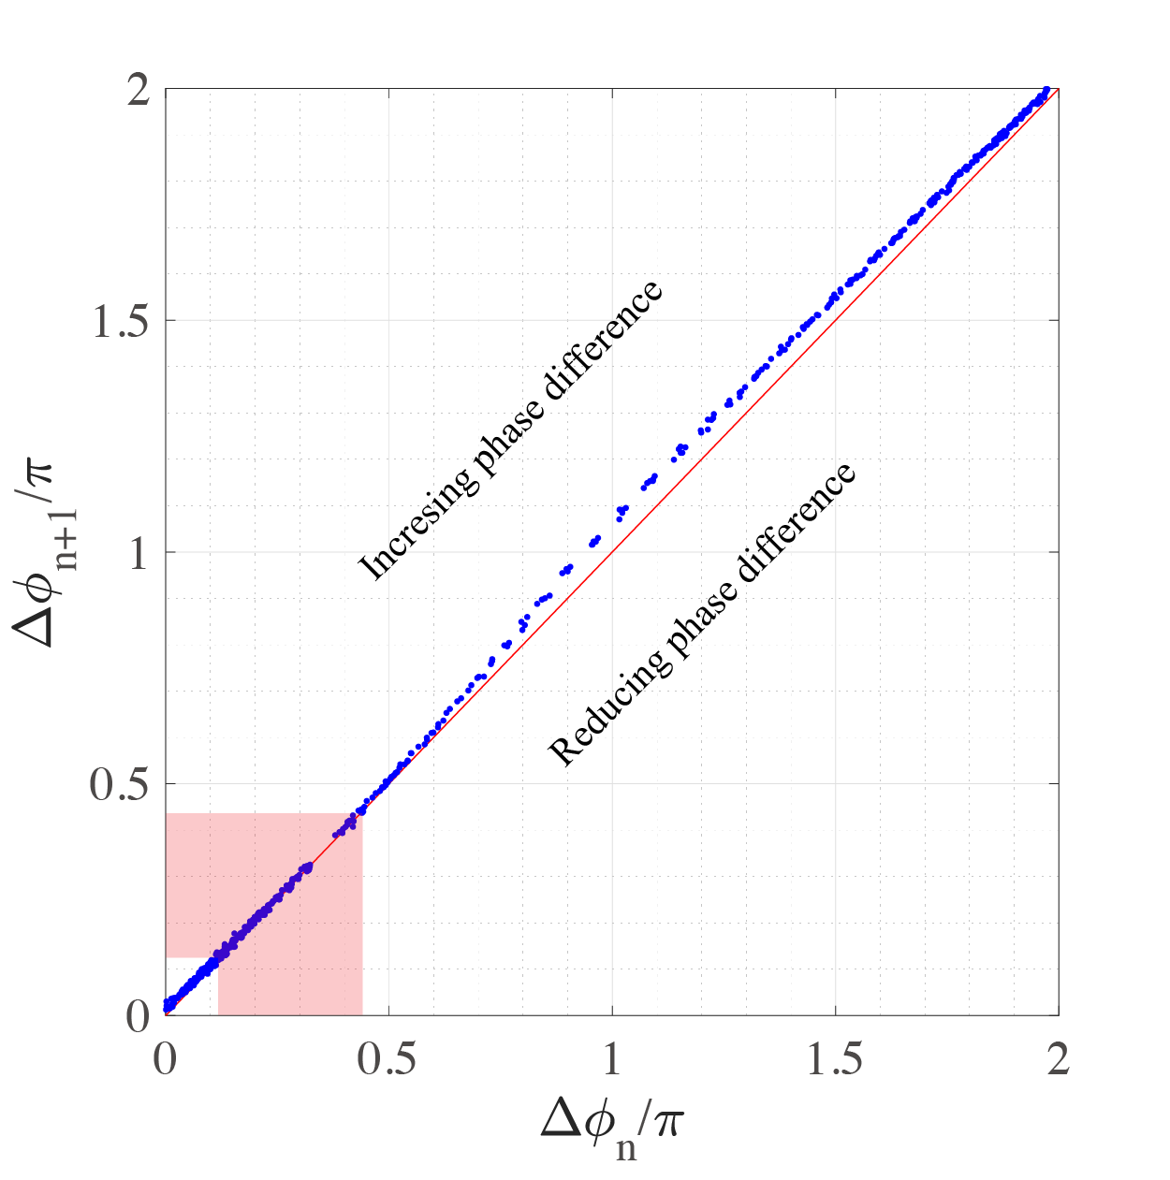
Figure A3. Return map of the proposed model. Blue dots are obtained from the swimming experiments with the altered initial phase difference The coloured region shows the high-thrust coordination patterns in the locomotor condition where the locomotor frequency is 0.6 [Hz] and the flipper distance is 4 chord length (24 [cm]) as shown in Fig. 4(A). The converged phase difference locates in this region. The control parameters are set as in Table 1: $ω$ is 1.08 [rad/s], $σ_{\text{fore}}$ is $1.56×{10}^{-2}$, and $σ_{\text{hind}}$ is $1.00×{10}^{-2}$.

1 Christini, D. J. & Collins, J. J. Controlling Nonchaotic Neuronal Noise Using Chaos Control Techniques. Physical Review Letters 75, 2782-2785, doi:10.1103/PhysRevLett.75.2782 (1995).

