Artifact removal by template subtraction enables recordings of the frequency following response in cochlear-implant users
Supplementary material
Robin Gransier¹, Robert P. Carlyon², Matthew L. Richardson^{3,4}, John C. Middlebrooks^{3,4.5}, and Jan Wouters¹
¹ ExpORL, Department of Neurosciences, Leuven Brain Institute, KU Leuven, Leuven, Belgium.
² Cambridge Hearing Group, MRC Cognition and Brain Sciences Unit, University of Cambridge, Cambridge, UK.
³ Department of Otolaryngology, University of California at Irvine, Irvine, CA, USA.
⁴Center for Hearing Research, , University of California at Irvine, Irvine, CA, USA.
⁵ Departments of Neurobiology & Behavior, Biomedical Engineering, Cognitive Sciences, University of California at Irvine, Irvine, CA, USA.

Corresponding author: jan.wouters@kuleuven.be

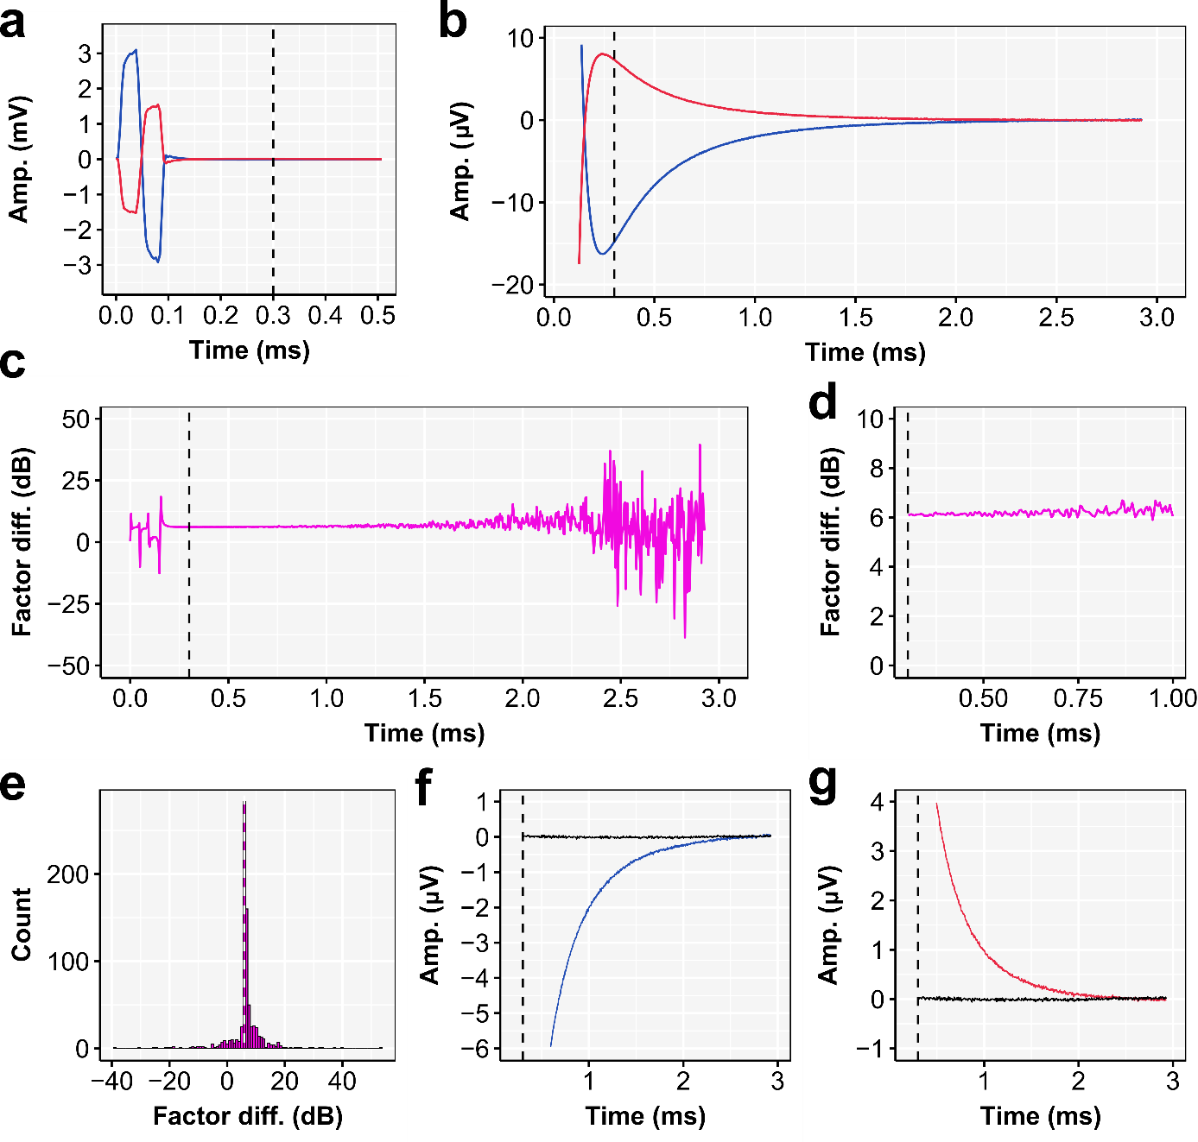
Supplementary Figure 1 | Illustration of weighting average approach in case no neural response is present. Data shown is from participant S2 and for the 303 pps condition. (a) The first 500 µs of the grand-averaged inter-pulse interval (${\overline{A}}_{{cor}_{pulse}}$) of both the ipsi and contralateral mastoid (i.e., MaL (Blue) and MaR (Red)). (b) the zoom of the artifact tail of the same single pulse stimulation artifact. (c) The factor difference as a function of time. (d) A zoom of the factor difference that shows that the factor difference is relatively stable over time when no neural response is present. (e) The histogram of the factor difference within an inter-pulse interval. The dashed white line shows the average factor difference of the first two samples of the tail, indicating that this is a good approximation to determine the amount pulses that need to be used in the weighted average. (f-g) The recorded tail (${\overline{A}}_{{cor}_{pulse}}$) in blue or red and the weighted average (${\overline{A}}_{{Neural}_{approx}}$) in black.

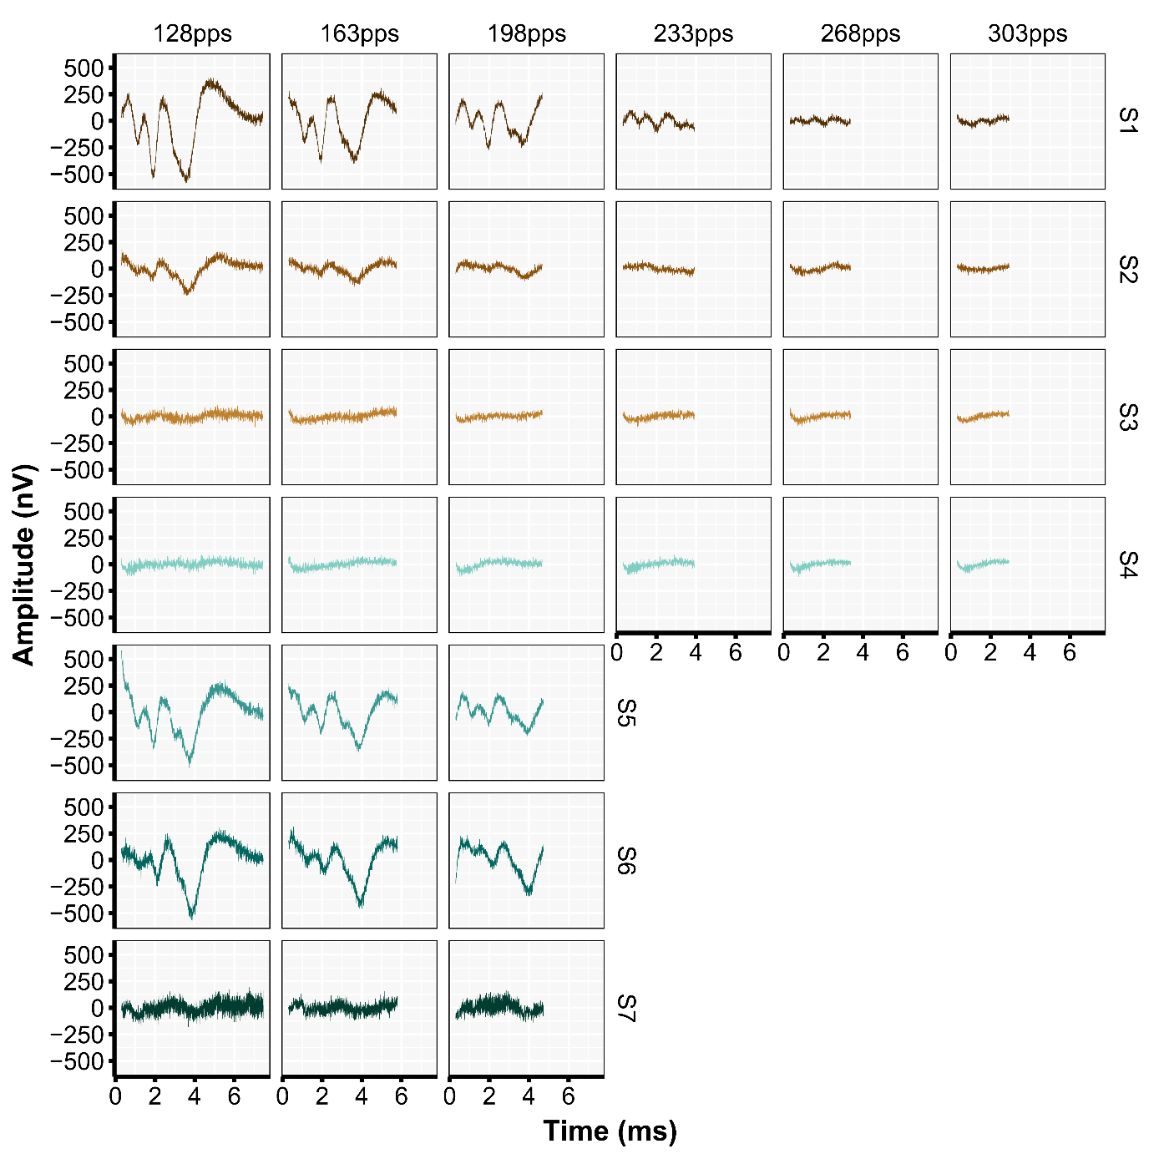
Supplementary Figure 2 | The subject-specific (rows) and condition-specific (columns) weighted average $({\overline{A}}_{{Neural}_{approx}}$). Note that only one inter-pulse interval is shown.
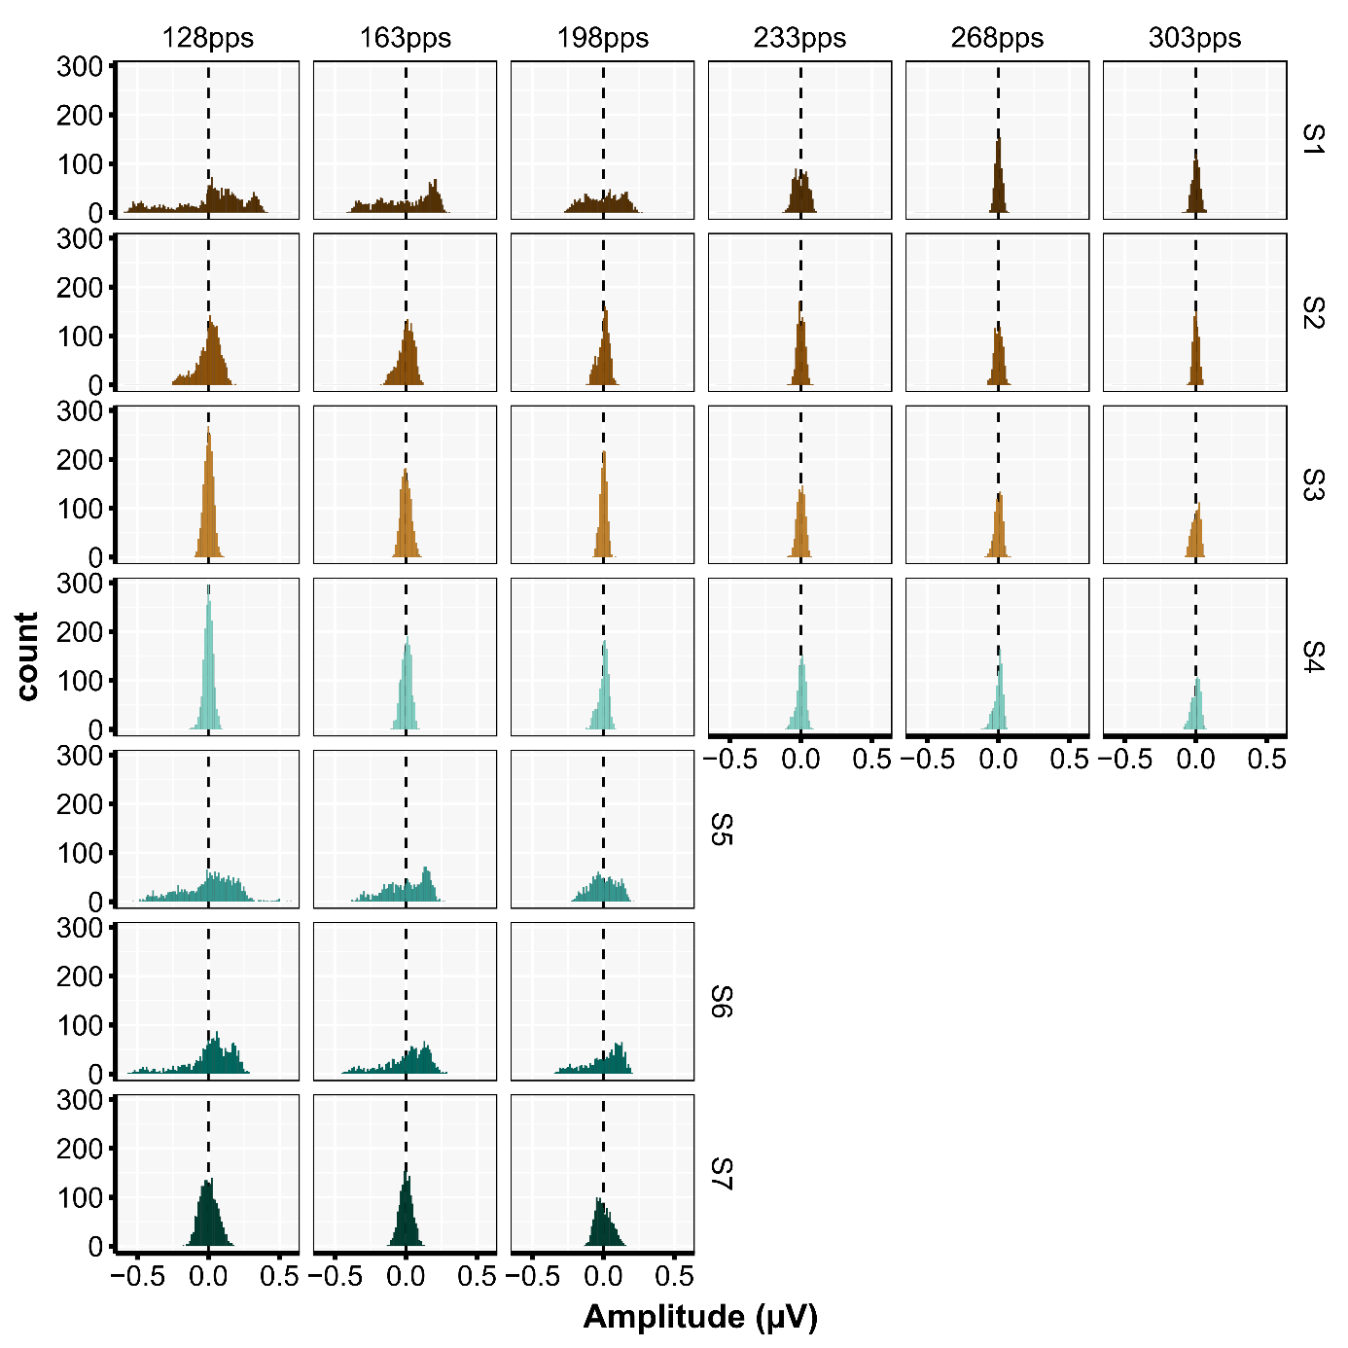
Supplementary Figure 3 | The subject-specific (rows) and condition-specific (columns) distribution of the amplitude values in the weighted average $({\overline{A}}_{{Neural}_{approx}}$). Note that the distributions are based on one inter-pulse interval.

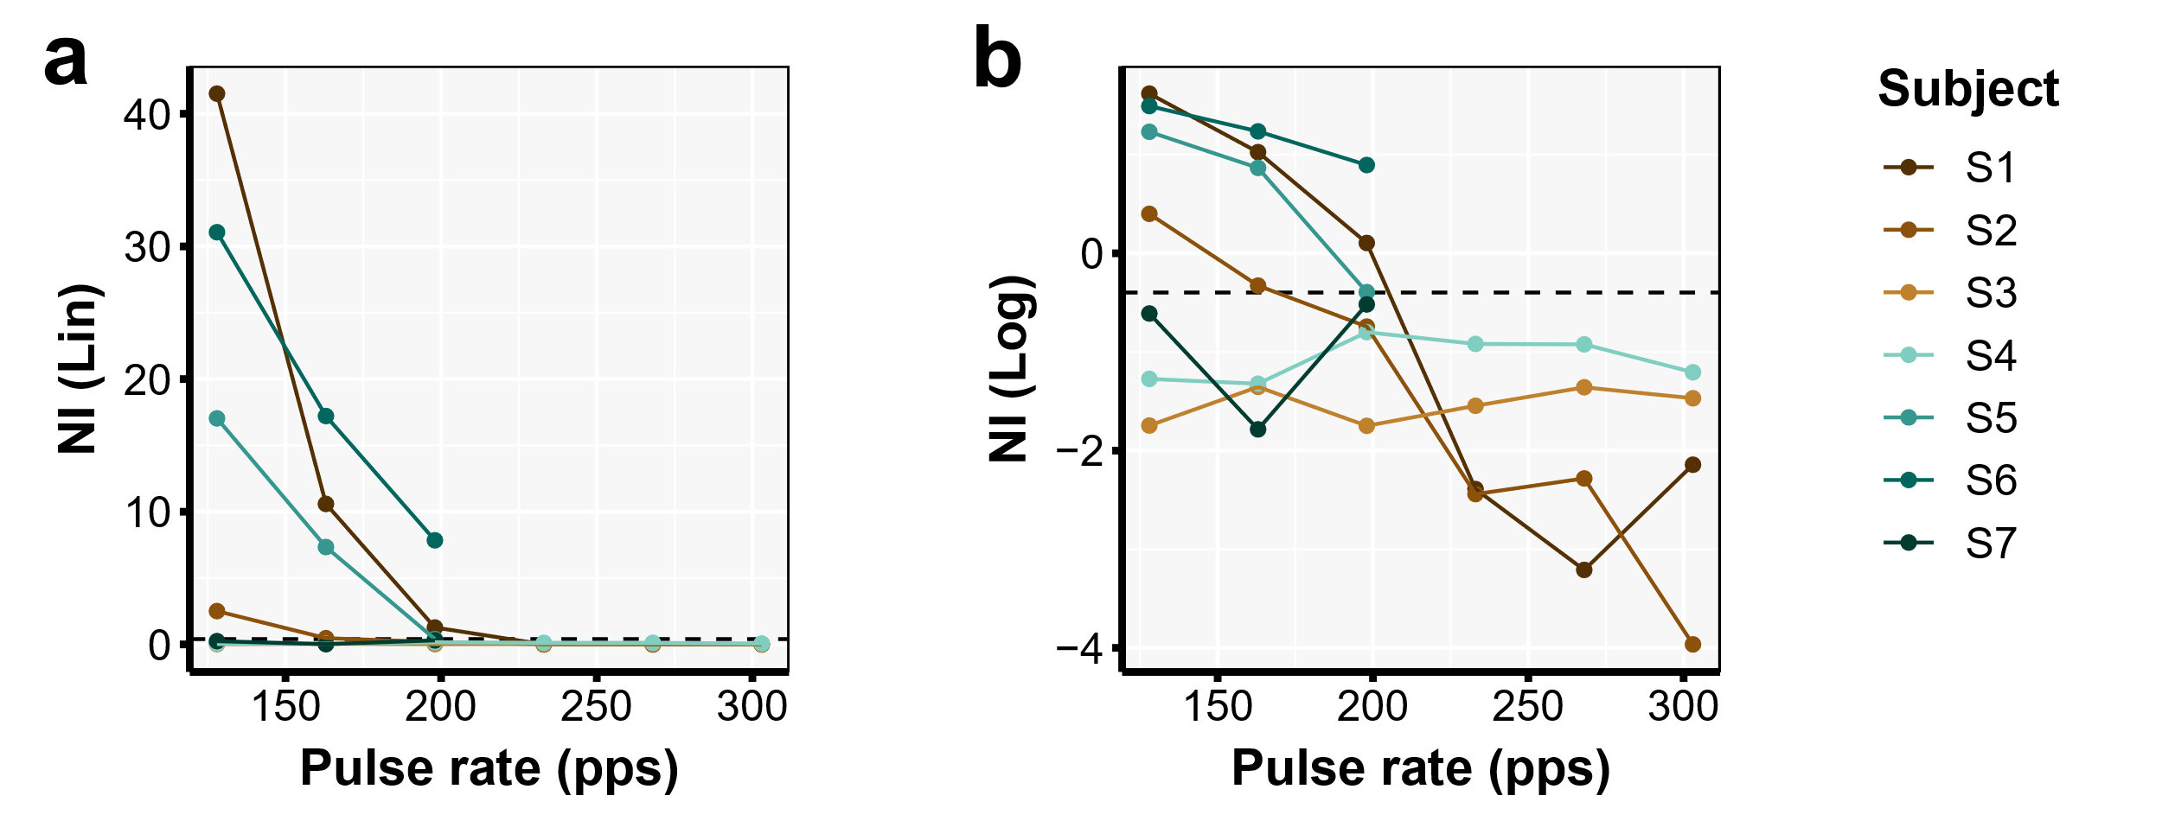
Supplementary Figure 4 | The subject-specific neural index as a function of pulse rate on a (a) linear scale and (b) for illustrative purposes on a log₁₀ scale (i.e., the log10(NI linear). The dashed line indicates the threshold that is used to determine if a neural response is present in the weighted average $({\overline{A}}_{{Neural}_{approx}}$).

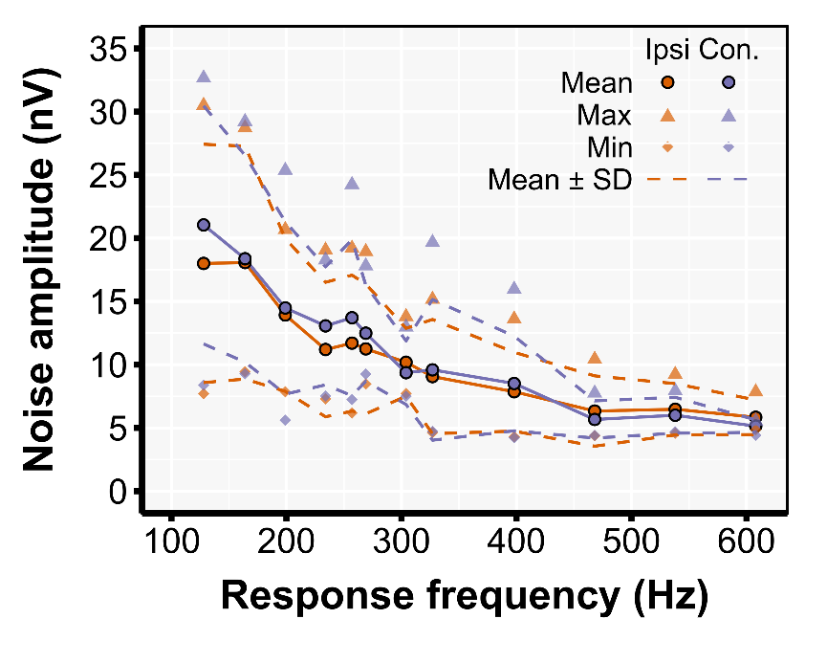
Supplementary Figure 5 | The characteristics of the neural noise levels across all participants as a function of the response frequency. Note that the response frequencies which differed minimally between dataset DS1 and DS2 are grouped to compute representative descriptive statistics. Note that the maximum pulse rate differed between DS1 and DS2 and therefore the sample size is lower for response frequencies > 400 Hz.

Supplementary Table I | descriptive information about the epochs and number of pulses included in the analyses. The total amount of pulses in the recording is the number on which the average pulse is based, as used in the construction of the artifact template.
Subject | Pulse rate (pps) | Recorded epochs  (n) | Epoch duration (s) | Total mount of pulses in the recording (n)
S1 | 128 | 388 | 2.042 | 101433
S1 | 164 | 388 | 2.042 | 129961
S1 | 198 | 388 | 2.042 | 157697
S1 | 234 | 388 | 2.042 | 185433
S1 | 269 | 388 | 2.042 | 213168
S1 | 303 | 388 | 2.042 | 240904
S2 | 128 | 485 | 2.042 | 126792
S2 | 164 | 388 | 2.042 | 129961
S2 | 198 | 449 | 2.042 | 182489
S2 | 234 | 485 | 2.042 | 231791
S2 | 269 | 388 | 2.042 | 213168
S2 | 303 | 449 | 2.042 | 278778
S3 | 128 | 388 | 2.042 | 101433
S3 | 164 | 388 | 2.042 | 129961
S3 | 198 | 485 | 2.042 | 197121
S3 | 234 | 388 | 2.042 | 185433
S3 | 269 | 388 | 2.042 | 213168
S3 | 303 | 485 | 2.042 | 301130
S4 | 128 | 430 | 2.042 | 112413
S4 | 164 | 528 | 2.042 | 176855
S4 | 198 | 485 | 2.042 | 197121
S4 | 234 | 430 | 2.042 | 205505
S4 | 269 | 528 | 2.042 | 290085
S4 | 303 | 485 | 2.042 | 301130
S5 | 128 | 386 | 1.735 | 85737
S5 | 162 | 387 | 1.937 | 121433
S5 | 196 | 387 | 1.972 | 149544
S6 | 128 | 388 | 2.048 | 101711
S6 | 162 | 388 | 2.048 | 128728
S6 | 196 | 385 | 2.048 | 154542
S7 | 128 | 384 | 2.048 | 100664
S7 | 162 | 385 | 2.048 | 127735
S7 | 196 | 384 | 2.048 | 154142

