Supplementary information

Table S1. Distribution of significant features of user activity in the social network VKontakte in models

Feature | Big Five | Verbal intelligence | Fluid intelligence
Activity | 17 | 15 | 17
albums | 1 | 1 | 1
audios | 1 | 1 | 1
comments | 1 | 1 | 1
count_mess | 1 | 1 | 1
followers | 1 | 1 | 1
gifts | 1 | 1 | 1
groups | 1 | 1 | 1
likes | 1 | 1 | 1
pages | 1 | 1 | 1
photos | 1 |  | 1
post | 1 | 1 | 1
repost | 1 | 1 | 1
reposts | 1 | 1 | 1
subscriptions | 1 |  | 1
videos | 1 | 1 | 1
views | 1 | 1 | 1
friends | 1 | 1 | 1
Person characteristic | 2 | 2 | 2
age | 1 | 1 | 1
education | 1 | 1 | 1
Text characteristics | 4 | 4 | 4
count_words_post | 1 | 1 | 1
count_words_repost | 1 | 1 | 1
mean_words_len_post | 1 | 1 | 1
mean_words_len_repost | 1 | 1 | 1
Theme | 28 | 15 | 28
post_theme_body_shaming | 1 | 1 | 1
post_theme_drugs | 1 |  | 1
post_theme_health_shaming | 1 | 1 | 1
post_theme_offline_crime | 1 | 1 | 1
post_theme_online_crime | 1 |  | 1
post_theme_politics | 1 |  | 1
post_theme_pornography | 1 | 1 | 1
post_theme_prostitution | 1 |  | 1
post_theme_racism | 1 |  | 1
post_theme_religion | 1 |  | 1
post_theme_sexism | 1 |  | 1
post_theme_social_injustice | 1 | 1 | 1
post_theme_weapons | 1 |  | 1
repost_theme_body_shaming | 1 | 1 | 1
repost_theme_drugs | 1 | 1 | 1
repost_theme_health_shaming | 1 | 1 | 1
repost_theme_offline_crime | 1 | 1 | 1
repost_theme_online_crime | 1 | 1 | 1
repost_theme_politics | 1 | 1 | 1
repost_theme_pornography | 1 | 1 | 1
repost_theme_prostitution | 1 |  | 1
repost_theme_racism | 1 |  | 1
repost_theme_religion | 1 | 1 | 1
repost_theme_sexism | 1 | 1 | 1
repost_theme_sexual_minorities | 1 |  | 1
repost_theme_social_injustice | 1 |  | 1
repost_theme_suicide | 1 |  | 1
repost_theme_weapons | 1 | 1 | 1
Sentiment | 3 | 3 | 3
negative | 1 | 1 | 1
neutral | 1 | 1 | 1
positive | 1 | 1 | 1
Frequency | 10 | 9 | 10
day_mean | 1 | 1 | 1
Fri | 1 | 1 | 1
Mon | 1 | 1 | 1
month_mean | 1 | 1 | 1
Sat | 1 | 1 | 1
Sun | 1 | 1 | 1
Thu | 1 | 1 | 1
Tue | 1 | 1 | 1
Wed | 1 | 1 | 1
year_mean | 1 |  | 1
Emotional evaluation | 12 | 10 | 12
anger | 1 | 1 | 1
anger_repost | 1 | 1 | 1
fear | 1 |  | 1
fear_repost | 1 |  | 1
joy | 1 | 1 | 1
joy_repost | 1 | 1 | 1
no_emotion | 1 | 1 | 1
no_emotion_repost | 1 | 1 | 1
sadness | 1 | 1 | 1
sadness_repost | 1 | 1 | 1
surprise | 1 | 1 | 1
surprise_repost | 1 | 1 | 1
Total | 76 | 58 | 76

Table S2. Models accuracy for Big Five traits and cognitive abilities.

Sample | R² | MSE
Neuroticism
Train | 0,97 | 0,03
Test | 0,96 | 0,04
Valid | 0,35 | 0,19
Extraversion
Train | 0,99 | 0,01
Test | 0,98 | 0,02
Valid | 0,44 | 0,16
Conscientiousness
Train | 0,99 | 0,01
Test | 0,98 | 0,02
Valid | 0,42 | 0,15
Agreeableness
Train | 0,99 | 0,002
Test | 0,99 | 0,01
Valid | 0,39 | 0,17
Openness
Train | 0,99 | 0,009
Test | 0,99 | 0,01
Valid | 0,43 | 0,11
Verbal intelligence
Train | 0,98 | 0,02
Test | 0,97 | 0,03
Valid | 0,49 | 0,50
Fluid intelligence
Train | 0,99 | 0,01
Test | 0,99 | 0,01
Valid | 0,38 | 0,6

Algorithm S1: Feature selection procedure for one scale
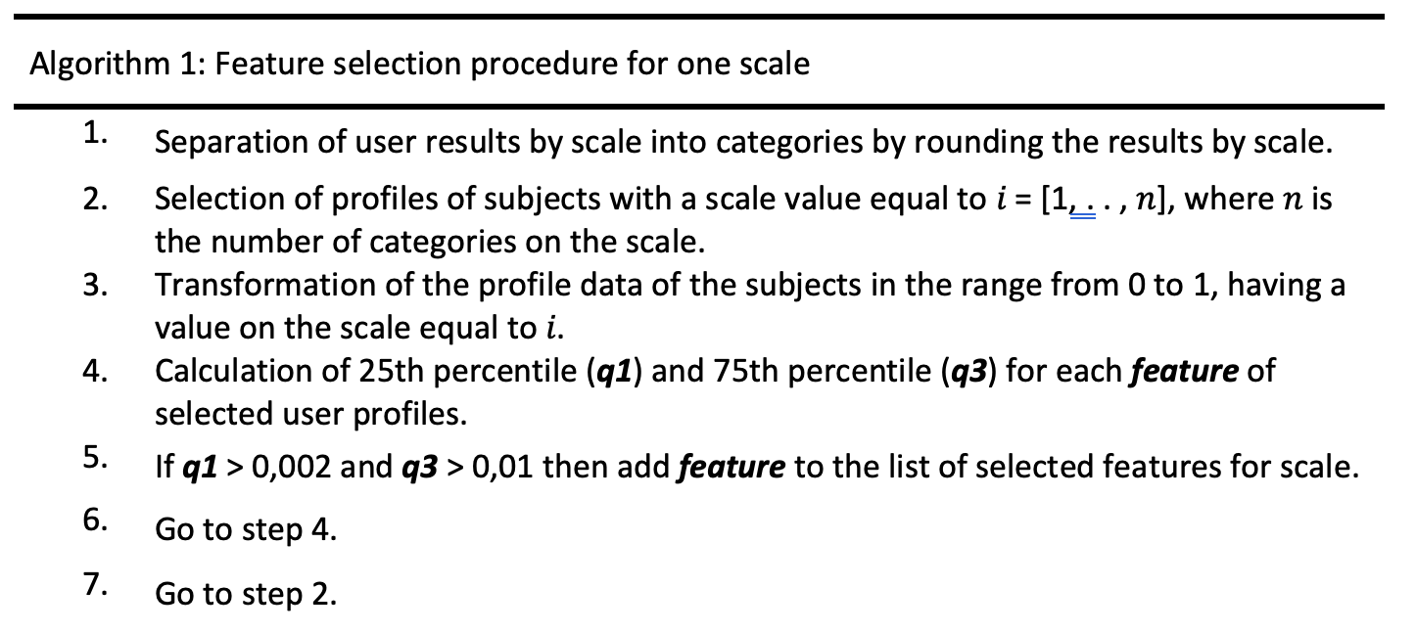

Algorithm S2: Data augmentation procedure for one scale
