Identification of microbial pathogens in Neolithic Scandinavian humans

Nora Bergfeldt*^{1,2,3}, Emrah Kırdök⁴, Nikolay Oskolkov⁵, Claudio Mirabello⁶, Per Unneberg⁷, Helena Malmström⁸, Magdalena Fraser⁸, Federico Sanchez-Quinto⁸, Roger Jorgensen⁹, Birgitte Skar¹⁰, Kerstin Lidén¹¹, Mattias Jakobsson⁸, Jan Storå¹¹, Anders Götherström^{1,11}

*Corresponding author

1. Centre for Palaeogenetics, Stockholm University, Stockholm, Sweden
2. Department of Zoology, Stockholm University, Stockholm, Sweden
3. Department of Bioinformatics and Genetics, Swedish Museum of Natural History, Stockholm, Sweden
4. Department of Biotechnology, Faculty of Science, Mersin University, Mersin Turkiye
5. Department of Biology, National Bioinformatics Infrastructure Sweden, Science for Life Laboratory, Lund University, Lund Sweden
6. Department of Physics, Chemistry and Biology, National Bioinformatics Infrastructure Sweden, Science for Life Laboratory, Linköping University, Linköping, Sweden
7. Department of Cell and Molecular Biology, National Bioinformatics Infrastructure Sweden, Science for Life Laboratory, Uppsala University, Uppsala, Sweden
8. Human Evolution, Department of Organism Biology, Uppsala University, Uppsala, Sweden
9. Tromsø University Museum, University of Tromsø-The Arctic University of Norway, Tromsø, Norway
10. Department of Archaeology and Cultural History, NTNU University Museum, Trondheim, Norway
11. Department of Archaeology and Classical Studies, Stockholm University, Stockholm, Sweden

Supplementary information

Table S1. Samples including age and reference to the source of DNA extraction. * Indicates reservoir corrected calibrated dates
Sample | Location | Context | Age cal. Years BP (2 sigma) | Source
hum1 | Hummervikholmen | SHG | 9471–9225 * | Gunther et al. 2018
hum2 | Hummervikholmen | SHG | 9732–9368 * | Gunther et al. 2018
sbj001 | Stora Bjers | SHG | 8963–8579* | Gunther et al. 2018
stg001 | Steigen | SHG | 5950–5764 * | Gunther et al. 2018
ans004 | Ansarve | LNF | 3793-3733 | Fraser et al. 2018
ans006 | Ansarve | FBC | 5040–4870 | Sanchez-Quinto et al. 2019
ans007 | Ansarve | FBC | 4960–4840 | Sanchez-Quinto et al. 2019
ans009 | Ansarve | FBC | 4830–4580 | Sanchez-Quinto et al. 2019
ans010 | Ansarve | LNF | 3638-3578 | Fraser et al. 2018
gok002 | Gökhem | FBC | 5050-4750 | Skoglund et al. 2012, 2014
gok004 | Gökhem | FBC | 4971-4871 | Skoglund et al. 2012, 2014
gok005 | Gökhem | FBC | 5050–4750 | Skoglund et al. 2012, 2014
ros003 | Rössberga | FBC | 5280–4880 | Malmström et al. 2019
ros004 | Rössberga | FBC | 5040–4870 | Malmström et al. 2019
ajv58 | Ajvide | PWC | 4900–4600 | Skoglund et al. 2014; Gunther et al. 2018
ajv82 | Ajvide | PWC | - | This study
ajv36 | Ajvide | PWC | 4961–4630 * | Coutinho et al., 2020
ajv49 | Ajvide | PWC | - | This study
ajv54 | Ajvide | PWC | 4850–4630 | Malmström et al. 2019
ajv70 | Ajvide | PWC | 4900–4600 | Skoglund et al. 2012, 2014; Gunther et al. 2018
ajv59 | Ajvide | PWC | 4900–4600 * | Coutinho et al., 2020
hem001 | Hemmor | PWC | 4961–4827 * | Coutinho et al., 2020
hem004 | Hemmor | PWC | 5257–4862 * | Coutinho et al., 2020
hem005 | Hemmor | PWC | 5289–4974 * | Coutinho et al., 2020
vbj001 | Västerbjers | PWC | 4812–4423 * | Coutinho et al., 2020
vbj002 | Västerbjers | PWC | 4832–4582 * | Coutinho et al., 2020
vbj004 | Västerbjers | PWC | 4825–4446 * | Coutinho et al., 2020
vbj006 | Västerbjers | PWC | 4870–4655 * | Coutinho et al., 2020
vbj007 | Västerbjers | PWC | 4499–4247 * | Coutinho et al., 2020
vbj008 | Västerbjers | PWC | 4814–4418 * | Coutinho et al., 2020
vbj012 | Västerbjers | PWC | 4961–4828 * | Coutinho et al., 2020
vbj013 | Västerbjers | PWC | 4833–4581 * | Coutinho et al., 2020
vbj014 | Västerbjers | PWC | 4849–4576 * | Coutinho et al., 2020
vbj017 | Västerbjers | PWC | 4867–4581 * | Coutinho et al., 2020
vbj018 | Västerbjers | PWC | 4860–4644 * | Coutinho et al., 2020
ber1 | Bergsgraven | BAC | 4570–4420 | Malmström et al. 2019
ber2 | Bergsgraven | BAC | 4590–4430 | Malmström et al. 2019
oll007 | Öllsjö | BAC | 4810–4450 | Malmström et al. 2019

Table S2. Species identified in the dataset

taxID | taxName
1006 | Marivirga tractuosa
1007105 | Pusillimonas sp. T7-7
101571 | Burkholderia ubonensis
1019 | Capnocytophaga sputigena
1033854 | Thioalkalivibrio sulfidiphilus
103733 | Saccharothrix syringae
103855 | Bordetella hinzii
104268 | Tenacibaculum mesophilum
104336 | Microbacterium foliorum
1049 | Allochromatium vinosum
105219 | Ralstonia mannitolilytica
1061 | Rhodobacter capsulatus
1063 | Rhodobacter sphaeroides
106590 | Cupriavidus necator
106592 | Ensifer adhaerens
1069 | Rhodomicrobium vannielii
1076 | Rhodopseudomonas palustris
1079 | Blastochloris viridis
10847 | Escherichia virus phiX174
1085 | Rhodospirillum rubrum
108981 | Acinetobacter schindleri
1090615 | Nakamurella panacisegetis
109328 | Leptotrichia trevisanii
1096868 | Pseudonocardia sp. EC080625-04
11 | Cellulomonas gilvus
1108 | Chloroflexus aurantiacus
1108595 | Chromobacterium vaccinii
110937 | Rathayibacter festucae
1109743 | Streptomyces sp. SCSIO 03032
111501 | Muricauda ruestringensis
114 | Gemmata obscuriglobus
1155739 | Moorea producens
1176649 | Agrobacterium fabrum
119219 | Cupriavidus metallidurans
1207504 | Burkholderia pseudomultivorans
1208324 | Celeribacter indicus
121719 | Pannonibacter phragmitetus
122355 | Pseudomonas psychrophila
1229727 | Thiobacimonas profunda
123899 | Bordetella trematum
1267768 | Brevirhabdus pacifica
1270 | Micrococcus luteus
1275 | Kocuria rosea
1280 | Staphylococcus aureus
1282 | Staphylococcus epidermidis
1283 | Staphylococcus haemolyticus
128780 | Stenotrophomonas acidaminiphila
1290 | Staphylococcus hominis
1291540 | Candidatus Methanomethylophilus alvus
129338 | Geobacillus subterraneus
1296 | Staphylococcus sciuri
1297742 | Myxococcus hansupus
1299 | Deinococcus radiodurans
129921 | Amycolatopsis keratiniphila
1302 | Streptococcus gordonii
1303 | Streptococcus oralis
1305 | Streptococcus sanguinis
1309 | Streptococcus mutans
1311 | Streptococcus agalactiae
1312183 | Rhizobium jaguaris
1313 | Streptococcus pneumoniae
1314 | Streptococcus pyogenes
131568 | Kineococcus radiotolerans
132132 | Desulfomicrobium orale
1328 | Streptococcus anginosus
1336 | Streptococcus equi
1338 | Streptococcus intermedius
1351 | Enterococcus faecalis
1354 | Enterococcus hirae
135487 | Nocardia cyriacigeorgica
1355015 | Streptomyces pluripotens
1355477 | Bradyrhizobium diazoefficiens
1358 | Lactococcus lactis
13690 | Sphingobium yanoikuyae
1379270 | Gemmatimonas phototrophica
1385591 | Burkholderia sp. BDU6
1385592 | Burkholderia sp. BDU8
1397 | Bacillus circulans
1398 | Bacillus coagulans
1404 | Bacillus megaterium
1404367 | Bradyrhizobium sp. 3(2017)
1405 | Bacillus mycoides
1406 | Paenibacillus polymyxa
1416803 | Bordetella genomosp. 9
1420917 | Marinobacter salarius
1421 | Lysinibacillus sphaericus
1423 | Bacillus subtilis
1427356 | Hyphomicrobium nitrativorans
1428 | Bacillus thuringiensis
143361 | Filifactor alocis
1437360 | Bradyrhizobium erythrophlei
146919 | Salinibacter ruber
147645 | Paracoccus yeei
1478 | Bacillus simplex
147802 | Lactobacillus iners
148447 | Paraburkholderia phymatum
1491 | Clostridium botulinum
1492 | Clostridium butyricum
1493872 | Chryseobacterium shandongense
1496 | Clostridioides difficile
1501 | Clostridium pasteurianum
1502 | Clostridium perfringens
1503054 | Burkholderia stagnalis
1504 | Clostridium septicum
1505 | Paeniclostridium sordellii
1513 | Clostridium tetani
1518022 | Siphovirus contig89
152297 | Pseudoalteromonas issachenkonii
152480 | Burkholderia ambifaria
152682 | Sphingomonas melonis
1534 | Clostridium kluyveri
153496 | Kozakia baliensis
1535768 | Streptomyces lunaelactis
153948 | Nitrosomonas sp. AL212
154 | Spirochaeta thermophila
1542 | Clostridium novyi
155077 | Cellvibrio japonicus
155892 | Caulobacter vibrioides
1561 | Clostridium baratii
1575 | Leifsonia xyli
157592 | Sterolibacterium denitrificans
157687 | Leptotrichia wadei
157782 | Pseudomonas parafulva
158 | Treponema denticola
1580596 | Phaeobacter piscinae
1583098 | Fusobacterium hwasookii
1584 | Lactobacillus delbrueckii
158836 | Enterobacter hormaechei
158899 | Collimonas fungivorans
160791 | Sphingomonas wittichii
160808 | Acidithiobacillus ferrivorans
1608628 | Candidatus Filomicrobium marinum
1613 | Lactobacillus fermentum
161493 | Anaeromyxobacter dehalogenans
162 | Treponema phagedenis
1620421 | Hoeflea sp. IMCC20628
1630135 | Dermabacter vaginalis
1637869 | Burkholderia sp. MSMB0856
1639 | Listeria monocytogenes
1641402 | Pseudonocardia sp. HH130629-09
164546 | Cupriavidus taiwanensis
1648 | Erysipelothrix rhusiopathiae
1655 | Actinomyces naeslundii
1656 | Actinomyces viscosus
1660 | Actinomyces odontolyticus
1661 | Trueperella pyogenes
1667 | Arthrobacter sp.
1673076 | Sphingobium hydrophobicum
167964 | Anaerolinea thermophila
1680 | Bifidobacterium adolescentis
1681 | Bifidobacterium bifidum
1683 | Bifidobacterium angulatum
168471 | Laribacter hongkongensis
1690815 | Pseudonocardia sp. HH130630-07
1694 | Bifidobacterium pseudolongum
169430 | Paraburkholderia hospita
1697053 | Oblitimonas alkaliphila
1703 | Brevibacterium linens
1705310 | Burkholderia sp. IDO3
1708 | Cellulomonas fimi
1710 | Cellulosimicrobium cellulans
1725 | Corynebacterium xerosis
173366 | Methylocystis rosea
173480 | Gemmatimonas aurantiaca
1735162 | Candidatus Peribacter riflensis
1744 | Propionibacterium freudenreichii
174633 | Candidatus Kuenenia stuttgartiensis
1747 | Cutibacterium acnes
1748 | Acidipropionibacterium acidipropionici
1749 | Acidipropionibacterium jensenii
1750 | Pseudopropionibacterium propionicum
1761016 | Paraburkholderia caffeinilytica
1764 | Mycobacterium avium
1767 | Mycobacterium intracellulare
1768 | Mycobacterium kansasii
1768108 | Deinococcus actinosclerus
1772 | Mycobacterium smegmatis
1788 | Mycobacterium terrae
1791 | Mycobacterium aurum
1792 | Mycobacterium chitae
1793 | Mycobacterium fallax
1795630 | Frondihabitans sp. PAMC 28766
179636 | Alicycliphilus denitrificans
180282 | Delftia tsuruhatensis
1804 | Mycobacterium gilvum
1804984 | Burkholderia sp. OLGA172
1814 | Amycolatopsis methanolica
181663 | Desulfococcus oleovorans
1823 | Nocardia otitidiscaviarum
1824 | Nocardia asteroides
182640 | Kribbella flavida
1828 | Rhodococcus fascians
1829 | Rhodococcus rhodochrous
1830 | Rhodococcus ruber
1833 | Rhodococcus erythropolis
1836 | Saccharopolyspora erythraea
184914 | Corallococcus coralloides
1852 | Saccharomonospora viridis
185642 | Mycobacterium parmense
1858609 | Acidovorax sp. T1
1859 | Frankia alni
1867 | Actinoplanes teichomyceticus
1867719 | Phyllobacterium sp. Tri-48
1869227 | bacterium
187137 | Oceanithermus profundus
187493 | Thalassolituus oleivorans
1877 | Micromonospora echinospora
1882682 | Microvirga ossetica
1884913 | Candidatus Planktophila lacus
1884914 | Candidatus Planktophila dulcis
1888 | Streptomyces albus
1889 | Streptomyces ambofaciens
1893 | Streptomyces atratus
189426 | Paenibacillus odorifer
1901 | Streptomyces clavuligerus
1907 | Streptomyces glaucescens
190721 | Ralstonia insidiosa
1908 | Streptomyces globisporus
1911 | Streptomyces griseus
1912 | Streptomyces hygroscopicus
1914 | Streptomyces lavendulae
191495 | Conexibacter woesei
1915 | Streptomyces lincolnensis
192 | Azospirillum brasilense
1927 | Streptomyces rimosus
192812 | Erythrobacter flavus
1931 | Streptomyces sp.
1933880 | Glutamicibacter halophytocola
194963 | Sinorhizobium americanum
1967 | Streptomyces kanamyceticus
196914 | Actinoplanes friuliensis
1984801 | Streptomyces sp. CLI2509
198618 | Pseudomonas umsongensis
198620 | Pseudomonas koreensis
199 | Campylobacter concisus
200 | Campylobacter curvus
2001 | Streptosporangium roseum
200451 | Pseudomonas poae
2006 | Thermobispora bispora
2014 | Nocardiopsis dassonvillei
2014542 | Alcanivorax sp. N3-2A
2026 | Thermoactinomyces vulgaris
2026199 | Paraburkholderia aromaticivorans
203 | Campylobacter rectus
204 | Campylobacter showae
2041 | Aeromicrobium erythreum
2047 | Rothia dentocariosa
2054 | Gordonia bronchialis
2055 | Gordonia terrae
2061 | Tsukamurella paurometabola
2066070 | Mesorhizobium japonicum
2074 | Pseudonocardia autotrophica
208223 | Kosakonia cowanii
210 | Helicobacter pylori
216778 | Stenotrophomonas rhizophila
216816 | Bifidobacterium longum
217203 | Achromobacter spanius
217204 | Achromobacter insolitus
2173 | Methanobrevibacter smithii
221822 | Phaeobacter inhibens
222805 | Mycobacterium chimaera
223967 | Methylobacterium populi
227 | Pseudoalteromonas carrageenovora
232537 | Candidatus Rhodoluna limnophila
237609 | Pseudomonas alkylphenolica
237610 | Pseudomonas psychrotolerans
239935 | Akkermansia muciniphila
240495 | Pseudonocardia dioxanivorans
2434 | Roseobacter denitrificans
244566 | Pseudomonas lurida
246432 | Staphylococcus equorum
252307 | Robiginitalea biformata
253 | Chryseobacterium indologenes
256618 | Parvibaculum lavamentivorans
265293 | [Pseudomonas] mesoacidophila
265959 | Komagataeibacter saccharivorans
266 | Paracoccus denitrificans
267128 | Sphingopyxis granuli
2702 | Gardnerella vaginalis
273384 | Brevibacterium aurantiacum
274 | Thermus thermophilus
2743 | Marinobacter hydrocarbonoclasticus
2751 | Carnobacterium maltaromaticum
279058 | Collimonas arenae
279113 | Collimonas pratensis
28025 | Bifidobacterium animalis
28049 | Acidothermus cellulolyticus
28068 | Rubrivivax gelatinosus
28087 | Legionella sainthelensi
28095 | Burkholderia gladioli
28109 | Pseudoalteromonas nigrifaciens
28112 | Tannerella forsythia
28116 | Bacteroides ovatus
28131 | Prevotella intermedia
28132 | Prevotella melaninogenica
28197 | Arcobacter butzleri
28198 | Arcobacter cryaerophilus
283811 | Stackebrandtia nassauensis
28447 | Clavibacter michiganensis
28448 | Komagataeibacter xylinus
28450 | Burkholderia pseudomallei
285 | Comamonas testosteroni
287 | Pseudomonas aeruginosa
288000 | Bradyrhizobium sp. BTAi1
28901 | Salmonella enterica
292 | Burkholderia cepacia
292800 | Flavonifractor plautii
293 | Brevundimonas diminuta
29385 | Staphylococcus saprophyticus
29391 | Gemella morbillorum
294 | Pseudomonas fluorescens
29447 | Xanthomonas albilineans
29449 | Rhizobium etli
29466 | Veillonella parvula
29542 | Pelobacter acetylenicus
29549 | Rhodothermus marinus
29570 | Halomonas meridiana
296 | Pseudomonas fragi
296587 | Micromonas commoda
300 | Pseudomonas mendocina
301 | Pseudomonas oleovorans
303 | Pseudomonas putida
304895 | Catenulispora acidiphila
305 | Ralstonia solanacearum
3055 | Chlamydomonas reinhardtii
3075 | Auxenochlorella protothecoides
312306 | Pseudomonas entomophila
313588 | Croceibacter atlanticus
313603 | Maribacter sp. HTCC2170
314722 | Pseudoxanthomonas suwonensis
315405 | Streptococcus gallolyticus
316 | Pseudomonas stutzeri
317 | Pseudomonas syringae
31958 | Amycolatopsis orientalis
32002 | Achromobacter denitrificans
321846 | Pseudomonas simiae
329 | Ralstonia pickettii
33010 | Cutibacterium avidum
330214 | Nitrospira defluvii
33033 | Parvimonas micra
33050 | Sphingopyxis macrogoltabida
33059 | Acidithiobacillus caldus
330922 | Psychrobacter cryohalolentis
332163 | Candidatus Solibacter usitatus
334542 | Rhodococcus qingshengii
337 | Burkholderia glumae
339 | Xanthomonas campestris
33903 | Streptomyces avermitilis
33910 | Amycolatopsis mediterranei
34 | Myxococcus xanthus
34018 | Rhodospirillum centenum
34029 | Leptothrix cholodnii
34062 | Moraxella osloensis
34073 | Variovorax paradoxus
34085 | Riemerella anatipestifer
34105 | Streptobacillus moniliformis
342113 | Burkholderia oklahomensis
343 | Xanthomonas translucens
346 | Xanthomonas citri
347 | Xanthomonas oryzae
348824 | Rhizobium favelukesii
35 | Myxococcus macrosporus
353 | Azotobacter chroococcum
354 | Azotobacter vinelandii
35554 | Geobacter sulfurreducens
357276 | Bacteroides dorei
35762 | Planobispora rosea
358 | Agrobacterium tumefaciens
35806 | Rhodovulum sulfidophilum
35814 | Bordetella holmesii
358220 | Acidovorax sp. KKS102
364029 | Comamonas sp. E6
364317 | Verminephrobacter eiseniae
364410 | Granulibacter bethesdensis
36809 | Mycobacterium abscessus
36861 | Thiobacillus denitrificans
37326 | Nocardia brasiliensis
37329 | Nocardia farcinica
37330 | Nocardia nova
37332 | Nocardia seriolae
374606 | Aminobacter sp. MSH1
374840 | Enterobacteria phage phiX174 sensu lato
375 | Bradyrhizobium japonicum
376 | Bradyrhizobium sp.
379067 | Streptomyces bingchenggensis
37919 | Rhodococcus opacus
379347 | Ruegeria mobilis
380 | Sinorhizobium fredii
380021 | Pseudomonas protegens
381 | Mesorhizobium loti
382 | Sinorhizobium meliloti
38289 | Corynebacterium jeikeium
38300 | Streptomyces pristinaespiralis
384 | Rhizobium leguminosarum
388357 | Kocuria turfanensis
39478 | Streptomyces laurentii
396 | Rhizobium phaseoli
39645 | Mesorhizobium ciceri
399 | Neorhizobium galegae
40137 | Oligotropha carboxidovorans
40214 | Acinetobacter johnsonii
40216 | Acinetobacter radioresistens
40269 | Aliivibrio salmonicida
40318 | Streptomyces nodosus
40324 | Stenotrophomonas maltophilia
40559 | Botrytis cinerea
408 | Methylobacterium extorquens
41 | Stigmatella aurantiaca
412690 | Microterricola viridarii
412963 | Paraburkholderia rhizoxinica
41899 | Burkholderia plantarii
41977 | Azoarcus communis
42197 | Actinosynnema pretiosum
42253 | Nitrospira moscoviensis
42256 | Rubrobacter radiotolerans
43348 | Mycobacterium branderi
434010 | Hydrogenophaga sp. PBL-H3
435897 | Lysobacter capsici
43675 | Rothia mucilaginosa
43767 | Rhodococcus hoagii
43768 | Corynebacterium matruchotii
43771 | Corynebacterium urealyticum
44008 | Enterococcus cecorum
44056 | Aureococcus anophagefferens
442 | Gluconobacter oxydans
445709 | Pandoraea thiooxydans
44577 | Nitrosomonas ureae
446 | Legionella pneumophila
450378 | Croceicoccus marinus
45243 | Capnocytophaga haemolytica
45398 | Streptomyces griseoviridis
455432 | Nocardia terpenica
45617 | Human endogenous retrovirus K
45634 | Streptococcus cristatus
458033 | Chloracidobacterium thermophilum
459526 | Flavobacterium anhuiense
45972 | Staphylococcus pasteuri
463025 | Bordetella bronchialis
466153 | Singulisphaera acidiphila
46679 | Pseudomonas mucidolens
470 | Acinetobacter baumannii
470934 | Pantoea vagans
471827 | Candidatus Desulforudis audaxviator
47421 | Hydrogenophaga pseudoflava
47671 | Lautropia mirabilis
47763 | Streptomyces lydicus
477641 | Modestobacter marinus
47850 | Micromonospora aurantiaca
47878 | Pseudomonas azotoformans
47879 | Pseudomonas corrugata
47880 | Pseudomonas fulva
47883 | Pseudomonas synxantha
47884 | Pseudomonas taetrolens
47885 | Pseudomonas oryzihabitans
47917 | Serratia fonticola
482957 | Burkholderia lata
48466 | Prosthecobacter vanneervenii
485 | Neisseria gonorrhoeae
486 | Neisseria lactamica
48664 | Xanthomonas fragariae
486698 | Mycobacterium riyadhense
487 | Neisseria meningitidis
4876 | Rhizophagus intraradices
488 | Neisseria mucosa
488447 | Burkholderia contaminans
488731 | Burkholderia seminalis
488732 | Burkholderia diffusa
49319 | Rubrobacter xylanophilus
495 | Neisseria elongata
4952 | Yarrowia lipolytica
496014 | Rubrobacterineae bacterium BR7-21
497727 | Candidatus Nitrososphaera gargensis
5059 | Aspergillus flavus
511 | Alcaligenes faecalis
51123 | [Eubacterium] saphenum
5127 | Fusarium fujikuroi
515393 | Pseudomonas yamanorum
518 | Bordetella bronchiseptica
521 | Bordetella avium
52584 | Brachyspira pilosicoli
52773 | Actinomyces meyeri
529 | Ochrobactrum anthropi
531813 | Pelagibacterium halotolerans
53358 | Intrasporangium calvum
53399 | Hyphomicrobium denitrificans
53408 | Pseudomonas citronellolis
53409 | Pseudomonas coronafaciens
536 | Chromobacterium violaceum
53635 | Acidimicrobium ferrooxidans
536441 | Chryseobacterium taklimakanense
539 | Eikenella corrodens
544580 | Actinomyces oris
54571 | Streptomyces venezuelae
546160 | Dietzia lutea
548 | Klebsiella aerogenes
549 | Pantoea agglomerans
550 | Enterobacter cloacae
5507 | Fusarium oxysporum
553 | Pantoea ananatis
553814 | Acidovorax sp. NA3
55518 | Magnetospirillum gryphiswaldense
55601 | Vibrio anguillarum
56 | Sorangium cellulosum
562 | Escherichia coli
56448 | Xanthomonas arboricola
56459 | Xanthomonas vasicola
56460 | Xanthomonas vesicatoria
56646 | Fusarium venenatum
56730 | Rhizobium gallicum
570505 | Methylobacterium bullatum
571913 | Luteipulveratus mongoliensis
573 | Klebsiella pneumoniae
575 | Raoultella planticola
5755 | Acanthamoeba castellanii
576610 | Polynucleobacter necessarius
576611 | Polynucleobacter asymbioticus
57704 | Tsukamurella tyrosinosolvens
57706 | Citrobacter braakii
5778 | Vermamoeba vermiformis
57975 | Burkholderia thailandensis
582 | Morganella morganii
584 | Proteus mirabilis
584609 | Tenacibaculum jejuense
585 | Proteus vulgaris
5866 | Babesia bigemina
587753 | Pseudomonas chlororaphis
588596 | Rhizophagus irregularis
588932 | Brevundimonas naejangsanensis
60550 | Burkholderia pyrrocinia
60552 | Burkholderia vietnamiensis
60890 | Phaeobacter gallaeciensis
60920 | Sanguibacter keddieii
615 | Serratia marcescens
61624 | Paenibacillus mucilaginosus
61647 | Pluralibacter gergoviae
61648 | Kluyvera intermedia
62322 | Shewanella baltica
630 | Yersinia enterocolitica
63186 | Zobellia galactanivorans
632 | Yersinia pestis
633 | Yersinia pseudotuberculosis
640511 | Burkholderia sp. CCGE1002
64104 | Bacillus pseudomycoides
644 | Aeromonas hydrophila
645 | Aeromonas salmonicida
649831 | Actinoplanes sp. N902-109
651 | Aeromonas media
652 | Aeromonas schubertii
654 | Aeromonas veronii
65555 | Desulfocapsa sulfexigens
65741 | Pseudomonas knackmussii
666 | Vibrio cholerae
666685 | Rhodanobacter denitrificans
671143 | Candidatus Methylomirabilis oxyfera
67267 | Streptomyces alboflavus
67304 | Streptomyces griseorubiginosus
673372 | Vibrio casei
673862 | Candidatus Babela massiliensis
68203 | Streptomyces fungicidicus
68214 | Streptomyces griseochromogenes
68270 | Streptomyces spectabilis
68570 | Streptomyces albulus
68895 | Cupriavidus basilensis
69 | Lysobacter enzymogenes
69218 | Enterobacter cancerogenus
69966 | Macrococcus caseolyticus
701042 | Mycobacterium marseillense
702115 | Pseudomonas arsenicoxydans
703222 | Kibdelosporangium sp. MJ126-NF4
712270 | Dietzia sp. oral taxon 368
712710 | Tannerella sp. oral taxon HOT-286
714 | Aggregatibacter actinomycetemcomitans
717785 | Hyphomicrobium sp. MC1
722731 | Mycobacterium shigaense
727 | Haemophilus influenzae
729 | Haemophilus parainfluenzae
731 | Histophilus somni
732 | Aggregatibacter aphrophilus
74426 | Collinsella aerofaciens
74829 | Pseudomonas balearica
75105 | Paraburkholderia caribensis
754476 | Methylophaga nitratireducenticrescens
75612 | Pseudomonas mandelii
756892 | Acinetobacter indicus
75697 | Castellaniella defragrans
758782 | Burkholderia sp. THE68
758793 | Burkholderia sp. RPE64
758796 | Burkholderia sp. RPE67
758826 | Acidovorax radicis
76021 | Amycolatopsis coloradensis
76124 | [Eubacterium] minutum
76594 | Cellulophaga baltica
76758 | Pseudomonas orientalis
76759 | Pseudomonas monteilii
76761 | Pseudomonas veronii
76775 | Malassezia restricta
76853 | Solibacillus silvestris
78331 | Mycobacterium canettii
78587 | Asticcacaulis excentricus
79329 | Chitinophaga pinensis
80816 | Haliangium ochraceum
80842 | Herbaspirillum rubrisubalbicans
80866 | Delftia acidovorans
80869 | Acidovorax citrulli
81028 | Treponema brennaborense
81462 | Thermanaerovibrio acidaminovorans
817 | Bacteroides fragilis
821 | Bacteroides vulgatus
824 | Campylobacter gracilis
82633 | Cupriavidus pauculus
82654 | Pseudanabaena sp. PCC 7367
82996 | Serratia plymuthica
83262 | Mycobacterium immunogenum
83291 | Streptomyces armeniacus
83564 | Desulfosarcina ovata
83656 | Streptomyces tsukubensis
837 | Porphyromonas gingivalis
83791 | Ulva flexuosa
84110 | Slackia heliotrinireducens
84112 | Eggerthella lenta
84531 | Lysobacter antibioticus
851 | Fusobacterium nucleatum
853 | Faecalibacterium prausnitzii
85698 | Achromobacter xylosoxidans
859 | Fusobacterium necrophorum
861299 | Gemmatirosa kalamazoonesis
86265 | Pseudomonas thivervalensis
86664 | Bacillus flexus
87883 | Burkholderia multivorans
879274 | Shinella sp. HZN7
881 | Desulfovibrio vulgaris
881260 | Enterobacter bugandensis
88688 | Caulobacter segnis
897 | Desulfococcus multivorans
9 | Buchnera aphidicola
92945 | Ketogulonicigenium vulgare
930166 | Pseudomonas brassicacearum
931 | Thiobacillus thioparus
93218 | Pandoraea apista
93220 | Pandoraea pnomenusa
93222 | Pandoraea sputorum
93944 | Nonomuraea gerenzanensis
94132 | Ramlibacter tataouinensis
94624 | Bordetella petrii
946333 | Rhizobacter gummiphilus
947919 | Desulfosarcina widdelii
95485 | Burkholderia stabilis
95486 | Burkholderia cenocepacia
960 | Bacteriovorax stolpii
9606 | Homo sapiens
96344 | Cupriavidus oxalaticus
96345 | Flavobacterium psychrophilum
964 | Herbaspirillum seropedicae
979 | Cellulophaga lytica
980427 | Deinococcus wulumuqiensis
985 | Cytophaga hutchinsonii
986 | Flavobacterium johnsoniae
996 | Flavobacterium columnare
996801 | Polaribacter reichenbachii
99802 | Spirometra erinaceieuropaei

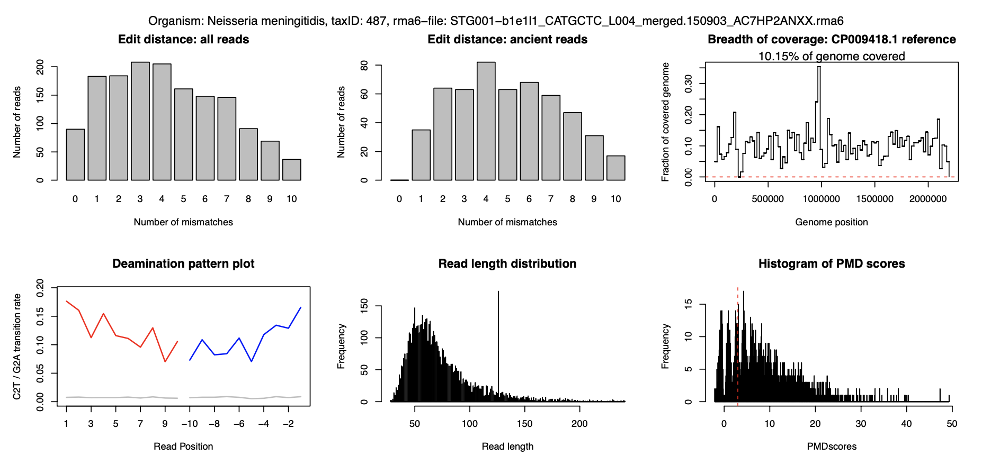
Figure S1. Edit distance, breadth of coverage, deamination plot, read length distribution of Neisseria meningitidis in individual stg001

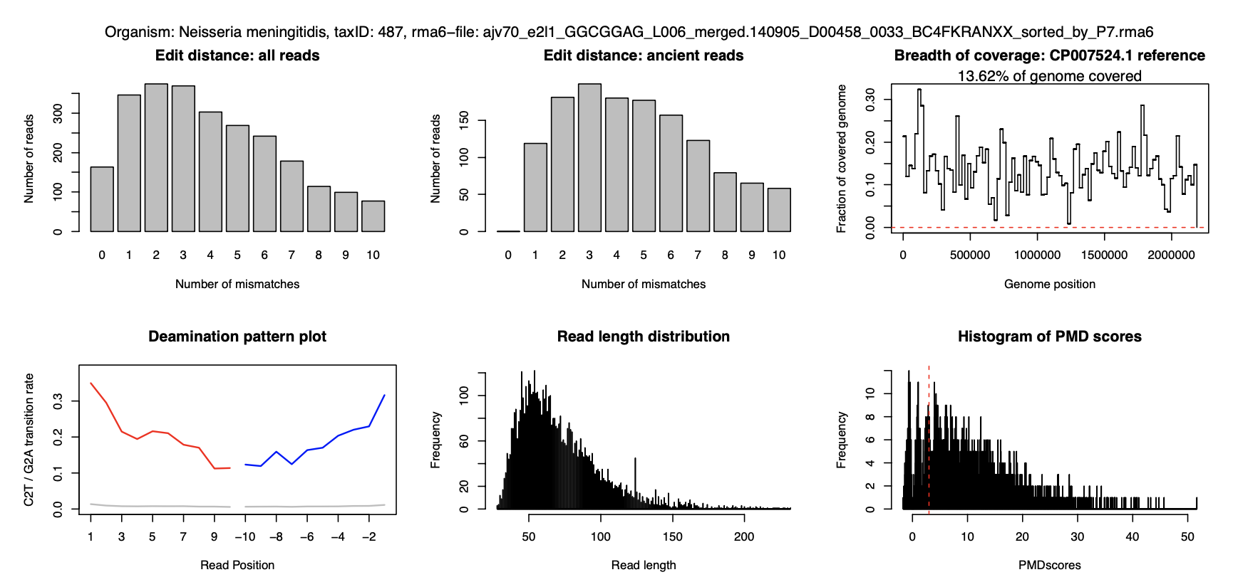
Figure S2. Edit distance, breadth of coverage, deamination plot, read length distribution of Neisseria meningitidis in individual ajv70

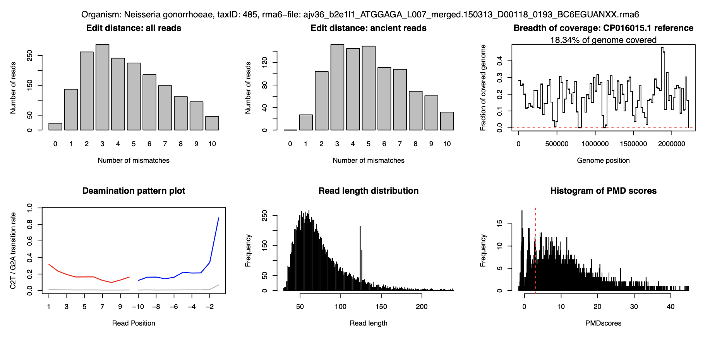
Figure S3. Edit distance, breadth of coverage, deamination plot, read length distribution of Neisseria gonorrhoeae in individual ajv36

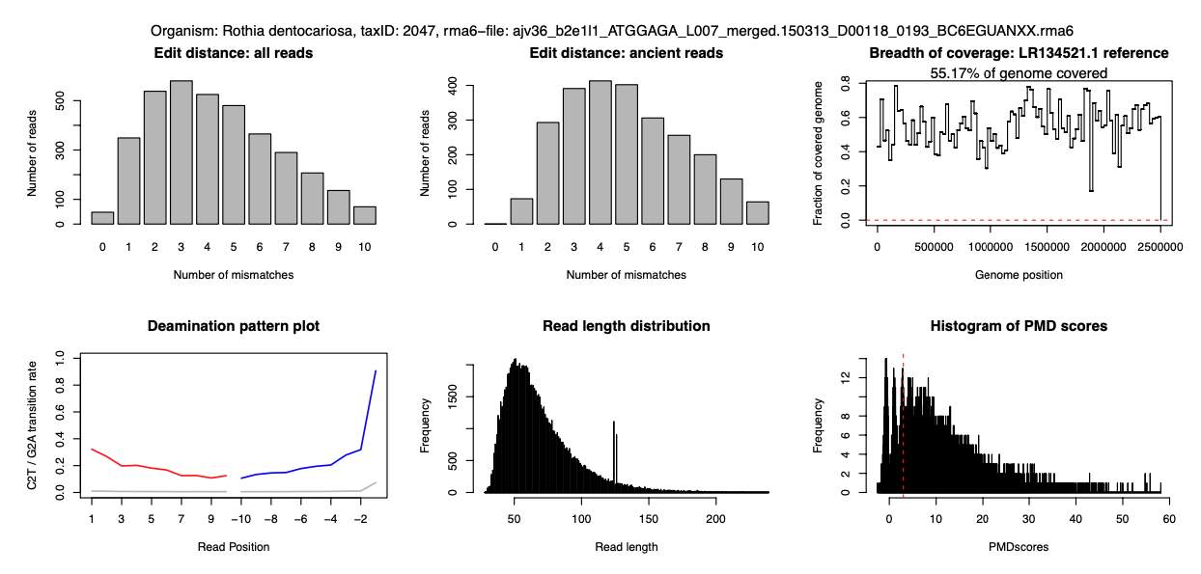
Figure S4. Edit distance, breadth of coverage, deamination plot, read length distribution of Rothia dentocariosa in individual ajv36

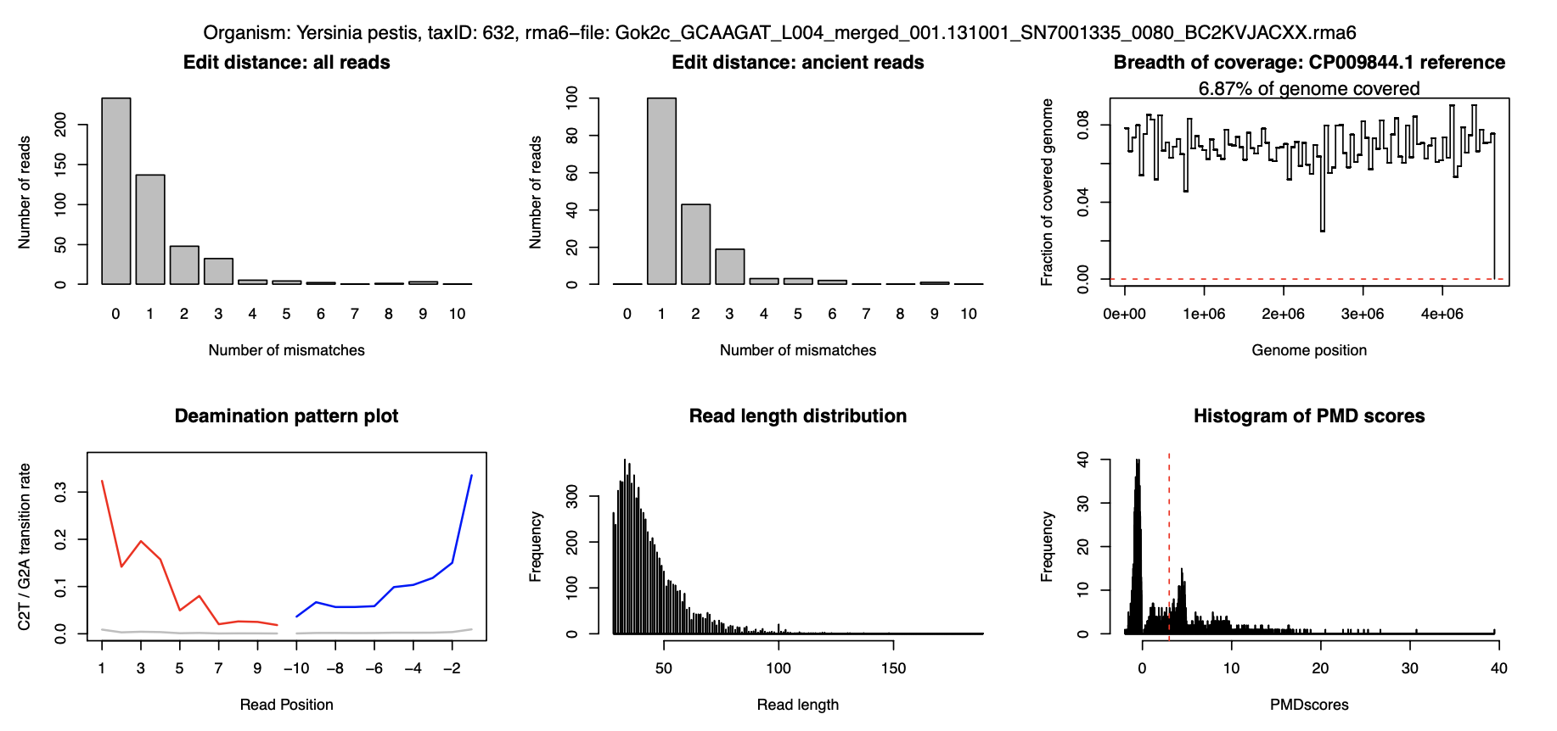
Figure S5. Edit distance, breadth of coverage, deamination plot, read length distribution of Yersinia pestis in individual gok2

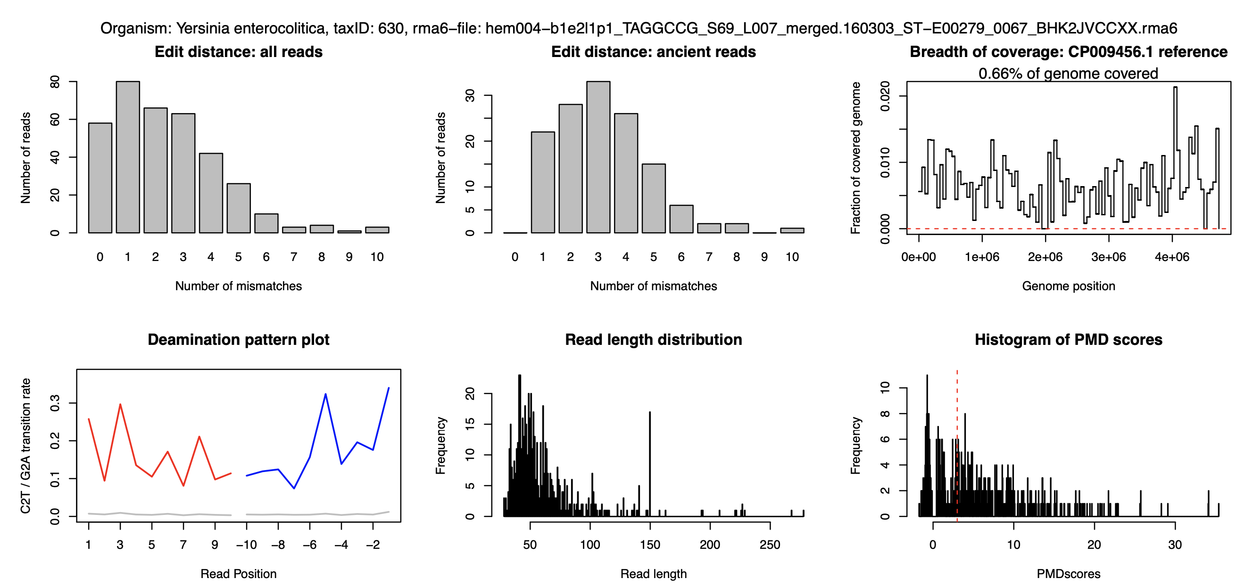

Figure S6. Edit distance, breadth of coverage, deamination plot, read length distribution of Yersinia enterocolitica in individual hem004

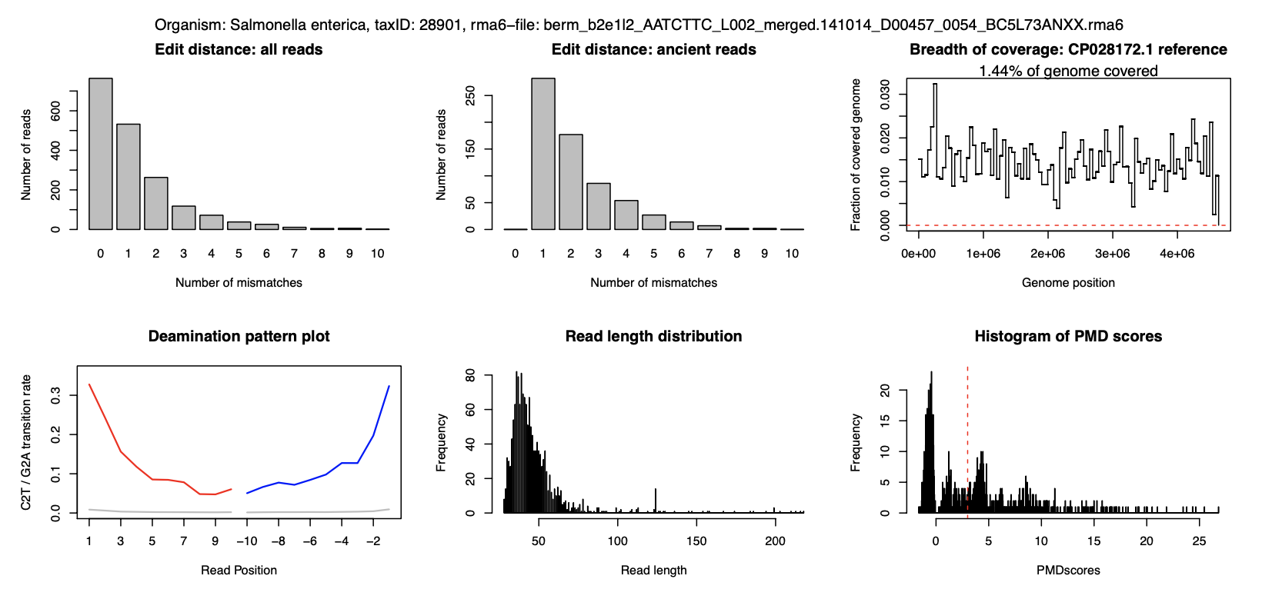
Figure S7. Edit distance, breadth of coverage, deamination plot, read length distribution of Salmonella enterica in individual ber1

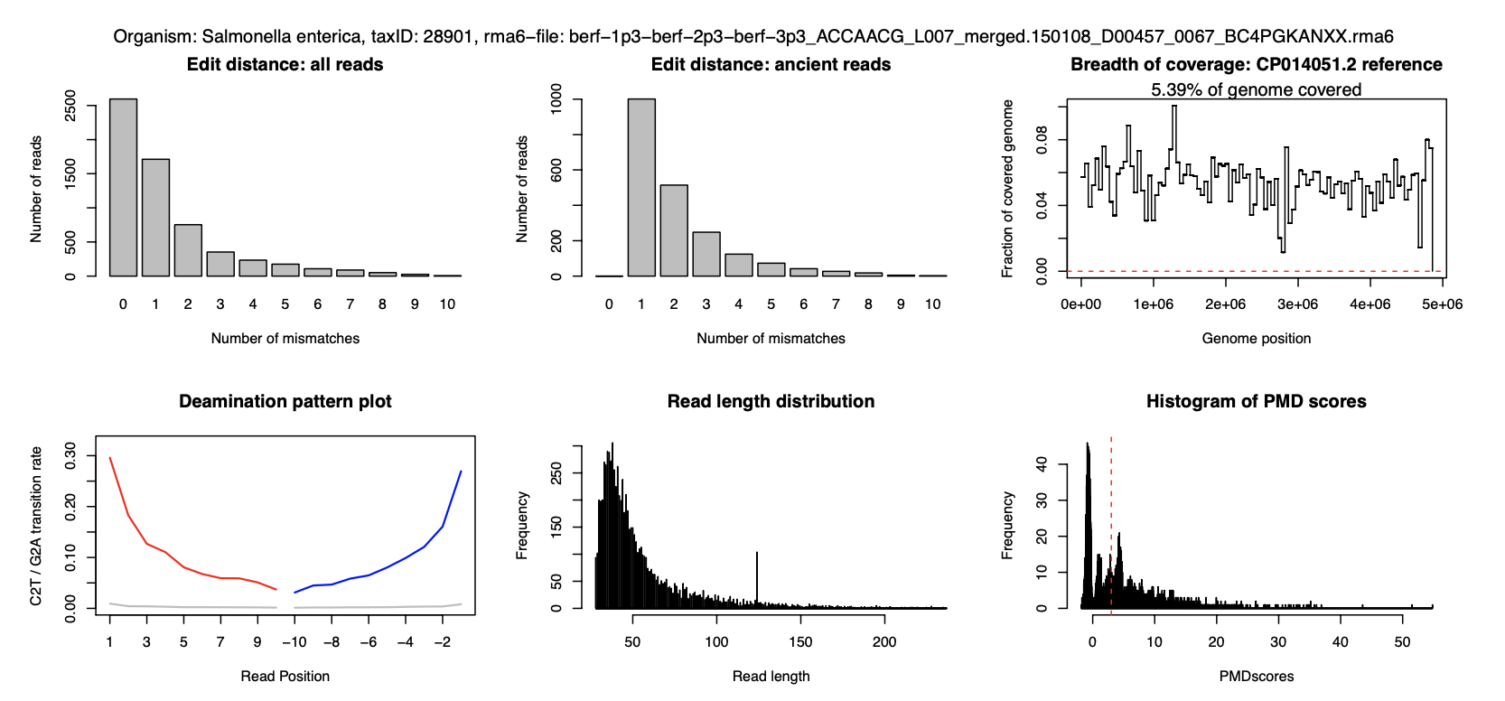
Figure S8. Edit distance, breadth of coverage, deamination plot, read length distribution of Salmonella enterica in individual Ber2

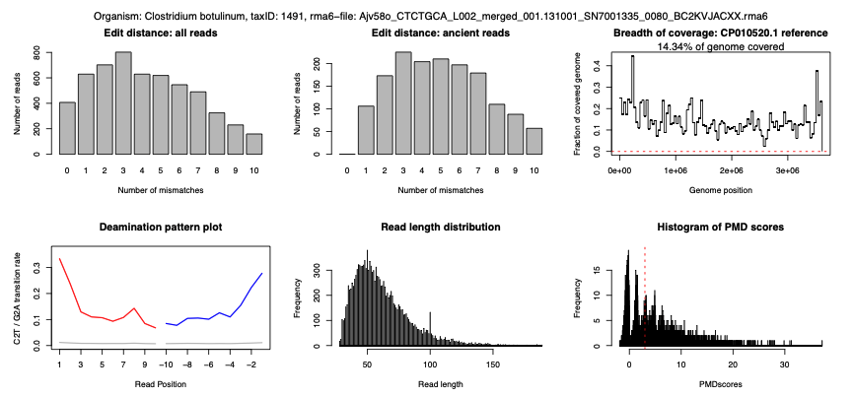
Figure S9. Edit distance, breadth of coverage, deamination plot, read length distribution of Clostridium botulinum in individual ajv58

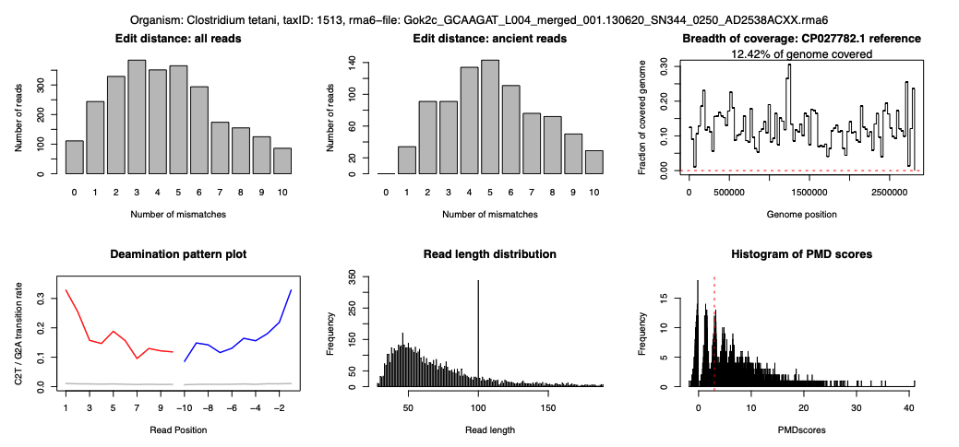
Figure S10. Edit distance, breadth of coverage, deamination plot, read length distribution of Clostridium tetani in individual gok2

