Supplementary Materials for
The effect of information provision on parental intention toward COVID-19 vaccination for children:
A nationwide survey experiment

- Data and random assignment of schools
The data of elementary schools in the Republic of Korea was obtained from Open Government Data Portal (https://www.data.go.kr/data/15049381/fileData.do) in which various data held by the government are opened in accordance with the Act on Promotion of the Provision and Use of Public Data (Open Government Data Act).

It contains information on 6,323 elementary schools in Korea, and the number and ratio of elementary schools belonging to each regional office of education are shown in the table below.
Region | Freq. | Percent (%)
Seoul | 604 | 9.55
Busan | 304 | 4.81
Daegu | 232 | 3.67
Incheon | 270 | 4.27
Gwangju | 154 | 2.44
Daejeon | 150 | 2.37
Ulsan | 122 | 1.93
Sejong | 51 | 0.81
Gyeonggi | 1,338 | 21.16
Gangwon | 374 | 5.91
Chungcheongbuk-do | 268 | 4.24
Chungcheongnam-do | 422 | 6.67
Jeollabuk-do | 422 | 6.67
Jeollanam-do | 462 | 7.31
Gyeongsangbuk-do | 507 | 8.02
Gyeongsangnam-do | 524 | 8.29
Jeju | 119 | 1.88
Total | 6,323 | 100

The data includes information about longitude, latitude, address of each elementary school, city and provincial office of education code, education support office code, and establishment date. For school-level random assignment, we used the information of latitude and longitude of school location after applying stratification using the Office of Education support code.
The following maps in Figure 1S show the results of random assignment in Seoul and in the entire area of South Korea. Group 1 represents the DI (Disease Informed) group, Group 2 the VI (Vaccine Profile Informed) group, and Group 3 the Control group.
Figure 1S. Maps of random assignment in Seoul (A) and in the entire area of South Korea (B)
- Random assignment in Seoul
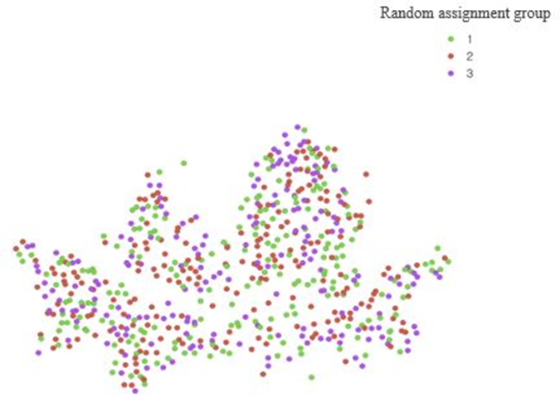

- Random assignment in Korea
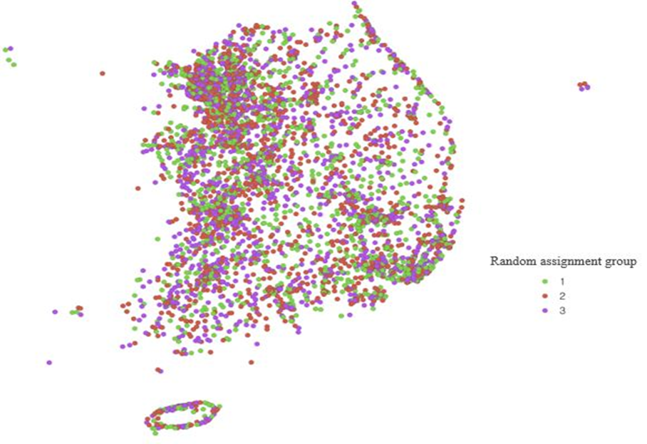

Table 1S reports the balance check of school assignment across the three groups using the information of latitude and longitude of school location. School assignment was well balanced because there is no significant difference in these location variables.

Table 1S. Balance checks using latitude and longitude information
Variables | DI group | VI group | Control group
Variables | Group 1  (Std.errors) | Group 2  (Std.errors) | Group 3  (Std.errors) | F-value  (p-value)
Latitude | 36.44 | 36.41 | 36.45 | 0.849
Latitude | (0.0371) | (0.0985) | (0.0319) | (0.429)
Longitude | 127.52 | 127.5 | 127.51 | 0.411
Longitude | (0.0290) | (0.0784) | (0.0285) | (0.664)

- Sample Survey Questionnaire in the Vaccine profile informed group (VI group)

This survey questionnaire is an English translation version of the questionnaire provided to the VI group. The control group and the DI group used the same questionnaire except for the figural information presented between Q11 and Q12 as information intervention. The links for original Korean version of the survey questionnaires are provided at the end of the sample survey questionnaire.
.
1. How many children do you have in total?
1) 1 child 2) 2 children 3) 3 children 4) 4 or more children
<If you have more than two children, please think of one child in elementary school 1st to 6th, and answer all the questions below.>
2. Please select your child's birth year.
1) 2015 2) 2014 3) 2013 4) 2012 5) 2011 6) 2010 7) 2009 8) others
3. What grade will your child enter in March this year?
1) Grade1 2) Grade2 3) Grade3 4) Grade4 5) Grade5 6) Grade6
4. What is your child's gender?
1) Female 2) Male
5. In which of the following areas is your child's school?
1) Seoul 2) Busan 3) Daegu 4) Incheon 5) Gwangju 6) Daejeon 7) Ulsan
8) Sejong 9) Gyeonggi 10) Gangwon 11) Chungcheongbuk-do
12) Chungcheongnam-do 13) Jeollabuk-do 14) Jeollanam-do
15) Gyeongsangbuk-do 16) Gyeongsangnam-do 17) Jeju
6. How is your child’s health?
1) Very good
2) Good
3) Normal
4) Not good
5) Very bad
7. Has your child been vaccinated over the past five years? (e.g., measles/spectrum/fungus (MMR), diphtheria/tide/whitening (DTP), Japanese encephalitis, flu, etc.)
1) Yes 2) No 3) I do not know/ I do not remember
8. Which of the following is the case for you(parents) regarding COVID-19 vaccination?
1) I’ve completed the 3rd vaccination.
2) I’ve completed the 2nd vaccination.
3) I’ve completed the 1st vaccination.
4) I’m not vaccinated.
9. How likely do you think your child may get COVID-19?
1) Extremely unlikely
2) Somewhat unlikely
3) Neutral
4) Somewhat likely
5) Extremely likely
10. If your child gets COVID-19, how likely do you think that its effects are serious on his/her health?
1) Not serious or severe at all
2) Not serious or severe
3) Neutral
4) Somewhat serious or severe
5) Extremely serious or severe
11. Which of the following is close to the degree of confidence that you have the information you need for your children's COVID-19 vaccination?
1) Not sure at all
2) Pretty sure
3) Sure it’s in the middle
4) Sure
5) Very sure

< The following are data on COVID-19 infection and vaccines in children and adolescents in Korea. Please take the time to review this material before moving to the next questions.>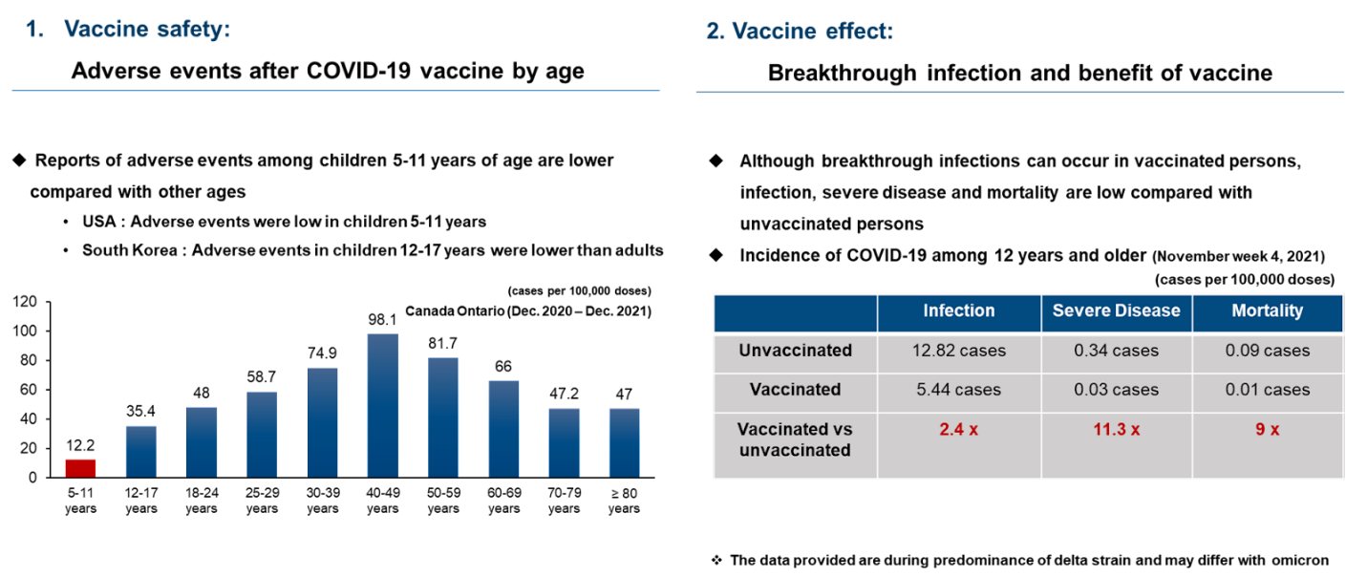
12. Which of the following is your intention for your children’s COVID-19 vaccination?
1) Willing to get vaccinated as soon as possible.
2) Willing to get vaccinated, but I want to see.
3) Don’t want to get vaccinated, but I want to see.
4) Not willing to get vaccinated and I’m not going to vaccinate my child.
5) Don’t know/ Not sure.
13. Which of the following is close to your thoughts on the safety of COVID-19 vaccines?
1) Very not safe
2) Not safe
3) Safe
4) Very safe
5) I do not know
14. What do you think about the effectiveness of the COVID-19 vaccine to prevent infection and prevent severe deaths?
1) Not effective at all
2) Not effective
3) Effective
4) Very effective
5) I do not know
15. If you were to compare the benefits and risks of getting a COVID-19
vaccine for your child's health or daily life, which of the following do you think is closer?
1) Risk is much greater than the benefit
2) Risk is greater than the benefit
3) Risks and benefits are half and half
4) Benefits are greater than the risks
5) Benefits are much greater than the risks
6) I do not know
16. If you compare the risk of COVID-19 infection with the risk of getting vaccinated for the health and daily life of children aged 5-11, which of the following do you think is closer?
1) For children of this age, the risk of COVID-19 infection is much greater than the risk of vaccination.
2) For children of this age, the risk of COVID-19 infection is greater than the risk of vaccination
3) The risk of COVID-19 infection in children of this age is the same as the risk of being vaccinated.
4) For children of this age, the risk of vaccination is greater than the risk of COVID-19 infection
5) For children of this age, the risk of vaccination is much greater than the risk of COVID-19 infection
6) I do not know
17. If you recommend your child to be vaccinated, choose the two most important reasons.
1) To prevent my child from being infected and to prevent serious infections and complications caused by infection
2) To prevent my child from spreading the infection to family or people around him/her.
3) To let my child get back to his/her pre-COVID-19 life by getting vaccinated
4) In order for our society to recover daily life such as economic recovery
5) To avoid the inconvenience of quarantine activities (body temperature measurement, meal partition, mask use, etc.)
6) Not applicable
18. If you do not recommend your child to be vaccinated, choose the two most important reasons.
1) Don't want to give my child an injection
2) To avoid my child experiencing adverse reactions or side effects after vaccination
3) To avoid disturbing my child's daily life and study, concerning about vaccination
4) don't think my child will get infected even if he/she doesn't get vaccinated.
5) The quarantine activities (body temperature measurement, meal partition, mask use, etc.) are enough, so don't want my child to get vaccinated.
6) Not applicable
19. Which of the following is close to the level of parents' consent to the validity or reliability of the COVID-19 vaccine information currently provided or accessed?
1) Strongly disagree
2) Disagree
3) Neither agree nor disagree
4) Agree
5) Strongly agree
20. What is your opinion on COVID-19 vaccination?
1) Vaccination is for myself
2) Vaccination is for the social community
3) Both
4) Neither
5) Don’t know
21. Mark all relevant experiences related to COVID-19.
1) Me/my family (parents, siblings, grandparents, etc.) have been infected
2) Me/my family (parents, siblings, grandparents, etc.) have been quarantined as a close contact
3) My child's school (or academy) teacher or friend has been infected
4) My child's school (or academy) teacher or friend has been quarantined as a close contact
5) Not applicable
22. How safe do you think your child's school is from COVID-19?
1) Not very safe
2) Not safe
3) Normal
4) Safe
5) Very safe

The original Korean version of the survey can be found through the link.
Vaccine profile informed group (VI group)
(https://www.dropbox.com/s/t327vl614fpvf18/%EA%B5%90%EC%9C%A1%EB%B6%80%20%EC%BD%94%EB%A1%9C%EB%82%9819%20%EB%B0%B1%EC%8B%A0%20%EC%9D%B8%EC%8B%9D%20%EC%84%A4%EB%AC%B8%EC%A1%B0%EC%82%AC%20%28VIG%29.pdf?dl=0)
Disease informed group (DI group)
(https://www.dropbox.com/s/6m7iyh1iigd57yw/%EA%B5%90%EC%9C%A1%EB%B6%80%20%EC%BD%94%EB%A1%9C%EB%82%9819%20%EB%B0%B1%EC%8B%A0%20%EC%9D%B8%EC%8B%9D%20%EC%84%A4%EB%AC%B8%EC%A1%B0%EC%82%AC%20%28DIG%29.pdf?dl=0)

Control group
(https://www.dropbox.com/s/v4peagax0oeysat/%EA%B5%90%EC%9C%A1%EB%B6%80%20%EC%BD%94%EB%A1%9C%EB%82%9819%20%EB%B0%B1%EC%8B%A0%20%EC%9D%B8%EC%8B%9D%20%EC%84%A4%EB%AC%B8%EC%A1%B0%EC%82%AC%20%28Control%29.pdf?dl=0)

- Additional results
Table 2S shows the distribution of the participants in the survey in comparison to the total population of children grade 1 to grade 6. The total population data was retrieved from the Korea Education Statistics Service.

Table 2S. Representativeness of the participants in the survey in comparison with the total population of children of grade 1 to grade 6
 | Variable |  | Our survey  (N = 359,110 ) |  | Total Population  (N = 2,664,278) |  | Response rate
Gender of child | Male |  | 184,648 | (51.4) | 1,366,211 | (51.3) | 13.5%
Gender of child | Female |  | 174,462 | (48.6) | 1,298,067 | (48.7) | 13.4%
School grade | Grade 1 |  | 11,251 | (3.1) | 431,222 | (16.2) | 2.6%
School grade | Grade 2 |  | 61,355 | (17.1) | 424,081 | (15.9) | 14.5%
School grade | Grade 3 |  | 62,106 | (17.3) | 424,454 | (15.9) | 14.6%
School grade | Grade 4 |  | 71,617 | (19.9) | 470,779 | (17.7) | 15.2%
School grade | Grade 5 |  | 75,188 | (20.9) | 458,085 | (17.2) | 16.4%
School grade | Grade 6 |  | 77,593 | (21.6) | 455,657 | (17.1) | 17.0%
Region | Seoul, Incheon |  | 84,253 | (23.5) | 549,471 | (20.6) | 15.3%
Region | Gyeonggi |  | 83,804 | (23.3) | 767,346 | (28.8) | 10.9%
Region | Daejeon, Sejong, Chungcheong |  | 34,801 | (9.7) | 311,245 | (11.7) | 11.2%
Region | Gwangju, Jeolla |  | 34,726 | (9.7) | 265,457 | (10.0) | 13.1%
Region | Busan, Ulsan, Gyeongsangnam-do |  | 67,560 | (18.8) | 408,731 | (15.3) | 16.5%
Region | Daegu, Gyeongsangbuk-do |  | 38,330 | (10.7) | 248,870 | (9.3) | 15.4%
Region | Gangwon, Jeju |  | 15,636 | (4.4) | 113,158 | (4.2) | 13.8%

Table 3S shows the results of the balance check. Column (2), (3) display the difference in means between the treatment group and the control group. Column (4) displays the p-value of the F-test under the null hypothesis that the means across the three groups are the same. Standard errors in parenthesis are clustered at the area level.
Table 3S. Balance check
 | (1) | (2) | (3) | (4)
Variables | Control group | VI Group | DI Group | F-value
Variables | (Std.errors) | (Std.errors) | (Std.errors) | (p-value)
Gender | 0.514 | 0.00136 | -0.00144 | 1.023
Gender | (0.00148) | (0.00196) | (0.00140) | (0.382)
Grade1 | 0.0317 | -0.00134 | 0.000148 | 0.206
Grade1 | (0.00479) | (0.00222) | (0.00213) | (0.816)
Grade2 | 0.170 | 0.000969 | 0.000798 | 0.107
Grade2 | (0.00199) | (0.00220) | (0.00265) | (0.899)
Grade3 | 0.172 | 0.00233 | 0.00129 | 0.571
Grade3 | (0.00175) | (0.00218) | (0.00194) | (0.576)
Grade4 | 0.200 | -0.00129 | -0.00111 | 0.535
Grade4 | (0.00153) | (0.00144) | (0.00137) | (0.596)
Grade5 | 0.211 | -0.00222 | -0.00201 | 0.804
Grade5 | (0.00197) | (0.00242) | (0.00159) | (0.465)
Grade6 | 0.215 | 0.00154 | 0.000887 | 0.276
Grade6 | (0.00456) | (0.00215) | (0.00149) | (0.762)
1, 2 children | 0.863 | -0.000789 | 0.00265 | 1.228
1, 2 children | (0.00930) | (0.00228) | (0.00183) | (0.319)
3+ children | 0.137 | 0.000789 | -0.00265 | 1.228
3+ children | (0.00930) | (0.00228) | (0.00183) | (0.319)

 | (1) | (2) | (3) | (4)
Variables | Control group | VI Group | DI Group | F-value
Variables | (Std.errors) | (Std.errors) | (Std.errors) | (p-value)
Seoul, Incheon | 0.231 | -0.0169 | 0.0242 | 1.455
Seoul, Incheon | (0.159) | (0.0250) | (0.0237) | (0.263)
Gyeonggi | 0.252 | -0.0450 | -0.0123 | 1.243
Gyeonggi | (0.204) | (0.0285) | (0.0133) | (0.315)
Daejeon, Sejong, Chungcheong | 0.0964 | 0.00682 | -0.00491 | 0.981
Daejeon, Sejong, Chungcheong | (0.0617) | (0.0129) | (0.00762) | (0.396)
Gwangju, Jeolla | 0.106 | -0.00986 | -0.0180 | 0.836
Gwangju, Jeolla | (0.0686) | (0.0143) | (0.0144) | (0.452)
Busan, Ulsan,  Gyeongsangnam-do | 0.169 | 0.0480 | 0.00932 | 2.316
Busan, Ulsan,  Gyeongsangnam-do | (0.114) | (0.0276) | (0.0283) | (0.131)
Daegu, Gyeongsangbuk-do | 0.0997 | 0.0217 | -7.57e-05 | 0.812
Daegu, Gyeongsangbuk-do | (0.0744) | (0.0171) | (0.00631) | (0.461)
Gangwon, Jeju | 0.0445 | -0.00480 | 0.00176 | 0.268
Gangwon, Jeju | (0.0363) | (0.00711) | (0.00313) | (0.768)
3rd shot | 0.489 | -0.00326 | -0.000932 | 0.296
 | (0.0101) | (0.00447) | (0.00469) | (0.748)
2nd shot | 0.395 | 0.00297 | 0.000822 | 0.311
 | (0.0105) | (0.00409) | (0.00421) | (0.737)
1st shot & none | 0.117 | 0.000294 | 0.000110 | 0.0221
 | (0.00315) | (0.00149) | (0.00170) | (0.978)

Table 4-1S. Average response rates on parental intention of COVID-19 vaccination for their children and parental perceptions across groups

 |  |  | Control group |  |  | VI Group |  |  | DI Group
Outcome |  |  | Mean response rate  (95% CI) | No. obs |  | Mean response rate  (95% CI) | No. obs |  | Mean response rate  (95% CI) | No. obs
Intention to vaccinate children
Strong |  |  | 0.0650 | 7,379 |  | 0.0730 | 8,561 |  | 0.0712 | 9,139
 |  |  | (0.0580 - 0.0721) | 7,379 |  | (0.0651 - 0.0809) | 8,561 |  | (0.0644 - 0.0780) | 9,139
Strong or moderate |  |  | 0.354 | 40,118 |  | 0.368 | 43,181 |  | 0.362 | 46,503
 |  |  | (0.330 - 0.377) | 40,118 |  | (0.343 - 0.394) | 43,181 |  | (0.340 - 0.384) | 46,503
No |  |  | 0.610 | 69,204 |  | 0.598 | 70,174 |  | 0.606 | 77,859
 |  |  | (0.585 - 0.635) | 69,204 |  | (0.572 - 0.625) | 70,174 |  | (0.583 - 0.630) | 77,859

 |  |  | Control group |  |  | VI Group |  |  | DI Group
Outcome |  |  | Mean response rate  (95% CI) | No. obs |  | Mean response rate  (95% CI) | No. obs |  | Mean response rate  (95% CI) | No. obs
Perception on Risk-Benefit
Benefit > Risk |  |  | 0.119 | 13,469 |  | 0.131 | 15,313 |  | 0.124 | 15,873
 |  |  | (0.110 - 0.127) | 13,469 |  | (0.119 - 0.142) | 15,313 |  | (0.114 - 0.134) | 15,873
Risk > Benefit |  |  | 0.517 | 58,641 |  | 0.478 | 56,090 |  | 0.498 | 63,915
 |  |  | (0.496 - 0.538) | 58,641 |  | (0.456 - 0.500) | 56,090 |  | (0.477 - 0.518) | 63,915
Perception on risk comparison of COVID-19 infection and vaccine
Infection risk > vaccine risk |  |  | 0.149 | 16,938 |  | 0.165 | 19,349 |  | 0.162 | 20,809
 |  |  | (0.142 - 0.157) | 16,938 |  | (0.157 - 0.173) | 19,349 |  | (0.155 - 0.169) | 20,809
vaccine risk > infection risk |  |  | 0.521 | 59,103 |  | 0.485 | 56,913 |  | 0.496 | 63,630
 |  |  | (0.495 - 0.547) | 59,103 |  | (0.459 - 0.511) | 56,913 |  | (0.471 - 0.520) | 63,630
Self-reported trust in COVID-19 vaccine information
Yes |  |  | 0.203 | 23,021 |  | 0.211 | 24,754 |  | 0.206 | 26,490
 |  |  | (0.190 - 0.216) | 23,021 |  | (0.197 - 0.226) | 24,754 |  | (0.193 - 0.220) | 26,490

Table 4-2S. Conditional average treatment effects
 |  |  |  | VI Group (Conditional) |  |  |  | DI Group (Conditional)
Outcome |  |  |  | DRR  (95% CI) | p-value | Normalized DRR |  | DRR  (95% CI) | p-value | Normalized DRR
Intention to vaccinate children

Strong |  |  |  | 0.00847 | <.001 | 0.130 |  | 0.00669 | <.001 | 0.103
 |  |  |  | (0.00653 - 0.0104) | <.001 | 0.130 |  | (0.00372 - 0.00965) | <.001 | 0.103
Strong or moderate |  |  |  | 0.0162 | <.001 | 0.046 |  | 0.0110 | .002 | 0.031
 |  |  |  | (0.0123 - 0.0201) | <.001 | 0.046 |  | (0.00458 - 0.0174) | .002 | 0.031
No |  |  |  | -0.0134 | <.001 | -0.022 |  | -0.00623 | .074 | -0.010
 |  |  |  | (-0.0182 - -0.00855) | <.001 | -0.022 |  | (-0.0131 - 0.000673) | .074 | -0.010

 |  |  | VI Group (Conditional) |  |  |  | DI Group (Conditional)
Outcome |  |  | DRR  (95% CI) | p-value | Normalized DRR |  | DRR  (95% CI) | p-value | Normalized DRR
Perception on Risk-Benefit
Benefit > Risk |  |  | 0.0133 | <.001 | 0.112 |  | 0.00523 | .009 | 0.044
 |  |  | (0.0101 - 0.0165) | <.001 | 0.112 |  | (0.00151 - 0.00894) | .009 | 0.044
Risk > Benefit |  |  | -0.0399 | <.001 | -0.077 |  | -0.0215 | <.001 | -0.042
 |  |  | (-0.0441 - -0.0357) | <.001 | -0.077 |  | (-0.0281 - -0.0148) | <.001 | -0.042
Perception on risk comparison of COVID-19
infection and vaccine
Infection risk > vaccine risk |  |  | 0.0167 | <.001 | 0.112 |  | 0.0136 | <.001 | 0.091
 |  |  | (0.0120 - 0.0213) | <.001 | 0.112 |  | (0.00937 - 0.0179) | <.001 | 0.091
vaccine risk > infection risk |  |  | -0.0367 | <.001 | -0.070 |  | -0.0285 | <.001 | -0.055
 |  |  | (-0.0421 - -0.0312) | <.001 | -0.070 |  | (-0.0349 - -0.0221) | <.001 | -0.055
Self-reported trust in COVID-19 vaccine
information
Yes |  |  | 0.00963 | .002 | 0.047 |  | 0.00422 | .067 | 0.021

Table 4-3S. Unconditional average treatment effects
The normalized difference of mean response rates between treatment group and control group (normalized DRR) to the mean response rate in the control group is also reported. The regression reported here does not contain any control variable.
Outcome |  |  | VI Group (Unconditional) |  |  |  | DI Group (Unconditional)
 |  |  | DRR (95% CI) | p-value | Normalized DRR |  | DRR (95% CI) | p-value | Normalized DRR
Intention to vaccinate children
Strong |  |  | 0.00796 | <.001 | 0.122 |  | 0.00614 | .002 | 0.094
 |  |  | (0.00490 - 0.0110) |  |  |  | (0.00261 - 0.00966)
Strong or moderate |  |  | 0.0146 | .017 | 0.041 |  | 0.00857 | .44 | 0.024
 |  |  | (0.00646 - 0.0228) |  |  |  | (-0.000499 - 0.0176)
No |  |  | -0.0116 | <.001 | -0.019 |  | -0.00360 | .07 | -0.006
 |  |  | (-0.0207 - -0.00239) |  |  |  | (-0.0132 - 0.00604)

Outcome |  |  | VI Group (Unconditional) |  |  |  | DI Group (Unconditional)
 |  |  | DRR (95% CI) | p-value | Normalized DRR |  | DRR (95% CI) | p-value | Normalized DRR
Perception on Risk-Benefit
Benefit > Risk |  |  | 0.0119 | <.001 | 0.100 |  | 0.00490 | .036 | 0.041
 |  |  | (0.00711 - 0.0166) |  |  |  | (0.000376 - 0.00943)
Risk > Benefit |  |  | -0.0386 | <.001 | -0.075 |  | -0.0191 | <.001 | -0.037
 |  |  | (-0.0453 - -0.0318) |  |  |  | (-0.0278 - -0.0104)
Perception on risk comparison of COVID-19 infection and vaccine
Infection risk > vaccine risk |  |  | 0.0157 | <.001 | 0.105 |  | 0.0128 | <.001 | 0.086
 |  |  | (0.0106 - 0.0208) |  |  |  | (0.00796 - 0.0176)
vaccine risk > infection risk |  |  | -0.0356 | <.001 | -0.068 |  | -0.0254 | <.001 | -0.049
 |  |  | (-0.0434 - -0.0278) |  |  |  | (-0.0333 - -0.0175)
Self-reported trust in COVID-19 vaccine information
Yes |  |  | 0.00818 | .01 | 0.040 |  | 0.00340 | .089 | 0.017
 |  |  | (0.00227 - 0.0141) |  |  |  | (-0.000577 - 0.00737)

Table 5S. Average treatment effects on parental intentions to vaccinate their children
This table shows the average treatment effect on each of vaccination intentions (strong, strong or moderate, and hesitant.)
Columns (1), (2), and (3) display the results without controlling any baseline covariates and Columns (4), (5), and (6) display the results with the full set of controls including demographic characteristics. Standard errors in parentheses are clustered at the area level. (* p<0.10 ** p<0.05 *** p<0.01.)
ATE | (1) | (2) | (3) | (4) | (5) | (6)
VI Group | 0.00796*** | 0.0146*** | -0.0116** | 0.00847*** | 0.0162*** | -0.0134***
VI Group | (0.00145) | (0.00385) | (0.00433) | (0.000916) | (0.00184) | (0.00228)
DI Group | 0.00614*** | 0.00857* | -0.00360 | 0.00669*** | 0.0110*** | -0.00623*
DI Group | (0.00166) | (0.00428) | (0.00455) | (0.00140) | (0.00302) | (0.00326)
Obs. | 359,110 | 359,110 | 359,110 | 359,110 | 359,110 | 359,110
R-squared | 0.000 | 0.000 | 0.000 | 0.092 | 0.192 | 0.186
Dep. Var. mean of control group | 0.065 | 0.354 | 0.610 | 0.065 | 0.354 | 0.610
Vaccination intention | Strong | Moderate | Hesitant | Strong | Moderate | Hesitant
Demographic info. | No | No | No | Yes | Yes | Yes
Other controls | No | No | No | Yes | Yes | Yes

Table 6S. Heterogeneous treatment effects on intention to vaccinate.
This table display the heterogeneous treatment effects on strong or moderate vaccination intention. (* p<0.10, ** p<0.05, *** p<0.01.)

Variables | Gender |  | Number |  | Health status of a child
Variables | Female | male | 1,2 children | 3+ children | Healthy | Moderate | Unhealthy
VI Group | 0.0164*** | 0.0161*** | 0.0167*** | 0.0130*** | 0.0158*** | 0.0166*** | 0.0410***
VI Group | (0.00259) | (0.00252) | (0.00194) | (0.00500) | (0.00193) | (0.00538) | (0.0152)
DI Group | 0.0122*** | 0.00979*** | 0.0107*** | 0.0134*** | 0.0110*** | 0.00901* | 0.0313**
DI Group | (0.00252) | (0.00246) | (0.00188) | (0.00492) | (0.00188) | (0.00523) | (0.0150)
Observation | 174462 | 184648 | 310168 | 48942 | 318370 | 37086 | 3654
R-squared | 0.186 | 0.192 | 0.185 | 0.197 | 0.189 | 0.163 | 0.142
Dep. Var. mean of control group | 0.347 | 0.360 | 0.342 | 0.427 | 0.364 | 0.281 | 0.177

Variables | Grade
Variables | Grade1 | Grade2 | Grade3 | Grade4 | Grade5 | Grade6
VI Group | -0.0113 | 0.00998** | 0.0119*** | 0.0169*** | 0.0215*** | 0.0225***
VI Group | (0.00990) | (0.00412) | (0.00417) | (0.00404) | (0.00406) | (0.00406)
DI Group | -0.0194** | 0.00905** | 0.0113*** | 0.00993** | 0.0110*** | 0.0170***
DI Group | (0.00958) | (0.00403) | (0.00408) | (0.00393) | (0.00395) | (0.00396)
Observation | 11251 | 61355 | 62106 | 71617 | 75188 | 77593
R-squared | 0.149 | 0.140 | 0.160 | 0.163 | 0.174 | 0.188
Dep. Var. mean of control group | 0.291 | 0.259 | 0.285 | 0.328 | 0.391 | 0.480

Variables | Past vaccination of a child |  |  | Parent's Covid-19 vaccination |  |  | Chance of Covid-19 infection (child)
Variables | Yes | No | Unknown | 3rd shot | 2nd shot | 1st shot & none | Unlikely | Neutral | Likely
VI Group | 0.0155*** | 0.0179** | 0.0229*** | 0.0198*** | 0.0129*** | 0.0116*** | 0.0150*** | 0.0156*** | 0.0193***
VI Group | (0.00192) | (0.00761) | (0.00720) | (0.00279) | (0.00266) | (0.00447) | (0.00361) | (0.00239) | (0.00424)
DI Group | 0.0103*** | 0.00441 | 0.0265*** | 0.0137*** | 0.00933*** | 0.00630 | 0.00630* | 0.00989*** | 0.0202***
DI Group | (0.00188) | (0.00731) | (0.00709) | (0.00272) | (0.00259) | (0.00434) | (0.00351) | (0.00233) | (0.00412)
Observation | 316381 | 20617 | 22112 | 174960 | 142249 | 41901 | 84901 | 205222 | 68987
R-squared | 0.189 | 0.194 | 0.180 | 0.132 | 0.089 | 0.163 | 0.199 | 0.175 | 0.197
Dep. Var. mean of control group | 0.355 | 0.358 | 0.327 | 0.498 | 0.222 | 0.194 | 0.321 | 0.341 | 0.429

Variables | Health risk of Covid-19 infection (child) |  |  | Confidence on Covid-19 vaccine information
Variables | Mild | Moderate | Severe | Not at all | Somewhat | Completely
VI Group | 0.00811* | 0.0190*** | 0.0160*** | 0.0202*** | 0.0165*** | 0.00674
VI Group | (0.00422) | (0.00285) | (0.00275) | (0.00285) | (0.00249) | (0.00456)
DI Group | 0.00608 | 0.0147*** | 0.00913*** | 0.0150*** | 0.0109*** | 0.00514
DI Group | (0.00408) | (0.00278) | (0.00269) | (0.00274) | (0.00244) | (0.00443)
Observation | 50799 | 144802 | 163509 | 91629 | 217151 | 50330
R-squared | 0.200 | 0.175 | 0.181 | 0.058 | 0.125 | 0.298
Dep. Var. mean of control group | 0.232 | 0.339 | 0.404 | 0.137 | 0.440 | 0.378

Table 7S. Response time
Table 7S displays the treatment effects on response time in seconds. Column (1) reports the results without controlling any baseline covariates and Column (2) with the full set of controls including demographic characteristics. Compared to the control group in which the average response time is 415 seconds, we observe subjects taking 41 seconds more in the VI Group and 43 seconds more in the DI Group. These results remain robust with the full set of controls. * p<0.10, ** p<0.05, *** p<0.01.

Response time | (1) | (2)
VI Group | 40.84*** | 41.36***
VI Group | (5.612) | (5.464)
DI Group | 43.35*** | 44.28***
DI Group | (8.516) | (8.825)
Obs. | 359,110 | 359,110
R-squared | 0.000 | 0.001
Dep. Var. mean of  control group | 415.1 | 415.1
Demographic info. | No | Yes
Other controls | No | Yes

