Supplementary Table 1. Paired t-test results comparing CBC parameters at pre-irradiation time points (day -7 and -3 combined) to the post-irradiation time points, day 4 and day 7, separately
 |  | Pre vs. day 4 |  | Pre vs. day 7
 | Group | One-Sided | Two-Sided | One-Sided | Two-Sided
WBC | GT3 PBI | < .001 | < .001 | < .001 | < .001
WBC | VEH PBI | < .001 | < .001 | < .001 | < .001
WBC | GT3 TBI | < .001 | < .001 | < .001 | < .001
WBC | VEH TBI | < .001 | < .001 | < .001 | .002
RBC | GT3 PBI | .066 | .131 | .233 | .467
RBC | VEH PBI | .003 | .006 | .224 | .448
RBC | GT3 TBI | .004 | .008 | .056 | .112
RBC | VEH TBI | <.001 | .001 | .106 | .211
HCT % | GT3 PBI | .034 | .068 | .357 | .714
HCT % | VEH PBI | .001 | .002 | .179 | .358
HCT % | GT3 TBI | .003 | .006 | .002 | .005
HCT % | VEH TBI | <.001 | <.001 | .035 | .070
PLT | GT3 PBI | .042 | .085 | <.001 | .001
PLT | VEH PBI | .368 | .736 | .004 | .007
PLT | GT3 TBI | .040 | .079 | <.001 | .001
PLT | VEH TBI | <.001 | .001 | <.001 | <.001
NEUT | GT3 PBI | <.001 | <.001 | .004 | .008
NEUT | VEH PBI | .002 | .003 | .003 | .005
NEUT | GT3 TBI | <.001 | <.001 | .001 | .003
NEUT | VEH TBI | <.001 | <.001 | .001 | .002
LYMPH | GT3 PBI | <.001 | <.001 | <.001 | .001
LYMPH | VEH PBI | <.001 | <.001 | <.001 | <.001
LYMPH | GT3 TBI | <.001 | <.001 | <.001 | <.001
LYMPH | VEH TBI | <.001 | <.001 | <.001 | .001
p-value of < 0.05 was considered significant by a one-sided and two-sided paired t-test.

Supplementary Table 2. Body weights of NHPs subjected to supralethal IR exposures (TBI or PBI) and treated with GT3 or vehicle
Radiation | Treatment | Euthanasia (day) | NHP# | Sex | Age  (years) | % Weight Change (kg) | (N size), % change - Average ± SD
 |  |  |  |  |  |  | Total | Males | Females
PBI | Vehicle | 4 | 1608024 | F | 3.5 | -7 | (3) - 6.33 ± 0.58 | (1) - 6.00 | (2) - 6.50 ± 0.71
PBI | Vehicle | 4 | 1603151 | M | 3.9 | -6 | (3) - 6.33 ± 0.58 | (1) - 6.00 | (2) - 6.50 ± 0.71
PBI | Vehicle | 4 | 1603060 | F | 3.9 | -6 | (3) - 6.33 ± 0.58 | (1) - 6.00 | (2) - 6.50 ± 0.71
PBI | Vehicle | 7 | 1607024 | F | 3.6 | -8 | (5) - 10.80 ± 1.92 | (3) - 11.3 ± 1.53 | (2) - 10.00 ± 2.80
PBI | Vehicle | 7 | 1604091 | M | 3.8 | -13 | (5) - 10.80 ± 1.92 | (3) - 11.3 ± 1.53 | (2) - 10.00 ± 2.80
PBI | Vehicle | 7 | 1605536 | F | 3.8 | -12 | (5) - 10.80 ± 1.92 | (3) - 11.3 ± 1.53 | (2) - 10.00 ± 2.80
PBI | Vehicle | 7 | 1603103 | M | 3.9 | -10 | (5) - 10.80 ± 1.92 | (3) - 11.3 ± 1.53 | (2) - 10.00 ± 2.80
PBI | Vehicle | 7 | 1603155 | M | 3.9 | -11 | (5) - 10.80 ± 1.92 | (3) - 11.3 ± 1.53 | (2) - 10.00 ± 2.80
PBI | GT3 | 4 | 1603080 | F | 3.9 | -1 | (3) - 3.00 ± 2.65 | (1) - 6.00 | (2) - 1.50 ± 0.71
PBI | GT3 | 4 | 1608009 | F | 3.5 | -2 | (3) - 3.00 ± 2.65 | (1) - 6.00 | (2) - 1.50 ± 0.71
PBI | GT3 | 4 | 1603051 | M | 3.9 | -6 | (3) - 3.00 ± 2.65 | (1) - 6.00 | (2) - 1.50 ± 0.71
PBI | GT3 | 7 | 1606094 | F | 3.7 | -12 | (5) - 12.20 ± 2.28 | (3) - 11.00 ± 1.00 | (2) - 14.00 ± 2.83
PBI | GT3 | 7 | 1604041 | M | 3.8 | -11 | (5) - 12.20 ± 2.28 | (3) - 11.00 ± 1.00 | (2) - 14.00 ± 2.83
PBI | GT3 | 7 | 1603158 | F | 3.9 | -16 | (5) - 12.20 ± 2.28 | (3) - 11.00 ± 1.00 | (2) - 14.00 ± 2.83
PBI | GT3 | 7 | 1603047 | M | 3.9 | -10 | (5) - 12.20 ± 2.28 | (3) - 11.00 ± 1.00 | (2) - 14.00 ± 2.83
PBI | GT3 | 7 | 1606085 | M | 3.7 | -12 | (5) - 12.20 ± 2.28 | (3) - 11.00 ± 1.00 | (2) - 14.00 ± 2.83
TBI | Vehicle | 4 | RA2619 | F | 5 | -6 | (3) - 6.33 ± 2.52 | (2) - 6.50 ± 3.53 | (1) - 6.00
TBI | Vehicle | 4 | RA2692 | M | 4.9 | -4 | (3) - 6.33 ± 2.52 | (2) - 6.50 ± 3.53 | (1) - 6.00
TBI | Vehicle | 4 | RA2892 | M | 3.7 | -9 | (3) - 6.33 ± 2.52 | (2) - 6.50 ± 3.53 | (1) - 6.00
TBI | Vehicle | 7 | RA2378 | F | 5 | -14 | (5) - 10.8 ± 2.77 | (1) - 8.00 | (4) - 11.50 ± 2.65
TBI | Vehicle | 7 | RA2931 | M | 4.2 | -8 | (5) - 10.8 ± 2.77 | (1) - 8.00 | (4) - 11.50 ± 2.65
TBI | Vehicle | 7 | RA2922 | F | 4.2 | -11 | (5) - 10.8 ± 2.77 | (1) - 8.00 | (4) - 11.50 ± 2.65
TBI | Vehicle | 7 | RA3238 | F | 3.8 | -13 | (5) - 10.8 ± 2.77 | (1) - 8.00 | (4) - 11.50 ± 2.65
TBI | Vehicle | 7 | RA3291 | F | 3.9 | -8 | (5) - 10.8 ± 2.77 | (1) - 8.00 | (4) - 11.50 ± 2.65
TBI | GT3 | 4 | RA2599 | M | 3.7 | 3 | (3) 0.67 ± 2.08 | (2) 1.00 ± 2.83 | (1) 0.00
TBI | GT3 | 4 | RA2781 | M | 5.1 | -1 | (3) 0.67 ± 2.08 | (2) 1.00 ± 2.83 | (1) 0.00
TBI | GT3 | 4 | RA2115 | F | 5.5 | 0 | (3) 0.67 ± 2.08 | (2) 1.00 ± 2.83 | (1) 0.00
TBI | GT3 | 7 | RA2829 | M | 5.2 | -8 | (5) - 12.20 ± 4.02 | (1) - 8.00 | (4) - 13.25 ± 3.77
TBI | GT3 | 7 | RA2626 | F | 5.2 | -9 | (5) - 12.20 ± 4.02 | (1) - 8.00 | (4) - 13.25 ± 3.77
TBI | GT3 | 7 | RA2528 | F | 4 | -18 | (5) - 12.20 ± 4.02 | (1) - 8.00 | (4) - 13.25 ± 3.77
TBI | GT3 | 7 | RA3246 | F | 3.9 | -14 | (5) - 12.20 ± 4.02 | (1) - 8.00 | (4) - 13.25 ± 3.77
TBI | GT3 | 7 | RA2762 | F | 5 | -12 | (5) - 12.20 ± 4.02 | (1) - 8.00 | (4) - 13.25 ± 3.77
±, standard deviation

Supplementary Table 3. Body temperatures of NHPs subjected to supralethal IR exposures (TBI or PBI) and treated with GT3 or vehicle
Radiation | Treatment | Euthanasia (day) | NHP# | Sex | Age  (years) | Temperature (Celsius) recorded post-irradiation (day)
 |  |  |  |  |  | -3 | Average ± SD  for day 3 | 4 | Average ± SD  for day 4 | 7 | Average ± SD  for day 7
PBI | Vehicle | 4 | 1608024 | F | 3.5 | 39.67 | 39.50 ± 0.15 | 38.94 | 38.76 ± 0.32
PBI | Vehicle | 4 | 1603151 | M | 3.9 | 39.44 | 39.50 ± 0.15 | 38.94 | 38.76 ± 0.32
PBI | Vehicle | 4 | 1603060 | F | 3.9 | 39.39 | 39.50 ± 0.15 | 38.39 | 38.76 ± 0.32
PBI | Vehicle | 7 | 1607024 | F | 3.6 | 39.67 | 39.72 ± 0.09 | 39.56 | 39.20 ± 0.67 | 37.72 | 36.66 ± 1.57
PBI | Vehicle | 7 | 1604091 | M | 3.8 | 39.78 | 39.72 ± 0.09 | 40.11 | 39.20 ± 0.67 | 38.00 | 36.66 ± 1.57
PBI | Vehicle | 7 | 1605536 | F | 3.8 | 39.61 | 39.72 ± 0.09 | 38.50 | 39.20 ± 0.67 | 35.72 | 36.66 ± 1.57
PBI | Vehicle | 7 | 1603103 | M | 3.9 | 39.72 | 39.72 ± 0.09 | 38.61 | 39.20 ± 0.67 | 37.50 | 36.66 ± 1.57
PBI | Vehicle | 7 | 1603155 | M | 3.9 | 39.83 | 39.72 ± 0.09 | 39.22 | 39.20 ± 0.67 | 34.33 | 36.66 ± 1.57
PBI | GT3 | 4 | 1603080 | F | 3.9 | 38.67 | 38.04 ± 0.70 | 39.11 | 37.98 ± 1.30
PBI | GT3 | 4 | 1608009 | F | 3.5 | 38.17 | 38.04 ± 0.70 | 38.28 | 37.98 ± 1.30
PBI | GT3 | 4 | 1603051 | M | 3.9 | 37.28 | 38.04 ± 0.70 | 36.56 | 37.98 ± 1.30
PBI | GT3 | 7 | 1606094 | F | 3.7 | 39.44 | 39.54 ± 0.27 | 39.33 | 38.93 ± 0.68 | 34.78 | 35.43 ± 1.23
PBI | GT3 | 7 | 1604041 | M | 3.8 | 39.39 | 39.54 ± 0.27 | 38.44 | 38.93 ± 0.68 | 34.83 | 35.43 ± 1.23
PBI | GT3 | 7 | 1603158 | F | 3.9 | 39.56 | 39.54 ± 0.27 | 39.11 | 38.93 ± 0.68 | 36.22 | 35.43 ± 1.23
PBI | GT3 | 7 | 1603047 | M | 3.9 | 40.00 | 39.54 ± 0.27 | 39.72 | 38.93 ± 0.68 | 37.17 | 35.43 ± 1.23
PBI | GT3 | 7 | 1606085 | M | 3.7 | 39.33 | 39.54 ± 0.27 | 38.06 | 38.93 ± 0.68 | 34.17 | 35.43 ± 1.23
TBI | Vehicle | 4 | RA2619 | F | 5.0 | 38.67 | 38.83 ± 0.44 | 38.22 | 38.22 ± 0.00
TBI | Vehicle | 4 | RA2692 | M | 4.9 | 38.50 | 38.83 ± 0.44 | 38.22 | 38.22 ± 0.00
TBI | Vehicle | 4 | RA2892 | M | 3.7 | 39.33 | 38.83 ± 0.44 | 38.22 | 38.22 ± 0.00
TBI | Vehicle | 7 | RA2378 | F | 5.0 | 38.22 | 38.19 ± 0.43 | 38.44 | 38.58 ± 0.51 | 37.61 | 36.79 ± 0.77
TBI | Vehicle | 7 | RA2931 | M | 4.2 | 38.33 | 38.19 ± 0.43 | 38.72 | 38.58 ± 0.51 | 36.44 | 36.79 ± 0.77
TBI | Vehicle | 7 | RA2922 | F | 4.2 | 37.44 | 38.19 ± 0.43 | 38.06 | 38.58 ± 0.51 | 35.83 | 36.79 ± 0.77
TBI | Vehicle | 7 | RA3238 | F | 3.8 | 38.50 | 38.19 ± 0.43 | 39.39 | 38.58 ± 0.51 | 36.50 | 36.79 ± 0.77
TBI | Vehicle | 7 | RA3291 | F | 3.9 | 38.44 | 38.19 ± 0.43 | 38.28 | 38.58 ± 0.51 | 37.56 | 36.79 ± 0.77
TBI | GT3 | 4 | RA2599 | M | 3.7 | 37.67 | 37.91 ± 1.27 | 38.00 | 38.48 ± 0.50
TBI | GT3 | 4 | RA2781 | M | 5.1 | 36.78 | 37.91 ± 1.27 | 38.44 | 38.48 ± 0.50
TBI | GT3 | 4 | RA2115 | F | 5.5 | 39.28 | 37.91 ± 1.27 | 39.00 | 38.48 ± 0.50
TBI | GT3 | 7 | RA2829 | M | 5.2 | 37.89 | 37.91 ± 0.40 | 38.11 | 38.27 ± 0.34 | 39.22 | 37.46 ± 1.75
TBI | GT3 | 7 | RA2626 | F | 5.2 | 37.67 | 37.91 ± 0.40 | 38.44 | 38.27 ± 0.34 | 39.28 | 37.46 ± 1.75
TBI | GT3 | 7 | RA2528 | F | 4.0 | 38.50 | 37.91 ± 0.40 | 38.33 | 38.27 ± 0.34 | 36.17 | 37.46 ± 1.75
TBI | GT3 | 7 | RA3246 | F | 3.9 | 37.44 | 37.91 ± 0.40 | 37.78 | 38.27 ± 0.34 | 35.44 | 37.46 ± 1.75
TBI | GT3 | 7 | RA2762 | F | 5.0 | 38.06 | 37.91 ± 0.40 | 38.67 | 38.27 ± 0.34 | 37.17 | 37.46 ± 1.75
±, standard deviation

Supplementary Table 4. Heart rates of NHPs subjected to supralethal IR exposures (TBI or PBI) and treated with GT3 or vehicle
Radiation | Treatment | Euthanasia (day) | NHP# | Sex | Age  (years) | Heart Rate (BPM) recorded post-irradiation (day)
 |  |  |  |  |  | -3 | Average ± SD for day -3 | Day 4 | Average ± SD for day 4 | Day 7 | Average ± SD for day 7
PBI | Vehicle | 4 | 1608024 | F | 3.5 | 160 | 171 ± 22 | 210 | 210 ± 6
PBI | Vehicle | 4 | 1603151 | M | 3.9 | 156 | 171 ± 22 | 215 | 210 ± 6
PBI | Vehicle | 4 | 1603060 | F | 3.9 | 196 | 171 ± 22 | 204 | 210 ± 6
PBI | Vehicle | 7 | 1607024 | F | 3.6 | 238 | 233 ± 22 | 212 | 225 ± 12 | 192 | 178 ± 33
PBI | Vehicle | 7 | 1604091 | M | 3.8 | 269 | 233 ± 22 | 223 | 225 ± 12 | 200 | 178 ± 33
PBI | Vehicle | 7 | 1605536 | F | 3.8 | 224 | 233 ± 22 | 224 | 225 ± 12 | 184 | 178 ± 33
PBI | Vehicle | 7 | 1603103 | M | 3.9 | 216 | 233 ± 22 | 224 | 225 ± 12 | 196 | 178 ± 33
PBI | Vehicle | 7 | 1603155 | M | 3.9 | 220 | 233 ± 22 | 244 | 225 ± 12 | 120 | 178 ± 33
PBI | GT3 | 4 | 1603080 | F | 3.9 | 216 | 190 ± 45 | 188 | 208 ± 25
PBI | GT3 | 4 | 1608009 | F | 3.5 | 216 | 190 ± 45 | 236 | 208 ± 25
PBI | GT3 | 4 | 1603051 | M | 3.9 | 139 | 190 ± 45 | 200 | 208 ± 25
PBI | GT3 | 7 | 1606094 | F | 3.7 | 220 | 200 ± 19 | 220 | 213 ± 19 | 148 | 140 ± 27
PBI | GT3 | 7 | 1604041 | M | 3.8 | 180 | 200 ± 19 | 200 | 213 ± 19 | 172 | 140 ± 27
PBI | GT3 | 7 | 1603158 | F | 3.9 | 180 | 200 ± 19 | 200 | 213 ± 19 | 116 | 140 ± 27
PBI | GT3 | 7 | 1603047 | M | 3.9 | 216 | 200 ± 19 | 244 | 213 ± 19 | 108 | 140 ± 27
PBI | GT3 | 7 | 1606085 | M | 3.7 | 204 | 200 ± 19 | 200 | 213 ± 19 | 156 | 140 ± 27
TBI | Vehicle | 4 | RA2619 | F | 5.0 | 248 | 249 ± 23 | 186 | 160 ± 24
TBI | Vehicle | 4 | RA2692 | M | 4.9 | 227 | 249 ± 23 | 153 | 160 ± 24
TBI | Vehicle | 4 | RA2892 | M | 3.7 | 273 | 249 ± 23 | 140 | 160 ± 24
TBI | Vehicle | 7 | RA2378 | F | 5.0 | 250 | 236 ± 33 | 206 | 228 ± 25 | 158 | 173 ± 13
TBI | Vehicle | 7 | RA2931 | M | 4.2 | 241 | 236 ± 33 | 263 | 228 ± 25 | 192 | 173 ± 13
TBI | Vehicle | 7 | RA2922 | F | 4.2 | 258 | 236 ± 33 | 240 | 228 ± 25 | 166 | 173 ± 13
TBI | Vehicle | 7 | RA3238 | F | 3.8 | 254 | 236 ± 33 | 229 | 228 ± 25 | 180 | 173 ± 13
TBI | Vehicle | 7 | RA3291 | F | 3.9 | 179 | 236 ± 33 | 202 | 228 ± 25 | 170 | 173 ± 13
TBI | GT3 | 4 | RA2599 | M | 3.7 | 121 | 159 ± 39 | 154 | 160 ± 7
TBI | GT3 | 4 | RA2781 | M | 5.1 | 157 | 159 ± 39 | 167 | 160 ± 7
TBI | GT3 | 4 | RA2115 | F | 5.5 | 198 | 159 ± 39 | 160 | 160 ± 7
TBI | GT3 | 7 | RA2829 | M | 5.2 | 137 | 202 ± 61 | 205 | 223 ± 27 | 158 | 187 ± 17
TBI | GT3 | 7 | RA2626 | F | 5.2 | 154 | 202 ± 61 | 222 | 223 ± 27 | 190 | 187 ± 17
TBI | GT3 | 7 | RA2528 | F | 4.0 | 292 | 202 ± 61 | 256 | 223 ± 27 | 205 | 187 ± 17
TBI | GT3 | 7 | RA3246 | F | 3.9 | 212 | 202 ± 61 | 242 | 223 ± 27 | 191 | 187 ± 17
TBI | GT3 | 7 | RA2762 | F | 5.0 | 213 | 202 ± 61 | 189 | 223 ± 27 | 191 | 187 ± 17
ND, not done; ±, standard deviation
Supplementary Table 5. Blood pressures of NHPs subjected to supralethal IR exposures (TBI or PBI) and treated with GT3 or vehicle
Radiation | Treatment | Euthanasia (day) | NHP# | Sex | Age  (years) | Blood pressure recorded post-irradiation (day)
 |  |  |  |  |  | -3 | Average ± SD for day -3 | Day 4 | Average ± SD for day 4 | Day7 | Average ± SD for day 7ay
PBI | Vehicle | 4 | 1608024 | F | 3.5 | 163/132 | 146/93 ± 24/36 | 148/84 | 126/80 ± 24/12
PBI | Vehicle | 4 | 1603151 | M | 3.9 | 157/83 | 146/93 ± 24/36 | 130/89 | 126/80 ± 24/12
PBI | Vehicle | 4 | 1603060 | F | 3.9 | 118/63 | 146/93 ± 24/36 | 101/66 | 126/80 ± 24/12
PBI | Vehicle | 7 | 1607024 | F | 3.6 | 139/63 | 120/74 ± 24/20 | 135/93 | 129/88 ± 16/14 | 106/81 | 117/89 ± 21/18
PBI | Vehicle | 7 | 1604091 | M | 3.8 | 82/56 | 120/74 ± 24/20 | 111/78 | 129/88 ± 16/14 | 107/88 | 117/89 ± 21/18
PBI | Vehicle | 7 | 1605536 | F | 3.8 | 121/87 | 120/74 ± 24/20 | 139/76 | 129/88 ± 16/14 | 130/108 | 117/89 ± 21/18
PBI | Vehicle | 7 | 1603103 | M | 3.9 | 117/63 | 120/74 ± 24/20 | 146/111 | 129/88 ± 16/14 | 148/105 | 117/89 ± 21/18
PBI | Vehicle | 7 | 1603155 | M | 3.9 | 143/105 | 120/74 ± 24/20 | 112/83 | 129/88 ± 16/14 | 96/65 | 117/89 ± 21/18
PBI | GT3 | 4 | 1603080 | F | 3.9 | 156/127 | 132/98 ± 27/26 | 106/77 | 124/76 ± 16/25
PBI | GT3 | 4 | 1608009 | F | 3.5 | 137/92 | 132/98 ± 27/26 | 129/50 | 124/76 ± 16/25
PBI | GT3 | 4 | 1603051 | M | 3.9 | 102/76 | 132/98 ± 27/26 | 137/100 | 124/76 ± 16/25
PBI | GT3 | 7 | 1606094 | F | 3.7 | 144/87 | 148/97 ± 11/10 | 124/67 | 121/77 ± 16/12 | 113/84 | 118/80 ± 16/20
PBI | GT3 | 7 | 1604041 | M | 3.8 | 160/104 | 148/97 ± 11/10 | 142/91 | 121/77 ± 16/12 | 96/65 | 118/80 ± 16/20
PBI | GT3 | 7 | 1603158 | F | 3.9 | 149/108 | 148/97 ± 11/10 | 108/71 | 121/77 ± 16/12 | 123/82 | 118/80 ± 16/20
PBI | GT3 | 7 | 1603047 | M | 3.9 | 132/87 | 148/97 ± 11/10 | 103/66 | 121/77 ± 16/12 | 117/60 | 118/80 ± 16/20
PBI | GT3 | 7 | 1606085 | M | 3.7 | 155/100 | 148/97 ± 11/10 | 126/90 | 121/77 ± 16/12 | 139/111 | 118/80 ± 16/20
TBI | Vehicle | 4 | RA2619 | F | 5.0 | 149/82 | 160/93 ± 15/21 |  | 118/61 ± 10/24
TBI | Vehicle | 4 | RA2692 | M | 4.9 | 177/80 | 160/93 ± 15/21 |  | 118/61 ± 10/24
TBI | Vehicle | 4 | RA2892 | M | 3.7 | 154/117 | 160/93 ± 15/21 |  | 118/61 ± 10/24
TBI | Vehicle | 7 | RA2378 | F | 5.0 | 158/99 | 168/98 ± 20/15 | 124/79 | 159/91 ± 20/29 | 135/87 | 116/78 ± 19/13
TBI | Vehicle | 7 | RA2931 | M | 4.2 | 191/99 | 168/98 ± 20/15 | 140/92 | 159/91 ± 20/29 | 110/69 | 116/78 ± 19/13
TBI | Vehicle | 7 | RA2922 | F | 4.2 | 154/73 | 168/98 ± 20/15 | 122/77 | 159/91 ± 20/29 | 98/65 | 116/78 ± 19/13
TBI | Vehicle | 7 | RA3238 | F | 3.8 | 187/111 | 168/98 ± 20/15 | 125/95 | 159/91 ± 20/29 | 137/96 | 116/78 ± 19/13
TBI | Vehicle | 7 | RA3291 | F | 3.9 | 149/110 | 168/98 ± 20/15 | 153/102 | 159/91 ± 20/29 | 99/72 | 116/78 ± 19/13
TBI | GT3 | 4 | RA2599 | M | 3.7 | 110/63 | 136/73 ± 24/12 |  | 102/59 ± 6/9
TBI | GT3 | 4 | RA2781 | M | 5.1 | 139/87 | 136/73 ± 24/12 |  | 102/59 ± 6/9
TBI | GT3 | 4 | RA2115 | F | 5.5 | 158/69 | 136/73 ± 24/12 |  | 102/59 ± 6/9
TBI | GT3 | 7 | RA2829 | M | 5.2 | 89/48 | 137/83 ± 36/25 | 96/79 | 153/93 ± 11/23 | 117/85 | 128/89 ± 31/26
TBI | GT3 | 7 | RA2626 | F | 5.2 | 125/66 | 137/83 ± 36/25 | 92/55 | 153/93 ± 11/23 | 182/130 | 128/89 ± 31/26
TBI | GT3 | 7 | RA2528 | F | 4.0 | 154/94 | 137/83 ± 36/25 | 145/88 | 153/93 ± 11/23 | 118/69 | 128/89 ± 31/26
TBI | GT3 | 7 | RA3246 | F | 3.9 | 134/103 | 137/83 ± 36/25 | 127/75 | 153/93 ± 11/23 | 100/67 | 128/89 ± 31/26
TBI | GT3 | 7 | RA2762 | F | 5.0 | 185/103 | 137/83 ± 36/25 | 169/124 | 153/93 ± 11/23 | 125/95 | 128/89 ± 31/26

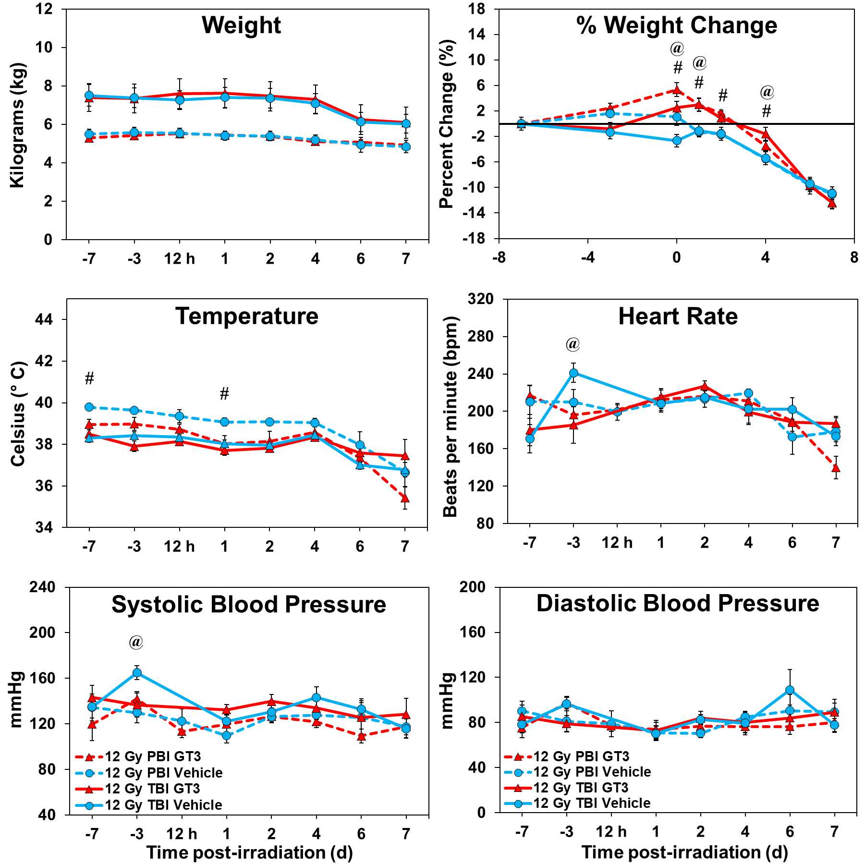
Supplementary Figure 1. Weight, percent weight change, temperature, heart rate, and systolic and diastolic blood pressure changes in NHPs treated with GT3 or vehicle and exposed to 12.0 Gy partial-body or total-body radiation. One-Way ANOVA tests were performed to compare differences between the GT3-treated groups and their respective vehicle-treated groups. Statistically significant changes between GT3-treated and vehicle-treated animals exposed to partial-body radiation are indicated by #, while significant changes between GT3-treated and vehicle-treated animals exposed to total-body radiation are indicated by @ (p-value < .05).
Tissue | Day 4, TBI – Vehicle | Day 4, TBI – GT3 | Day 4, PBI – Vehicle | Day 4, PBI – GT3
40x – Sternum | 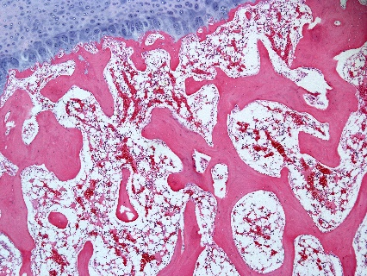 | 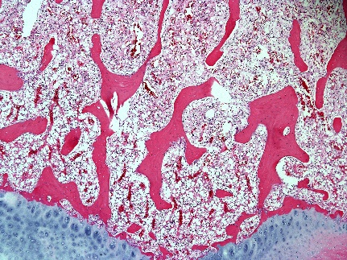 | 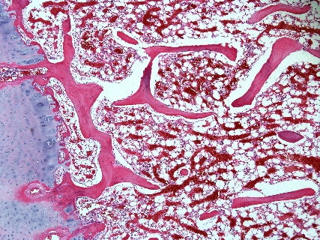 | 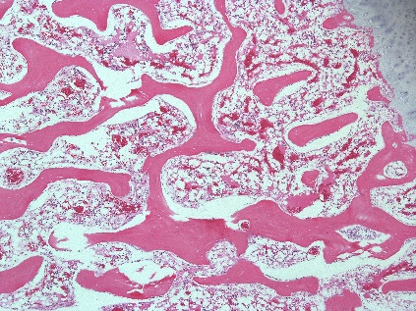
200x – Sternum | 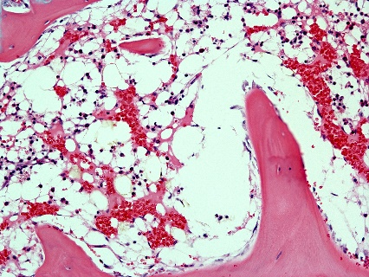 | 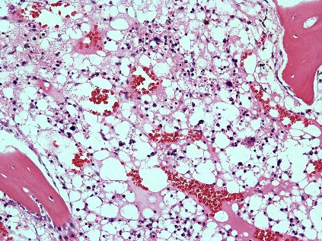 | 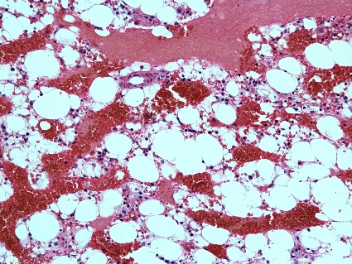 | 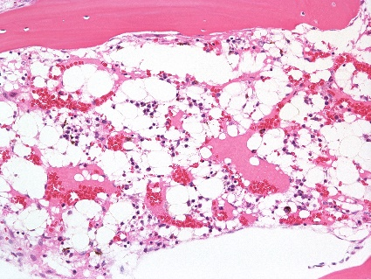
40x –  Spleen | 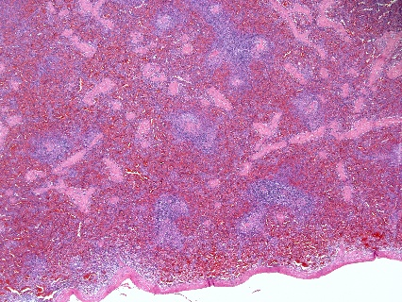 | 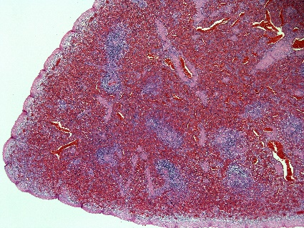 | 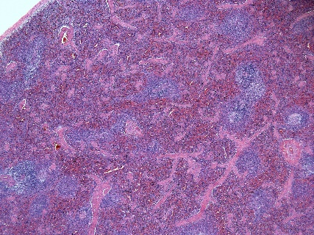 | 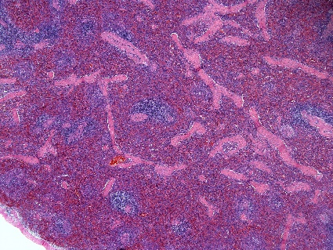
200x – Spleen | 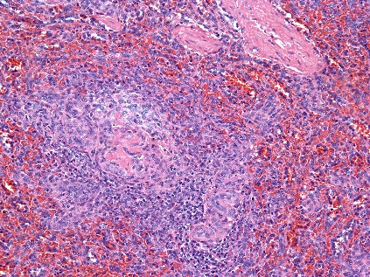 | 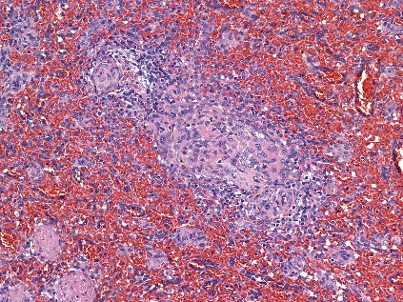 | 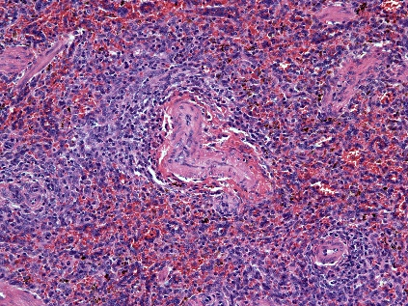 | 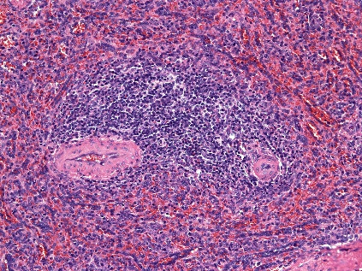

Supplementary Figure 2. Comparison of lymphohematopoietic organs collected from vehicle- and GT3-treated NHPs day 4 post-irradiation with 12 Gy. Radiation exposure was either partial-body (PBI) or total-body (TBI). Sternum: Vehicle TBI RA2619F, GT3 TBI RA2115F, Vehicle PBI 1603060F, GT3 PBI 1603080F. Spleen: Vehicle TBI RA2692M, GT3 TBI RA2781M, Vehicle PBI 1603151M, GT3 PBI 1603051M.

Tissue | Day 4, TBI – Vehicle | Day 4, TBI – GT3 | Day 4, PBI – Vehicle | Day 4, PBI – GT3
40x – Duodenum | 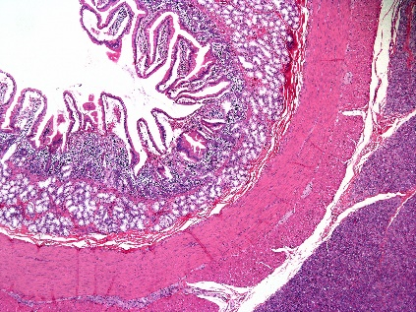 | 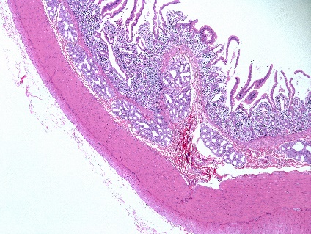 | 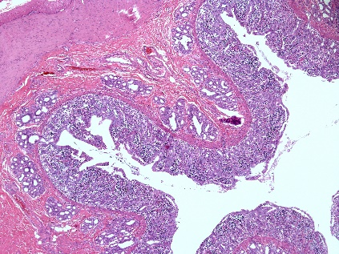 | 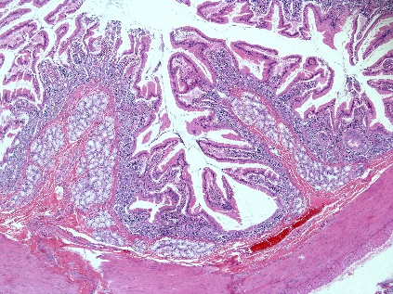
200x – Duodenum | 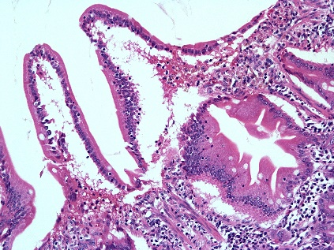 | 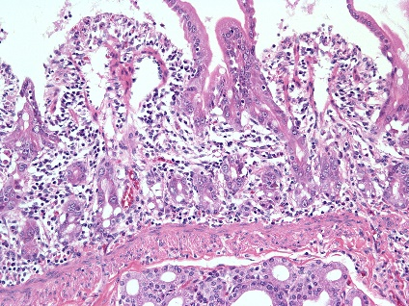 | 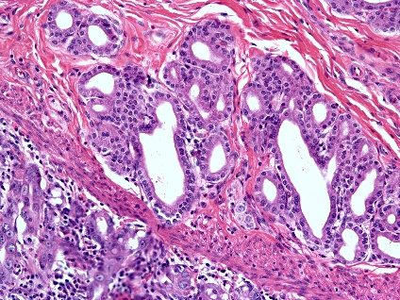 | 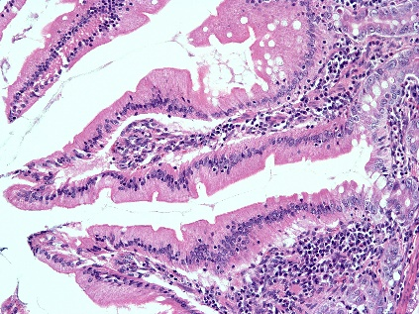
40x – Jejunum | 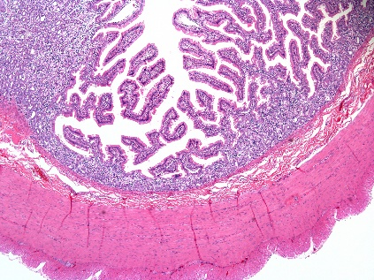 | 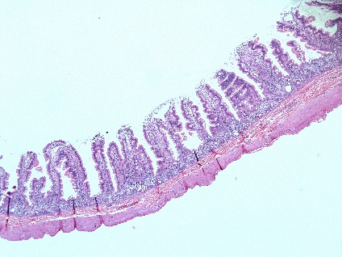 | 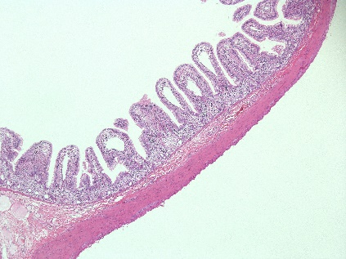 | 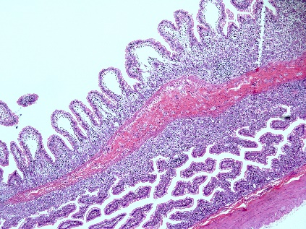
200x – Jejunum | 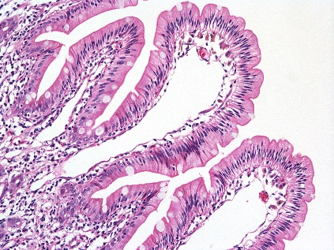 | 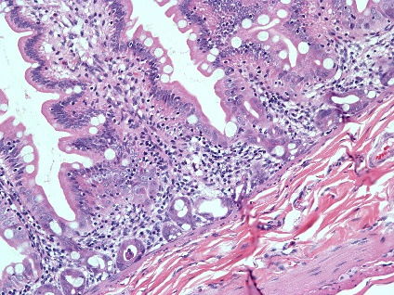 | 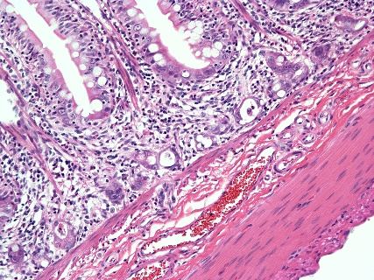 | 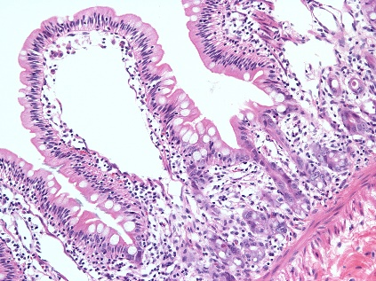
40x –  Ileum | 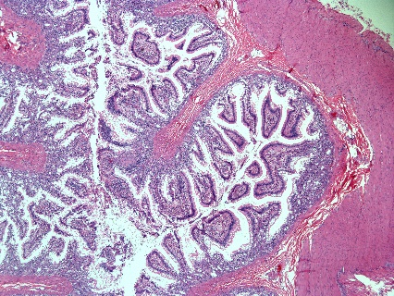 | 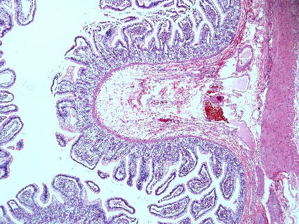 | 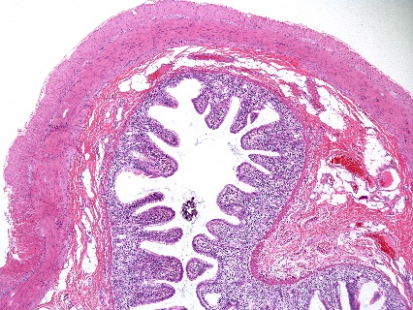 | 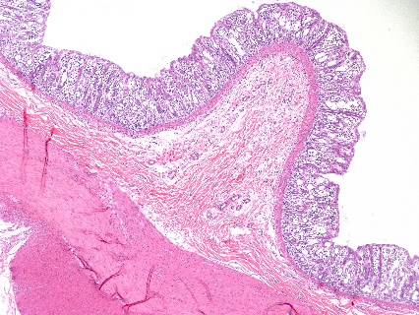
200x –  Ileum | 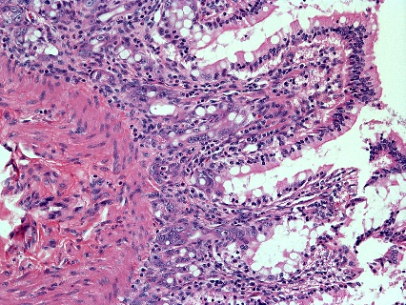 | 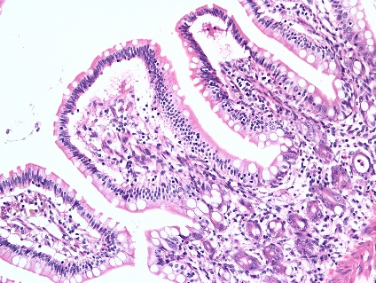 | 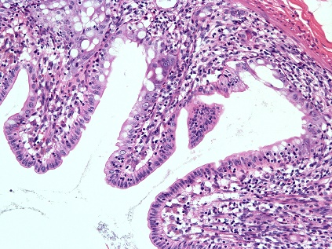 | 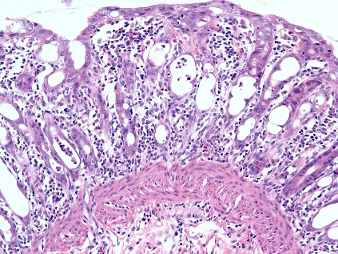
40x –  Colon | 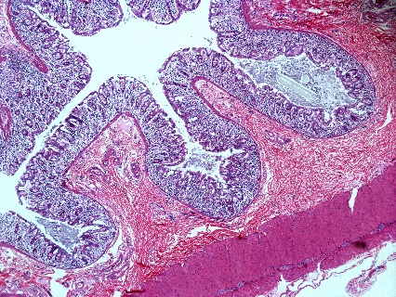 | 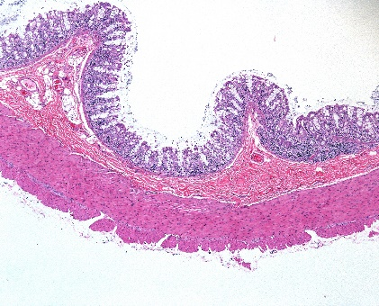 | 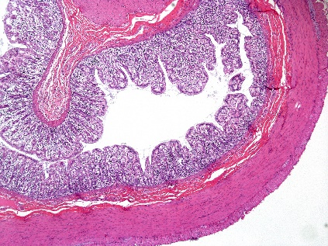 | 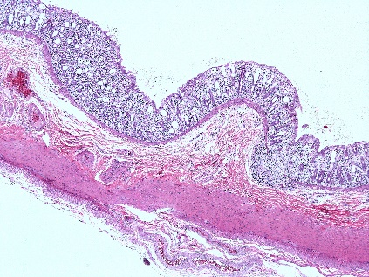
200x –  Colon | 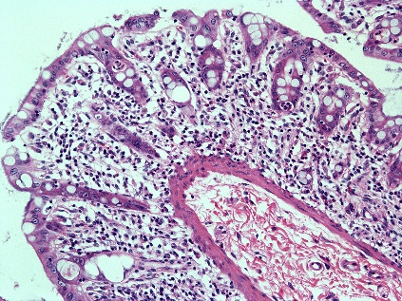 | 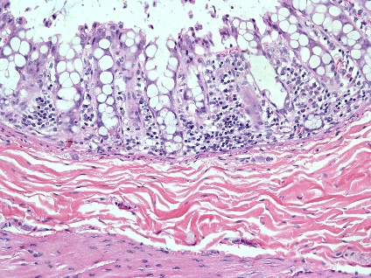 | 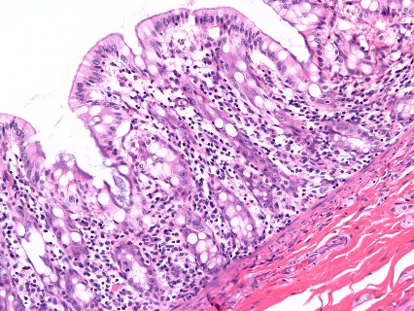 | 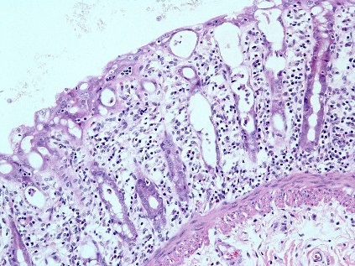

Supplementary Figure 3. Comparison of gastrointestinal tissue sections collected from vehicle- and GT3-treated NHPs day 4 post-irradiation with 12 Gy (either partial-body or total-body irradiation (PBI/TBI)). Duodenum: Vehicle TBI RA2892M, GT3 TBI RA2115F, Vehicle PBI 1603151M, GT3 PBI 1603051M. Jejunum: Vehicle TBI RA2692M, GT3 TBI RA2599M, Vehicle PBI 1603151M, GT3 PBI 1603051M. Ileum: Vehicle TBI RA2692M, GT3 TBI RA2115F, Vehicle PBI 1603151M, GT3 PBI 1603051M. Colon: Vehicle TBI RA2892M, GT3 TBI RA2599M, Vehicle PBI 1608024F, GT3 PBI 1608009F.

Tissue | Day 4, TBI – Vehicle | Day 4, TBI – GT3 | Day 4, PBI – Vehicle | Day 4, PBI – GT3
40x – Kidney | 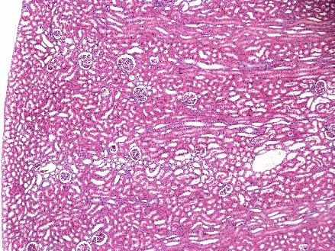 | 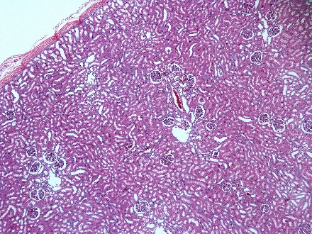 | 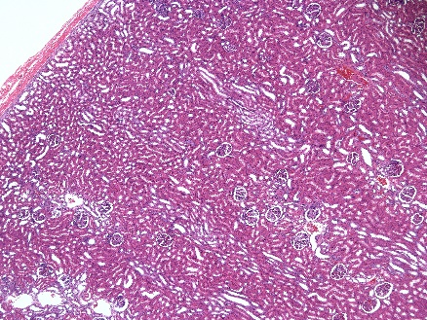 | 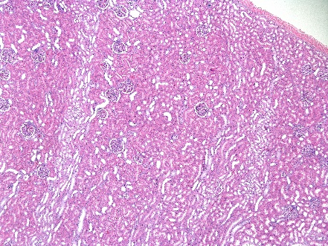
200x – Kidney | 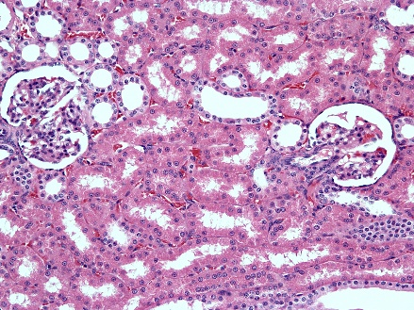 | 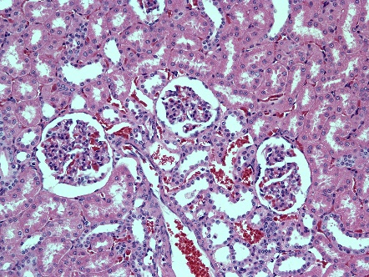 | 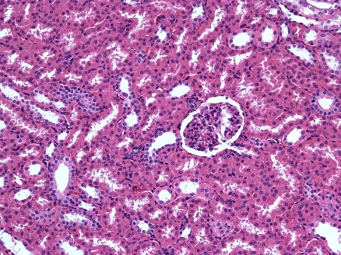 | 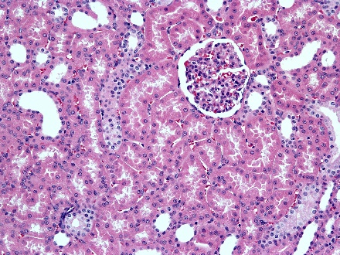

Supplementary Figure 4. Comparison of kidneys collected from vehicle- and GT3-treated NHPs day 4 post-irradiation with 12 Gy. Radiation exposure was either partial-body (PBI) or total-body (TBI). Kidney: Vehicle TBI RA2892M, GT3 TBI RA2599M, Vehicle PBI 1608024F, GT3 PBI 1608009F.

Tissue | Day 4, TBI – Vehicle | Day 4, TBI – GT3 | Day 4, PBI – Vehicle | Day 4, PBI – GT3
40x –  Lung | 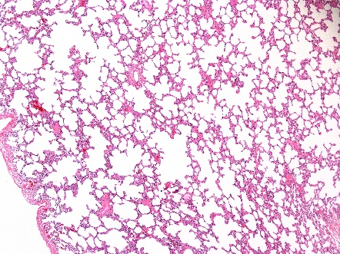 | 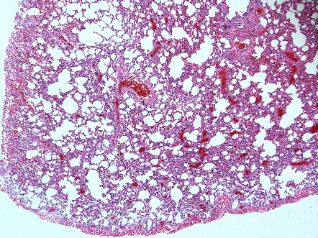 | 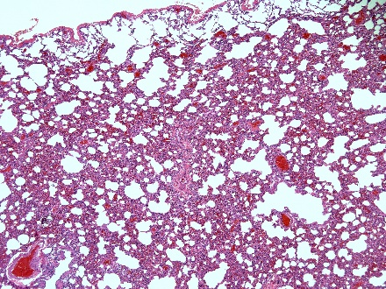 | 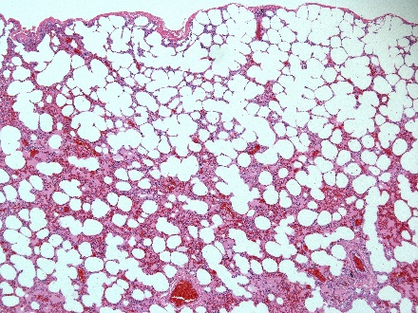
200x –  Lung | 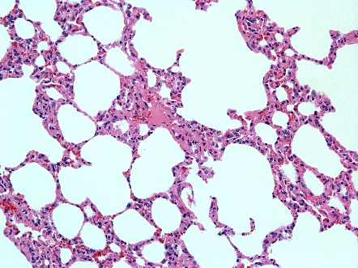 | 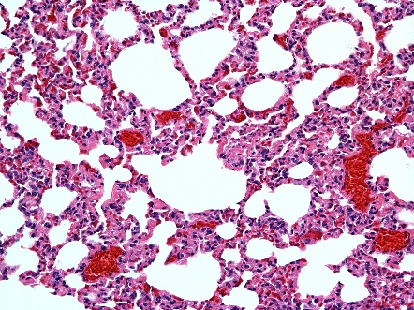 | 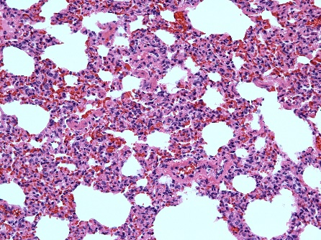 | 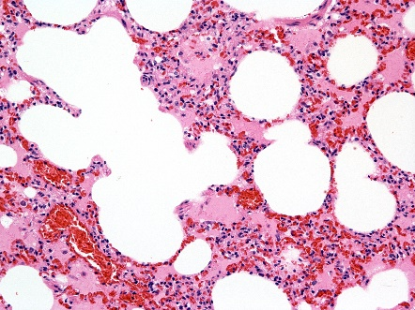

Supplementary Figure 5. Comparison of lung tissue collected from vehicle- and GT3-treated NHPs day 4 post-irradiation with 12 Gy. Radiation exposure was either partial-body (PBI) or total-body (TBI). Lung: Vehicle TBI RA2692M, GT3 TBI RA2781M, Vehicle PBI 1608024F, GT3 PBI 1603080F.

