Design, synthesis and bioactivity study on oxygen-heterocyclic-based pyran analogues as effective P-glycoprotein-mediated multidrug resistance in MCF-7/ADR cell
Ashraf H.F. Abd El-Wahab ª, Rita M.A. Borik ª, Al-Anood M. Al-Dies,^{b} Ahmed M. Fouda ^{c}, Hany M. Mohamed ª, R.A. El-Eisawy ^{d,e}, Ahmed Mora ^{d}, Mohammed A.A. El-Nassag ^{d}, Ahmed M. A. I. Abd El-Hady ^{d},Ahmed A. Elhenawy ^{d,f,,}*, Ahmed M. El-Agrody ^{d,}*
ª Chemistry Department, Faculty of Science, Jazan University, B.O. Box 2097, Jazan 45142, Kingdom of Saudi Arabia
^{b} Chemistry Department, Umm Al-Qura University, Al-Qunfudah University College, Al-Qunfudah 21912, Saudi Arabia
^{c} Chemistry Department, Faculty of Science, King Khalid University, Abha 61413, Saudi Arabia
^{d} Chemistry Department, Faculty of Science, Al-Azhar University, Nasr City 11884, Cairo, Egypt
^{e} Chemistry Department, Faculty of Science and Art, Al-Baha University, Al-Baha, 1988, Saudi Arabia
^{f} Chemistry Department, Faculty of Science and Art, AlBaha University, Al Bahah 65731, Saudi Arabia
⁎ Corresponding author: Ahmed M. El-Agrody (elagrody_am@azhar.edu.eg), Ahmed A. Elhenawy (elhenawy_sci@hotmail.com)

Table of Contents: | Page
Figure S1: ¹H NMR of cpd. (4c). | S3
Figure S2: ¹³C NMR of cpd. (4c). | S4
Figure S3: ¹³C NMR/APT of cpd. (4c). | S5
Figure S4: ¹H NMR of cpd. (4f). | S6
Figure S5: ¹³C NMR of cpd. (4f). | S7
Figure S6: ¹³C NMR/APT of cpd. (4f). | S8
Figure S7: ¹H NMR 8.5-6.5 ppm of cpd. (4h). | S9
Figure S8: ¹H NMR of cpd. (4h). | S10
Figure S9: ¹³C NMR of cpd. (4h). | S11
Figure S10: ¹H NMR 8.5-6.5 ppm of cpd. (4i). | S12
Figure S11: ¹H NMR of cpd. (4i). | S13
Figure S12: ¹³C NMR of cpd. (4i). | S14
Figure S13: ¹H NMR 8.5-6.5 ppm of cpd. (4j). | S15
Figure S14: ¹H NMR of cpd. (4j). | S16
Figure S15: ¹³C NMR of cpd. of cpd. (4j). | S17
Figure S16: ¹H NMR 8.5-6.5 ppm of cpd. (4k). | S18
Figure S17: ¹H NMR of cpd. (4k). | S19
Figure S18: ¹³C NMR of cpd. (4k). | S20
Figure S19: ¹H NMR 8.5-6.5 ppm of cpd. (4l). | S21
Figure S20: ¹H NMR of cpd. (4l). | S22
Figure S21: ¹³C NMR of cpd. (4l). | S23

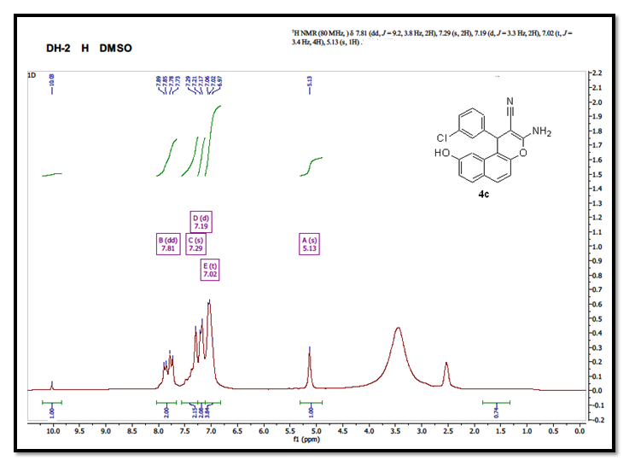

Figure S1: ¹H NMR of cpd. (4c).

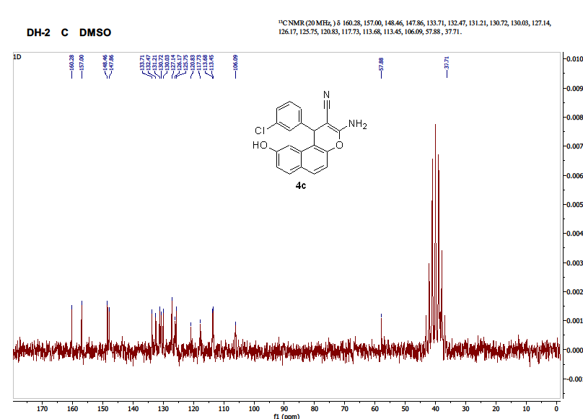

Figure S2: ¹³C NMR of cpd. (4c).

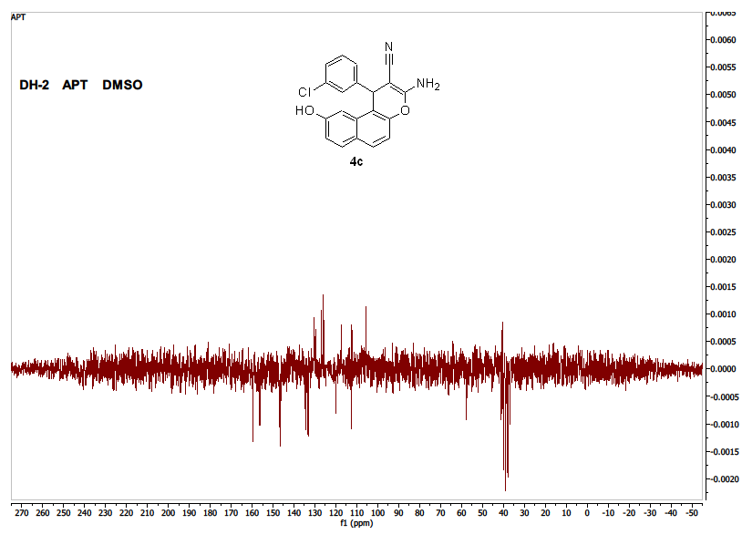

Figure S3: ¹³C NMR/APT of cpd. (4c).

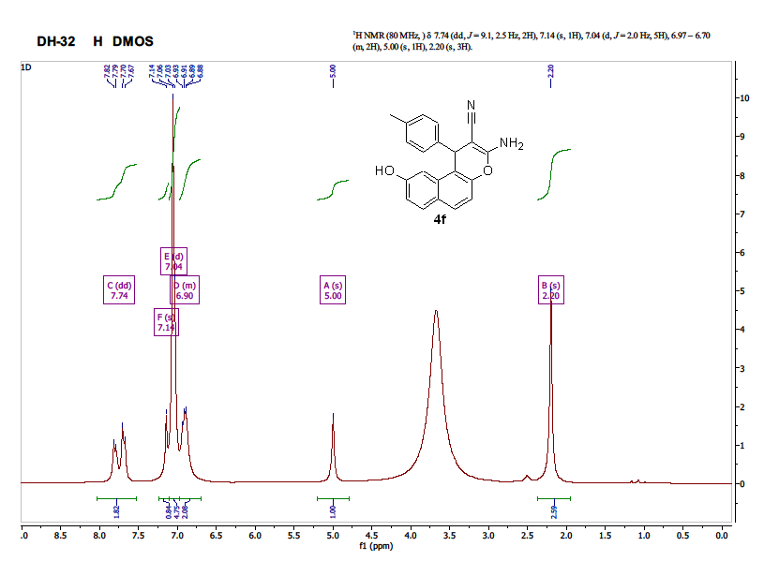

Figure S4: ¹H NMR of cpd. (4f).

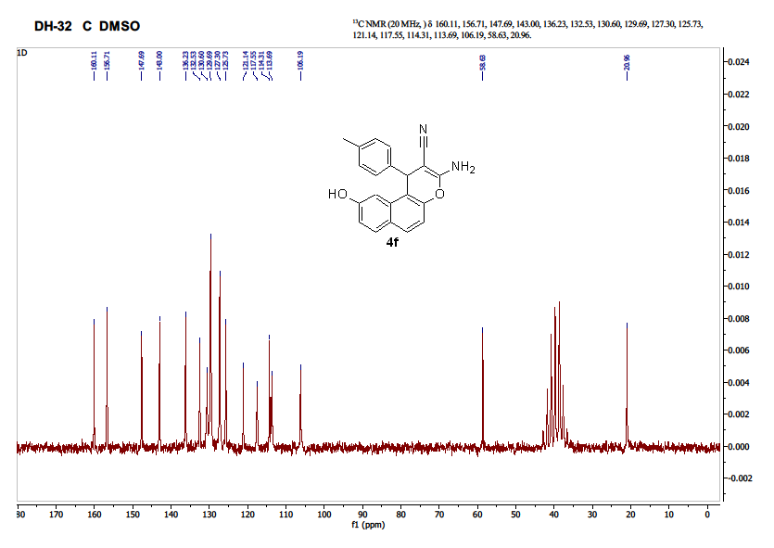

Figure S5: ¹³C NMR of cpd. (4f).

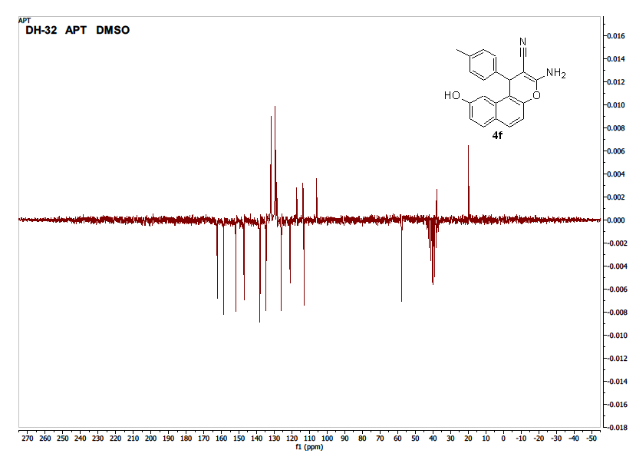

Figure S6: ¹³C NMR/APT of cpd. (4f).

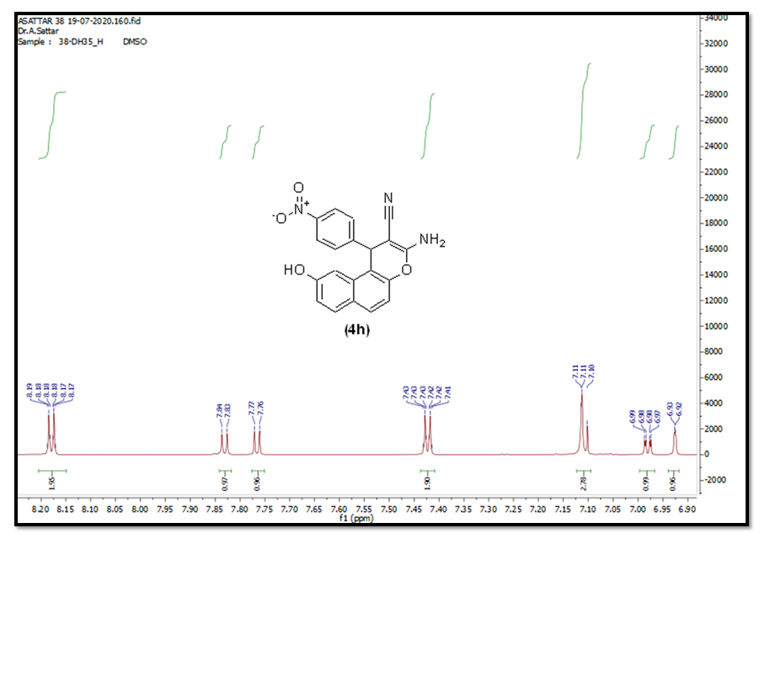

Figure S7: ¹H NMR 8.5-6.5 ppm of cpd. (4h).

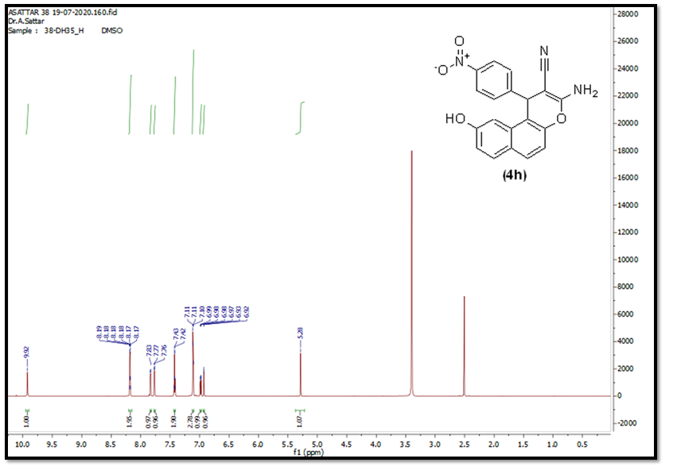

Figure S8: ¹H NMR of cpd. (4h).

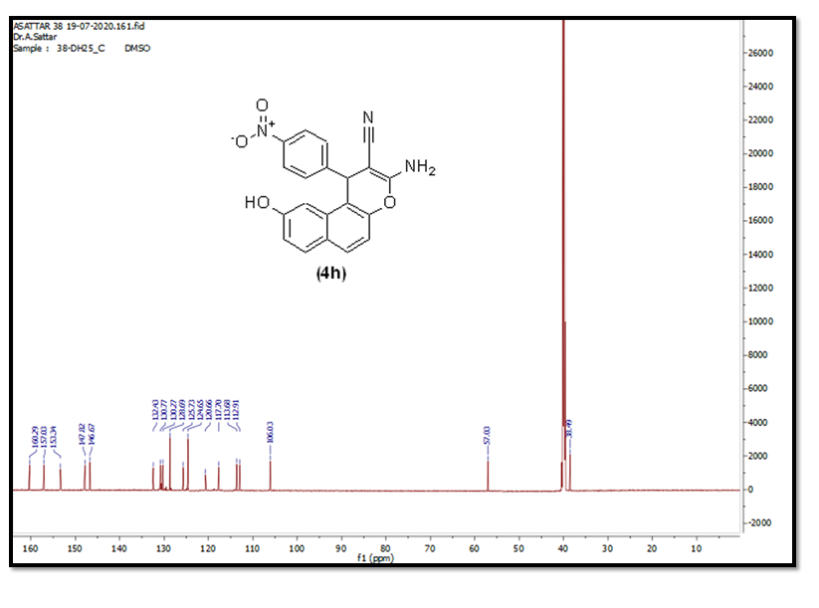

Figure S9: ¹³C NMR of cpd. (4h).

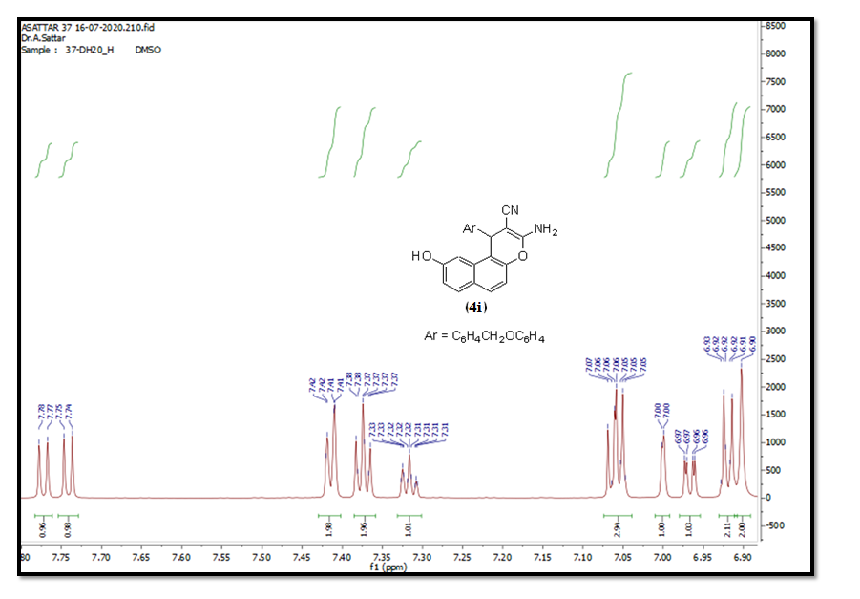

Figure S10: ¹H NMR 8.5-6.5 ppm of cpd. (4i).

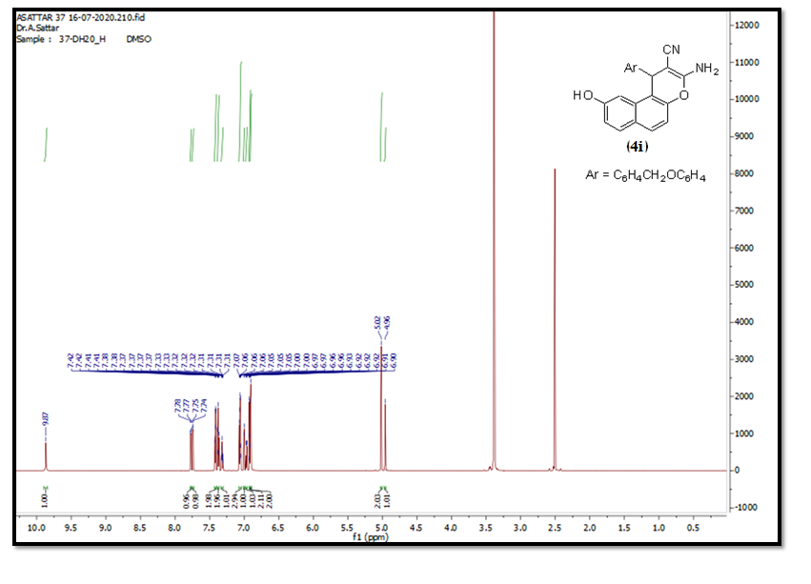
Figure S11: ¹H NMR of cpd. (4i).

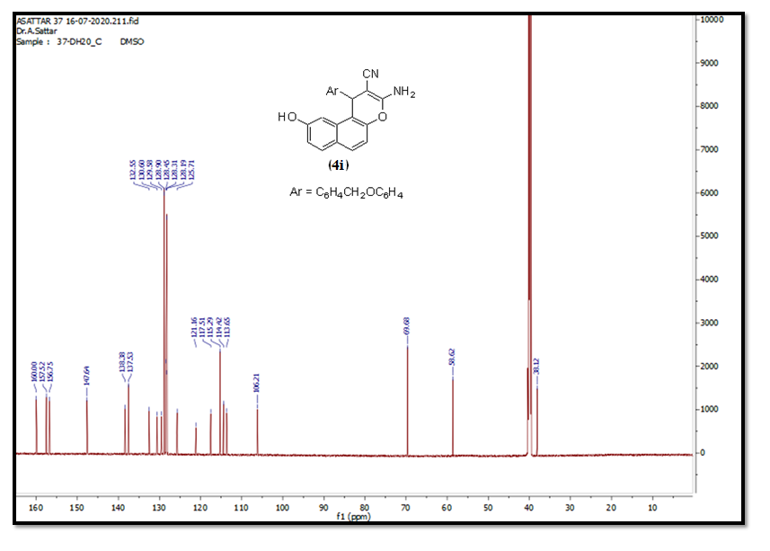
Figure S12: ¹³C NMR of cpd. (4i).

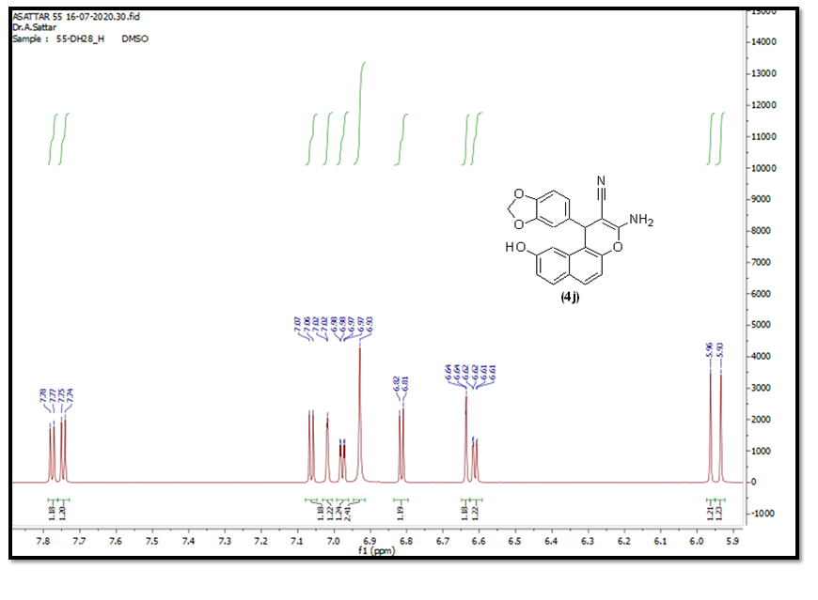
Figure S13: ¹H NMR 8.5-6.5 ppm of cpd. (4j).

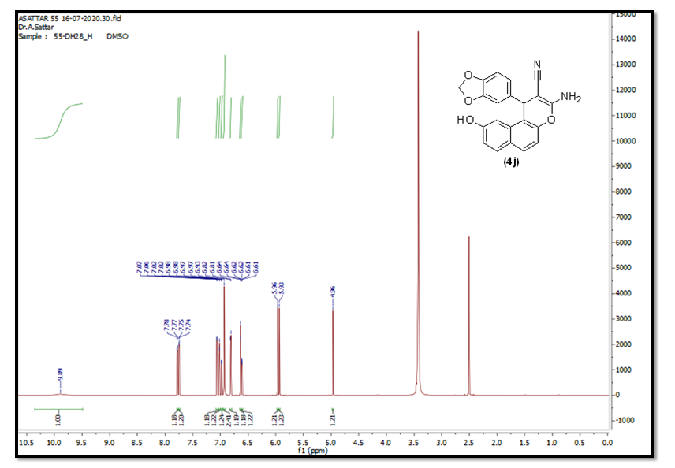
Figure S14: ¹H NMR of cpd. (4j).

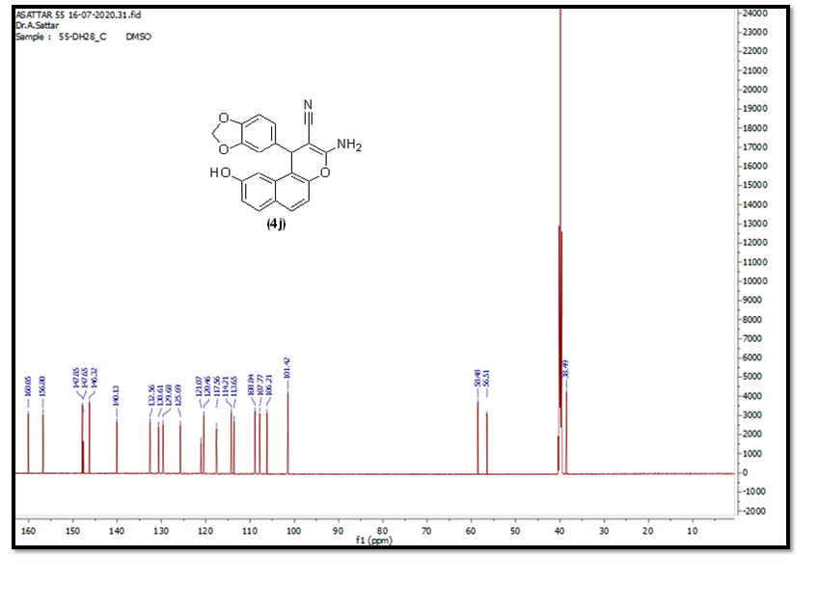
Figure S15: ¹³C NMR of cpd. (4j).

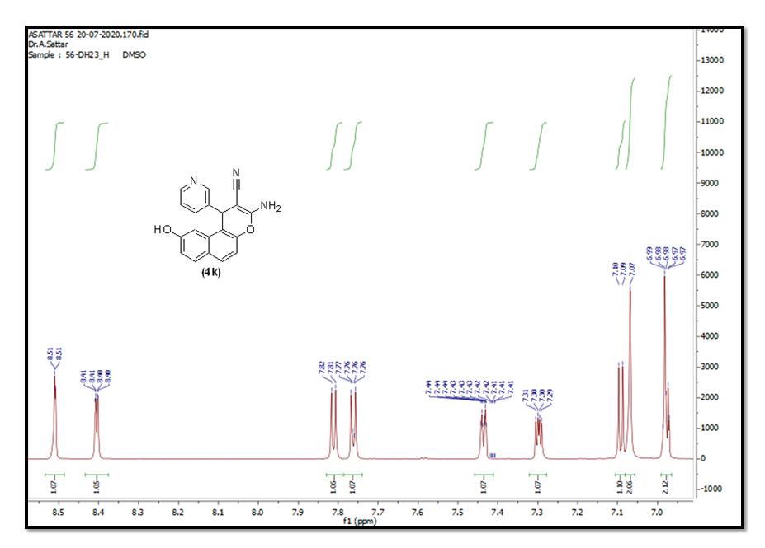
Figure S16: ¹H NMR 8.5-6.5 ppm (4k).

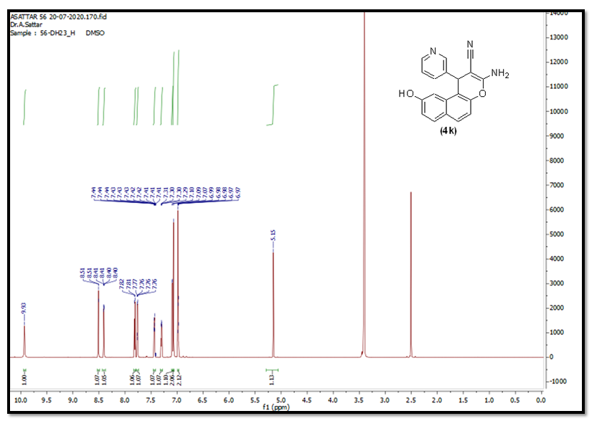
Figure S17: ¹H NMR of cpd. (4k).

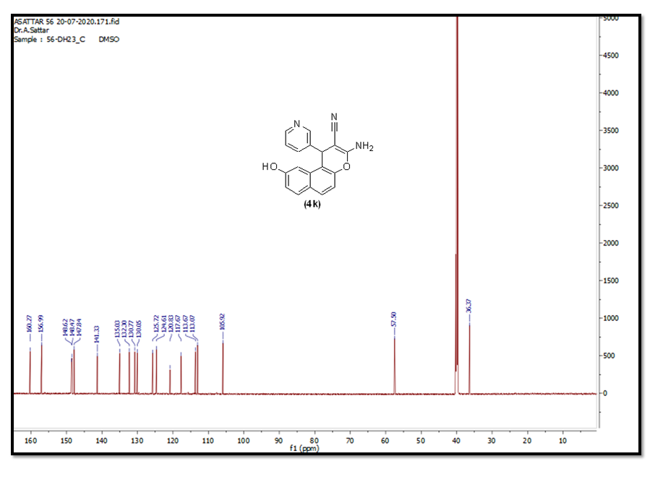
Figure S18: ¹³C NMR of cpd. (4k).

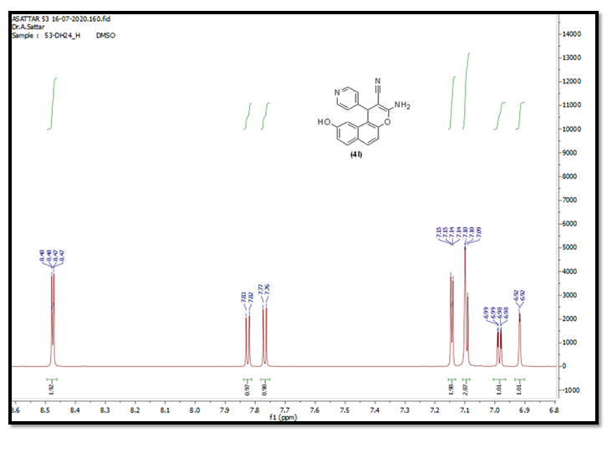
Figure S19: ¹H NMR 8.5-6.5 ppm of cpd (4l).

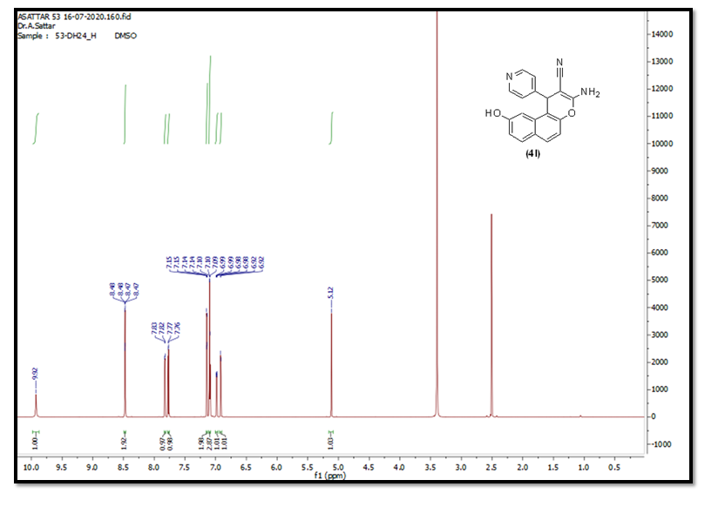
Figure S20: ¹H NMR of cpd (4l).

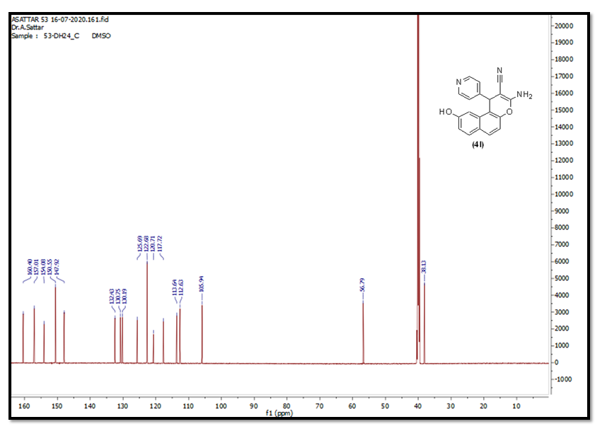
Figure S21: ¹³C NMR of cpd. (4l).

