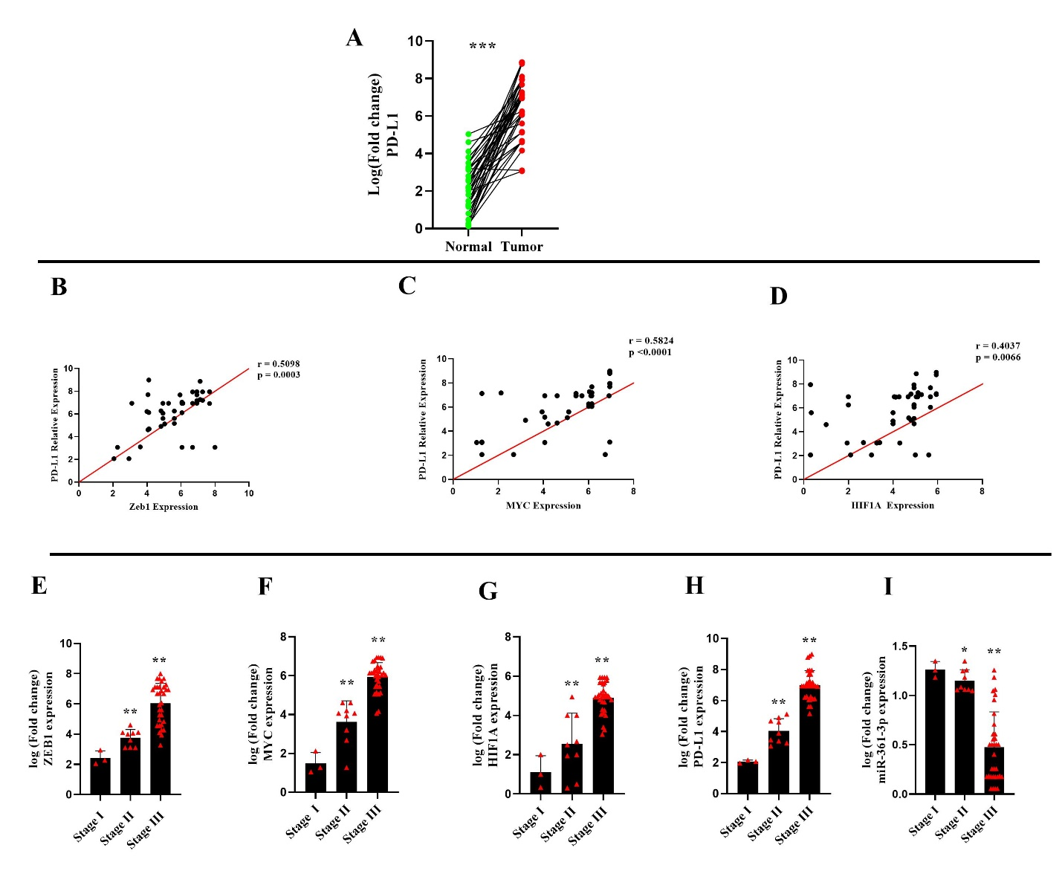

SUPPLEMENTARY1:
(A): the results showed that the expression of PD-L1 gene was significantly increased in BC tissues compared with adjacent normal tissues (Supp.1A, P < 0.001).
(B, C, D): Pearson correlation analyses of ZEB1, MYC, and HIF1A gene expression in BC tissues demonstrated a positive correlation between PD-L1 expression and ZEB1 (Supp. 1B, r = 0.5098; P = 0.0003), MYC (Supp.1C, r = 0.5824; P < 0.0001), and HIF1A mRNA levels (Supp. 1D, r = 0.4037; P < 0.0066).
(E, F, G, H, I): The results of qRT-PCR revealed that the expression levels of ZEB1 (Supp.1E, P < 0.001), MYC (Supp.1F, P < 0.001), and HIF1A (Supp.1G, P < 0.001), PD-L1 genes (Supp.1H, P < 0.001) were significantly increased and miR-561-3p (Supp.1I, P < 0.001, P < 0.05) was abnormally down-regulated in BC tissues stage III compared with BC tissues stage I.

