Supplementary

Catastrophic costs incurred by tuberculosis-affected households: Thailand’s first national tuberculosis patient cost survey.

Sitaporn Youngkong^{1,2}, Phalin Kamolwat³, Phichet Wongrot^{2,4}, Montarat Thavorncharoensap^{1,2}, Usa Chaikledkaew^{1,2}, Sriprapa Nateniyom³, Petchawan Pungrassami³, Naiyana Praditsitthikorn⁵, Surakameth Mahasirimongkol⁶, Jiraphun Jittikoon⁷, Nobuyuki Nishikiori⁸, Ines Garcia Baena⁸, Takuya Yamanaka^{8, 9, 10}
¹ Mahidol University Health Technology Assessment (MUHTA) Graduate Program, Mahidol University, Thailand
² Social and Administrative Pharmacy Division, Department of Pharmacy, Faculty of Pharmacy, Mahidol University, Thailand
³ Division of Tuberculosis, Department of Disease Control, Ministry of Public Health, Thailand
⁴ Faculty of Nursing, Mahidol University, Thailand
⁵ Department of Disease Control, Ministry of Public Health, Thailand
⁶ Department of Medical Sciences, Ministry of Public Health, Thailand
⁷ Department of Biochemistry, Faculty of Pharmacy, Mahidol University, Thailand
⁸ World Health Organization Global Tuberculosis Programme, Geneva, Switzerland
⁹ Department of Global Health and Development, London School of Hygiene & Tropical Medicine, London, UK
¹⁰ School of Tropical Medicine and Global Health, Nagasaki University, Nagasaki, Japan

Corresponding author:
Sitaporn Youngkong, Ph.D.
Social and Administrative Pharmacy Division, Department of Pharmacy, Faculty of Pharmacy, Mahidol University, 447 Sri-Ayudhaya Rd., Phayathai, Ratchathevi, Bangkok 10400, Thailand
E-mail: sitaporn.you@mahidol.edu
Figure S1 Impoverishment of TB-affected households during TB treatment (in PPP)

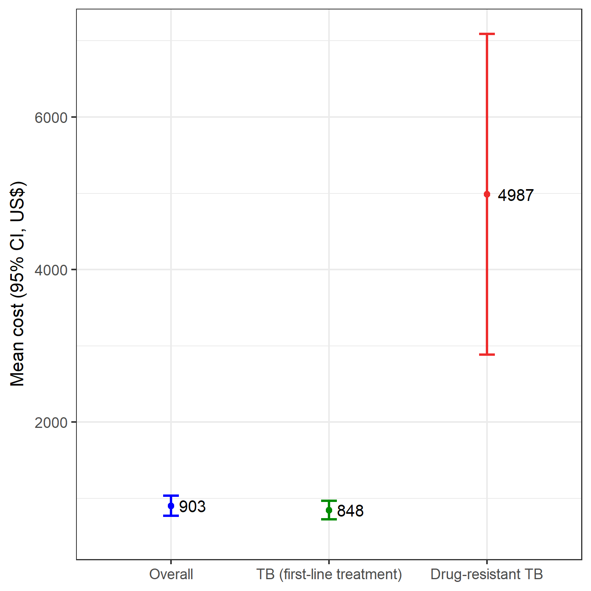

Figure S2 Total cost incurred per TB-affected household (current 2020 USD)

Table S1 Risk factors for catastrophic costs
Risk factors |  | Univariate analysis |  |  | Multivariate analysis
 |  | Crude OR | 95% CI | p-value | Adjusted OR | 95% CI | p-value
Age group (year) | 0-14 | 1.4 | (0.3-6.8) | 0.698 | - | - | -
Age group (year) | 15-24 | 0.9 | (0.5-1.7) | 0.781 | - | - | -
Age group (year) | 25-34 | Ref | - | - | - | - | -
Age group (year) | 35-44 | 1.4 | (0.7-2.6) | 0.322 | - | - | -
Age group (year) | 45-54 | 1.5 | (0.9-2.5) | 0.129 | - | - | -
Age group (year) | 55-64 | 1.4 | (0.9-2.2) | 0.128 | - | - | -
Age group (year) | 65+ | 1.8 | (1.1-3.0) | 0.029* | - | - | -
Sex | Female | Ref | - | - | - | - | -
Sex | Male | 0.9 | (0.7-1.1) | 0.473 | - | - | -
Drug resistance status | TB (first line treatment) | Ref | - | - | Ref | - | -
Drug resistance status | Drug resistant TB | 3.8 | (1.2-12.2) | 0.034* | 10.2 | (3.0-34.8) | 0.001**
Type of TB | Bacteriologically confirmed pulmonary TB | Ref | - | - | Ref | - | -
Type of TB | Clinically diagnosed pulmonary TB | 0.8 | (0.6-1.1) | 0.205 | 0.9 | (0.6-1.5) | 0.809
Type of TB | Extrapulmonary TB | 1.1 | (0.8-1.6) | 0.461 | 3.0 | (1.2-7.9) | 0.037*
HIV status | Negative | Ref | - | - | - | - | -
 | Positive | 0.9 | (0.7-1.2) | 0.370 | - | - | -
 | Unknown | 0.6 | (0.3-1.2) | 0.162 | - | - | -
Treatment group | New | Ref | - | - | - | - | -
Treatment group | Relapse | 1.7 | (1.0-2.9) | 0.046* | - | - | -
Treatment group | Retreatment | 1.0 | (0.4-2.8) | 0.933 | - | - | -
Employment status before TB | Unemployed | Ref | - | - | Ref | - | -
Employment status before TB | Formal employment | 1.0 | (0.7-1.4) | 0.873 | 2.1 | (1.1-4.1) | 0.048*
Employment status before TB | Informal employment | 1.3 | (0.9-1.9) | 0.114 | 1.8 | (1.0-3.2) | 0.084
Employment status before TB | Other (student, retired, monk) | 0.9 | (0.4-1.7) | 0.705 | 2.3 | (0.8-6.3) | 0.125
Education level | No education | Ref | - | - | Ref | - | -
Education level | Pre/Primary school | 1.2 | (0.8-1.7) | 0.480 | 1.1 | (0.7-1.8) | 0.725
Education level | Secondary school or above | 1.1 | (0.7-1.7) | 0.723 | 1.6 | (0.8-2.9) | 0.176
Insurance status | With insurance | Ref | - | - | Ref | - | -
Insurance status | No insurance | 1.6 | (0.7-3.6) | 0.311 | 5.0 | (1.4-17.2) | 0.021*
Household size | ≥3 | Ref | - | - | - | - | -
Household size | <3 | 1.5 | (1.1-1.9) | 0.015* | - | - | -
Household expenditure quintile | Fifth (highest) | Ref | - | - | Ref | - | -
Household expenditure quintile | Fourth | 1.5 | (0.8-2.8) | 0.237 | 2.1 | (1.0-4.2) | 0.056
Household expenditure quintile | Third | 2.4 | (1.4-4.1) | 0.003* | 3.6 | (1.9-6.7) | 0.001*
Household expenditure quintile | Second | 5.1 | (3.3-8.0) | <0.001* | 8.1 | (4.8-13.7) | <0.001*
Household expenditure quintile | First (lowest) | 19.1 | (11.4-32.1) | <0.001* | 54.6 | (30.3-98.5) | <0.001*
Treatment support | Self-administered | Ref | - | - | Ref | - | -
Treatment support | Home-based directly observed therapy | 1.1 | (0.8-1.5) | 0.626 | 1.2 | (0.9-1.7) | 0.301
Treatment support | Facility-based directly observed therapy | 2.9 | (1.7-4.9) | 0.001* | 1.7 | (1.1-2.5) | 0.022*
Primary income earner | No | Ref | - | - | Ref | - | -
Primary income earner | Yes | 1.5 | (1.2-1.9) | 0.002* | 1.4 | (1.0-2.0) | 0.063
Current hospitalization | Currently not hospitalized | Ref | - | - | - | - | -
Current hospitalization | Currently hospitalized | 2.7 | (1.6-4.3) | <0.001* | - | - | -
Previous hospitalization | Previously not hospitalized | Ref | - | - | Ref | - | -
Previous hospitalization | Previously hospitalized | 4.6 | (3.4-6.2) | <0.001* | 2.2 | (1.7-2.8) | <0.001*

