Supplementary Table S1. Health administrative data sources housed at ICES.

Number | Database | Information on Data
1 | Ontario Health Insurance Plan (OHIP) Database | Contains information on all fee-for-service billings for physician services
2 | Canadian Institute for Health Information Discharge Abstract Database (CIHI-DAD) | Records hospitalizations using the most responsible diagnoses for all patients discharged from acute-care hospitals
3 | National Ambulatory Care Reporting System (NACRS) | Contains data for emergency department (ED) visits, coded using International Classification of Disease (ICD) codes
4 | Registered Persons Database (RPDB) | Includes information on sex, date of birth, and residence postal code
5 | Ontario Marginalization Index (ON-Marg) | ON-Marg uses Census data to measure four dimensions of marginalization (material deprivation, dependency, ethnic concentration, and residential instability) at the neighbourhood-level; individuals in the study were assigned a value from 1 (least marginalized) to 5 (most marginalized) for each dimension based on residence at baseline
6 | Ontario Asthma Surveillance Information System (OASIS; https://lab.research.sickkids.ca/oasis/) | OASIS is a cohort of Ontarians aged 0-99 years old with physician-diagnosed asthma between 1996 and 2021 and was used to identify date of asthma diagnosis
7 | Mom-Baby Database | Used to identified mothers and siblings of children in the pediatric cohorts
8 | Permanent Resident Database of Citizenship and Immigration Canada (CIC) | Contains information on Ontario immigrants between 1985-2020 and was used to establish the immigration status of study participants

Supplementary Table S2. Latent class model fit statistics, N=15,724.

 |  |  |  |  |  |  |  |  | Predicted class membership
Fit statistics |  |  |  |  |  |  |  |  | by model posterior probability
Number of Classes | Maximum Log-likelihood | Residual Degrees of Freedom | Bayesian Information Criterion | Akaike Information Criterion | Likelihood-ratio chi-square test | Entropy | Lo-Mendell-Rubin Test |  | 1 | 2 | 3 | 4
1 |  | 15682.00 | 502671.50 | 502349.70 | 200833.10 | NA |  |  | 1.0000
2 | -243656.80 | 15639.00 | 488134.90 | 487483.50 | 185881.00 | 0.85 |  |  | 0.4674 | 0.5320
3 | -239259.70 | 15596.00 | 479756.20 | 478775.30 | 177086.80 | 0.81 | p<0.001 |  | 0.3082 | 0.2842 | 0.4076
4 | -236656.50 | 15553.00 | 474965.30 | 473655.00 | 171880.40 | 0.82 | p<0.001 |  | 0.3075 | 0.2646 | 0.2342 | 0.1937

Supplementary Table S3. Conditional probabilities by concomitant variables and the latent classes, N=15,724.

Indicator Variables | Class 1 | Class 2 | Class 3 | Class 4
Maternal and child characteristics
Mother’s age at delivery
12-19 | 0.0025 | 0.0023 | 0.0090 | 0.0450
20-29 | 0.0745 | 0.1193 | 0.2696 | 0.4280
30-39 | 0.8275 | 0.8164 | 0.6573 | 0.4886
40-52 | 0.0956 | 0.0619 | 0.0642 | 0.0384
Mother’s highest education attainment
University and above | 0.7858 | 0.6614 | 0.5504 | 0.2499
College | 0.1681 | 0.2760 | 0.2811 | 0.3727
High school and below | 0.0462 | 0.0626 | 0.1685 | 0.3774
Mother’s immigration status
Non-immigrant | 0.8833 | 0.9251 | 0.5389 | 0.5742
Landed immigrant | 0.1081 | 0.0723 | 0.4063 | 0.3625
Refugee | 0.0086 | 0.0025 | 0.0548 | 0.0633
Prevalence of pregnancy complications  (pregnancy induced hypertension, gestational diabetes, pre-eclampsia) | 0.0518 | 0.0484 | 0.0654 | 0.0842
No prenatal care visit during pregnancy | 0.0706 | 0.0770 | 0.0469 | 0.0310
Child being breastfed | 0.9688 | 0.9598 | 0.9296 | 0.8614
Number of siblings in the household when the child was born
0 | 0.4432 | 0.5763 | 0.4995 | 0.6264
1 | 0.4275 | 0.3491 | 0.3442 | 0.2833
2 | 0.1127 | 0.0658 | 0.1122 | 0.0716
≥3 | 0.0166 | 0.0088 | 0.0441 | 0.0187
Neighborhood characteristics
(Ontario Marginalization Index):
Deprivation Quintiles (Q)
Q1 (Least) | 0.3283 | 0.3983 | 0.1030 | 0.0396
Q2 | 0.3242 | 0.2523 | 0.0883 | 0.0593
Q3 | 0.2071 | 0.1882 | 0.1544 | 0.1358
Q4 | 0.1126 | 0.1324 | 0.2731 | 0.2470
Q5 (Most) | 0.0278 | 0.0288 | 0.3813 | 0.5183
Instability Quintiles
Q1 (Least) | 0.0906 | 0.0446 | 0.1998 | 0.0333
Q2 | 0.1249 | 0.1088 | 0.1066 | 0.0625
Q3 | 0.2102 | 0.1898 | 0.0976 | 0.1300
Q4 | 0.3075 | 0.3238 | 0.1501 | 0.3233
Q5 (Most) | 0.2668 | 0.3330 | 0.4459 | 0.4509

Supplementary Table S3. Continued.

Indicator Variables | Class 1 | Class 2 | Class 3 | Class 4
Ethnic Concentration Quintiles
Q1 (Least) | 0.0166 | 0.0853 | 0.0049 | 0.0007
Q2 | 0.1036 | 0.2080 | 0.0013 | 0.0048
Q3 | 0.4189 | 0.3444 | 0.0045 | 0.0335
Q4 | 0.4538 | 0.3070 | 0.2119 | 0.2397
Q5 (Most) | 0.0071 | 0.0552 | 0.7775 | 0.7213
Dependency Quintiles
Q1 (Least) | 0.2807 | 0.2273 | 0.5042 | 0.2923
Q2 | 0.3021 | 0.2651 | 0.2457 | 0.2671
Q3 | 0.2095 | 0.2121 | 0.1200 | 0.2109
Q4 | 0.1177 | 0.1616 | 0.0808 | 0.1414
Q5 (Most) | 0.0900 | 0.1340 | 0.0493 | 0.0883
Environmental exposures
Environmental tobacco smoke exposure | 0.0819 | 0.0495 | 0.1636 | 0.2067
Nitrogen dioxide (NO₂)
Q1 | 0.5040 | 0.0042 | 0.4220 | 0.0029
Q2 | 0.4307 | 0.0803 | 0.3776 | 0.0468
Q3 | 0.0641 | 0.4707 | 0.1724 | 0.3136
Q4 | 0.0011 | 0.4447 | 0.0280 | 0.6366
Ozone (O₃)
Q1 | 0.0000 | 0.5685 | 0.0022 | 0.5927
Q2 | 0.3090 | 0.1833 | 0.2618 | 0.2215
Q3 | 0.3786 | 0.1135 | 0.3414 | 0.0998
Q4 | 0.3124 | 0.1347 | 0.3946 | 0.0860
Fine particulate matter ≤2.5 microns in width (PM_{2.5})
Q1 | 0.4599 | 0.0114 | 0.4536 | 0.0508
Q2 | 0.3231 | 0.1319 | 0.3220 | 0.1723
Q3 | 0.1871 | 0.3117 | 0.1712 | 0.3607
Q4 | 0.0299 | 0.5450 | 0.0532 | 0.4162
Normalized Difference Vegetation Index (NDVI)
Q1 | 0.1366 | 0.1697 | 0.3530 | 0.4104
Q2 | 0.1867 | 0.2222 | 0.3122 | 0.3188
Q3 | 0.2860 | 0.2948 | 0.2007 | 0.1817
Q4 | 0.3907 | 0.3132 | 0.1341 | 0.0891
Supplementary Figure S1. Cohort selection flow chart.

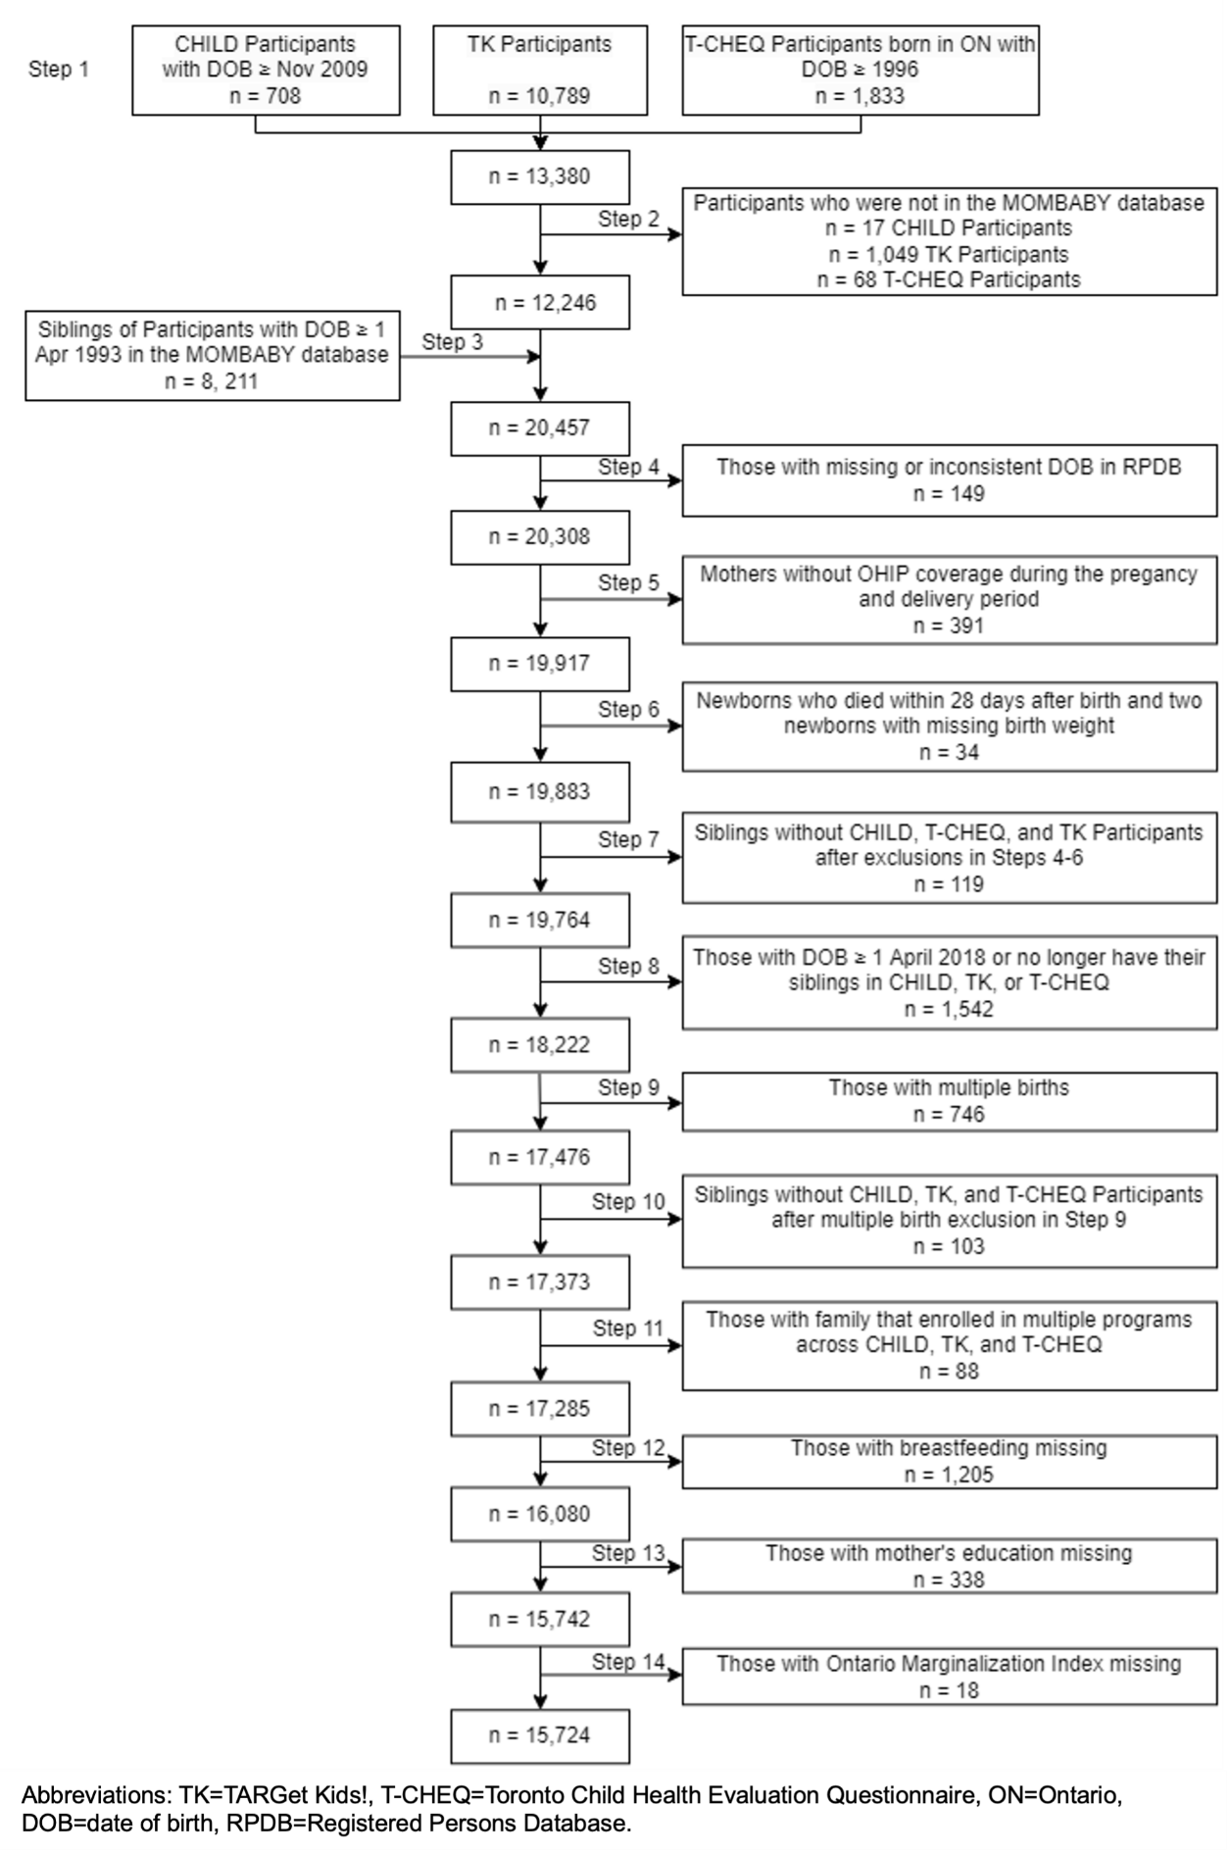

Supplementary Figure S2. Radar plots of Latent Class Analysis of 16 indicators in three domains.

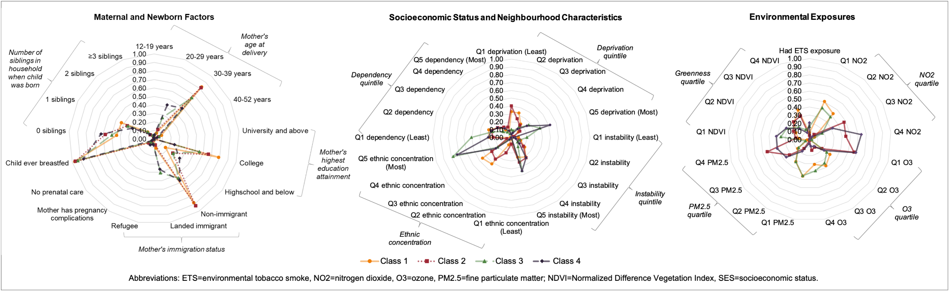

Latent class identification: Class 1: mothers in their 30s-40s with university or above education, non-immigrants, who likely had one or two children, lived in high SES neighborhoods with good air quality and greenspace; Class 2: mothers who were > 30s with university or above education, non-immigrants, who likely had a single child, lived in a high SES neighborhood, but with relatively poorer air quality and lower amount of greenspace; Class 3: mothers in their 30s with university or above education, likely a landed immigrant (or a refugee), with one or more children, lived in average SES neighborhoods with relatively good air quality and a good amount of greenspace; Class 4: mothers in their 20s with high school to college education, likely a landed immigrant (or a refugee) and with a single child, lived in low SES neighborhoods with high traffic-related air pollution and lower amount of greenspace.

